Note: The text in the shaded boxes below will not be included in the survey (the visitors will not read this as a part of the survey process). This text is used to annotate the questions in response to Part A question 2 of the PRA Supporting Statement. The text boxes will be removed and will not be printed on the final version of the approved questionnaire.

NPS Study of Value of Natural Sounds: A Pilot Study
On-site Visitor Survey
Computer Tablet Version

OMB Control Number 1024-0XXX
Expiration Date: XX/XX/XXXX

This survey instrument will be programmed into a tablet computer. Respondents will supply their answers using a touch screen and keypad. The sound clips used in the valuation exercises will be played for the respondent using high quality headphones that are calibrated to specific volume levels.
This is the draft survey instrument that will be used in a pilot testing exercise with 16 visitors to the national park. The respondents will take the survey using the tablet computers and headphones and will then answer the debriefing questions from the interviewer.
The final form of the choice exercises (Q.15 , Q.16 ,Q.17 ) will be determined using the results of visitor focus groups. The exercises used in this document are placeholders until the results of the visitor focus groups are available.

Thank you for agreeing to take this survey. We are asking for your help to improve this version of the survey that we will use in the future to measure visitor perception of sounds in National Parks. Your participation will help us to make sure that other visitors like you will be able to complete this survey using a tablet computer or something similar. We are going to ask you to use this tablet computer to answer a series of questions and to listen to some recorded sounds. That will be the first part and after that we would like to debrief with you about your experience taking the survey.

This question will be used to make comparisons of survey responses with other surveys at the park under consideration or other national parks.
- What kind of personal group (not guided tour/school group) are you with? (please check one)
- Alone
- Friends
- Family
- Family and friends
- Other (please specify:__________________)
This question will be used to make comparisons of survey responses with other surveys at the park under consideration or other national parks.
- Are you and your personal travel group part of a commercial, guided tour group?
- Yes
- No
This question will be used to make comparisons of survey responses with other surveys at the park under consideration or other national parks. It may also be needed to calculate statistical weights.
- How many people are in your personal travel group, including you?
____ (number of people)
This question will be used make comparisons of survey responses with other surveys at the park under consideration or other national parks. The information will be used to test a hypothesis that families with children hold different values for natural sound conditions. Dose-response work indicates that families with young children are less annoyed by human-caused sound.
- For each member in your personal travel group, please indicate his/her current age.
Age
Yourself ___
Member #2 ___
Member #3 ___
Member #4 ___
Member #5 ___
Member #6 ___
Member #7 ___
This question will be used to make comparisons of survey responses with other surveys at the park under consideration or other national parks.
- How long will you and your group stay at [insert park name]? Please list partial hours or days as ¼, ½, or ¾
If less than 24 hours: ____ (Number of hours)
If 24 hours or more: ____ (Number of days)
This question will be used to control for respondent characteristics in the estimated models.
- How does this visit to [insert park name] fit into your travel plans?
- [insert park name] is the primary destination
- [insert park name] is one of several destinations
- [insert park name] was not a planned destination
This question will be used be used to appropriately factor the estimates of visitor expenditures. Estimates of visitor expenditures can be used in an economic impact analysis.
- How many days is your entire trip, including all the destinations you visited/will visit (do not count days spent travelling to and from your home)?
____ (days)
This question will be used to test a hypothesis that frequent visitors to the park under consideration hold different values for natural sound conditions. Dose-response work suggests that people who have strong expectations of what sound conditions should be (e.g. those who have visited the park before, are more annoyed by human-have caused sound).
- Is this your first visit to [insert park name]?
- Yes
- No
- Don’t know
The following questions (9-11) will be used to test a hypothesis that people who put more effort into finding solitude (such as longer distance hikers) hold a different value for natural sound conditions. Dose-response work indicates that longer distance hikers are more annoyed by human-caused sound.
- Have you or will you hike during your visit to [insert park name]?
- Yes Go to Q.10
- No Skip to Q.12
- Please describe the longest hike you have participated in or will participate in during this visit to [insert park name]?
- Less than ½ mile
- Between ½ and 1 mile
- Between 1 and 2 miles
- Between 2 and 5 miles
- Between 5 and 10 miles
- 10 miles or more
- Which trails did you or will you use during your longest hike? (please check all that apply)
- [insert name of trail]
- [insert name of trail]
- [insert name of trail]
- [insert name of trail]
- [insert name of trail]
- Other (Please specify:________________________________________)
Questions 12 and 13 will be used to test whether values for different sound conditions vary by the type of activities engaged in by the respondent.
- What activities will you and your group participate in while at [insert park name]? (please check all that apply)
- Sightseeing or scenic driving by automobile
- Sightseeing or scenic driving by motorcycle
- Overnight backpacking
- Tent camping in developed campgrounds
- RV camping in developed campgrounds
- Photography/painting/drawing
- Nature study
- Horseback riding
- Ranger-led programs and activities
- Stargazing activities/astronomy
- Picnicking
- Bicycling
- Other (Please specify:________________________________________)
- Which ONE activity that you selected is the primary reason for visiting [insert park name]? Please check only one response:
- Sightseeing or scenic driving by automobile
- Sightseeing or scenic driving by motorcycle
- Overnight backpacking
- Tent camping in developed campgrounds
- RV camping in developed campgrounds
- Photography/painting/drawing
- Nature study
- Horseback riding
- Ranger-led programs and activities
- Stargazing activities/astronomy
- Picnicking
- Bicycling
- Other (Please specify:________________________________________)
This question will be used to determine if people who rate hearing sounds of nature as a high value also have a high value of other natural features/experiences within national parks.
- On this visit to [insert park name], how important are each of the following characteristics or resources to you? (please check one box for each item)
[NOTE: Attributes relevant to park under consideration will be inserted. This is an example for Bryce Canyon NP]
 | Not at all important | Not very important | Moderately important | Very important | Extremely important | Don’t know
Clean air
Geologic/rock formations
Scenic drives
Scenic views
Recreational opportunities (hiking, camping, biking, etc)
Human/cultural history (cave paintings, arrowheads)
Solitude
Sounds of nature
Plants and animals
Dark, starry night sky
Learning/educational opportunities

Sounds of Nature at [insert park name]

Wildlife at national parks can be affected by various sounds. Predators rely on sounds to detect prey and likewise sound often alerts prey to the presence of predators. Some species use sound to locate and attract mates. Man-made sounds such as talking, road vehicles, and aircraft have the potential to cover up the sounds of nature that wildlife use to survive.
Man-made sounds may also affect a visitors’ experience at a national park. The man-made sounds heard in the front country at national parks (scenic overlooks, trail heads, portions of hiking trails close to trail heads and developed campsites) are generally louder and more prevalent than the man-made sounds heard in the back country. However, man-made sounds heard in the back country can cause a disturbance to a visitor’s feeling of solitude.

The instructions for the exercises explain how the sound conditions are described (the metrics used) and explain that each trip has a corresponding change in costs. The instructions also contain a reminder of the respondent’s budget constraint and the availability of substitute goods, following standard protocols for stated preference valuation work.
Instructions for Exercises
On the following pages you will find a series of exercises that ask you to choose between three possible experiences at [insert park name]. In all the exercises, the first option (Trip A) represents the current typical summer visit to [insert park name]. While the conditions you have experienced during your visit might be different, the conditions listed under Trip A are the usual conditions you would expect to experience. The other two trip experiences are hypothetical.
The trip experiences have different sound conditions which are described using two pieces of information.
- The first piece of information is: “the percent of time you would hear only the sounds of nature.” This means that there are no man-made sounds during that time. The rest of the time some amount of man-made sounds could be heard. The man-made sounds would be like those that are currently heard at [insert park name].
- The second piece of information is: “the maximum sound level for man-made sound events” which you can hear using the headphones when you press the “play” button. The recording plays an example of the loudest volume for man-made sounds that would be heard for that trip.
The sound conditions are described separately for front country and back country. On the map on the following page, the green shaded area marks the front country. The front country includes scenic overlooks, trail heads, hiking trails within a half mile of trailheads and developed campsites. The backcountry is the rest of the park, including hiking trails farther than a half mile from trailheads and primitive campsites.
The trip experiences are also described by a change in the per person trip costs for trips B and C. Assume that all other characteristics of the park visit would be exactly as you experienced them on your current visit to [insert park name].
During this exercise, we will ask that you please keep in mind your current financial situation and that you may prefer to use your money for other purposes. Also keep in mind that there are other natural areas (for example: other national parks, national forests, and state parks) where the sounds of nature may be heard.
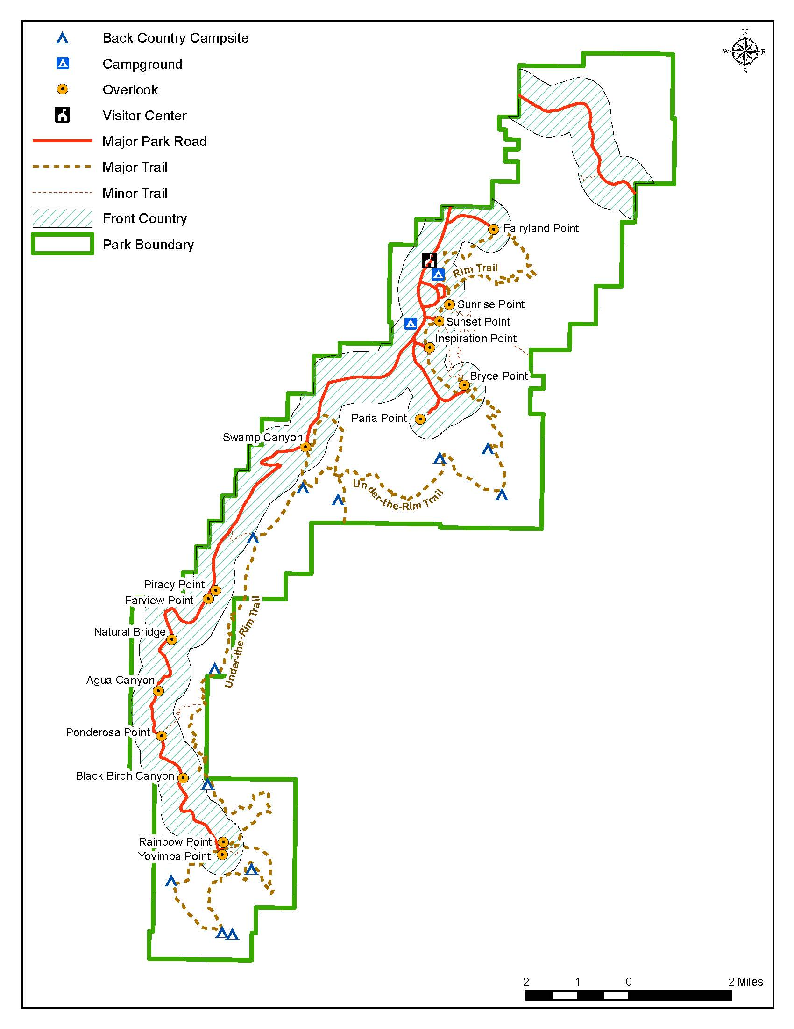
Bryce Canyon National Park

The following three questions are an example of one of the hypothetical examples that will be used in the final version of the survey. The values for each of the trip characteristic in the final survey will be based on the actual management alternatives present at each participating park. This will be done to mimic real life scenarios and efficiency of the choice options. The volume levels for the soundclips will be programmed so that one alternative is not clearly better or worse than the others (i.e., “dominated”). For example, in Exercise 1, Trip B has lower percent of time only sounds of nature are heard and has a $5 increase in cost over Trip A which makes it a “worse” alternative than A. However, the sound clip will present a lower maximum sound level than the sound level for Trip A which would be an improvement over Trip A for that characteristic. For the eventual full-scale study, the responses to the three exercises below will be used for estimating a logit choice model.
- Exercise 1: Please read all the information in the table below and then select the [insert name of park] trip you would prefer.
I would prefer (choose only one)
- Trip A
- Trip B
- Trip C
 |  | Trip A  No change from current typical summer conditions | Trip B  Hypothetical change from current typical summer conditions | Trip C  Hypothetical change from current typical summer conditions
If you were in the Front Country at one of the following locations:  - scenic overlooks  - trail heads  - hiking trails within 1/2 miles of trail head  - developed campsites | Daytime | Below is the percent of time you would hear only the sounds of nature (during a 12 hour period)
 |  | 60% | 50% | 40%
 |  | These audio clips play an example of the maximum sound level for man-made sound events
 |  | NOTE: Trip A max level will be medium, Trip B will be Lower (better), Trip C will be Higher (worse)
 |  | Trip A  (click to play) | Trip B  (click to play) | Trip C  (click to play)
 | Nighttime | Trips A, B, and C have the same sound conditions
If you were in the Back Country at one of the following locations:  - hiking trails further than 1/2 miles from trail heads  - primitive campsites | Daytime | Trips A, B, and C have the same sound conditions
 | Nighttime | Trips A, B, and C have the same sound conditions
The change in per person trip cost would be |  | No Change | $5 increase | $5 decrease

- Exercise 2: Please read all the information in the table below and then select the [insert name of park] trip you would prefer.
I would prefer (choose only one)
- Trip A
- Trip B
- Trip C
 |  | Trip A  No change from current typical summer conditions |  | Trip B  Hypothetical change from current typical summer conditions | Trip C  Hypothetical change from current typical summer conditions
If you were in the Front Country at one of the following locations:  - scenic overlooks  - trail heads  - hiking trails within 1/2 miles of trail head  - developed campsites | Daytime | Trips A, B, and C have the same sound conditions
 | Nighttime | Trips A, B, and C have the same sound conditions
If you were in the Back Country at one of the following locations:  - hiking trails further than 1/2 miles from trail heads  - primitive campsites | Daytime | Below is the percent of time you would hear only the sounds of nature (during a 12 hour period)
 |  | 60% | 55% |  | 70%
 |  | These audio clips play an example of the maximum sound level for man-made sound events
 |  | NOTE: Trip A max level will be medium, Trip B will be Higher (worse), Trip C will be Lower (better)
 |  | Trip A  (click to play) | Trip B  (click to play) |  | Trip C  (click to play)
 | Nighttime | Trips A, B, and C have the same sound conditions
Change in per person trip cost |  | No Change |  | $5 decrease | $3 increase

- Exercise 3: Please read all the information in the table below and then select the [insert name of park] trip you would prefer.
I would prefer (choose only one)
- Trip A
- Trip B
- Trip C
 |  | Trip A  No change from current typical summer conditions |  | Trip B  Hypothetical change from current typical summer conditions |  |  | Trip C  Hypothetical change from current typical summer conditions
If you were in the Front Country at one of the following locations:  - scenic overlooks  - trail heads  - hiking trails within 1/2 miles of trail head  - developed campsites | Daytime | Trips A, B, and C have the same sound conditions
 | Nighttime | Below is the percent of time you would hear only the sounds of nature (during a 12 hour period)
 |  | 40% | 45% |  | 60%
These audio clips play an example of the maximum sound level for man-made sound events

NOTE: Trip A max level will be medium, Trip B will be medium, Trip C will be Higher (worse)
 |  | Trip A  (click to play) | Trip B  (click to play) |  | Trip C  (click to play)
If you were in the Back Country at one of the following locations:  - hiking trails further than 1/2 miles from trail heads  - primitive campsites | Daytime | Trips A, B, and C have the same sound conditions
 | Nighttime | Trips A, B, and C have the same sound conditions
NOTE: The sound clips will be constructed so that no alternative is dominant or dominated (clearly better or worse than another). Each alternative will be a mix of things that are better for some attributes but worse for another attribute
Change in per person trip cost |  | No Change |  | $5 increase |  | $3 increase

This contingent valuation question is included as additional method for estimating that respondent’s value for natural sound conditions. (This method was suggested by a member of the expert review panel as an alternative to use if the choice exercises above do not work out.)
- Currently at [insert name of park] only natural sounds are heard 60% of the time during in the day in the front country. What would you pay (in higher per person trip costs) to improve conditions so that only natural sounds are heard 75% of the time during the day in the front country? Circle the one amount that best represents your answer:
$0.00 | $2 | $8 | $25 | $60 | $150 | $400
$0.50 | $3 | $10 | $30 | $75 | $200 | $500
$1.00 | $4 | $15 | $40 | $100 | $250 | $750
$1.50 | $5 | $20 | $50 | $125 | $300 | $1,000
 |  |  |  |  | Don’t know | More than $1,000

This question will be used to identify potential protest bids from the CV question.

- If you selected $0.00 above, please briefly explain why. Otherwise, please go toQ.20 .
________________________________________________________________________________________________________________________________________________________________________________________________________________________________________________________________________________________

Travel Expenses
This question will be used to estimate visitor expenditures. Estimates of visitor expenditures can be used in an economic impact analysis.
- For each item listed below, please report all anticipated expenditures for you and your group during your visit to [insert park name]. Please write “0” if do not plan on spending any money in a particular category.
 | Expenditures
Lodging during visit to [insert park name] (hotel, motel, camping etc.) | $
Food and drink at restaurants and bars during visit to [insert park name] | $
Food and drink from grocery store or convenience stores during visit to [insert park name] | $
Transportation (airfare, gas, etc) from your home to [insert region] | $
Transportation around [insert region] (rental vehicle or other transport including gas) | $
Entry fee to [insert park name] | $
Guided tour, recreation, entertainment fees  Please describe_________________ | $
Purchases at [insert park name] (clothing, film, souvenirs or gifts) | $
Other expenses  Please describe__________________ | $

Opinions on Sound at [insert park name]
This question will be used to provide baseline descriptors of the public’s view of natural sound conditions at the park under consideration.
- How pleased or annoyed are you with the amount of natural sounds you have experienced at [insert park name] during this visit?
Annoyed |  |  |  |  |  | Pleased
Extremely |  | Very | Moderately | Slightly | Neutral | Slightly | Moderately | Very | Extremely

This question will be used to provide baseline descriptors of the public’s view of natural sound conditions at the park under consideration.
- How pleased or annoyed are you with the amount of man-made sound you have experienced at [insert park name] during this visit?
Annoyed |  |  |  |  | Pleased
Extremely | Very | Moderately | Slightly | Neutral | Slightly | Moderately | Very | Extremely

This question will be used to test a hypothesis that expectations influence values for natural sound conditions. Dose-response work suggests that people who have strong expectations of what sound conditions should be are more annoyed by human-have caused sound.
- How does the amount of man-made sound you have experienced at [insert park name] compare to your expectations?
- Amount of man-made sound was lower than I expected
- Amount of man-made sound was about what I expected
- Amount of man-made sound was more than I expected
- I had no expectations related to amount of man-made sound
- Don’t know
This question will be used to investigate the behavioral effects on park visitors from man-made sound. It can also be used to identify respondents who might be more sensitive to sound conditions and hence have higher values for natural sound conditions.
- Did the amount of man-made sound you experienced at [insert park name] cause you to change any of your activities during your visit?
- Yes What did you do differently? (please check all that apply)
- I made my visit shorter
- I moved to quieter parts of the park
- I chose more remote areas
- I hiked longer trails to avoid crowds
- I chose a campsite further away from sound sources
- I planned my visit for times early or late in the day
- Other_________________________
- No
This question gathers baseline information on the likelihood of a visitor returning to the park in the future.
- How likely are you to return to [insert park name] at some point in the future?
Definitely would not visit again | Probably would not visit again | Might  or  might not visit again | Probably would visit again | Definitely would visit again | Don’t Know

This information combined with information from the previous question will provide information on how the likelihood of visitation is affected by natural sound conditions. Estimates of visitation impacts can be used in an economic impact analysis.
- Please select how the following situations related to man-made sound would affect your likelihood of visiting [insert park name] in the future.
If the amount of man-made sound… | My likelihood of visiting would be…
 | Much less likely | Somewhat less likely | No effect | Somewhat more likely | Much more likely | Don’t Know
increased substantially
increased moderately
decreased moderately
decreased substantially

This question is adapted from an Outdoor Recreation Noise Sensitivity Scale used in the master’s thesis research of Kara L. Grau (2005). These three self-reported noise sensitivity questions can be used to test whether those who are more sensitive to sounds in natural settings have higher values for natural sound conditions.
- Please indicate how strongly you agree or disagree with each of the following statements. (please check one box for each row)
 | Strongly disagree | Disagree | Neutral | Agree | Strongly Agree | Don’t know
Hearing man-made sound interferes with my enjoyment of the outdoors
If I can hear man-made sound in an outdoor area, it makes the place seem less natural
I can only experience solitude in quiet places

Respondent Characteristics
The socio-demographic questions in this section will be used to provide establish a set of baseline data that can be used to characterize any changes in visitor demographics after December 31, 2013.
- What is your gender?
- Male
- Female
- Are you Hispanic or Latino?
- Yes
- No
- What is your race? (please check all that apply):
- American Indian or Alaska Native
- Asian
- Black or African American
- Native Hawaiian or other Pacific Islander
- White

- What is your current marital status?
- Married
- Widowed
- Divorced
- Separated
- Never married
- What is the highest level of education that you have completed? (please check one)
- Some high school or less
- High school diploma/GED
- Some college/Associate’s degree
- Bachelor’s degree
- Graduate degree
- Other (Please specify ____________________________________________)

- Where do you live?

City___________________State___________________ZIP_______________

Country (if Not U.S.)_______________________
This question can be used to test a hypothesis that people who are particularly interested in environmental issues hold different values for natural sound conditions.
- Does anyone in your household make charitable contributions to environmental organizations?
- Yes
- No
- Don’t know
This question will be used as an objective measure that may be linked to sound sensitivity.
- Do you use a hearing aid?
- Yes
- No
- Which category best represents your total annual household income in [year] before taxes?
- Less than $25,000
- $25,000 to $34,999
- $35,000 to $49,999
- $50,000 to $74,999
- $75,000 to $99,999
- $100,000 to $149,999
- $150,000 to $199,999
- $200,000 and over
- Do not wish to answer

Thank you very much for completing this survey.

PAPERWORK REDUCTION ACT STATEMENT: The National Park Service is authorized by 6 U.S.C. 1a-7 to collect this information. This information will be used by park managers to understand visitor perceptions of sound in [insert park name]. Response to this request is voluntary. No action may be taken against you for refusing to supply the information requested. The permanent data connected with this collection will be anonymous. Please do not put your name or that of any member of your household on the questionnaire. An agency may not conduct or sponsor, and a person is not required to respond to, a collection of information unless it displays a currently valid OMB control number.
BURDEN ESTIMATE: The public reporting for this collection is estimated to be 20 minutes per respondent. This includes the time to complete the questionnaire and to participate in the follow-up interview process. Direct comments regarding the burden estimate or any other aspect of this form to: Catherine Taylor, Volpe National Transportation Systems Center, 55 Broadway, Cambridge, MA 02142, catherine.taylor@dot.gov (email).

http://www.itrr.umt.edu/theses/SocialConditionsinZNPGrauThesis.pdf

