APPENDIX B – 2013 AND 2015 SUPERINDENT SCHOOL DISTRICT LETTER



July 2013

Dear Superintendent:

The National Center for Education Statistics (NCES) has initiated a data collection effort to collect school attendance boundary data for all public schools in the United States and the District of Columbia. This project is an expansion of NCES’s very successful on-going collection of School District boundary data for all districts in the country. To ensure the success of the school attendance boundary project, we need your help. In the next 2-3 weeks, instructions for participating in this project will be sent to you. Please designate a Key Holder to be responsible for providing boundary information for schools within your district. We will accept paper maps or electronic shape files. Data collection begins September 1, 2013.

By providing NCES with your school attendance boundary information, NCES will be able to provide a publically accessible mapping system that contains school boundaries for all public schools in this country. It will be possible to overlay other databases from the Census Bureau and NCES to the catchment areas of the individual schools in your district. This information can then be used at the district, State, and national levels to inform policy decisions regarding funding and disaster relief programs.

The cooperation of your District is important to the success of this national survey of school attendance boundaries. NCES will not sell this data and will provide public access to the consolidated geo-database. This file will be updated every two years to account for school attendance boundary changes. If you have questions about the School Attendance Boundary Survey (SABS), please contact Tai Phan at Tai.Phan@ed.gov.

Sincerely,

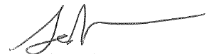

Jack Buckley

Commissioner

National Center for Education Statistics

Institute of Education Sciences

APPENDIX C – 2013 AND 2015 KEYHOLDER PACKET



August 2013

Dear Superintendent:

The National Center for Education Statistics (NCES) is conducting a biennial survey of public school attendance boundaries in the fifty states and the District of Columbia. Please designate a Key Holder to be responsible for data entry and forward the enclosed survey information to that person as soon as possible.

Data collection for the FY 2013 School Attendance Boundary Survey (SABS) begins September 1, 2013, and the URL for the survey is <http://nces.ed.gov/surveys/sdds/index.aspx>. The Key Holder should *register* beginning on September 1, 2013 using the enclosed user ID and password. Data collection ends on August 31, 2014.

The goal of obtaining these public school attendance boundaries is to incorporate school boundary data in the NCES’s consolidated geo-database in order to better serve the school districts and members of the general public. For more information about the survey, see the SABS home page at <http://nces.ed.gov/surveys/sdds/index.aspx> .

By providing NCES with your school boundary information, NCES will be able to provide a publically accessible mapping system that contains school boundaries for all public schools in this country. It will be possible to overlay other databases from the Census Bureau and NCES to the catchment areas of the individual schools in your district. This information can then be used at the district, State, and national levels to inform policy decisions regarding funding and disaster relief programs.

Thank you for your cooperation and support of this very important voluntary survey.

Sincerely,

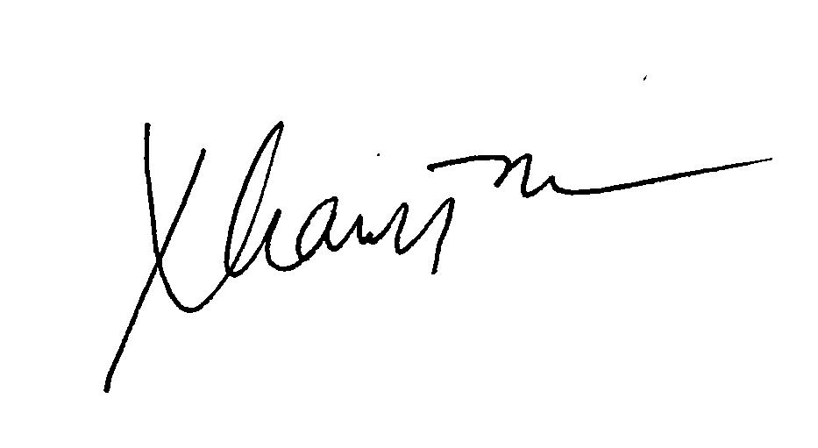

Tai Phan, Program Director

Enclosure



# August 2013

# Dear SABS Key Holder:

# As Key Holder for the FY 2013 School Attendance Boundaries Survey (SABS), you play an important role in this national data collection effort sponsored by the National Center for Education Statistics (NCES). You are responsible for your district’s data submission. Only designated staff with assigned SABS user IDs and passwords can access the survey system, located at <http://nces.ed.gov/surveys/sdds/index.aspx> . Data collection begins September 1, 2013 and ends on August 31, 2014. Registration can begin on September 1 and should be completed as soon as possible.

# This packet contains the key holder certificate, which contains your SABS user ID number, personal password, UNIT-ID, school district name, as well as critical dates and SABS Help Desk Information. Please keep this document in a safe place and do not share this password with anyone.

You will register using the *Key Holder Certificate, FY 2013 SABS*. The Web registration form asks for specific contact information, which will then be used by the Census Bureau, the data collection agent for NCES, in all further contacts with your district during this data collection. Once your data have been entered, the Census Bureau will review your submission and may contact you with questions about the data.

Technical assistance for your data submission will be available from the Census Bureau at [govs.sabs@census.gov](mailto:govs.sabs@census.gov) or by calling (877) 749-4925. If you have questions or comments about the survey program, you may contact me at Tai.Phan@ed.gov or (202) 502-7431.

Thank you for your cooperation and support of this survey.

Sincerely,



Tai Phan

Program Director

Enclosures

**Key Holder Certificate**

**FY2013 School Attendance Boundaries Survey (SABS)**

Please keep this certificate in a safe place and

*do not share the password*

School District Number: «unitid»

«district name»

**SABS USERID: «userid»**

**SABS Password: «password»**

***(Note: Passwords are case sensitive)***

**SABS HELP DESK: govs.sabs@census.gov**

**1-877-749-4925**

**On-line Registration and Data Collection Period**

September 1, 2013 through August 31, 2014

**(**http://nces.ed.gov/surveys/sdds/index.aspx**)**

APPENDIX D – 2013 AND 2015 NON-RESPONSE CALL SCRIPT

MEMORANDUM

To: Phyllis G. Smith

Jeffersonville Telephone Center

National Processing Center

From: Laura Hardesty

Education and Library Statistics Branch

Governments Division

Subject: School Attendance Boundary Survey (SABS) – Non-response Calls

This memorandum describes the non-response telephone procedures that will be used for the 2013 School Attendance Boundary Survey (SABS). The purpose of the telephone calls is to encourage non-respondent school districts to respond to the survey.

**FILES PROVIDED**

The National Center for Education Statistics (NCES) will provide an Access database containing the contact information for each non-respondent district.

**MATERIALS**

Each caller will be given:

1. A section of the database printout for calling
2. Call sheets to record the information from the call. The call sheets will include name, mailing addresses, emailaddress**,** and a comment area to record phone call outcomes.

# The Call

1. Call the district and ask to speak to the designated key holder.
2. If you aren’t able to speak to the key holder,
   1. Ask for the respondent’s email address so that we can send the survey user ID and password.
   2. If you can’t get the email address, ask to leave a voice mail.

*Good morning (afternoon, etc.). My name is_____. I am calling for the School Attendance Boundary Survey, sponsored by the National Center for Education Statistics, in the U.S. Department of Education. We are collecting data on school boundaries because the survey deadline is August 31, 2014. I am calling to offer assistance to help you register for the survey.*

*Please call me at 1-877-749-4925 at your earliest convenience. Thank you.*

1. If you are able to speak with the respondent, follow the script below for the calls. (Items in blue are not part of the script.)

*Good morning (afternoon, etc.). My name is_____. I am calling for the School Attendance Boundary Survey, sponsored by the National Center for Education Statistics, in the U.S. Department of Education. We are collecting data on school boundaries that your district was earlier offered to submit. I am calling to offer assistance to help you register and complete your online survey.*

*Your participation is very important to the success of the survey.*

*I would like to email this information to you. May I have your email address?*

(If yes, copy email address onto call sheet and repeat the e-mail address back for verification.)

*May I also have a mailing address for your district?*

(If yes, write this on your call sheet).

*Thank you for your time. Have a good ____(morning, etc.).*

Record on the call sheet the name of the person and any other information they gave you.

1. Make up to 3 calls to the district to try to speak to a person who can give you the information. If you have no success, record that on the call sheet.

**END OF PROJECT**

Ship the call sheets by FedEx to Governments Division at the Census Bureau, to the address below, or e-mail them to Laura Hardesty (laura.c.hardesty@census.gov).

US Bureau of the Census

Attn: Laura Hardesty

Governments Division, 6K152B

4600 Silver Hill Road

Washington DC 20233

APPENDIX E – 2013 AND 2015 REMINDER LETTER

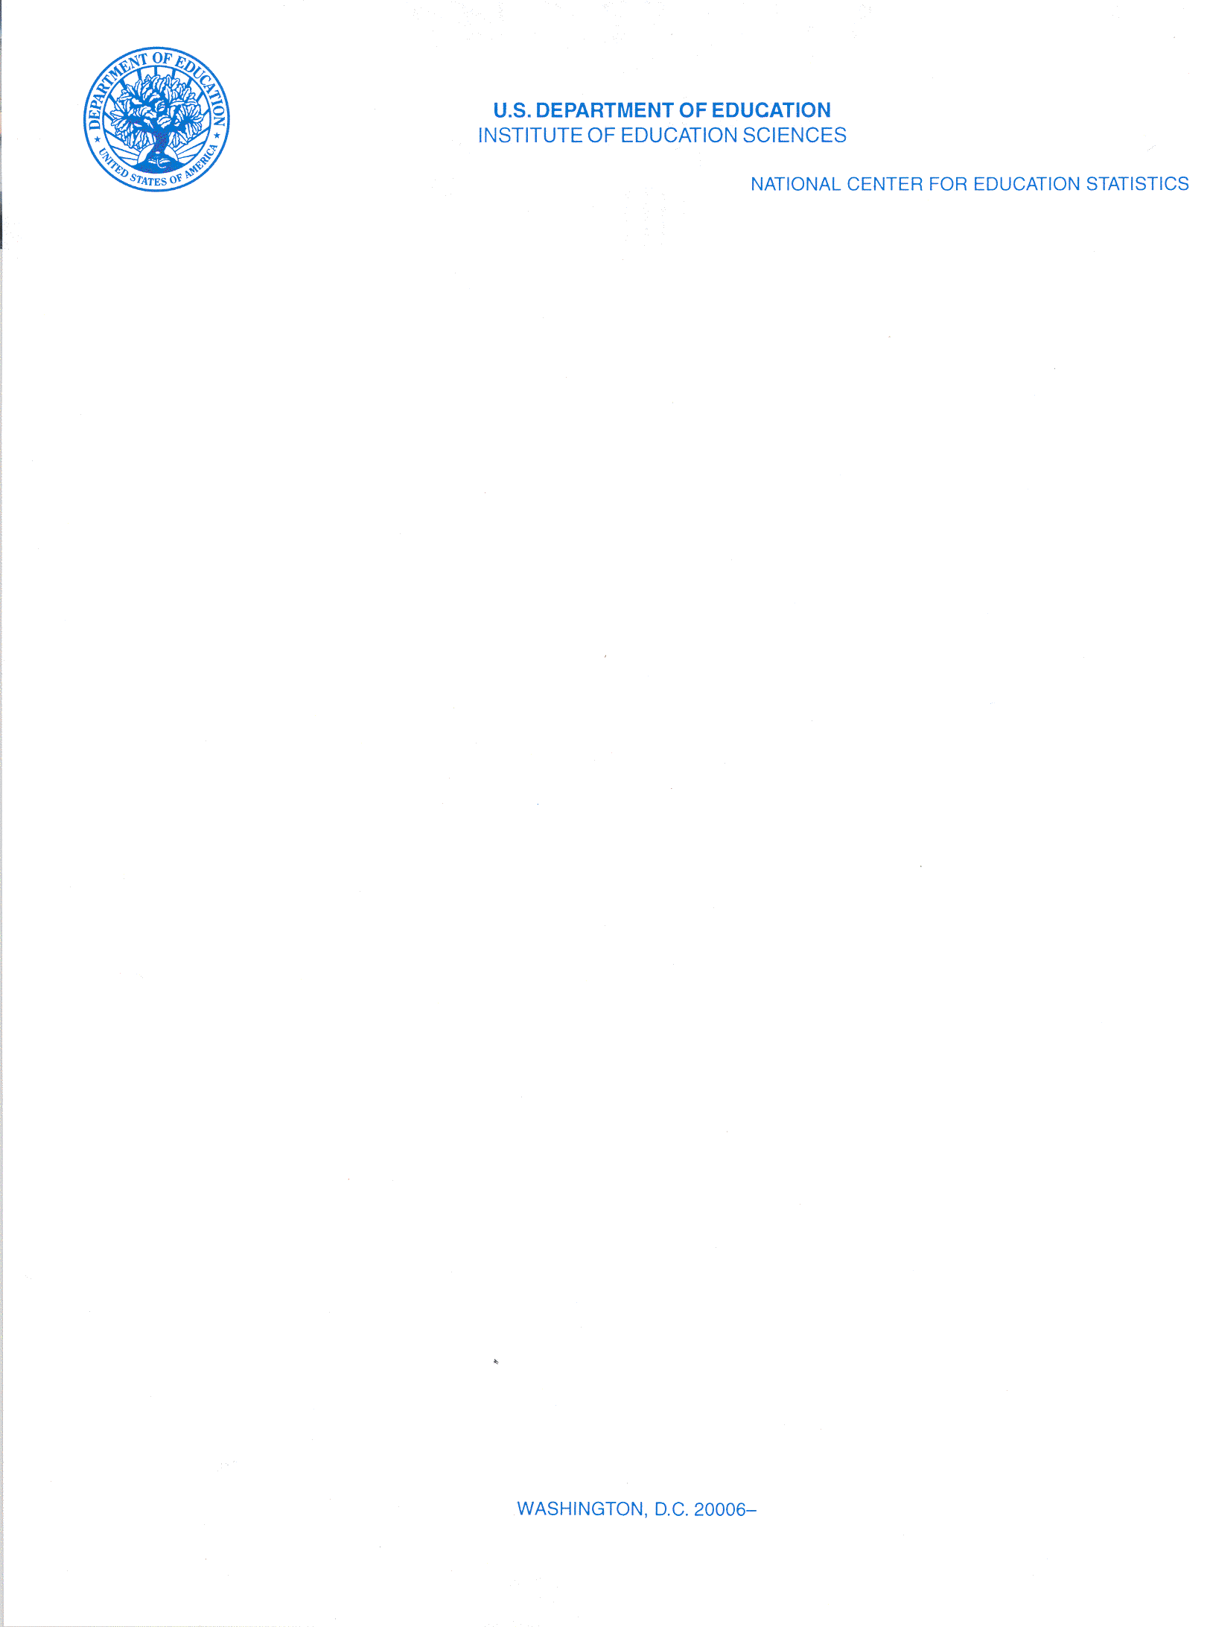

# Gentle Reminder

November 2013

Dear Superintendent:

Data collection for the 2012 School Attendance Boundary Survey (SABS) began on September 1, 2013. According to our records, your district has not completed the survey. The survey ends on August 31, 2014. Please complete the survey, as soon as possible on the SABS Web site at https://[**http://nces.ed.gov/surveys/sdds/index.aspx**](http://nces.ed.gov/surveys/sdds/index.aspx). The survey consists of one question and a request to receive your district’s school boundary files in electronic or paper format.

If you need your User ID and password, please have your key holder contact the SABS Help Desk at 1-877-749-4925 or e-mail at [govs.sabs@census.gov](mailto:govs.sabs@census.gov).

Once complete, SABS will provide a mechanism for school districts, researchers, and the public to view school boundaries and overlay them with information from other sources such as the Census Bureau. Thus, it will be possible to add demographic and poverty measures to the school catchment areas.

We appreciate your participation in this survey and look forward to receiving your data submission in the near future. Thank you for your cooperation and support for this national School Attendance Boundary Survey. If you have questions about the survey content, please contact me at [Tai.Phan@ed.gov](mailto:Tai.Phan@ed.gov) or 202-502-7431.

Sincerely,



Tai Phan

Survey Director