

Office of Transportation and Air Quality (OTAQ)

Fuels Programs Registration User Guide

Environmental Protection Agency

Delivery Order # GS00Q09BGD0022

Task Order # EP-G11H-00154

Project # TDD 9.16

Version 3.0

June 27, 2014
Table of Contents
1 Introduction 1
2 Registration 2
2.1 CDX Registration 2
2.2 OTAQReg Registration for New CDX Users 2
2.2.1 Proceed to LexisNexis 7
2.2.2 Print and Sign CDX Electronic Signature Agreement 12
2.3 OTAQReg Registration for Existing CDX Users 13
2.3.1 Proceed to LexisNexis 16
2.3.2 Print and Sign CDX Electronic Signature Agreement 21
3 User Profiles 23
3.1 Create a New User Profile (New OTAQReg Users) 23
3.2 Edit Existing User Profile 25
3.3 Deactivated Users 26
4 Company Associations 27
4.1 Add Company Association 27
4.2 Update Company Roles 32
4.3 Remove Existing Company Association 36
4.4 Pending Company Association Requests 39
5 Create New Company 41
5.1 Verify Company Does Not Exist in OTAQReg 42
5.2 Create Company Details 43
5.2.1 Select Company Roles 45
5.3 Adding Company Facilities 46
5.4 Verify Facility Does Not Exist in OTAQReg 48
5.5 Review and Submit New Company Information 54
5.6 Pending New Company Requests 56
6 View Company Details 59
7 Edit Company Details 61
7.1 Edit Company Details 61
7.2 Review Company Details Changes 65
7.3 Pending Company Update Request 67
7.4 Edit Facility Details 69
7.5 Remove Facility 73
7.6 Initiate RCO Update Request 74
7.7 Pending RCO Update Request 79
8 Appendix A: OTAQ Registration Roles 82
8.1 OTAQ Registration Roles 82
8.2 OTAQ Program Roles: 82
9 Appendix B: Using the e-Signature Widget 84
10 Appendix C: OTAQ Registration Lists 86
11 Appendix D: Support Information 87

List of Figures
Figure 2-1 Terms and Conditions 2
Figure 2-2 Add Program 3
Figure 2-3 Part I User Information 3
Figure 2-4 Part 2 Organization Information – Organization Search 4
Figure 2-5 Part 2 Organization Information 5
Figure 2-6 Confirmation 5
Figure 2-7 Core Registration Email Verification Request 6
Figure 2-8 Identity Verification Page 7
Figure 2-9 LexisNexis 8
Figure 2-10 LexisNexis Results 9
Figure 2-11 Retry LexisNexis 10
Figure 2-12 20-5-1 Challenge Questions and Answers 10
Figure 2-13 Electronic ESA 11
Figure 2-14 MyCDX Home Page 11
Figure 2-15 Paper ESA 12
Figure 2-16 MyCDX Home Page 13
Figure 2-17 MYCDX Home Page 14
Figure 2-18 Manage Program Services 14
Figure 2-19 Edit Account Profile 15
Figure 2-20 Organization Information. 15
Figure 2-21 Identity Verification 16
Figure 2-22 LexisNexis 17
Figure 2-23 LexisNexis Results 18
Figure 2-24 Retry LexisNexis 19
Figure 2-25 20-5-1 Challenge Questions and Answers 19
Figure 2-26 Electronic ESA 20
Figure 2-27 MyCDX Home Page 20
Figure 2-28 Paper ESA 21
Figure 2-29 MyCDX Home Page 22
Figure 3-1 MyCDX Home Page 23
Figure 3-2 Edit User Profile Page 24
Figure 3-3 OTAQ Registration Home Page 24
Figure 3-4 OTAQ Registration Home Page 25
Figure 3-5 Edit User Page 25
Figure 3-6 OTAQ Deactivated Home Page 26
Figure 4-1 OTAQ Registration Home Page 27
Figure 4-2 Associate to Company Search Page 27
Figure 4-3 Associate to Company Search Results 27
Figure 4-4 Associate to Company: Create Company Associations Page 28
Figure 4-5 Company Roles Pop-Up 29
Figure 4-6 Associate to Company: Create Company Associations Page with Roles 29
Figure 4-7 Associate to Company: Review Page 30
Figure 4-8 Associate to Company: Submit Request Page 30
Figure 4-9 Further Action Required Page 31
Figure 4-10 OTAQ Registration Home Page 32
Figure 4-11 Update Company Associations Page 33
Figure 4-12 Update Roles 33
Figure 4-13 Updated Company Associations 34
Figure 4-14 Confirm Updated Company Association 34
Figure 4-15 Submit Request Page 35
Figure 4-16 Further Action Required Page 35
Figure 4-17 Remove Company Association 36
Figure 4-18 Remove Company Pop-Up 36
Figure 4-19 Removed Company Association 37
Figure 4-20 Remove Company Association Confirmation 37
Figure 4-21 Submit Request Page 38
Figure 4-22 Further Action Required Page 38
Figure 4-23 Pending Company Association Requests 39
Figure 4-24 Company Association Request 40
Figure 5-1 OTAQ Registration Home Page 41
Figure 5-2 Associate to Company: Search for Existing Company Page 42
Figure 5-3 Associate to Company: Search for Existing Company Results 42
Figure 5-4 Create New Company: Company Details Page 43
Figure 5-5 Program Types and Business Activities 44
Figure 5-6 Company Contacts 45
Figure 5-7 Create New Company: Company Roles 45
Figure 5-8 Company Roles Pop-Up 46
Figure 5-9 Selected Company Roles 46
Figure 5-10 Create New Company: Facility List 47
Figure 5-11 Create New Company: Facility List Requires Facility 47
Figure 5-12 Create New Company: Facility Type 47
Figure 5-13 Create New Company: Facility Activities 48
Figure 5-14 Create New Company: Search for Existing Facility 48
Figure 5-15 Facility Search Results 49
Figure 5-16 Create New Company: Basic Facility Details 49
Figure 5-17 Create New Company: Facility Details 50
Figure 5-18 Create New Company: Facility List 51
Figure 5-19 Select Existing Facility 51
Figure 5-20 Existing Facility Details 52
Figure 5-21 Create Facility Details 53
Figure 5-22 Review Facility List 54
Figure 5-23 Create New Company: Review 54
Figure 5-24 Create New Company: Submit Request Page 55
Figure 5-25 Further Action Required Page 55
Figure 5-26 OTAQ Registration Home page: Pending Requests 56
Figure 5-27 New Company Request 57
Figure 6-1 OTAQ Registration Home Page 59
Figure 6-2 Company Information: Company Details 60
Figure 7-1 OTAQ Registration Home Page 61
Figure 7-2 Company Information: Company Details 62
Figure 7-3 Company Details Edit Page 63
Figure 7-4 Company Information: Review 65
Figure 7-5 Company Information: Submit Request Page 66
Figure 7-6 Further Action Required Page 66
Figure 7-7 Updated Company Pending Request 67
Figure 7-8 Company Update Request 68
Figure 7-9 Facility Details Tab 70
Figure 7-10 Company Information: Facility List 71
Figure 7-11 Company Information: Facility Type 71
Figure 7-12 Company Information: Facility Activities 71
Figure 7-13 Company Information: Basic Facility Details 72
Figure 7-14 Company Information: Facility Details 73
Figure 7-15 Facility List: Updated Facility 73
Figure 7-16 Company Information: Facility List 74
Figure 7-17 Remove Facility Confirmation 74
Figure 7-18 Facility List: Removed Facility 74
Figure 7-19 Initiate RCO Update Request 76
Figure 7-20 RCO Update 77
Figure 7-21 Further Action Required 78
Figure 7-22 Submit Request 78
Figure 7-23 Further Action Required Page 79
Figure 7-24 Pending RCO Update 80
Figure 7-25 RCO Update Request 81
Figure 9-1 Authentication 84
Figure 9-2 Answer Secret Question 84
Figure 9-3 Sign File 85
Figure 10-1 Registration Lists 86

Introduction
This document is the User Guide for the OTAQ Fuels Program Registration (OTAQReg) online application. It describes the processes a user must follow to register; update their user profile; associate to companies as well as create, view, and edit companies.
If you have any questions about the content, format, or policies for the Office of Transportation and Air Quality (OTAQ) please reference the Fuels Program website at http://www.epa.gov/otaq/fuels/index.htm.
If you have any general or technical questions related to the Central Data Exchange (CDX) you may contact any of the following:
- Telephone - Person-to-person telephone support is available from the CDX Help Desk 8:00 am to 6:00 pm EST. Call our toll-free line at 888-890-1995.
- Email - Send e-mail to Technical Support at helpdesk@epacdx.net with “Technical Support” in the Subject line.
If you have any questions relating to fuels programs registration, reporting, or OTAQReg, please contact the EPA Fuels Programs and EMTS Support Line: support@epamts-support.com.

Registration
The following sections describe how to register for the Fuels Programs Registration (OTAQReg) application.

CDX Registration
The OTAQReg application is hosted by the Central Data Exchange (CDX). CDX is the system that EPA has provided to all programs to standardize and centralize the reporting functions and data submissions that are required of the various EPA regulated communities. In order to access OTAQReg, users must first be registered users of CDX.
Registration for the OTAQReg application is open to all CDX users. If you are an existing CDX user please refer to Section 2.3.

OTAQReg Registration for New CDX Users
If you do not have an existing CDX user account please go to the following URL and complete your CDX Registration: https://epacdx.net/Registration/Terms.
Figure 2-1 displays the Terms and Conditions page.
Figure 2-1 Terms and Conditions
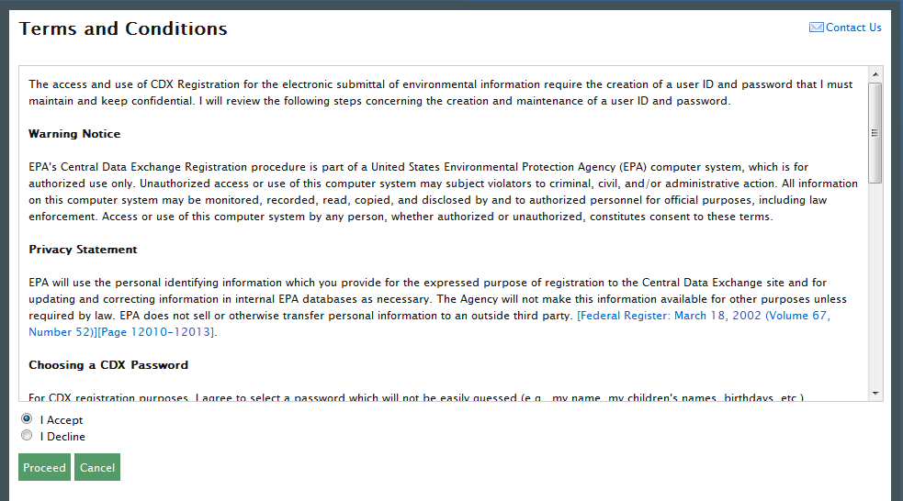
After accepting the Terms and Conditions you will see the “Request Program Service” page. This page will display the full list of CDX program services, make sure to select “OTAQREG: Office of Transportation and Air Quality Fuels Registration”, as shown in Figure 2-2. You can do this by either typing OTAQReg in the text field or scrolling down through the list of program services.
Note: Users should not register for multiple CDX accounts.
If you are an existing CDX user please refer to Section 2.3.
Figure 2-2 Add Program
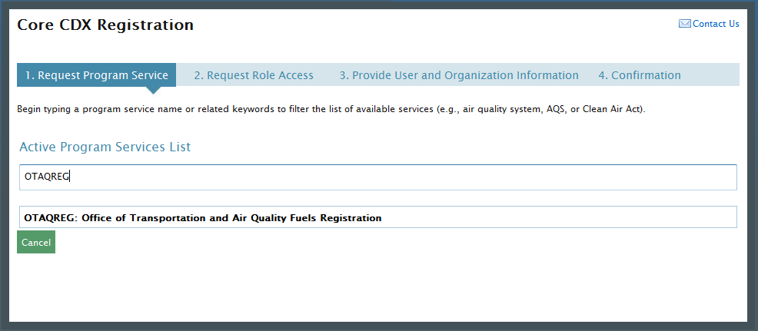
Click on the hyperlinked name to select the program service and navigate to the next step in registration. Figure 2-3 will display the Provide User and Organization Information page.
Figure 2-3 Part I User Information
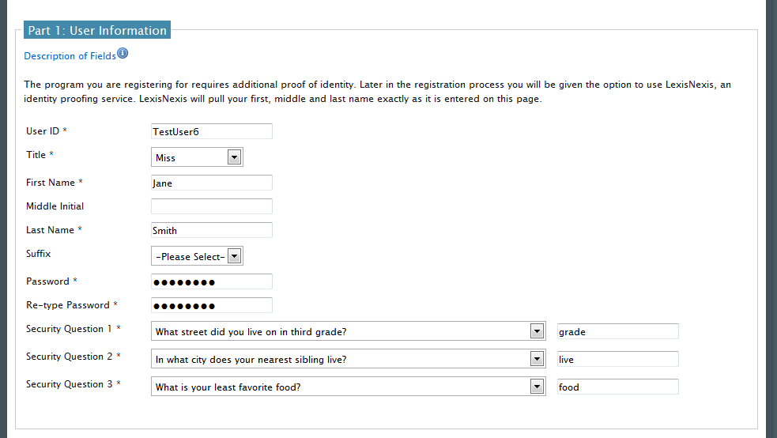
Enter your personal information and select three security questions. Scroll down to complete the organization information section, as shown in Figure 2-4.
Figure 2-4 Part 2 Organization Information – Organization Search
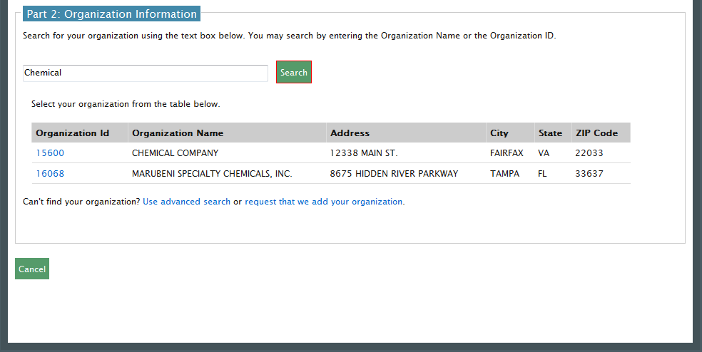
Enter an organization name and click the “Search” button. Matching search results will display in a table below. If you do not see your organization you can try the advanced search or create a new organization through the links located directly below the search results table.
Select your organization from the table by clicking on the hyperlinked Organization ID. Once you have selected an organization, additional fields will display, as shown in Figure 2-5 Part 2 Organization Information
Figure 2-5 Part 2 Organization Information
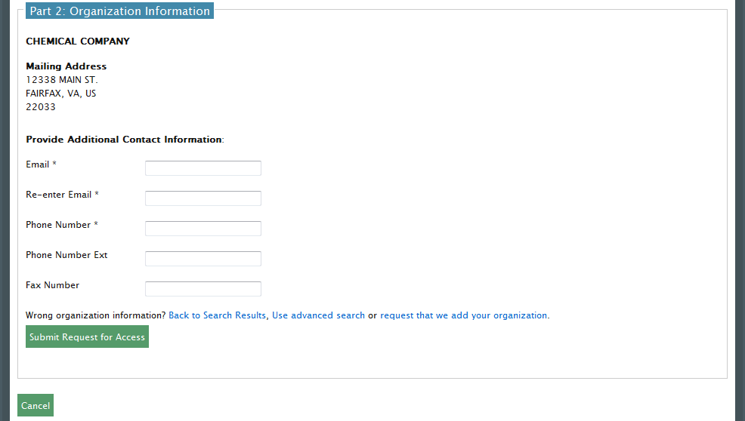
Enter your email address and phone number in the fields provided. Click the “Submit Request for Access” button. Figure 2-6 will display.
Figure 2-6 Confirmation
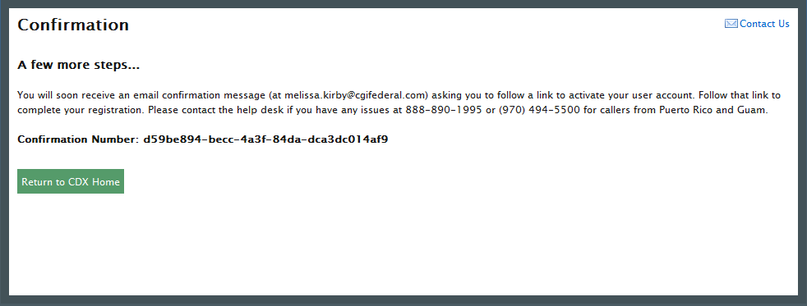
After receiving this confirmation message you will need to check your inbox for an email from the CDX Help Desk. This email will contain a URL to continue through registration, as shown in Figure 2-7.
Figure 2-7 Core Registration Email Verification Request
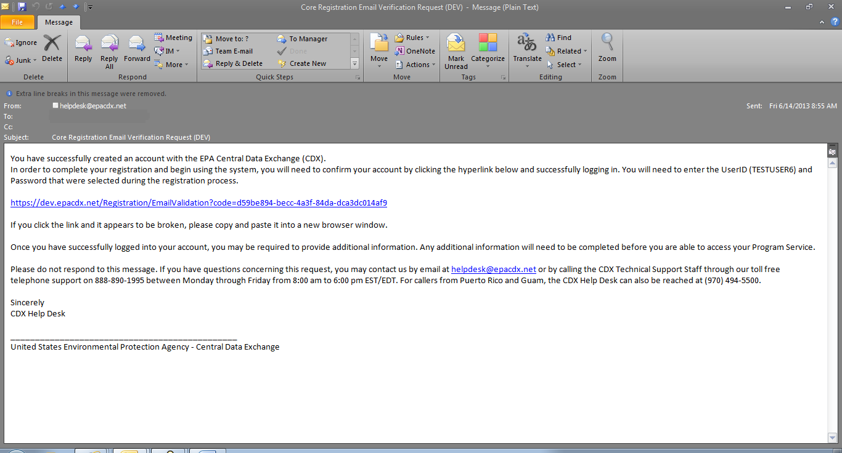
Click on the hyperlink provided in the email. Clicking on this link will open a new browser window displaying the CDX log-in page. Enter your log-in credentials created during the registration process and click the “Log-in” button.
After logging into CDX you will be taken to the “Identity Verification” page, as shown in Figure 2-8.
Figure 2-8 Identity Verification Page
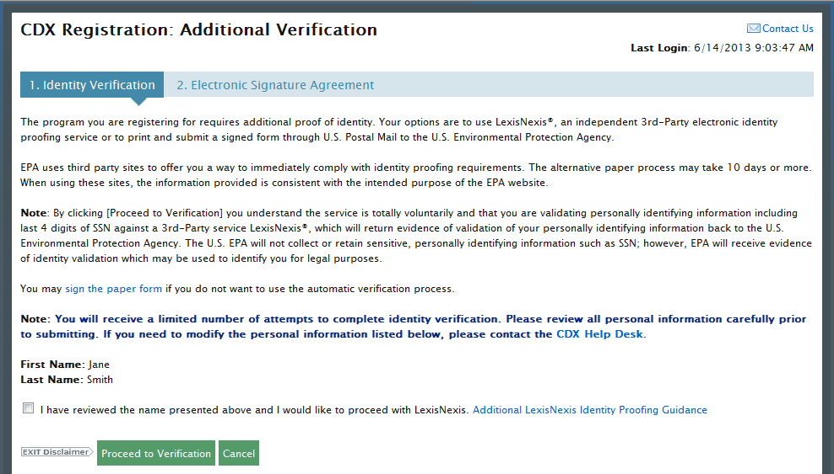
This page will provide you with two options: (1) use LexisNexis Identity Proofing to electronically validate your identity, allowing you to electronically sign an Electronic Signature Agreement (ESA) or (2) move forward to print, sign and mail in a paper ESA. Section 2.2.1 will take you through the process of completing LexisNexis and electronically signing your ESA. Section 2.2.2 will take you through the process of printing, signing and mailing in your paper ESA.

Proceed to LexisNexis
This section will take you through the registration steps if you choose to use the LexisNexis Identity Proofing process.
If you choose to proceed with LexisNexis you will need to review all of the information provided on the Identity Verification page, as shown in Figure 2-8 above. After you have reviewed the information and verified your first and last name, check the checkbox and click the “Proceed to Verification” button.
LexisNexis Identity Proofing will be completed in a separate pop-up window. The first page will display an acknowledgement statement. Click the “OK” button. The next screen will require you to enter personal information. Figure 2-9 displays the LexisNexis pop-up window and required fields.
Figure 2-9 LexisNexis
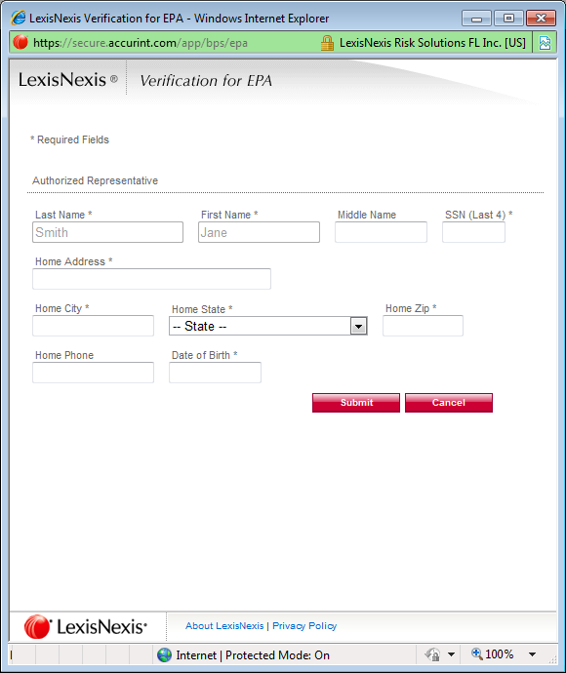
After entering information in each field, click the “Submit” button. After completing this step the LexisNexis popup window will display a confirmation message. Click the “OK” button to close the popup window and return to the CDX application.
Note: The LexisNexis popup window will pre-populate your first and last name with the information entered during core registration. These fields will be read-only.
Figure 2-10 LexisNexis Results
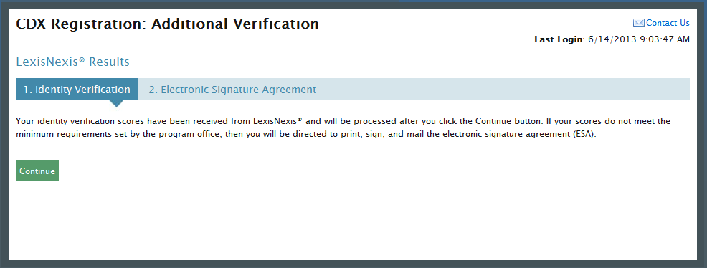
Click the “Continue” button to process your LexisNexis score and proceed with registration. Figure 2-10 displays the Identity Verification page. If you are successfully identity proofed by LexisNexis you will be taken to the Challenge Questions and Answers page, as shown in Figure 2-12. If you are not successfully identity proofed by LexisNexis you will be taken to the Electronic Signature Agreement page to print, sign and mail in your ESA.
In some cases, you may be eligible to retry LexisNexis validation. If you are eligible for this retry you will be taken to the Retry LexisNexis page where you can launch the popup window once again. You will also be presented with the opportunity to verify or edit your first name, as shown in Figure 2-11. The opportunity to edit your first name will only be presented to you as long as you do not have another CDX role with a status of “Awaiting ESA.” At this point you may also choose to opt-out of the LexisNexis identity proofing by clicking the “Sign Paper Form” button.
Figure 2-11 Retry LexisNexis
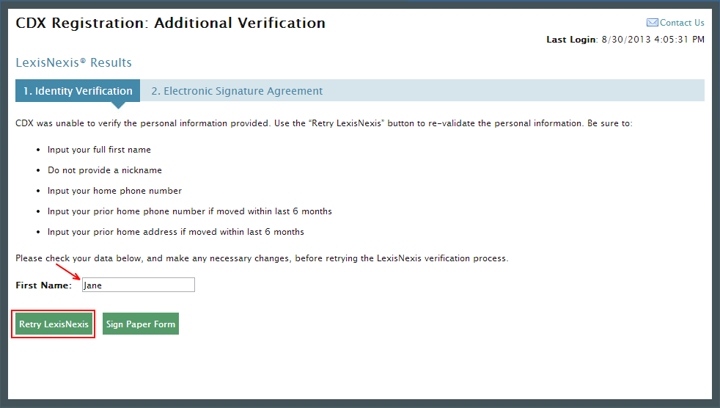
Click the “Retry LexisNexis” button. You will then be returned to the Identity Verification Page, as seen in Figure 2-8, and may begin your verification again. LexisNexis retries may be attempted up to five times before the identity proofing will be considered unsuccessful.
Figure 2-12 20-5-1 Challenge Questions and Answers
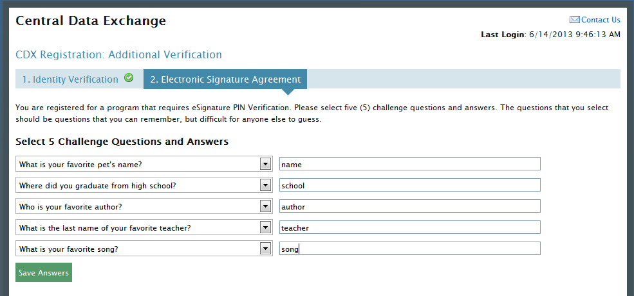
Once you have answered your 20-5-1 Challenge Questions you will need to click the “Save Answers” button, as seen in Figure 2-12, to be taken to the electronic version of the Electronic Signature Agreement. From this page you will click the “Sign Electronically” button, as shown in Figure 2-13.
Figure 2-13 Electronic ESA
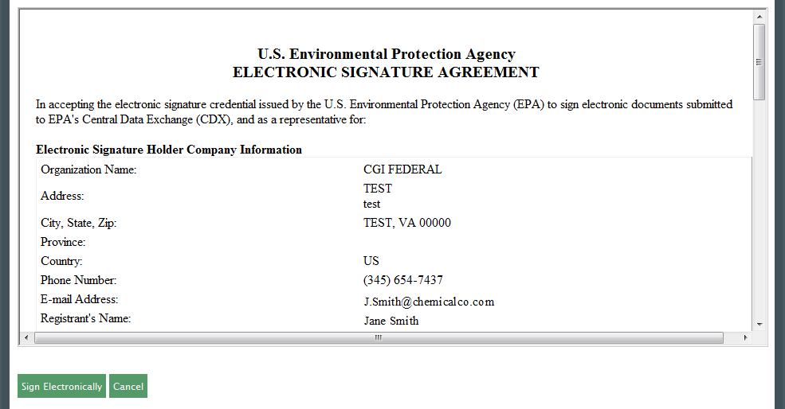
Clicking the “Sign Electronically” button will trigger a popup window which allows you to complete the e-signing process. This popup window will prompt you to enter your CDX password, answer one of the 5 challenge questions and click the “Sign” button. Please reference Appendix B: Using the e-Signature Widget for instructions on signing electronically.

After your e-signature has been processed you will be redirected to the MyCDX Home page. Your MyCDX page will now display an active hyperlink to open the OTAQReg application, as shown in Figure 2-14.
Figure 2-14 MyCDX Home Page
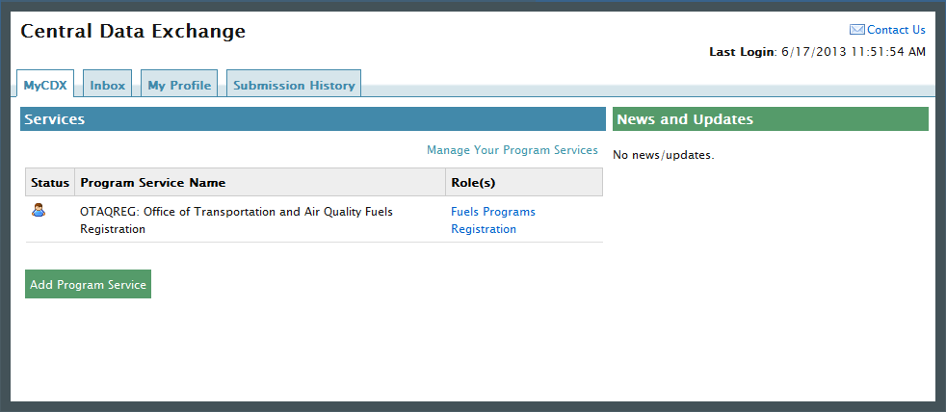

Print and Sign CDX Electronic Signature Agreement
This section will take you through the registration steps if you choose to print, sign and mail a paper ESA.
If you choose to opt-out of LexisNexis or you are not successfully identity proofed by LexisNexis you will be taken to the Electronic Signature Agreement page to print, sign and mail in your ESA. Figure 2-15 displays the paper version of the Electronic Signature Agreement.
Figure 2-15 Paper ESA
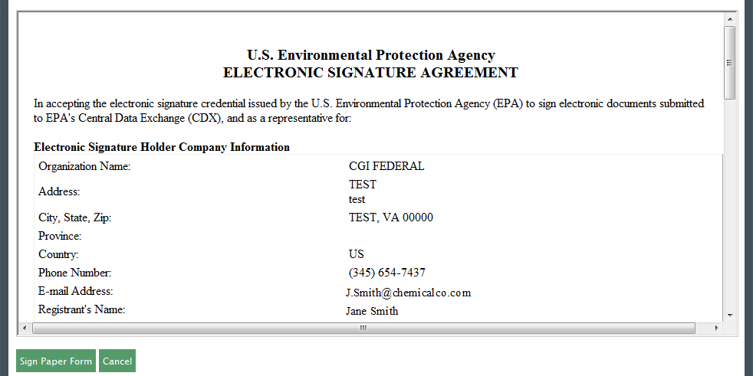
Clicking the “Sign Paper Form” button will trigger a popup window which allows you to print the ESA.
Print, sign and mail the CDX ESA to the Fuels Program Helpdesk at one of the following mailing addresses:
For US Mail:
U.S. Environmental Protection Agency
Fuels Programs Registration (6406J)
1200 Pennsylvania Avenue, NW
Washington, DC 20460

For Commercial Delivery:
U.S. Environmental Protection Agency
Fuels Programs Registration
Room 647C
1310 L Street, NW
Washington, DC 20005
Note: When using a commercial delivery service, do not use the U.S. mail address (or vice versa) as your mail will be delayed, may be returned to you, or may even never arrive at our offices. Be aware that sending materials via US Mail will require an irradiation process and could possibly delay delivery.
Paper ESAs will be processed and activated by EPA. Once your ESA has been activated you will be able to complete the 20-5-1 Challenge Questions, as seen in Figure 2-12.
New companies, company associations, company updates and RCO updates submitted within the OTAQReg application will not be accepted until your CDX ESA is received by the Fuels Program. If you have any questions regarding the status of your ESA, please contact the EPA Fuels Program Support Line by sending an email to support@epamts-support.com.
Figure 2-16 MyCDX Home Page
You will be given the “Fuels Programs Registration” program service link, as seen in Figure 2-16.
Existing CDX users should refer to Section 2.3 for further details.

OTAQReg Registration for Existing CDX Users
This section is only for existing CDX users who do not have OTAQReg access. New CDX users should refer to Section 2.2 for further details.
After logging into CDX, Figure 2-17 will display. To register for OTAQReg you must first add the dataflow to your account.
Figure 2-17 MYCDX Home Page
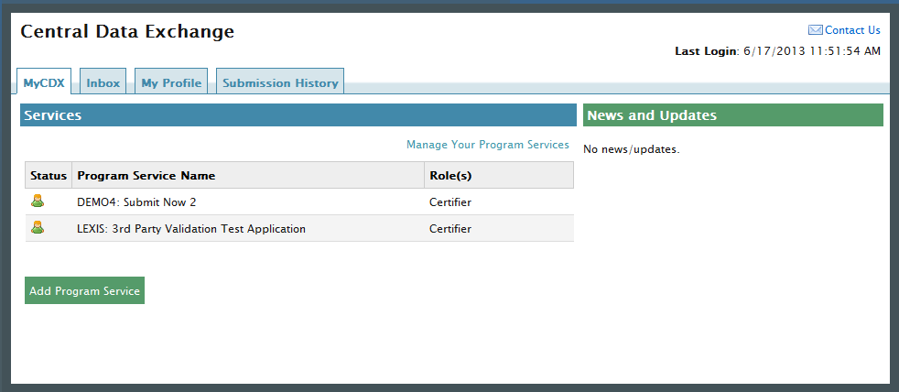
Click the “Manage Your Program Services” link. Figure 2-18 will display.
Figure 2-18 Manage Program Services
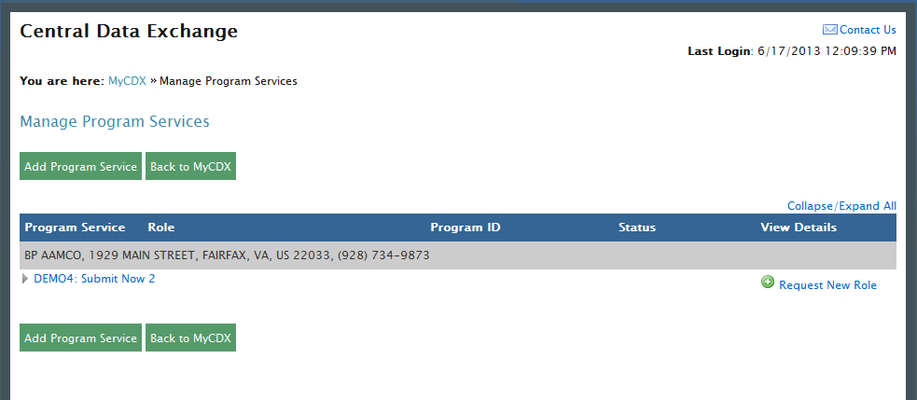
Click the “Add Program Service” button. This button will take you to the Edit Account Profile page, as shown in Figure 2-19.
Figure 2-19 Edit Account Profile
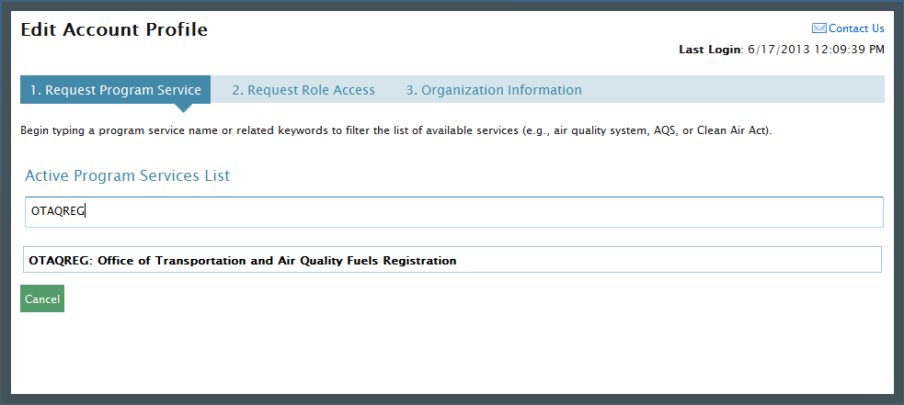
The “Edit Account Profile” page lists all of the available data flows available for registration. You will need to begin typing “OTAQREG” in the text field or scroll down and search for OTAQREG within the list. Click on the hyperlinked name to select the program service and navigate to the next step.
After selecting the OTAQREG program service you will be taken to the Organization Information page where you can choose from a list of organizations that you already have access to or gain access to an additional organization, as shown in Figure 2-20.
Figure 2-20 Organization Information
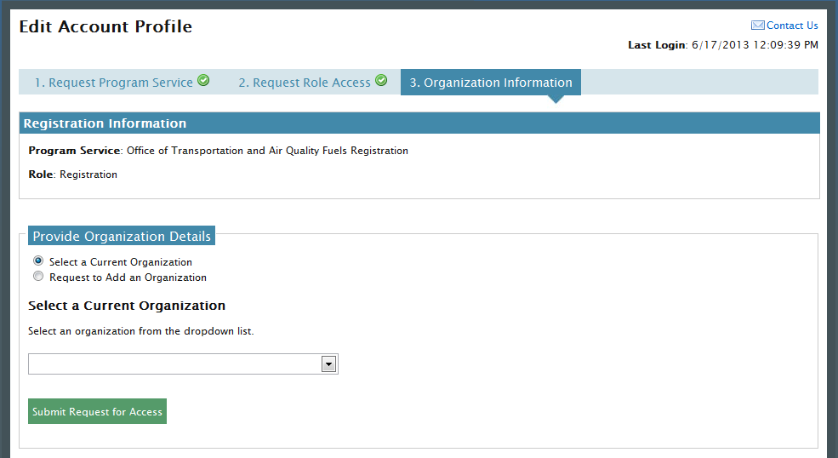
Select or add an organization and click the “Submit Request for Access” button.
If you have already been identity proofed or have a paper ESA for that organization you will be taken directly to the MyCDX Home page.
If you have not been identity proofed and do not have an ESA for that organization, you will be taken to the Identity Verification page, as shown in Figure 2-21. Here you will have two options; print, sign and mail a paper ESA or complete LexisNexis Identity Proofing and e-sign an ESA.
Figure 2-21 Identity Verification

Proceed to LexisNexis
This section will take you through the registration steps if you choose to use the LexisNexis Identity Proofing process.
If you choose to proceed with LexisNexis you will need to review all of the information provided on the Identity Verification page, as seen in Figure 2-21 above. After you have reviewed the information and verified your first and last name, check the checkbox and click the “Proceed to Verification” button.
LexisNexis will be completed through a separate pop-up window. The first page will display an acknowledgement statement. Click the “OK” button. The next screen will require you to enter personal information. Figure 2-22 displays the LexisNexis pop-up window.
Figure 2-22 LexisNexis
After entering information in each field, click the “Submit” button. After completing this step the LexisNexis popup window will display a confirmation message. Click the “OK” button to close the popup window and return to the CDX application.
Figure 2-23 LexisNexis Results
In order to process your LexisNexis score and proceed with registration, click the “Continue” button, as seen in Figure 2-23. If you are successfully identity proofed by LexisNexis you will be taken to the Challenge Questions and Answers page, as shown in Figure 2-25. If you are not successfully identity proofed by LexisNexis you will be taken to the Electronic Signature Agreement page to print, sign and mail in your ESA.
In some cases, you may be eligible to retry LexisNexis validation. If you are eligible for this retry you will be taken to the Retry LexisNexis page where you can launch the popup window once again. You will also be presented with the opportunity to verify or edit your first name, as shown in Figure 2-24. The opportunity to edit your first name will only be presented to you as long as you do not have another CDX role with a status of “Awaiting ESA.” At this point you may also choose to opt-out of the LexisNexis identity proofing by clicking the “Sign Paper Form” button.
Figure 2-24 Retry LexisNexis
Click the “Retry LexisNexis” button. You will then be returned to the Identity Verification Page, as seen in Figure 2-24, and may begin your verification again. LexisNexis retries may be attempted up to five times before the identity proofing will be considered unsuccessful.
Figure 2-25 20-5-1 Challenge Questions and Answers
Once you have answered your 20-5-1 Challenge Questions and clicked the “Save Answers” button, as seen in Figure 2-25, you will be taken to the electronic version of the Electronic Signature Agreement. From this page you will click the “Sign Electronically” button, as shown in Figure 2-26.
Figure 2-26 Electronic ESA
Clicking the “Sign Electronically” button will trigger a popup window which allows you to complete the e-signing process. This popup window will prompt you to enter your CDX password, answer one of the 5 challenge questions and click the “Sign” button. Please reference Appendix B: Using the e-Signature Widget for instructions on signing electronically.

After your e-signature has been processed you will be redirected to the MyCDX Home page. Your MyCDX page will now display an active hyperlink to open the OTAQReg application, as shown in Figure 2-27.
Figure 2-27 MyCDX Home Page

Print and Sign CDX Electronic Signature Agreement
This section will take you through the registration steps if you choose to print, sign and mail a paper ESA.
If you are not successfully identity proofed by LexisNexis you will be taken to the Electronic Signature Agreement page to print, sign and mail in your ESA. Figure 2-28 displays the paper version of the Electronic Signature Agreement.
Figure 2-28 Paper ESA
Clicking the “Sign Paper Form” button will trigger a popup window which allows you to print the ESA.
Print, sign and mail the CDX ESA to the Fuels Program Helpdesk at one of the following mailing addresses:
For US Mail:
U.S. Environmental Protection Agency
Fuels Programs Registration (6406J)
1200 Pennsylvania Avenue, NW
Washington, DC 20460

For Commercial Delivery:
U.S. Environmental Protection Agency
Fuels Programs Registration
Room 647C
1310 L Street, NW
Washington, DC 20005
Note: When using a commercial delivery service, do not use the U.S. mail address (or vice versa) as your mail will be delayed, may be returned to you, or may even never arrive at our offices. Be aware that sending materials via US Mail will require an irradiation process and could possibly delay delivery.
Paper ESAs will be processed and activated by EPA. Once your ESA has been activated you will be able to complete the 20-5-1 Challenge Questions, as seen in Figure 2-25 and will then be able to e-sign within the OTAQReg application.
New companies, company associations, company updates and RCO updates submitted within the OTAQReg application will not be accepted until your CDX ESA is received by the Fuels Program. If you have any questions regarding the status of your ESA, please contact the EPA Fuels Program Support Line by sending an email to support@epamts-support.com.
Figure 2-29 MyCDX Home Page
You will be given the “Fuels Programs Registration” program service link, as seen in Figure 2-29.
Note: You must have a CDX ESA on file in order to electronically sign submissions and letters within the OTAQReg application. You will be prompted to sign and submit your CDX ESA upon accessing the OTAQReg application until your ESA has been received by the Fuels Program.

User Profiles
The following sections describe how to navigate within the OTAQReg application to create and edit a User Profile.
If you are an existing OTAQReg user please proceed to section 3.2.
Section 3.3 pertains to users that are currently deactivated and restricted from accessing the OTAQReg application. Please skip this section if you are a current active OTAQReg user.

Create a New User Profile (New OTAQReg Users)
Figure 3-1 MyCDX Home Page
Click the “Fuels Programs Registration” link on your MyCDX Home page, as seen in Figure 3-1. Upon your initial login to OTAQReg, Figure 3-2 will display.
Figure 3-2 Edit User Profile Page
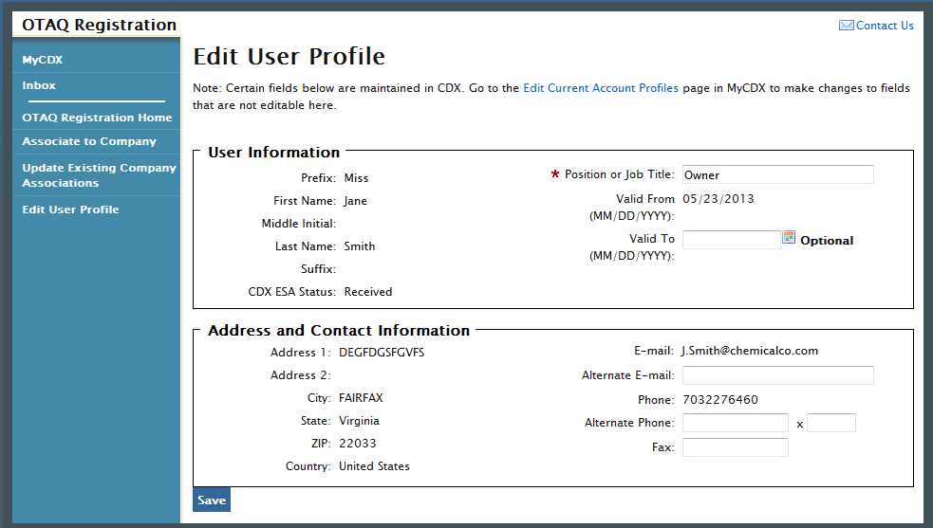
The page will pre-populate the contact information associated to your CDX account. To edit the pre-populated information, click the “Edit Current Account Profiles” link to be taken to the CDX Edit Organization Profiles page.
If no changes to the pre-populated information are needed, enter data into any of the applicable textboxes. You must provide data for the “Position or Job Title” field. Click the “Save” button. Your user profile will be saved and Figure 3-3 will display.
Figure 3-3 OTAQ Registration Home Page
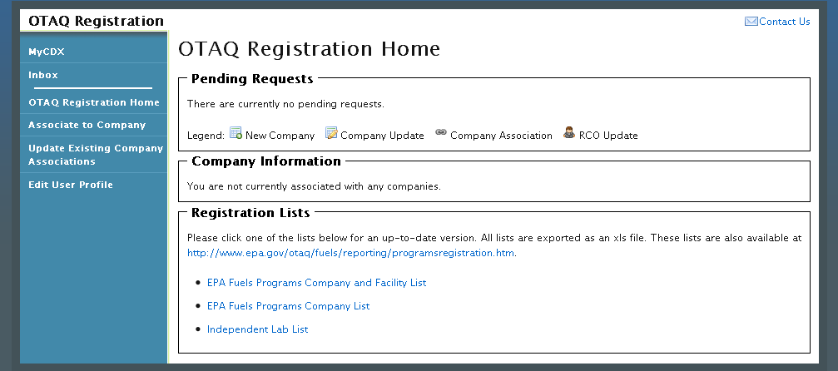

Edit Existing User Profile
The following section describes how to edit your OTAQReg User Profile information.
Figure 3-4 OTAQ Registration Home Page
Click the “Edit User Profile” link in the left side toolbar of your OTAQ Registration Home page, as seen in Figure 3-4. Figure 3-5 will display.
Figure 3-5 Edit User Page
The page will pre-populate with your current OTAQReg User Profile information. To update the un-editable CDX user information, click the “Edit Current Account Profiles” link to be taken to the CDX Edit Organization Profiles page.
Edit any of the additional user profile data by updating the data in the textboxes and clicking the “Save” button.

Deactivated Users
If you have been deactivated by an EPA Administrator for the OTAQReg application, upon clicking the OTAQReg application link on the MyCDX Home page, Figure 3-6 will display.
Figure 3-6 OTAQ Deactivated Home Page
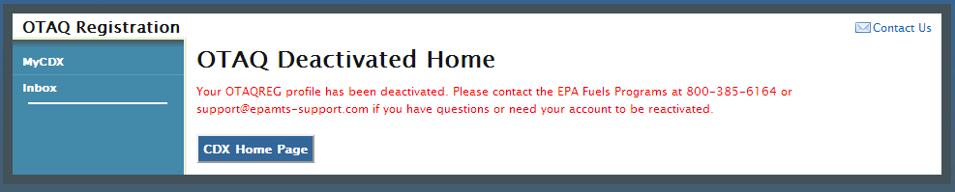
This screen notifies you that your OTAQReg profile has been deactivated and provides the phone number and e-mail address to contact the EPA Fuels Programs for any questions or to reactivate your account.
Click the “CDX Home Page” button to return to the MyCDX Home page.

Company Associations
The following sections describe how to add and update company associations within the OTAQReg application.

Add Company Association
Figure 4-1 OTAQ Registration Home Page
Click the “Associate to Company: Search for Existing Company” link in the left side toolbar of your OTAQ Registration Home page, as seen in Figure 4-1. Figure 4-2 will display.
Figure 4-2 Associate to Company Search Page
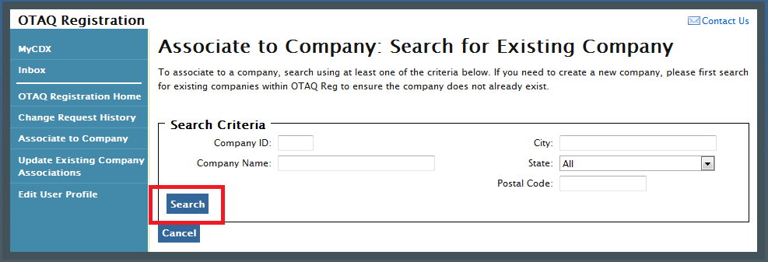
Enter your company specific search criteria into the textboxes and click the “Search” button. A list of all companies matching your search criteria will display, as shown in Figure 4-3.

Figure 4-3 Associate to Company Search Results
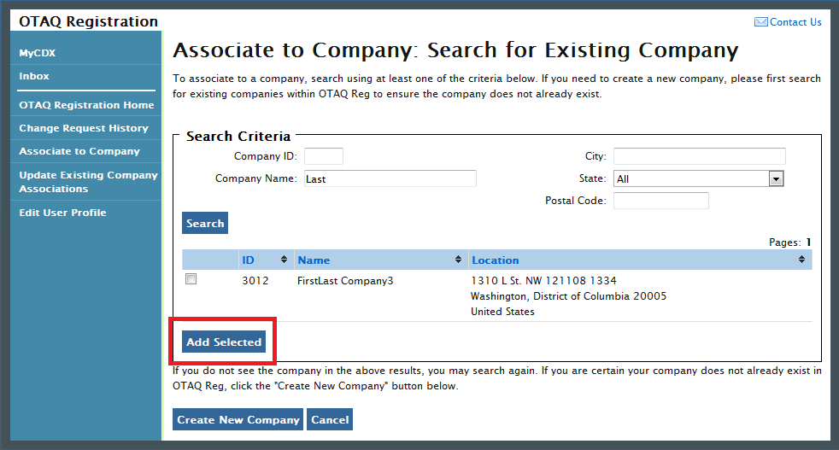
Select the checkbox next to the company with which you wish to associate (if you do not see your company listed in the results, click the “Create New Company” button to create your company; see Section 5 for further details). Click the “Add Selected” button. Figure 4-4 will display.
Note: You may select multiple check boxes if you wish to associate to more than one company.
Figure 4-4 Associate to Company: Create Company Associations Page
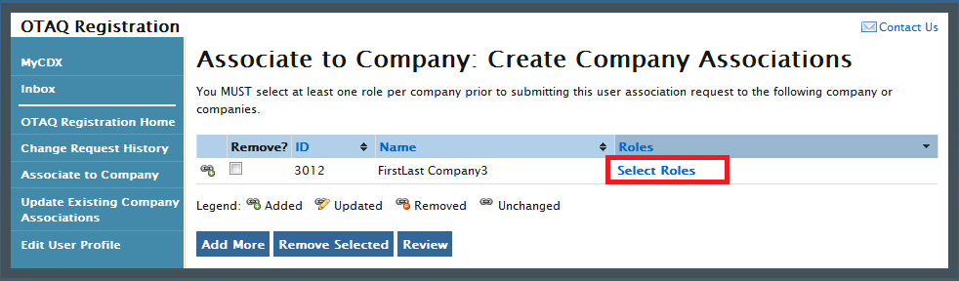
You must select at least one role per company prior to submitting your user association request. Click the “Select Roles” link to display a pop-up of available roles for the company. Figure 4-5 will display.
Figure 4-5 Company Roles Pop-Up
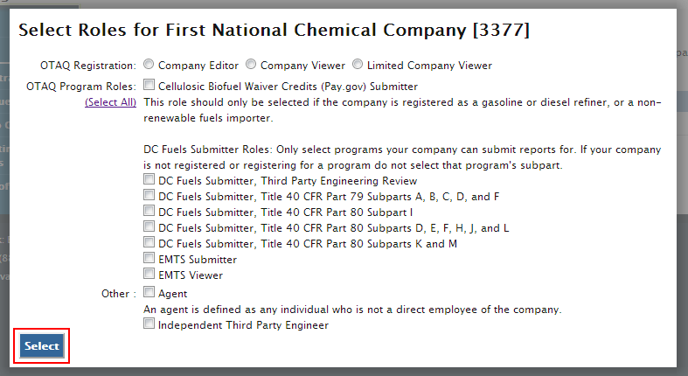
Choose the appropriate OTAQ Registration and OTAQ Program Roles by selecting the corresponding radio button and checkboxes (reference Appendix A: OTAQ Registration Roles if you are unsure which roles to select). You may select only one OTAQ Registration role, however multiple OTAQ Program roles are allowed. Click the “Select All” link to select all OTAQ Program Roles.
Click the “Select” button once you have made your selections. Figure 4-6 will display.
Figure 4-6 Associate to Company: Create Company Associations Page with Roles
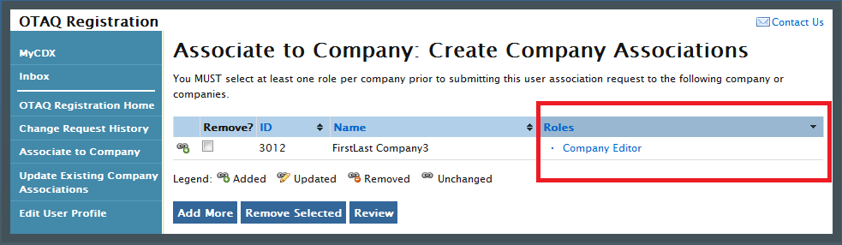
Your selected roles will now display beside the selected company. Click the “Review” button to continue. Figure 4-7 will display.
Figure 4-7 Associate to Company: Review Page
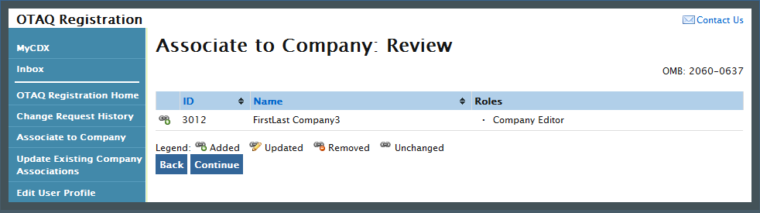
The "Associate to Company: Review" page displays a read-only version of your company association details. If the company and role information are correct, click the “Continue” button.
Figure 4-8 will display.
Figure 4-8 Associate to Company: Submit Request Page
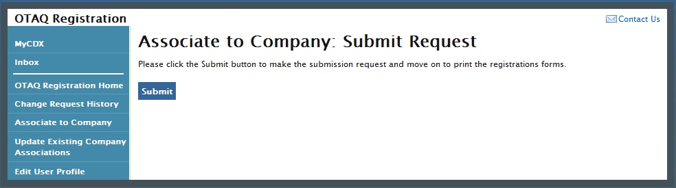
Click the “Submit” button to submit the request. Figure 4-9 will display.
Figure 4-9 Further Action Required Page
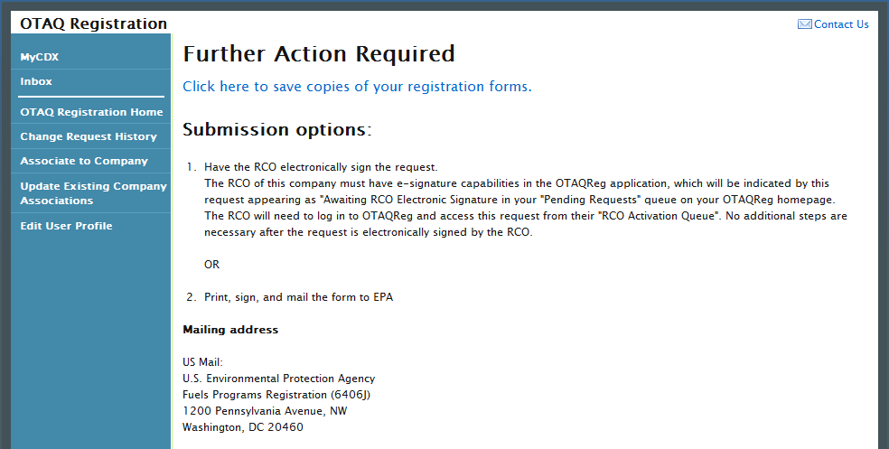

Click the “Click here to save copies of your registration forms” link to save a hard copy of your registration forms in PDF form. It is required that you save a copy of your registration forms before submitting your request. If you attempt to select the “Home” button without first saving a copy of your registration forms, a notification window will appear prompting you to first save your forms.
Once you have submitted your Company Association Request, you will receive an email notification stating that your Company Association Request is awaiting RCO signature along with a hard copy of your company association registration forms. The Company Association request will appear in the Pending Requests section of your OTAQ Registration Home Page, as shown in Figure 4-10.
Note: All Company Association requests require a signed RCO Delegation Letter by your Company Responsible Corporate Officer. The RCO Delegation Letter is included in the hard copy of your company association registration forms. This letter can be electronically signed by the RCO in OTAQReg if they have a valid CDX ESA.

Update Company Roles
Figure 4-10 OTAQ Registration Home Page
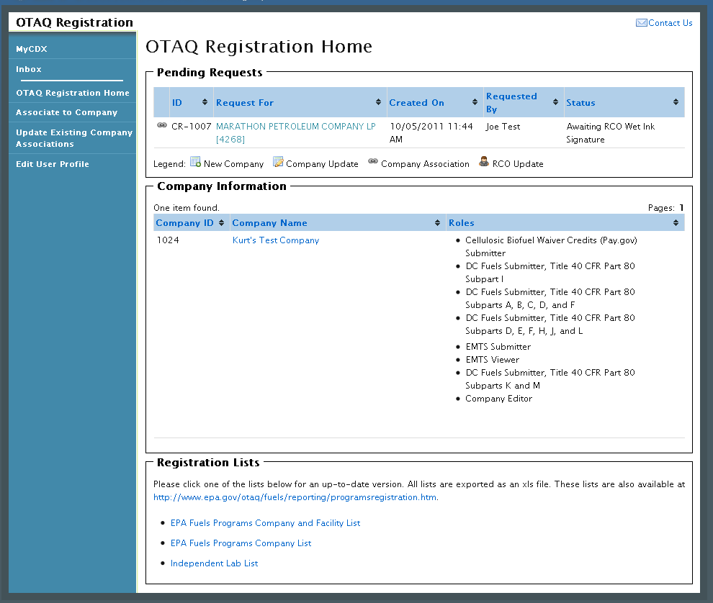
Click the “Update Existing Company Association” link in the left side toolbar of your OTAQ Registration Home Page. Figure 4-11 will display.
Figure 4-11 Update Company Associations Page
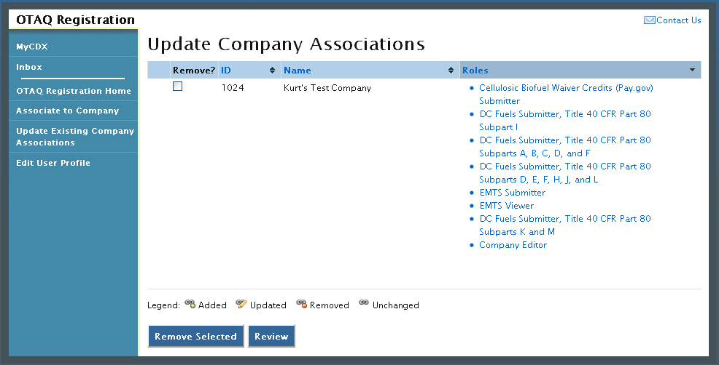
Select the Roles link for the company you wish to update. Figure 4-12 will display.
Figure 4-12 Update Roles
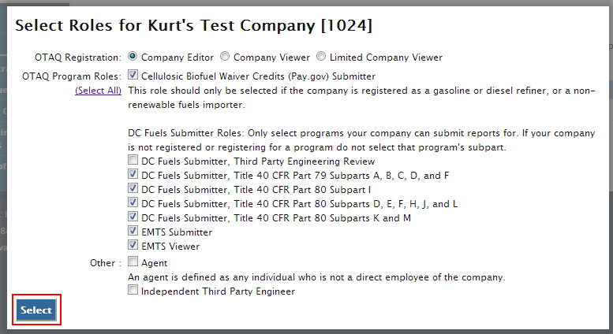
Your existing roles will be pre-selected on the page. Update your OTAQ Registration and OTAQ Program Roles by selecting a new radio button and/or checkboxes (reference Appendix A: OTAQ Registration Roles if you are unsure which roles to select). You may select only one OTAQ Registration role however multiple OTAQ Program Roles are allowed.
Click the “Select” button once you have made your selections. Figure 4-13 will display.
Figure 4-13 Updated Company Associations
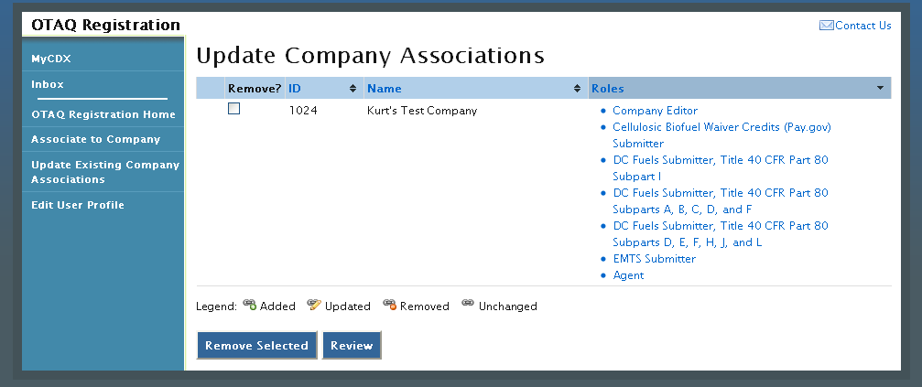
The Update Company Associations Page will now display your updated roles. Click the “Review” button. Figure 4-14 will display.
Figure 4-14 Confirm Updated Company Association
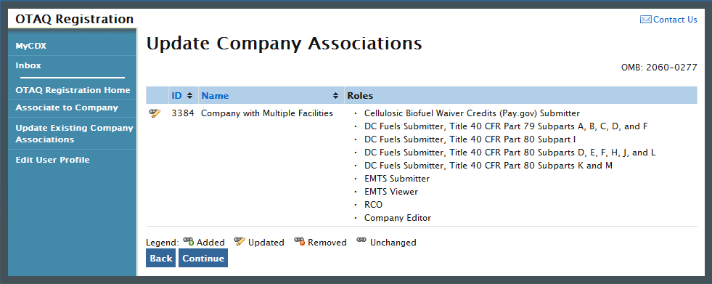
The page will display the updated icon for the updated company association. If the updated company association is correct, click the “Continue” button. Figure 4-15 will display.

Figure 4-15 Submit Request Page
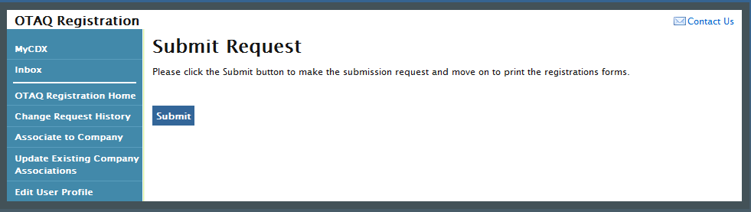
Click the “Submit” button to submit your request. Figure 4-16 will display.
Figure 4-16 Further Action Required Page
Click the “Click here to save copies of your registration forms” link to save a hard copy of your registration forms in PDF form. It is required that you save a copy of your registration forms before submitting your request. If you attempt to select the “Home” button without first saving a copy of your registration forms, a notification window will appear prompting you to first save your forms.
Note: All Company Association Update Requests require a signed RCO Delegation Letter by your Company Responsible Corporate Officer. The RCO Delegation Letter is included in the hard copy of your company association registration forms. This letter can be electronically signed by the RCO in OTAQReg if they have a valid CDX ESA.
Once you have submitted your Updated Company Association, you will receive an email notification stating your request is awaiting RCO signature along with a hard copy of your company association registration forms. The updated company association request will appear in the pending requests section of your OTAQ Registration Home Page. Please reference Section 4.4 for information on viewing pending association requests.

Remove Existing Company Association
To remove an existing company association, navigate to the Update Company Associations page, as shown in Figure 4-17.
Figure 4-17 Remove Company Association
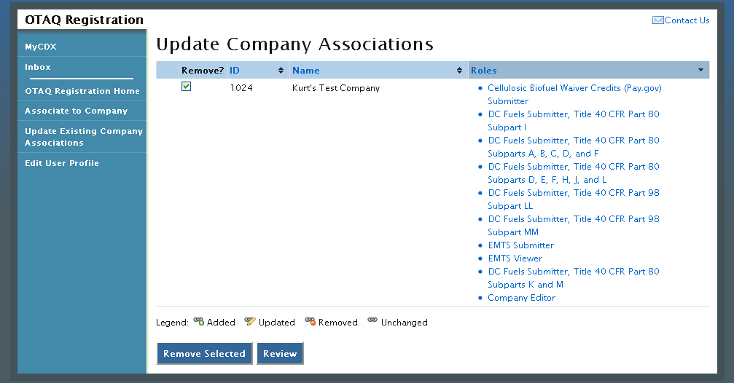
Select the checkbox next to the company association you wish to remove and click the “Remove Selected” button. Figure 4-18 will display.
Figure 4-18 Remove Company Pop-Up
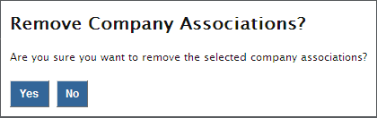
Click the “Yes” button to confirm that you would like to remove the selected company association. Figure 4-19 will display.
Figure 4-19 Removed Company Association
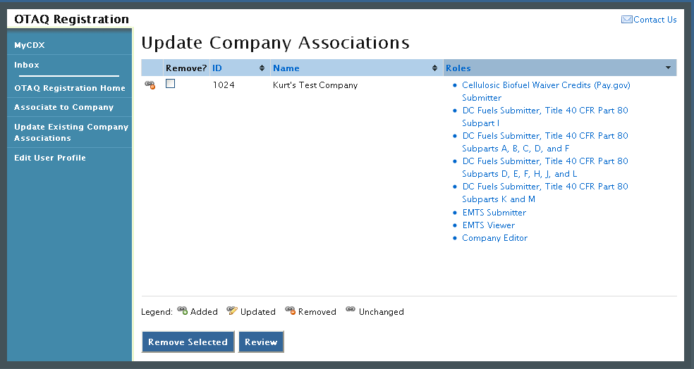
The removed icon will now display next to the company association you have removed. Click the “Review” button. Figure 4-20 will display.
Figure 4-20 Remove Company Association Confirmation
If the removed company association is correct, click the “Continue” button. Figure 4-21 will display.

Figure 4-21 Submit Request Page
Click the “Submit” button to submit your request. Figure 4-22 will display.
Figure 4-22 Further Action Required Page
Click the “Click here to save copies of your registration forms” link to save a hard copy of your registration forms in PDF form. It is required that you save a copy of your registration forms before submitting your request. If you attempt to select the “Home” button without first saving a copy of your registration forms, a notification window will appear prompting you to first save your forms.
Note: All Company Association Removal Requests require a signed User Association Termination Letter by your Company Responsible Corporate Officer. The User Association Termination Letter is included in the hard copy of your company association registration forms. This letter can be electronically signed by the RCO in OTAQReg if they have a valid CDX ESA.
Once you have submitted your Remove Company Association request, you will receive an email notification stating your request is awaiting RCO signature along with a hard copy of your company association registration forms. The updated company association request will appear in the pending requests section of your OTAQ Registration Home Page. Please refer to section 4.4 for information on viewing pending association requests.

Pending Company Association Requests
Congratulations! You have successfully submitted your Company Association Request in the OTAQReg application. As shown in Figure 4-23, your request will be displayed in your Pending Requests queue on your OTAQ Registration Home Page along with its current status.
Figure 4-23 Pending Company Association Requests
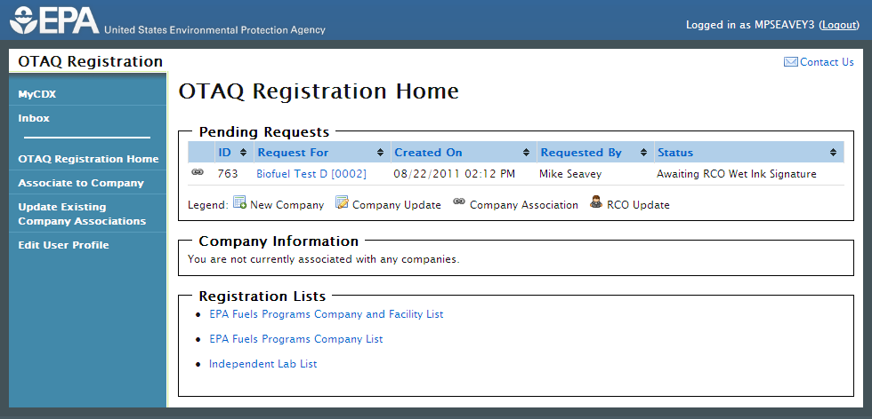
To view a pending Company Association Request, click the Company Name link for a request in the Pending Requests Queue with the Company Association icon. Figure 4-24 will display.
Figure 4-24 Company Association Request
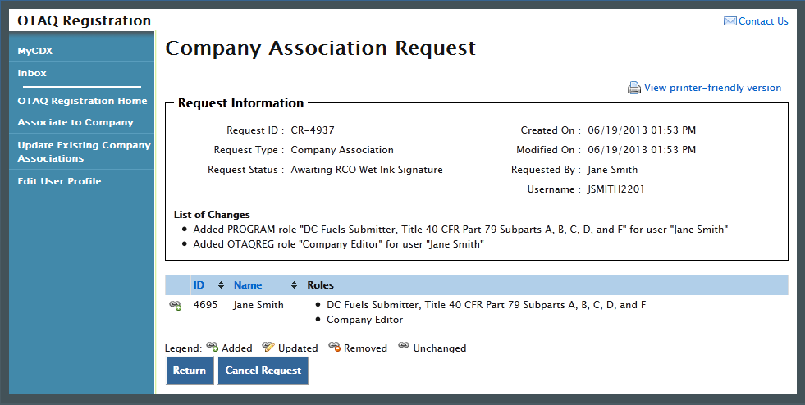
The Company Association Request page displays all request information. To return to the OTAQReg Home Page click the “Return” button.
To cancel the Company Association Request, click the “Cancel Request” button. A notification window will appear, prompting you to select the “Yes” button to continue with the request cancellation or the “No” button to return to the previous page. The request will be canceled immediately and will no longer display in the Pending Requests queue.

Create New Company
The following sections describe how to create a new company in the OTAQReg application.
Figure 5-1 OTAQ Registration Home Page
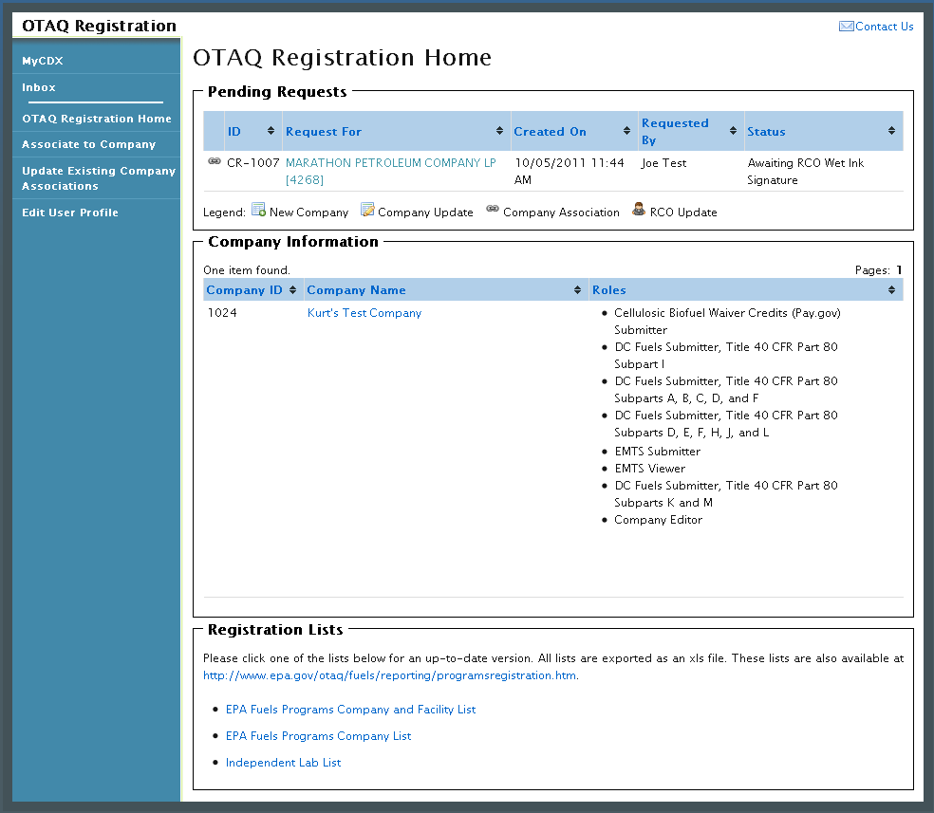
Click the “Associate to Company” link in the left side toolbar of your OTAQ Registration Home Page as seen in Figure 5-1. Figure 5-2 will display.

Verify Company Does Not Exist in OTAQReg
Figure 5-2 Associate to Company: Search for Existing Company Page
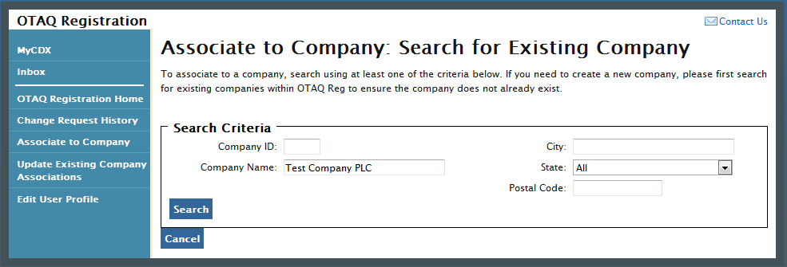
Before you can create a new company, you must first confirm that the company you intend to create does not already exist in OTAQReg. Enter search criteria pertinent to your company and click the “Search” button, as seen in Figure 5-2. Figure 5-3 will display.
Please note, search terms act together to narrow results. For example, searching on the state New York and the city New will return all companies located in New York state that have New in their city’s name. It is recommended that companies use broad searches to avoid delays and registration issues caused by a user attempting to duplicate a company registration.
Figure 5-3 Associate to Company: Search for Existing Company Results
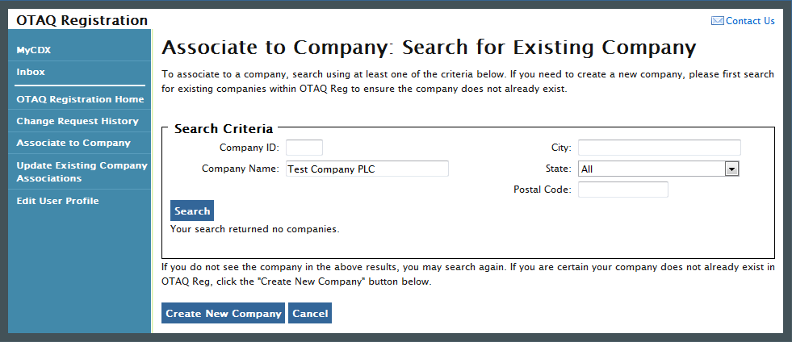
The page will return a list of companies matching the provided search criteria. If your company is displayed in the search results then please refer to Section 4.1 for instructions on how to associate to an existing company.
If it is determined that your company does not currently exist in OTAQReg, click the “Create New Company” button. Figure 5-4 will display.

Create Company Details
Figure 5-4 Create New Company: Company Details Page
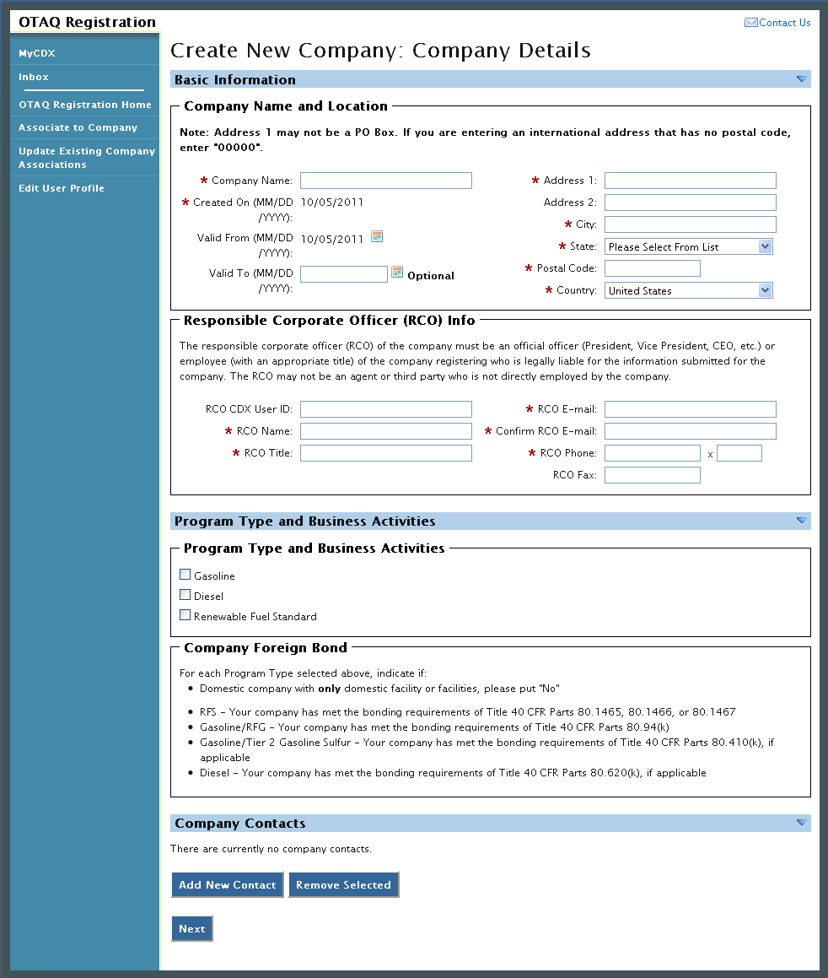
The Create New Company: Company Details page displays fields for you to provide the Company Name, Location, Responsible Corporate Officer information, Program Types, Business Activities, Company Contacts, and other required company details.
Enter information for all required fields. Required fields are marked with a red star.
The Business Activities associated to each Program Type are displayed once a Program Type is selected, as shown in Figure 5-5.
Figure 5-5 Program Types and Business Activities
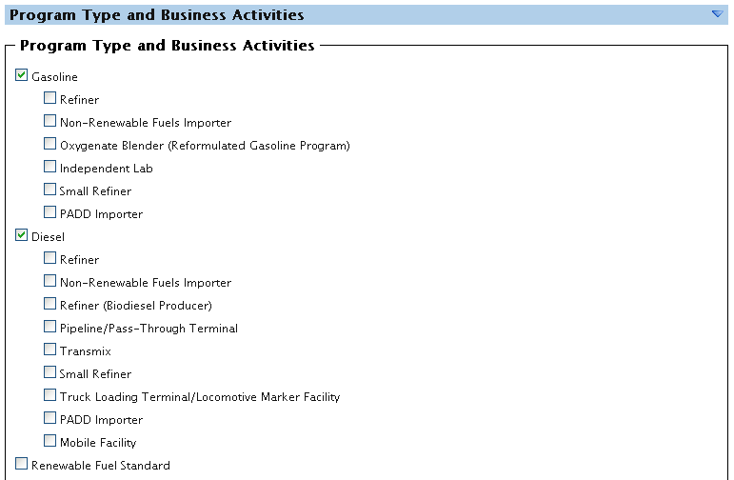
To add a company contact, click the “Add New Contact” button. Figure 5-6 will display.
Figure 5-6 Company Contacts
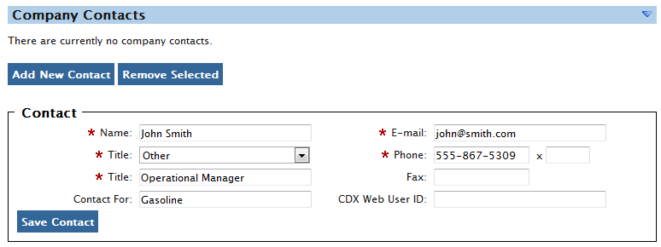
Enter information in all required fields by typing in the textboxes. Click the “Save Contact” button. The contact will now be listed in the company details.
After you have provided your complete company details, click the “Next” button. Figure 5-7 will display.

Select Company Roles
Figure 5-7 Create New Company: Company Roles
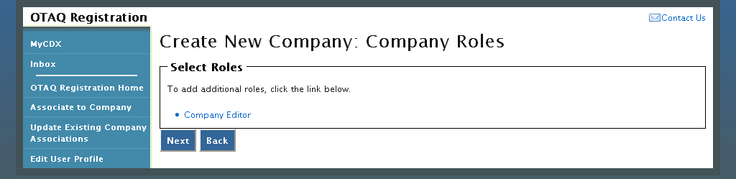
As the creator of a company, the Company Editor role is pre-selected for you. Click the “Company Editor” link to add additional roles. Figure 5-8 will display.
Figure 5-8 Company Roles Pop-Up
Choose the appropriate OTAQ Registration and OTAQ Program roles by selecting the corresponding radio button and checkboxes (reference Appendix A: OTAQ Registration Roles if you are unsure which roles to select). You may select only one OTAQ Registration role however multiple OTAQ Program roles are allowed. Click the “Select All” link to select all OTAQ Program Roles. Figure 5-9 will display.
Figure 5-9 Selected Company Roles
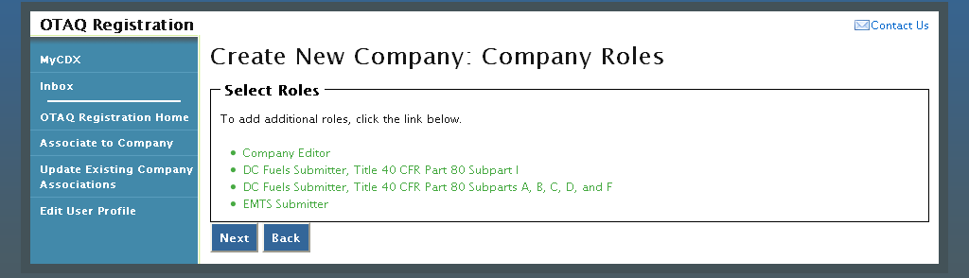
Click the “Next” button. Figure 5-10 will display.

Adding Company Facilities
Your company may or may not require that you add a Facility depending on the Program Types and Business Activities selected for your company.
Figure 5-10 Create New Company: Facility List
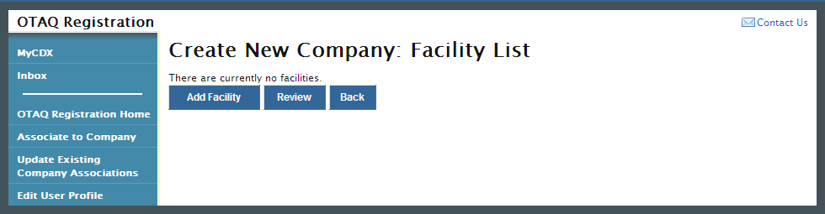
Click the “Review” button. Figure 5-11 will display if your company is required to have at least one facility. If your company is not required to have at least one facility then you will be directed to the Create New Company Signature page, as shown in Figure 4-11 (continue to Section 5.5).
Figure 5-11 Create New Company: Facility List Requires Facility
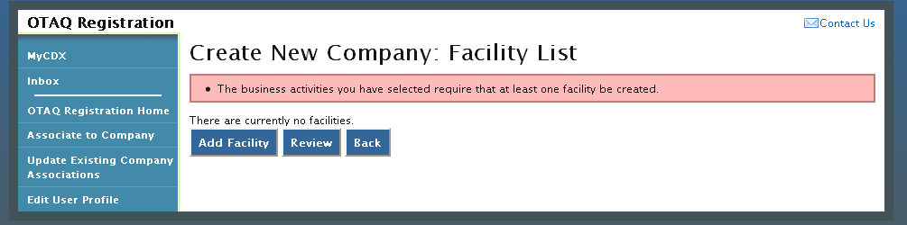
To add a facility to your company click the “Add Facility” button. Figure 5-12 will display.
Figure 5-12 Create New Company: Facility Type
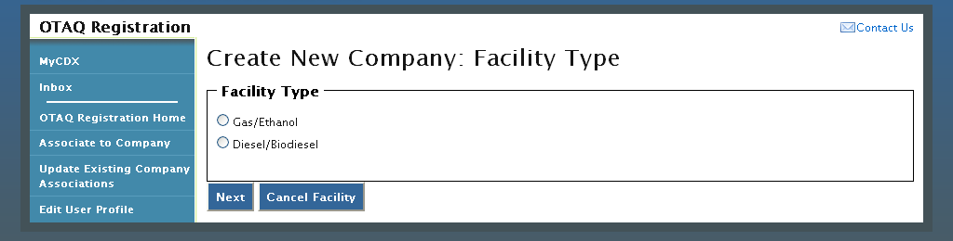
The Facility Types are pre-populated on the page based on the Program Type(s) and Business Activity(s) you selected for your company. Select the radio button next to the appropriate facility type you wish to add and click the “Next” button. Figure 5-13 will display. (Note: if your facility processes both diesel/biodiesel and gas/ethanol, it will be necessary to create two facilities with the same address and different facility types.)
Note: You may cancel adding a facility at any time by selecting the “Cancel Facility” button.
Figure 5-13 Create New Company: Facility Activities
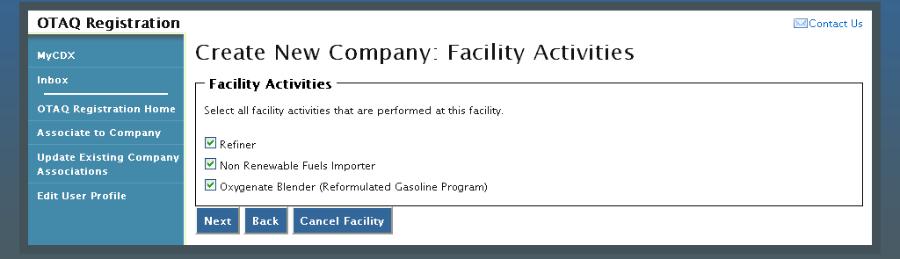
The Facility Activities are pre-populated onto the page based on the Program Type(s), Business Activity(s), and Facility Type you selected. Click the checkbox next to all applicable facility activities and click the “Next” button. Figure 5-14 will display.

Verify Facility Does Not Exist in OTAQReg
Figure 5-14 Create New Company: Search for Existing Facility
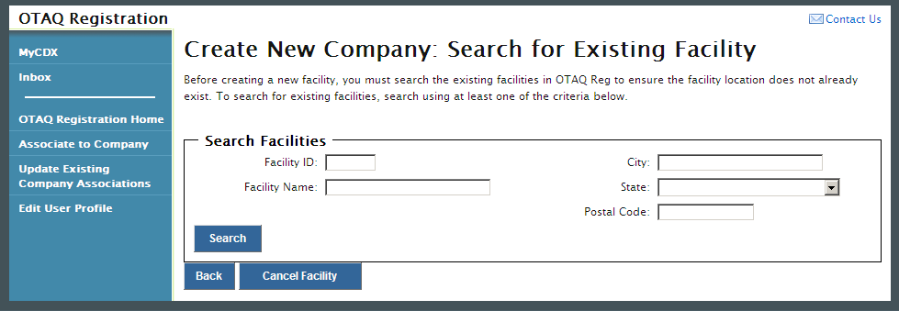
Before you can create a new facility, you must first confirm the facility you intend to create does not already exist in the OTAQReg application. To confirm whether or not your facility already exists in OTAQReg, search for your facility by providing search criteria into the facility search fields. Click the “Search” button. Figure 5-15 will display.
Please note, search terms act together to narrow results. For example, searching on the state New York and the city New will return all facilities located in New York state that have New in their city’s name. It is recommended that companies use broad searches to avoid delays and registration issues caused by a user attempting to duplicate a facility registration.

Figure 5-15 Facility Search Results
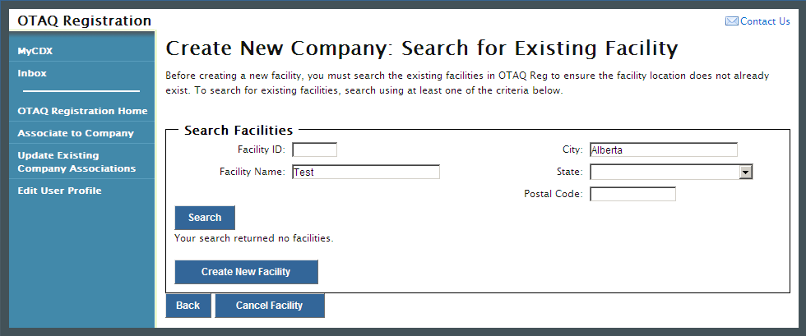
The page will return a list of facilities matching the provided search criteria. If your facility is displayed in the search results then please refer to Section 5.4.1.2 for instructions on how to add an existing facility.
If it is determined that your facility does not currently exist in OTAQReg, click the “Create New Facility” button. Figure 5-16 will display.

Create New Facility
Figure 5-16 Create New Company: Basic Facility Details
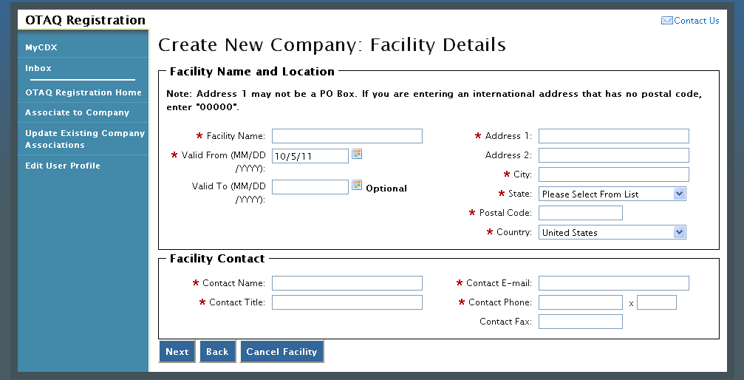
Enter information for all required fields. Required fields are identified with a red star. Click the “Next” button when finished. Figure 5-17 will display.
Note: Address 1 may not be a P.O. Box address. If you are entering an international address that has no postal code, enter “00000.”
Figure 5-17 Create New Company: Facility Details
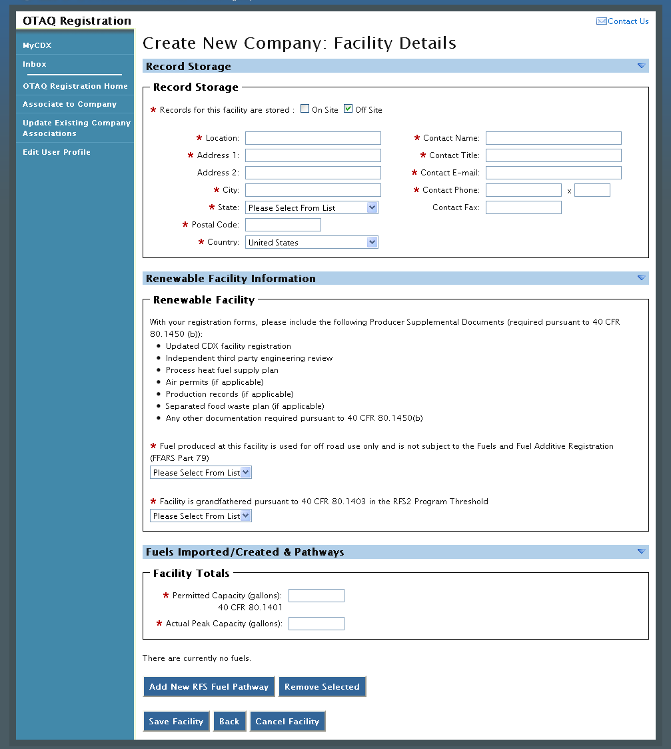
Enter information in all required fields by typing in the textboxes and selecting from available drop-down menus. The sections and required fields displayed on the Facility Details page will vary depending on the Facility Types and Facility Activities you previously selected for the facility.
Click the “Save Facility” button when finished. Figure 5-18 will display.
Figure 5-18 Create New Company: Facility List
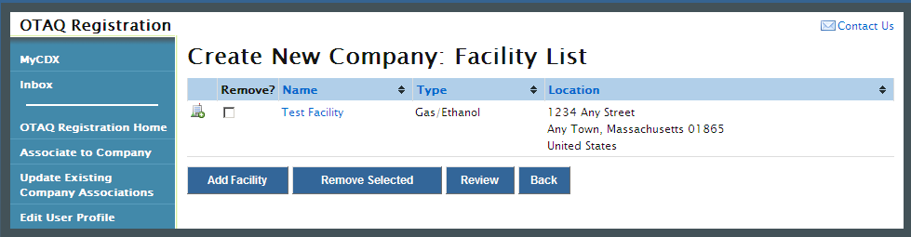
If the displayed facility information is correct, click the “Review” button. Figure 5-23 will display (continue to Section 5.5).

Add Existing Facility
Figure 5-19 Select Existing Facility
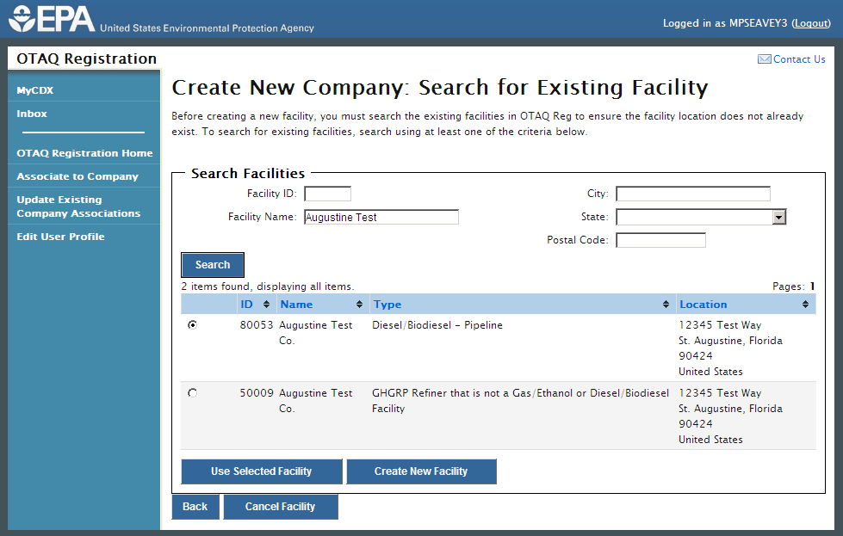
If it is determined that your Facility exists in OTAQReg, choose the desired facility by selecting the corresponding radio button and clicking the “Use Selected Facility” button, as seen in Figure 5-19. Figure 5-20 will display.
Figure 5-20 Existing Facility Details
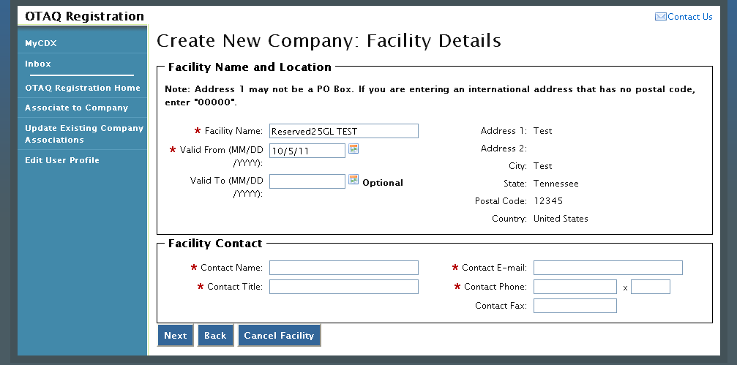
The existing Facility Name and Location will be pre-populated on the page. The Facility Name field is editable however you are not able to edit the facility location for an existing facility. Provide information for all required fields and click the “Next” button. Figure 5-21 will display.
Figure 5-21 Create Facility Details
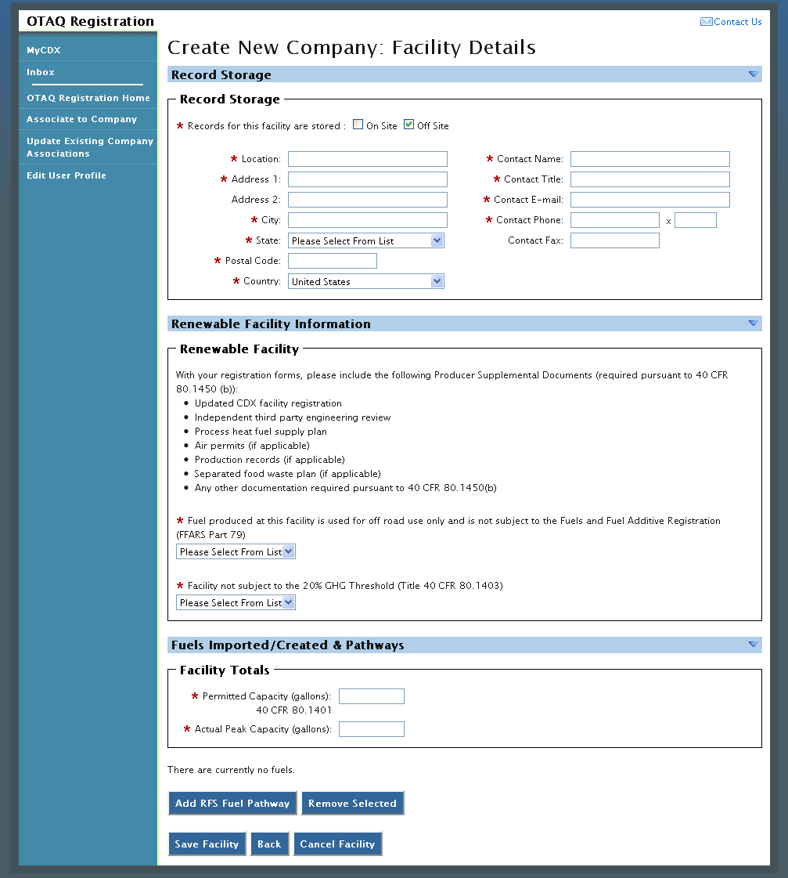
Enter information in all required fields by typing in the textboxes and selecting from available drop-down menus. The sections and required fields displayed on the Facility Details page will vary depending on the Facility Types and Facility Activities you previously selected for the facility.
Click the “Save Facility” button when finished. Figure 5-22 will display.
Figure 5-22 Review Facility List
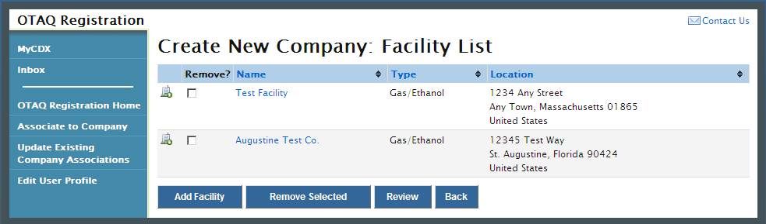
If the displayed facility information is correct, click the “Review” button. Figure 5-23 will display.

Review and Submit New Company Information
Figure 5-23 Create New Company: Review
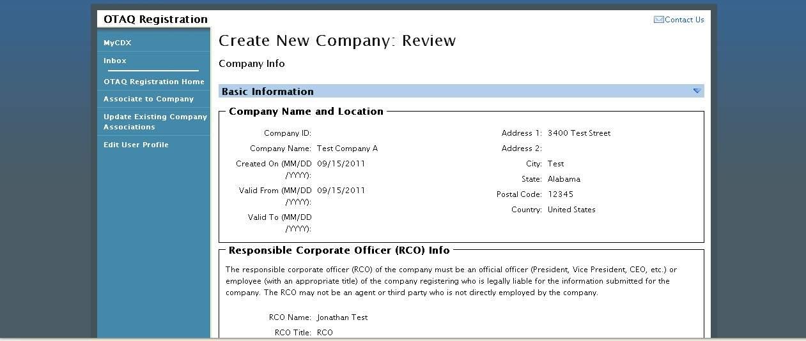
The Create New Company: Review page displays a read-only version of the company and facility details provided. If the new company information on the page is correct click the “Continue” button. Figure 5-24 will display.

Figure 5-24 Create New Company: Submit Request Page
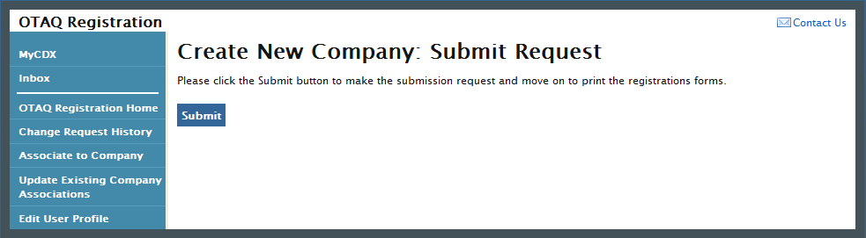
Click the “Submit” button to submit your request. Figure 5-25 will display.
Figure 5-25 Further Action Required Page
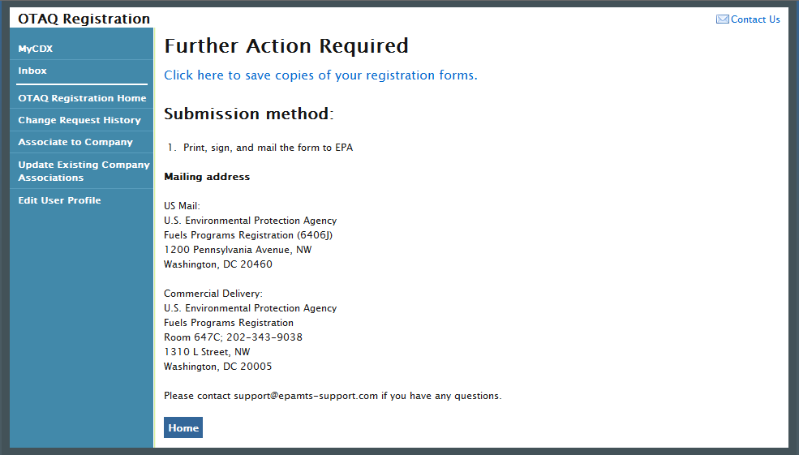
Click the “Click here to save copies of your registration forms” link to save a hard copy of your registration forms in PDF form. It is required that you save a copy of your registration forms before submitting your request. If you attempt to select the “Home” button without first saving a copy of your registration forms, a notification window will appear prompting you to first save your forms.
Once you have submitted your New Company Request, you will receive an email notification stating your new company is awaiting RCO signature. The company request will appear in the pending requests section of your OTAQ Registration Home Page, as shown in Figure 5-26.
Note: All New Company requests require a signed RCO statement by your company’s Responsible Corporate Officer. The RCO signature statement is included in the hard copy of your new company registration forms.
New Company Requests cannot be electronically signed.

Pending New Company Requests
Congratulations! You have successfully submitted your New Company Request in the OTAQReg application. As shown in Figure 5-26, your request will be displayed in your Pending Requests queue on your OTAQ Registration Home Page along with its current status.
Figure 5-26 OTAQ Registration Home page: Pending Requests
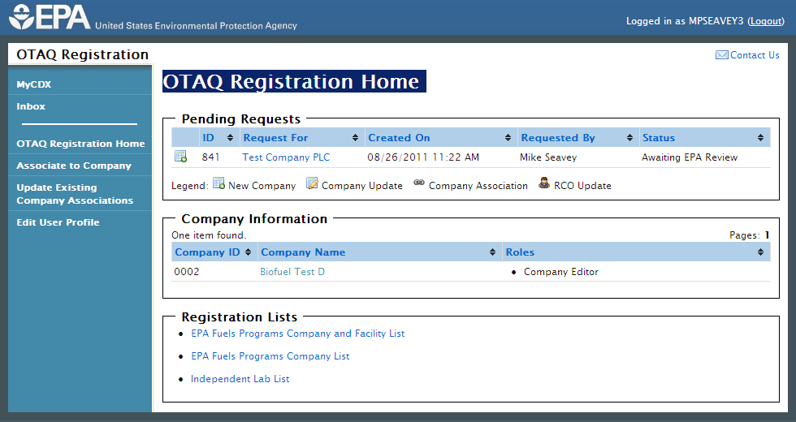
To view a pending New Company Request, click the Company Name link in the Pending Requests Queue for a request identified with the New Company icon. Figure 5-27 will display.
Figure 5-27 New Company Request
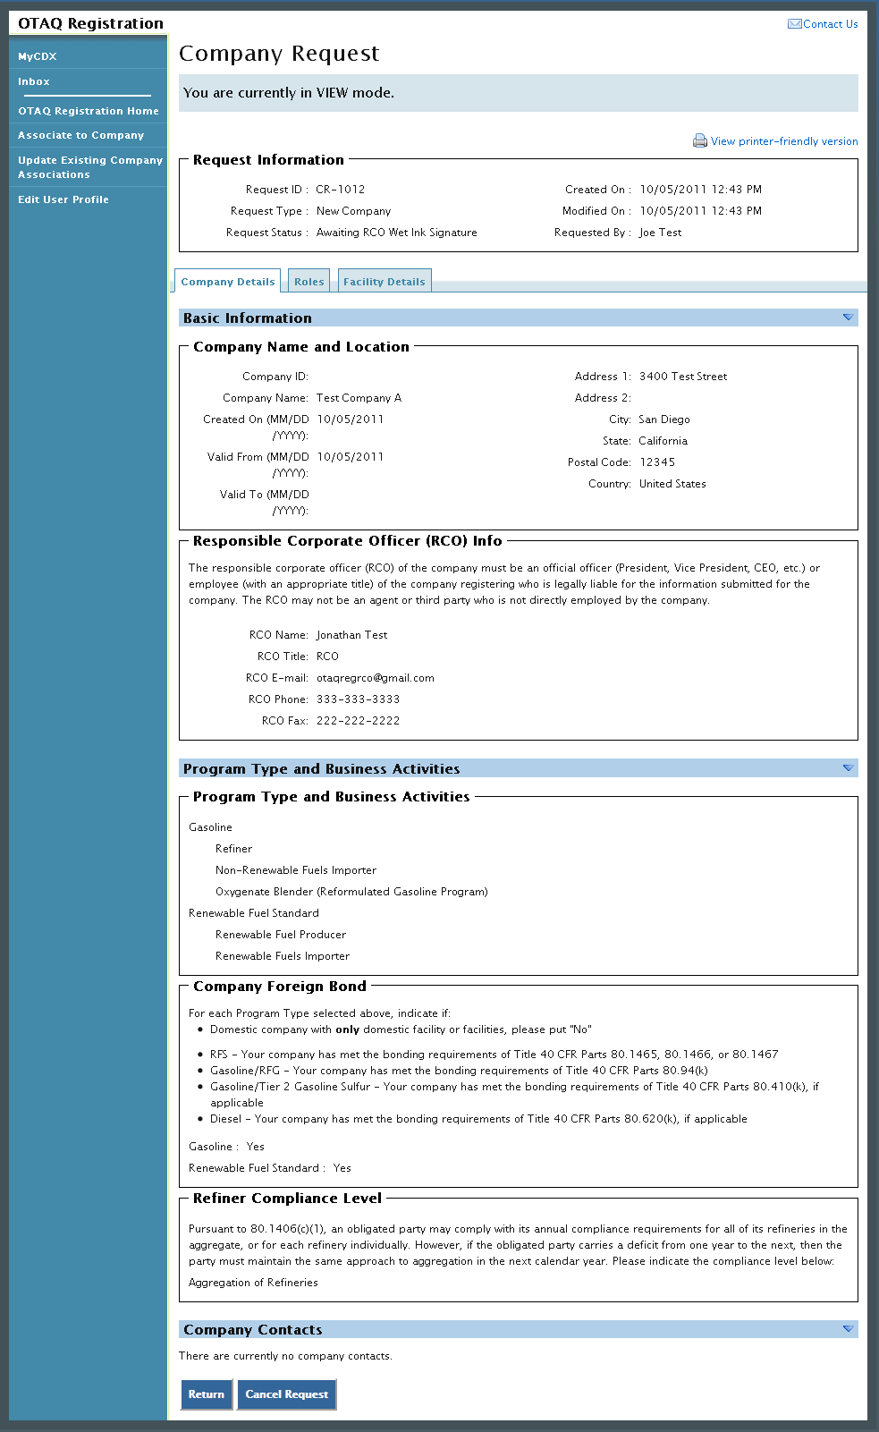
The New Company Request page displays all of the company’s information. To return to the OTAQReg Home Page click the “Return” button.
To cancel the New Company Request, click the “Cancel Request” button. A notification window will appear, prompting you to select the “Yes” button to continue with the request cancellation or the “No” button to return to the previous page. The request will be canceled immediately and will no longer display in the Pending Requests queue.

View Company Details
The following section describes how to view company details in the OTAQReg application.
Figure 6-1 OTAQ Registration Home Page
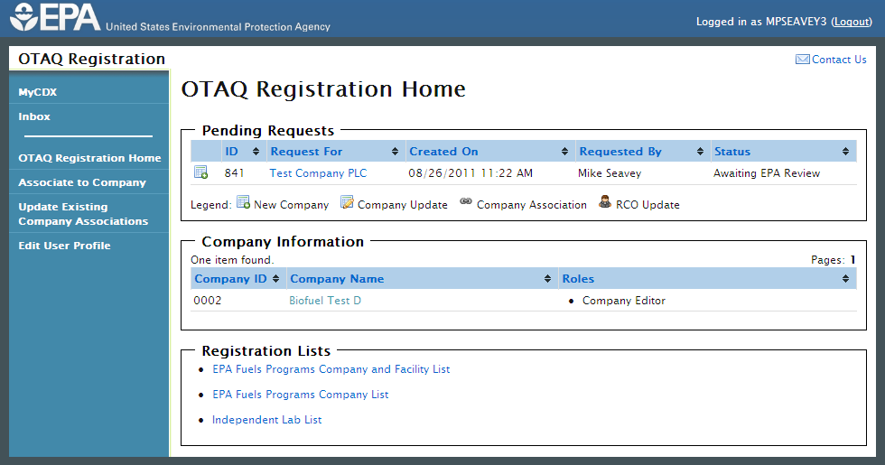
To view a company’s details, navigate to your OTAQ Registration Home Page and click the Company Name link for a company with which you have an active role, as seen in Figure 6-1. The company details will display, as shown in Figure 6-2.
Figure 6-2 Company Information: Company Details
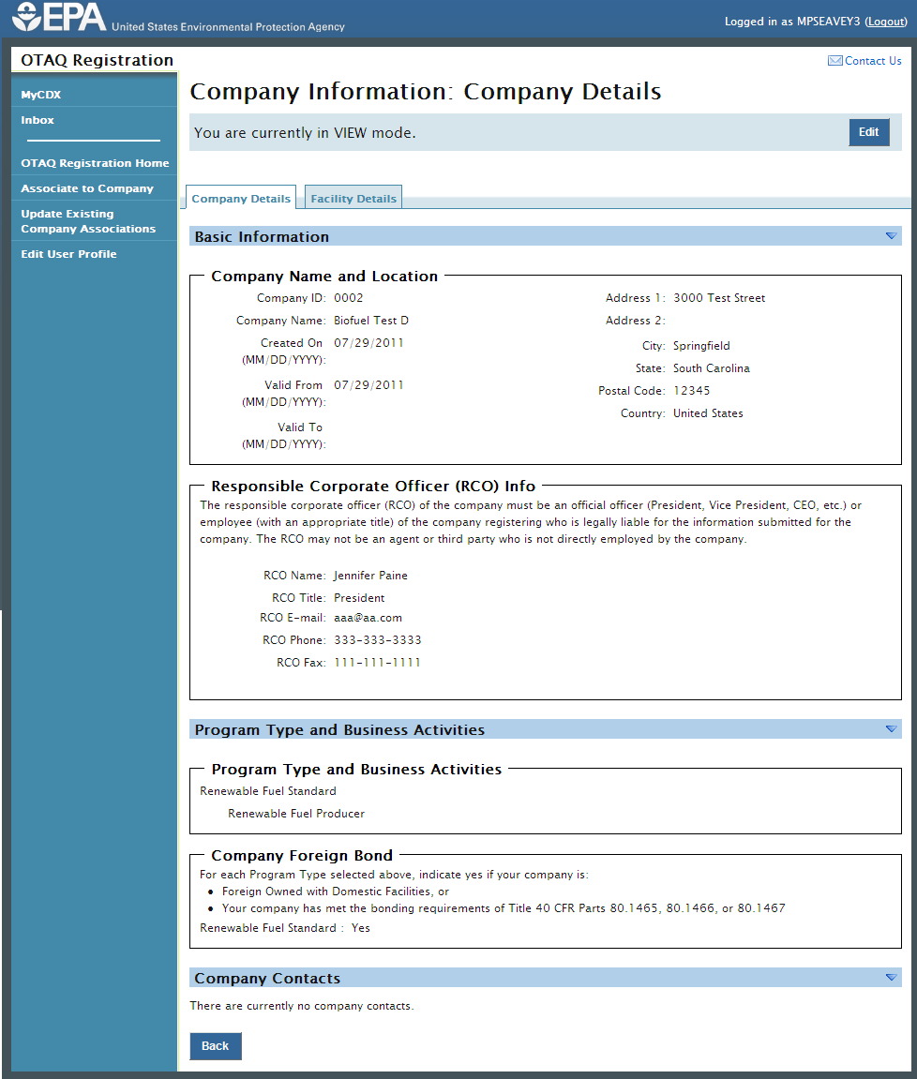
The level of company information displayed depends on your OTAQ Registration role for the company. Please reference Appendix A: OTAQ Registration Roles for further information on the OTAQ Registration Roles and their designated rights.

Edit Company Details
The following sections describe how to edit company details in the OTAQReg application.
Note: You MUST have the Company Editor role for your company to edit company details.

Edit Company Details
Figure 7-1 OTAQ Registration Home Page
To edit a company’s details, navigate to your OTAQ Registration Home Page and click the Company Name link for a company with which you have an active Company Editor role, as seen in Figure 7-1. Figure 7-2 will display.
Figure 7-2 Company Information: Company Details
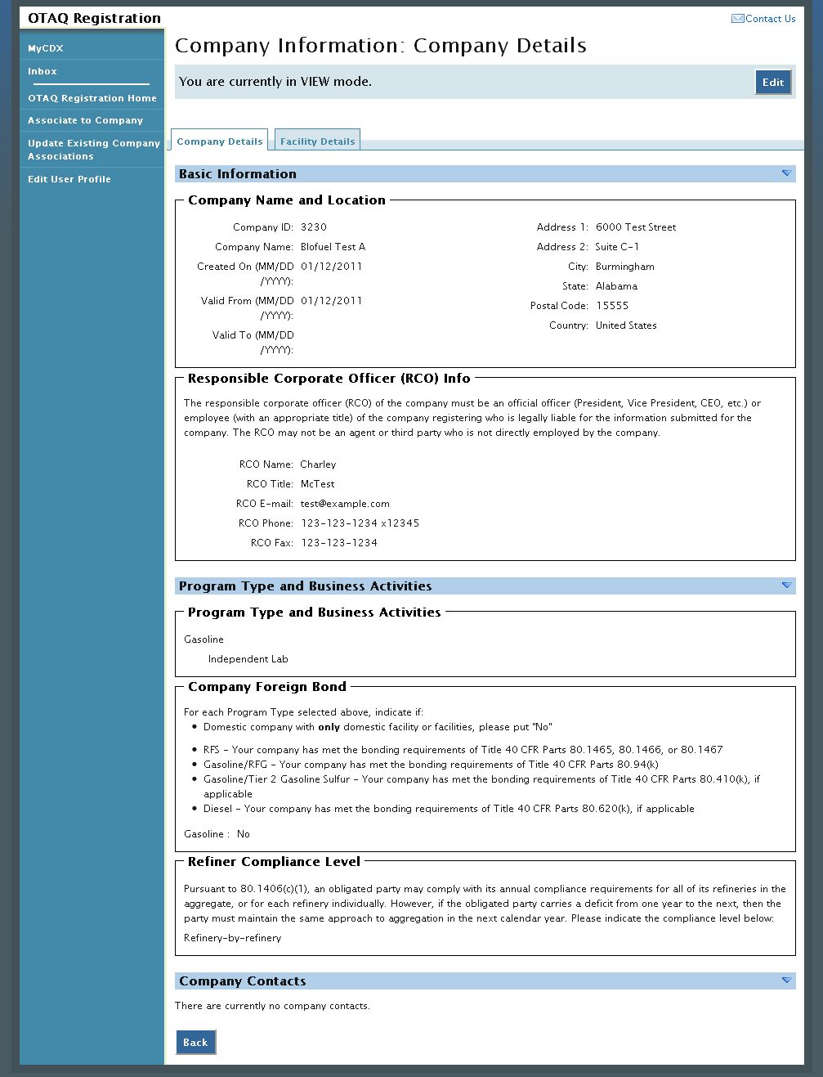
The top of the page states, “You are currently in VIEW mode.” Click the “Edit” button located on the top right side of the page. Figure 7-3 will display.
Figure 7-3 Company Details Edit Page
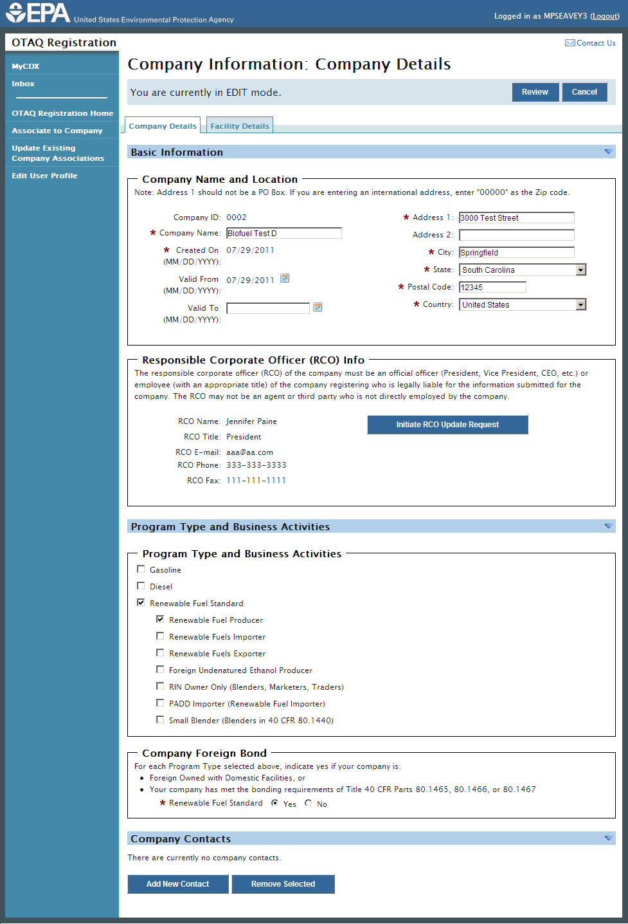
The page will now state, “You are currently in EDIT mode.”
Edit the company information by typing in the textboxes, selecting new checkboxes, and/or selecting new radio buttons. The company’s facility details and RCO information may also be updated. Information on how to edit these pieces of information can be found in Sections 7.4 and 7.6 respectively.
When all updates have been made, click the “Review” button. Figure 7-4 will display.
Note: If the company edits contain changes to the company’s Program Types and Business Activities that have specific facility requirements, you will be prompted with an error message to edit the Facility Information accordingly.

Review Company Details Changes
Figure 7-4 Company Information: Review
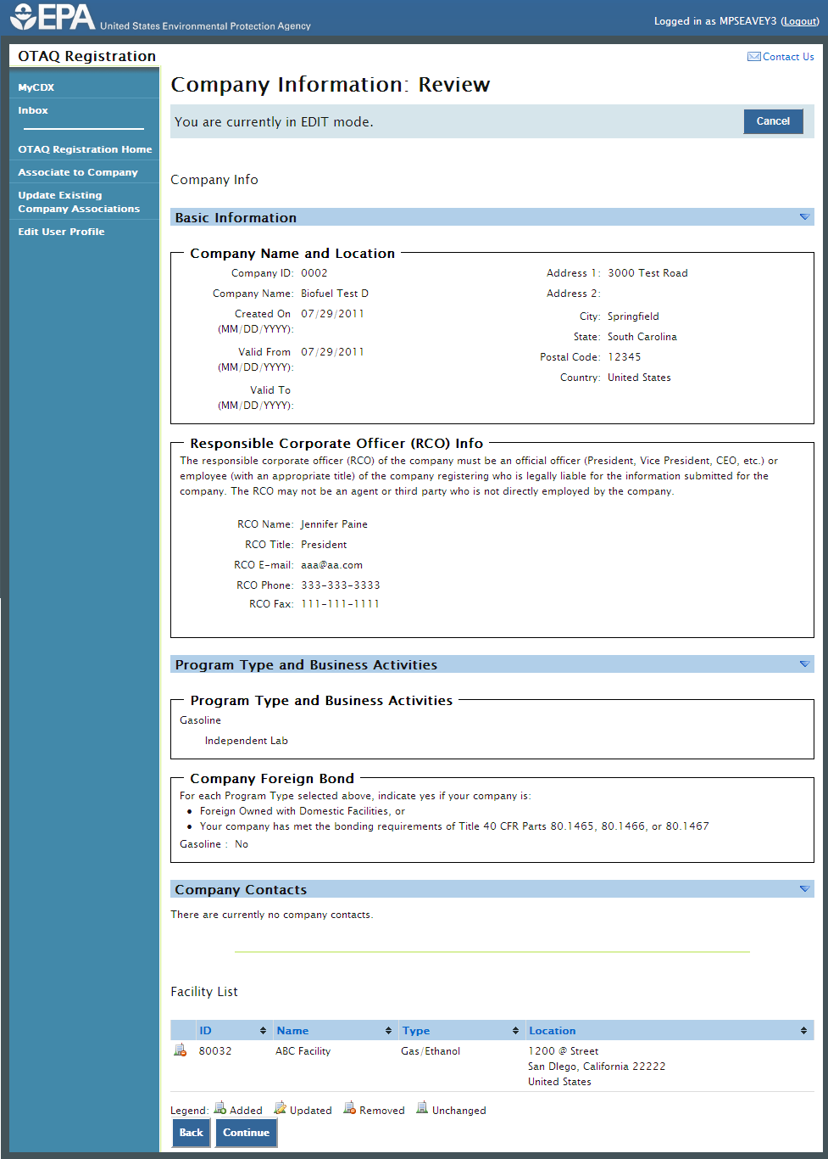
The Company Information Review page displays a read-only version of the updated company record. If the information displayed on the review screen is correct, click the “Continue” button. Figure 7-5 will display.
Figure 7-5 Company Information: Submit Request Page
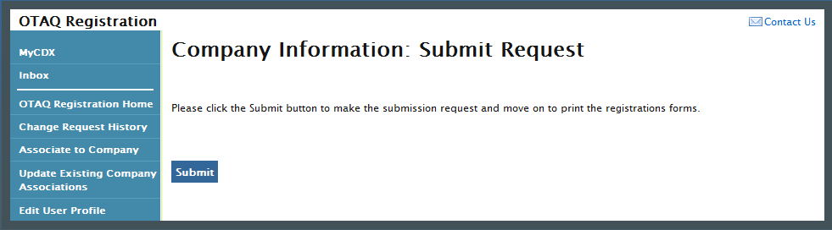
Click the “Submit” button to submit your request. Figure 7-6 will display.
Figure 7-6 Further Action Required Page
Click the “Click here to save copies of your registration forms” link to save a hard copy of your registration forms in PDF form. It is required that you save a copy of your registration forms before submitting your request. If you attempt to select the “Home” button without first saving a copy of your registration forms, a notification window will appear prompting you to first save your forms.
Once you have submitted your Company Update request, you will receive an email notification stating your company update request is awaiting RCO signature along with a hard copy of your company update registration forms.
The request will also be listed in the pending requests section of your OTAQ Registration Home Page, as shown in Figure 7-7. Company Updates must be signed by the Company RCO and approved by EPA.
Note: All Company Update requests require a signed RCO statement by your Company’s Responsible Corporate Officer. The RCO signature statement is included in the hard copy of your company update registration forms. This letter can be electronically signed by the RCO in OTAQReg if they have a valid CDX ESA.

Pending Company Update Request
Congratulations! You have successfully submitted your Company Update Request in the OTAQReg application. As shown in Figure 7-7, your request will be displayed in your Pending Requests queue on your OTAQ Registration Home Page along with its current status.
Figure 7-7 Updated Company Pending Request
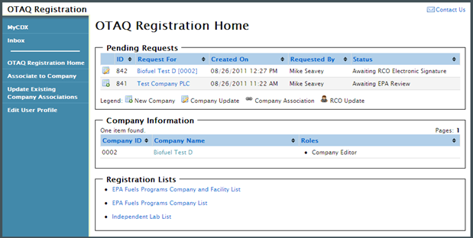
To view a pending Company Update Request, click the Company Name link in the Pending Requests Queue for a request identified with the Company Update icon. Figure 7-8 will display.
Figure 7-8 Company Update Request
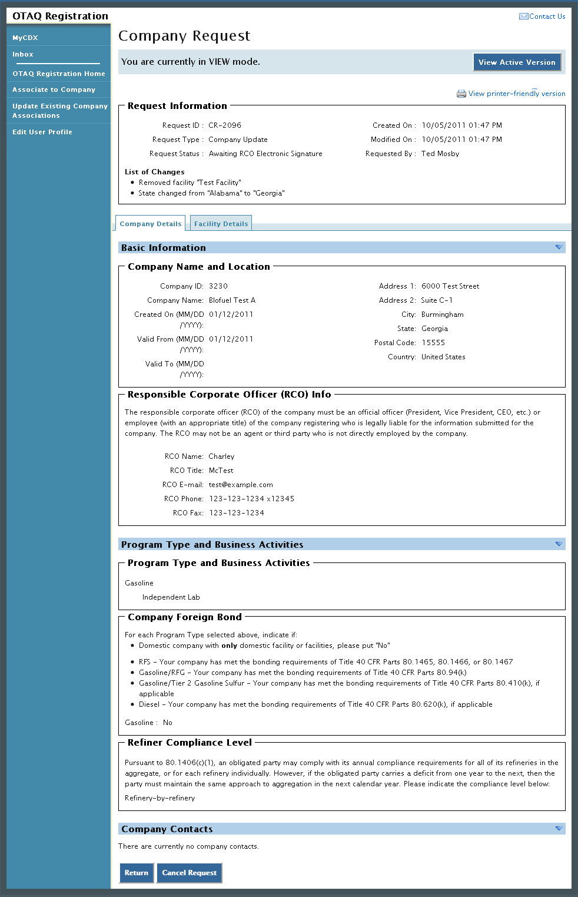
The Company Update Request page displays the current company information as well as a list of changes made by the request. To view the active version of the company record, click the “View Active Version” button.
To return to the OTAQReg Home Page, click the “Return” button.
To cancel the Company Update Request, click the “Cancel Request” button. A notification window will appear, prompting you to select the “Yes” button to continue with the request cancellation or the “No” button to return to the previous page. The request will be canceled immediately and will no longer display in the Pending Requests queue.

Edit Facility Details
To edit Facility Details for a company, click the Facility Details tab, shown in Figure 7-9, while in EDIT mode. Figure 7-10 will display.
Figure 7-9 Facility Details Tab
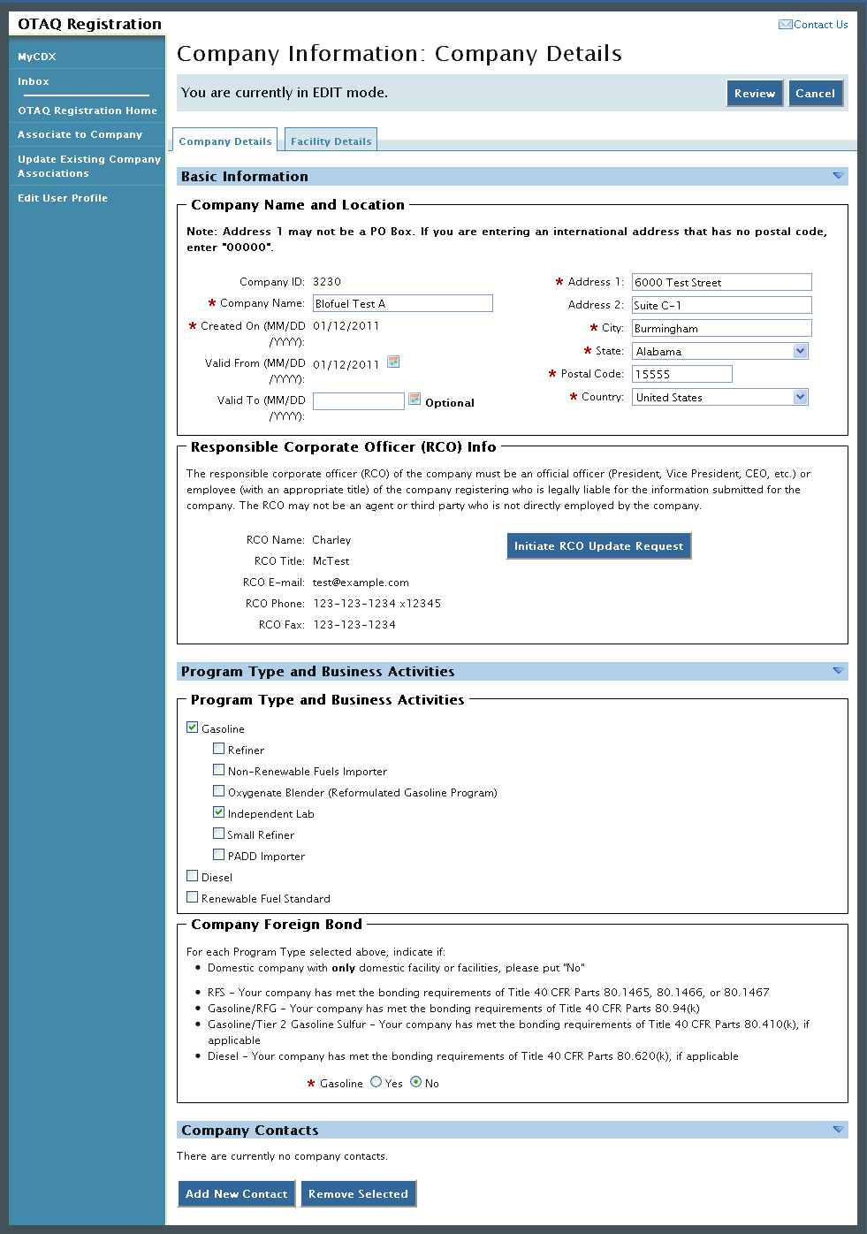
Figure 7-10 Company Information: Facility List
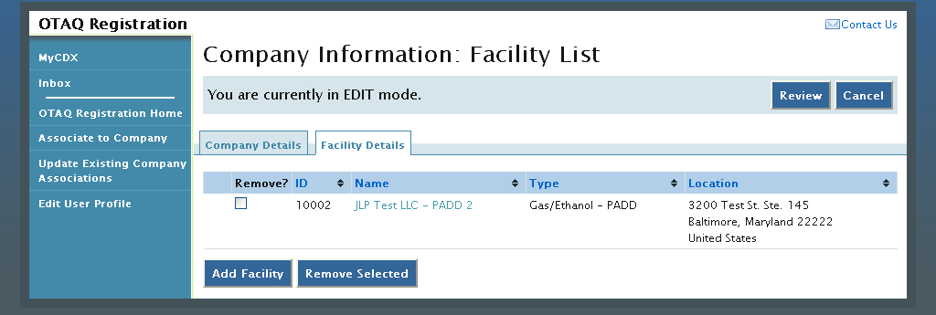
Click the facility name link. Figure 7-11 will display.
Figure 7-11 Company Information: Facility Type
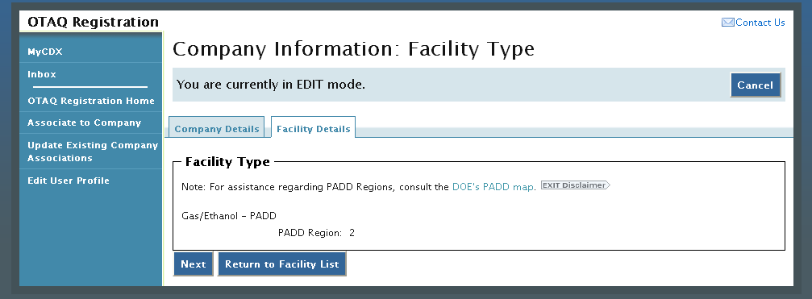
The Facility Type page displays the facility’s current facility type. This information is not editable for any existing facilities. Click the “Next” button. Figure 7-12 will display.
Figure 7-12 Company Information: Facility Activities
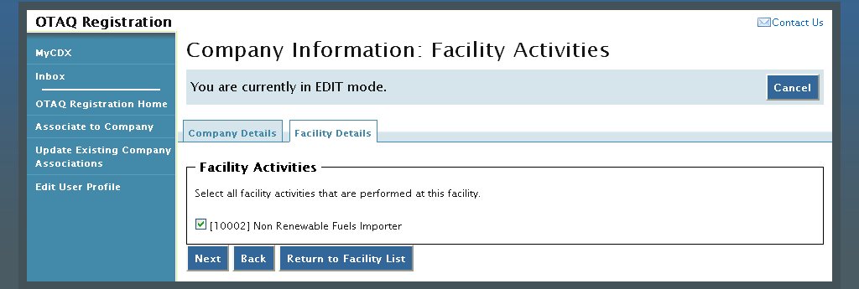
The Facility Activities page displays all possible facility activities. Select the appropriate facility activities and click the “Next” button. Figure 7-13 will display.
Figure 7-13 Company Information: Basic Facility Details
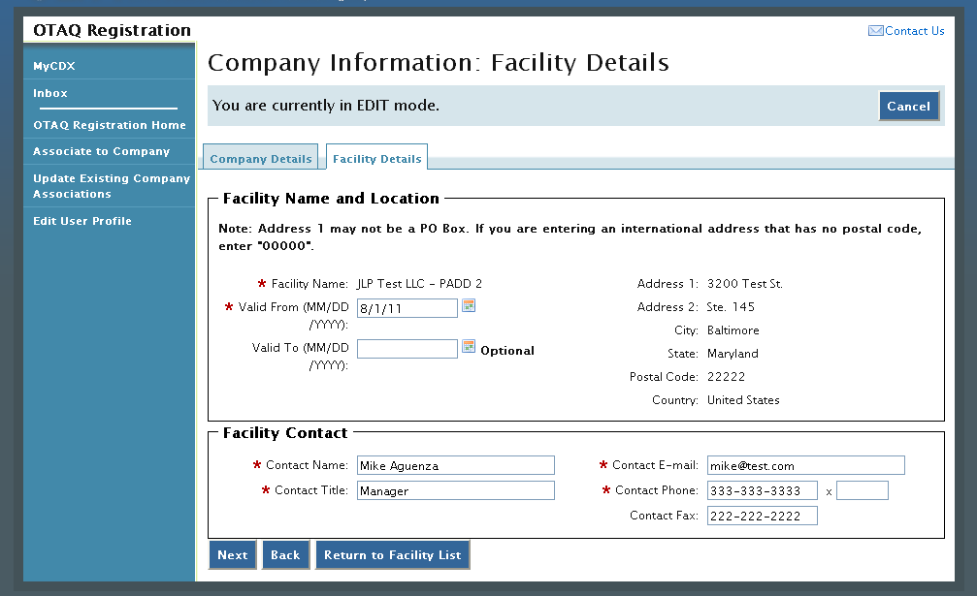
The Basic Facility Details page is pre-populated with the current facility detail information. Update the information by typing in the textboxes. When finished click the “Next” button. Figure 7-14 will display.
Figure 7-14 Company Information: Facility Details
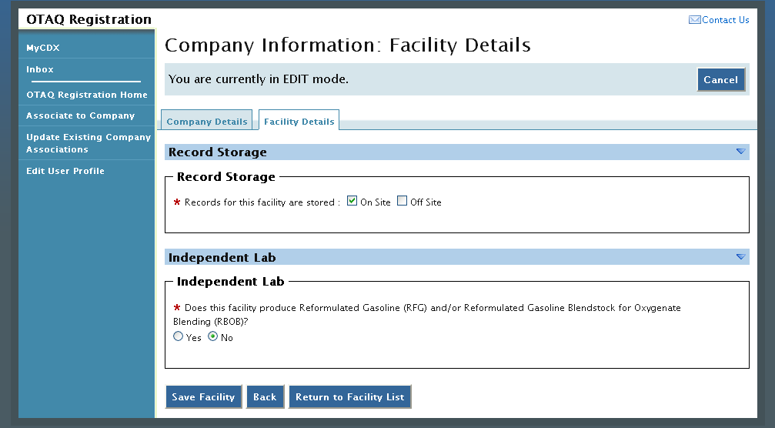
The Facility Details page is pre-populated with the current facility information. Make any required updates to the facility specific information and click the “Save Facility” button to apply the changes. Figure 7-15 will display.
Figure 7-15 Facility List: Updated Facility
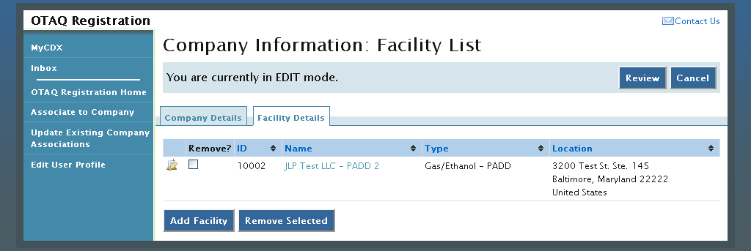
The facility will display with the updated icon. Click the “Review” button and follow the steps in Section 7.2 to complete your Company Update submission.

Remove Facility
To remove a Facility from a company, click the Facility Details tab, as seen in Figure 7-15, while in EDIT mode. Figure 7-16 will display.
Figure 7-16 Company Information: Facility List
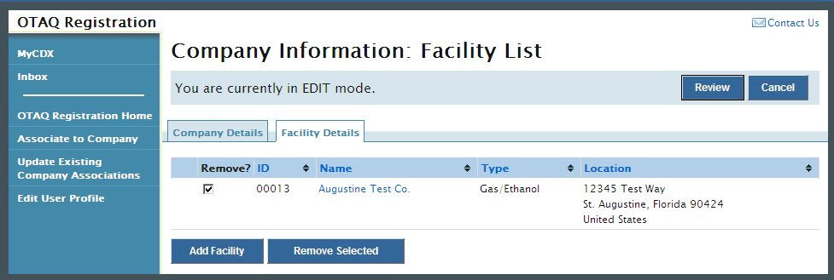
Select the checkbox for the corresponding facility and click the “Remove Selected” button. Figure 7-17 will display.
Figure 7-17 Remove Facility Confirmation
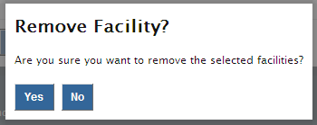
Click the “Yes” button to remove the facility. Figure 7-18 will display.
Figure 7-18 Facility List: Removed Facility
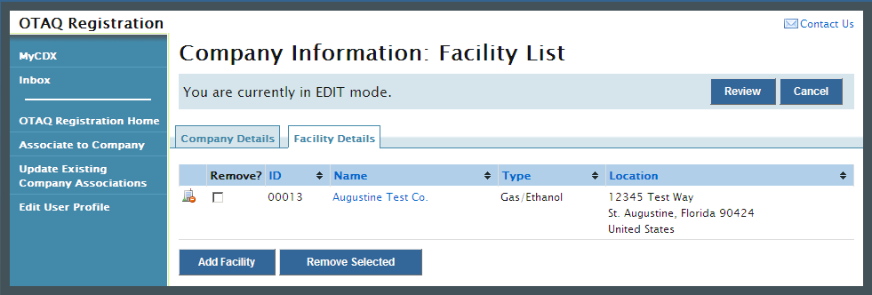
The facility will display with the removed icon. Click the “review” button and follow the steps in Section 7.2 to complete your Company Update submission.

Initiate RCO Update Request
To update the RCO information for your company, click the “Initiate RCO Update Request” button shown in while in EDIT mode, as shown in Figure 7-19. Figure 7-20 will display.
Note: Clicking the “Initiate RCO Update Request” button will initiate a RCO Update request which is processed separately from any company edits.
Figure 7-19 Initiate RCO Update Request
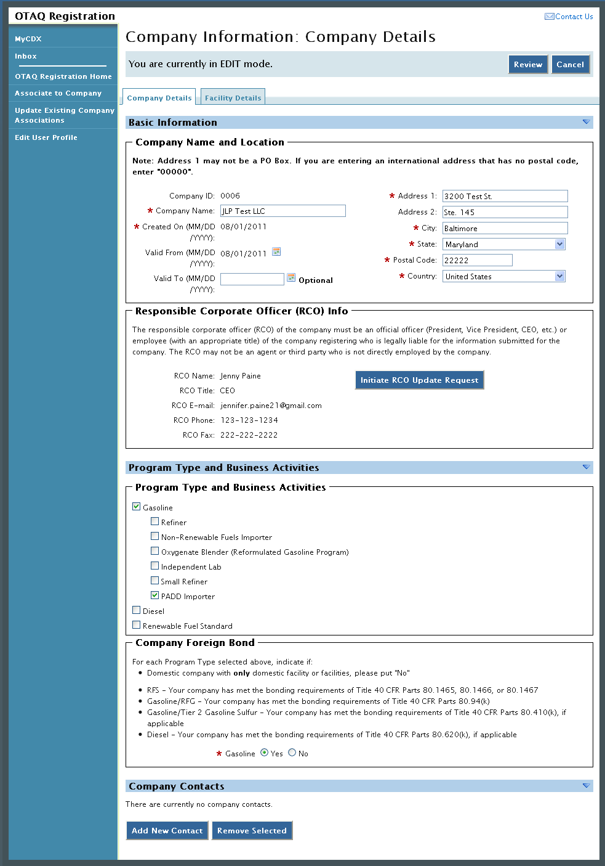
Figure 7-20 RCO Update
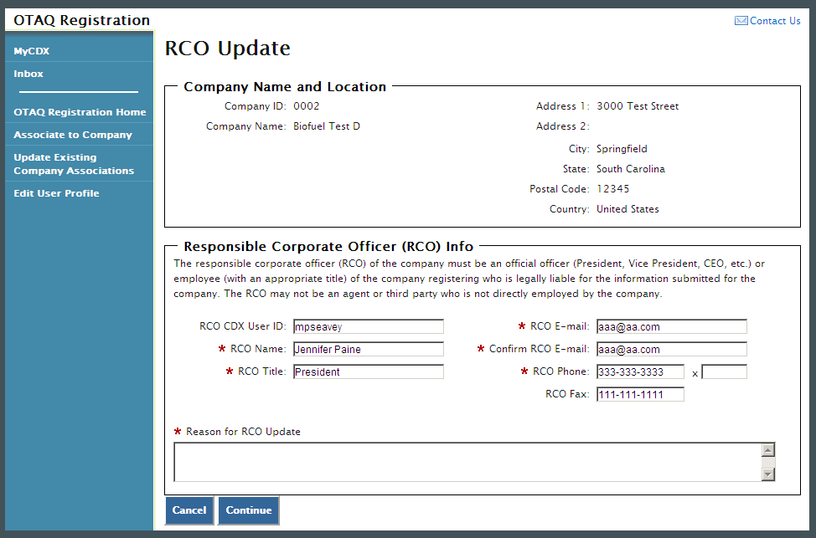
The RCO Update page is pre-populated with the current RCO information. Update the RCO information by typing in the displayed textboxes. Please note you must enter a reason for the RCO update. Once you have completed your RCO updates, click the “Continue” button. Figure 7-21 will display.
Figure 7-21 Further Action Required
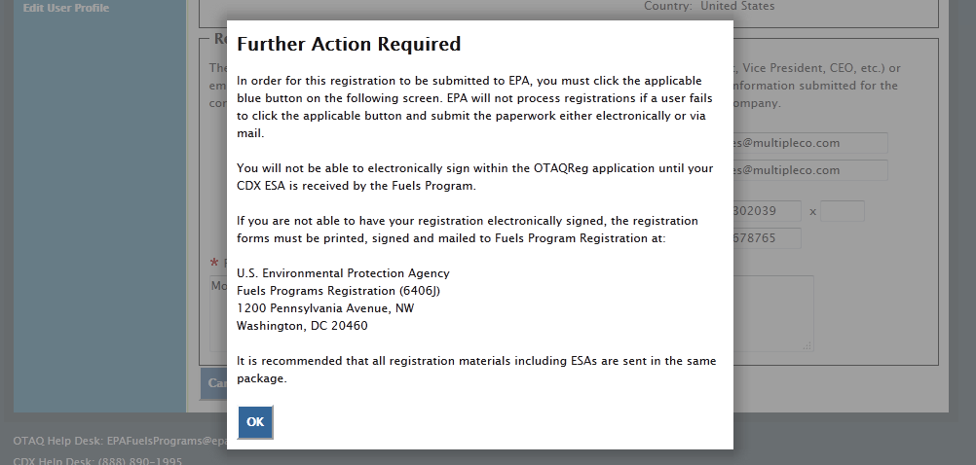
A popup window will display indicating that further action is required to complete this RCO update. Once you have reviewed the message, click the “OK” button. Figure 7-22 will display.
Figure 7-22 Submit Request
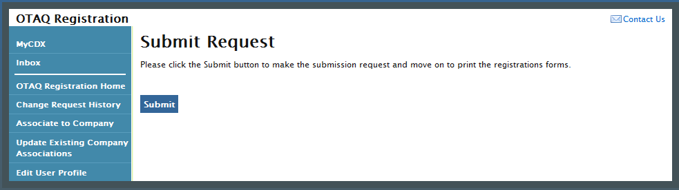
Click the “Submit” button. Figure 7-23 will display.

Figure 7-23 Further Action Required Page
Click the “Click here to save copies of your registration forms” link to save a hard copy of your registration forms in PDF form. It is required that you save a copy of your registration forms before submitting your request. If you attempt to select the “Home” button without first saving a copy of your registration forms, a notification window will appear prompting you to first save your forms.
An email will be sent to you, the current company RCO, and the new company RCO (if applicable) containing a hardcopy of the request and confirming your RCO update request. The request will also be listed in the pending requests section of your OTAQ Registration Home Page, as shown in Figure 7-24.
Note: All RCO Updates must be hand-signed by the existing company RCO and the new company RCO (if the RCO is changing) and mailed to the Fuels Program. The signature letter is included in the hard copy of the request. RCO Update requests cannot be electronically signed.

Pending RCO Update Request
Congratulations! You have successfully submitted your RCO Update Request in the OTAQReg application. As shown in Figure 7-24, your request will be displayed in your Pending Requests queue on your OTAQ Registration Home Page along with its current status.
Figure 7-24 Pending RCO Update
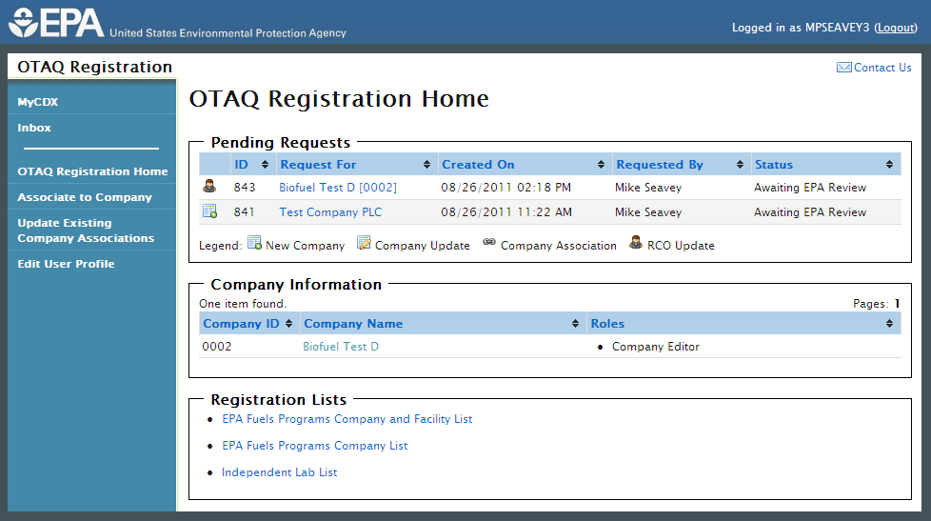
To view a pending RCO Update Request, click the Company Name link in the Pending Requests Queue for a request identified with the RCO update icon. Figure 7-25 will display.
Figure 7-25 RCO Update Request
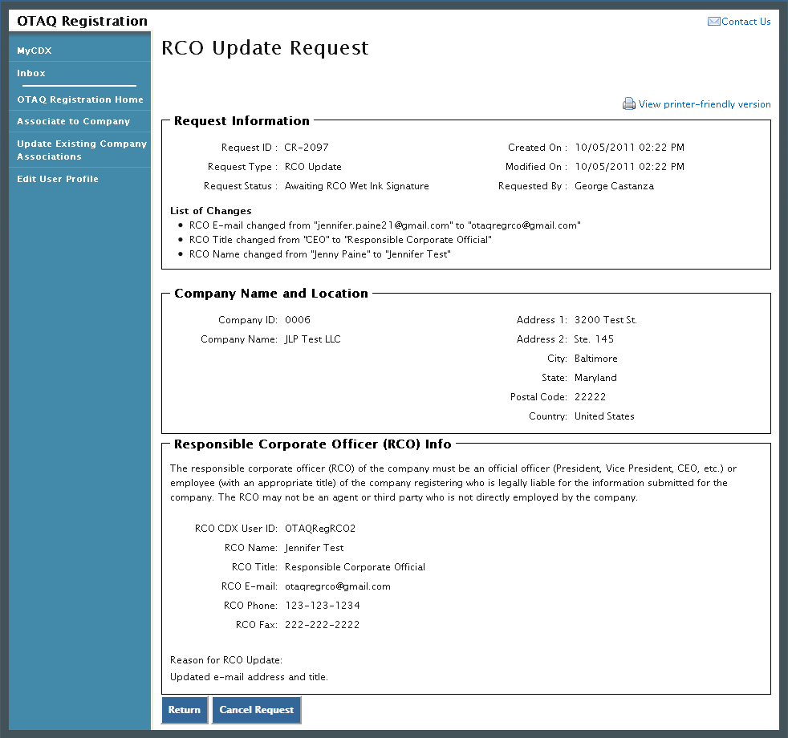
The RCO Update Request page displays the current RCO information as well as a list of changes made by the request. To return to the OTAQReg Home Page click the “Return” button.
To cancel the RCO Update Request, click the “Cancel Request” button. A notification window will appear, prompting you to select the “Yes” button to continue with the request cancellation or the “No” button to return to the previous page. The request will be canceled immediately and will no longer display in the Pending Requests queue.

Appendix A: OTAQ Registration Roles

OTAQ Registration Roles
- Limited Company Viewer: This role has limited read-only access to associated company and facility information. Users with this role will not be able to see RCO information. These users will also be limited to only basic facility information on the Facility Details page.
- Company Viewer: This role has full read-only access to associated company and facility information.
- Company Editor: This role has full viewing and editing rights to associated company and facility information.

OTAQ Program Roles:
- Cellulosic Biofuel Waiver Credits (Pay.gov) Submitter: Users should select this role if they are registering for the Cellulosic Biofuel Waiver Credits Pay.gov application to purchase cellulosic biofuel waiver credits on behalf of the company (This role should only be selected if the company registered as a gasoline or diesel refiner or a non-renewable fuels importer).
- DC Fuels Submitter, Third Party Engineering Review: This role applies only if users are registering for the DC Fuels data flow and Title 40 CFR Part 80 Subpart M Independent Third Party Engineering Review. This will be automatically selected when “Independent Third Party Engineer” is chosen.
- DC Fuels Submitter, Title 40 CFR Part 79 Subparts A,B,C,D, and F: Users should select this role if they are registering for the DC Fuels data flow and Title 40 CFR Part 79 Regulation of Fuels and Fuel Additives.
- DC Fuels Submitter, Title 40 CFR Part 80 Subparts D, E, F, H, J, and L: Users should select this role if they are registering for the DC Fuels data flow and Title 40 CFR Part 80 Reformulated Gasoline / Anti-Dumping / Gasoline Toxics / Gasoline Sulfur / Gasoline Benzene.
- DC Fuels Submitter, Title 40 CFR Part 80 Subpart I: Users should select this role if they are registering for the DC Fuels data flow and Title 40 CFR Part 80 Motor Vehicle, Nonroad, Locomotive, and Marine Diesel Fuel.
- DC Fuels Submitter, Title 40 CFR Part 80 Subparts K and M: Users should select this role if they are registering for the DC Fuels data flow and Title 40 CFR Part 80 Renewable Fuel Standard.
- EMTS Viewer: User should select this role if they are requesting view-only access to the EMTS data flow.
- EMTS Submitter: Users should select this role if they are requesting both editing and submitting rights to EMTS.
- Agent: Users should select this role if they are an agent for a company (The definition of an agent is a person who is not a direct employee of the company).
- Independent Third Party Engineer: Users should select this role if they are an independent third party engineer. Selecting this role will automatically de-select all other OTAQReg Program roles, and add the DC Fuel Submitter, Third Party Engineering Review and OTAQ Registration Company Viewer roles. All other roles will be disabled.

Appendix B: Using the e-Signature Widget
Users should refer to the steps outlined in this section to successfully sign their Electronic Signature Agreement. For information regarding signing change requests in the OTAQReg application, please see the Responsible Corporate Officer (RCO) User Guide.
Figure 9-1 will display.
Figure 9-1 Authentication
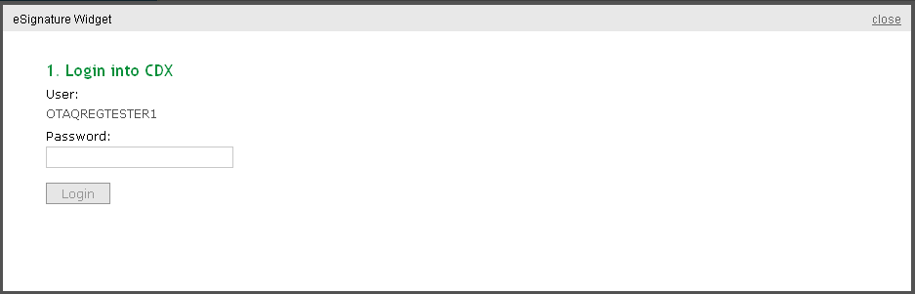
This page requires you to verify your CDX identity. The page displays your CDX User ID and a field to provide your CDX password. If you enter an incorrect password, you will be prompted with an error message. After three failed attempts, your CDX account will be locked. To unlock your account, contact the CDX Help Desk at 888-890-1995 or helpdesk@epacdx.net.
Enter your CDX user account password and click the “Login” button. Figure 9-2 will display.
Figure 9-2 Answer Secret Question
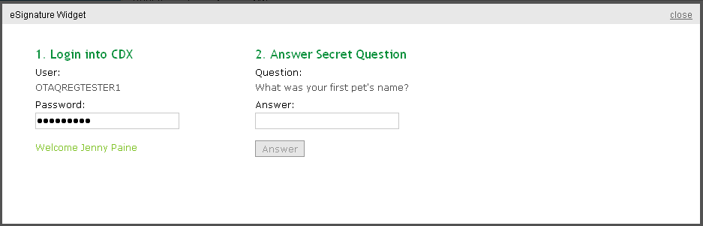
The next step is to provide the answer to your secret question. The page will display one of the five secret questions you chose during your e-Signature PIN verification.
If you fail to respond or enter an incorrect answer, you will be prompted with an error message. Please note that the secret question will not change should you answer incorrectly. After three failed attempts, your CDX account will be locked. To unlock your account, contact the CDX Help Desk at 888-890-1995 or heldesk@cdx.net.
Enter the answer you provided during your e-Signature PIN verification and click the “Answer” button. Figure 9-3 will display.
Figure 9-3 Sign File
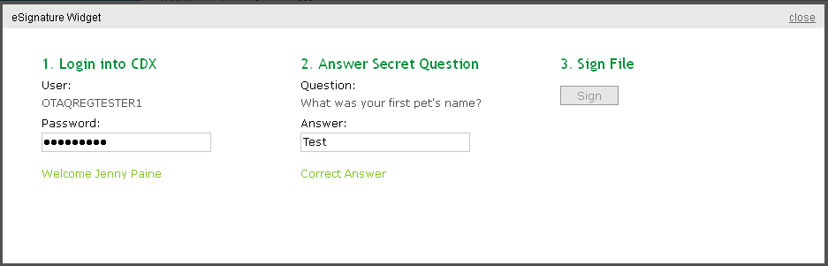
Click the “Sign” button.
Congratulations! You have successfully electronically signed and submitted your Electronic Signature Agreement.

Appendix C: OTAQ Registration Lists
Users can view and download the OTAQ Registration Lists by clicking any of the hyperlinks provided in the Registration Lists section of their OTAQ Registration Home Page as shown in Figure 10-1. This list is updated daily.
Figure 10-1 Registration Lists
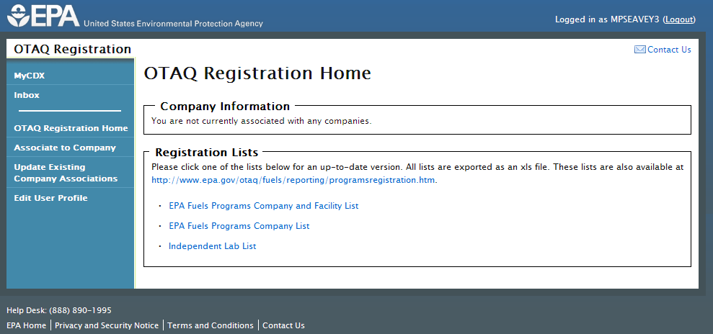

Appendix D: Support Information
For frequently asked questions about the content, formats, or policies for the Office of Transportation and Air Quality (OTAQ) please reference the Fuels Program website at http://www.epa.gov/otaq/fuels/index.htm.
For any general or technical questions related to the Central Data Exchange you may contact any of the following:
- Telephone - Person-to-person telephone support is available from the CDX Help Desk 8:00 am to 6:00 pm EST. Call our toll-free line at 888-890-1995.
- Email - Send e-mail to Technical Support at helpdesk@epacdx.net with “Technical Support” in the Subject line.
If you have any questions relating to fuels programs registration, reporting, or OTAQReg, please contact the EPA Fuels Programs and EMTS Support Line at support@epamts-support.com.

