**OMB Request for Approval of USAJOBS field Addition (as of 3/4/13)**

**Requirement for Profile Change:**

1. USAJOBS Profile, Personal Information page: Label Change – Change “Email Address” label to “Primary Email ”
2. USAJOBS Profile, Personal Information page: add a second Email Address field called “Secondary Email”.

* This field will be optional.
* Will appear under the existing red note.
* Edit – Secondary email can’t be the same as Primary Email
* Add the Secondary Email field to Web Admin and make it searchable for the help

1. Add new help text: Under the new Secondary Email Address field add a sentence “What is my Secondary Email Address used for?” “Secondary Email Address” will be a link to help text.

* The help text will read, “The Secondary Email Address field will help you with the password reset process. This email address can be used for login, however, it will not be sent to agencies as part of your application, and will not be used for USAJOBS system notifications such as application status and saved search.”

**Business Reason:**

This would accommodate an immediate POA&M item that would also help us reduce password management burden on our users.

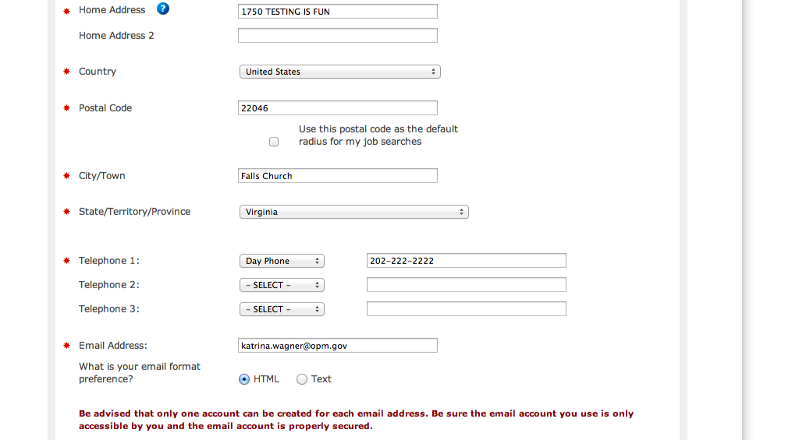

Add “Secondary Email” field as optional and add help text

Change field label from “Email Address” to “Primary Email Address”