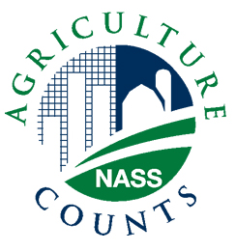
NEWS RELEASE
United States Department of Agriculture
NATIONAL AGRICULTURAL STATISTICS SERVICE
[STATE NAME] FIELD OFFICE
[ADDRESS]

FOR IMMEDIATE RELEASE | Contact: [Firstname] [Lastname]
[Month ##], YEAR | (XXX) XXX-XXXX

USDA TO SURVEY SHEEP AND GOAT PRODUCERS

[City, State] – This July, the U.S. Department of Agriculture’s National Agricultural Statistics Service (NASS) will reach out to producers in 42 states for the biannual Sheep and Goat Survey. The survey provides critical information on breeding and marketing herds, as well as lamb and kid crops in the United States.
“NASS will contact [###] sheep and goat producers in [State] during the first two weeks of July to obtain animal inventory and lamb and kid crop information,” said [FirstName LastName], director of the NASS [State] Field Office. “Results of this survey will provide the latest information on conditions and trends in the U.S. sheep and goat industry for 2010.”
Producers selected to participate in the July survey will be asked to provide information on inventory of breeding and market sheep and goats, as well as lambs and kids born. For convenience, producers have the option of responding to the survey by [telephone, mail, during a personal interview, or online].
“The results of the Sheep and Goat Survey are primarily used by producers themselves to help determine their production and marketing strategies,” added [LastName]. “This information also increases consumer understanding and awareness of the benefits of U.S. sheep and goats and their products.”
[LastName] noted that, as is the case with all NASS surveys, information provided by respondents is confidential by law. NASS safeguards the privacy of all survey responses ensuring that no individual operation or producer can be identified.
Results will be published in the Sheep and Goats report, scheduled for release on July 23. The report will provide current national-level estimates on the sheep and goat industry. This and all NASS reports are available online at: www.nass.usda.gov.

###

