**APPENDIX D5  
INVITATION LETTER TO SFA DIRECTORS,**

**FREQUENTLY ASKED QUESTIONS (FAQs), AND**

**WEB SURVEY INFORMATION SHEET**

# APPENDIX D5. INVITATION LETTER TO SCHOOL FOOD SERVICE DIRECTORS

OMB Number: 0584-0562

Expiration Date: XX/XX/XXXX

XX/XX/2013

SUBJECT: Participation in the Special Nutrition Program Operations Study (SN-OPS), 2013

TO: School Food Authority (SFA) Directors

The Food and Nutrition Services (FNS) of the U.S. Department of Agriculture (USDA), is requesting your participation in the Special Nutrition Program Operations Study (SN-OPS). The information for this study is being collected by Westat, a research firm in Rockville, Maryland for FNS, U.S. Department of Agriculture. The SN-OPS is being conducted to understand and address the current policy issues related to Special Nutrition Program (SNP) operations.

The goal of this study is to improve the implementation of the Child Nutrition Program by examining:

* Data on the Child Nutrition (CN) program characteristics to help FNS respond to questions about the SNPs in schools;
* Data related to program administration for designing and revising program regulations, managing resources, and reporting requirements; and
* Data related to program operations to help FNS develop and provide training and technical assistance for SFAs and State Agencies responsible for administering the CN program.

The topics included on the survey are school and student participation rates, food service operations, local school wellness policy, new meal pattern requirements, meal prices, revenues, expenditures, Farm to School activities, training and technical assistance, and SFA foodservice staff background.

The survey is designed to be completed in about 1 hour and 45 minutes by the SFA Director. This is a web survey and you can complete the online version of the survey available through the Internet. You also have the option of completing the survey and mailing it to Westat. The online version of the survey is available at [http://**www.sfanutritionsurvey.org**](http://www.sfanutritionsurvey.org). Your username and password appear on the enclosed Web Survey Information Sheet. If you complete the paper version of the questionnaire, please return it to Westat in the enclosed postage-paid envelope. **Please complete the survey only once, using either the paper or the online version.**

We ask that the survey be completed **within 3 weeks** and that you keep a copy of the completed survey for your files. If you have any questions about this survey, please contact the Westat survey helpline at

1-888-202-1565 (toll-free) or by email: [SNPOS@westat.com](mailto:SNPOS@westat.com). You may also call John Endahl, the FNS Project Officer, at 703-305-2127.

Thank you for your assistance.

Signature (FNS PD)

Enclosed: SN-OPS Survey and Frequently Asked Questions

According to the Paperwork Reduction Act of 1995, no persons are required to respond to a collection of information unless it displays a valid OMB number. The valid OMB control number for this information collection is 0584-0562. The time required to complete this information collection is estimated to average 3 minutes per response, including the time for reviewing instructions, searching existing data sources, gathering and maintaining the data needed, and completing and reviewing the collection of information.

**Special Nutrition Program Operations Study (SN-OPS)**

**Frequently Asked Questions**

|  |  |
| --- | --- |
| Q | Why is FNS conducting the survey? |
| A | This survey is being conducted to provide nationally representative information about Child Nutrition programs and programs available in public school districts. The goal of the SN-OPS is to understand the policy and operational issues surrounding the Child Nutrition Programs. Specifically, survey topics include the preparation of program budget, development and implementation of program policy and regulations, and identification of areas for provision of technical assistance and training. |
| Q | Who is invited to participate in SN-OPS? |
| A | This is a survey of 56 State Child Nutrition Program Directors and 1875 School Food Authority Directors. We are also visiting 125 SFAs and up to 375 schools. |
| Q | Why is participation by your School Food Authority (SFA) important? |
| A | Your SFA’s participation, while voluntary, is important because it is vital to the development of national estimates. We need your input because your SFA is one of a small sample of SFAs selected for the study. Your cooperation is critical to make the results of this survey comprehensive, accurate, and timely. |
| Q | How long is the data collection period? |
| A | Because of the time sensitive nature of data that are being collected, we expect to receive all completed surveys within 6 weeks of initial mailing. |
| Q | Can I complete the survey on-line? |
| A | Yes, you can visit http://**www.sfanutritionsurvey.org** website to access the survey. Use your Study ID to access and complete your survey. While you can complete your survey over multiple sittings, the survey can be completed in about 1 hour and 45 minutes and we urge you to complete it in one sitting or to take fewer breaks and save your responses if you have to stop along the way. |
| Q | How does FNS protect the confidentiality of the information that you provide? |
| A | Your answers may be used only for statistical purposes and may not be disclosed, or used, in identifiable form for any other purpose unless otherwise compelled by law. The federal Office of Management and Budget (OMB) has approved the survey (OMB No. OMB Number: 0584-0562. Expiration Date: X/XX/XXXX). |
| Q | Who should I contact if I have questions about the study or the survey? |
| A | If you have any questions about this survey, please contact the Westat survey helpline at  1-888-202-1565 (toll-free) or by email: [SNPOS@westat.com](mailto:SNPOS@westat.com). You may also call John Endahl, the FNS Project Officer, at 703-305-2127. |

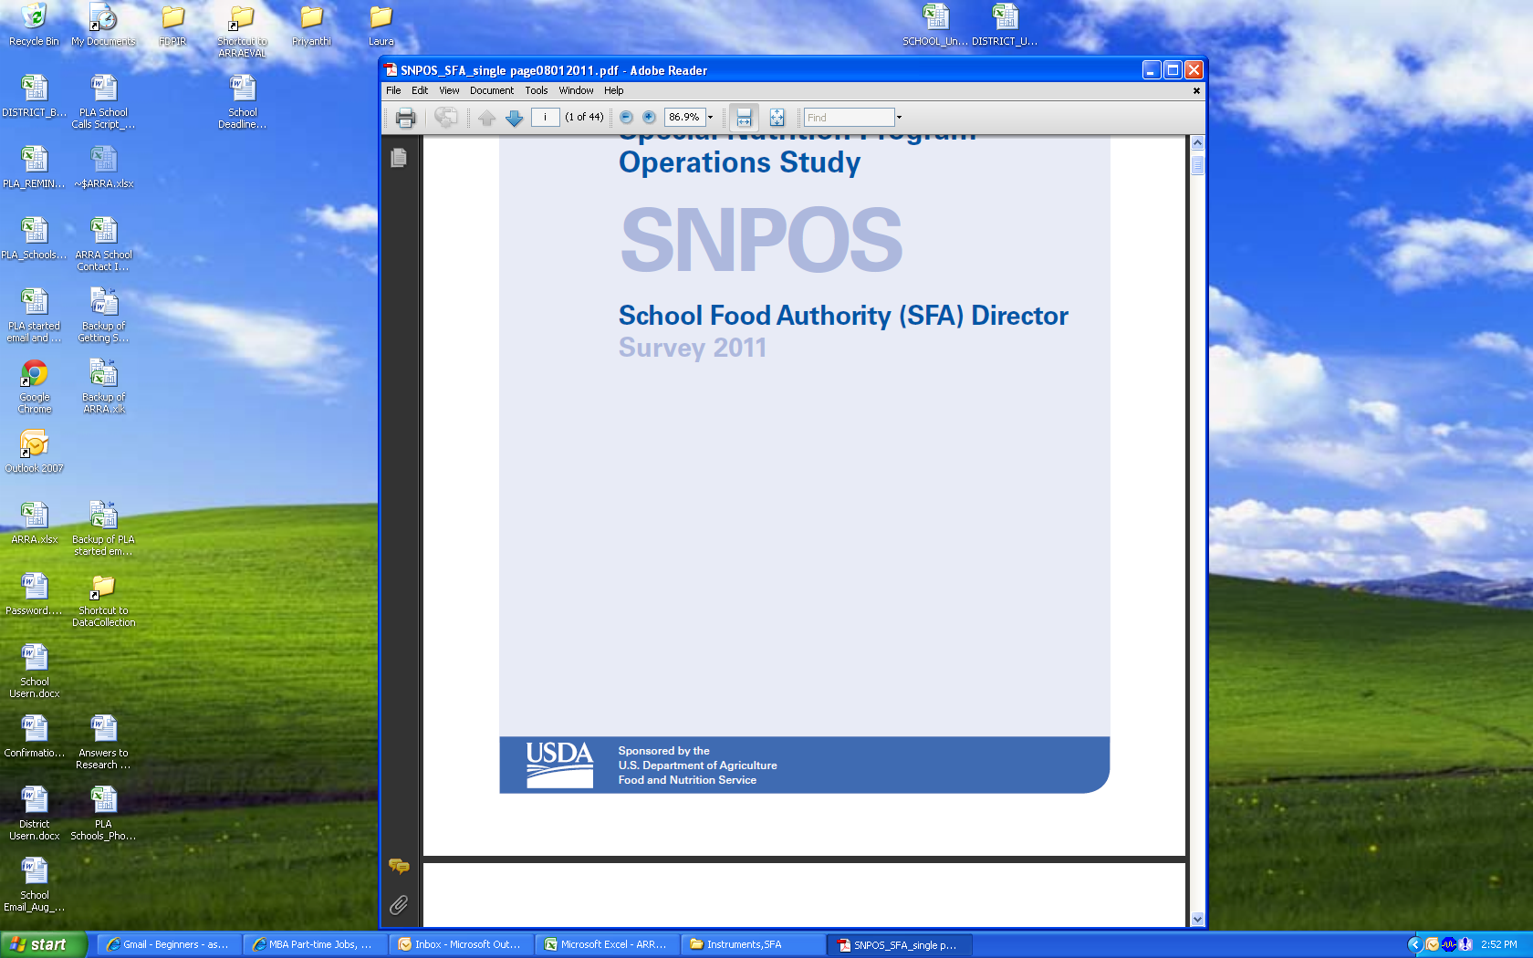**Web Survey Information Sheet**

**Getting Started with Your SFA Director Survey**

Step 1: Go to the web browser on any computer with Internet access and enter the web site address below in the address bar to access the evaluation’s data collection site. Do not enter the address into a search engine.

Survey address: https://[www.SFANutritionSurvey.org](http://www.SFANutritionSurvey.org)

User Login: Username

Password: Password

Step 2: Click on the survey link to reach the login page.

Step 3: Look at the letter you received with this instruction sheet to find your confidential user login and password. Enter this information into the corresponding boxes and click the login button to access your account, where you will see the Introduction page of your district survey. **All staff responding to the survey will need to use the same user login and password.**

Step 4: **The first time** you log into the survey you will be directed to the Menu page, which lists each survey section.

Step 5: Prior to responding to the web survey, we recommend that you review the posted PDF copy of the survey to get a general sense of the survey content and to help identify which individuals are in the best position to complete survey sections. You can access the PDF copy of the survey by clicking the link labeled “PDF Version of the Survey” in the survey header (which appears on every page after you log in).

We also recommend that you review the frequently asked questions document before responding to the survey, which includes tips for navigating through the web survey. You can access this document by clicking the link labeled “Frequently Asked Questions” in the survey header.

Step 6: Once you have completed all sections of the SFA Director Survey, click on the "Submit Survey" button (on the Menu page).

If you ever lose your user login and/or password information, please contact the study team at [SNPOS@Westat.com](mailto:SNPOS@Westat.com) call toll-free (888) 202-1565 and provide your district’s name, city, and state, and we will provide the information for you again.