OMB #: 0596-NEW
Expiration Date: XX/XX/201X

Brainard Lake Recreation Area
Visitor Survey
2014

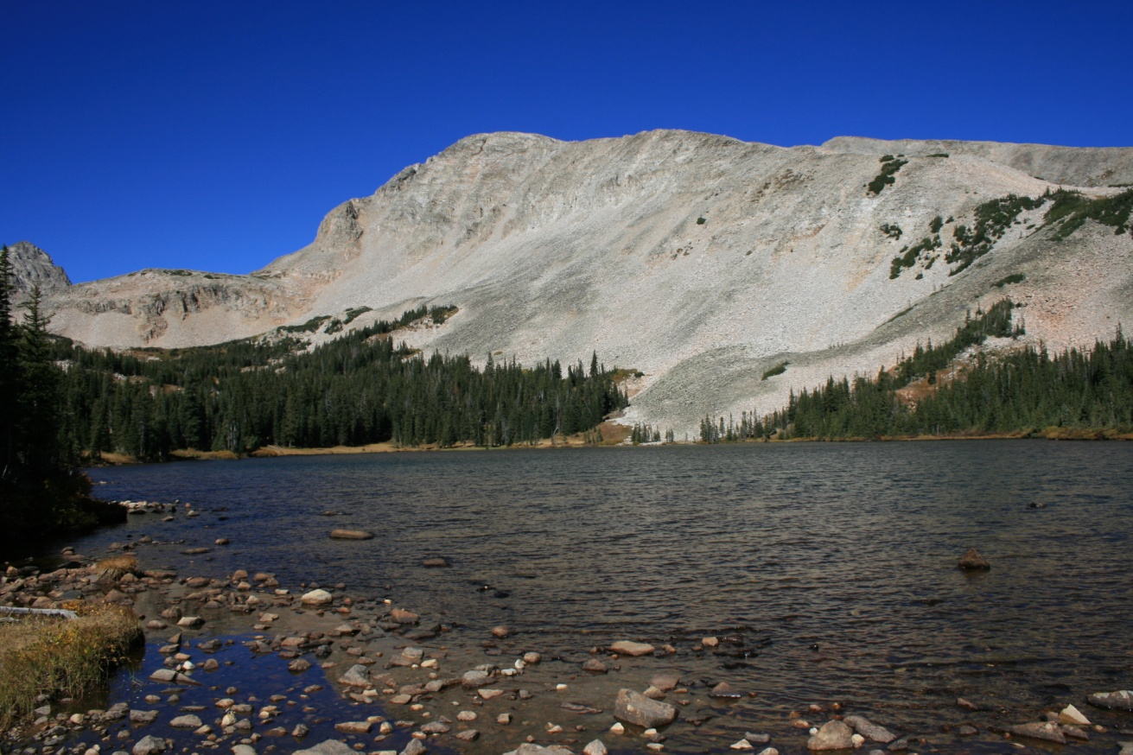

ID: ________ Date: ______________

Time:___________AM/PM Binder # ____________

Location: Day Use / Trailhead/ Portal / Roadside

Weather: Sunny / Partly / Overcast / Raining

Special Event: No/Yes________________________________________

PRIVACY ACT STATEMENT
16 U.S.C. 1a-7 authorizes collection of this information. This information will be used by USDA Forest Service managers to better serve the public. Response to this request is voluntary. No action may be taken against you for refusing to supply the information requested. Thus the permanent data will be anonymous. Data collected through visitor surveys may be disclosed to the Department of Justice when relevant to litigation or anticipated litigation, or to appropriate Federal, State, local or foreign agencies responsible for investigating or prosecuting a violation of law.

Burden Statement

According to the Paperwork Reduction Act of 1995, an agency may not conduct or sponsor, and a person is not required to respond to a collection of information unless it displays a valid OMB control number. The valid OMB control number for this information collection is 0596-NEW. The time required to complete this information collection is estimated to average 10 minutes per response, including the time for reviewing instructions, searching existing data sources, gathering and maintaining the data needed, and completing and reviewing the collection of information.

The U.S. Department of Agriculture (USDA) prohibits discrimination in all its programs and activities on the basis of race, color, national origin, gender, religion, age, disability, political beliefs, sexual orientation, and marital or family status. (Not all prohibited bases apply to all programs.) Persons with disabilities who require alternative means for communication of program information (Braille, large print, audiotape, etc.) should contact USDA’s TARGET Center at 202-720-2600 (voice and TDD).

To file a complaint of discrimination, write USDA, Director, Office of Civil Rights, 1400 Independence Avenue, SW, Washington, DC 20250-9410 or call (800) 795-3272 (voice) or (202) 720-6382 (TDD). USDA is an equal opportunity provider and employer.

A. Trip Description

The questions in this section ask about your current trip to Brainard Lake Recreation Area (BLRA).
Please ask the surveyor to show you a map of the area, if you need it to help answer the questions.

Topic Area 1-Visitor and Trip Characteristics
Pre-tested and administered in previous OMB-approved study (OMB Control Number 1024-0224)
1. Including yourself, how many people are in your personal group on this trip to Brainard Lake Recreation Area (BLRA)? (Enter number of people.)

Number of people:____________

Topic Area 1-Visitor and Trip Characteristics
Pre-tested and administered in previous OMB-approved study (OMB Control Number 1024-0224)
2. Are there any children under the age of 16 in your personal group on this trip to BLRA? (Check one box.)

❑ Yes (Number of children):__________
❑ No

Topic Area 1-Visitor and Trip Characteristics
Pre-tested and administered in previous OMB-approved study (OMB Control Number 1024-0224)
3. At approximately what time did you arrive at BLRA today? (Enter time or check
box.)

Approximate arrival time today:_____________AM/PM (CIRCLE ONE)

OR

❑ I arrived on a different day (Please specify date of arrival):___________________

Topic Area 1-Visitor and Trip Characteristics
Pre-tested and administered in previous OMB-approved study (OMB Control Number 1024-0224)
4. Which of the following locations in BLRA have you visited on this trip? (Check one box for each location.)

 | Visited on this Trip | Did not Visit on this Trip | Don’t Know/ Not Sure
A. Brainard Lake | ❑ | ❑ | ❑
B. Red Rock Lake | ❑ | ❑ | ❑
C. Indian Peaks Wilderness | ❑ | ❑ | ❑
D. Pawnee Campground | ❑ | ❑ | ❑
E. Left Hand Park Reservoir | ❑ | ❑ | ❑
F. Other (Please specify):________________________ | ❑ | ❑ | ❑
Topic Area 1-Visitor and Trip Characteristics
Pre-tested and administered in previous OMB-approved study (OMB Control Number 1024-0224)
5. Which of the locations listed in Question 4 is your primary destination on this trip to BLRA? (Enter letter of primary destination or check the box.)

Letter of primary destination:_______

OR

❑ I did not have a primary destination on this trip to BLRA.

Topic Area 1-Visitor and Trip Characteristics
Pre-tested and administered in previous OMB-approved study (OMB Control Number 1024-0224)
6. Which of the following activities did you do during this trip to BLRA? (Check one box for each item.)

 | Did on  this Trip | Did Not do on this Trip
A. Walking/Short hike (less than 1 hour) | ❑ | ❑
B. Day hiking (more than 1 hour) | ❑ | ❑
C. Backpacking (# of nights): ______ | ❑ | ❑
D. Camping in Pawnee Campground (# of nights):______ | ❑ | ❑
E. Picnicking | ❑ | ❑
F. Swimming | ❑ | ❑
G. Boating | ❑ | ❑
H. Fishing | ❑ | ❑
I. Mountain biking | ❑ | ❑
J. Creative arts (photography/drawing/ painting/writing) | ❑ | ❑
K. Other (Please specify):__________________________ | ❑ | ❑

Topic Area 1-Visitor and Trip Characteristics
Pre-tested and administered in previous OMB-approved study (OMB Control Number 1024-0224)
7. Which of the activities listed in Question 6 is your primary activity on this trip to BLRA? (Enter letter of primary activity or check the box.)

Letter of primary activity: _______

OR

❑ I do not have a primary activity on this trip to BLRA.

B. Travel and Parking

The next set of questions asks about your travel to and parking at BLRA on this trip.

Topic Area 1-Visitor and Trip Characteristics
Pre-tested and administered in previous OMB-approved study (OMB Control Number 1024-0145)
8. Which route did you use to travel to BLRA on this trip? (Refer to the surveyor’s route map and check all that apply.)

❑ Highway 119 from the East (Boulder) to Highway 72 (#1 on route map)
❑ Highway 119 from the South (I-70 Corridor) to Highway 72 (#2 on route map)
❑ Highway 7 from the North (Estes Park) to Highway 72 (#3 on route map)
❑ Left Hand Canyon Drive (thru Ward) to Highway 72 (#4 on route map)
❑ Other (Please specify):_________________________________________

Topic Area 1-Visitor and Trip Characteristics
Pre-tested and administered in previous OMB-approved study (OMB Control Number 1024-0224)
9. In how many vehicles did you and your personal group travel to BLRA on this trip? (Enter number of vehicles.)

Number of vehicles:____________

OR

❑ I/my personal group bicycled to BLRA on this trip (SKIP TO QUESTION 19)

Topic Area 2-Perceptions and Evaluations of Transportation-related Conditions
New question; pre-tested in this project with volunteer participants
10. Do you agree or disagree with each of the following statements about where you parked at BLRA? (Check one box for each item.)

Where I parked is… | Strongly Disagree | Disagree | Neither Agree nor Disagree | Agree | Strongly Agree
Safe | ❑ | ❑ | ❑ | ❑ | ❑
Convenient | ❑ | ❑ | ❑ | ❑ | ❑
Easy to find | ❑ | ❑ | ❑ | ❑ | ❑
Close to my destination(s) | ❑ | ❑ | ❑ | ❑ | ❑
Well marked (e.g., paint striping) | ❑ | ❑ | ❑ | ❑ | ❑
My preferred parking location | ❑ | ❑ | ❑ | ❑ | ❑
In a congested parking area | ❑ | ❑ | ❑ | ❑ | ❑

Topic Area 1-Visitor and Trip Characteristics
New question, site-specific; pre-tested in this project with volunteer participants
11. Did you park in the parking lot near the entrance station today? (Refer to the surveyor’s parking map and check one box.)

❑ Yes (CONTINUE TO QUESTION 12)
❑ No (SKIP TO QUESTION 14)

Topic Area 5-Transportation-related Preferences
New question, site-specific; pre-tested in this project with volunteer participants
12. What reasons best explain why you parked in the lot near the entrance station? (Check all that apply.)

I parked in the lot near the entrance station because…

❑ | I knew I wouldn’t have to pay the fee to visit BLRA if I parked here.
❑ | I tried parking closer to my destination, but couldn’t find a parking place.
❑ | I assumed parking lots closer to my destination would be full.
❑ | This parking lot is the closest parking to my destination.
❑ | I wanted to hike or bike from this parking lot to my destination.
❑ | Hiking or biking on trails from this parking lot was my primary reason for visiting BLRA.
❑ | Other (please specify):___________________________________________

Topic Area 4-Attitudes and Opinions about Services, Facilities, and Management
New question, site-specific; pre-tested in this project with volunteer participants
13. Do you agree or disagree with each of the following statements about parking in the lot near the entrance station? (Check one box for each item.)

 | Strongly Disagree | Disagree | Neither Agree nor Disagree | Agree | Strongly Agree
It’s worth it to park here to avoid paying the entrance fee. | ❑ | ❑ | ❑ | ❑ | ❑
It would be better if I could ride a shuttle from here to my destination(s) in BLRA. | ❑ | ❑ | ❑ | ❑ | ❑
It would be better if there was a trail directly to my destination(s) in BLRA. | ❑ | ❑ | ❑ | ❑ | ❑
It’s better to park here than to deal with parking congestion in BLRA. | ❑ | ❑ | ❑ | ❑ | ❑
I would not have come today, if I knew I would park this far from my destination(s) in BLRA. | ❑ | ❑ | ❑ | ❑ | ❑

IF YOU PARKED IN THE LOT NEAR THE ENTRANCE STATION, SKIP TO QUESTION 17

Topic Area 1-Visitor and Trip Characteristics
New question, site-specific; pre-tested in this project with volunteer participants
14. If you didn’t park in the lot near the entrance station, where did you park today? (Refer to the surveyor’s parking map and check one box.)

❑ Day Use Parking Lot next to Brainard Lake
❑ Campsite in Pawnee Campground
❑ Mitchell Lake or Long Lake Trailhead Parking Lot
❑ Along the roadside
❑ Other (Please specify):__________________________________________

Topic Area 5-Transportation-related Preferences
New question, site-specific; pre-tested in this project with volunteer participants
15. Did you know that if you park in the lot near the entrance station you don’t have to pay the fee to visit BLRA? (Check one box.)

❑ Yes
❑ No, but I would not have parked there anyway
❑ No, and I would have parked there if I knew

Topic Area 5-Transportation-related Preferences
New question, site-specific; pre-tested in this project with volunteer participants
16. For each of the following scenarios, would you have preferred to park in the lot near the entrance station instead of where you parked today? (Check one box for each item.)

Plenty of parking in the lot near the entrance station and… | Prefer this Option to  Where You Parked Today?
 | Yes | No | Not Sure
…I could ride a shuttle bus from there to my destination(s). | ❑ | ❑ | ❑
…there was a direct hiking trail from there to my destination(s). | ❑ | ❑ | ❑
…I knew in advance how much parking congestion there would be where I parked today. | ❑ | ❑ | ❑

Topic Area 5-Transportation-related Preferences
Pre-tested and administered in previous OMB-approved study (OMB Control Number 1024-0145)
17. Imagine that when you arrived at the entrance station, a road sign notified you that
parking lots in BLRA were full, but you could park at the lot near the entrance station and
ride a shuttle bus into BLRA. What would you do? (Check one box.)

❑ Drive into BLRA and look for parking anyway
❑ Park in the lot near the entrance station and ride the shuttle bus into BLRA
❑ Leave and come back later in the day when you could find parking in BLRA
❑ Go to a different recreation area instead (Please specify):______________________
❑ Other (Please specify):___________________________________________

Topic Area 5-Transportation-related Preferences
Pre-tested and administered in previous OMB-approved study (OMB Control Number 1024-0145)
18. Imagine that when you were about 1/2 hour away from here, a road sign notified you that
all parking lots for BLRA were full, but you could park outside BLRA and ride a shuttle bus here.
What would you do? (Check one box.)

❑ Drive to BLRA and look for parking anyway
❑ Park there and take the 30 minute shuttle bus ride into BLRA
❑ Go somewhere else until later in the day when you could find parking in BLRA
❑ Go to a different recreation area instead (Please specify):______________________
❑ Other (Please specify):___________________________________________
Topic Area 2-Perceptions and Evaluations of Transportation-related Conditions
Pre-tested and administered in previous OMB-approved study (OMB Control Number 1024-0224)
19. How much parking congestion do you think there is at BLRA today? (Circle one number.)

No Parking Congestion at all |  | Slight Parking Congestion |  | Moderate  Parking  Congestion |  |  |  |  | Extreme Parking Congestion
 | 1 | 2 | 3 | 4 | 5 | 6 | 7 | 8 | 9

Topic Area 4-Attitudes and Opinions about Services, Facilities, and Management
Pre-tested and administered in previous OMB-approved study (OMB Control Number 1024-0224)
20. Do you agree or disagree with each of the following statements about potential actions when parking lots in BLRA are full? (Check one box for each item.)

When parking lots in BLRA are full people should be… | Strongly Disagree | Disagree | Neither Agree nor Disagree | Agree | Strongly Agree
…allowed to enter BLRA and drive around until a parking space opens up. | ❑ | ❑ | ❑ | ❑ | ❑
…stopped at the entrance station until some parking spaces open up and only then allowed to enter. | ❑ | ❑ | ❑ | ❑ | ❑
…directed to park at the lot near the entrance station and ride a shuttle bus into BLRA. | ❑ | ❑ | ❑ | ❑ | ❑
…directed to a park-and-ride lot outside of BLRA and ride a shuttle bus into BLRA. | ❑ | ❑ | ❑ | ❑ | ❑
…directed to other recreation areas instead of visiting BLRA that day. | ❑ | ❑ | ❑ | ❑ | ❑

C. Planning Your Trip to BLRA

The next set of questions asks about planning you may have done to prepare for this trip to BLRA.

Topic Area 1-Visitor and Trip Characteristics
Pre-tested and administered in previous OMB-approved study (OMB Control Number 1024-0145)
21. How long ago did you decide to take this trip to BLRA? (Check one box.)

❑ Sometime today
❑ Yesterday
❑ In the last week
❑ More than a week ago, but less than a month ago
❑ A month or more before today

Topic Area 1-Visitor and Trip Characteristics
Pre-tested and administered in previous OMB-approved study (OMB Control Number 1024-0224)
22. Which of the following sources of information did you use to plan this trip to BLRA? (Check all that apply.)

❑ | Knowledge from previous visit (# of previous visits in last 3 years):_________
❑ | Family/friends/word of mouth
❑ | Website (Please specify):__________________________________
❑ | Smartphone app
❑ | Social media (e.g., Facebook, Twitter)
❑ | Outdoor sports shop (Please specify):_________________________________
❑ | Traveler information radio station
❑ | Travel guide/Tour book
❑ | Convention/Visitor Bureau
❑ | Television
❑ | Newspaper/Magazine article
❑ | Hotel/Motel/Campground staff
❑ | Other (please specify):________________________________________.

Topic Area 3-Crowding and Visitor Experience Quality
Pre-tested and administered in previous OMB-approved study (OMB Control Number 1024-0145)
23. When you planned this trip to BLRA, did you think about the possibility that it might be crowded here? (Check one box.)

❑ Yes
❑ No (SKIP TO QUESTION 25)

Topic Area 3-Crowding and Visitor Experience Quality
Pre-tested and administered in previous OMB-approved study (OMB Control Number 1024-0145)
24. If you thought about the possibility of crowding when you planned this trip to BLRA, how did it affect your trip plans? (Check all that apply.)

❑ It did not affect my plans
❑ I visited at a time of day I thought would be less crowded
❑ I visited on a day of the week I thought would be less crowded
❑ I avoided places here I thought would be crowded today
❑ Other (Please specify):_________________________________________

Topic Area 5-Transportation-related Preferences
Pre-tested and administered in previous OMB-approved study (OMB Control Number 1024-0224)
25. How likely would you have been to use each of the following sources of information to plan your trip to BLRA, if you could have gotten information about parking and crowding conditions at BLRA? (Check one box for each item.)

 | Likely | Not  Likely | Don’t Know/Not Sure
Website | ❑ | ❑ | ❑
Smartphone app | ❑ | ❑ | ❑
Social media (e.g., Facebook, Twitter) | ❑ | ❑ | ❑
Text updates on cellular phone/smartphone | ❑ | ❑ | ❑
AM radio station | ❑ | ❑ | ❑
Telephone information line (message updated daily) | ❑ | ❑ | ❑
Telephone information line (live person) | ❑ | ❑ | ❑
Tourist information center | ❑ | ❑ | ❑
Other (Please specify):_____________________ | ❑ | ❑ | ❑

D. Background Information

Topic Area 1-Visitor and Trip Characteristics
Pre-tested and administered in previous OMB-approved study (OMB Control Number 1024-0224)
26. What is your gender? (Check one box.)

❑ Male
❑ Female

Topic Area 1-Visitor and Trip Characteristics
Pre-tested and administered in previous OMB-approved study (OMB Control Number 1024-0224)
27. In what year were you born?

Year born:___________

Topic Area 1-Visitor and Trip Characteristics
Pre-tested and administered in previous OMB-approved study (OMB Control Number 1024-0224)
28. Do you live in the United States? (Check one box.)

❑ Yes (What is your zip code? __________)
❑ No (What country do you live in? ______________________________)

Topic Area 1-Visitor and Trip Characteristics
Pre-tested and administered in previous OMB-approved study (OMB Control Number 1024-0224)
29. What is the highest level of formal education you have completed?
(Check one box.)

❑ Some high school
❑ High school graduate or GED
❑ Some college, business or trade school
❑ College, business or trade school graduate
❑ Some graduate school
❑ Master’s, doctoral or professional degree

Topic Area 1-Visitor and Trip Characteristics
Pre-tested and administered in previous OMB-approved study (OMB Control Number 1024-0224)
30. Are you Hispanic or Latino? (Check one box.)

❑ Yes
❑ No

Topic Area 1-Visitor and Trip Characteristics
Pre-tested and administered in previous OMB-approved study (OMB Control Number 1024-0224)
31. What is your race? (Check all that apply.)
❑ American Indian or Alaska Native
❑ Asian
❑ Black or African American
❑ Native Hawaiian
❑ Pacific Islander other than Native Hawaiian
❑ White

Thank you for your help with this survey!
Please return it to the surveyor.

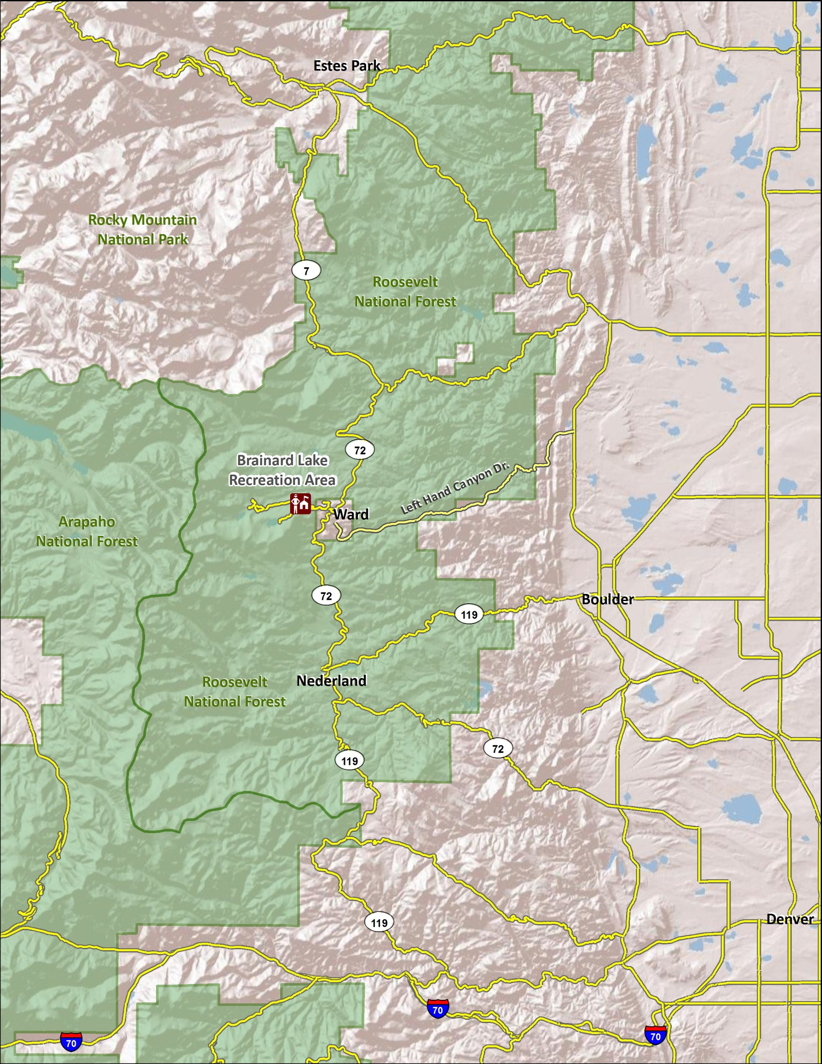
Route Map
4
3
2
1

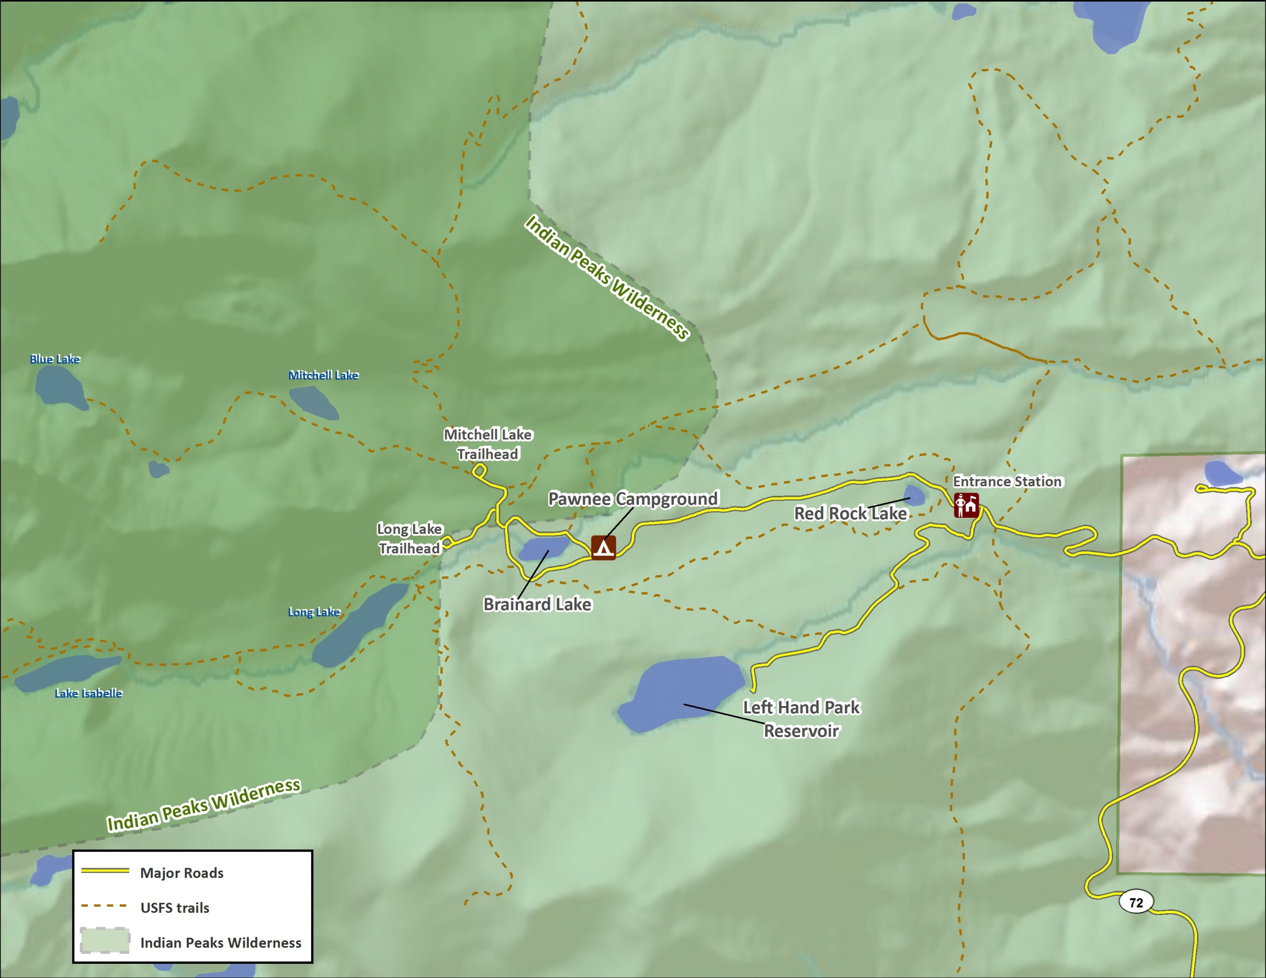
Area Map
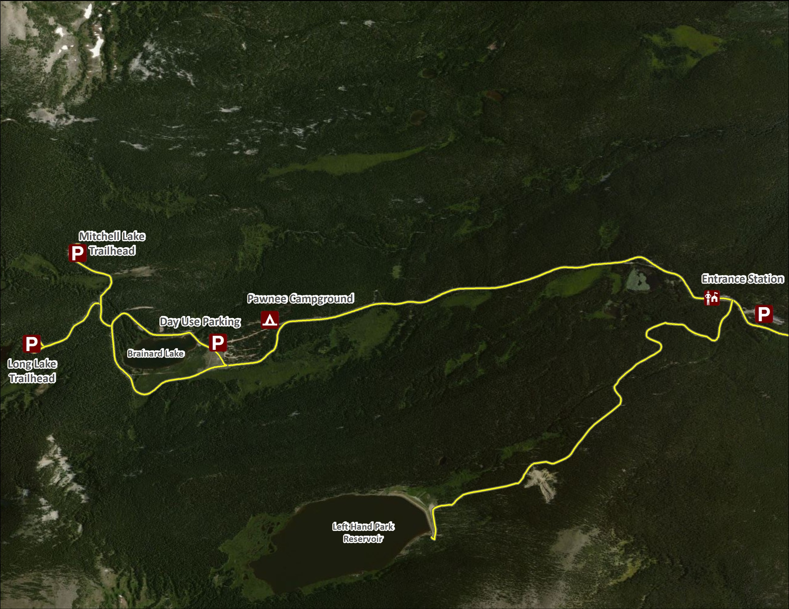
Parking Map

