OMB #: 0596-NEW
Expiration Date: XX/XX/201X

Guanella Pass
Visitor Survey
2014

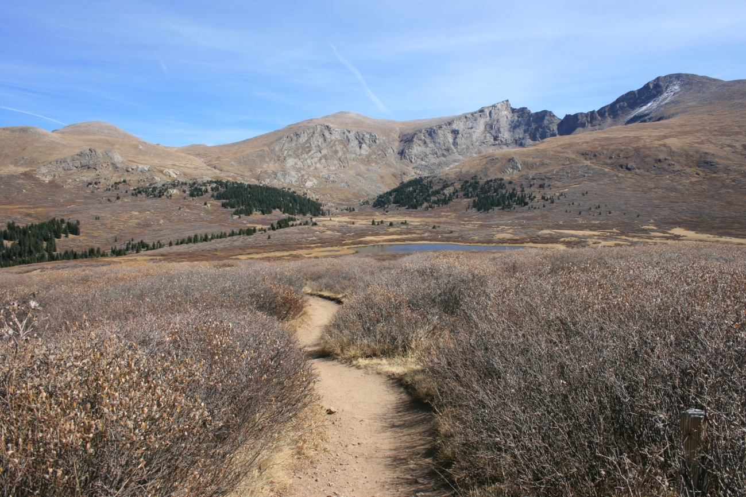

ID: ________ Date: ______________

Time:___________AM/PM Binder #: ___________

Location: Bierstadt / Square Top

Weather: Sunny / Partly / Overcast / Raining

Special Event: No/Yes_________________________________________

PRIVACY ACT STATEMENT
16 U.S.C. 1a-7 authorizes collection of this information. This information will be used by USDA Forest Service managers to better serve the public. Response to this request is voluntary. No action may be taken against you for refusing to supply the information requested. Thus the permanent data will be anonymous. Data collected through visitor surveys may be disclosed to the Department of Justice when relevant to litigation or anticipated litigation, or to appropriate Federal, State, local or foreign agencies responsible for investigating or prosecuting a violation of law.

Burden Statement

According to the Paperwork Reduction Act of 1995, an agency may not conduct or sponsor, and a person is not required to respond to a collection of information unless it displays a valid OMB control number. The valid OMB control number for this information collection is 0596-NEW. The time required to complete this information collection is estimated to average 10 minutes per response, including the time for reviewing instructions, searching existing data sources, gathering and maintaining the data needed, and completing and reviewing the collection of information.

The U.S. Department of Agriculture (USDA) prohibits discrimination in all its programs and activities on the basis of race, color, national origin, gender, religion, age, disability, political beliefs, sexual orientation, and marital or family status. (Not all prohibited bases apply to all programs.) Persons with disabilities who require alternative means for communication of program information (Braille, large print, audiotape, etc.) should contact USDA’s TARGET Center at 202-720-2600 (voice and TDD).

To file a complaint of discrimination, write USDA, Director, Office of Civil Rights, 1400 Independence Avenue, SW, Washington, DC 20250-9410 or call (800) 795-3272 (voice) or (202) 720-6382 (TDD). USDA is an equal opportunity provider and employer.

A. Trip Description

The questions in this section ask about your current trip to Guanella Pass. Please ask the surveyor to show
you a map of the area, if you need it to help answer the questions.

Topic Area 1-Visitor and Trip Characteristics
Pre-tested and administered in previous study (OMB Control Number 1024-0224)
1. Including yourself, how many people are there in your personal group on this trip to Guanella Pass? (Enter number of people.)

Number of people:____________

Topic Area 1-Visitor and Trip Characteristics
Pre-tested and administered in previous study (OMB Control Number 1024-0224)
2. Are there any children under the age of 16 in your personal group on this trip to Guanella Pass? (Check one box.)

❑ Yes (Number of children):__________
❑ No

Topic Area 1-Visitor and Trip Characteristics
Pre-tested and administered in previous study (OMB Control Number 1024-0224)
3. Which of the following activities did you do during this trip to Guanella Pass? (Check one box for each item.)

 | Did  on this Trip | Did Not Do on this Trip
A. Day hiking to Mt. Bierstadt summit | ❑ | ❑
B. Day hiking to Square Top Lakes | ❑ | ❑
C. Day hiking on Rosalie Trail | ❑ | ❑
D. Day hiking to Mt. Evans via Mt. Bierstadt | ❑ | ❑
E. Walking/Short hike (less than 1 hour) | ❑ | ❑
F. Overnight backpacking (# of nights):________ | ❑ | ❑
G. Picnicking | ❑ | ❑
H. Scenic driving | ❑ | ❑
I. Fishing | ❑ | ❑
J. Horseback riding | ❑ | ❑
K. Road biking | ❑ | ❑
L. Other (Please specify):__________________________ | ❑ | ❑

Topic Area 1-Visitor and Trip Characteristics
Pre-tested and administered in previous study (OMB Control Number 1024-0224)
4. What of the activities listed in Question 3 is your primary activity on this trip to Guanella Pass? (Enter letter of primary activity or check the box.)

Letter of primary activity:_____

OR

❑ I do not have a primary activity on this trip to Guanella Pass.

Topic Area 1-Visitor and Trip Characteristics
Pre-tested and administered in previous study (OMB Control Number 1024-0224)
5. Which of the following other locations on Guanella Pass Road have you/will you visit today? (Check one box for each location.)

 | Have Visited Today | Plan to Visit Today | Don’t Plan  to Visit Today
Hiking Trails at Silver Dollar Lake | ❑ | ❑ | ❑
Hiking Trails at Silverdale | ❑ | ❑ | ❑
Hiking Trails at Abyss Lake | ❑ | ❑ | ❑
Picnic Area | ❑ | ❑ | ❑
Clear Lake Campground (# of nights):________ | ❑ | ❑ | ❑
Roadside Campsite (# of nights): ________ | ❑ | ❑ | ❑
Other (Please specify):___________________ | ❑ | ❑ | ❑

IF YOU HIKED PART OR ALL OF THE WAY TO THE SUMMIT OF MT. BIERSTADT TODAY CONTINUE TO THE NEXT SECTION; OTHERWISE SKIP TO SECTION C

B. Hike to Mt. Bierstadt Summit

The questions in this section ask about your hike to the Mt. Bierstadt summit today. If you did not hike
part or all of the way to the Mt. Bierstadt summit today, skip to Section C of the questionnaire.

Topic Area 1-Visitor and Trip Characteristics
Pre-tested and administered in previous study (OMB Control Number 1024-0224)
6. Did you hike part or all of the way to the summit of Mt. Bierstadt today? (Check one box.)

❑ Yes, I hiked part of the way to the summit
❑ Yes, I hiked all of the way to the summit
❑ No (SKIP TO QUESTION 12 in SECTION C)

Topic Area 3-Crowding and Visitor Experience Quality
Pre-tested and administered in previous study (OMB Control Number 1024-0224)
7. Did you think it was crowded at any point during your hike to Mt. Bierstadt today? (Check
all that apply.)

❑ Yes, it was crowded some or all of the time I was on the trail
❑ Yes, it was crowded some or all of the time I was on the summit
❑ No, it wasn’t crowded at any point during my hike

Topic Area 3-Crowding and Visitor Experience Quality
Pre-tested and administered in previous study (OMB Control Number 1024-0224)
8. Did the presence of other people on the trail make you feel rushed or slow you down at any point during your hike to Mt. Bierstadt today? (Check one box.)

❑ Yes
❑ No

Topic Area 3-Crowding and Visitor Experience Quality
Pre-tested and administered in previous study (OMB Control Number 1024-0224)
9. Did you feel like the number of other people around you increased your risk or other people’s risk of being injured at any point during your hike to Mt. Bierstadt today? (Check all that apply.)

❑ Yes, I felt this way some or all of the time I was on the trail
❑ Yes, I felt this way some or all of the time I was on the summit
❑ No, I didn’t feel this way at any point during my hike

For the next question, please ask the surveyor to show you the photos he/she has of people on the
summit of Mt. Bierstadt.

Topic Area 3-Crowding and Visitor Experience Quality
Pre-tested and administered in previous study (OMB Control Number 1024-0224)
10. Which photo shows the maximum number of people you could see at one time on Mt. Bierstadt without thinking it was crowded? (Enter photo number or check the box.)

Photo number:_________

OR

❑ I don’t think it looks crowded in any of the photos.

Topic Area 4-Attitudes and Opinions about Services, Facilities, and Management
Pre-tested and administered in previous study (OMB Control Number 1024-0224)
11. Should the number of people allowed to hike to the summit of Mt. Bierstadt each day be limited if it is needed to prevent crowding, even if it means you might have to change your plans about when to hike? (Check one box.)

❑ Yes
❑ No

C. Travel and Parking

The next set of questions asks about your travel to and parking at Guanella Pass on this trip.

Topic Area 1-Visitor and Trip Characteristics
Pre-tested and administered in previous study (OMB Control Number 1024-0145)
12. Which route did you use to travel to Guanella Pass on this trip? (Refer to the surveyor’s route map and check one box.)

❑ From I-70 in Georgetown (#1 on route map)
❑ From Highway 285 in Grant (#2 on route map)
❑ Other (Please specify):_________________________________________

Topic Area 1-Visitor and Trip Characteristics
Pre-tested and administered in previous study (OMB Control Number 1024-0224)
13. In how many vehicles did you and your personal group travel to Guanella Pass on this trip? (Enter number of vehicles.)

Number of vehicles:____________

OR

❑ I/my personal group bicycled to Guanella Pass on this trip (SKIP TO QUESTION 18)

Topic Area 1-Visitor and Trip Characteristics
Pre-tested and administered in previous study (OMB Control Number 1024-0224)
14. At approximately what time did you arrive at Guanella Pass today? (Enter time or
check box.)

Approximate arrival time today:_____________AM/PM (CIRCLE ONE)

OR

❑ I arrived on a different day (Please specify date of arrival):___________________

Topic Area 1-Visitor and Trip Characteristics
New question, site-specific; pre-tested in this project with volunteer participants
15. Where did you park on this trip to Guanella Pass? (Refer to the surveyor’s parking map and check one box.)

❑ Lower parking lot (Mt. Bierstadt Trailhead)
❑ Upper parking lot (Square Top Lakes Trailhead)
❑ Along the roadside on Guanella Pass Road
❑ Other (Please specify):__________________________________________

Topic Area 2-Perceptions and Evaluations of Transportation-related Conditions
New question; pre-tested in this project with volunteer participants
16. Do you agree or disagree with each of the following statements about where you parked at Guanella Pass? (Check one box for each item.)

Where I parked is… | Strongly Disagree | Disagree | Neither Agree nor Disagree | Agree | Strongly Agree
Safe | ❑ | ❑ | ❑ | ❑ | ❑
Convenient | ❑ | ❑ | ❑ | ❑ | ❑
Easy to find | ❑ | ❑ | ❑ | ❑ | ❑
Close to my destination(s) | ❑ | ❑ | ❑ | ❑ | ❑
Well marked (e.g., paint striping) | ❑ | ❑ | ❑ | ❑ | ❑
My preferred parking location | ❑ | ❑ | ❑ | ❑ | ❑
In a congested parking area | ❑ | ❑ | ❑ | ❑ | ❑

Topic Area 5-Transportation-related Preferences
Pre-tested and administered in previous study (OMB Control Number 1024-0145)
17. Imagine that when you were in Georgetown or Grant (depending on your travel route) a road
sign notified you that there was no more parking at Guanella Pass, but you could park and ride a
shuttle bus from town. What would you do? (Check one box.)

❑ Go directly to Guanella Pass and look for parking anyway
❑ Park in town and take the shuttle bus to Guanella Pass
❑ Do something else until later in the day when you could find parking at Guanella Pass, then go
❑ Go to a different recreation area instead (Please specify):______________________
❑ Other (Please specify):___________________________________________

Topic Area 2-Perceptions and Evaluations of Transportation-related Conditions
Pre-tested and administered in previous study (OMB Control Number 1024-0224)
18. How much parking congestion do you think there is at Guanella Pass today? (Circle one number.)

No Parking Congestion at all |  | Slight Parking Congestion |  | Moderate  Parking  Congestion |  |  |  |  | Extreme Parking Congestion
 | 1 | 2 | 3 | 4 | 5 | 6 | 7 | 8 | 9

Topic Area 4-Attitudes and Opinions about Services, Facilities, and Management
Pre-tested and administered in previous study (OMB Control Number 1024-0224)
19. Do you agree or disagree with each of the following statements about potential actions when parking lots are full at Guanella Pass? (Check one box for each item.)

When parking lots at Guanella Pass are full people should be… | Strongly Disagree | Disagree | Neither Agree nor Disagree | Agree | Strongly Agree
…allowed to drive here and park wherever they can, including on the roadside. | ❑ | ❑ | ❑ | ❑ | ❑
…allowed to drive here to look for parking anyway, but not allowed to park on the roadside. | ❑ | ❑ | ❑ | ❑ | ❑
…directed to park in town and ride a shuttle bus here. | ❑ | ❑ | ❑ | ❑ | ❑
…directed to other recreation areas instead of visiting Guanella Pass that day. | ❑ | ❑ | ❑ | ❑ | ❑

D. Planning Your Trip to Guanella Pass

The next set of questions asks about planning you may have done to prepare for this trip to Guanella Pass.

Topic Area 1-Visitor and Trip Characteristics
Pre-tested and administered in previous study (OMB Control Number 1024-0145)
20. How long ago did you decide to take this trip to Guanella Pass? (Check one box.)

❑ Sometime today
❑ Yesterday
❑ In the last week
❑ More than a week ago, but less than a month ago
❑ A month or more before today

Topic Area 1-Visitor and Trip Characteristics
Pre-tested and administered in previous study (OMB Control Number 1024-0224)
21. Which of the following sources of information did you use to plan this trip to Guanella Pass? (Check all that apply.)

❑ | Knowledge from previous visit (# of previous visits in last 3 years):_________
❑ | Family/friends/word of mouth
❑ | Website (Please specify):__________________________________
❑ | Smartphone app
❑ | Social media (e.g., Facebook, Twitter)
❑ | Outdoor sports shop (Please specify):_________________________________
❑ | Traveler information radio station
❑ | Travel guide/Tour book
❑ | Convention/Visitor Bureau
❑ | Television
❑ | Newspaper/Magazine article
❑ | Hotel/Motel/Campground staff
❑ | Other (please specify):________________________________________.

Topic Area 3-Crowding and Visitor Experience Quality
Pre-tested and administered in previous study (OMB Control Number 1024-0145)
22. When you planned this trip to Guanella Pass, did you think about the possibility that it might be crowded here? (Check one box.)

❑ Yes
❑ No (SKIP TO QUESTION 24)

Topic Area 3-Crowding and Visitor Experience Quality
Pre-tested and administered in previous study (OMB Control Number 1024-0145)
23. If you thought about the possibility of crowding when you planned this trip to Guanella Pass, how did it affect your trip plans? (Check all that apply.)

❑ It did not affect my plans
❑ I visited at a time of day I thought would be less crowded
❑ I visited on a day of the week I thought would be less crowded
❑ I avoided places here I thought would be crowded today
❑ Other (Please specify):_________________________________________

Topic Area 5-Transportation-related Preferences
Pre-tested and administered in previous OMB-approved study (OMB Control Number 1024-0224)
24. How likely would you have been to use each of the following sources of information to plan your trip to Guanella Pass, if you could have gotten information about parking and crowding conditions? (Check one box for each item.)

 | Likely | Not  Likely | Don’t Know/Not Sure
Website | ❑ | ❑ | ❑
Smartphone app | ❑ | ❑ | ❑
Social media (e.g., Facebook, Twitter) | ❑ | ❑ | ❑
Text updates on cellular phone/smartphone | ❑ | ❑ | ❑
AM radio station | ❑ | ❑ | ❑
Telephone information line (message updated daily) | ❑ | ❑ | ❑
Telephone information line (live person) | ❑ | ❑ | ❑
Tourist information center | ❑ | ❑ | ❑
Other (Please specify):_____________________ | ❑ | ❑ | ❑

E. Background Information

Topic Area 1-Visitor and Trip Characteristics
Pre-tested and administered in previous study (OMB Control Number 1024-0224)
25. What is your gender? (Check one box.)

❑ Male
❑ Female

Topic Area 1-Visitor and Trip Characteristics
Pre-tested and administered in previous study (OMB Control Number 1024-0224)
26. In what year were you born?

Year born:___________

Topic Area 1-Visitor and Trip Characteristics
Pre-tested and administered in previous study (OMB Control Number 1024-0224)
27. Do you live in the United States? (Check one box.)

❑ Yes (What is your zip code? __________)
❑ No (What country do you live in? ______________________________)

Topic Area 1-Visitor and Trip Characteristics
Pre-tested and administered in previous study (OMB Control Number 1024-0224)
28. What is the highest level of formal education you have completed?
(Check one box.)

❑ Some high school
❑ High school graduate or GED
❑ Some college, business or trade school
❑ College, business or trade school graduate
❑ Some graduate school
❑ Master’s, doctoral or professional degree

Topic Area 1-Visitor and Trip Characteristics
Pre-tested and administered in previous study (OMB Control Number 1024-0224)
29. Are you Hispanic or Latino? (Check one box.)

❑ Yes
❑ No

Topic Area 1-Visitor and Trip Characteristics
Pre-tested and administered in previous study (OMB Control Number 1024-0224)
30. What is your race? (Check all that apply.)
❑ American Indian or Alaska Native
❑ Asian
❑ Black or African American
❑ Native Hawaiian
❑ Pacific Islander other than Native Hawaiian
❑ White

Thank you for your help with this survey!
Please return it to the surveyor.

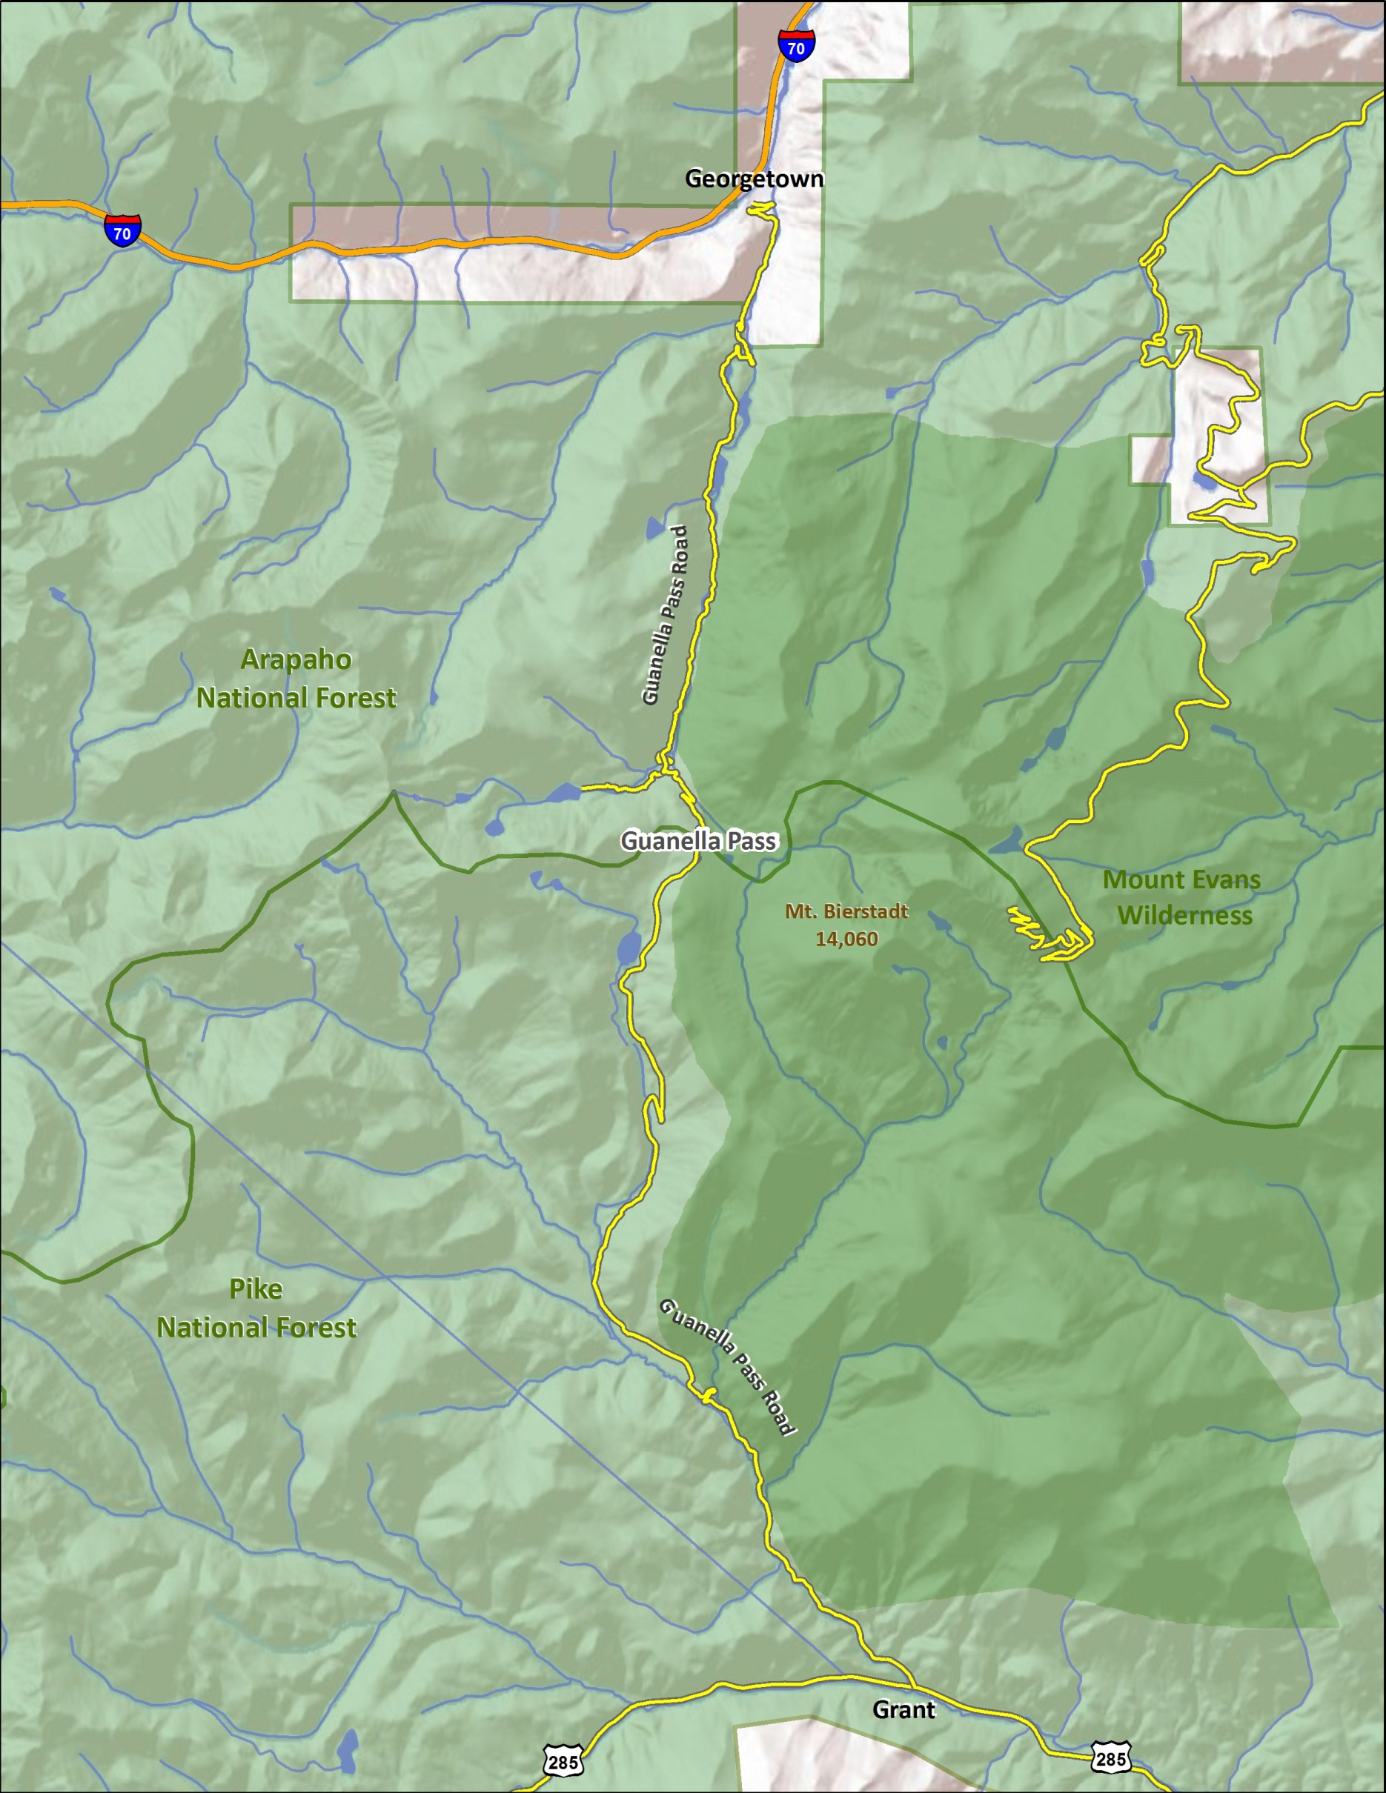
Route Map
2
1
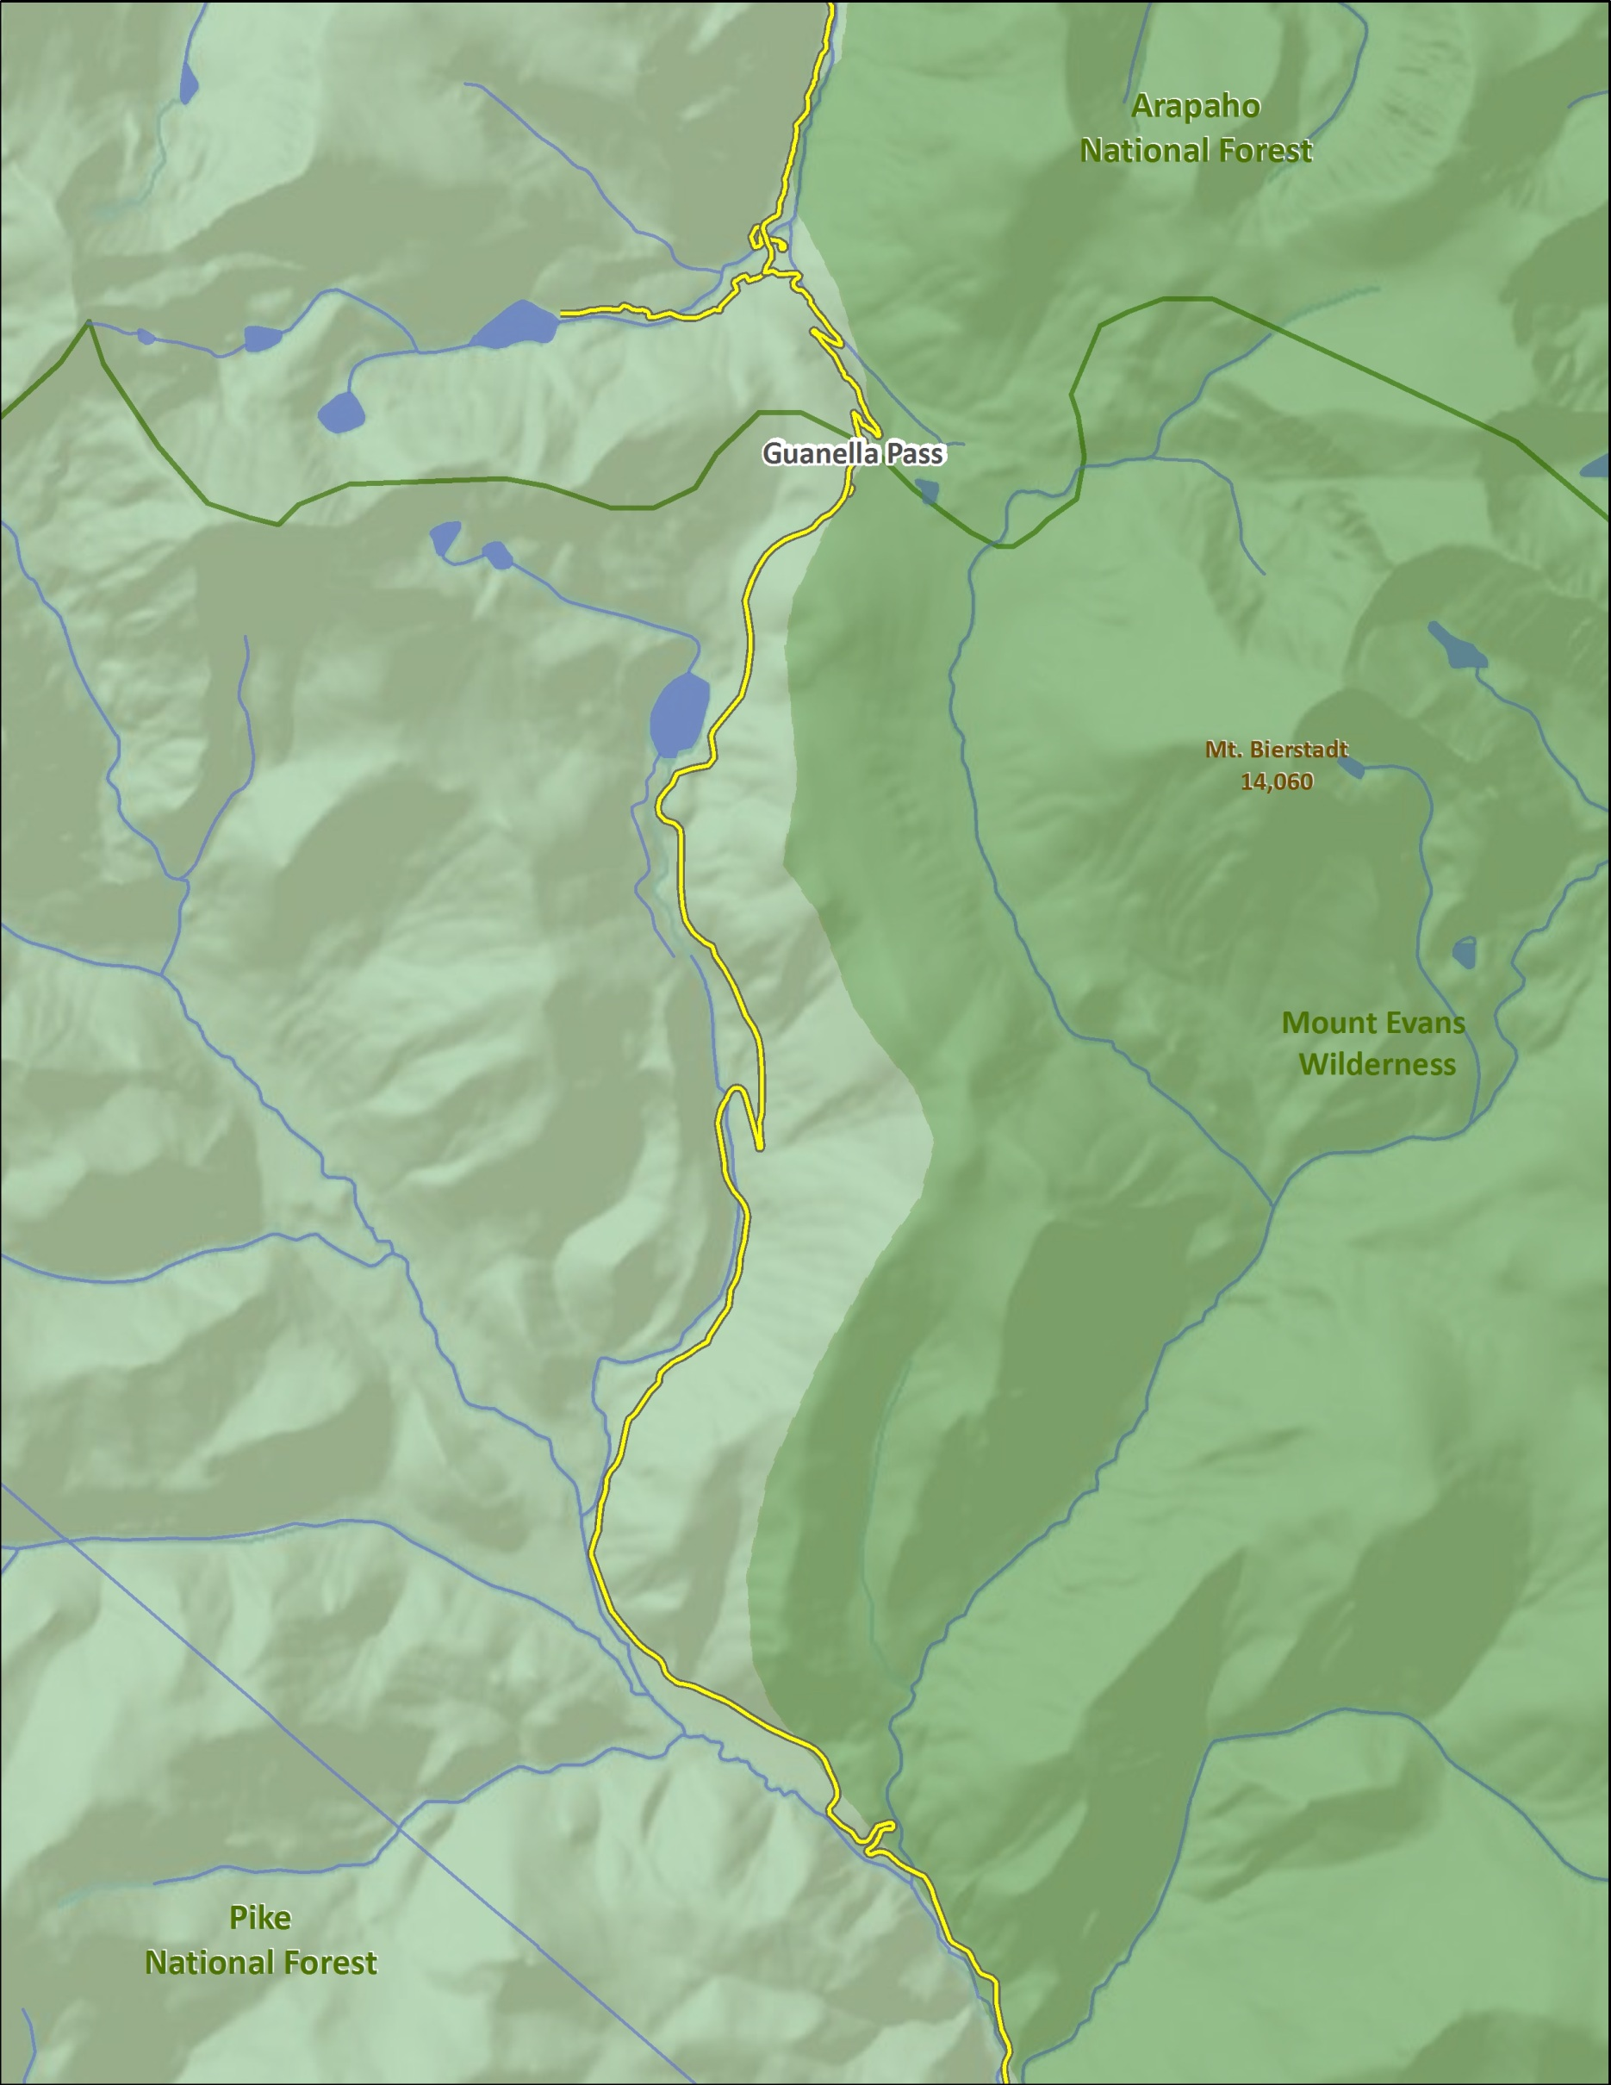
Abyss Lake Trails
Area Map
Silverdale
Silver Dollar Lake
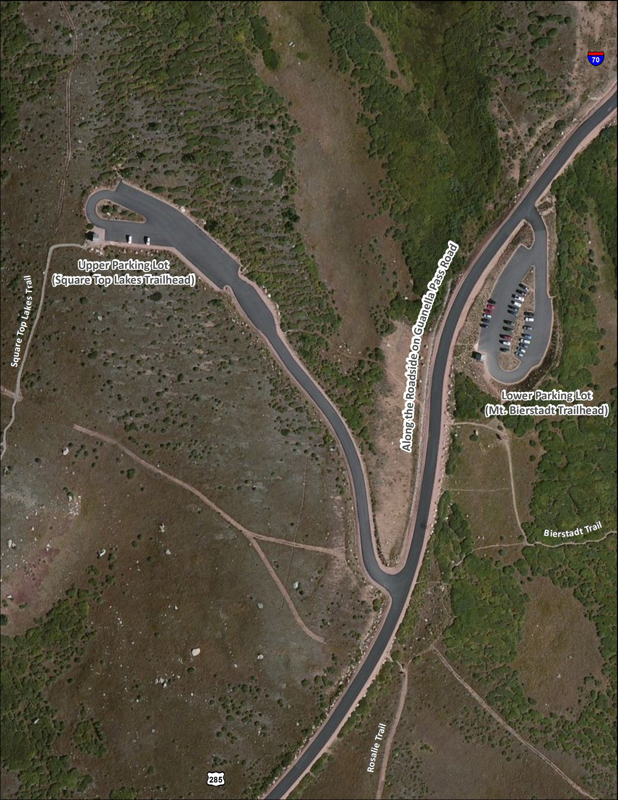
To Georgetown &
Parking Map
To Grant &

