OMB #: 0596-NEW
Expiration Date: XX/XX/201X

Mount Evans
Visitor Survey
2014

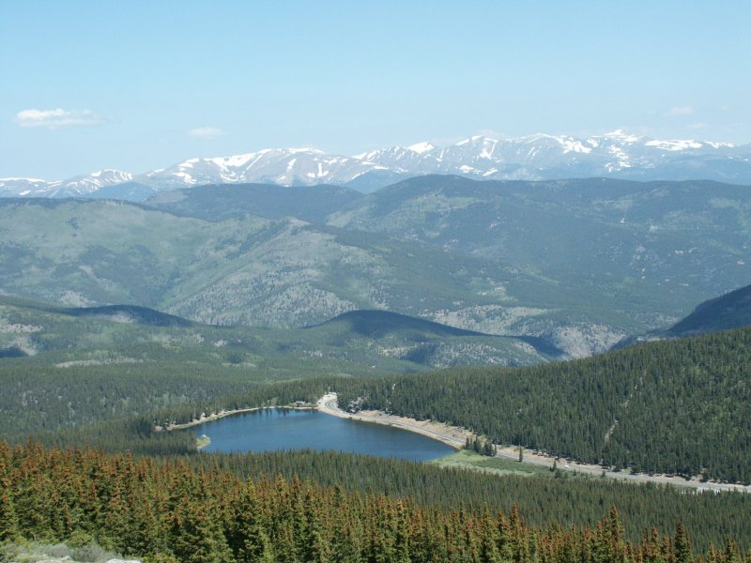

ID: ________ Date: ______________

Time:___________AM/PM Binder #: ___________

Location: Summit / Summit Lake

Weather: Sunny / Partly / Overcast / Raining

Special Event: No/Yes_________________________________________

PRIVACY ACT STATEMENT
16 U.S.C. 1a-7 authorizes collection of this information. This information will be used by USDA Forest Service managers to better serve the public. Response to this request is voluntary. No action may be taken against you for refusing to supply the information requested. Thus the permanent data will be anonymous. Data collected through visitor surveys may be disclosed to the Department of Justice when relevant to litigation or anticipated litigation, or to appropriate Federal, State, local or foreign agencies responsible for investigating or prosecuting a violation of law.

Burden Statement

According to the Paperwork Reduction Act of 1995, an agency may not conduct or sponsor, and a person is not required to respond to a collection of information unless it displays a valid OMB control number. The valid OMB control number for this information collection is 0596-NEW. The time required to complete this information collection is estimated to average 10 minutes per response, including the time for reviewing instructions, searching existing data sources, gathering and maintaining the data needed, and completing and reviewing the collection of information.

The U.S. Department of Agriculture (USDA) prohibits discrimination in all its programs and activities on the basis of race, color, national origin, gender, religion, age, disability, political beliefs, sexual orientation, and marital or family status. (Not all prohibited bases apply to all programs.) Persons with disabilities who require alternative means for communication of program information (Braille, large print, audiotape, etc.) should contact USDA’s TARGET Center at 202-720-2600 (voice and TDD).

To file a complaint of discrimination, write USDA, Director, Office of Civil Rights, 1400 Independence Avenue, SW, Washington, DC 20250-9410 or call (800) 795-3272 (voice) or (202) 720-6382 (TDD). USDA is an equal opportunity provider and employer.

A. Trip Description

The questions in this section ask about your current trip to Mount Evans Recreation Area (MERA). Please
ask the surveyor to show you a map of the area, if you need it to help answer the questions.

Topic Area 1-Visitor and Trip Characteristics
Pre-tested and administered in previous study (OMB Control Number 1024-0224)
1. Including yourself, how many people are there in your personal group on this trip to Mount Evans Recreation Area (MERA)? (Enter number of people.)

Number of people:____________

Topic Area 1-Visitor and Trip Characteristics
Pre-tested and administered in previous study (OMB Control Number 1024-0224)
2. Are there any children under the age of 16 in your personal group on this trip to MERA? (Check one box.)

❑ Yes (Number of children):__________
❑ No

Topic Area 1-Visitor and Trip Characteristics
Pre-tested and administered in previous study (OMB Control Number 1024-0224)
3. Which of the following locations in MERA have you/will you visit on this trip? (Check one box for each location.)

 | Have Visited on this Trip | Plan to Visit on this Trip | Don’t Plan  to Visit on this Trip
A. Mount Evans Summit | ❑ | ❑ | ❑
B. Summit Lake | ❑ | ❑ | ❑
C. Mount Goliath Natural Area | ❑ | ❑ | ❑
D. Other (Please specify):________________________ | ❑ | ❑ | ❑

Topic Area 1-Visitor and Trip Characteristics
Pre-tested and administered in previous study (OMB Control Number 1024-0224)
4. Which of the locations listed in Question 3 is your primary destination on this trip to MERA? (Enter letter of primary destination or check the box.)

Letter of primary destination:____________________________________

OR

❑ I did not have a primary destination on this trip to MERA.
Topic Area 1-Visitor and Trip Characteristics
Pre-tested and administered in previous study (OMB Control Number 1024-0224)
5. Which of the following activities did you/will you do during this trip to MERA? (Check one box for each item.)

 | Did on  this Trip | Plan to Do on this Trip | Don’t Plan to Do on  this Trip
A. Scenic driving | ❑ | ❑ | ❑
B. Walking/Short hike (less than 1 hour) | ❑ | ❑ | ❑
C. Day hiking (more than 1 hour) | ❑ | ❑ | ❑
D. Overnight backpacking (# of nights):________ | ❑ | ❑ | ❑
E. Picnicking | ❑ | ❑ | ❑
F. Road biking | ❑ | ❑ | ❑
G. Wildlife viewing | ❑ | ❑ | ❑
H. Attend ranger program | ❑ | ❑ | ❑
I. Fishing | ❑ | ❑ | ❑
J. Creative arts (photography/drawing/ painting/writing) | ❑ | ❑ | ❑
K. Other (Please specify):__________________________ | ❑ | ❑ | ❑

Topic Area 1-Visitor and Trip Characteristics
Pre-tested and administered in previous study (OMB Control Number 1024-0224)
6. Which of the activities listed in Question 5 is your primary activity on this trip to MERA? (Enter letter of primary activity or check the box.)

Letter of primary activity:____________________________________

OR

❑ I do not have a primary activity on this trip to MERA.

B. Walk/Hike to Mt. Evans Summit

The summit of Mt. Evans can be reached by walking a short trail from the parking lot just below
the summit, or by hiking from Summit Lake or other trails. The questions in this section ask about your
walk/hike to the Mt. Evans summit today. If you did not walk/hike to the Mt. Evans summit today, skip to
Section C of the questionnaire.

Topic Area 1-Visitor and Trip Characteristics
Pre-tested and administered in previous study (OMB Control Number 1024-0224)
7. Did you walk/hike to the summit of Mt. Evans today? (Check one box.)

❑ Yes, I walked from the parking lot just below the summit
❑ Yes, I hiked from Summit Lake
❑ Yes, I hiked from another location (Please specify):__________________________________
❑ No (SKIP TO QUESTION 13 in SECTION C)

Topic Area 3-Crowding and Visitor Experience Quality
Pre-tested and administered in previous study (OMB Control Number 1024-0224)
8. Did you think it was crowded at any point while you were on the summit of Mt. Evans
today? (Check one box.)

❑ Yes, it was crowded some or all of the time I was on the summit
❑ No, it wasn’t crowded at any point during my time on the summit

Topic Area 3-Crowding and Visitor Experience Quality
Pre-tested and administered in previous study (OMB Control Number 1024-0224)
9. Did the presence of other people on the trail make you feel rushed or slow you down at any point during your walk/hike to the Mt. Evans summit today? (Check one box.)

❑ Yes
❑ No

Topic Area 3-Crowding and Visitor Experience Quality
Pre-tested and administered in previous study (OMB Control Number 1024-0224)
10. Did you feel like the number of other people around you increased your risk or other people’s risk of being injured at any point while you were on the summit of Mt. Evans today? (Check all that apply.)

❑ Yes, I felt this way some or all of the time I was on the summit
❑ No, I didn’t feel this way at any point during my time on the summit

For the next question, please ask the surveyor to show you the photos he/she has of people on the
summit of Mt. Evans.

Topic Area 3-Crowding and Visitor Experience Quality
Pre-tested and administered in previous study (OMB Control Number 1024-0224)
11. Which photo shows the maximum number of people you could see at one time on Mt. Evans without thinking it was crowded? (Enter photo number or check the box.)

Photo number:_________

OR

❑ I don’t think it looks crowded in any of the photos.

Topic Area 4-Attitudes and Opinions about Services, Facilities, and Management
Pre-tested and administered in previous study (OMB Control Number 1024-0224)
12. Should the number of people allowed to visit Mt. Evans each day be limited if it is needed to prevent crowding on the summit, even if it means you might have to change your plans about when to visit? (Check one box.)

❑ Yes
❑ No

C. Travel and Parking

The next set of questions asks about your travel to and parking at MERA on this trip.

Topic Area 1-Visitor and Trip Characteristics
Pre-tested and administered in previous study (OMB Control Number 1024-0145)
13. Which route did you use to travel to MERA on this trip? (Refer to the surveyor’s route map and check one box.)

❑ Highway 103 from the North (#1 on route map)
❑ Highway 103 from the East (#2 on route map)
❑ Other (Please specify):_________________________________________

Topic Area 1-Visitor and Trip Characteristics
Pre-tested and administered in previous study (OMB Control Number 1024-0224)
14. In how many vehicles did you/your personal group travel to MERA on this trip? (Enter number of vehicles.)

Number of vehicles:____________

OR

❑ I/my personal group bicycled to MERA today (SKIP TO QUESTION 22)

Topic Area 1-Visitor and Trip Characteristics
Pre-tested and administered in previous study (OMB Control Number 1024-0224)
15. At approximately what time did you arrive at MERA today? (Enter time or check
box.)

Approximate arrival time:_____________AM/PM (CIRCLE ONE)

OR

❑ Don’t know/Not sure

Topic Area 2-Perceptions and Evaluations of Transportation-related Conditions
Pre-tested and administered in previous study (OMB Control Number 1024-0224)
16. Did you have to wait behind other vehicles at the entrance station to enter MERA today? (Check one box.)

❑ Yes, but there were only one or a few vehicles ahead of me
❑ Yes, and there were several to many vehicles ahead of me
❑ No, I did not have to wait behind any other vehicles to enter today

Topic Area 2-Perceptions and Evaluations of Transportation-related Conditions
Pre-tested and administered in previous study (OMB Control Number 1024-0224)
17. Which of the following descriptions is most like the number of cars that were on the Mt. Evans Road during your drive from the entrance station to here? (Circle one number.)

❑ There were no other cars on the road
❑ There were just a few other cars on the road
❑ There were several other cars on the road
❑ There many other cars on the road

Topic Area 2-Perceptions and Evaluations of Transportation-related Conditions
New question, site-specific; pre-tested in this project with volunteer participants
18. Do you agree or disagree with each of the following statements about driving on the Mt. Evans Road from the entrance station to here today? (Check one box for each item.)

 | Strongly Disagree | Disagree | Neither Agree nor Disagree | Agree | Strongly Agree
The number of cars on the road made driving conditions unsafe. | ❑ | ❑ | ❑ | ❑ | ❑
I enjoyed driving on the Mt. Evans Road today. | ❑ | ❑ | ❑ | ❑ | ❑
I would prefer to ride a van or shuttle than drive on the narrow, winding roads myself. | ❑ | ❑ | ❑ | ❑ | ❑
The number of bicycles on the road made driving conditions unsafe. | ❑ | ❑ | ❑ | ❑ | ❑
I like the challenge and adventure of driving conditions on this road. | ❑ | ❑ | ❑ | ❑ | ❑

Topic Area 1-Visitor and Trip Characteristics
Pre-tested and administered in previous study (OMB Control Number 1024-0224)
19. Where did you park when you arrived here at this site today? (Check one box.)

❑ In a designated parking space in the parking lot
❑ Along the roadside
❑ Other (Please specify):__________________________________________

Topic Area 2-Perceptions and Evaluations of Transportation-related Conditions
New question; pre-tested in this project with volunteer participants
20. Do you agree or disagree with each of the following statements about where you parked here? (Check one box for each item.)

Where I parked here is… | Strongly Disagree | Disagree | Neither Agree nor Disagree | Agree | Strongly Agree
Safe | ❑ | ❑ | ❑ | ❑ | ❑
Convenient | ❑ | ❑ | ❑ | ❑ | ❑
Easy to find | ❑ | ❑ | ❑ | ❑ | ❑
Close to my destination(s) | ❑ | ❑ | ❑ | ❑ | ❑
Well marked (e.g., paint striping) | ❑ | ❑ | ❑ | ❑ | ❑
My preferred parking location | ❑ | ❑ | ❑ | ❑ | ❑
In a congested parking area | ❑ | ❑ | ❑ | ❑ | ❑

Topic Area 5-Transportation-related Preferences
Pre-tested and administered in previous study (OMB Control Number 1024-0145)
21. Imagine that when you were about 1/2 hour away from here, a road sign notified you that all
parking lots at MERA were full, but you could park outside MERA and ride a shuttle bus here.
What would you do? (Check one box.)

❑ Drive here and look for parking anyway
❑ Park there and take the 30 minute shuttle bus ride to get here
❑ Go somewhere else until later in the day when you could find parking here
❑ Go to a different recreation area instead (Please specify):______________________
❑ Other (Please specify):___________________________________________

Topic Area 4-Attitudes and Opinions about Services, Facilities, and Management
Pre-tested and administered in previous study (OMB Control Number 1024-0224)
22. Do you agree or disagree with each of the following statements about potential actions when parking lots are full at MERA? (Check one box for each item.)

When parking lots at MERA are full people should be… | Strongly Disagree | Disagree | Neither Agree nor Disagree | Agree | Strongly Agree
…allowed to drive here and park wherever they can, including on the roadside. | ❑ | ❑ | ❑ | ❑ | ❑
…allowed to drive here to look for parking anyway, but not allowed to park on the roadside. | ❑ | ❑ | ❑ | ❑ | ❑
…directed to a park-and-ride lot outside of MERA and ride a shuttle bus here. | ❑ | ❑ | ❑ | ❑ | ❑
…directed to other recreation areas instead of visiting MERA that day. | ❑ | ❑ | ❑ | ❑ | ❑

D. Planning Your Trip to MERA

The next set of questions asks about planning you may have done to prepare for this trip to MERA.

Topic Area 1-Visitor and Trip Characteristics
Pre-tested and administered in previous study (OMB Control Number 1024-0145)
23. How long ago did you decide to take this trip to MERA? (Check one box.)

❑ Sometime today
❑ Yesterday
❑ In the last week
❑ More than a week ago, but less than a month ago
❑ A month or more before today

Topic Area 1-Visitor and Trip Characteristics
Pre-tested and administered in previous study (OMB Control Number 1024-0224)
24. Which of the following sources of information did you use to plan this trip to MERA? (Check all that apply.)

❑ | Knowledge from previous visit (# of previous visits in last 3 years):_________
❑ | Family/friends/word of mouth
❑ | Website (Please specify):__________________________________
❑ | Smartphone app
❑ | Social media (e.g., Facebook, Twitter)
❑ | Outdoor sports shop (Please specify):_________________________________
❑ | Traveler information radio station
❑ | Travel guide/Tour book
❑ | Convention/Visitor Bureau
❑ | Television
❑ | Newspaper/Magazine article
❑ | Hotel/Motel/Campground staff
❑ | Other (please specify):________________________________________.

Topic Area 3-Crowding and Visitor Experience Quality
Pre-tested and administered in previous study (OMB Control Number 1024-0145)
25. When you planned this trip to MERA, did you think about the possibility that it might be crowded here? (Check one box.)

❑ Yes
❑ No (SKIP TO QUESTION 27)

Topic Area 3-Crowding and Visitor Experience Quality
Pre-tested and administered in previous study (OMB Control Number 1024-0145)
26. If you thought about the possibility of crowding when you planned this trip to MERA, how did it affect your trip plans? (Check all that apply.)

❑ It did not affect my plans
❑ I visited at a time of day I thought would be less crowded
❑ I visited on a day of the week I thought would be less crowded
❑ I avoided places here I thought would be crowded today
❑ Other (Please specify):_________________________________________

Topic Area 5-Transportation-related Preferences
Pre-tested and administered in previous OMB-approved study (OMB Control Number 1024-0145)
27. How likely would you have been to use each of the following sources of information to plan your trip to MERA, if you could have gotten information about parking and crowding conditions? (Check one box for each item.)

 | Likely | Not  Likely | Don’t Know/Not Sure
Website | ❑ | ❑ | ❑
Smartphone app | ❑ | ❑ | ❑
Social media (e.g., Facebook, Twitter) | ❑ | ❑ | ❑
Text updates on cellular phone/smartphone | ❑ | ❑ | ❑
AM radio station | ❑ | ❑ | ❑
Telephone information line (message updated daily) | ❑ | ❑ | ❑
Telephone information line (live person) | ❑ | ❑ | ❑
Tourist information center | ❑ | ❑ | ❑
Other (Please specify):_____________________ | ❑ | ❑ | ❑

E. Background Information

Topic Area 1-Visitor and Trip Characteristics
Pre-tested and administered in previous study (OMB Control Number 1024-0224)
28. What is your gender? (Check one box.)

❑ Male
❑ Female

Topic Area 1-Visitor and Trip Characteristics
Pre-tested and administered in previous study (OMB Control Number 1024-0224)
29. In what year were you born?

Year born:___________

Topic Area 1-Visitor and Trip Characteristics
Pre-tested and administered in previous study (OMB Control Number 1024-0224)
30. Do you live in the United States? (Check one box.)

❑ Yes (What is your zip code? __________)
❑ No (What country do you live in? ______________________________)

Topic Area 1-Visitor and Trip Characteristics
Pre-tested and administered in previous study (OMB Control Number 1024-0224)
31. What is the highest level of formal education you have completed?
(Check one box.)

❑ Some high school
❑ High school graduate or GED
❑ Some college, business or trade school
❑ College, business or trade school graduate
❑ Some graduate school
❑ Master’s, doctoral or professional degree

Topic Area 1-Visitor and Trip Characteristics
Pre-tested and administered in previous study (OMB Control Number 1024-0224)
32. Are you Hispanic or Latino? (Check one box.)

❑ Yes
❑ No

Topic Area 1-Visitor and Trip Characteristics
Pre-tested and administered in previous study (OMB Control Number 1024-0224)
33. What is your race? (Check all that apply.)
❑ American Indian or Alaska Native
❑ Asian
❑ Black or African American
❑ Native Hawaiian
❑ Pacific Islander other than Native Hawaiian
❑ White

Thank you for your help with this survey!
Please return it to the surveyor.

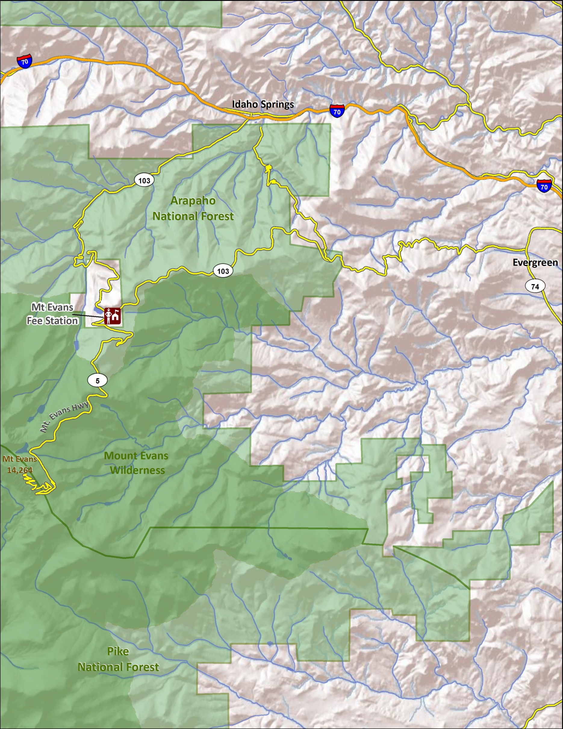
Route Map
2
1
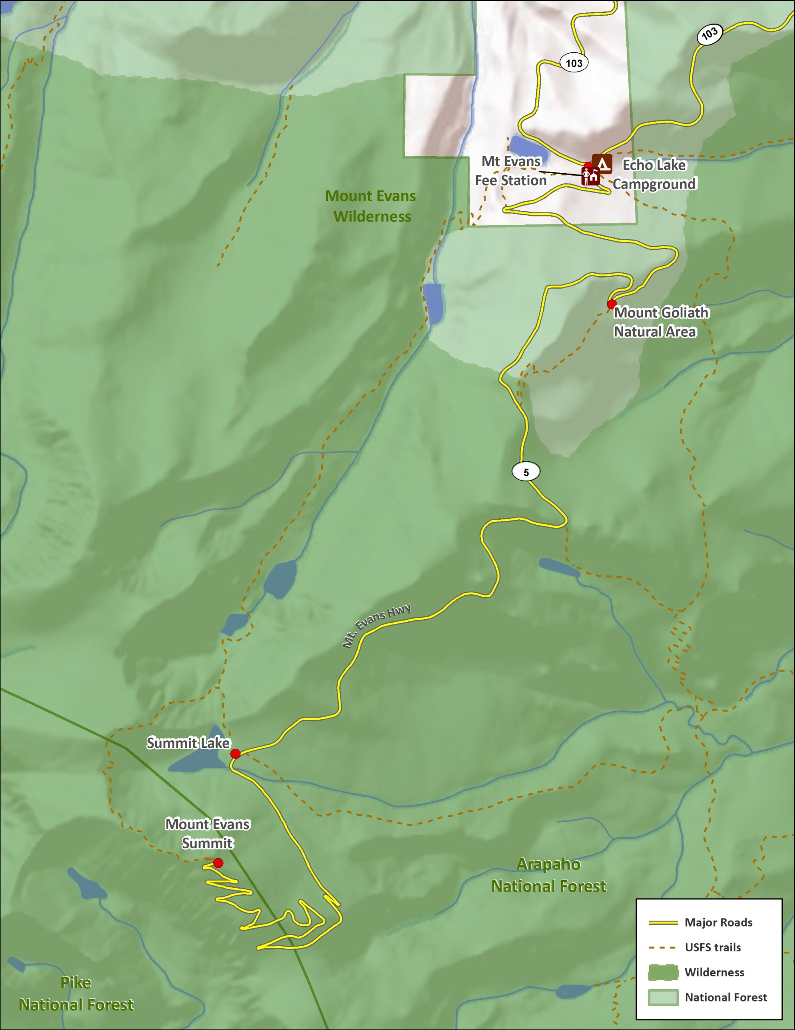
Area Map

