OMB #: 0596-NEW
Expiration Date: XX/XX/201X

Indian Peaks Wilderness
Visitor Survey
2014

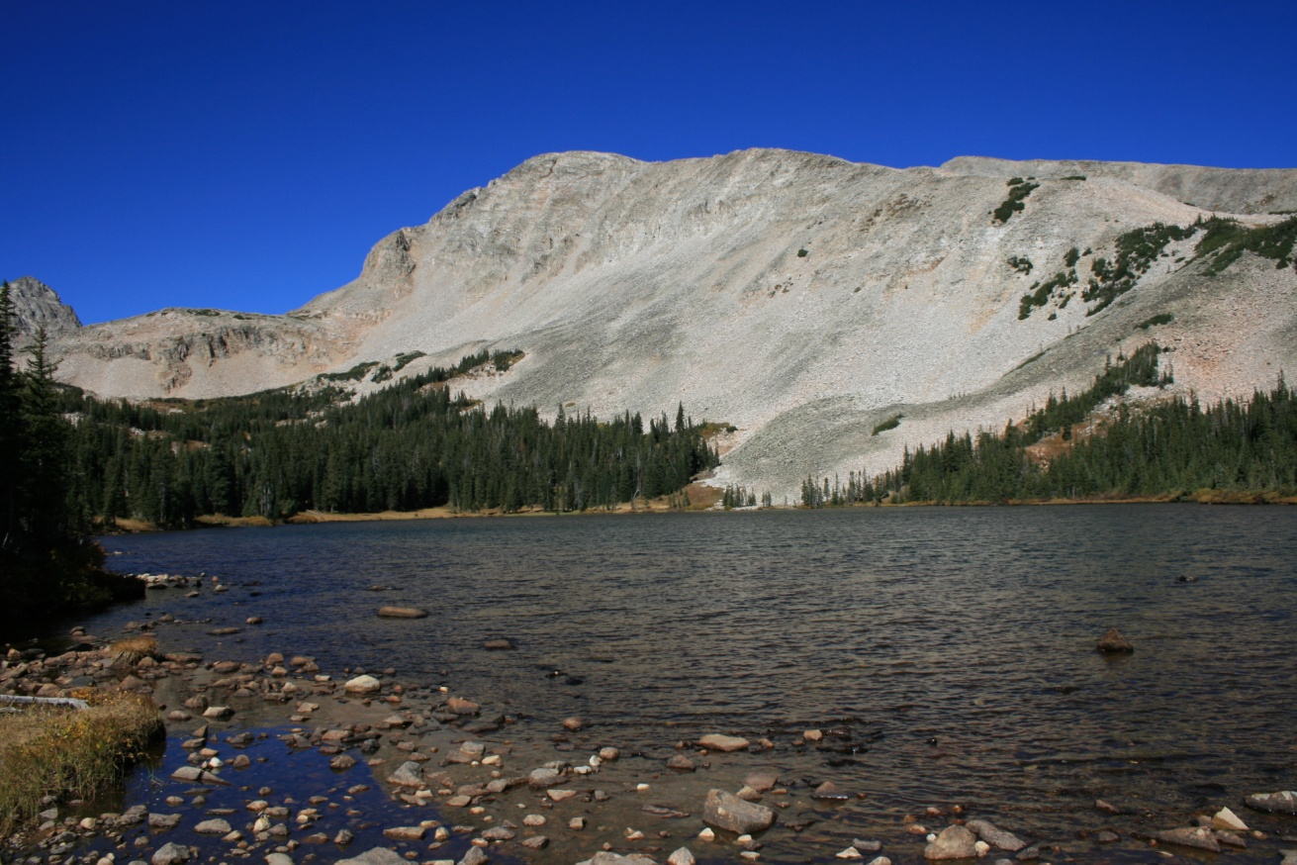

ID: ________ Date: ______________

Time:___________AM/PM Binder # ____________

Location: Mitchell Lake Trailhead / Long Lake Trailhead

Weather: Sunny / Partly / Overcast / Raining

Special Event: No/Yes________________________________________

PRIVACY ACT STATEMENT
16 U.S.C. 1a-7 authorizes collection of this information. This information will be used by USDA Forest Service managers to better serve the public. Response to this request is voluntary. No action may be taken against you for refusing to supply the information requested. Thus the permanent data will be anonymous. Data collected through visitor surveys may be disclosed to the Department of Justice when relevant to litigation or anticipated litigation, or to appropriate Federal, State, local or foreign agencies responsible for investigating or prosecuting a violation of law.

Burden Statement

According to the Paperwork Reduction Act of 1995, an agency may not conduct or sponsor, and a person is not required to respond to a collection of information unless it displays a valid OMB control number. The valid OMB control number for this information collection is 0596-NEW. The time required to complete this information collection is estimated to average 10 minutes per response, including the time for reviewing instructions, searching existing data sources, gathering and maintaining the data needed, and completing and reviewing the collection of information.

The U.S. Department of Agriculture (USDA) prohibits discrimination in all its programs and activities on the basis of race, color, national origin, gender, religion, age, disability, political beliefs, sexual orientation, and marital or family status. (Not all prohibited bases apply to all programs.) Persons with disabilities who require alternative means for communication of program information (Braille, large print, audiotape, etc.) should contact USDA’s TARGET Center at 202-720-2600 (voice and TDD).

To file a complaint of discrimination, write USDA, Director, Office of Civil Rights, 1400 Independence Avenue, SW, Washington, DC 20250-9410 or call (800) 795-3272 (voice) or (202) 720-6382 (TDD). USDA is an equal opportunity provider and employer.

A. Trip Description

The questions in this section ask about your current trip to the Indian Peaks Wilderness (IPW). Please ask
the surveyor to show you a map of the area, if you need it to help answer the questions.

Topic Area 1-Visitor and Trip Characteristics
Pre-tested and administered in previous OMB-approved study (OMB Control Number 1024-0224)
1. Including yourself, how many people are in your personal group on this trip to the Indian Peaks Wilderness (IPW)? (Enter number of people.)

Number of people:____________

Topic Area 1-Visitor and Trip Characteristics
Pre-tested and administered in previous OMB-approved study (OMB Control Number 1024-0224)
2. Are there any children under the age of 16 in your personal group on this hike in the IPW? (Check one box.)

❑ Yes (Number of children):__________
❑ No

Topic Area 1-Visitor and Trip Characteristics
Pre-tested and administered in previous OMB-approved study (OMB Control Number 1024-0224)
3. Were you day hiking or overnight backpacking on this trip to the IPW? (Check one box.)

❑ Day hiking (SKIP TO QUESTION 5)
❑ Overnight backpacking (# of nights):_______ (CONTINUE TO QUESTION 4)

Topic Area 1-Visitor and Trip Characteristics
Pre-tested and administered in previous OMB-approved study (OMB Control Number 1024-0224)
4. If you were overnight backpacking on this trip to the IPW, where did you start your backpacking trip? (Check one box.)

❑ Mitchell Lake Trailhead
❑ Long Lake Trailhead
❑ Other Trailhead (Please specify):__________________________________________

Topic Area 1-Visitor and Trip Characteristics
Pre-tested and administered in previous OMB-approved study (OMB Control Number 1024-0224)
5. At approximately what time did you start hiking today? (Enter time or check the box.)

Approximate time started hiking today:_____________AM/PM (CIRCLE ONE)

OR

❑ Don’t Know/Not Sure

Topic Area 1-Visitor and Trip Characteristics
Pre-tested and administered in previous OMB-approved study (OMB Control Number 1024-0224)
6. Where did you start your hike today? (Check one box.)

Mitchell Lake Trailhead | ❑
Long Lake Trailhead | ❑
Backcountry campsite in IPW | ❑
Other (Please specify):_______________________________ | ❑
Don’t know/Not sure | ❑

Topic Area 1-Visitor and Trip Characteristics
Pre-tested and administered in previous OMB-approved study (OMB Control Number 1024-0224)
7. Which of the following locations did you hike to or pass through today? (Check all that apply.)

❑ Mitchell Lake
❑ Blue Lake
❑ Long Lake
❑ Lake Isabelle
❑ Isabelle Glacier
❑ Shoshoni Peak
❑ Pawnee Peak
❑ Paiute Peak
❑ Mt. Toll
❑ Mt. Audubon
❑ Apache Peak
❑ Other location (Please specify):__________________________________________

OR

❑ Don’t know/Not sure

Topic Area 3-Crowding and Visitor Experience Quality
Pre-tested and administered in previous OMB-approved study (OMB Control Number 1024-0224)
8. Did you think it was crowded at any point during your hike today? (Check all that apply.)

❑ Yes, it was crowded some or all of the time on the trail
❑ Yes, it was crowded some or all of the time at destinations (lakes, mountain summits, etc.)
❑ No, it wasn’t crowded at any point during my hike today

Topic Area 3-Crowding and Visitor Experience Quality
Pre-tested and administered in previous OMB-approved study (OMB Control Number 1024-0224)
9. Did the presence of other people on the trail make you feel rushed or slow you down at any point during your hike today? (Check one box.)

❑ Yes
❑ No

For the next question, please ask the surveyor to show you the photos he/she has of people hiking in
this area.

Topic Area 3-Crowding and Visitor Experience Quality
Pre-tested and administered in previous OMB-approved study (OMB Control Number 1024-0224)
10. Which photo shows the maximum number of people you could see on the trail at one time and still feel like you were in a wilderness area? (Enter photo number or check the box.)

Photo number:_________

OR

❑ I don’t think it looks too crowded to feel like a wilderness area in any of the photos.

Topic Area 4-Attitudes and Opinions about Services, Facilities, and Management
Pre-tested and administered in previous OMB-approved study (OMB Control Number 1024-0224)
11. Should the number of people allowed to hike on this trail each day be limited if it is needed to prevent crowding, even if it means you might have to change your plans about when to hike? (Check one box.)

❑ Yes
❑ No

B. Travel and Parking

The next set of questions asks about your travel to the IPW and parking on this trip.

Topic Area 1-Visitor and Trip Characteristics
Pre-tested and administered in previous OMB-approved study (OMB Control Number 1024-0145)
12. Which route did you use to travel to the IPW on this trip? (Refer to surveyor’s route map and check one box.)

❑ Highway 119 from the East (Boulder) to Highway 72 (#1 on route map)
❑ Highway 119 from the South (I-70 Corridor) to Highway 72 (#2 on route map)
❑ Highway 7 from the North (Estes Park) to Highway 72 (#3 on route map)
❑ Left Hand Canyon Drive (thru Ward) to Highway 72 (#4 on route map)
❑ Other (Please specify):_________________________________________

Topic Area 1-Visitor and Trip Characteristics
Pre-tested and administered in previous OMB-approved study (OMB Control Number 1024-0224)
13. In how many vehicles did you and your personal group travel to the IPW on this trip? (Enter number of vehicles.)

Number of vehicles:____________

OR

❑ I/my personal group bicycled to the IPW on this trip (SKIP TO QUESTION 21)

Topic Area 1-Visitor and Trip Characteristics
New question, site-specific; pre-tested in this project with volunteer participants
14. Where did you park on this trip to the IPW? (Refer to the surveyor’s parking map and check one box.)

❑ Mitchell Lake/Long Lake Trailhead Parking Lot
❑ Day Use Parking Lot next to Brainard Lake
❑ Campsite in Pawnee Campground
❑ Parking Lot near the Brainard Lake Entrance Station
❑ Along the roadside
❑ Other (Please specify):__________________________________________

Topic Area 2-Perceptions and Evaluations of Transportation-related Conditions
New question; pre-tested in this project with volunteer participants
15. Do you agree or disagree with each of the following statements about where you parked on this trip to the IPW? (Check one box for each item.)

Where I parked is… | Strongly Disagree | Disagree | Neither Agree nor Disagree | Agree | Strongly Agree
Safe | ❑ | ❑ | ❑ | ❑ | ❑
Convenient | ❑ | ❑ | ❑ | ❑ | ❑
Easy to find | ❑ | ❑ | ❑ | ❑ | ❑
Close to my destination(s) | ❑ | ❑ | ❑ | ❑ | ❑
Well marked (e.g., paint striping) | ❑ | ❑ | ❑ | ❑ | ❑
My preferred parking location | ❑ | ❑ | ❑ | ❑ | ❑
In a congested parking area | ❑ | ❑ | ❑ | ❑ | ❑

Topic Area 1-Visitor and Trip Characteristics
New question, site-specific; pre-tested in this project with volunteer participants
16. Did you know there is a large parking lot near the entrance station to Brainard Lake Recreation Area where you can park? (Check one box.)

❑ Yes, but I did not park there on this trip
❑ Yes, I parked there on this trip (SKIP TO QUESTION 20)
❑ No (SKIP TO QUESTION 20)

Topic Area 5-Transportation-related Preferences
New question, site-specific; pre-tested in this project with volunteer participants
17. Did you know that if you park at the lot near the entrance station you don’t have to pay the fee to enter Brainard Lake Recreation Area? (Check one box.)

❑ Yes
❑ No, but I would not have parked there anyway
❑ No, and I would have parked there if I knew

Topic Area 5-Transportation-related Preferences
New question, site-specific; pre-tested in this project with volunteer participants
18. For each of the following scenarios, would you have preferred to park at the lot near the entrance station instead of where you parked today? (Check one box for each item.)

Plenty of parking in the lot near the entrance station and… | Prefer this Option to  Where You Parked Today?
 | Yes | No | Not Sure
…I could ride a shuttle bus from there to the place where I started my hike in the IPW. | ❑ | ❑ | ❑
…there was a direct hiking trail from there to the place where I started my hike in the IPW. | ❑ | ❑ | ❑

Topic Area 5-Transportation-related Preferences
Pre-tested and administered in previous OMB-approved study (OMB Control Number 1024-0145)
19. Imagine that when you arrived at the Brainard Lake Recreation Area entrance station, a road
sign notified you that parking lots in this area were full, but you could park at the lot near the
entrance station and ride a shuttle bus to this trailhead. What would you do? (Check one box.)

❑ Drive in and look for parking near this trailhead anyway
❑ Park in the lot near the entrance station and ride the shuttle bus here
❑ Leave and come back later in the day when you could find parking near this trailhead
❑ Go to a different recreation area instead (Please specify):______________________
❑ Other (Please specify):___________________________________________

Topic Area 5-Transportation-related Preferences
Pre-tested and administered in previous OMB-approved study (OMB Control Number 1024-0145)
20. Imagine that when you were about 1/2 hour away from here, a road sign notified you that
parking lots in this area were full, but you could park there and ride a shuttle bus here. What
would you do? (Check one box.)

❑ Drive in and look for parking near this trailhead anyway
❑ Park there and take the 30 minute shuttle bus ride here
❑ Go somewhere else until later in the day when you could find parking near this trailhead
❑ Go to a different recreation area instead (Please specify):______________________
❑ Other (Please specify):___________________________________________

Topic Area 2-Perceptions and Evaluations of Transportation-related Conditions
Pre-tested and administered in previous OMB-approved study (OMB Control Number 1024-0224)
21. How much parking congestion do you think there is here today? (Circle one number.)

No Parking Congestion at all |  | Slight Parking Congestion |  | Moderate  Parking  Congestion |  |  |  |  | Extreme Parking Congestion
 | 1 | 2 | 3 | 4 | 5 | 6 | 7 | 8 | 9
Topic Area 4-Attitudes and Opinions about Services, Facilities, and Managment
Pre-tested and administered in previous OMB-approved study (OMB Control Number 1024-0224)
22. Do you agree or disagree with each of the following statements about potential actions when parking lots in this area are full? (Check one box for each item.)

When parking lots in this area are full people should be… | Strongly Disagree | Disagree | Neither Agree nor Disagree | Agree | Strongly Agree
…allowed to enter and drive around until a parking space opens up. | ❑ | ❑ | ❑ | ❑ | ❑
…stopped at the entrance station until some parking spaces open up and only then allowed to enter. | ❑ | ❑ | ❑ | ❑ | ❑
…directed to park at the lot near the entrance station and ride a shuttle bus here. | ❑ | ❑ | ❑ | ❑ | ❑
…directed to a park-and-ride lot outside this area and ride a shuttle bus here. | ❑ | ❑ | ❑ | ❑ | ❑
…directed to other recreation areas instead of hiking here that day. | ❑ | ❑ | ❑ | ❑ | ❑

C. Planning Your Trip to the IPW

The next set of questions asks about planning you may have done to prepare for this visit to the IPW.

Topic Area 1-Visitor and Trip Characteristics
Pre-tested and administered in previous OMB-approved study (OMB Control Number 1024-0145)
23. How long ago did you decide to take this trip ? (Check one box.)

❑ Sometime today
❑ Yesterday
❑ In the last week
❑ More than a week ago, but less than a month ago
❑ A month or more before today

Topic Area 1-Visitor and Trip Characteristics
Pre-tested and administered in previous OMB-approved study (OMB Control Number 1024-0224)
24. Which of the following sources of information did you use to plan this trip? (Check all that apply.)

❑ | Knowledge from previous visit (# of previous visits in last 3 years):_________
❑ | Family/friends/word of mouth
❑ | Website (Please specify):__________________________________
❑ | Smartphone app
❑ | Social media (e.g., Facebook, Twitter)
❑ | Outdoor sports shop (Please specify):_________________________________
❑ | Traveler information radio station
❑ | Travel guide/Tour book
❑ | Convention/Visitor Bureau
❑ | Television
❑ | Newspaper/Magazine article
❑ | Hotel/Motel/Campground staff
❑ | Other (please specify):________________________________________.

Topic Area 3-Crowding and Visitor Experience Quality
Pre-tested and administered in previous OMB-approved study (OMB Control Number 1024-0145)
25. When you planned this trip, did you think about the possibility that it might be crowded here? (Check one box.)

❑ Yes
❑ No (SKIP TO QUESTION 27)

Topic Area 3-Crowding and Visitor Experience Quality
Pre-tested and administered in previous OMB-approved study (OMB Control Number 1024-0145)
26. If you thought about the possibility of crowding when you planned this trip, how did it affect your trip plans? (Check all that apply.)

❑ It did not affect my plans
❑ I visited at a time of day I thought would be less crowded
❑ I visited on a day of the week I thought would be less crowded
❑ I avoided places here I thought would be crowded today
❑ Other (Please specify):_________________________________________

Topic Area 5-Transportation-related Preferences
Pre-tested and administered in previous OMB-approved study (OMB Control Number 1024-0224)
27. How likely would you have been to use each of the following sources of information to plan your trip here, if you could have gotten information about parking and crowding conditions? (Check one box for each item.)

 | Likely | Not  Likely | Don’t Know/Not Sure
Website | ❑ | ❑ | ❑
Smartphone app | ❑ | ❑ | ❑
Social media (e.g., Facebook, Twitter) | ❑ | ❑ | ❑
Text updates on cellular phone/smartphone | ❑ | ❑ | ❑
AM radio station | ❑ | ❑ | ❑
Telephone information line (message updated daily) | ❑ | ❑ | ❑
Telephone information line (live person) | ❑ | ❑ | ❑
Tourist information center | ❑ | ❑ | ❑
Other (Please specify):_____________________ | ❑ | ❑ | ❑

D. Background Information

Topic Area 1-Visitor and Trip Characteristics
Pre-tested and administered in previous OMB-approved study (OMB Control Number 1024-0224)
28. What is your gender? (Check one box.)

❑ Male
❑ Female

Topic Area 1-Visitor and Trip Characteristics
Pre-tested and administered in previous OMB-approved study (OMB Control Number 1024-0224)
29. In what year were you born?

Year born:___________

Topic Area 1-Visitor and Trip Characteristics
Pre-tested and administered in previous OMB-approved study (OMB Control Number 1024-0224)
30. Do you live in the United States? (Check one box.)

❑ Yes (What is your zip code? __________)
❑ No (What country do you live in? ______________________________)

Topic Area 1-Visitor and Trip Characteristics
Pre-tested and administered in previous OMB-approved study (OMB Control Number 1024-0224)
31. What is the highest level of formal education you have completed?
(Check one box.)

❑ Some high school
❑ High school graduate or GED
❑ Some college, business or trade school
❑ College, business or trade school graduate
❑ Some graduate school
❑ Master’s, doctoral or professional degree

Topic Area 1-Visitor and Trip Characteristics
Pre-tested and administered in previous OMB-approved study (OMB Control Number 1024-0224)
32. Are you Hispanic or Latino? (Check one box.)

❑ Yes
❑ No

Topic Area 1-Visitor and Trip Characteristics
Pre-tested and administered in previous OMB-approved study (OMB Control Number 1024-0224)
33. What is your race? (Check all that apply.)
❑ American Indian or Alaska Native
❑ Asian
❑ Black or African American
❑ Native Hawaiian
❑ Pacific Islander other than Native Hawaiian
❑ White

Thank you for your help with this survey!
Please return it to the surveyor.

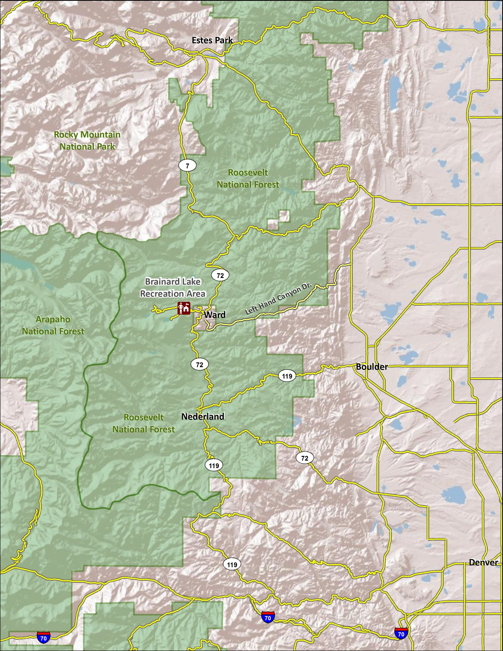
Route Map
4
3
2
1

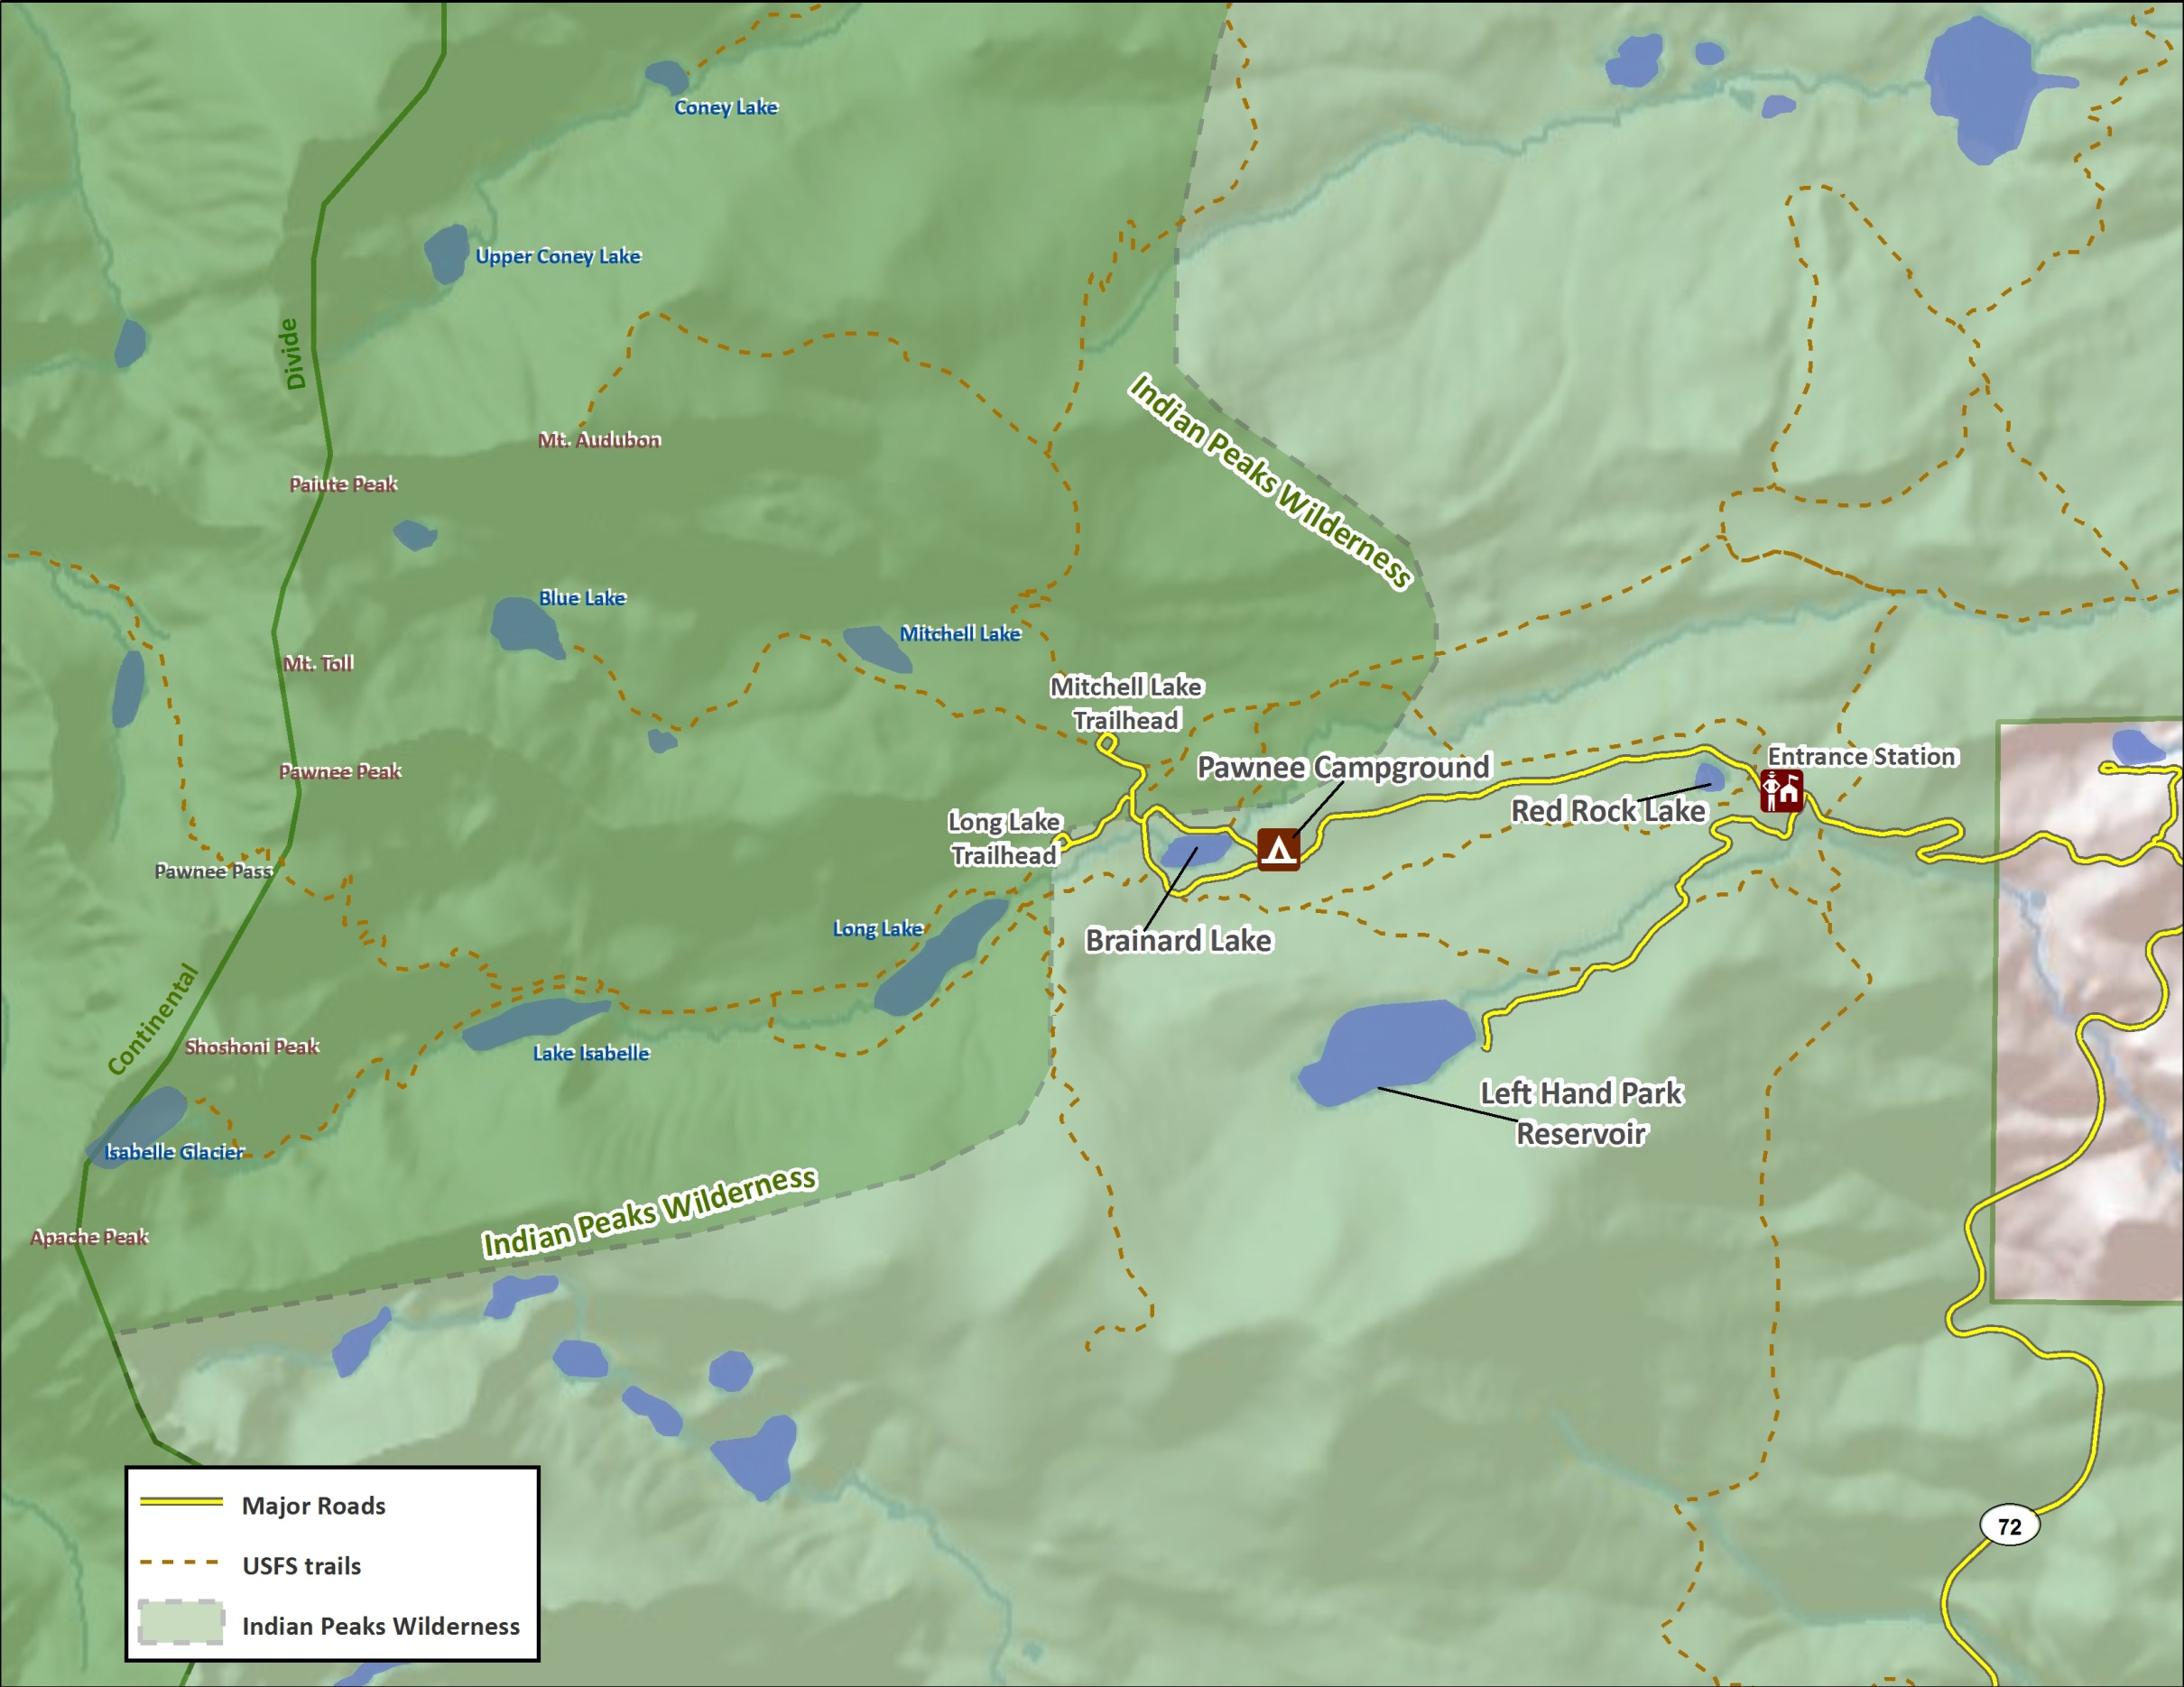
Area Map
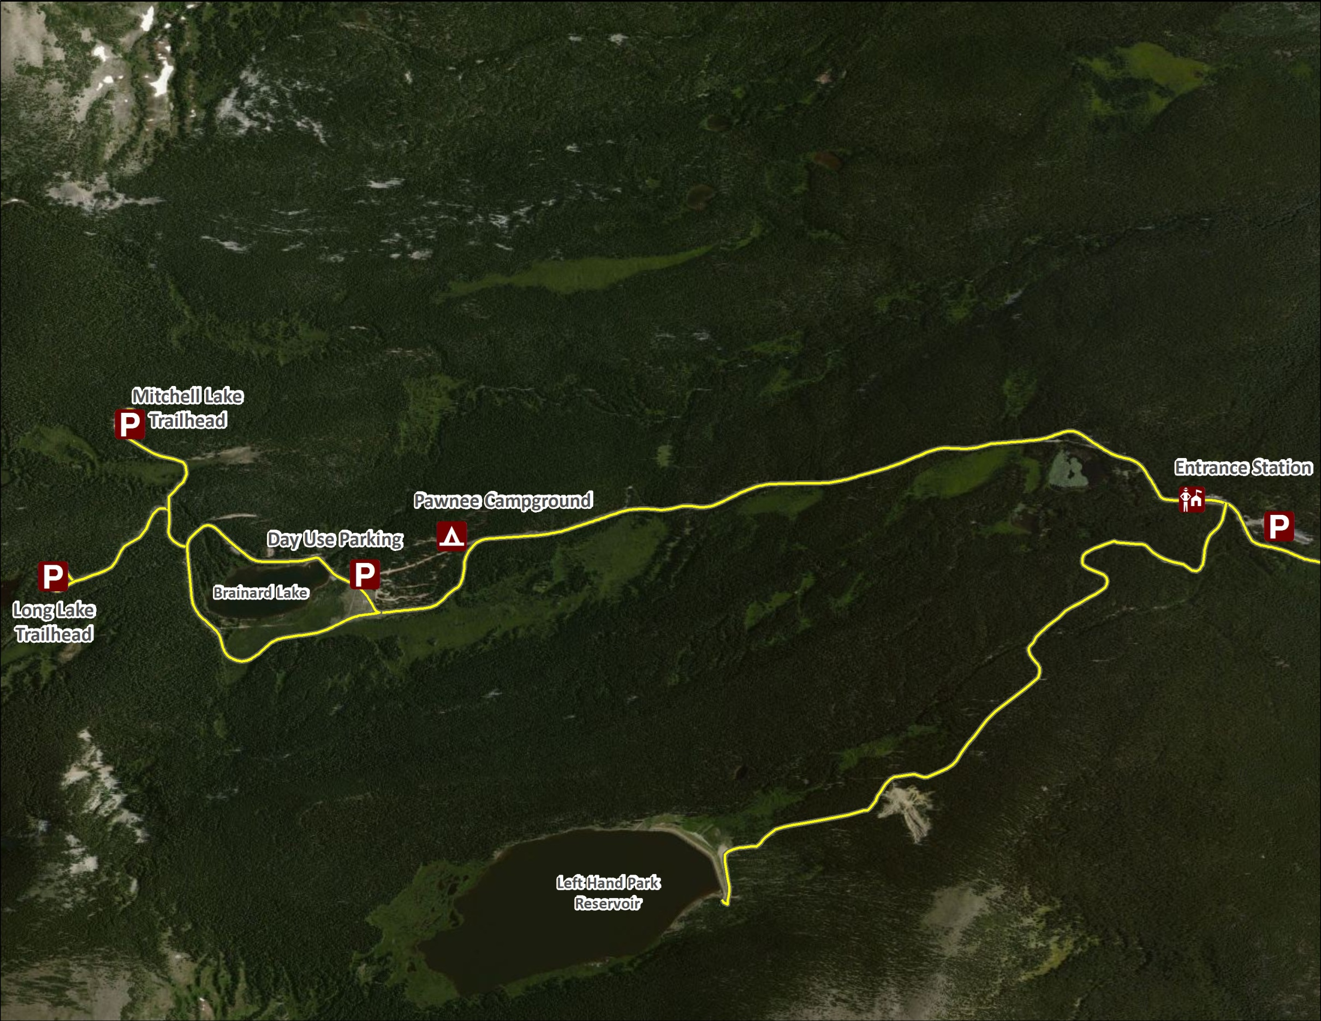
Parking Map

