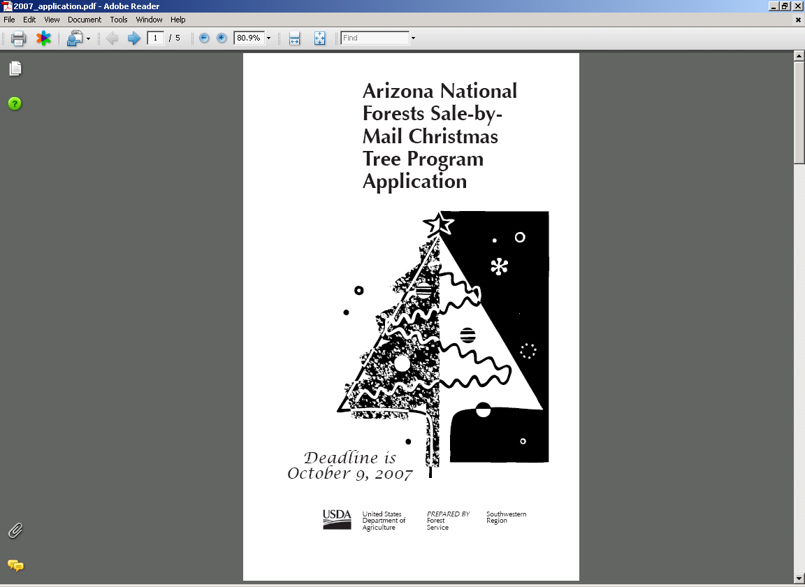

General Information

Arizona Sale-by-Mail Christmas Tree Program requirements:
- Only one tree per household
- Only one household per application
- Maximum of 5 applications per group, per envelope
- Applications MUST be postmarked by October 1, 2007
- If your application is drawn, you will be notified to send payment.
The Arizona Sale-by-Mail Program is administered by:
USDA Forest Service
Christmas Tree Program
2324 E. McDowell Road
Phoenix, AZ 85006
Telephone: (602) 225-5258
Web site: www.fs.fed.us/r3/tonto
Burden Statement
According to the Paperwork Reduction Act of 1995, an agency may not conduct or sponsor, and a person is not required to respond to a collection of information unless it displays a valid OMB control number. The valid OMB control number for this information collection is 0596-0085. The time required to complete this information collection is estimated to average 5 minutes per response, including the time for reviewing instructions, searching existing data sources, gathering and maintaining the data needed, and completing and reviewing the collection of information.
The U.S. Department of Agriculture (USDA) prohibits discrimination in all its programs and activities on the basis of race, color, national origin, gender, religion, age, disability, political beliefs, sexual orientation, and marital or family status. (Not all prohibited bases apply to all programs.) Persons with disabilities who require alternative means for communication of program information (Braille, large print, audiotape, etc.) should contact USDA’s TARGET Center at 202-720-2600 (voice and TDD).
To file a complaint of discrimination, write USDA, Director, Office of Civil Rights, 1400 Independence Avenue, SW, Washington, DC 20250-9410 or call (800) 795-3272 (voice) or (202) 720-6382 (TDD). USDA is an equal opportunity provider and employer.

Privacy Act Statement
The Privacy Act of 1974 and the regulations in 43 CFR 2.48(d) provide that you be furnished with the following information: The Forest Service use this information to maintain an inventory of forest product information and to adjudicate your rights to forest products. The information required by this form may be disclosed pursuant to the regulations in 7 CFR 1.5 or 43 CFR 2.56. If you do not furnish all information required by this form, your application may be rejected.
Application Instructions for Your Personal Use Christmas Tree Tag – 2007
Keep this document as a reference for when you receive your tag.
NOTE:
- Only one tree per household
- Group applications for up to five households will be accepted
  - Paper application: Fill out separate form for each household and staple together and mail in one envelope
  - Internet application: Internet form has room for five names and addresses.
Instructions for Completing the Application:
- Please use the enclosed map to select your desired forest and cutting area. Then rank your choice(s) [1 being your top choice] in the designated column on the application form. Although five areas are listed, you need only rank those in which you are interested. Remember, the more choices you rank, the better your chances are to be drawn.
- Fill in all the blanks on the application (name, address, etc.). Complete one application for each tree requested. If drawn as a group, each applicant in the group will receive a tag for the same cutting area, all mailed in the same envelope.
- Application submittal:
- Paper application: Application is on the last page of document. Cut along the dotted line. Complete one application for each household (up to five), staple all applications together, place in an envelope and mail to:
USDA Forest Service
Attn: Christmas Tree Program
2324 E. McDowell Road
Phoenix, AZ 85006
- Internet application: Internet form has room for five names and addresses. Complete the form as instructed and submit.

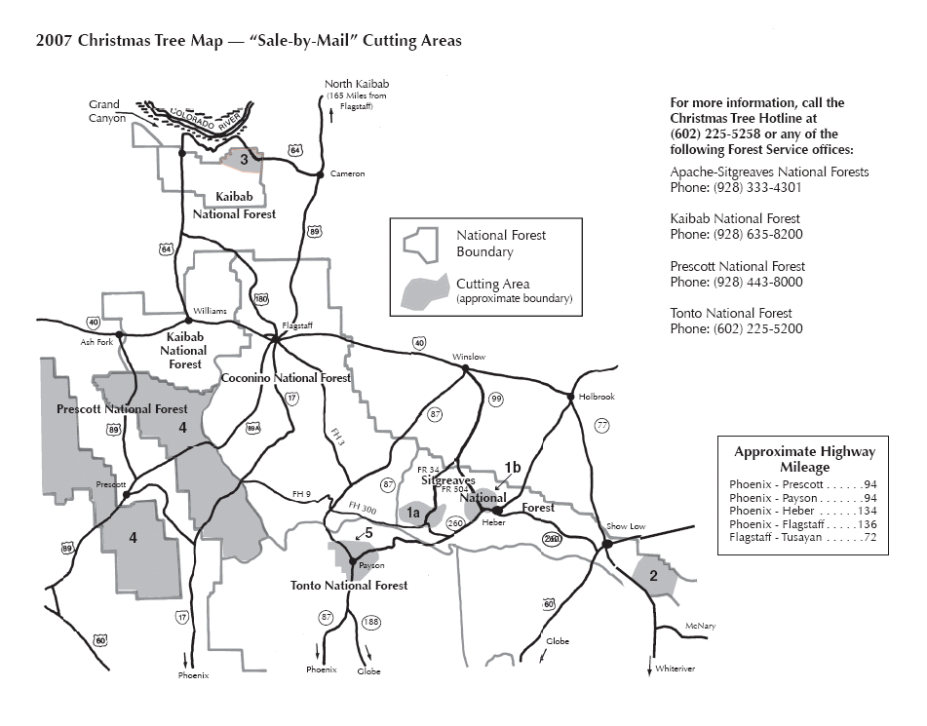

Program Rules

- All applications must be mailed or submitted via the Internet. Only paper applications postmarked by October 1, 2007, or Internet applications submitted by Midnight on October 1, 2007, will be entered in the drawing (lottery). Any applications postmarked/received via Internet after October 1, 2007 will be invalid.
- Those selected to receive permit will be notified and sent payment instructions.
- Tags will be mailed to successful applicants no later than November 9, 2007.
- Applications will be invalid and you will be notified if:
  - The application was postmarked or received via Internet after October 1, 2007.
  - The application is for more than one tree per household.
  - The application was filled out incorrectly.
All Sales are Final!
No refunds will be made for issued permits, even if the weather conditions prevent tag holder from reaching designated cutting area.
- Paper application must be postmarked no later than October 1, 2007, and mailed to:
USDA Forest Service
Attn: Christmas Tree Program
2324 E. McDowell Road
Phoenix, AZ 85006
- Internet application: Must be submitted no later than Midnight on October 1, 2007.
Answers to Frequently Asked Questions
Q: When will my tag be mailed?
A: All permits will be mailed by November 9, 2007

Q: May I bring my application in personally?
A: No, all applications must be mailed or submitted via Internet.

Q: Why must everyone use this system?
A: This allows everyone an equal opportunity to get a tag.

Q: May I apply for tags for other households?
A: Yes, up to five (5) households may apply at the same time either by filling out a paper application for each household, stapling together, and mailing in same envelope; or via the Internet.

Q: What will happen to me if I cut a tree without a tag?
A: You could be fined and your tree confiscated.

Q: May a tree be obtained for a church, school, company, or other organization?
A: No, this program is intended for individual/family use only.

Q: May I send in more than one application to raise my odds of being drawn?
A: No, duplicate applications will not be accepted.

Q: Where can I obtain more information?
A: From the Christmas Tree Hotline at (602) 225-5258, any of the Forest Services office listed on the map page, or at www.fs.fed.us/r3/tonto

