Screenshots for the Electronic Form FDA 3744 -
Antimicrobial Animal Drug Distribution Report for ADUFA Section 105

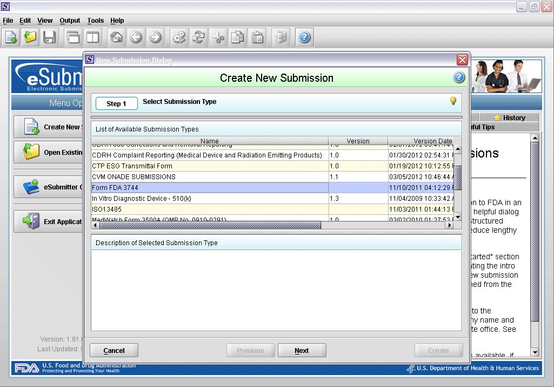
1. Create new submission.

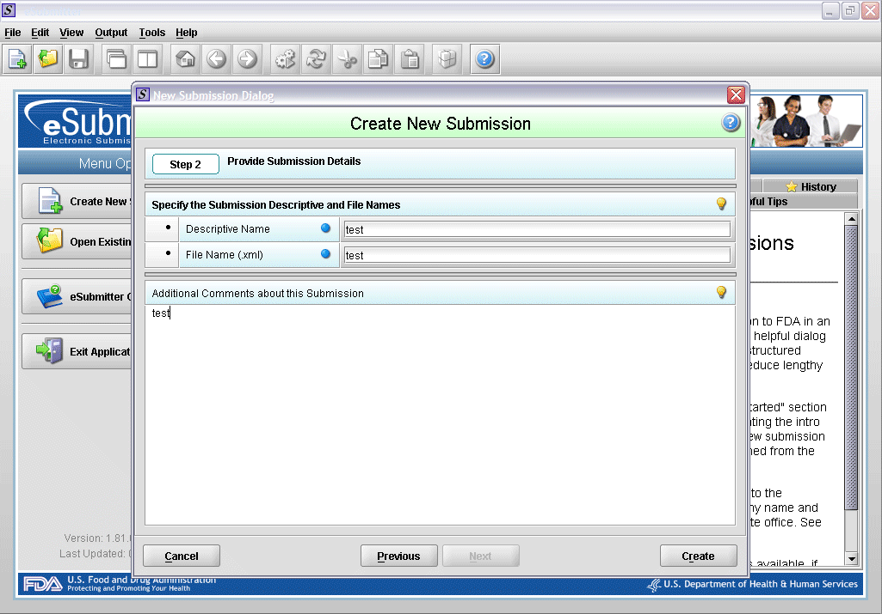
2. Enter description.
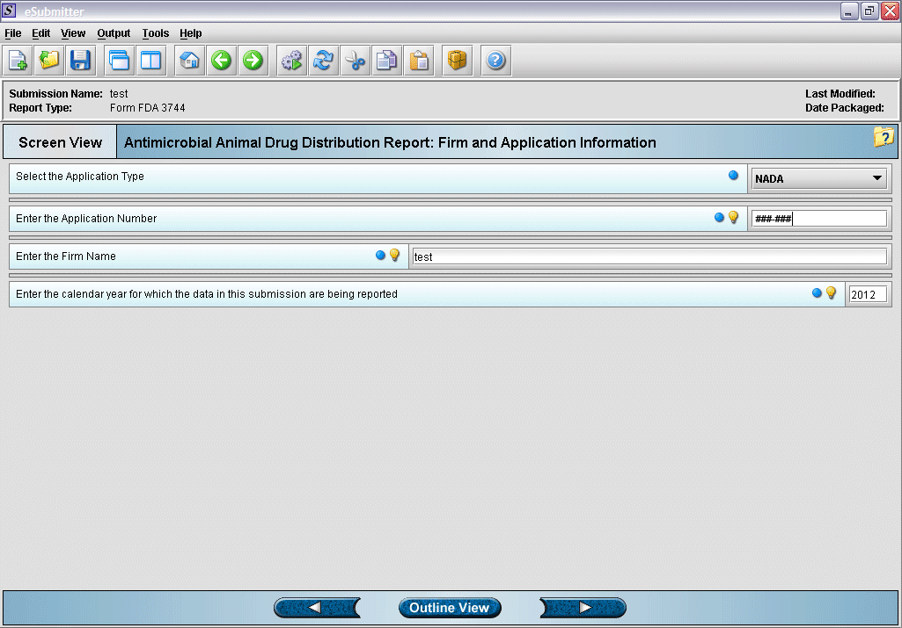
3. Enter identifying information for application.

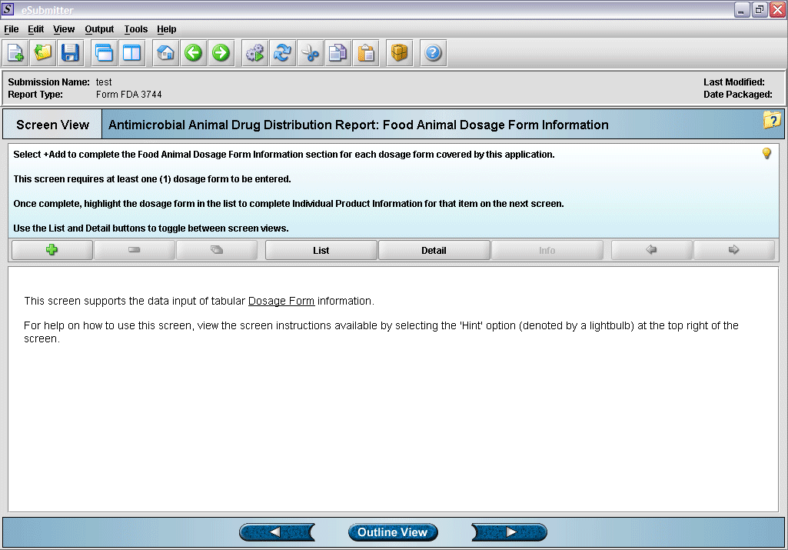
4. “Dosage Form” overview screen.
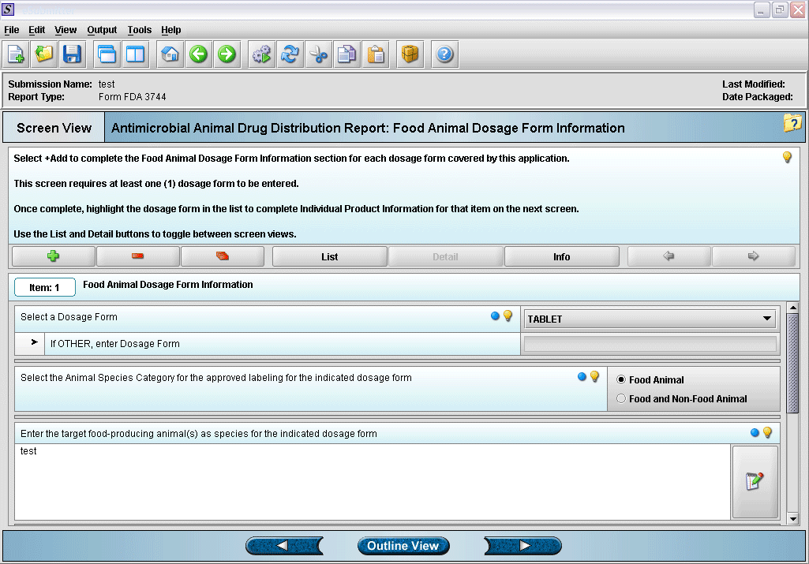
5. Entering dosage form information.

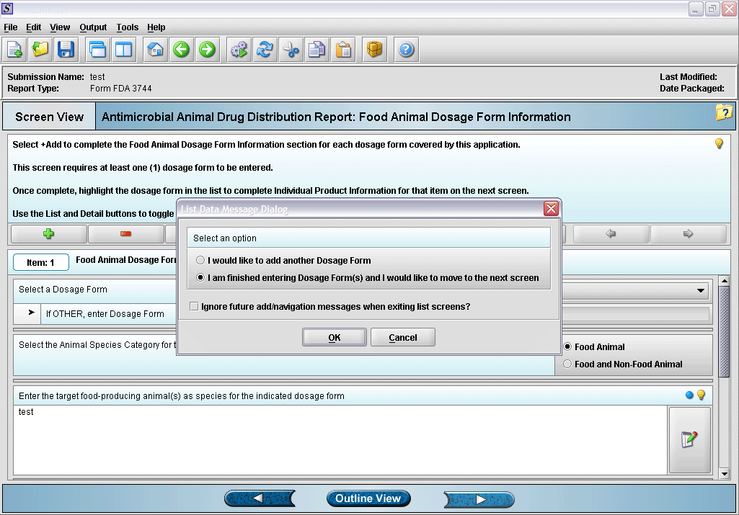
6. Prompt after finishing with dosage form information entry.
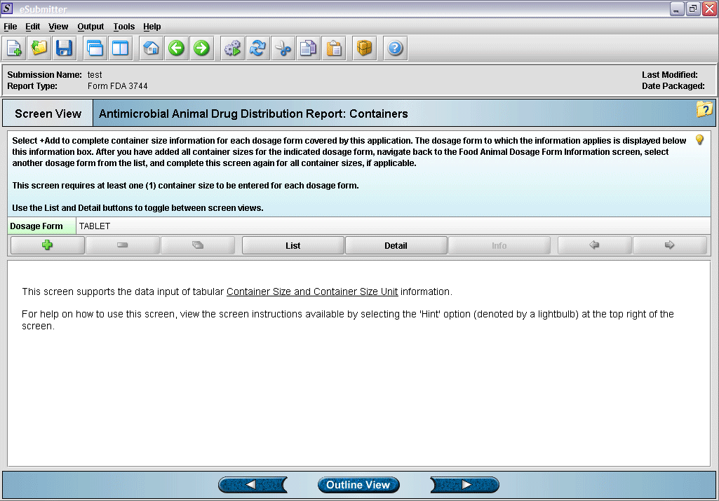
7. Container size and unit overview screen.

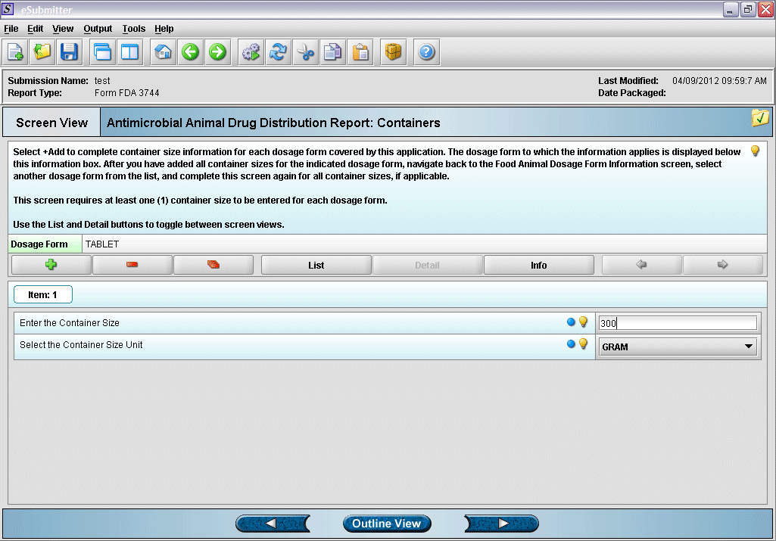
8. Entering container size and unit information (click green plus to add a container).
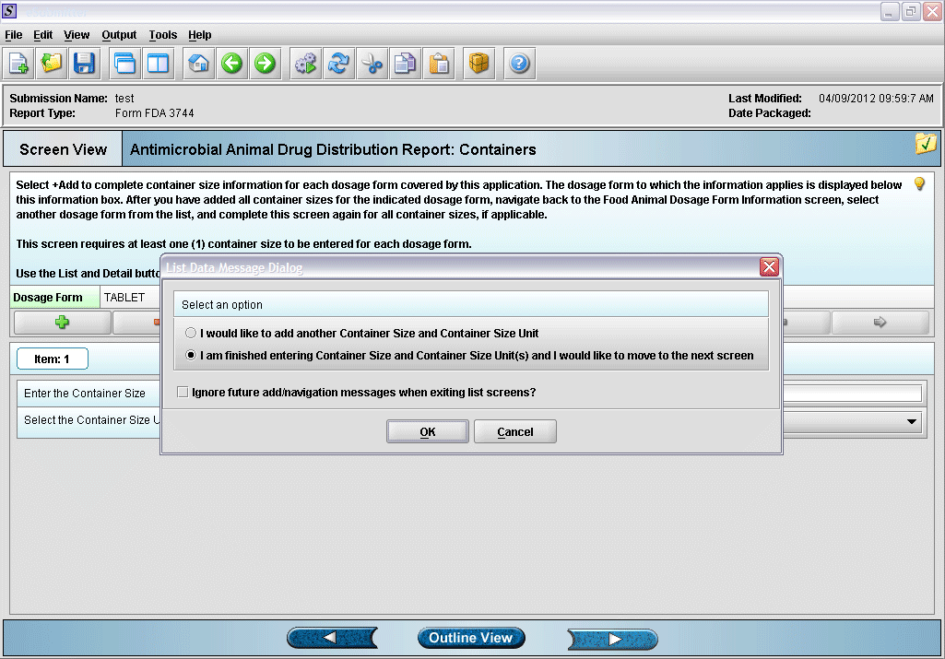
9. Prompt after finishing with container size and unit information entry.

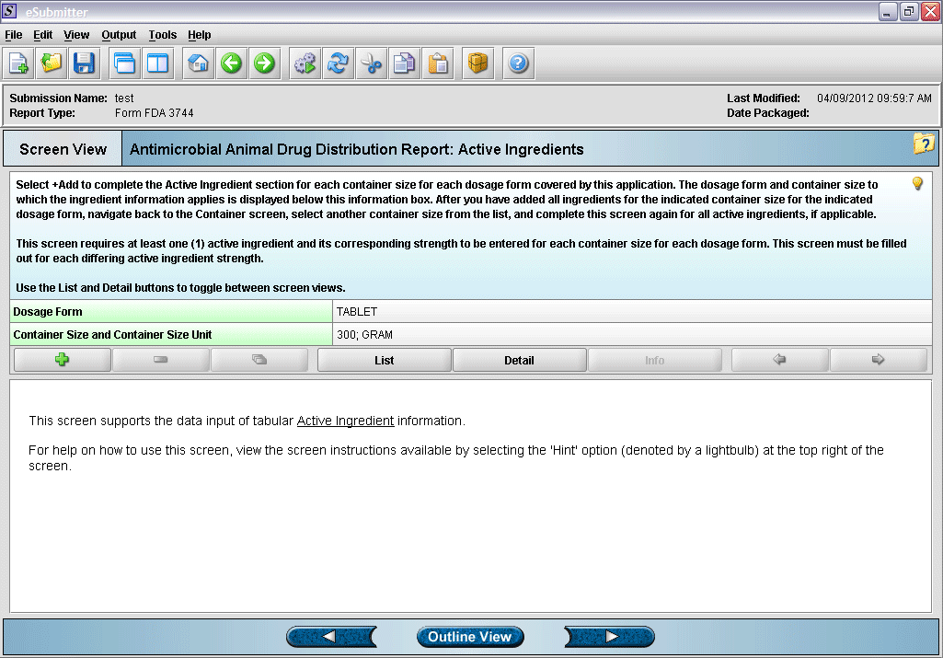
10. “Active Ingredient” overview screen.
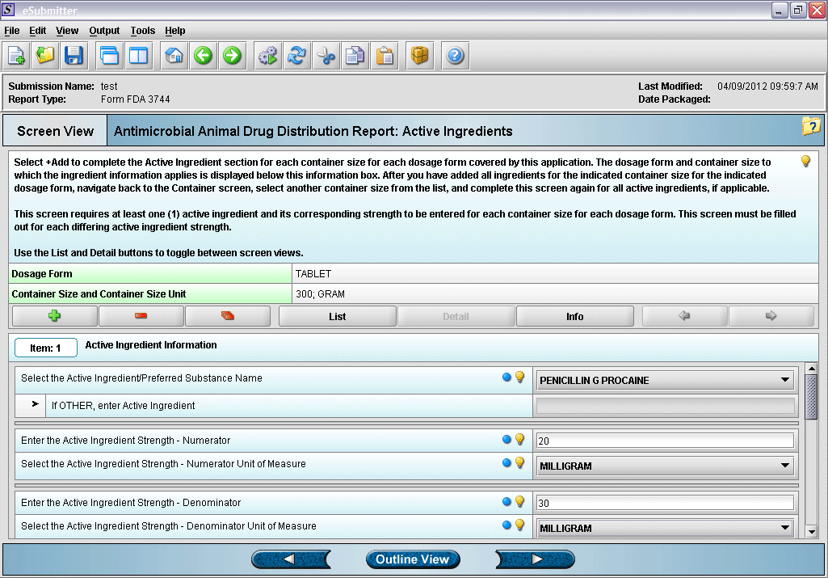
11. Entering active ingredient information.

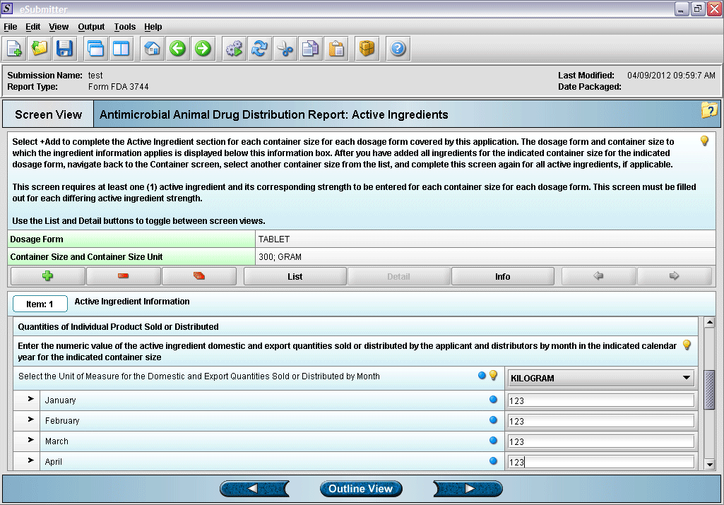
12. Entering active ingredient information (continued).
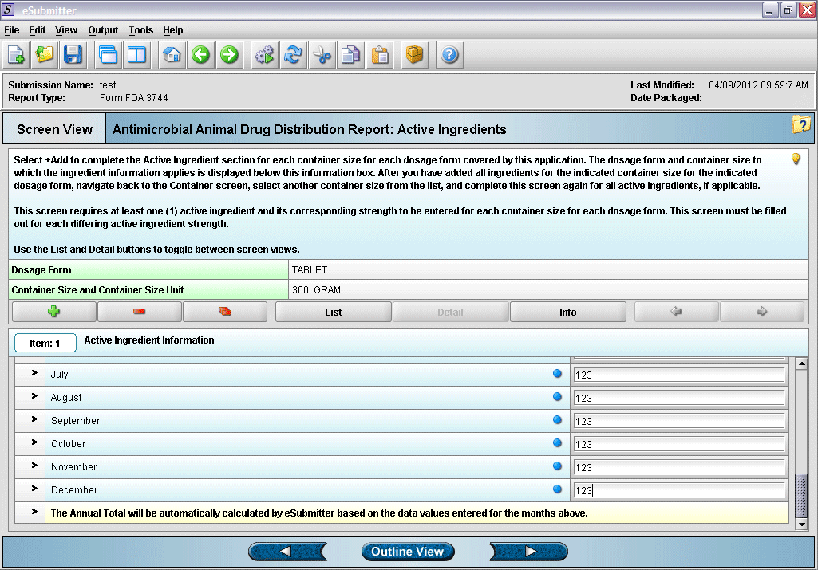
13. Entering active ingredient information (continued).

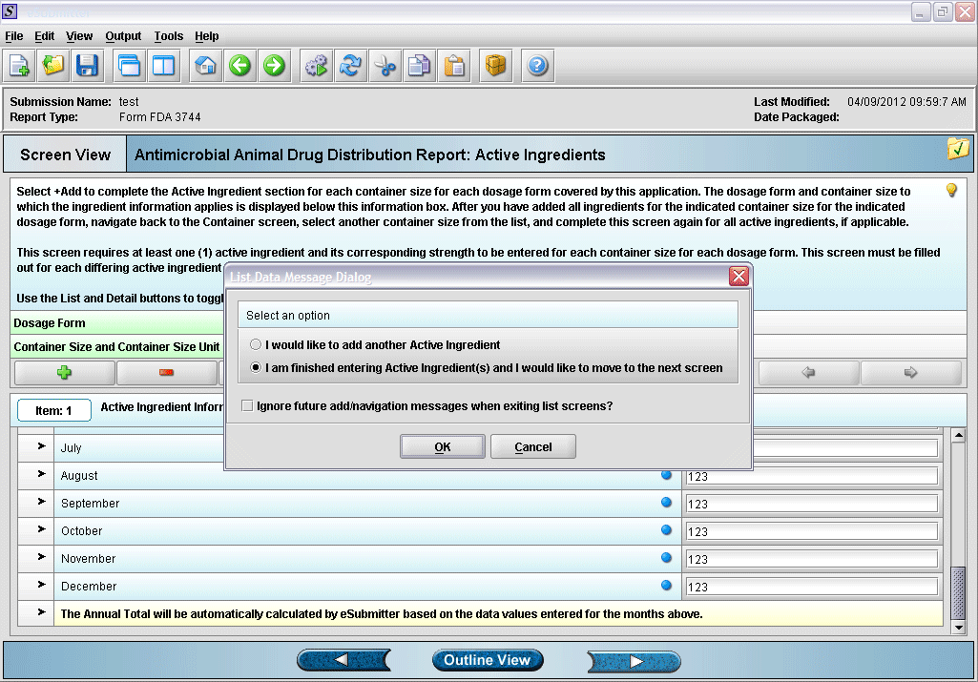
14. Prompt after finishing with active ingredient information entry.
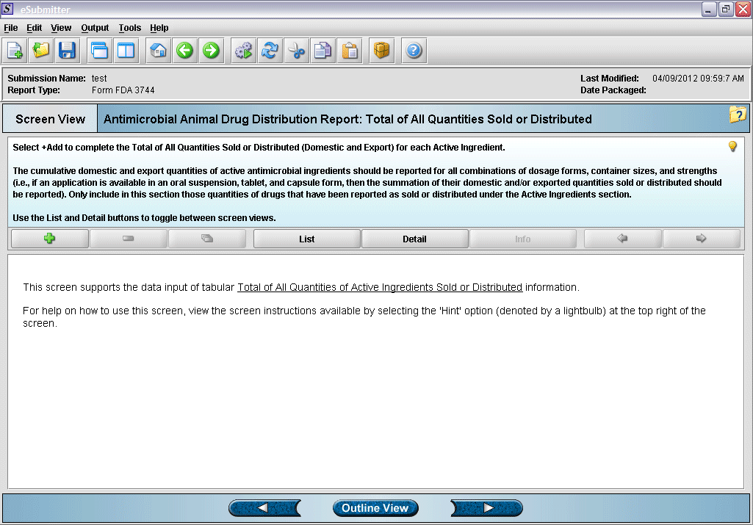
15. “Total of All Quantities Sold or Distributed” overview screen.

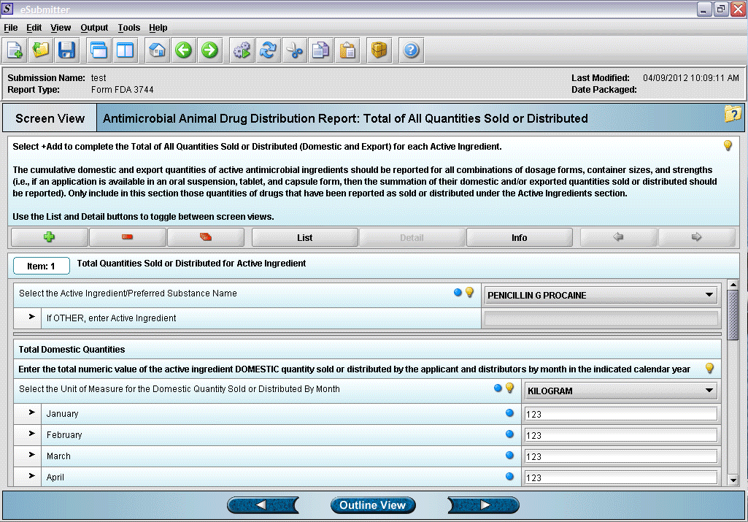
16. Entering total quantity sold information.
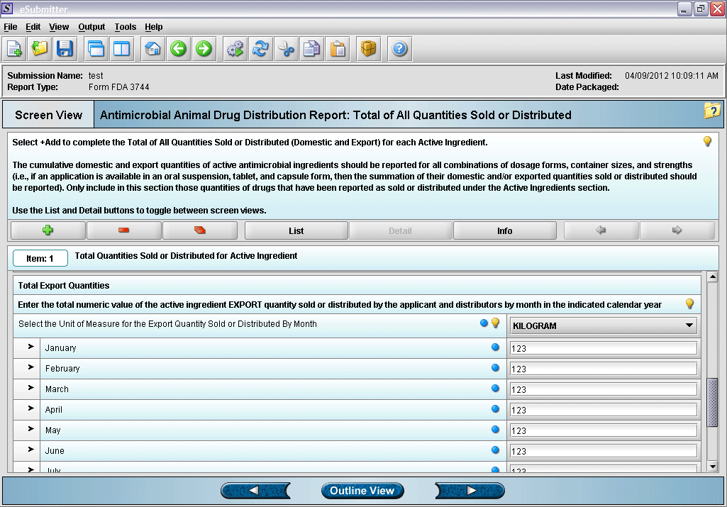
17. Entering total quantity sold information (continued).

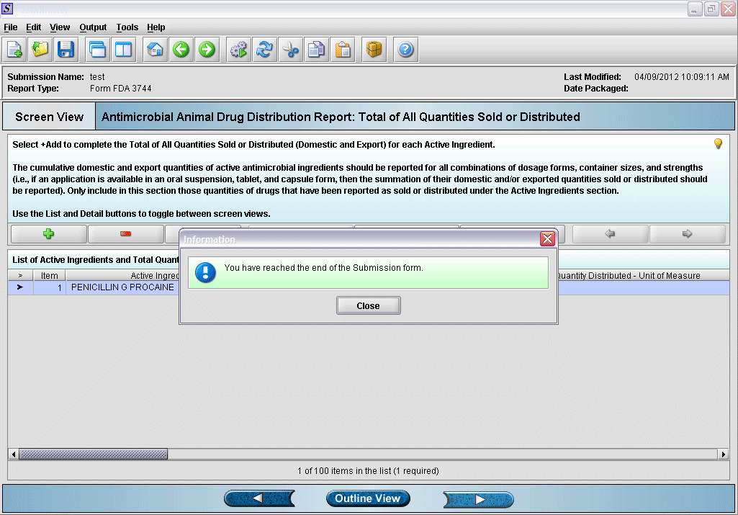
18. Form completed.

