0920-0004 National Disease Surveillance Program II-Disease Summaries
(expiration 8/31/14)
Change Request
April 5, 2013

Amy McMillen
CDC/NCEZID
1600 Clifton Rd
Atlanta GA 30333
404-639-1045
Auh1@cdc.gov

List of Attachments
National Outbreak Reporting System (NORS) – CDC 52.13 form
National Outbreak Reporting System (NORS) – CDC 52.12 form
Human Infection with Novel Influenza A Virus Case Report Form
Antiviral-Resistant Influenza Case Report Form

National Outbreak Reporting System (NORS) – CDC 52.13 form, Circumstances of Change Request for OMB 0920-0004
This is a nonmaterial/non-substantive change request for #0920-0004, which received a 3-year extension through August 2014 for the reporting of foodborne, enteric person-to-person, animal contact, environmental contamination other than food/water, and other/unknown modes of transmission outbreak data from 59 reporting jurisdictions (50 states, and 9 territories) to the National Outbreak Reporting System (NORS).
Although foodborne outbreaks surveillance has occurred since the 1970’s, NORS was launched in 2009 as the CDC Form 52.13, and collects aggregate outbreak data on foodborne, enteric person-to-person, animal contact, environmental contamination other than food/water, and other/unknown modes of transmission outbreaks. Data elements requiring change will improve clarification and readability of the data collection form; see table below. The settings or locations of the outbreak are routinely summarized in annual summaries and have been the subject of inquiry from the reporting agencies as well as US federal regulatory agencies. The setting or location where the outbreak occurred is important and essential to inform targeted intervention strategies, regardless of the primary mode of transmission. Currently, settings or locations of the outbreak are collected for animal contact, foodborne, and person-to-person outbreaks. However, the settings for environmental contamination other than food/water and other/unknown outbreaks are not collected. In response to the importance of the settings or locations of those outbreaks, reporting sites will be asked to complete an additional section, ‘Settings’, (formerly named ‘Person-to-Person’); no data collection fields will be added or changed to this section. The data collection changes are summarized in the table below.

Changes for clarification and readability
Section |  | Current Question/Item | Requested Change
General Section, Primary Mode of Transmission
No additional questions have been added
- General section sub-header was added for more detailed instructions
- All references to ‘Lab’ has been changed to ‘Etiology’ given feedback from reporting agencies that this label should be clearer
- All references to ‘Person-to-Person’ tab has been changed to ‘Settings’ to make the header more applicible to other modes of transmission
- ‘Indeterminate/Other/Unknown’ has been changed to ‘Other/Unknown’ because reporting sites noted the word ‘Indeterminate’ as a point of confusion and repetition.
- The Water checkbox has been greyed out because this information is collected through another reporting form
Primary Cases
No additional questions have been added
- The words ‘Primary Case Outcomes’ were added as a sub-header to show continuation between sections and for clarification
Incubation Period and Duration of Illness
No additional questions have been added
- Second column was greyed out to more clearly illustrate no information should be reported in that area
Secondary Cases
No additional questions have been added
- ‘Indeterminate/Other/Unknown’ has been changed to ‘Other/Unknown’ because the word ‘Indeterminate’ reporting sites noted the word as a point of confusion
Etiology Section and page headers
No additional questions have been added
- All references to ‘Laboratory’ has been changed to ‘Etiology’ given feedback from reporting sites agencies that this label should be clearer
- Etiology section sub-header was added for more detailed instructions
Isolates/ Strains
No additional questions have been added
- Isolates/Strains section has been updated to be more consistent with laboratory-based surveillance systems
  - ‘State lab ID’ changed to ‘State Lab ID/CaliciNet Key’
  - ‘PulseNet outbreak code’ changed to ‘CDC PulseNet or CaliciNet Outbreak Number’
  - ‘Other molecular designation’ changed to ‘CaliciNet Sequenced Region/Other Molecular Designation’
Animal Contact
No additional questions have been added
- Animal Contact Section sub-header was added for more detailed instructions
Food
No additional questions have been added
- Food Section sub-header was added for more detailed instructions
Changes in data collection related to Settings
Section | Current Question/Item |  | Requested Change
Primary Mode of Transmission
No additional questions have been added
- Instructions added for ‘Environmental contamination other than food/water’ and ‘Other/Unknown’ to complete the ‘Settings’ tab
Page 3 Header
No additional questions have been added
- ‘Person-to-Person’ tab has been changed to ‘Settings’
Settings Section
No additional questions have been added
- Settings Section sub-header was added for more detailed instructions
- This will be considered a new section for ‘Environmental contamination other than food/water’ and ‘Other/Unknown’ primary mode of transmission outbreaks

At the national level, the outbreak surveillance data are used to describe outbreaks and their characteristics through publications and data inquiries, identify trends in common exposures (including foodborne attribution and burden of illness estimates), inform public health policies, determine reporting metrics, and grant funding allocation.

Burden
The annualized burden hours and cost to reporting agencies to submit this data to CDC will not change significantly, if at all, from the estimates providing during the 2008 Paperwork Reduction Act Change Worksheet OMB 83-C (E) for OMB #0920-0004. The change to the annualized burden hours and cost is minimal because the reporting agencies currently collect these data elements for foodborne, person-to-person, and animal contact outbreaks. In addition, the setting or location where the outbreak occurred is a common data element reporting agencies track for internal documentation. Therefore, the effort to include these additional data elements does require a minimal up-front cost in hours. In addition, the changes to the annual submissions to CDC are not expected to change after these changes are implemented. The burden hours were based on the average time to complete the common data collection fields by multiple team members. In addition, the burden cost was based on the form being completed by master-level staff at the reporting site.

Estimates of Annualized Burden Hours (no change)
Type of Respondents | Form name | Number of Respondents | Number of Responses per Respondent | Average Burden Per Response (in hours) | Total Burden (in hours)
State or local governments | CDC Form 52.13 | 50 | 33.5 | 20/60 | 558
Territories | CDC Form 52.13 | 9 | 2.9 | 20/60 | 9
Total |  |  |  |  | 567

Estimates of Annualized Cost Burden (no change)
Respondents | Number of Respondents | Number of Responses per Respondent | Average Burden Per Response (in hours) | Hourly Wage Rate | Respondent Cost
State or local governments | 50 | 33.5 | 20/60 | $19.92 | $11,122
Territories | 9 | 2.9 | 20/60 | $19.92 | $173.30
Total |  |  |  |  | $11,295.30
Privacy Impact Assessment
No individually identifiable information is being collected.

National Outbreak Reporting System (NORS) – CDC 52.12 form, Circumstances of Change Request for OMB 0920-0004
The Waterborne Disease and Outbreak Surveillance System (WBDOSS) is a collaboration between the Centers for Disease Control (CDC), the Council of State and Territorial Epidemiologists (CSTE), and the Environmental Protection Agency (EPA). This system tracks and analyzes waterborne disease outbreaks in the United States. WBDOSS has received disease outbreak reports through the electronic National Outbreak Reporting System (NORS) since a revised form was approved by the Office of Management and Budget (OMB) in 2009. NORS variables correspond to variables in the CDC 52.12 form. The CDC 52.12 (rev 01 2010) has been revised to improve overall data quality and usability by local, state and national partners. Feedback from state and federal epidemiologists was solicited prior to making these changes. The most substantial changes on the revised form (CDC 52.12, rev 02 2013) are: 1) the simplification of an existing section that is used to report outbreak etiology; 2) the consolidation of questions about water sampling; and 3) the addition of a checkbox to better characterize exposures that cause waterborne disease outbreaks. Changes to the layout of the form are detailed in the table below. Neither the actual annual number of reports nor the burden hours for users are expected to increase or decrease as a result of the changes present in the CDC 52.12 (rev 01 2010), however a change has been made to how the numbers are calculated. This change is also described below.

Section | Current Question/Item | Requested Change
General | 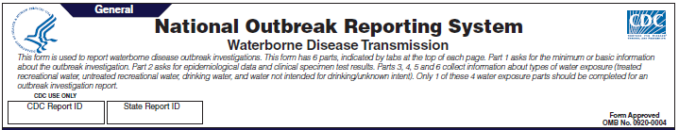 | 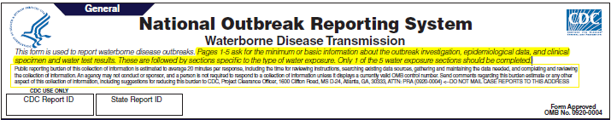
- Instructions have been updated based on changes throughout the form.
- Information about the public reporting burden has been moved from the bottom of page 14 (rev 01 2010) to the beginning of page 1 (rev 02 2013)
General Section, Primary Mode of Transmission | 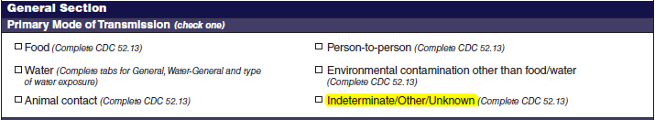 | 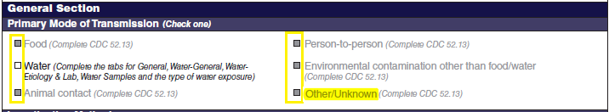
No additional questions have been added
- All checkboxes and text for modes of transmission besides ’Water’ have been greyed out because this information is collected through a different reporting form (the CDC 52.13 form).
- The instructions following the ‘Water’ checkbox have been updated to correspond with renamed or new sections of the form. ‘Indeterminate/Other/Unknown’ has been changed to ‘Other/Unknown’ because use of the word ‘indeterminate’ was repetitive and caused some confusion.
Primary Cases | 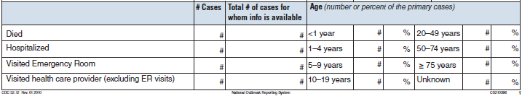 | 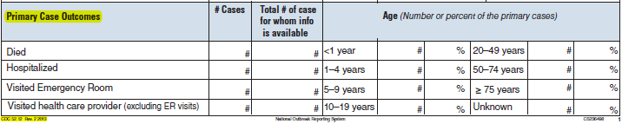
No additional questions have been added
- The title ‘Primary Case Outcomes’ has been added as a sub-header to show that the section is separate from the section called ‘Number of primary cases.’ The sub-header further clarifies that the section only collects data about primary cases. The revision date for the form has been updated in the bottom left corner of page 1 and all subsequent pages.

General Section, Incubation Period | 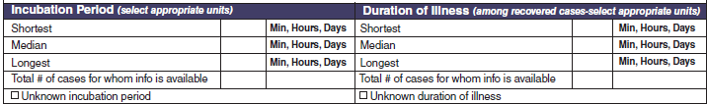 | 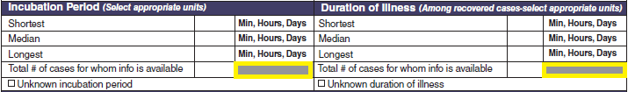
No additional questions have been added
- Two rectangles have been greyed out to more clearly illustrate no information should be reported in those areas.
Signs or Symptoms | 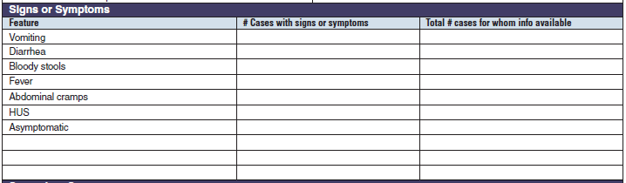 | 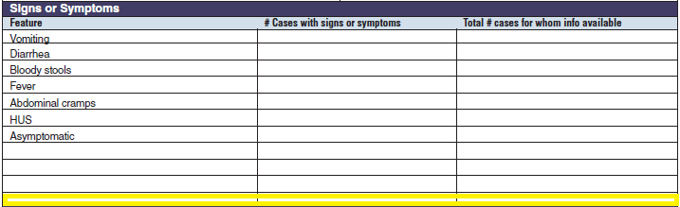
No new questions have been added
- An extra row has been added to the Signs or Symptoms table based on a review of outbreaks reported to CDC in 2009-2010, in which it was found that more than three additional symptoms had been reported in multiple waterborne disease outbreak reports.
Secondary Cases | 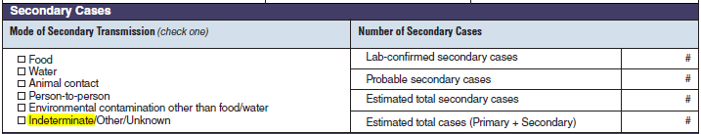 | 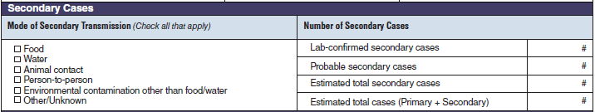
No additional questions have been added
- ‘Indeterminate/Other/Unknown’ has been changed to ‘Other/Unknown’ because use of the word ‘indeterminate’ was repetitive and caused some confusion.
Environmental Health Specialists Network
No new questions have been added
- An extra field has been added to the Environmental Health Specialists Network section to facilitate the linking of waterborne disease outbreak reports with environmental health assessments in an electronic database.

Waterborne Disease and Outbreaks - General | 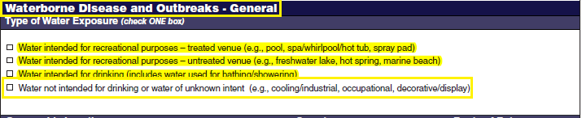 | 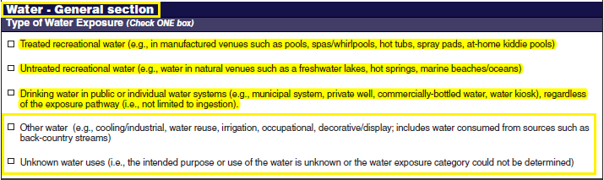
- The header has been shortened from ‘Waterborne Disease and Outbreaks – General’ to ‘Water – General section’
- Revisions have been made to the text associated with the first three check boxes, based on feedback that the meaning of the original text was not always clear.
- The text associated with the fourth check box has been revised for clarity. Further, while it initially combined two different categories of information, it now only describes one category. A fifth check box option has been added to describe the final category. The changes to the text and the addition of the fifth check box are based on feedback from public health professionals who report waterborne disease outbreaks to CDC.
Epidemiologic Data | 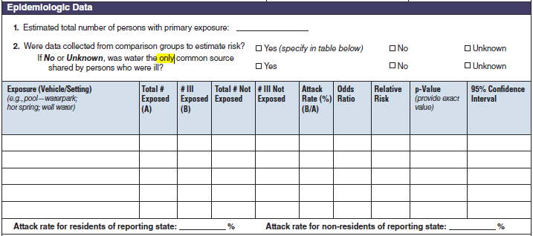 | 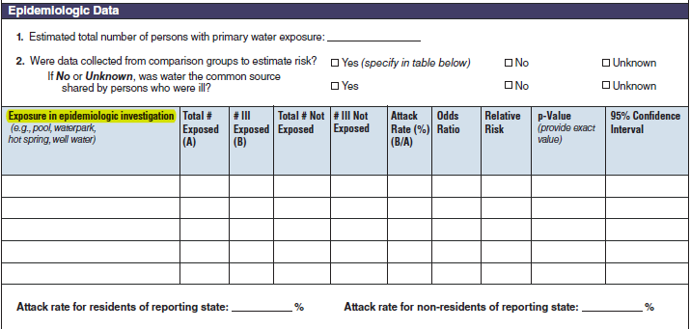
No additional questions have been added
- The Epidemiologic Data section has been moved higher up on Page 3. It now follows the Type of Water Exposure section.
- The word ‘only’ has been removed from question 2 for clarity.
- The first column in the table has been renamed from ‘Exposure’ to ‘Exposure in epidemiologic investigation’
Geographic location, Symptoms | 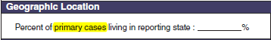 | 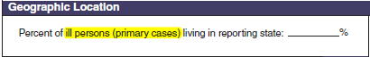
No additional questions have been added
- Geographic Location – This section has been moved down on page 3 and is now positioned below the Epidemiologic Data section
- Geographic location – The question has been reworded from ‘Percent of primary cases living in reporting state’ to ‘Percent of ill persons (primary cases) living in reporting state’ for clarity

 | 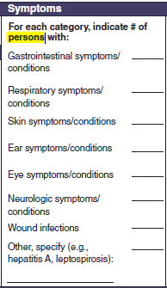 | 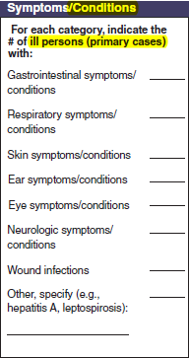
- Symptoms – This section has been moved down on page 3 and is now positioned below the Epidemiologic Data section
- Symptoms – The header has been changed from ‘Symptoms’ to ‘Symptoms/Conditions’
- Symptoms – The question has been revised for clarity. It was originally worded ‘For each category, indicate # of persons with:’ It now asks ‘For each category, indicate the # of ill persons (primary cases) with:’

Page 4 Header

No additional questions have been added
- The tab at the top of the page has been changed from ‘Water-General’ to ‘Water- Etiology & Lab’ to better describe the type of information being requested. The page has been reorganized to place high-priority questions about the outbreak etiology first, followed by questions about outbreak isolates, clinical specimens, and a new section call test type. The changes are detailed below.
Clinical Specimens – Laboratory Results | 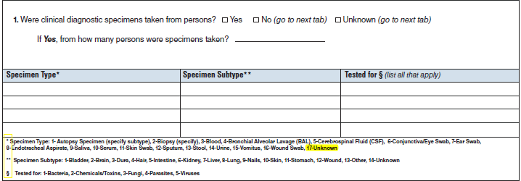 | 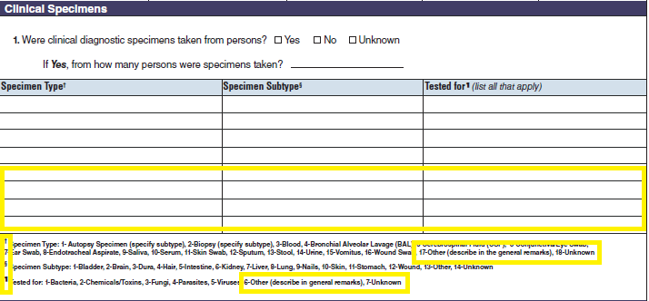
No additional questions have been added
- The header ‘Clinical Specimens – Laboratory Results’ has been shortened, as a reference to laboratory results is now part of the new tab name.
- The Clinical specimens has been moved down and is now table three on page 4.
- Four additional rows have been added to the table to accommodate information and to fill out white space on the page.
- The footnote symbols have been updated.
- The footnote for the ‘Specimen Type’ field has been updated to add a new value for specimen types that might not match the provided list. ‘17- Other (describe in the general remarks) has been added and ‘17-Unknown’ has been changed to ‘18- Unknown’
- The footnote for the ‘Tested for’ field has been updated to add two additional values. ‘6- Other (describe in general remarks)’ and ‘7- Unknown’ have been added.
Etiology | 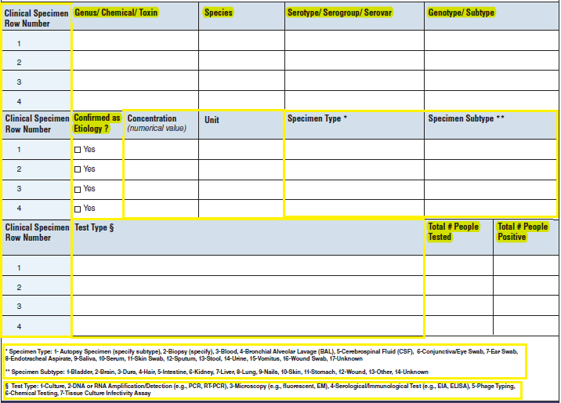 | 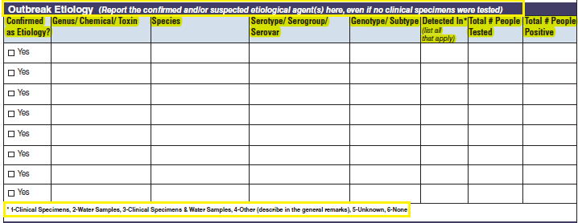
No additional questions have been added
- The outbreak etiology table has been given its own header labeled as ‘Outbreak Etiology,’ which is followed by corresponding guidance
- The outbreak etiology table has been moved to the top of page 4.
- The ‘Confirmed as Etiology?’ column has been moved to the beginning of the table.
- The table has been simplified. Variables have been either removed or added from this table to make the table easier to use while still retaining fields for critical questions.
  - Removed ‘Clinical Specimen Row Number’ – This field is no longer needed. It was used to link rows when the table was divided into three sections.
  - Removed ‘Concentration’ and ‘Unit’ columns, which were infrequently used and were not needed to answer the question asked by this section.
  - Removed ‘Specimen Type’ and ‘Specimen Subtype’ as well as corresponding footnotes as addressed in ‘Clinical Specimens’ section. This information can be sufficiently captured in the Clinical Specimens table (described previously).
  - Removed the ‘Test Type’ column and corresponding footnote from this table. Created a new section in the reporting form (Test Type section, described below).
  - Added a new question called ‘Detected in*’ with a corresponding footnote (‘1-Clinical Specimens, 2-Water Samples, 3-Clinical Specimens & Water Samples, 4- Other (describe in general remarks), 5- Unknown, 6- None’). This new question is comparable to one that is asked on the CDC 52.13 form. It provides a quick way to report the evidence supporting each etiology that has been entered in this table.
  - Reduced the overall size of the outbreak etiology table, which created space to add four rows to the table. Based on historical data, the four rows in the original form were sufficient for almost all outbreak reports, but some outbreaks require more than four entries.
Isolates | 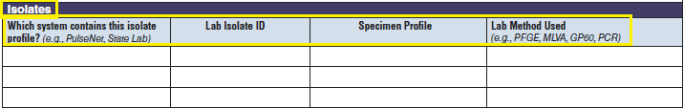 | 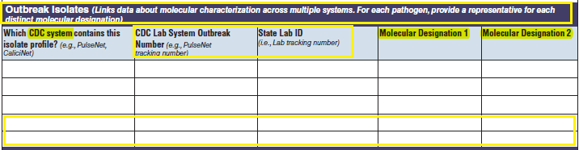
- The Isolates table has been renamed ‘Outbreak Isolates’ and corresponding guidance has been added for clarity, based on feedback from public health professionals who use the form.
- The Outbreak Isolates table has been moved to the middle of page 4, but remains directly after the Outbreak Etiology table.
- The column, ‘Which system contains this isolate profile?’ has been reworded to ‘Which CDC system contains this isolate profile?’ in order to focus on linking data in NORS with CDC laboratory data systems.
- To support linking of laboratory systems at both CDC and state levels, ‘Lab Isolate ID’ has been replaced by two distinct questions: ‘CDC Lab System Outbreak Number’ (a new field) and ‘State Lab ID’
- ‘Specimen profile’ has been renamed ‘Molecular Designation 1’ for clarity.
- ‘Lab Method Used’ has been inconsistently filled out and has been used by some people as a field to enter a second molecular designation. This question has been replaced with a field for a second molecular designation, called ‘Molecular Designation 2’
- Two additional rows have been added to this table to provide more fields for reporting molecular data.
Test Types |  | 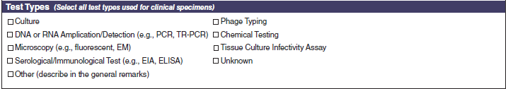
A section called Test Types has been added to the bottom of page 4.
- This section has replaced a column in the Outbreak Etiology table. It simplifies how test type information is reported. Previously, it was necessary to enter multiple rows of data in the etiology table and to select one test type for each row. Now multiple test types can be reported more easily by marking the appropriate checkboxes within this section.
- The Test Type options have not changed. The options were formerly listed in a footnote for the Outbreak Etiology table. The list has been used to create the new set of checkboxes.

Laboratory Section | 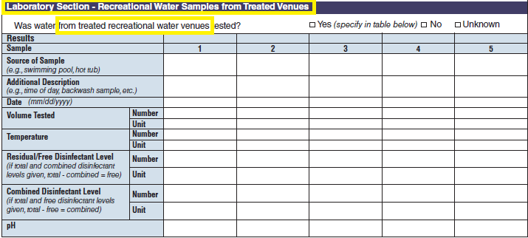  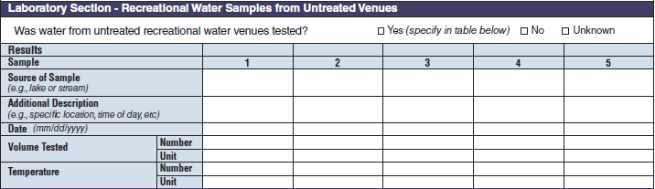  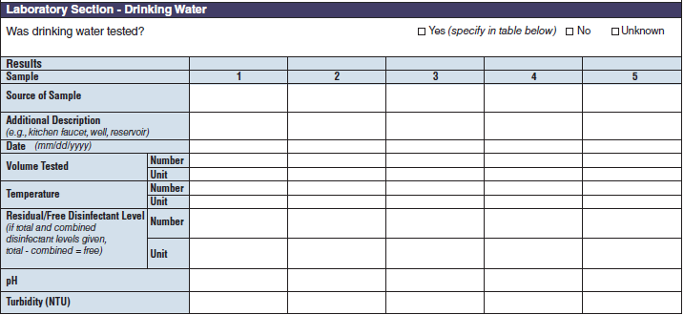  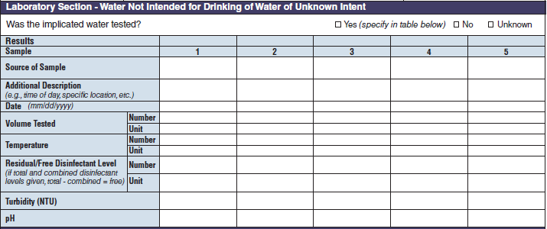 | 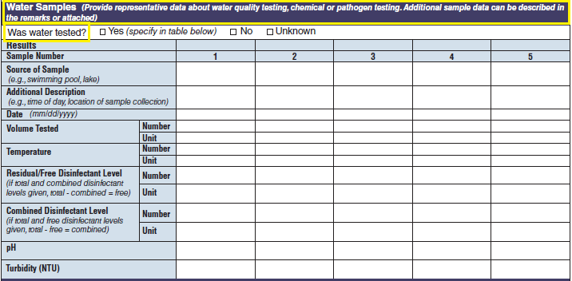
No additional questions have been added
• Previously, there were four different sections about water sampling in the form. One section would be filled in per report, depending on the type of water exposure selected at the top of page 3 (i.e., Recreational water – treated, Recreational water – untreated, Drinking Water, and Water Not Intended for Drinking or Unknown). Each water sample section collected the same type of information. As a result, the sections were very similar. The four sections have been removed and consolidated into one section and page. The consolidated section and page have been labeled as a new tab called Water Samples. The Water Samples page, which can be used for any outbreak report, has been placed on page 5 so that it precedes sections of the form that are specific to the type of water exposure categories.

The four water sample tables (below, at left) have been combined into one (below, at right):
- The multiple choice question that preceded every water sample table has been reworded to be more general, so that it asks about any water testing, rather than water testing for specific types of water exposures. This better reflects the original intent of the question and makes the question generalizable across all types of waterborne disease outbreaks.
- The header has been changed from ‘Laboratory Section’ to ‘Water Samples.’ Additional guidance has been provided after the header.
- The consolidated water sample table has been placed at the top of page 5.
- All of the fields from the original tables on pages 5, 7, 9, and 13 have been consolidated into one table. The final table contains some fields that may not apply to all reports but provides more flexibility for reporting water samples if multiple types of water samples are collected during an outbreak investigation.
- The final table contains all variables listed in the four source tables: ‘Sample (number)’, ‘Source of Sample’, ‘Additional Description’, ‘Date’, ‘Volume Tested w/Number and Unit’, ‘Temperature w/Number and Unit’, ‘Residual/Free Disinfectant level w/Number and Unit’, ‘pH’, and ‘Turbidity’.
Water Quality Indicator | 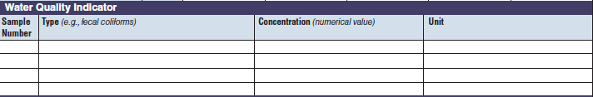 | 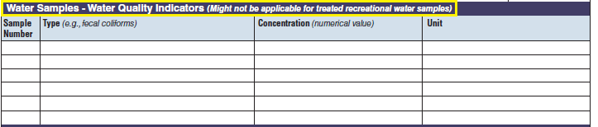
The three water quality indicator tables have been combined into one (below, at right). The left side of table shows an example of the original tables, because all three tables are the same:
- The header has been changed from ‘Water Quality Indicator’ to ‘Water Samples – Water Quality Indicator’ with corresponding guidance. This table was previously not available for treated recreational water outbreaks. The guidance explains that these questions may not apply for those outbreaks but does not prevent the use of this table.
- All of the fields from the original tables on pages 7, 10, and 13 have been consolidated into one table.
- Two additional rows have been added to allow for the submission of more water quality data.
Microbiology or Chemical/ Toxin Analysis | 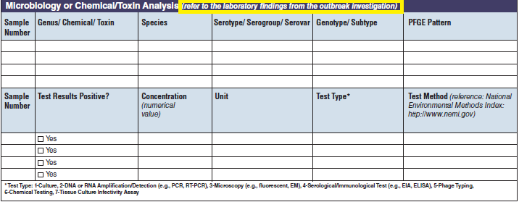 | 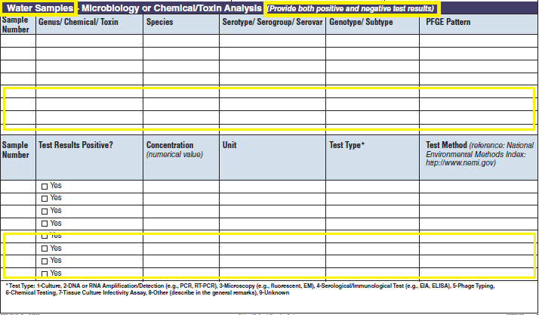
The four microbiology or chemical/toxin analysis tables have been combined into one (below, at right). The left side of table shows an example of the original tables, because all four tables are the same:
- The header has been changed from ‘Microbiology or Chemical/Toxin Analysis’ to ‘Water Samples – Microbiology or Chemical/Toxin Analysis’ with corresponding guidance.
- The guidance following the header has been revised in response to questions and data received from form users.
- All of the fields from the original tables on pages 7, 10, and 14 have been consolidated into one table.
- Four additional rows have been added to allow for the submission of additional water testing results.

Recreational Water – Treated Venue, Recreational Water Vehicle Description | 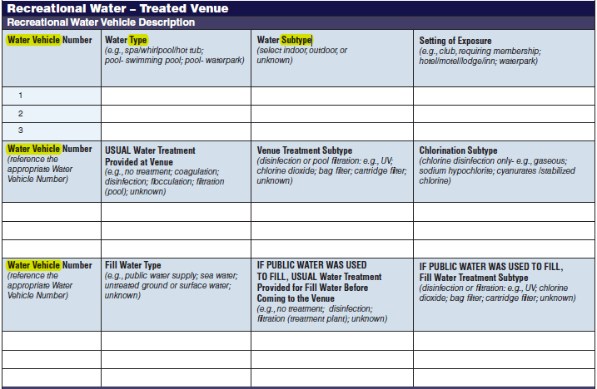 | 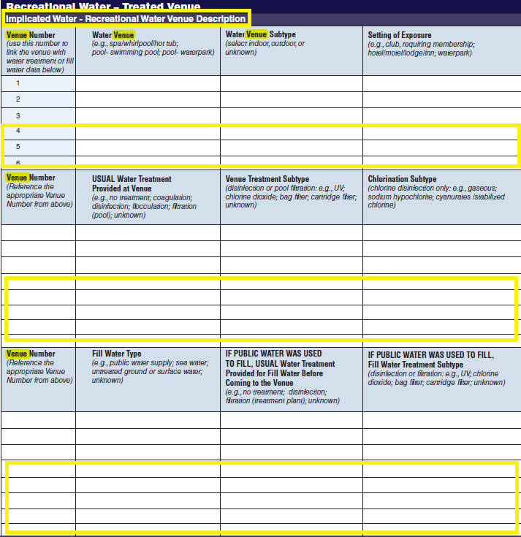
No additional questions have been added
- The sub-header description has been changed from ‘Recreational Water Vehicle Description’ to ‘Implicated Water – Recreational Water Venue Description’
- All ‘Water Vehicle Number’ column names have been changed to ‘Venue Number’
- References to ‘Water Type’ and ‘Water Subtype’ in the first table have been changed to ‘Water Venue’ and ‘Water Venue Subtype’, respectively.
- Three additional rows have been added to the first table to allow for the submission of more data.
Five additional rows have been added to both the second and third tables to allow for the submission of more data. More rows were added to these two tables because for a single row in the first table, multiple rows of data may be filled out in second and third tables.
Recreational Water Quality | 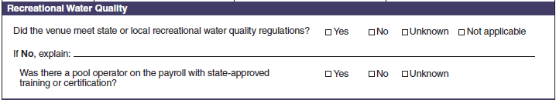 | 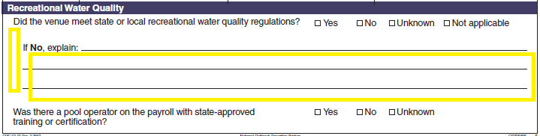
- No additional questions have been added. The question beginning with ‘If No, explain’ has been indented to clarify that it is only applicable if the previous question has been answered ‘No’.
- Additional lines have been added after this question to provide more space for an explanation.
Laboratory Section – Recreational Water Samples from Treated Venues | 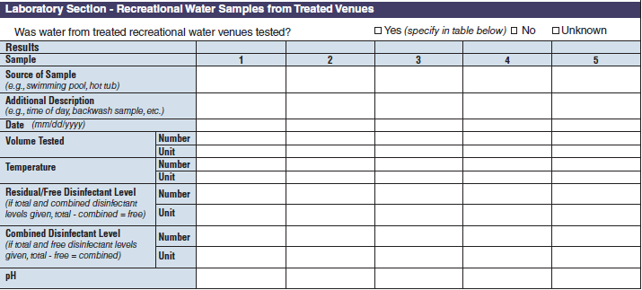
 | - This section has been deleted from page 5 and consolidated into a section called Water Samples (described previously).
Microbiology or Chemical/  Toxin Analysis | 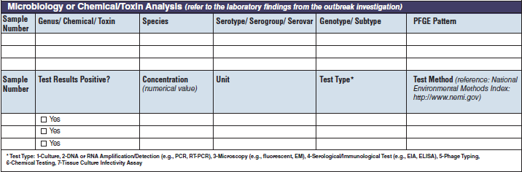
 | - This section has been deleted from page 6 and consolidated into a section called Water Samples (described previously).

Factor Contributing to Recreational Water Contamination and/or Increased Exposure in Treated Venues | 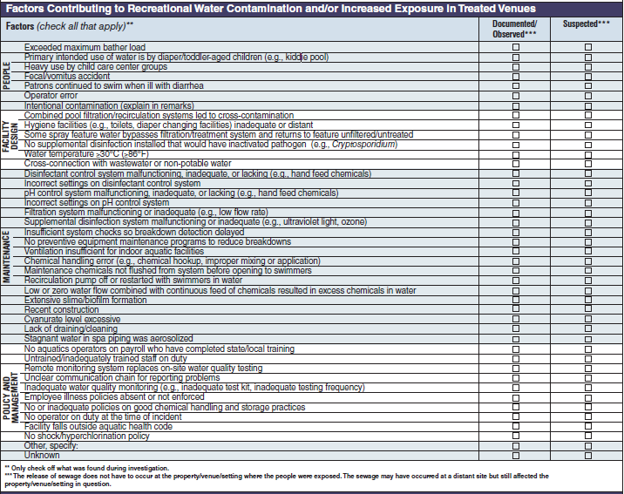 | 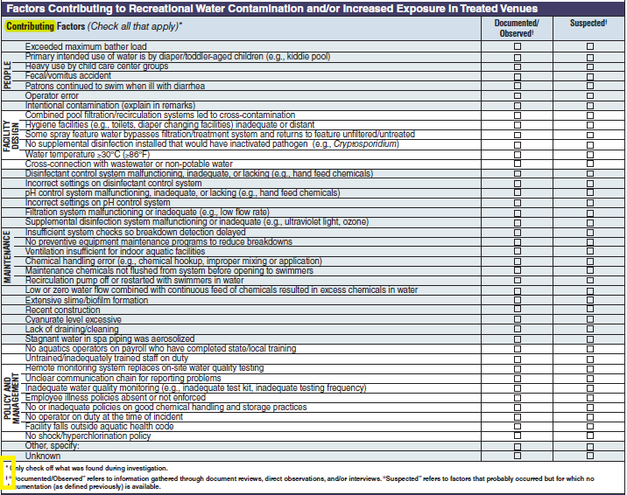
No additional questions have been added
- The sub-header text has been changed ‘Factors’ to ‘Contributing Factors’
- The footnote symbols have been updated as part of an effort to make them more consistent throughout the form.
- A correction has been made to the second footnote, which should have provided guidance on reporting suspected contributing factors but instead provided guidance from another section about contributing factors related to sewage releases.
Remarks
No additional questions have been added
- The remarks section has been expanded to make use of the remaining space at the end of the page.

Recreational Water – Untreated Venue. Recreational Water Vehicle  Description | 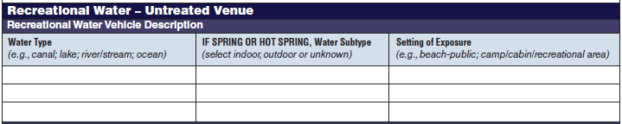 | 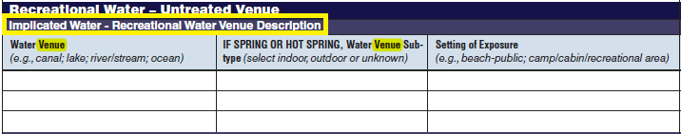
No additional questions have been added
- The sub-header description has been changed from ‘Recreational Water Vehicle Description’ to ‘Implicated Water – Recreational Water Venue Description’
- References to ‘Water Type’ and ‘Water Subtype’ have been changed to ‘Water Venue’ and ‘Water Venue Subtype’, respectively.
Recreational Water Quality | 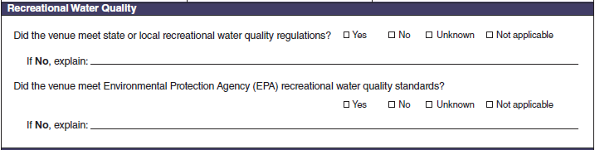 | 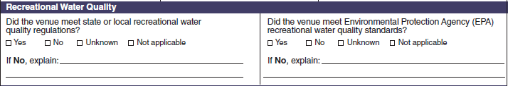
No additional questions have been added
- The questions have been reformatted to appear side by side.
Laboratory Section – Recreational Water Samples from Untreated Venues
 | - This section has been deleted from page 7 and consolidated into a section called Water Samples (described previously).
Water Quality Indicator
 | - This section has been deleted from page 7 and consolidated into a section called Water Samples (described previously).
Microbiology or Chemical/ Toxin Analysis | 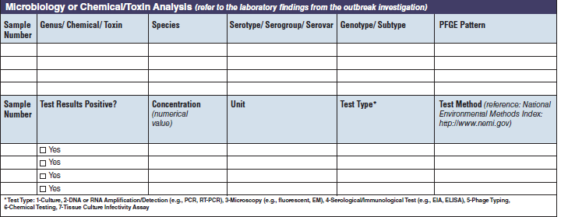
 | - This section has been deleted from page 7 and consolidated into a section called Water Samples (described previously).
Factors Contributing to Recreational Water Contamination and/or Increased Exposure in Untreated Venues | 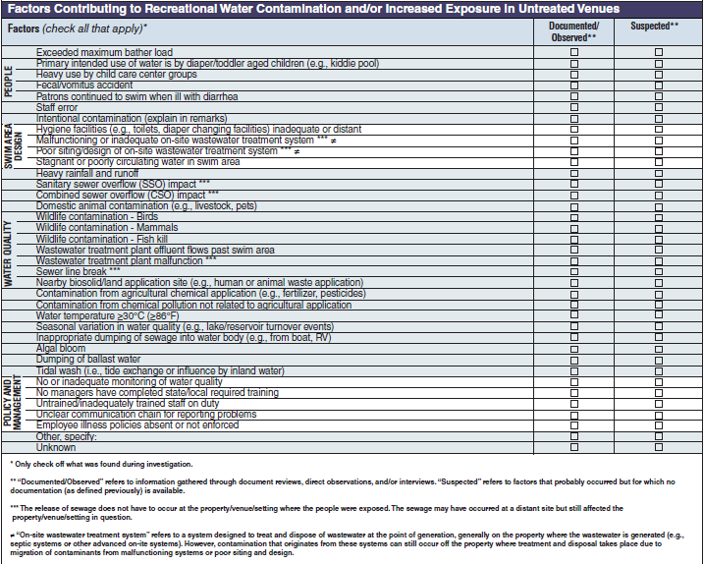 | 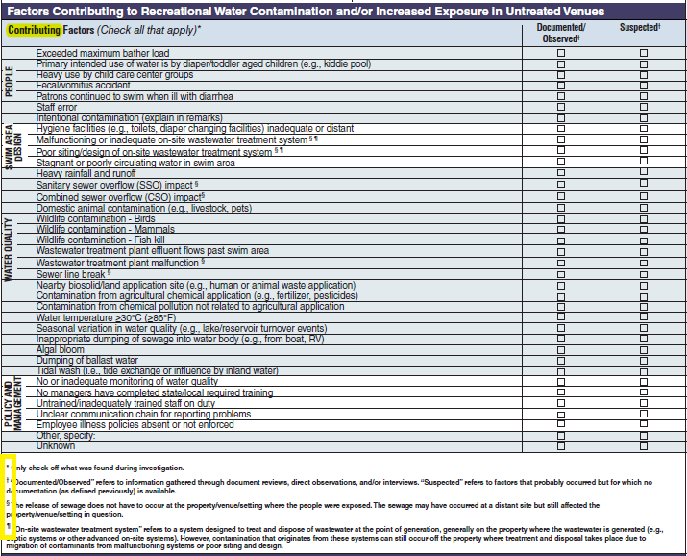
No additional questions have been added
- The sub-header text has been changed ‘Factors’ to ‘Contributing Factors’
- The footnote symbols have been updated as part of an effort to make them more consistent throughout the form.

Remarks
No additional questions have been added
- The space for the remarks section has been reduced to fit within the remaining space on the page.

Drinking Water Vehicle Description | 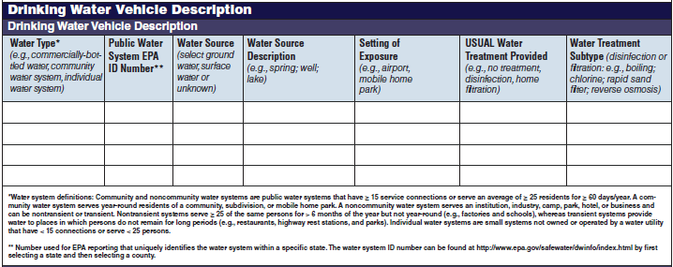 | 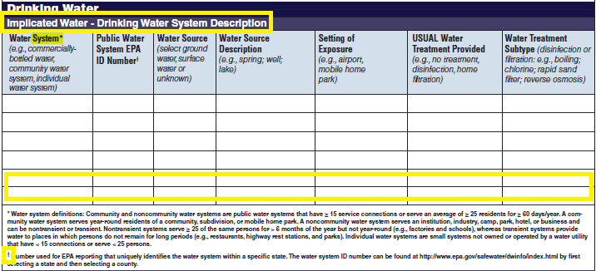
No additional questions have been added
- The header has been changed from Drinking Water Vehicle Description to Drinking Water.
- The sub-header description has been changed from ‘Drinking Water Vehicle Description’ to ‘Implicated Water – Drinking Water System Description’
- The reference to ‘Water Type’ in the first column has been changed to ‘Water System’
- Two additional rows have been added to allow for the submission of more water system data.
- A footnote symbol has been updated as part of an effort to make the footnotes symbols more consistent throughout the form.
Drinking Water Quality | 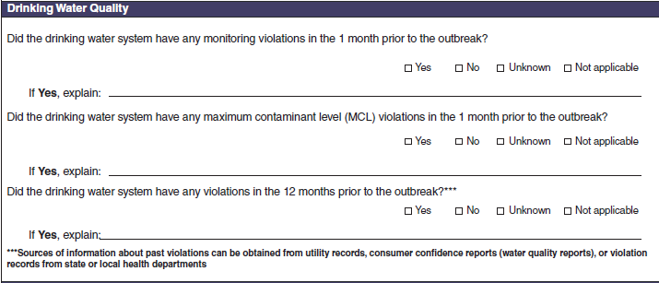 | 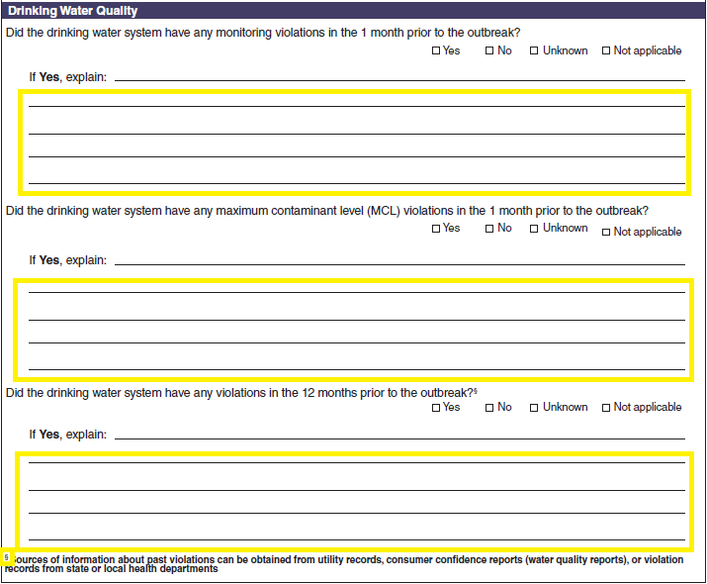
No additional questions have been added
- Additional lines have been added following all three questions that begin with ‘If Yes, explain’ in order to provide more space for the explanations.
- A footnote symbol has been updated as part of an effort to make the footnote symbols more consistent throughout the form.
Laboratory Section – Drinking Water
 | - This section has been deleted from page 9 and consolidated into a section called Water Samples (described previously).
Water Quality Indicator | 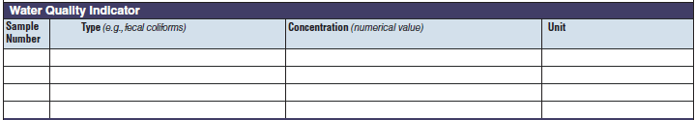
 | - This section has been deleted from page 10 and consolidated into a section called Water Samples (described previously).
Microbiology or Chemical/Toxin Analysis | 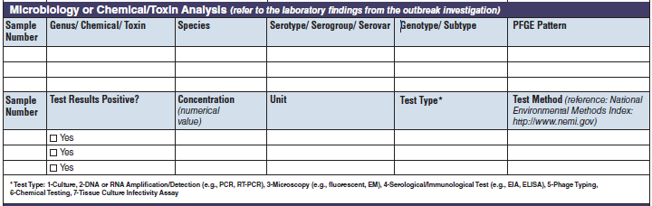
 | - This section has been deleted from page 10 and consolidated into a section called Water Samples (described previously).

Factors Contributing to Drinking Water Contamination and/or Increased Exposure to Contaminated Drinking Water  Source Water Factors | 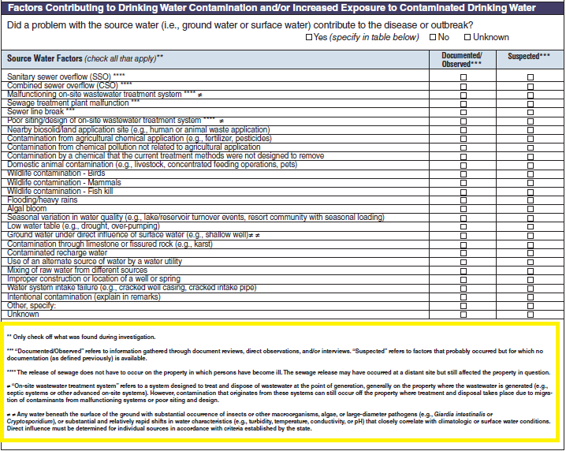 | 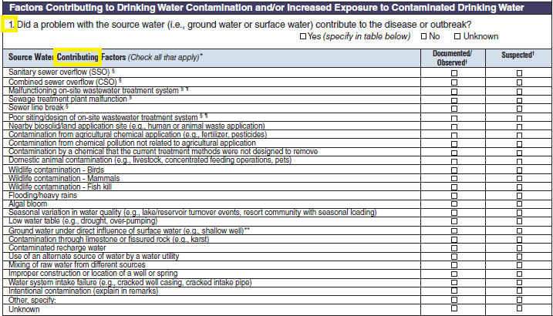
No additional questions have been added
- The multiple choice question has been numbered ‘1’ because it is the first of four questions. The sub-header text has been changed from ‘Source Water Factors’ to ‘Source Water Contributing Factors’.
- The footnote symbols have been updated as part of an effort to make them more consistent throughout the form.
- This section now begins at the top of page 10 so any footnote text has been moved to the bottom of the page (see next section).
Treatment Factors | 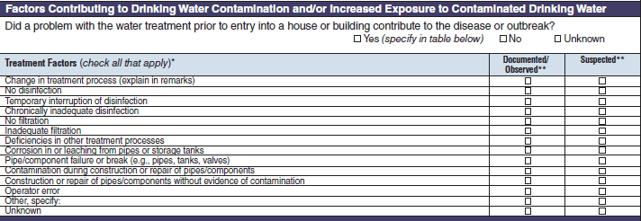 | 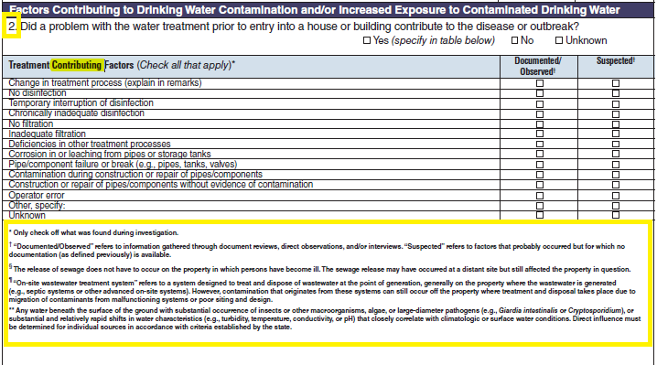
No additional questions have been added
- The multiple choice question has been numbered ‘2’ because it is the second of four questions.
- The sub-header text has been changed from ‘Treatment Factors’ to ‘Treatment Contributing Factors’.
- The footnote symbols have been updated as part of an effort to make them more consistent throughout the form.
- This section has been moved from the top of page 11 to the bottom of page 10 and is followed by all of the footnote text for this page.
Distribution and Storage Factors | 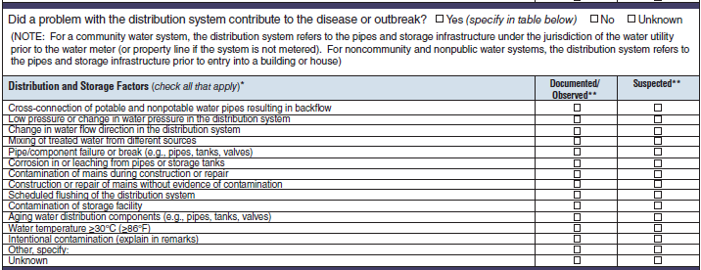 | 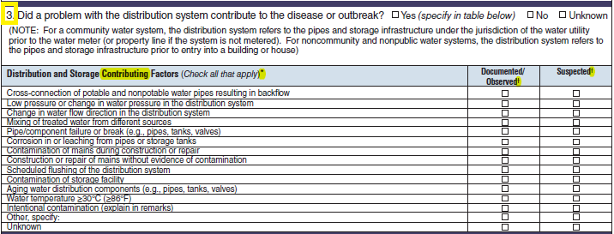
No additional questions have been added
- The multiple choice question has been numbered ‘3’ because it is the third of four questions.
- The sub-header text has been changed from ‘Distribution and Storage Factors’ to ‘Distribution and Storage Contributing Factors’
- The footnote symbols have been updated as part of an effort to make them more consistent throughout the form.
Factors Not Under the Jurisdiction of a Water Utility or Factors at the Point of Use | 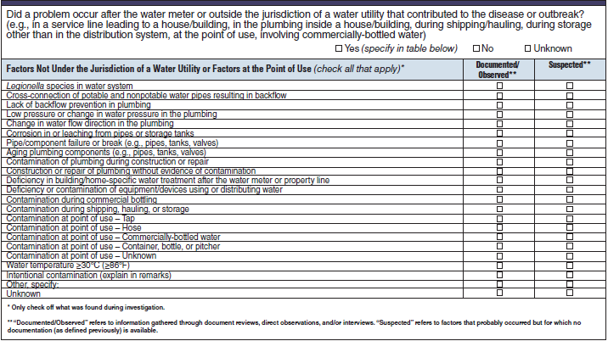 | 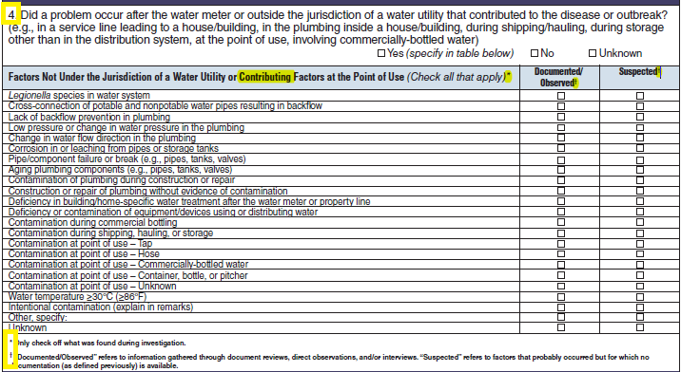
No additional questions have been added
- The multiple choice question has been numbered ‘4’ because it is the fourth of four questions.
- The sub-header text has been changed from ‘Factors Not Under the Jurisdiction of a Water Utility or Factors at the Point of Use’ to ‘Factors Not Under the Jurisdiction of Water Utility or Contributing Factors at the Point of Use’
- The footnote symbols have been updated as part of an effort to make them more consistent throughout the form.
Remarks
No additional questions have been added
- The space for the remarks section has been reduced to fit within the remaining space on the page.

Section | Current Question/Item | Requested Change
Water Not Intended for Drinking or Water of Unknown Intent
No additional questions have been added
- The tab at the top of page 12 has been renamed from ‘Water Not Intended for Drinking or Water of Unknown Intent’ to ‘Other or Unknown Water’ in order to match the revisions to the type of water exposure categories on page 3.
- The header has been changed from Water Not Intended for Drinking or Water of Unknown Intent (WNID/WUI) to Other or Unknown Water.
Intent for Use | 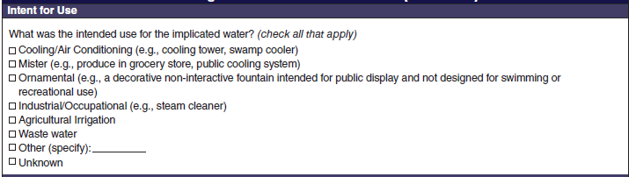 | 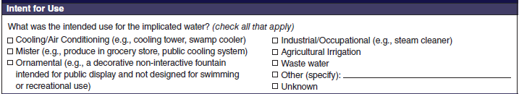
No additional questions have been added
- The section has been reformatted to reduce the total amount of space required.
Water Description | 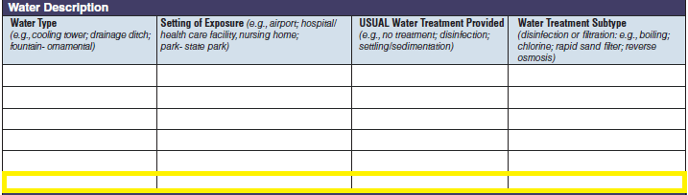 | 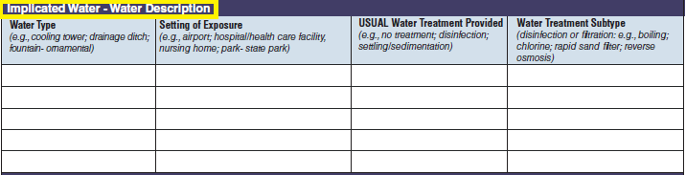
No additional questions have been added
- The sub-header has been changed from ‘Water Description’ to ‘Implicated Water – Water Description’
- One additional row has been added to allow for the submission of more data.
Laboratory Section – Water Not Intended for Drinking of Water of Unknown Intent
 | - This section has been deleted from page 13 and consolidated into a section called Water Samples (described previously).
Water Quality Indicator | 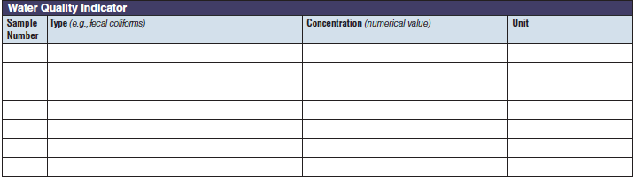
 | - This section has been deleted from page 13 and consolidated into a section called Water Samples (described previously).
Microbiology or Chemical/Toxin Analysis | 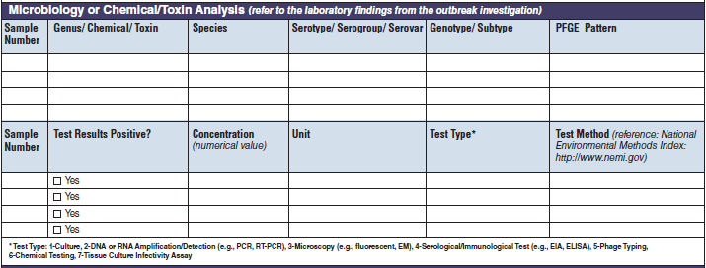
 | - This section has been deleted from page 14 and consolidated into a section called Water Samples (described previously).
Factors Contributing to Contamination and/or Increased Exposure to Contaminated Water | 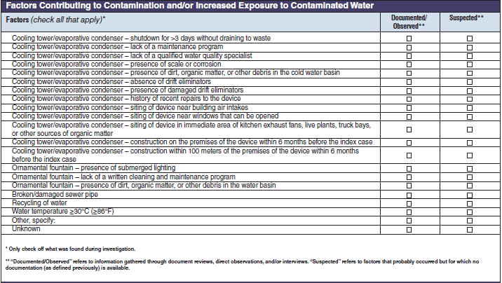 | 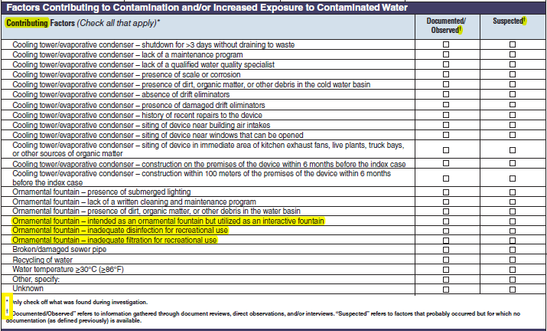
- The sub-header text has been changed from ‘Factors’ to ‘Contributing Factors’
- The footnote symbols have been updated as part of an effort to make them more consistent throughout the form.
- Three additional contributing factors have been added for outbreaks involving ornamental fountains:
  - Ornamental fountain – intended as an ornamental fountain but utilized as an interactive fountain
  - Ornamental fountain – inadequate disinfection for recreational use
  - Ornamental fountain – inadequate filtration for recreational use
Remarks | 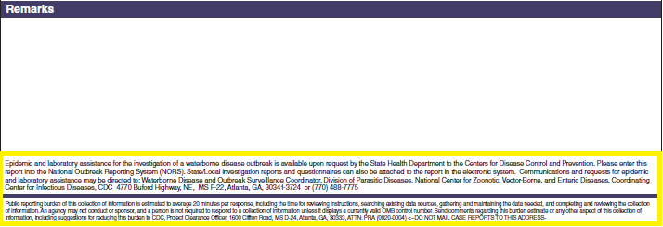
No additional questions have been added
- The information about how to access epidemic and laboratory assistance has been removed.
- The information about the public reporting burden has been moved to the beginning of page 1 and deleted from the end of the form.

Purpose and Use of Information Collection
At the national level, waterborne outbreak surveillance data are used to describe outbreaks and their characteristics through publications and data inquiries; identify trends in common exposures; and inform public health policies and interventions. WBDOSS has collected data since 1971. No other United States public health surveillance system collects aggregate data about waterborne disease outbreaks and human illness at a national level.
Burden
The annualized burden hours and cost to reporting agencies that submit waterborne disease outbreak data to CDC will not change significantly, if at all, from the estimates provided previously in 2010. The change to the annualized burden hours and cost is minimal because the form asks the same questions but has been revised to be easier to use. Additional fields or data table rows have been added based on form user feedback, reporting practices, or for convenience where extra space was available on a page. In addition, the form has been shortened by two pages, therefore, if any change in burden and cost were anticipated, the result would likely be a lower cost and burden. The number of annual submissions to CDC is not expected to change as a result of the modifications to form.
The burden hours and cost below are based on the calculations from the previous CDC 52.12 form OMB submission in 2010.The tables have been revised. The 2010 OMB paperwork described 57 respondents (50 states and 7 other reporting jurisdictions). NORS currently supports outbreak reporting by 59 sites (50 US states, the District of Columbia, five US territories, and three Freely Associated States), however, not all states or other reporting jurisdictions report waterborne disease outbreaks each calendar year. The burden hours have therefore increased from 19 to 23 but this represents a maximum value. The cost burden has also increased from $1,322.40 to $1,368.80 but this also represents a maximum value.
Privacy Impact Assessment
No individually identifiable information is being collected.
Estimates of Annualized Burden Hours (change to the total number of reporting sites from NORS, but no actual change in burden hours because not all reporting sites submit an outbreak report annually)
Type of Respondents | Form name | Number of Respondents | Number of Responses per Respondent | Average Burden Per Response (in hours) | Total Burden (in hours)
State governments | CDC Form 52.12 | 50 | 1 | 20/60 | 17
Territories, District of Columbia, Freely-associated states | CDC Form 52.12 | 9 | 1 | 20/60 | 3
Total |  |  |  |  | 20

Estimates of Annualized Cost Burden (change to the total number of reporting sites from NORS, but no actual change in cost burden because not all reporting sites submit an outbreak report annually)
Respondents | Number of Respondents | Number of Responses per Respondent | Average Burden Per Response (in hours) | Cost Per Response | Respondent Cost
State governments | 50 | 1 | 20/60 | $23.20 | $386.67
Territories, District of Columbia, Freely-associated states | 9 | 1 | 20/60 | $23.20 | $69.60
Total |  |  |  |  | $456.27

Influenza – Revision of one form, addition of 1 form.
Novel influenza A virus:
In 2007, the Council of State and Territorial Epidemiologists (CSTE) adopted a position statement making human infection with a novel influenza A virus a nationally notifiable condition. Novel influenza A virus infections include all human infections with influenza A viruses that are different from currently circulating human influenza H1 and H3 viruses. These viruses include those that are subtyped as nonhuman in origin and those that are unsubtypable with standard methods and reagents. Rapid reporting of human infections with novel influenza A viruses will facilitate prompt detection and characterization of influenza A viruses.

From 2005 to early 2012, only 36 cases of variant (v) influenza virus infection were reported to the Centers for Disease Control and Prevention (CDC). From July–September 2012, however, 306 cases of H3N2v were reported in 10 states, representing the largest outbreak of human infections with a variant influenza virus since the 2009 H1N1 pandemic. A majority of cases had self-limited illness, but hospitalizations were more prevalent among those with young age and the presence of underlying medical conditions. Most cases reported prolonged and direct exposure to swine at an agricultural fair, suggesting that was the primary risk factor for illness.

This outbreak highlighted the assertion that every case of variant influenza virus infection has epidemic potential and must be investigated thoroughly and rapidly. Therefore, a working group was convened to identify and incorporate additional data elements that will be instrumental in the efficient and rapid investigations of all variant influenza virus infections. The additional elements include new sections to assess the signs and symptoms associated with the illness, the clinical course of the illness, the exposures to agricultural fairs and animals prior to illness onset, and the potential for human-to-human transmission, especially among household members and healthcare workers. These additional elements will accelerate the understanding of the basic epidemiology of new variant influenza viral infections and the implementation of effective public health responses, thereby preventing additional morbidity and mortality.

The Human Infection with Novel Influenza A Virus Case Report Form, is a standardized case questionnaire which contains detailed questions on relevant clinical and epidemiologic features of influenza, was developed by CSTE and CDC. State or territorial influenza surveillance epidemiologists report these data over the Internet on the Secure Data Network (SDN). The title of this form has been slightly revised from its original title of the Novel Human Influenza A Virus Infection Case Report Form.

Privacy Impact Assessment
Personal identifiers are collected by state or local public health officials and maintained at the state or local health department before submission to CDC.

Estimated Burden
The annualized total burden hours did increase from the previous approval. A significant increase in the number of human infections from novel influenza A virus were identified during 2012, compared to previous influenza seasons. The increase in the number of responses per respondent was needed to more accurately portray the burden on respondents. The annualized burden to complete one case report form did not change from the previous approval.

Human Infections with Novel Influenza A Virus
Type of Respondents | Form Name | No. of Respondents | No. of Responses per Respondent | Hrs/response | Total Burden in hrs.
State and Local Governments | Human Infection with Novel Influenza A Virus Case Report Form | 57 | 6 | 30/60 | 171 hours

Antiviral resistance form
Antiviral drugs are the second line of defense against influenza viruses. Currently, only 2 drugs are licensed for use and active against circulating viruses, oseltamivir and zanamivir; oral oseltamivir is used for almost all infections in the US. There are limited treatment options for an infection with an oseltamivir-resistant viruses, experimental drug use would e required; thus widespread circulation of resistant viruses is a public health emergency requiring special guidance and testing. After a resistant virus is identified by the laboratory, it is necessary to obtain key information from the infected patient to determine whether the resistant virus was circulating in the community or whether the resistant virus developed during treatment. This information is critical to antiviral recommendations and guidance. Over the past several seasons since the pandemic 2009 virus began circulating, we have seen a small but steady increase in the circulation of oseltamivir-resistant viruses. Any additional and significant increase will require new guidance and health alerts. This new form, Antiviral Resistant Influenza Infection Case Report Form, will be critical to the collection of information that is essential to antiviral use guidance. Since circulating viruses are constantly changing, annual monitoring is needed.

Privacy Impact Assessment
Personal identifiers are collected by state or local public health officials and maintained at the state or local health department before submission to CDC.

Antiviral Resistant Influenza Infection
Type of Respondents | Form Name | No. of Respondents | No. of Responses per Respondent | Hrs/response | Total Burden in hrs.
State and Local Governments | Antiviral Resistant Influenza Infection Case Report Form | 57 | 3 | 30/60 | 86 hours

