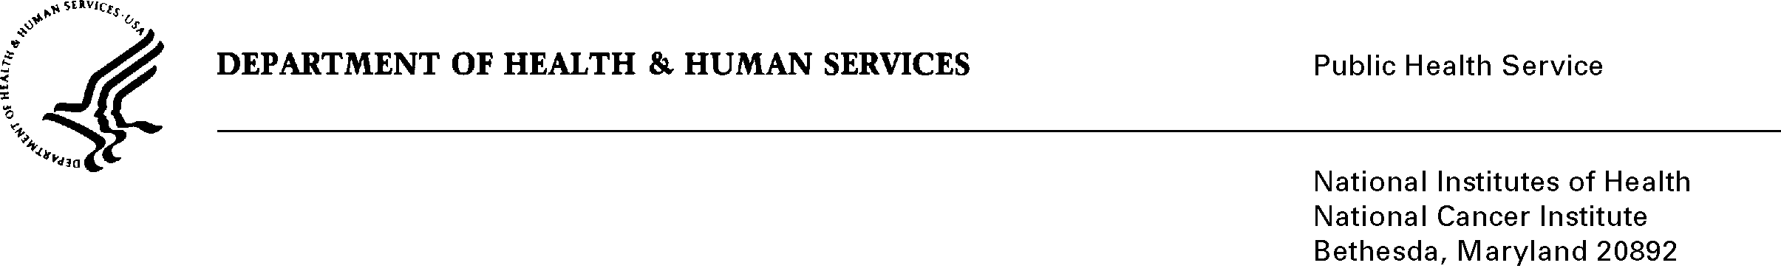

DATE: April 8, 2013

TO: OMB Desk Officer, OMB

Through: Keith Tucker, Report Clearance Officer, HHS

Seleda Perryman, Reports Clearance Officer, NIH

Vivian Horovitch-Kelley, PRA Project Clearance Liaison, NCI

FROM: Nina Goodman, Project Officer

National Cancer Institute (NCI)

SUBJ: A Generic Submission for Formative Research, Pretesting, and Customer Satisfaction of NCI’s Office of Communications and Education,

OMB#0925-0046, expiration 2/28/13

This is a request for OMB to approve this reinstatement with change request for “*Formative Research, Pretesting, and Customer Satisfaction of NCI’s Communication and Education Resources”.* The only change is a decrease in burden being requested. Purpose, use, methodology and design all remain the same as the previously approved submission.

As part of NCI’s mandate from Congress to disseminate information on cancer research, detection, prevention, and treatment, the Institute develops a wide variety of messages and materials. Testing these messages and materials assesses their potential effectiveness in reaching and communicating with their intended audience while they are still in the developmental stage and can be revised. The formative research and pretesting process thus contributes to maximizing NCI’s limited dollar resources for information dissemination and education. NCI also must ensure the relevance, utility, and appropriateness of the many educational programs and products that the Institute produces. Customer satisfaction studies help NCI identify modifications necessary to meet the needs of NCI’s various target audiences. Since the previous submission, there have been 22 approved sub-studies with just under 3,000 burden hours over 2.5 years.

Approval is requested for the conduct of multiple studies annually using such methods as interviews, focus groups, and various types of surveys. The content, timing, and number of respondents to be included in each sub-study will vary, depending on the nature of the message/material/program being assessed, the methodology selected, and the target audiences. Total burden to respondents is estimated at 6,600 hours for three years (or an average of 2,200 hours per year).

Please feel free to call me if there are any questions about this submission. Thank you in advance for your consideration.

Nina Goodman