OMB No.: 0925-0046
Expiration Date: 5/31/2016
Public reporting burden for this collection of information is estimated to average 15 minutes per response, including the time for reviewing instructions, searching existing data sources, gathering and maintaining the data needed, and completing and reviewing the collection of information. An agency may not conduct or sponsor, and a person is not required to respond to, a collection of information unless it displays a currently valid OMB control number. Send comments regarding this burden estimate or any other aspect of this collection of information, including suggestions for reducing this burden to: NIH, Project Clearance Branch, 6705 Rockledge Drive, MSC 7974, Bethesda, MD 20892-7974, ATTN: PRA (0925-0046). Do not return the completed form to this address.

Open Call Usability Testing
Lay Audiences Standard Screener

Every two months, recruit 9-16 people, who use the web to find health information:
- patients, friends & family, survivors
with a balanced mix of:
- ages (under 30, 30-60, over 60)
- income/education level
- race and ethnicity

Introduction to the research requirements
NCI will conduct bimonthly Open Call usability tests for work on cancer.gov. Testing will be scheduled in the third week of every other month starting in August 2015.

To recruit participants for remote testing, a section of this screener called, “remote sessions,” should be used whenever appropriate.

A diverse mix of participants is a priority and should include a balance of age, income/education, and Internet use. It is possible that a specific month may include a more specific ethnicity, age and/or education level.
CONSUMER SCREENER

Hello, I’m __________ from [name of firm]. I’m calling today on behalf of the National Cancer Institute, or NCI. NCI is exploring how people get the cancer information they need themselves, or for family and friends. The NCI would like to know how well NCI communication materials meet the needs of people who are looking for cancer information. They may like to include your views. If you do participate you will receive a transportation reimbursement of up to $100 in accordance with the standard federal reimbursement rate for travel. My questions today will only take a short time.

I would like to ask you just a few questions to determine if you qualify to participate in the interview, which will be in Rockville, Maryland. Some of the questions are about your experience with cancer and finding the information you need. Your responses will be completely confidential and will not be shared with others. My questions today to see if you qualify will only take a couple of minutes.

May I continue with my questions?

- Are you an employee of the U.S. Federal Government?
Skip to question 2 >> Yes_____
Skip to question 3 >> No _____

- Do you work in one of the departments of the U.S. Dept. of Health and Human Services*?
Dismiss>> Yes____
Continue>> No____

- Are you or anyone in your household . . .

A computer programmer, developer, professional web designer, or usability tester? _____
Employed in advertising, marketing, market research, public relations,
public health or health promotion? _____
An employee or volunteer in the medical field? _____
An employee of the U.S. Department of Health and Human Services or any of its divisions?* _____

Dismiss >> If any YES

*See “Annex” for a list of divisions under the U.S. Dept. of Health and Human Services.

- Do you work for the American Cancer Society, National Cancer Institute or a similar organization that focuses on cancer, or does your work involve people with cancer or their families?

Dismiss>> Yes_____
No _____

- Which of the following statements best describes your personal experiences with cancer? (Check all that apply.)

(Patient) >> I have been diagnosed with cancer _____
(Family) >> A close family member, such as a parent, sibling,
child, or grandparent, has or has had cancer _____
(Friend) >> A close friend has or has had cancer _____
Dismiss>> No one I am close to has cancer _____
- [IF FAMILY or FRIEND]: How much are you or were you involved in finding information about cancer or cancer treatment for that person, or with that person? Would you say that you are…
Dismiss>> Not at all involved _____
Dismiss>> Slightly involved _____
Continue>> Somewhat Involved _____
Continue>> Very much involved _____

- When [you or your family member or friend] were/was diagnosed with cancer or going through treatment, did you personally use the Internet to look for information on their cancer?
Dismiss>> No _____
Yes _____

[This question is intended to screen out people who receive information from the Internet only through the help of another person. For example, reading articles found or printed for you would not meet the intent of this question.]

- [IF PATIENT, FAMILY, FRIEND]: In what year [was your family member/friend | were you] diagnosed with cancer?

Dismiss if diagnosed before June 2001 >>> Year: ____________

TERMINATE if cancer was not diagnosed within the past 5 years.

- [IF PATIENT, FRIEND, FAMILY]: We are seeking a variety of perspectives. If I may ask, what type of cancer have you/has your family member or friend been diagnosed with?
[Record type(s) of cancer]_______________________________

- [IF FAMILY]: Is your family member with cancer your . . .
(Parent, brother or sister, child, grandparent, other relative)

[Record relationship]____________________________________

- Which of these statements best matches your experience using the Internet?

Dismiss>> I use the Internet once in a while, but other members of my
family help me figure out where to go and what to click on _____
Dismiss>> I rarely find what I am looking for without help _____
I sometimes find it hard to find the information I am looking for _____
I am generally successful at finding information _____
I often help my friends and family find information _____

- How often over the past 6 months have you used the Internet to search for cancer related information?
Dismiss>> Never / Not at all _____
Dismiss>> A few times _____
Dismiss>> About once a month _____
Several times a month _____
Several times a week _____

- For which type or types of cancer do you generally search for information online?

[Record] ___________________________________________________________

[DISMISS IF NOT A COMMON CANCER TYPE (THE COMMON CANCER TYPES ARE LISTED at the end of this screener.) HOWEVER, DO NOT DISMISS IF THEY SAY THEY SEARCH FOR GENERAL CANCER INFORMATION BUT NOT A PARTICULAR TYPE OF CANCER.]

- Tell me about the last time you went to look for cancer information online? [Probes: How long ago was this? Can you tell me what site you visited? What information were you looking for?]

[Record site name and other relevant information]

________________________________________________________________________

________________________________________________________________________

________________________________________________________________________

________________________________________________________________________

[The person needs to be able to recall some details about their information seeking experience. If they mention using Google to find sites or they mention going to sites that are similar to the one being tested (cancer.gov) such as the American Cancer Society, WebMD, Mayo Clinic---they are likely appropriate. If this person mentions only going to sites that are very different from cancer.gov (pharmaceutical sites, hospital sites, CNN.com) they are likely NOT appropriate.

This question is also intended to establish whether the respondent is reasonably articulate and audible, fluent in English, and willing to converse. If respondent has a strong accent, difficulty speaking English, serious speech impediment or has trouble communicating (e.g., “shuts down”), thank and Dismiss.]

- About how many hours per week do you use your smartphone to browse the Internet?

If less than 3, Terminate>> (Specify) ____________________________________

- Which of the following social media websites do you visit on a regular basis?
Linked In _____
Blogs _____
Facebook _____
Twitter _____
YouTube _____
Other _____
(Specify) ____________________________________

- What is the highest level of education you have completed? [Recruit a mix, but a max of 2 with a college or graduate degree.]

Less than high school _____
High school diploma/GED _____
Some college _____
College degree _____
Graduate degree _____

- To help us recruit a mix of people, please identify which of the following ranges matches your income? [For information only]

Under $35,000 _____
$35,00 - $50,000 _____
$50,000 - $75,000 _____
Over $75,000 _____

- What is your age? [Recruit a mix]
|___|___| [RECORD AGE]
Under 30 _____
30 - 60 _____
Over 60 _____

- Which of the following best describes your ethnicity?

If Yes, continue to question 21] Hispanic or Latino _____
[Skip to question 22] Not Hispanic or Non-Latino _____

- Which do you consider your country of origin?
[Record country]____________________________________

IF THE ANSWER IS USA, PLEASE PROBE FURTHER BY ASKING:
Where does the Hispanic origin come from?
[Record country]____________________________________

- Which of the following phrases best describes how you communicate at home? (READ LIST)

I always speak English ____
I speak more English than Spanish ____
Dismiss>> I always speak in Spanish ____
I speak more Spanish than English ____
I speak Spanish as often as I speak English ____
Dismiss>> Refused ____

- Do you read in Spanish or in English?

I always read in English ____
I read more English than Spanish ____
Dismiss>> I read only in Spanish ____
I read more Spanish than English ____
I read Spanish as often as I read English ____
Dismiss>> Refused ____

- Which of these best describes your race (choose one or more)? [Recruit a mix]
American Indian or Alaska Native _____
Asian _____
Black or African American _____
Native Hawaiian or Other Pacific Islander _____
Caucasian/White _____

- [Record gender; recruit a mix]
Female _____
Male _____
- Do you have a history of epilepsy, seizures, or a sensitivity to flashing lights?

Dismiss>> Yes_____
No _____

- Finally, have you participated in any research projects where you were asked to sit in front of a computer with an interviewer and review websites or other things on the Internet?

Invite to interview>> No _____
Continue to 25a>> Yes _____

25a. Did you participate in any of these types of research projects in the last 6 months?

Yes _____
No_____
If Yes, continue with next question. If No, skip to question 25c.

25b. Was the topic health-related?
[Record topic]____________________________________

Dismiss>> Yes _____
Continue>> No_____

25c. Have you ever participated in three or more of these types of projects?

Dismiss>> Yes _____
Continue>> No_____
Remote Sessions

- Do you have access to a computer with a broadband Internet connection?
Yes_____
Terminate >> No _____

- Do you have access to a landline telephone or reliable cell phone connection? The interview will require simultaneous use of the Internet while conversing on a landline telephone.
Yes_____
Terminate >> No _____

**DISMISSAL LANGUAGE: Thank you very much for your time. We have recruited all of the persons like you that we need to talk to, so we won’t be able to include you in our study. Thank you for your time and interest. Have a good day/evening.

INVITE TO INTERVIEW

Thank you for answering my questions. As I mentioned this study is being conducted on behalf of the National Cancer Institute about how people get health related information and we would like to include your views.

In order for us to learn from your experience firsthand, I would like to invite you to participate in a one-on-one interview. The interview will last about sixty minutes and will take place at the National Cancer Institute. I have several time slots on, so we can conduct the interview when it’s convenient for you.

This is not a sales effort of any kind and no one will call on you as a result of your participation. We will provide a transportation reimbursement of up to $100 and will provide more details. Can we schedule your participation?

Check day and time; see details below.

NAME: _________________________________________________
ADDRESS: _________________________________________________
CITY: _________________________________________________
ZIP CODE: _________________________________________________
PHONE: (DAY) _____________________________________
(EVE) _____________________________________
(CELL) _____________________________________
(EMAIL) _____________________________________

Session Dates/Time Slots

[Date]

- 9:00am
- 10:30am
- 12:00pm
- 2:00pm
- 3:30pm
- 5:00pm

[Date]

- 9:00am
- 10:30am
- 12:00pm
- 2:00pm
- 3:30pm
- 5:00pm

Driving Directions to the NCI Shady Grove Campus
9609 Medical Center Drive, Rockville, MD 20850
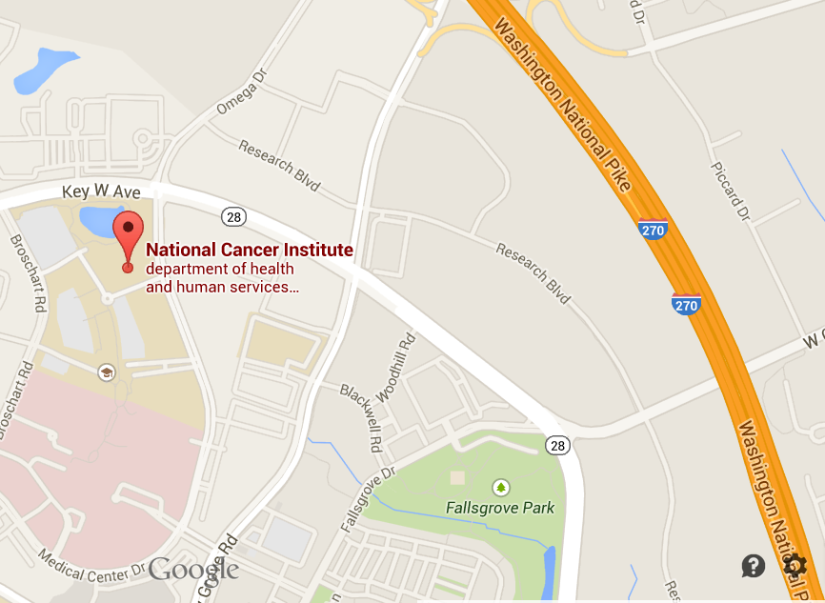

South of Rockville Pike using Route 270
- Take exit 8 toward Shady Grove Road
- Keep left on the exit ramp, and at the end of the ramp, turn left at the light onto Shady Grove Road heading west
- Get into the right lane, and turn right onto Key West Avenue (MD 28 W)
- Turn left at the next light onto Medical Center Drive.
- Turn right onto Blackwell Road
- Turn right again into the NCI employee parking garage

North of Rockville Pike using Route 270
- Take exit 8 and keep right to take the Omega Drive ramp. The ramp will bring you to a stop sign.
- Turn left and continue on to Omega Drive, which turns into Medical Center Drive.
- From Medical Center Drive, turn right onto Blackwell Road and turn right again into the NCI employee parking garage

Upon entering the lobby
You will be entering a Federal building. Government issued photo ID is required. Please got to the guard desk, give them your name, and let them know that you will need an escort.

Visitors can have their parking ticket validated at the guard station inside the main lobby.

Via Bus
Various Montgomery County Ride-On bus routes service the National Cancer Institute (NCI) Shady Grove Campus. These buses all have bike racks. Additionally, the Maryland Transit Administration (MTA) offers commuter bus routes to the Shady Grove Metro.
The following routes provide services to the NCI Shady Grove Campus:
- Route 43 – From Traville Transit Center and Shady Grove Metro. Drops off/Picks up in front of NCI Shady Grove on Medical Center Drive


- Route 56 – From Rockville Metro and Lakeville Center. Drops off/Picks up at the intersection of Medical Way and Shady Grove Rd., approximately 200 yards away from NCI Shady Grove

- Route 66 – From Traville Transit Center and Shady Grove Metro. Drops off/Picks up in front of NCI Shady Grove on Medical Center Drive

- Route 74 – From Germantown Transit Center and Shady Grove Metro. Drops off/Picks up on Key West Ave., approximately 100 yards from NCI Shady Grove entrance
View of the National Cancer Institute from the bus stop on Medical Center Drive

Upon entering the lobby
You will be entering a Federal building. Government issued photo ID is required. Please got to the guard desk, give them your name, and let them know that you will need an escort.

Visitors can have their parking ticket validated at the guard station inside the main lobby.

Via Metro
To get to NCI Shady Grove, take the Washington, DC Metro Red line to the Shady Grove stop.

The NCI Shady Grove Metro shuttle picks up passengers on the west side of the Metro. To reach it:
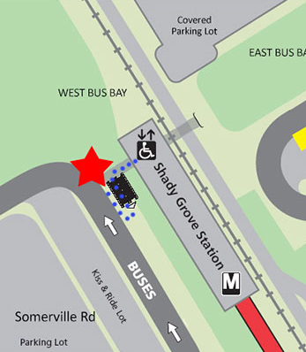
- Take the exit on your left when exiting the metro station
- Take the escalator or stairs
- The shuttle stops on your right side as you walk up the stairs
- Look for the signs saying “NCI shuttle stops here” written in red letters on a white background
- The NCI shuttle schedule is included on the next page
- The shuttle will take approximately 15 minutes to arrive at Shady Grove

From 6:00 – 9:30 a.m. and 3:00 – 7:00 p.m., service runs every 15 minutes. From 9:30 a.m. – 3:00 p.m., shuttle service is every 30 minutes. The last shuttle from NCI to the Metro leaves at 6:45 p.m.

Upon entering the lobby
You will be entering a Federal building. Government issued photo ID is required. Please got to the guard desk, give them your name, and let them know that you will need an escort.

Visitors can have their parking ticket validated at the guard station inside the main lobby.
National Cancer Institute (NCI) Shady Grove Shuttle Service Schedule
Live Shuttle Route: http://ncishadygroveshuttle.com/map
Departing  Shady Grove Metro | Departing  National Cancer Institute (NCI)
6:00 AM
6:15 AM
6:30 AM | 6:15 AM
6:45 AM | 6:30 AM
7:00 AM | 6:45 AM
7:15 AM | 7:00 AM
7:30 AM | 7:15 AM
7:45 AM | 7:30 AM
7:52 AM | 7:37 AM
8:00 AM | 7:45 AM
8:15 AM | 8:00 AM
8:22 AM | 8:07 AM
8:30 AM | 8:15 AM
8:45 AM | 8:30 AM
8:52 AM | 8:37 AM
9:00 AM | 8:45 AM
9:15 AM | 9:00 AM
9:22 AM | 9:07 AM
9:30 AM | 9:15 AM
9:45 AM | 9:30 AM
10:00 AM | 9:45 AM
10:15 AM | 10:00 AM
10:30 AM | 10:15 AM
10:45 AM | 10:30 AM
11:00 AM | 10:45 AM
11:15 AM | 11:00 AM
11:30 AM | 11:15 AM
11:45 AM | 11:30 AM

Departing  Shady Grove Metro | Departing  National Cancer Institute (NCI)
12:00 PM | 11:45 AM
12:15 PM | 12:00 PM
12:30 PM | 12:15 PM
12:45 PM | 12:30 PM
1:00 PM | 12:45 PM
1:15 PM | 1:00 PM
1:30 PM | 1:15 PM
1:45 PM | 1:30 PM
2:00 PM | 1:45 PM
2:15 PM | 2:00 PM
2:30 PM | 2:15 PM
2:45 PM | 2:30 PM
3:00 PM | 2:45 PM
3:15 PM | 3:00 PM
3:30 PM | 3:15 PM
3:37 PM | 3:22 PM
3:45 PM | 3:30 PM
4:00 PM | 3:45 PM
4:15 PM | 4:07 PM
4:22 PM | 4:15 PM
4:30 PM | 4:30 PM
4:45 PM | 4:37 PM
4:52 PM | 4:45 PM
5:00 PM | 5:00 PM
5:15 PM | 5:07 PM
5:22 PM | 5:15 PM
5:30 PM | 5:30 PM
5:45 PM | 5:37 PM
5:52 PM | 5:45 PM
6:00 PM | 6:00 PM
6:15 PM | 6:07 PM
6:30 PM | 6:15 PM
6:45 PM | 6:30 PM
 | 6:45 PM

ANNEX

List of U.S. Department of Health and Human Services (HHS) Operating and Staff Divisions

- Administration for Children and Families (ACF)
- Administration for Children, Youth and Families (ACYF)
- Administration on Aging (AoA)
- Agency for Healthcare Research and Quality (AHRQ)
- Agency for Toxic Substances and Disease Registry (ATSDR)
- Center for Faith-Based and Neighborhood Partnerships (CFBNP)
- Centers for Disease Control and Prevention (CDC)
- Departmental Appeals Board (DAB)
- Food and Drug Administration (FDA)
- Health Resources and Services Administration (HRSA)
- Indian Health Service (IHS)
- Intergovernmental Affairs and Regional Representatives (IGA)
- National Cancer Institute (NCI)
- National Coordinator for Health Information Technology (ONC)
- National Institutes of Health (NIH)
- Office for Civil Rights (OCR)
- Office of Consumer Information and Insurance Oversight (OCIIO)
- Office of Global Health Affairs (OGHA)
- Office of Medicare Hearings and Appeals (OMHA)
- Office of the Assistant Secretary for Health (ASH)
- Office of the General Counsel (OGC)
- Office of the Inspector General (OIG)
- Office of the Inspector General (OIG)
- Office of the Surgeon General (OSG)
- Office on Disability (OD)
- Substance Abuse and Mental Health Services Administration (SAMHSA)

COMMON TYPES OF CANCER

(From http://www.cancer.gov/cancertopics/types/commoncancers)

Bladder Cancer
Breast Cancer
Colon and Rectal Cancer
Endometrial Cancer
Kidney (Renal Cell) Cancer
Leukemia
Lung Cancer
Melanoma
Non-Hodgkin Lymphoma
Pancreatic Cancer
Prostate Cancer
Thyroid Cancer
Skin Cancer

