OMB No.: 0925-0046
Expiration Date: 5/31/2016
Public reporting burden for this collection of information is estimated to average 15 minutes per response, including the time for reviewing instructions, searching existing data sources, gathering and maintaining the data needed, and completing and reviewing the collection of information. An agency may not conduct or sponsor, and a person is not required to respond to, a collection of information unless it displays a currently valid OMB control number. Send comments regarding this burden estimate or any other aspect of this collection of information, including suggestions for reducing this burden to: NIH, Project Clearance Branch, 6705 Rockledge Drive, MSC 7974, Bethesda, MD 20892-7974, ATTN: PRA (0925-0046). Do not return the completed form to this address.

Open Call Usability Testing

Healthcare Professionals Standard Screener

Every two months, recruit 9-16 people, who use the web to find health information:
- Healthcare professionals, principal investigators, researchers, grantees, advocates, and strategic influencers
with a balanced mix of:
- ages (under 30, 30-60, over 60)
- income/education level
- race and ethnicity

Introduction to the research requirements
NCI will conduct bimonthly Open Call usability tests for work on cancer.gov. Testing will be scheduled in the third week of every other month starting in August 2015.

To recruit participants for remote testing, a section of this screener called, “remote sessions,” should be used whenever appropriate.

This screener is designed to recruit various types of audiences and user groups. Two sections of the screener are labeled as “For all user groups” which indicates that all user groups should provide responses. Particular sections of this screener are applicable when working with the following user groups:

- Healthcare professionals
- Principal investigators, researchers, & grantees
- Advocates and strategic influencers

NCI will provide guidance on which sections of the screener to use during each round of testing. To recruit participants for remote testing, a section of this screener called, “remote sessions,” should be used whenever appropriate.

A diverse mix of participants is a priority and should include a balance of age, income/education, and Internet use. It is possible that a specific month may include a more specific ethnicity, age and/or education level.

HEALTHCARE PROFESSIONAL SCREENER

Hello, I’m __________ from [name of firm]. I’m calling today on behalf of the National Cancer Institute, or NCI, the U.S. Federal government’s principal agency for cancer research and training. NCI is exploring how health care professionals find information about cancer for themselves and their patients, and would like to include your views. I need to ask you just a few questions to determine whether I can invite you to participate in an interview in Rockville, Maryland. They may like to include your views. If you do participate you will receive a transportation reimbursement of up to $100 in accordance with the standard federal reimbursement rate for travel. My questions today will only take a short time.

IF THEY DO NOT HAVE TIME NOW, ASK IF THERE IS A TIME WHEN THEY WOULD BE ABLE TO TALK or a better phone number to use. [assuming we know they’re in a medical office or center]
When would be a better time for you: ________________ (record and re-contact)

May I continue with my questions?

- Are you an employee of the U.S. Federal Government?
Skip to question 2 >> Yes _____
Skip to question 3 >> No _____

- Are you or anyone in your household . . .

A computer programmer, developer, professional web designer, or usability tester? _____
Employed in advertising, marketing, market research, public relations,
public health or health promotion? _____
An employee or volunteer in the medical field? _____
*Dismiss >>An employee of the U.S. Department of Health and Human Services_____

*See Annex A of this screener for a list of divisions under the U.S. Dept. of
Health and Human Services.

- Do you work for the American Cancer Society, National Cancer Institute or a similar organization that focuses on cancer?
Yes _____
No _____
- Which of the following applies to you?

Skip to Healthcare Professionals>> Clinician, physician _____
Skip to Healthcare Professionals>> Nurse _____
Skip to Healthcare Professionals>> Public health practitioner _____
Skip to Healthcare Professionals>> Physician assistant _____
Skip to Healthcare Professionals>> Health educator, patient navigator, or other role directly involved with patients _____
Skip to Advocate >> Advocate _____
Skip to Principal Investigators >> Post Doc _____
Skip to Principal Investigators >> Researcher, fellow, grantee _____
Skip to Principal Investigators >> Basic clinical investigator _____
Skip to Principal Investigators >> Principal Investigator (PI) _____
Other _____

[Record “Other” Title] _________________________________________

Healthcare Professionals Section

- What is your medical specialty, if any?
[Record specialty] ______________________________

- Which of the following best describes the time you spend seeing or treating patients?

I see or treat 25 or more patients each week _____
I see or treat fewer than 25 patients each week _____
Terminate >> I do not see or treat patients _____

3a. In what setting do you typically work? [Recruit a mix]
Hospital _____
NCI Designated Cancer Center _____
Community health center/clinic _____
Large private practice _____
Small private practice _____
Other _____
_________________________________________ [Record]

- How many years have you been working in your present field or profession?

[Record number of years] ______________________________

- How much are you involved in discussing information about cancer or cancer treatment with patients? Would you say that you are…
Terminate >> Not at all involved _____
Terminate >> Slightly involved _____
Continue >> Somewhat Involved _____
Continue >> Very much involved _____

- Tell me about the last time you provided information on cancer to a patient. [Probes: How long ago was this? Can you tell me what information you provided? Did you use any web-based information? Can you tell me what site you visited? What type of information did you and the patient discuss?]
[Record site name and other relevant information]

________________________________________________________________________

________________________________________________________________________

[This question is intended to establish whether the respondent is reasonably articulate and audible, fluent in English, and willing to converse. If respondent has a strong accent, difficulty speaking English, serious speech impediment or has trouble communicating (e.g., “shuts down”), thank and Dismiss.]

- Do you refer patients to clinical trials?
Yes_____
No _____

Principal Investigators, Researchers & Grantees

- Can you briefly describe the type of research you conduct?

[Record type of research] ______________________________________________________

This question is intended to establish whether the respondent is reasonably articulate and audible, fluent in English, and willing to converse. If respondent has a strong accent, difficulty speaking English, serious speech impediment or has trouble communicating, (e.g., “shuts down”), thank and terminate.

- Can you briefly describe your clinical work?

[Record type of clinical work and the type of setting]

______________________________________________________________________
[For example work can be at a hospital, cancer center, or private practice]

- How many years have you been working in your given field?

[Record years working in the field] ______________________________________________

- Do you refer patients to clinical trials?
Yes_____
No _____
Advocates & Strategic Influencers

- Can you briefly describe the type of advocacy work you are engaged in? Is it for a specific type of cancer?

[Record type advocacy organization
NOTE: Terminate any breast cancer advocacy organization]

____________________________________________________________________________
[For example patient advocates, the American Cancer Society, and organizations that advocate for research dedicated to a specific type of cancer are some examples.]

This question is intended to establish whether the respondent is reasonably articulate and audible, fluent in English, and willing to converse. If respondent has a strong accent, difficulty speaking English, serious speech impediment or has trouble communicating, (e.g., “shuts down”), thank and terminate.

- How many years have you been working in your given field?

[Record years working in the field] ______________________________________________

- Do you refer patients to clinical trials?
Yes_____
No _____
- Do you personally look on the Internet for information regarding NCI’s budget, programs, research or other NCI-related news?
Yes _____
TERMINATE >> No _____

- How often would you say you personally look on the Internet for information regarding NCI’s budget, program, research or other NCI-related news? [Read response options]

Very often _____
Often _____
TERMINATE >> Sometimes _____
TERMINATE >> Never/Rarely _____

- In your current position at your organization, does your role involve, to any extent, doing the following…
[NOTE: Ask them to respond “yes” or “no” to each. Clarify that they can respond “yes” even if they don’t regularly engage in these activities.]
 |  | YES | NO*
10a | Monitoring NCI’s budget and research portfolio
10b | Advocating for NCI’s budget, programs, and research
10c | Reading the latest news about NCI
10d | Networking with colleagues and/or other organization about NCI’s efforts

Terminate if they only say “yes” to 10c.

- Does your position within your organization involve conducting patient advocacy work?
YES _____
NO _____
- How often over the past 6 months have you personally gone on the Internet to search for information to assist you in your patient advocacy work?
Never / Not at all _____
Less than once a month _____
About once a month _____
RECRUIT AS “PATIENT ADVOCATE” >>> Several times a month _____
RECRUIT AS “PATIENT ADVOCATE” >>> Several times a week _____

For All User Groups

- How often over the past 6 months have you personally gone on the Internet to search for health related information?

Dismiss >> Never / Not at all _____
Dismiss >> A few times _____
About once a month _____
Several times a month _____
Several times a week _____

- Which of these statements best matches your experience using the Internet [Recruit a mix]

Terminate>> I use the Internet once in a while, but other members of my
family help me figure out where to go and what to click on _____
Terminate>> I rarely find what I am looking for without help _____
I sometimes find it hard to find the information I am looking for _____
I am generally successful at finding information _____
I often help my friends and family find information _____

- Which of the following social media websites do you visit on a regular basis?
Linked In _____
Blogs _____
Facebook _____
Twitter _____
YouTube _____
Other _____
(Specify) ____________________________________

- About how many hours per week do you use your smartphone to browse the Internet?

If less than 3, Terminate>> (Specify) ____________________________________

- What is the highest level of education you have completed? [Record only]

Less than high school _____
High school diploma/GED _____
Some college _____
College degree _____
Graduate degree _____
Doctorate _____
- What is your age?
|___|___| [RECORD AGE]
Under 30 _____
30-60 _____
Over 60 _____

- Please identify which of the following ranges matches your income?

Under $35,000 _____
$35,00 - $50,000 _____
$50,000 - $75,000 _____
Dismiss>> Over $75,000 _____

- Which of the following best describes your ethnicity?

If Yes, continue to question 9] Hispanic or Latino _____
[Skip to question 10] Not Hispanic or Non-Latino _____

- Which do you consider your country of origin?
[Record country]____________________________________

IF THE ANSWER IS USA, PLEASE PROBE FURTHER BY ASKING:
Where does the Hispanic origin come from?
[Record country]____________________________________

- Which of the following phrases best describes how you communicate at home? (READ LIST)
Dismiss>> I always speak in Spanish ____
I always speak English ____
I speak more Spanish than English ____
I speak Spanish as often as I speak English ____
I speak more English than Spanish ____
Dismiss>> Refused ____

- Do you read in Spanish or in English?
Dismiss>> I read only in Spanish ____
I always read English ____
I read more Spanish than English ____
I read Spanish as often as I read English ____
I read more English than Spanish ____
Dismiss>> Refused ____

- Which of the following best describes your race? [Recruit a Mix]
American Indian or Alaska Native _____
Asian _____
Black or African American _____
Native Hawaiian or Other Pacific Islander _____
Caucasian/White _____

- What is your gender? [Recruit a Mix]
Female _____
Male _____

- Do you use reading glasses, including bifocal or trifocal glasses?

Yes_____
No _____

- Do you have a history of epilepsy, seizures, or sensitivity to flashing lights?

Dismiss>> Yes_____
No _____

- Finally, have you participated in any market research projects or projects where you tried out a website or computer software while talking to an interviewer?

No >> Invite to interview _____
Yes>> Continue _____

Remote Sessions

- Do you have access to a computer with a broadband Internet connection?
Yes_____
Terminate >> No _____

- Do you have access to a landline telephone or reliable cell phone connection? The interview will require simultaneous use of the Internet while conversing on a landline telephone.
Yes_____
Terminate >> No _____

**DISMISS LANGUAGE: Thank you very much for your time. We have recruited all of the persons like you that we need to talk to, so we won’t be able to include you in our study. Thank you for your time and interest. Have a good day/evening.

INVITE TO INTERVIEW

Thank you for answering my questions. As I mentioned this study is being conducted on behalf of the National Cancer Institute about how people get health related information and would like to include your views.

In order for us to learn from your experience firsthand, I would like to invite you to participate in a one-on-one interview. The interview will last about sixty minutes and will take place at the National Cancer Institute. I have several time slots on, so we can conduct the interview when it’s convenient for you.

This is not a sales effort of any kind and no one will call on you as a result of your participation. We will provide a transportation reimbursement of up to $100 and will provide more details. Can we schedule your participation?

NAME: _________________________________________________
EMAIL *** _________________________________________________
PHONE: (DAY) _____________________________________
(EVE) _____________________________________
(FAX) _____________________________________
(CELL) _____________________________________

Session Dates/Time Slots

[Date]

- 9:00am
- 10:30am
- 12:00pm
- 2:00pm
- 3:30pm
- 5:00pm

[Date]

- 9:00am
- 10:30am
- 12:00pm
- 2:00pm
- 3:30pm
- 5:00pm
Driving Directions to the NCI Shady Grove Campus
9609 Medical Center Drive, Rockville, MD 20850
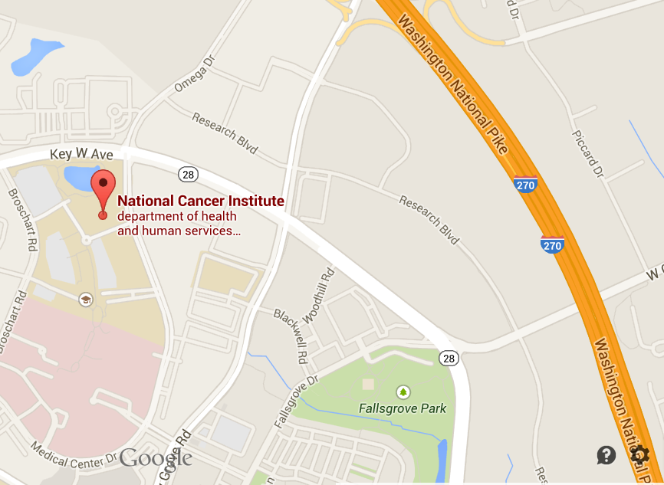

South of Rockville Pike using Route 270
- Take exit 8 toward Shady Grove Road
- Keep left on the exit ramp, and at the end of the ramp, turn left at the light onto Shady Grove Road heading west
- Get into the right lane, and turn right onto Key West Avenue (MD 28 W)
- Turn left at the next light onto Medical Center Drive.
- Turn right onto Blackwell Road
- Turn right again into the NCI employee parking garage

North of Rockville Pike using Route 270
- Take exit 8 and keep right to take the Omega Drive ramp. The ramp will bring you to a stop sign.
- Turn left and continue on to Omega Drive, which turns into Medical Center Drive.
- From Medical Center Drive, turn right onto Blackwell Road and turn right again into the NCI employee parking garage

Upon entering the lobby
You will be entering a Federal building. Government issued photo ID is required. Please got to the guard desk, give them your name, and let them know that you will need an escort.

Visitors can have their parking ticket validated at the guard station inside the main lobby.

Via Bus
Various Montgomery County Ride-On bus routes service the National Cancer Institute (NCI) Shady Grove Campus. These buses all have bike racks. Additionally, the Maryland Transit Administration (MTA) offers commuter bus routes to the Shady Grove Metro.
The following routes provide services to the NCI Shady Grove Campus:
- Route 43 – From Traville Transit Center and Shady Grove Metro. Drops off/Picks up in front of NCI Shady Grove on Medical Center Drive

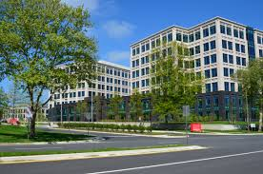
- Route 56 – From Rockville Metro and Lakeville Center. Drops off/Picks up at the intersection of Medical Way and Shady Grove Rd., approximately 200 yards away from NCI Shady Grove

- Route 66 – From Traville Transit Center and Shady Grove Metro. Drops off/Picks up in front of NCI Shady Grove on Medical Center Drive

- Route 74 – From Germantown Transit Center and Shady Grove Metro. Drops off/Picks up on Key West Ave., approximately 100 yards from NCI Shady Grove entrance
View of the National Cancer Institute from the bus stop on Medical Center Drive

Upon entering the lobby
You will be entering a Federal building. Government issued photo ID is required. Please got to the guard desk, give them your name, and let them know that you will need an escort.

Visitors can have their parking ticket validated at the guard station inside the main lobby.

Via Metro
To get to NCI Shady Grove, take the Washington, DC Metro Red line to the Shady Grove stop.

The NCI Shady Grove Metro shuttle picks up passengers on the west side of the Metro. To reach it:
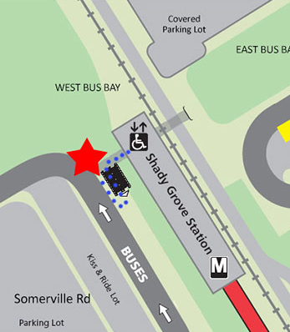
- Take the exit on your left when exiting the metro station
- Take the escalator or stairs
- The shuttle stops on your right side as you walk up the stairs
- Look for the signs saying “NCI shuttle stops here” written in red letters on a white background
- The NCI shuttle schedule is included on the next page
- The shuttle will take approximately 15 minutes to arrive at Shady Grove

From 6:00 – 9:30 a.m. and 3:00 – 7:00 p.m., service runs every 15 minutes. From 9:30 a.m. – 3:00 p.m., shuttle service is every 30 minutes. The last shuttle from NCI to the Metro leaves at 6:45 p.m.

Upon entering the lobby
You will be entering a Federal building. Government issued photo ID is required. Please got to the guard desk, give them your name, and let them know that you will need an escort.

Visitors can have their parking ticket validated at the guard station inside the main lobby.
National Cancer Institute (NCI) Shady Grove Shuttle Service Schedule
Live Shuttle Route: http://ncishadygroveshuttle.com/map
Departing  Shady Grove Metro | Departing  National Cancer Institute (NCI)
6:00 AM
6:15 AM
6:30 AM | 6:15 AM
6:45 AM | 6:30 AM
7:00 AM | 6:45 AM
7:15 AM | 7:00 AM
7:30 AM | 7:15 AM
7:45 AM | 7:30 AM
7:52 AM | 7:37 AM
8:00 AM | 7:45 AM
8:15 AM | 8:00 AM
8:22 AM | 8:07 AM
8:30 AM | 8:15 AM
8:45 AM | 8:30 AM
8:52 AM | 8:37 AM
9:00 AM | 8:45 AM
9:15 AM | 9:00 AM
9:22 AM | 9:07 AM
9:30 AM | 9:15 AM
9:45 AM | 9:30 AM
10:00 AM | 9:45 AM
10:15 AM | 10:00 AM
10:30 AM | 10:15 AM
10:45 AM | 10:30 AM
11:00 AM | 10:45 AM
11:15 AM | 11:00 AM
11:30 AM | 11:15 AM
11:45 AM | 11:30 AM

Departing  Shady Grove Metro | Departing  National Cancer Institute (NCI)
12:00 PM | 11:45 AM
12:15 PM | 12:00 PM
12:30 PM | 12:15 PM
12:45 PM | 12:30 PM
1:00 PM | 12:45 PM
1:15 PM | 1:00 PM
1:30 PM | 1:15 PM
1:45 PM | 1:30 PM
2:00 PM | 1:45 PM
2:15 PM | 2:00 PM
2:30 PM | 2:15 PM
2:45 PM | 2:30 PM
3:00 PM | 2:45 PM
3:15 PM | 3:00 PM
3:30 PM | 3:15 PM
3:37 PM | 3:22 PM
3:45 PM | 3:30 PM
4:00 PM | 3:45 PM
4:15 PM | 4:07 PM
4:22 PM | 4:15 PM
4:30 PM | 4:30 PM
4:45 PM | 4:37 PM
4:52 PM | 4:45 PM
5:00 PM | 5:00 PM
5:15 PM | 5:07 PM
5:22 PM | 5:15 PM
5:30 PM | 5:30 PM
5:45 PM | 5:37 PM
5:52 PM | 5:45 PM
6:00 PM | 6:00 PM
6:15 PM | 6:07 PM
6:30 PM | 6:15 PM
6:45 PM | 6:30 PM
 | 6:45 PM

ANNEX A

List of U.S. Department of Health and Human Services (HHS) Operating and Staff Divisions

- Administration for Children and Families (ACF)
- Administration for Children, Youth and Families (ACYF)
- Administration on Aging (AoA)
- Agency for Healthcare Research and Quality (AHRQ)
- Agency for Toxic Substances and Disease Registry (ATSDR)
- Center for Faith-Based and Neighborhood Partnerships (CFBNP)
- Centers for Disease Control and Prevention (CDC)
- Departmental Appeals Board (DAB)
- Food and Drug Administration (FDA)
- Health Resources and Services Administration (HRSA)
- Indian Health Service (IHS)
- Intergovernmental Affairs and Regional Representatives (IGA)
- National Cancer Institute (NCI)
- National Coordinator for Health Information Technology (ONC)
- National Institutes of Health (NIH)
- Office for Civil Rights (OCR)
- Office of Consumer Information and Insurance Oversight (OCIIO)
- Office of Global Health Affairs (OGHA)
- Office of Medicare Hearings and Appeals (OMHA)
- Office of the Assistant Secretary for Health (ASH)
- Office of the General Counsel (OGC)
- Office of the Inspector General (OIG)
- Office of the Inspector General (OIG)
- Office of the Surgeon General (OSG)
- Office on Disability (OD)
- Substance Abuse and Mental Health Services Administration (SAMHSA)

COMMON TYPES OF CANCER

(From http://www.cancer.gov/cancertopics/types/commoncancers)

Bladder Cancer
Breast Cancer
Colon and Rectal Cancer
Endometrial Cancer
Kidney (Renal Cell) Cancer
Leukemia
Lung Cancer
Melanoma
Non-Hodgkin Lymphoma
Pancreatic Cancer
Prostate Cancer
Thyroid Cancer
Skin Cancer

