Data User Impact Team
Questionnaire Draft V8
December 13, 2013

Thank you for participating in this survey. An integral part of the process of redesigning the Consumer Expenditure Survey (CE) is obtaining feedback from data users and other interested parties on the methodology of the new survey design and the utility of the data products it would produce. As such, your views are important to consider as the redesign process unfolds.

Responses to this survey will be compiled in a report for the Gemini Project management team, highlighting both the concerns and advantages respondents express in examining the new design. These may lead to recommendations to revise the design accordingly.

Your participation in this survey is voluntary. We estimate that it will take you 15 minutes to complete this survey. We are collecting this information under OMB Number 1225-0059. Without this currently approved number, we could not conduct this survey. (Expiration: March 31, 2014).

Please complete the survey by February 15, 2014.

This survey is being administered by SurveyMonkey.com and resides on a server outside of the BLS domain. Since the BLS cannot guarantee the protection of survey responses, we advise against including any sensitive or personal information.

Thank you for your time and help.
REDESIGN OVERVIEW

The new Consumer Expenditure Survey (CE) design includes two waves of data collection set 12 months apart, with each wave consisting of the same structure. Prior to the start of each wave, an advanced letter will be mailed with information about the survey and its importance, a token incentive of $2, and additional information on promised incentives throughout the interview (detailed below). Each wave contains the same interview structure consisting of two personal visits and a one-week diary.

Visit 1
- In-person recall interview
- Collects large, easily-recalled household expenditures
- Includes global questions covering expenditure categories to be collected from diary. Global questions will be at higher level (e.g., expenditures on clothing) than detailed questions (e.g., expenditures on pants).
- Includes Instructions to collect relevant expenditure records for Visit 2
- Trains respondents on using the electronic web-based diary.
- Upon completion respondent receives $20 incentive.

Diary Week
- Each household member aged 15+ maintains an individual diary
- Individual diary is web-based (accessible via PC, smartphone, or other mobile device)
- Paper option available based on respondents’ preference
- Upon completion, each eligible member completing an individual diary receives $20 incentive.

Visit 2
- In-person records interview
- Collects expenditures that can reasonably be found in records such as receipts, utility bills, and bank statements.
- Upon completion respondent that use records receive $30 incentive, respondents that don’t use records use a $20 incentive.

Each of the components of the new design has been developed to address factors identified as potentially contributing to measurement error in the current CE survey:
- Web and mobile-based diary surveys will encourage real-time data capture reducing underreporting by respondents.
- Individual diaries should also reduce underreporting due to proxy reporting.
- Shortened interview length should reduce burden, which is linked to data quality.
- Emphasis on record use should lead to more accuracy in the reporting of expenditures.
- Incentives should address respondent motivation, leading to higher quality of data reported.

Redesigning the CE survey is a long term project. The data from this redesign are expected to be available in 2024. Details on the full proposal can be found on the CE website: http://www.bls.gov/cex/ce_gemini_redesign.pdf

Overview of the CE redesign:

- Please indicate what type of CE data products you use most frequently:

Public-use microdata
Publication tables
Other outputs that rely on CE data (reports, internal analysis)
None/Don’t know

- In particular, what design features are most appealing to you?

[CHECK ALL THAT APPLY, WITH OTHER SPECIFY]

12-month interval between waves to facilitate analysis of year over year change

Incentives to increase participation and engagement

Shorter interviews to lower burden and increase accuracy
Use of technology for diary keeping (web, smartphones)

Individual diaries to increase accuracy

Other, please specify

[Other-specify field for last check box to be added in SurveyMonkey]

Comparison of current design features to new design features:

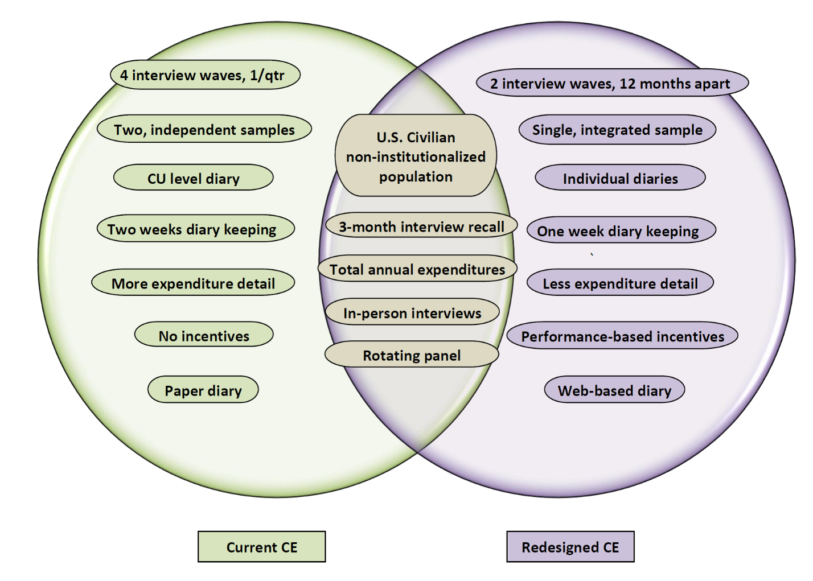

- Does the new CE design retain or include new features that support the type of analyses you generally perform using CE data?

(Y/N/Don’t know or don’t use)

If yes, please elaborate.

- Does the new design include features that would allow you to perform desired analyses that are not possible with the current design?

(Y/N/Don’t know or don’t use)

If yes, please elaborate.

- Does the new CE design as shown in the figure above include changes that will limit your use of the data, as compared to the current design?

(Y/N/Don’t know or don’t use)

If yes, what design features will limit the type of analyses you generally perform using CE data?

The following set of questions ask about the impact of specific design changes. These design changes may pose limitations for some types of analyses.
- [For public-use microdata users:]
To provide data for expenditures reported in the Diary (e.g., food and clothing) for the past three months, broad questions about these items are included in the Interview. In this way, data for items currently reported on in detail in the Diary are included in the Interview microdata files, though in less detail. Will this change limit the type of analyses you generally perform using CE data?
(Y/N)
If yes, please elaborate.

- [For public-use microdata users:]
The new design collects data from 2 waves conducted 12 months apart, which will enable data users to assess year over year change. However, this means that data users will no longer have 12 consecutive months of expenditure data (assuming no attrition) through a quarterly panel design. Is the availability of 12 consecutive months of data from each CU important for your analysis needs?

(Y/N)
If yes, please elaborate.

- The new design will not provide data to satisfy the same level of detail in expenditure categories as the current design. It will instead provide data at a level that satisfies the requirements of the CE, CPI, and Index Number Research Divisions at BLS. As an example:

Current Design | New Design
 | Fresh fruits
  Apples
  Bananas
  Oranges
  Citrus Fruits Excl. Oranges
  Other Fresh Fruits
 | Housekeeping supplies
  Laundry And Cleaning Equip.
  Soaps And Detergents
  Other Laundry /Cleaning Prods.
  Paper Towels/Napkins/Toilet Tissue
  Misc Household Products

For a full description of the proposed expenditure categories in the new design, see Appendix A of the OPLC Requirements document.

Will this change adversely affect the type of research you generally perform using CE data?

(Y/N/Don’t know or don’t use)

If yes, please elaborate.

- Prior to the release of data from the new design, supporting materials, such as data dictionaries, microdata users’ documentation, listings of available expenditure, demographic, and socioeconomic variables, sample programs to produce statistical measures, and pre-release workshops/webinars, will be available.

If you use the data, what other information would you need in preparation for the new data?

- If you use the data, how much lead time do you think you will need to receive this information, prior to the release of data from the new design?

Less than one week
More than one week but less than one month
One to two months
Three to six months
More than six months
Other (specify below)

- Do you have any additional comments on any aspect of the redesign not covered by previous questions?

Thank you for taking time to complete this survey on the new CE design. If you have any questions or additional comments, please send an email to CE_Users_Impact@bls.gov or call Bill Passero at 202-691-5126.

