ATTACHMENT F:

LETTER FROM USCIS FOR EMPLOYERS

U.S. Citizenship and Immigration Services
Office of Policy and Strategy
Washington, DC 20529

Dear E-Verify User:
August 2013

The U.S. Citizenship and Immigration Services (USCIS) of the Department of Homeland Security (DHS) is pleased that you are participating in the E-Verify Program, which is administered jointly by DHS and the Social Security Administration.

An integral part of this Program, as described in the Memorandum of Understanding that you signed when you registered to participate in E-Verify, is an evaluation to assess the effectiveness of the Program. The goals of the evaluation are to understand whether the Program is working as intended and to determine whether the Program is protecting against discrimination, safeguarding privacy, and avoiding undue employer burden. Congress is interested in this information to help it determine whether E-Verify should be made mandatory for a larger group of employers and, if so, what modifications to the current Program need to be made. Your participation in this evaluation will, therefore, be an important factor in the future direction of employment verification in this country.

As part of this evaluation, we have authorized Westat, an independent social science research firm, to interview 250 E-Verify participants. The information that Westat collects will be kept private, to the extent permitted by law. Westat will not provide DHS or others who are not part of the evaluation team with data containing identifiable information about organizations or individuals. Only summaries of results, which do not permit identification of individual respondents or corporate names or locations, will be released to the public. We plan to publish the final report with the study results on the Web; this will give you an opportunity to see how the information that you and others provide is being used to improve the E-Verify Program.

Although it is your choice to take part, I would very much appreciate your full cooperation with Westat’s request that you participate in this important evaluation. On behalf of USCIS, I would also like to take this opportunity to thank you for your participation in the E-Verify employment verification program. If you have any concerns regarding this evaluation of the Program, please call Natasha McCann, Program Manager, or me at (202) 272-8122.

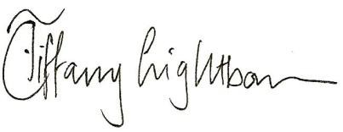
Sincerely,

Tiffany Lightbourn, Ph.D.
Chief, Research and Evaluation Division
Office of Policy and Strategy

