ATTACHMENT H:

AUTHORIZATION LETTER FROM USCIS FOR WORKERS

2013

To Whom It May Concern:

The purpose of this letter is to introduce [INTERVIEWER’S NAME] as a professionally trained interviewer employed by Westat, a research organization located in Rockville, Maryland.

On behalf of the U.S. Department of Homeland Security (DHS), Westat is conducting a Study of Employment Eligibility (SEE) to better understand the experiences of workers with the job application process.

[INTERVIEWER’S NAME] is currently collecting information from individuals selected from a list of recently employed people. Each selected person who completes the interview will receive $35 in cash, in appreciation for his or her participation.

Although it is your choice to be interviewed, I hope you will agree to do it. Please be assured that all responses to this interview are private, to the extent permitted by law. Westat will only provide summary results; your individual responses will not be shared with your employer, DHS, the police, or any other local or state law enforcement agency.

On behalf of the DHS, I want to take this opportunity to thank you for your cooperation and participation. [INTERVIEWER’S NAME] will be happy to answer any questions you have about the study. If you have any concerns regarding the evaluation, please call Natasha McCann, Project Manager, or me at (202) 272-8122.

Sincerely,
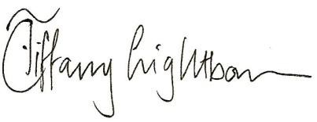

Tiffany Lightbourn, Ph.D.
Chief, Research and Evaluation Division
Office of Policy and Strategy

