To: NCAP
From: Strat@comm
Date: 7/31/2026
Re: QuickQuery and Focus Groups Final Report
The memo that follows outlines summary findings from the online QuickQuery research conducted as well as the focus group testing. Detailed findings from the quantitative QuickQuery research can be found in the corresponding PowerPoint document.

After conducting qualitative research to determine visual options to depict presence of crash prevention technologies, online quantitative testing was done of the best liked options. The best liked options from the focus groups were the colored checks and both black and colored text.

Though all display options are functional, personal preferences indicated an overall preference for colored check marks over black or colored text indicators. The majority of respondents found check marks to be easiest to read and understood, most visually appealing, most effective in illustrating the presence of crash prevention features, and most effective in communicating the importance of Electronic Stability Control. Additionally, when asked to rank the displays from most appealing to least appealing overall, over half of respondents choose the check marks.

An interesting finding from the QuickQuery research was that crash protection ratings displays without placeholder stars are preferred most often overall. This contradicts findings from the focus groups in which the majority of participants preferred displays with placeholder stars. The exact reason for this change in opinion is unknown as no follow-up questions were asked; however, it is most likely a result of the added legend on the display without placeholder stars, which indicates that crash prevention ratings are out of a possible 5 stars.
Detailed summaries follow.

SUMMARY OF QUICKQUERY RESEARCH RECOMMENDATIONS
The following section of the report provides a summary of action steps from the quantitative portion of the research. Detailed findings from the quantitative research can be found on the corresponding PowerPoint document.

Check marks and text indicators are both viable options for crash prevention feature displays.
After narrowing down display options to single check marks and “standard” and “optional” text indicators in focus groups testing, quantitative research suggests that either indicator is suitable for implementation. Check marks, black text, and colored text indicators are all considered easy to read and understand, visually appealing, effective in illustrating crash prevention features, and effective in communicating the importance of Electronic Stability Control.

Implement a check mark system to illustrate presence of crash prevention features.
Though all display options are functional, personal preferences indicate an overall favor toward check marks over black or colored text indicators. The majority of respondents find check marks to be easiest to read and understand, most visually appealing, most effective in illustrating the presence of crash prevention features, and most effective in communicating the importance of Electronic Stability Control. Additionally, when asked to rank the displays from most appealing to least appealing overall, over half of respondents choose check marks. The next most appealing display option, colored text, is only chosen by a quarter of respondents.

Crash star rating displays need a key/legend.
Despite strong evidence in the focus group testing that placeholder stars are more effective in illustrating crash protection ratings, quantitative research suggests that the majority of people (62%) prefer the displays without placeholder stars. While we don’t know specifically why respondents on the QuickQuery gravitated toward this display option, it is likely a result of the added legend to the display without placeholder stars that indicates that crash protection ratings are out of a possible 5 stars. The absence of the placeholder stars combined with this explanation gives the display a cleaner, less cluttered appearance. NHTSA may want to re-evaluate its plan to discontinue displays without placeholder stars and simply add the same legend to all crash protection rating displays from this point forward.

Clearly communicate the importance of Electronic Stability Control.
Focus group research suggests that the general public wants a clear indicator as to which crash prevention feature(s) are most important. If NHTSA wishes to make a distinction between Electronic Stability Control and other crash prevention features, it should be clearly and concisely communicated on the displays, either in the crash prevention feature descriptions on in a footnote near the display.

SUMMARY OF FOCUS GROUP RESEARCH RECOMMENDATIONS
This first part of the report provides a summary of action steps from the research. The detailed findings from the groups begin on page 6 below.

Test check marks and text indicators in quantitative research to determine which is most preferred to illustrate presence of crash prevention features.
After viewing multiple treatments, all with different indicators, single check marks and text emerge as the most successful tactics in communicating the presence of crash prevention features. Participants find both options to be clear, understandable, and capable of helping them make a more informed decision when buying their next vehicle. Harris recommends that NHTSA use the upcoming quantitative research to determine the clear leader between the two displays.

Ensure crash test ratings and crash prevention features look mutually exclusive in all displays.
Many participants express confusion over the closeness of crash test ratings and crash prevention features on the treatments. This creates an impression that the two are somehow connected to each other rather than being completely separate entities. Separating the charts entirely would be unnecessary, but NHTSA should attempt to visually distinguish the two sections to avoid misinterpretation. This concept can also be an element of the quantitative testing in phase II of the research.

Display the maximum amount of stars in all vehicle crash test ratings.
Participants prefer having the ability to see the total number of stars achievable in the crash test ratings rather than only having the ability to see the actual number of stars a specific vehicle received. NHTSA should switch the crash test ratings displays to this format from this point forward.

If crash prevention technologies are here to stay and a new focus for NHTSA, the government must demonstrate the importance of crash prevention features to the general public in terms that are personally relevant – that is, framed as increasing survival rates or decreasing mortality rates while driving.
Most participants have at least some familiarity with crash prevention features but fail to grasp their full value. The results from the groups demonstrate that the public wants to understand the intrinsic value of these technologies in saving lives. Currently, participants seem to think of these features as “nice to haves” rather than “must haves” because they are not yet aware of how the features can reduce fatalities. Additionally, many participants have the perception that the features will only be available in luxury vehicles and suggest that if they are so important, they should be mandatory in all vehicles. If crash prevention features are here for the long haul, and if they will ever be mandatory, NHTSA should communicate this to the general public by showcasing the benefits of each feature in terms of how these features save lives.

Awareness and usage of Safercar.gov are near zero. The plan to get this information out to the broadest audience possible should include partnerships with various organizations and online channels that are already highly familiar to the general public.
Most participants can not readily name NHTSA and not one respondent has ever heard of safercar.gov. Participants are relying on other sources for general vehicle and vehicle safety information, including Consumer Reports, car dealer or manufacturer websites, or other websites that come up in their internet searches. NHTSA should consider partnering with such other, more visible entities to communicate information for maximum general public penetration.

FOCUS GROUP FINDINGS OVERVIEW

Four focus group sessions were conducted during the week of March 3, 2008. Two sessions were conducted in Baltimore, MD on March 5 and two sessions were conducted in Richmond, VA on March 6. Participants in these sessions had to qualify as either a primary or shared decision maker with respect to automobile purchases for their household and intend to purchase a new or used automobile in the next two years.

Participants in both groups were also screened to ensure they had some level of concern about the safety of automobiles and approximately half of each group was comprised of adults who have children under 18 living in their households. Additionally, participants in the groups represented a mix of age, education, and income. Each session lasted approximately 1.5 hours. The following is a description of the groups held at each location:
- March 5 (Baltimore, MD)
  - Female new car purchasers
  - Male used car purchasers

- March 6 (Richmond, VA)
  - Female used car purchasers
  - Male new car purchasers

The main objective of the sessions was to test a series of crash prevention treatments for overall visual appeal and understandability. Additional information was also gathered based on participants’ use of vehicle information sources and familiarity with crash test ratings, NHTSA, and crash prevention features.

A Note on Qualitative Research
In reviewing these findings, it is important to remember that qualitative research, by design, is not meant to be projectable within accurate statistical ranges. Focus groups allow for the understanding and investigation of group consensus, not individual reactions. Qualitative research, and the resulting findings, offer insights into the thematic and directional information of participants.

SUMMARY OF FOCUS GROUP FINDINGS

- Factors Considered and Information Sources Used When Purchasing a Vehicle
  - When asked which factors are important when considering a new or used vehicle, nearly all participants mention safety, price, and overall look/style. Used car purchasers are more likely to be concerned over a vehicle’s reliability, warranty, and mileage.
  - Most participants mention crash test ratings when asked what comes to mind when thinking of vehicle safety. Other common thoughts include air bags, brakes (anti-lock) and vehicle size. A select few participants mention looking for stability control and lane change monitors.
  - Consumer Reports, both in print and online, is often used for general vehicle research and vehicle safety research. Participants generally view Consumer Reports to be a very credible source. Other commonly used sources include dealer and manufacturer websites, Kelly Bluebook’s website, and Google.
    - Non-internet sources, such as recommendations from friends and family, newspapers and magazines, and car salespeople are also used.
    - Many participants will seek out crash test ratings on the internet; however, no one is familiar with or uses safercar.gov.
    - NHTSA, though recognized by a few participants, is not immediately thought of as a vehicle safety source. Several participants expect to find vehicle safety information in vehicle television commercials and other primetime programming, such as Dateline or 20/20.
- Crash Test Ratings
  - Nearly all participants have some level of familiarity with crash test ratings. However, participants are divided in their consultation of crash test ratings when considering purchasing a new or used vehicle.
    - Several use crash test ratings as a deciding factor in their vehicle purchase – citing they would not buy a vehicle unless it had four or five stars. Others report never using the crash test ratings as a decision making factor in the past.
  - Most participants believe the crash test ratings are put out by a government organization but are unable to readily name NHTSA. However, when specifically asked if they had heard of NHTSA before, about half indicate that they have.
  - After viewing the treatment illustrating the crash test ratings, participants agree that more information is needed on the speed of impact, the size of cars involved, and the metrics of the rating scale. Most participants indicate that having the ability to click on the various terms for more information online would be invaluable to their overall understanding of the crash test rating system.
  - Most participants recognize that the star ratings are based on testing vehicles in the same weight class; however, there should be some indication of this on the layout or in the descriptions.
  - After seeing the layout and hearing the description of the NHTSA crash test ratings, participants from all groups agree they would feel safer in a vehicle that tested well in a crash and would use the ratings to avoid purchasing vehicles that test poorly. Several participants who did not use crash test ratings in the past reported that they would consult them in the future.
  - In general, participants prefer to see the full number of stars the crash test ratings can have (hollowed out stars) rather than the number of stars the specific vehicle achieved. This allowed participants to better understand the pros and cons of each vehicle.

- Crash Prevention Features
  - Most participants can readily identify a few crash prevention features, but not by the exact name. Rear view cameras, crash warnings, stability control, and lane change monitors are often mentioned.
  - Participants generally understand the difference between crash prevention and crash protection features, citing that one is proactive while the other is reactive.
    - Participants most often list air bags, seat belts, and anti-lock brakes as crash protection features.
  - Overall, participants view crash prevention features as “nice-to-haves” rather than necessities in their vehicles. Nearly all express concern over the cost implications of crash prevention features. The female, used car purchasers, in particular, assume they would not be able to afford the features or would not have access to the features in older used vehicles. Participants from all groups express concern that crash prevention features may allow drivers to become lazy and inattentive on the road.
  - Female participants are more likely to believe crash prevention features should be mandatory for all vehicles; however, they do not believe this should impact vehicle cost. In general, male participants believe the features should be optional.
  - Though participants indicate they would feel safer in a vehicle with crash prevention features, they unanimously agree that crash test ratings are more important overall. Most recognize that crashes will inevitably happen, even with the presence of crash prevention features, and they want to know that their vehicle will be able to protect them.
  - Participants believe a variety of entities should communicate the importance of crash prevention features and crash test ratings, specifically dealer and manufacturer websites, government organizations, Consumer Reports, insurance companies, and the media.

- Treatment Testing
*Note: All treatments and workbook scores can be found in the appendix at the end of the report.
  - After viewing the first treatment (Option 1 for groups 1 and 4 and Option 4 for groups 2 and 3), participants unanimously agree that the colors are not visually appealing and the font is too small. At first glance, most participants concur that there is not enough information to fully comprehend what they are viewing. More information on the crash test rating scale, the specific crash tests, and the crash prevention technologies would be extremely valuable.
  - Overall, single check markings and text are the most understandable ways to illustrate the presence of crash prevention technologies, though neither marking is overwhelmingly preferred. To further drill down into overall preference, these two markings will be tested in the upcoming quantitative study.
  - Participants overwhelmingly object to the multiple checks, star markings and A-D grading scale, citing they are very difficult to understand, despite having an associated key.
    - The main issue with multiple checks and star markings is the confusion over the value of multiple markings. Participants are unsure whether the multiple markings denote presence of crash prevention technologies or if they indicate some sort of value. If Electronic Stability Control (ESC) is the most important crash prevention technology, most agree that it should be specifically communicated or noted on the layout.
    - Several participants mention that the crash test ratings and the crash prevention technologies should not have the same markings (stars) because they communicate two very different things. Using the same markings suggests that the crash test ratings and crash prevention featured are measured the same way.
  - All participants prefer the three separate columns for crash prevention technologies rather than the one column format.
  - Participants often express confusion over the blank boxes in the crash prevention technologies section. Most understand its implication – that the prevention technologies do not come with the vehicle at all; however, they would like more of an indication to confirm if that is the case. A few suggest blacking out the boxes, while others recommend putting a N/A (not available) in the space, though some participants are unsure of what N/A means.
  - Participants in the second set of groups, those presented with treatments with the new color schemes, unanimously agree that the colors and larger font size in the new treatments are better than the originals.
    - Marking font color preference is relatively divided. Some participants find colored fonts to be distracting and confusing, while others suggest they help differentiate the meanings of the symbols and text. Most participants agree that Option 2 (the treatment with “Standard” and “Optional” text) should have black font only to avoid confusion.
  - A few participants in each group, and the majority in the male, new car purchasers group, recommend increasing the separation between sections to make a distinction between the crash test ratings and the crash prevention technologies. This would reinforce the fact that the two sections are completely independent of each other and alleviate misunderstanding.
  - The final discussion on importance of crash test ratings and crash prevention features reinforces the weight participants place on crash test ratings. All participants would choose to buy a car with a five star crash test rating rather than a car equipped with all crash prevention technologies.

Appendix: QuickQuery Images
The images below were tested in the quantitative portion of the project.

Crash Prevention Displays – Black Text

Crash Prevention Displays – Colored Text
Crash Prevention Displays – Check Marks

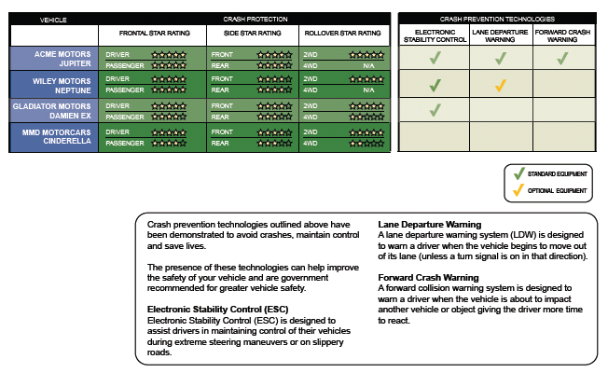

Crash Protection Ratings Displays – Placeholder Stars

Crash Protection Ratings Displays – No Placeholder Stars

Appendix: Workbook Results

The charts below illustrate the total workbook results for each treatment.

Option 1 | Completely Agree | Somewhat Agree | Do not Agree
I fully understand what crash prevention technologies each vehicle has | 20 | 12 | 1
The layout of this treatment is visually appealing | 14 | 18 | 1
The symbols used are easy to understand | 25 | 7 | 1
The language and terminology used is easy to understand | 26 | 6 | 1
If I saw this layout online, I would stop to look at it | 16 | 16 | 1
This information would help me make a more informed safety decision when purchasing my next vehicle | 16 | 16 | 1

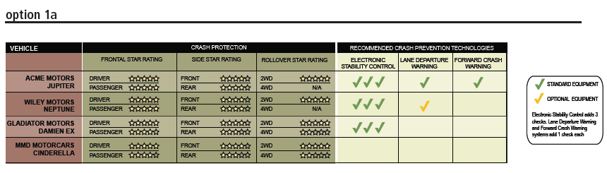

Option 1a | Completely Agree | Somewhat Agree | Do not Agree
I fully understand what crash prevention technologies each vehicle has | 15 | 10 | 8
The layout of this treatment is visually appealing | 7 | 24 | 2
The symbols used are easy to understand | 12 | 12 | 9
The language and terminology used is easy to understand | 14 | 13 | 6
If I saw this layout online, I would stop to look at it | 13 | 17 | 3
This information would help me make a more informed safety decision when purchasing my next vehicle | 12 | 14 | 7

Option 1b | Completely Agree | Somewhat Agree | Do not Agree
I fully understand what crash prevention technologies each vehicle has | 12 | 15 | 6
The layout of this treatment is visually appealing | 6 | 21 | 6
The symbols used are easy to understand | 4 | 18 | 11
The language and terminology used is easy to understand | 7 | 18 | 8
If I saw this layout online, I would stop to look at it | 10 | 17 | 6
This information would help me make a more informed safety decision when purchasing my next vehicle | 9 | 15 | 9

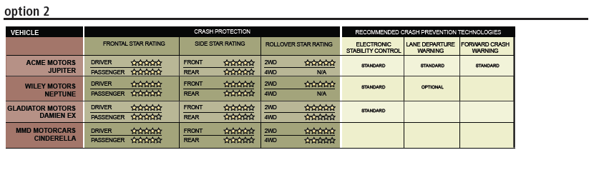
Option 2- Text | Completely Agree | Somewhat Agree | Do not Agree
I fully understand what crash prevention technologies each vehicle has | 25 | 7 | 1
The layout of this treatment is visually appealing | 13 | 20 | 0
The symbols used are easy to understand | 23 | 9 | 1
The language and terminology used is easy to understand | 25 | 7 | 1
If I saw this layout online, I would stop to look at it | 20 | 11 | 2
This information would help me make a more informed safety decision when purchasing my next vehicle | 20 | 11 | 2

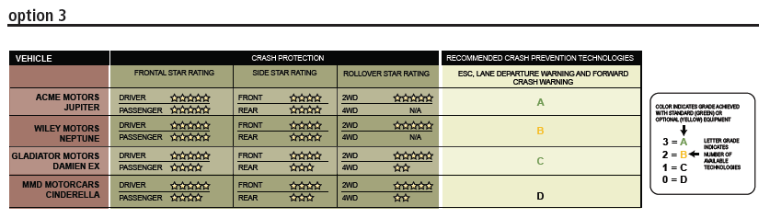

Option 3 | Completely Agree | Somewhat Agree | Do not Agree
I fully understand what crash prevention technologies each vehicle has | 6 | 6 | 21
The layout of this treatment is visually appealing | 5 | 9 | 19
The symbols used are easy to understand | 3 | 7 | 23
The language and terminology used is easy to understand | 3 | 11 | 17
If I saw this layout online, I would stop to look at it | 5 | 13 | 15
This information would help me make a more informed safety decision when purchasing my next vehicle | 3 | 14 | 15

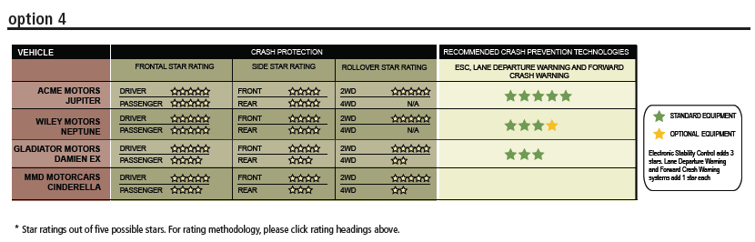

Option 4 | Completely Agree | Somewhat Agree | Do not Agree
I fully understand what crash prevention technologies each vehicle has | 7 | 12 | 14
The layout of this treatment is visually appealing | 9 | 15 | 9
The symbols used are easy to understand | 12 | 11 | 9
The language and terminology used is easy to understand | 8 | 15 | 9
If I saw this layout online, I would stop to look at it | 10 | 15 | 8
This information would help me make a more informed safety decision when purchasing my next vehicle | 6 | 18 | 9

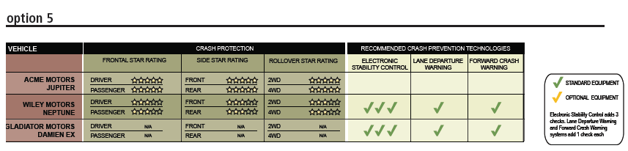

*Option 5 | Completely Agree | Somewhat Agree | Do not Agree
I fully understand what crash prevention technologies each vehicle has | 5 | 7 | 5
The layout of this treatment is visually appealing | 3 | 9 | 5
The symbols used are easy to understand | 4 | 7 | 6
The language and terminology used is easy to understand | 5 | 8 | 4
If I saw this layout online, I would stop to look at it | 5 | 4 | 7
This information would help me make a more informed safety decision when purchasing my next vehicle | 5 | 6 | 6
*Groups 3 and 4 were not asked to evaluate Option 5 in their workbooks.

