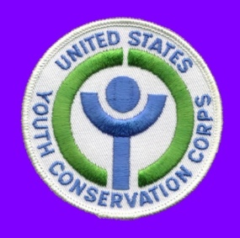
United States Youth Conservation Corps
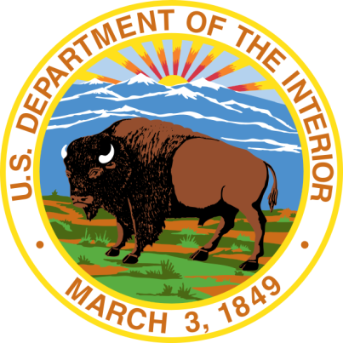
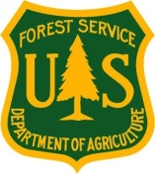
Application

Please fill out this application as thoroughly and legibly as possible and return it to the Youth Conservation Corps (YCC) program site location where you would like to work, or forward it to the YCC contact listed on the Federal Agency’s website. Mailing addresses for YCC programs by state are available at https://youthgo.gov
Applications can also be accepted online.

Applicant Information (please complete electronically, type, or print legibly)
Name: |  |  |  |  |  |  |  |  |  |  |  |  |  |  |  |  | ☐Male ☐Female
Address:
Street City State Zip
Email: |  |  |  |  |  |  |  |  | Date of Birth: (MM/DD/YYYY) |  |  |  |  |  |  |  |  | Age:
Home Phone: |  |  |  | ( )- - |  |  |  |  | Cell Phone: |  |  |  |  |  | ( )- -
Best way & time to get in touch with you:
If Under 18, Parent/Guardian Contact Information:
Name: |  |  |  |  |  |  |  |  |  |  | Email:
Home Phone: |  |  |  | ( )- - |  | Work Phone: |  |  |  | ( )- -
What is the location of the YCC Program for which you are applying? |  |  |  |  |  |  |  |  |  |  |  |  |  |  | Where did you learn about YCC?  ☐Newspaper  ☐Past/Current YCC Member  ☐School Presentation  ☐School Counselor  ☐Poster  ☐Other:
Name of Unit/Location e.g. Ocala National Forest, FL or Yellowstone National Park, WY)

OR:

☐ No location selected- I am flexible
Educational Background
School Name: |  |  |  |  |  |  |  | City/State:
Highest Grade Completed (as of June): |  |  |  |  |  |  |  | Last day of school this year:  (MM/DD/YYY)

Overview
The Youth Conservation Corps (YCC) is a well-balanced work-learn-earn program that develops an understanding and appreciation in participating youth of the nation's environment and heritage. It is administered by the U.S. Department of Agriculture - Forest Service, and by the U.S. Department of the Interior - Fish and Wildlife Service and National Park Service. YCC offers gainful summer employment to youth, for approximately eight weeks, in a healthful outdoor atmosphere. Enrollees will be paid the minimum wage for a 40-hour work week. Most projects will enroll an equal number of males and females. YCC members work on a variety of projects including building trails, maintaining fences, cleaning up campgrounds, improving wildlife habitat, and thinning timber stands. Participants will do hard physical work and may be exposed to insects, poison oak and ivy, adverse weather, and difficult working conditions.

Eligibility Requirements
Young men and women, 15 through 18 years of age, who are permanent residents of the United States, its Territories, or possessions, are eligible for employment without regard to social, economic, racial, or ethnic backgrounds. Youth with physical or other challenges who can effectively participate in most YCC activities are eligible. Youth must have no history of serious criminal or other antisocial behavior that might endanger their safety or that of others; have or be able to obtain a work permit as required under the laws of their State; have a Social Security number or have made application for one; be willing and able to work hard and participate in most work projects. Employment is without regard to Civil Service or classification laws, rules, or regulations.

How You Can Enroll
To apply, youth meeting these qualifications should complete this YCC application form and return it at the earliest possible date to the nearest unit of a National Park, National Forest, or national Fish and Wildlife Refuge or Hatchery.
Applicants will be selected on a random basis and will be notified of selection. Demographic information such as age, race, and family income is not used in the selection process.

PRIVACY ACT STATEMENT
YCC Application (FS-1800-18)
The following information is provided to comply with the Privacy Act of 1974 (PL-579). 5 U.S.c. 301 and 7 CFR 260 authorize acceptance of the information requested on this form. The data will be used in the selection process of applicants for the YCC crews, and for contacting the selected applicants. This information is requested on a voluntary basis, failure to complete this form will result in exclusion from the program. Privacy Act Systems of Records USDA/FS-29 Youth Conservation Corps Enrollee Records and USDA/FS-30 Youth Conservation Corps Recruitment System cover the collection and storage of, and access to these records.

Non-Discrimination and Burden Statements

According to the Paperwork Reduction Act of 1995, an agency may not conduct or sponsor, and a person is not required to respond to a collection of information unless it displays a valid OMB control number. The valid OMB control number for this information collection is 0596-0084. The time required to complete this information collection is estimated to average 25 minutes per response, including the time for reviewing instructions, searching existing data sources, gathering and maintaining the data needed, and completing and reviewing the collection of information.

The U.S. Department of Agriculture (USDA) prohibits discrimination in all its programs and activities on the basis of race, color, national origin, gender, religion, age, disability, political beliefs, sexual orientation, and marital or family status. (Not all prohibited bases apply to all programs.) Persons with disabilities who require alternative means for communication of program information (Braille, large print, audiotape, etc.) should contact USDA’s TARGET Center at 202-720-2600 (voice and TDD).

To file a complaint of discrimination, write USDA, Director, Office of Civil Rights, 1400 Independence Avenue, SW, Washington, DC 20250-9410 or call (800) 795-3272 (voice) or (202) 720-6382 (TDD). USDA is an equal opportunity provider and employer.

Work, Community Service, and Extra-Curricular Experiences
Please describe any work, volunteer, and/or extra-curricular (clubs, sports, hobbies) activities you have participated in the last two years.
Participating in the YCC may be physically demanding; including living and working outdoors for part of the program and working up to eight hours a day on conservation projects. Please describe any experience you have had that would prepare you for this program such as camping, backpacking, hiking, sports, household chores, regular exercise.
General Questions
Why do you want to be part of a Youth Conservation Corps?
Describe an experience you have had working with a team or group. What did you gain from that experience?

Certification

I am familiar with the Youth Conservation Corps (YCC) program and interested in working to develop and maintain the natural and cultural resources of the United States. If selected, I will obtain a work permit if required. I have or am applying for a social security number. I am a citizen or permanent resident of the United States or its Territories or possession.

I certify that all information I have given above is true and correct to the best of my knowledge. I understand that incorrect statements constitute grounds for immediate dismissal. You have my permission to give this application to any YCC official.

Applicant Signature:__________________________________________ Date:________________________
I, the parent/legal guardian of the under-18 applicant, have discussed this program with the applicant and I authorize him/ her to apply.
Parent/Guardian Signature:_____________________________________ Date:________________________

This application must be filled out completely to determine applicant's eligibility and availability. Incomplete applications may have to be rejected. Participants must be at least 15 years of age by the beginning of enrollment and not have reached age 19 during enrollment.
Please go to www.youthgo.gov to find out where to send your completed application.

ETHNICITY & RACE (Optional):
The US Government is committed to providing YCC experiences to young people that represent the diversity of our nation. You can help us track who serves in YCC programs by reporting both ethnicity and race using the following selections. Multiracial respondents may select two or more races.

Please be advised that this information is optional and you are not required to complete this section.
Ethnicity (Select one):  ☐ Hispanic or Latino  ☐ Not Hispanic or Latino | Race (Select one or more, regardless of Ethnicity):  ☐ American Indian or Alaskan Native  ☐ Asian  ☐ Native Hawaiian or Other Pacific Islander  ☐ Black or African American  ☐ White or Caucasian

