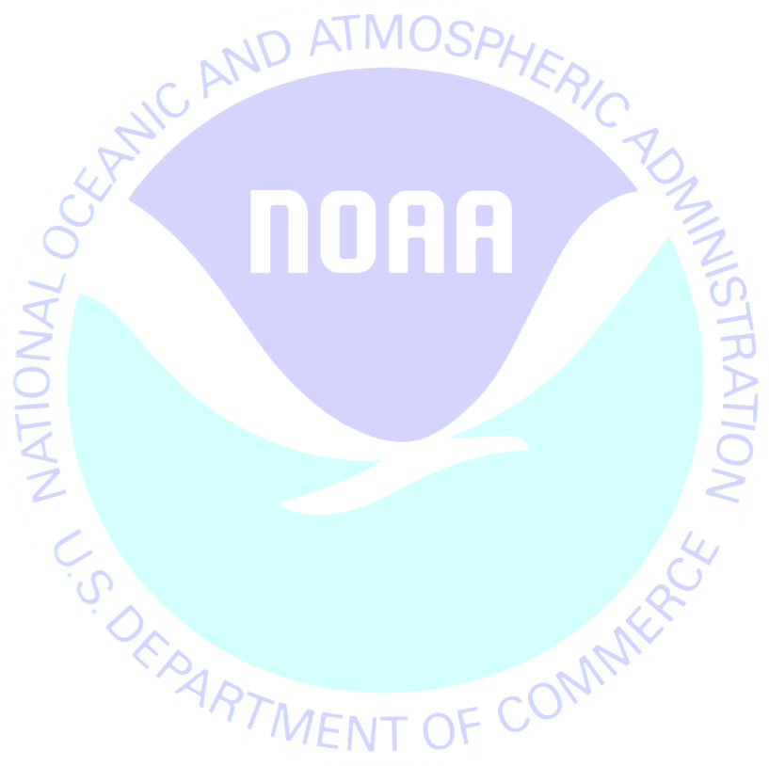
DATE

Last week we sent you an Outdoor Activity Survey on behalf of the National Oceanic and Atmospheric Administration. If you have already completed and returned the survey, please accept our sincere thanks. If not, please do so today.
This study is being conducted to learn more about outdoor activity participation. Please know that your answers are completely confidential and will be used only for this study in accordance with the Magnuson-Stevens Act and NOAA Administrative Order 216-100.
If you did not receive the survey or need another copy, please call XXXXXXXX toll-free at 1-XXX-XXX-XXXX.
Sincerely,
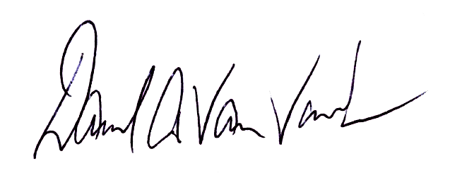

David A. Van Voorhees
Chief, Fisheries Statistics Division
NOAA Fisheries, Office of Science and Technology
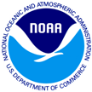
Outdoor Acitivity Survey
1009 Slater Rd
Suite 110
Durham, NC 27703

Proper Name
Add1
Add2
City, St Zip

