Attachment 2. Screen Shots of the MMWR 2016 Customer Service Feedback Survey Pilot
[PAGE 1] INTRODUCTION
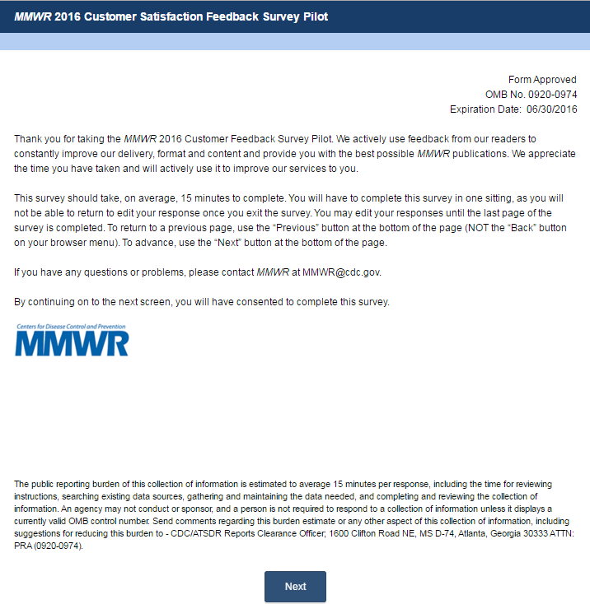

[PAGE 2] DEMOGRAPHICS
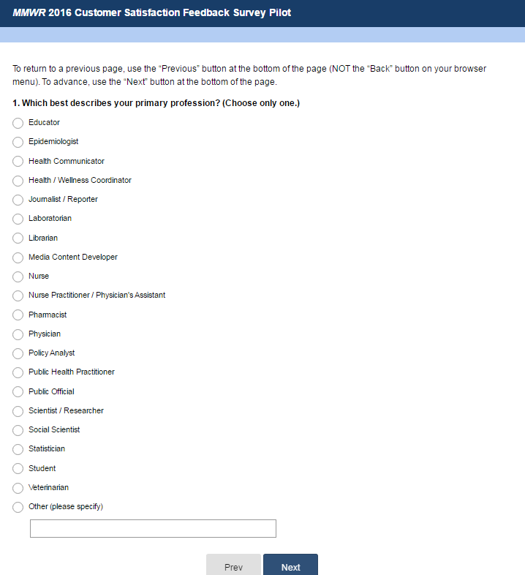

[PAGE 3] DEMOGRAPHICS CONTINUED
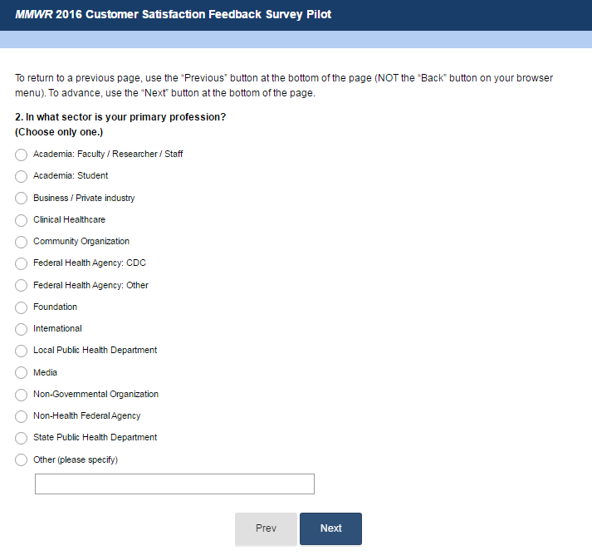
[PAGE 4] DEMOGRAPHICS CONTINUED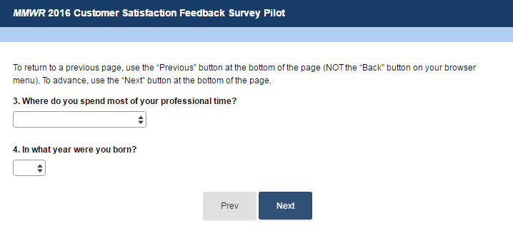
Drop-down in Question 3 expanded:
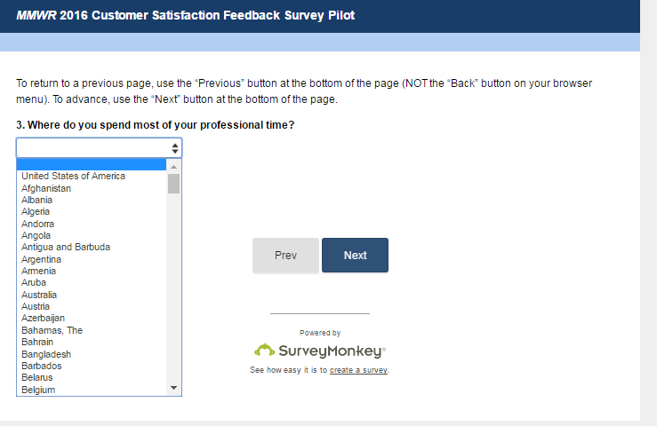

Drop-down in Question 4 expanded:

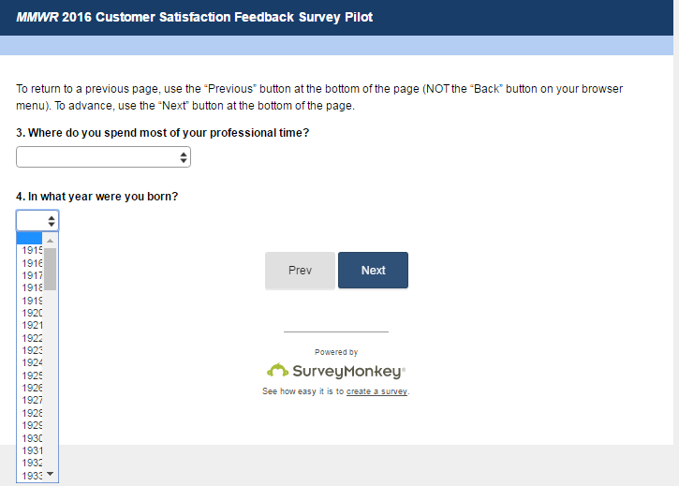

[PAGE 5] SCREENING QUESTION
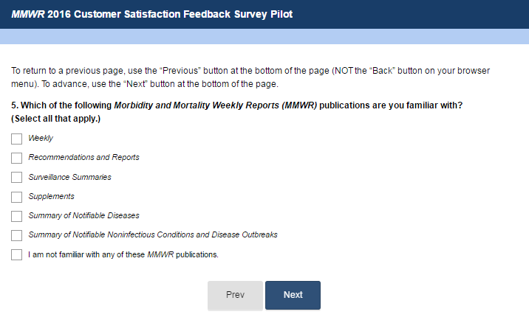

[PAGE 6] DEMOGRAPHICS CONTINUED
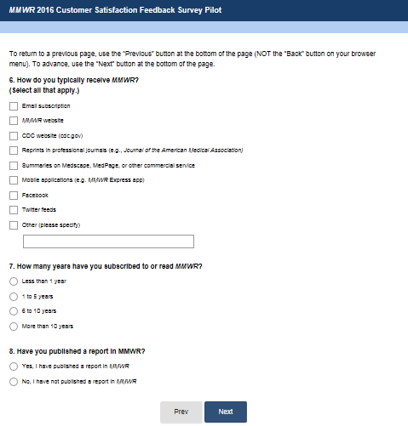
[PAGE 7] DEMOGRAPHICS CONTINUED
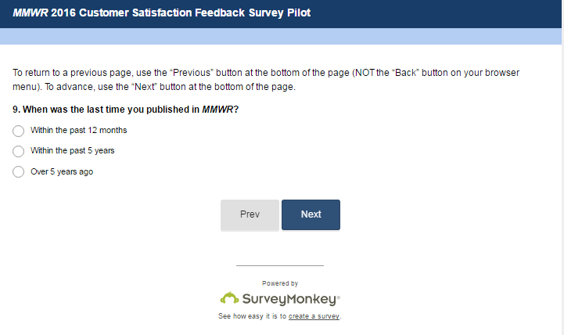

[PAGE 8] FREQUENCY OF USE & SATISFACTION
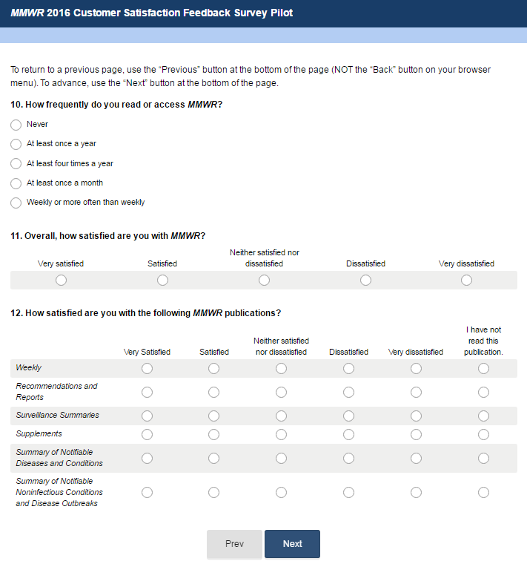

[PAGE 9] SATISFACTION CONTINUED
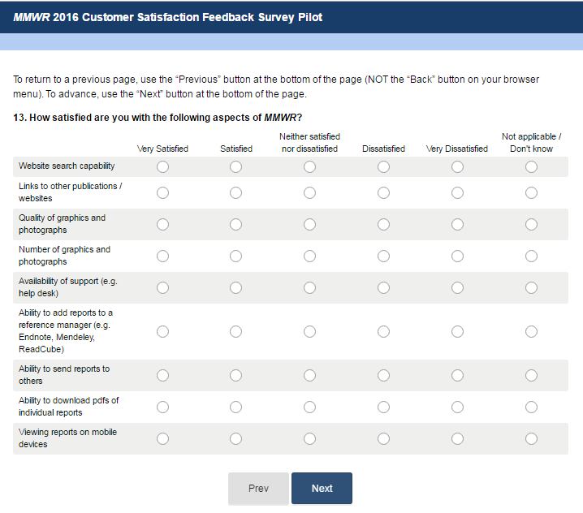

[PAGE 10] SATISFACTION CONTINUED
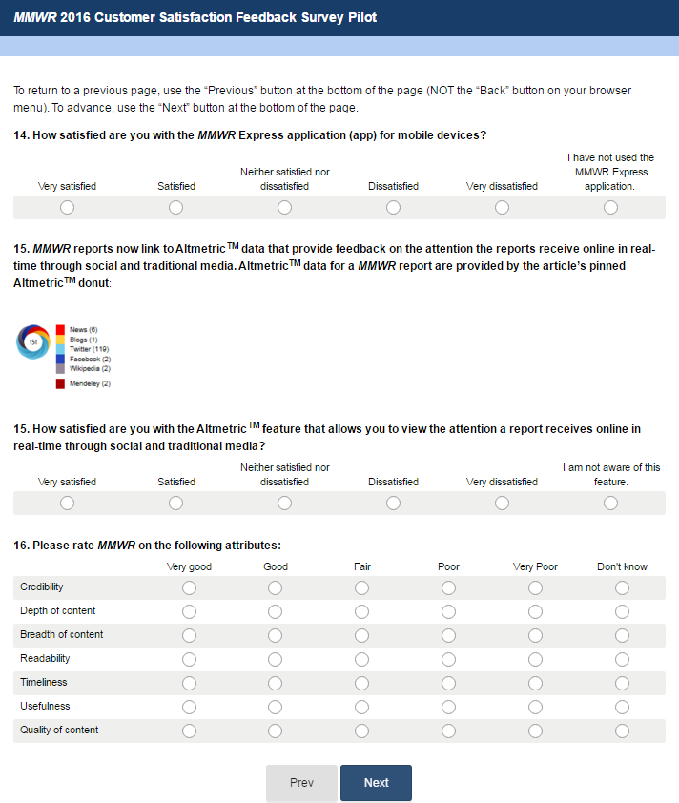

[PAGE 11] INTEREST IN INNOVATIONS
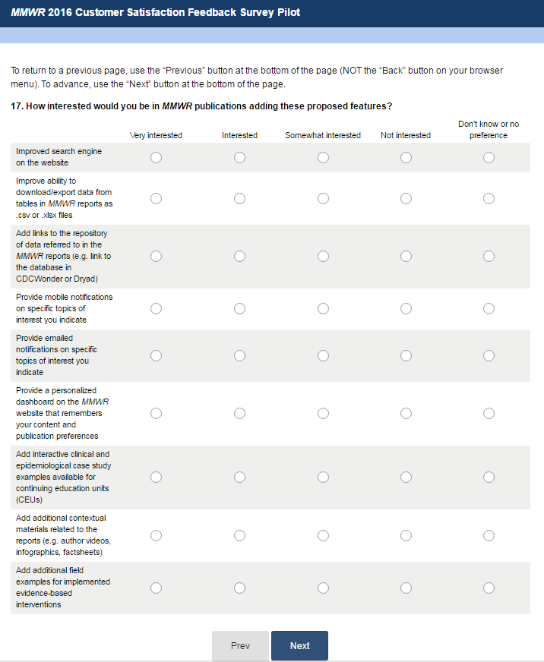

[PAGE 12] INTEREST IN INNOVATIONS CONTINUED
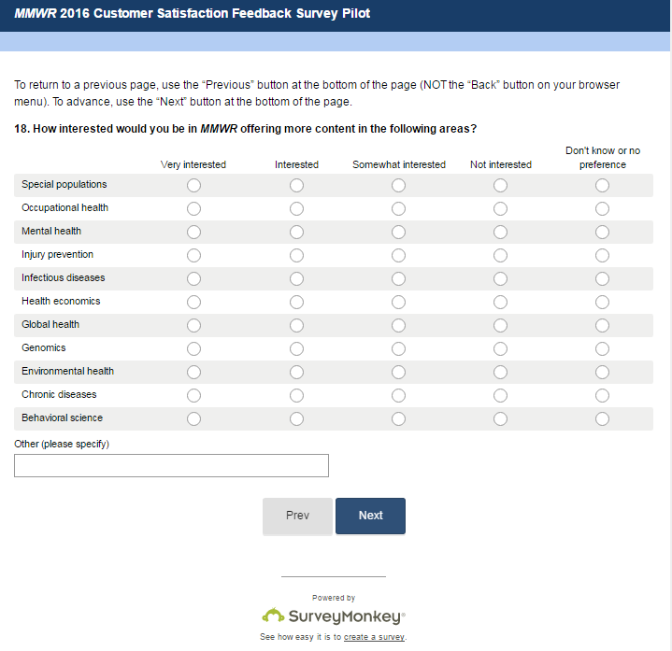

[PAGE 13] PREFERENCE ON SOURCE OF INFORMATION
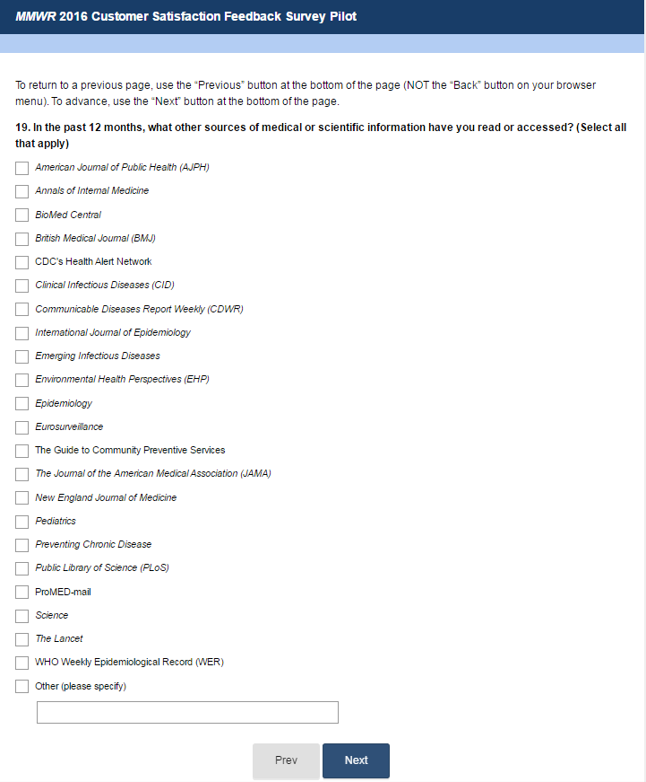

[PAGE 14] PREFERENCE ON SOURCE OF INFORMATION CONTINUED
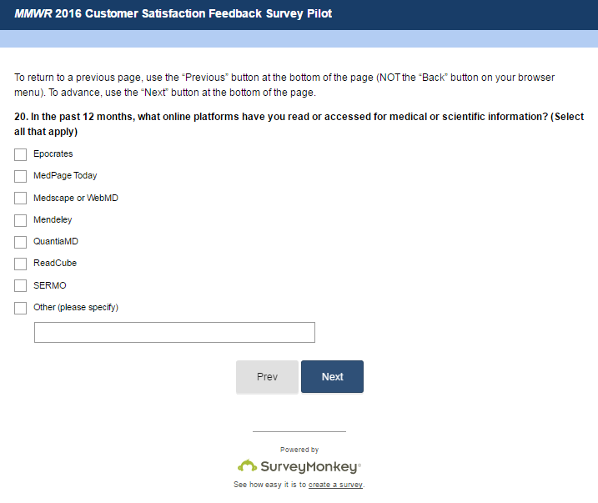

[PAGE 15] PREFERENCE ON SOURCE OF INFORMATION CONTINUED
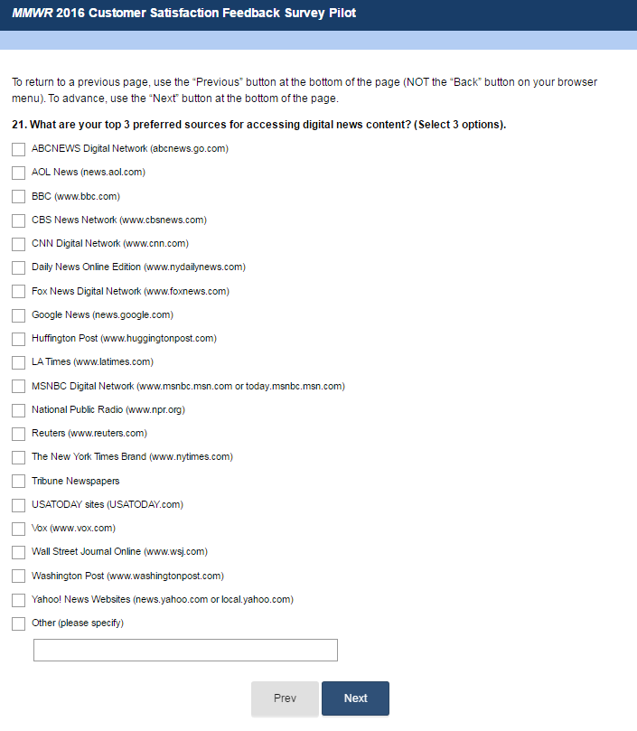

[PAGE 16] VALUE
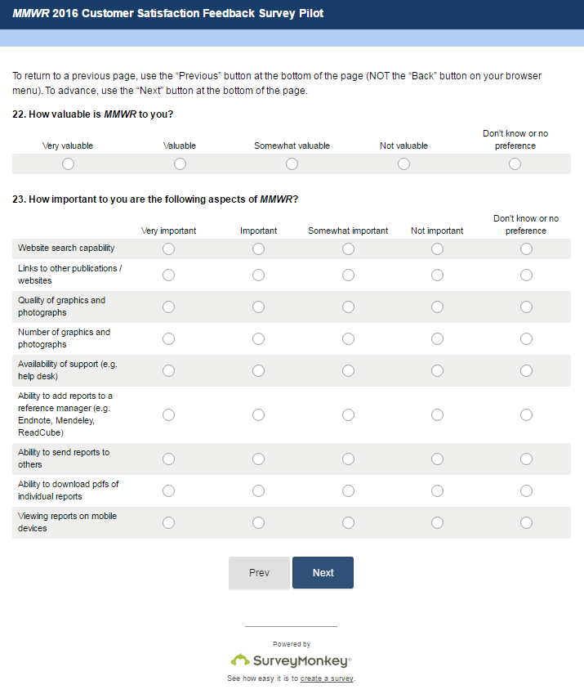
[PAGE 17] VALUE CONTINUED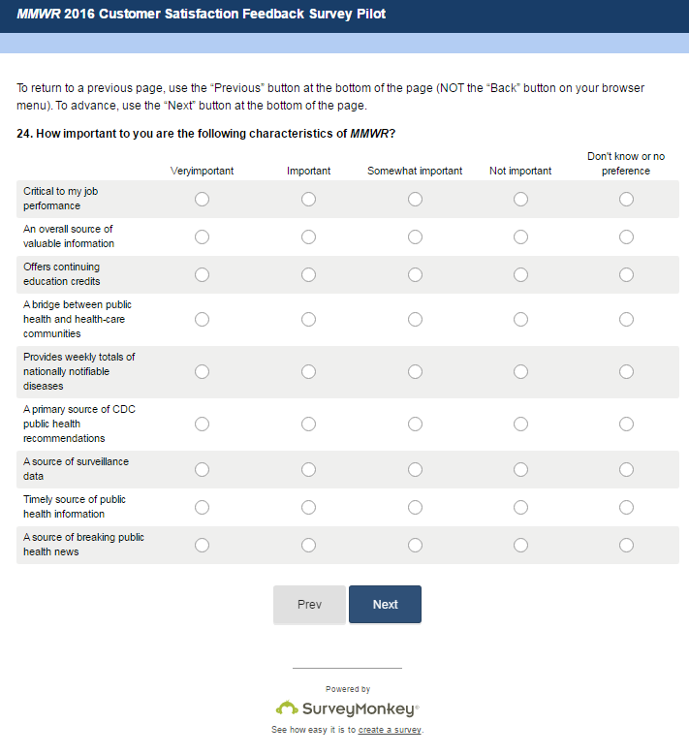

[PAGE 18] USE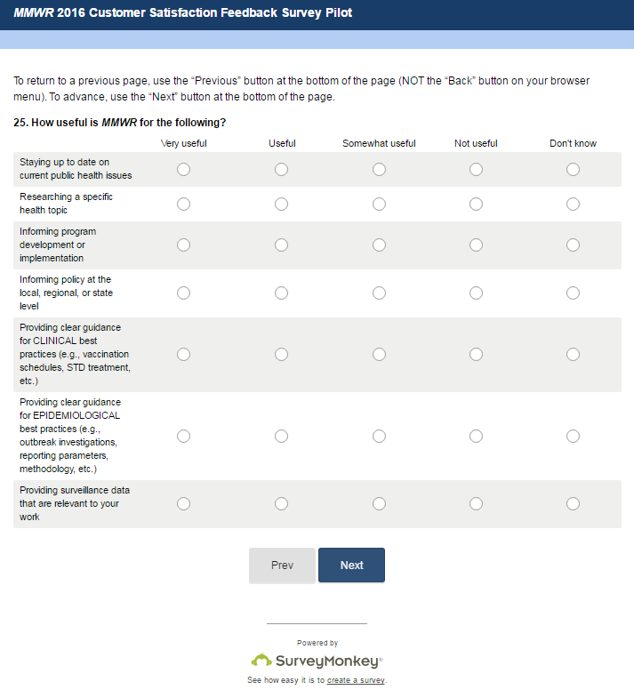
[PAGE 19] USE CONTINUED
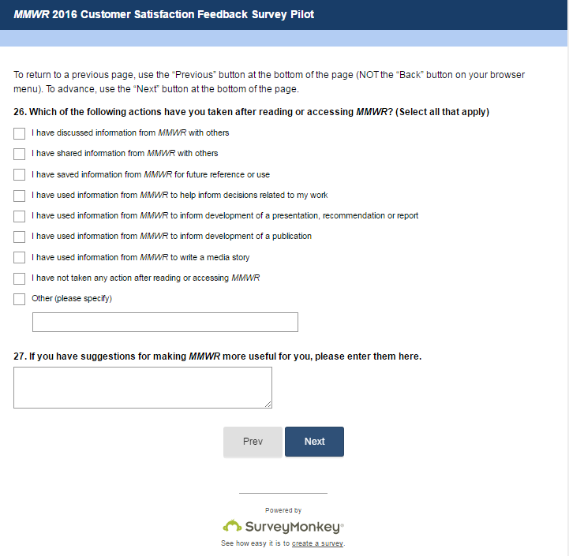

[PAGE 20] CONCLUSION

