Attachment 6a
Screen Shots Previously Approved Surveys

Figure 1: PALS Login Landing Page to Access Surveys 2
Figure 2: Select Survey to Take 3
Figure 3: General Instructions 4
Figure 4: Survey 1, Page 1 of 4 5
Figure 5: Survey 1, Page 2 of 4 6
Figure 6: Survey 1, Page 3 of 4 7
Figure 7: Survey 1, Page 4 of 4 8
Figure 8: Survey Taken Confirmation Page (Same for ALL Surveys) 9
Figure 9: Survey 2, Page 1 of 3 10
Figure 10: Survey 2, Page 2 of 3 11
Figure 11: Survey 2, Page 3 of 3 12
Figure 12: Survey 3, Page 1 of 2 13
Figure 13: Survey 3, Page 2 of 2 14
Figure 14: Survey 4, Page 1 of 3 15
Figure 15: Survey 4, Page 2 of 3 16
Figure 16: Survey 4, Page 3 of 3 17
Figure 17: Survey 5, Page 1 of 2 18
Figure 18: Survey 5, Page 2 of 2 19
Figure 19: Survey 6, Page 1 of 9 20
Figure 20: Survey 6, Page 2 of 9 21
Figure 21: Survey 6, Page 3 of 9 22
Figure 22: Survey 6, Page 4 of 9 23
Figure 23: Survey 6, Page 5 of 9 24
Figure 24: Survey 6, Page 6 of 9 25
Figure 25: Survey 6, Page 7 of 9 26
Figure 26: Survey 6, Page 8 of 9 27
Figure 27: Survey 6, Page 9 of 9 27
Figure 28: Disease Progression Survey, Page 1 of 8 28
Figure 29: Disease Progression Survey, Page 2 of 8 29
Figure 30: Disease Progression Survey, Page 3 of 8 30
Figure 31: Disease Progression Survey, Page 4 of 8 31
Figure 32: Disease Progression Survey, Page 5 of 8 32
Figure 33: Disease Progression Survey, Page 6 of 8 33
Figure 34: Disease Progression Survey, Page 7 of 8 34
Figure 35: Disease Progression Survey, Page 8 of 8 35

Please Note: OMB Burden Statement appears on the individual’s Survey Accounts page. Because participants can take surveys in any order, the OMB Burden Statement was placed on the one page that everyone has to view.
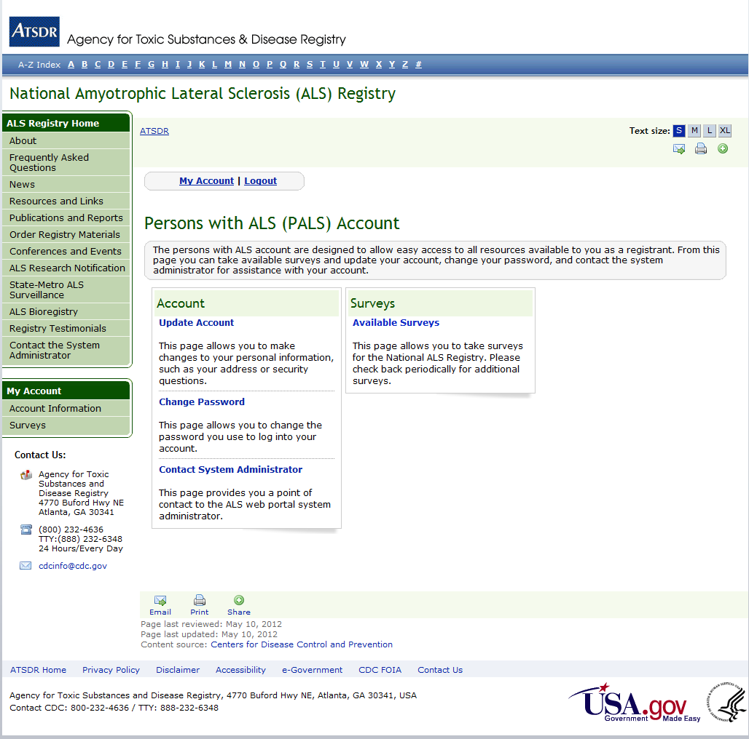
Figure 1: PALS Login Landing Page to Access Surveys

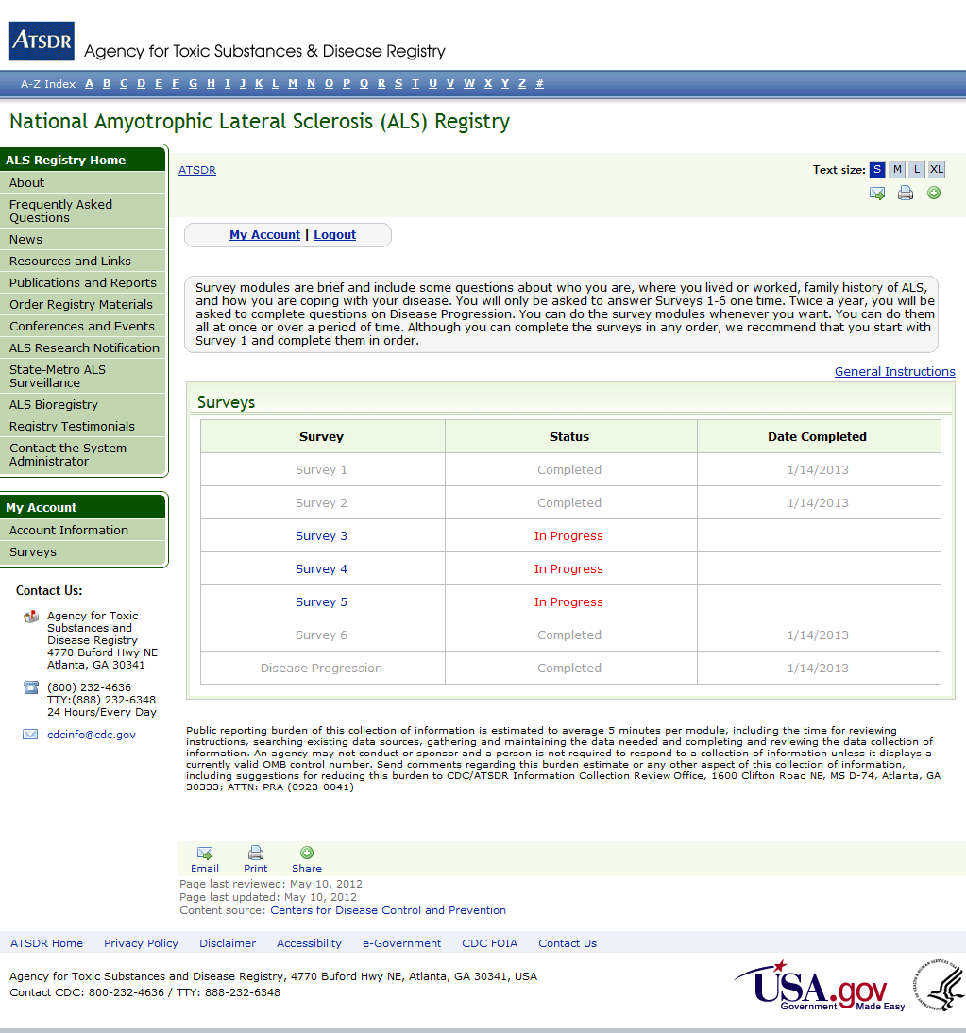

Figure 2: Select Survey to Take
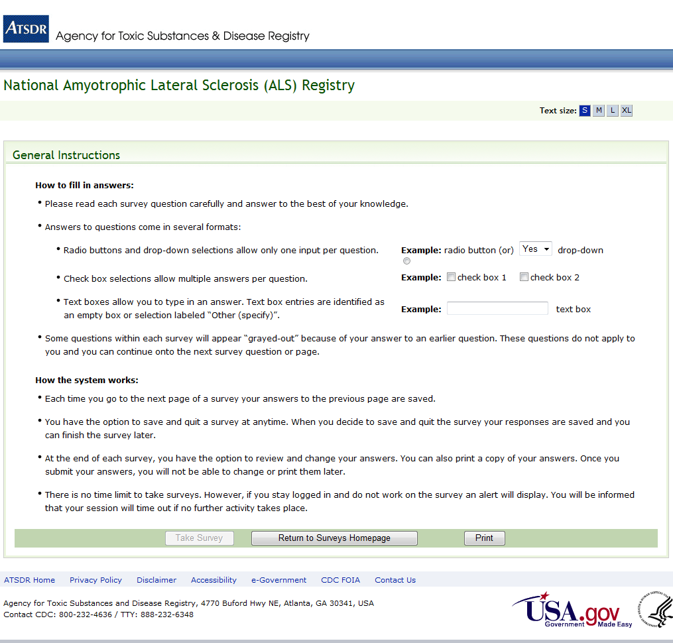

Figure 3: General Instructions
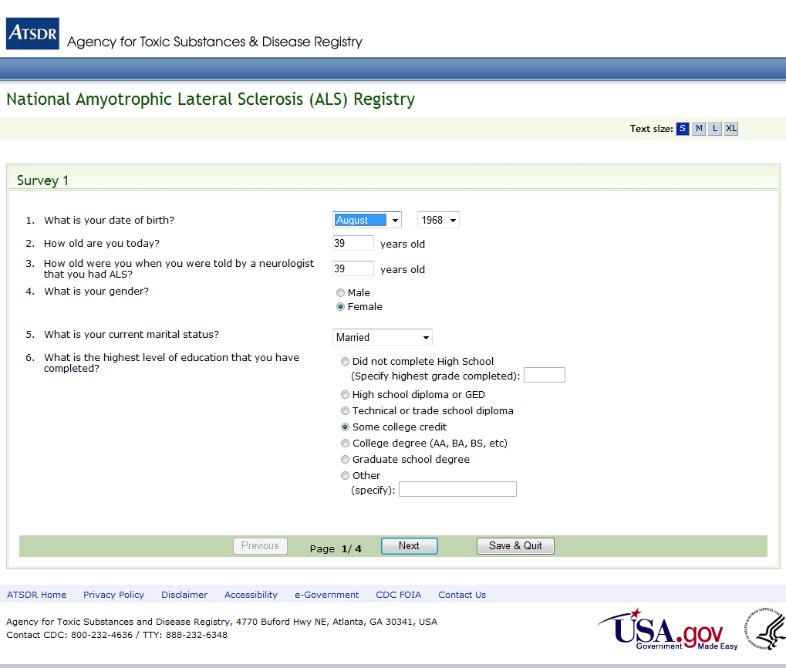
Figure 4: Survey 1, Page 1 of 4
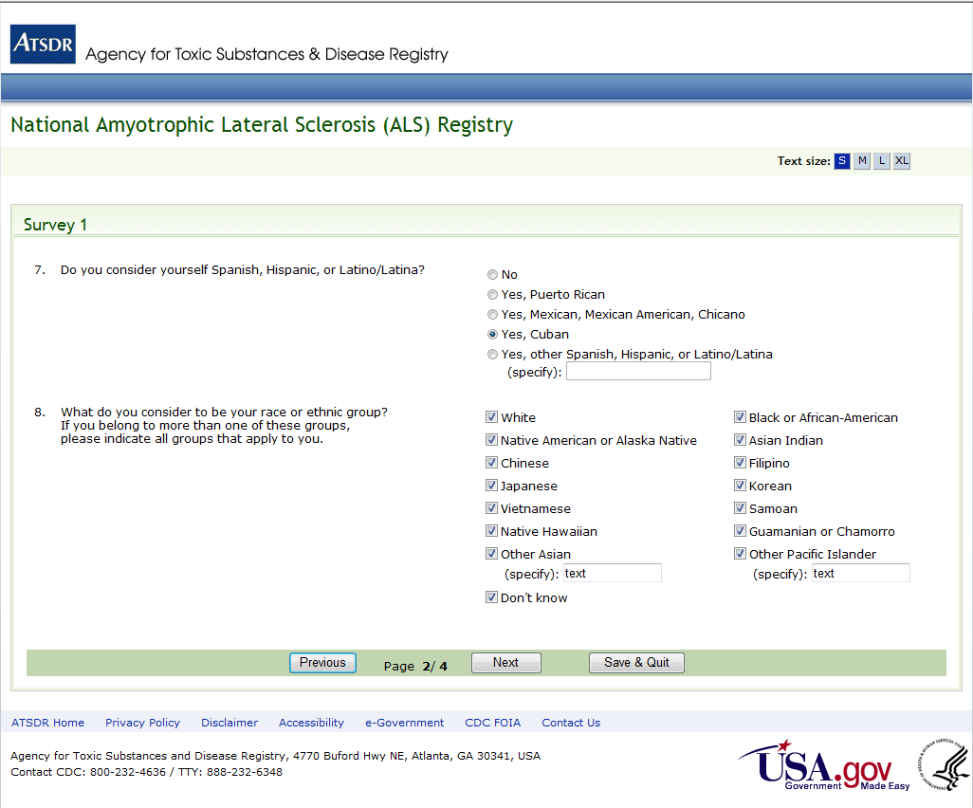
Figure 5: Survey 1, Page 2 of 4
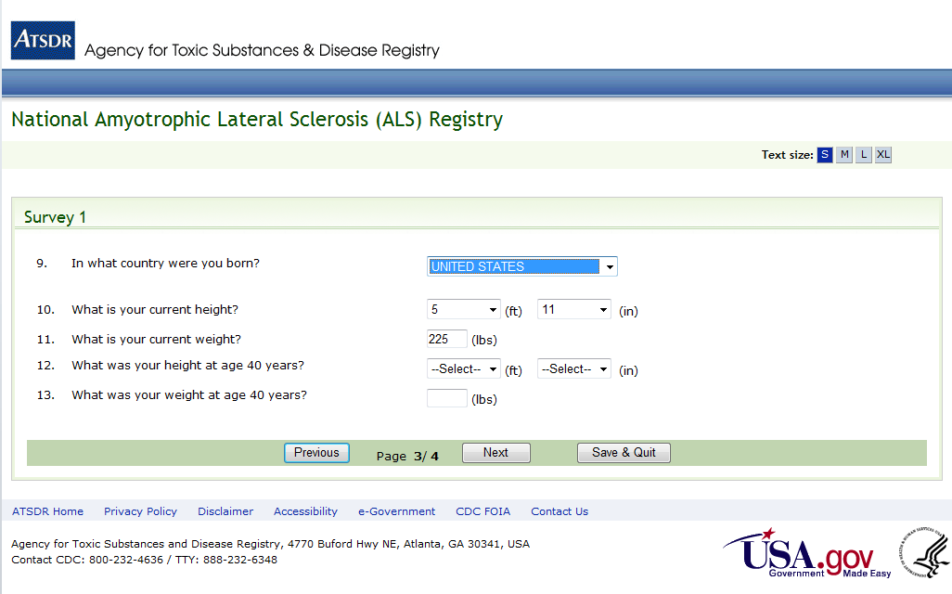
Figure 6: Survey 1, Page 3 of 4
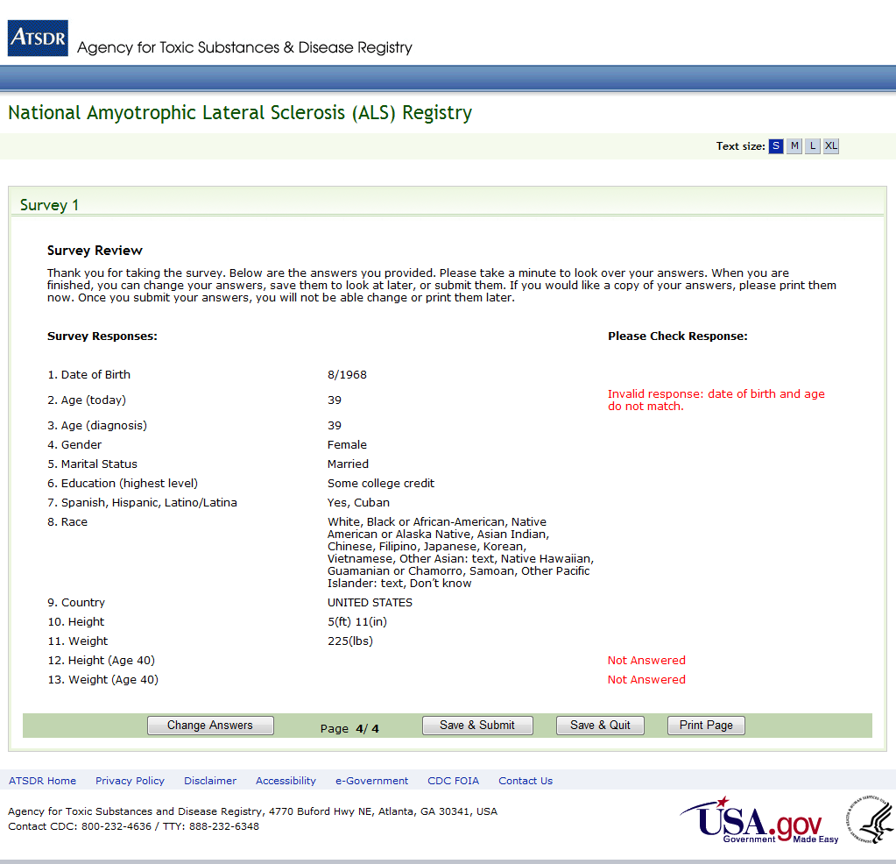
Figure 7: Survey 1, Page 4 of 4
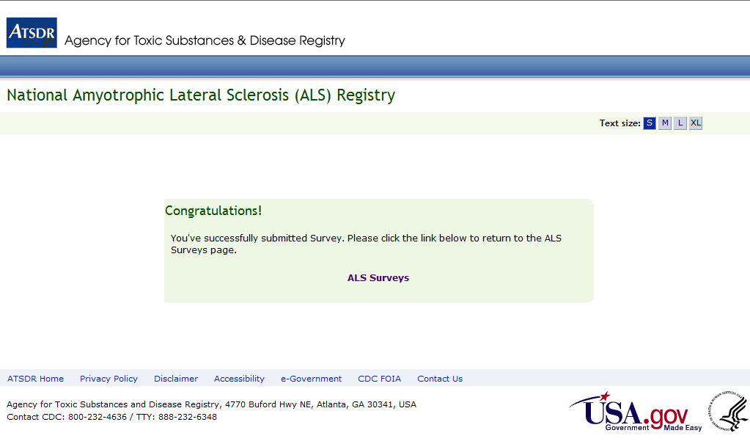
Figure 8: Survey Taken Confirmation Page (Same for ALL Surveys)
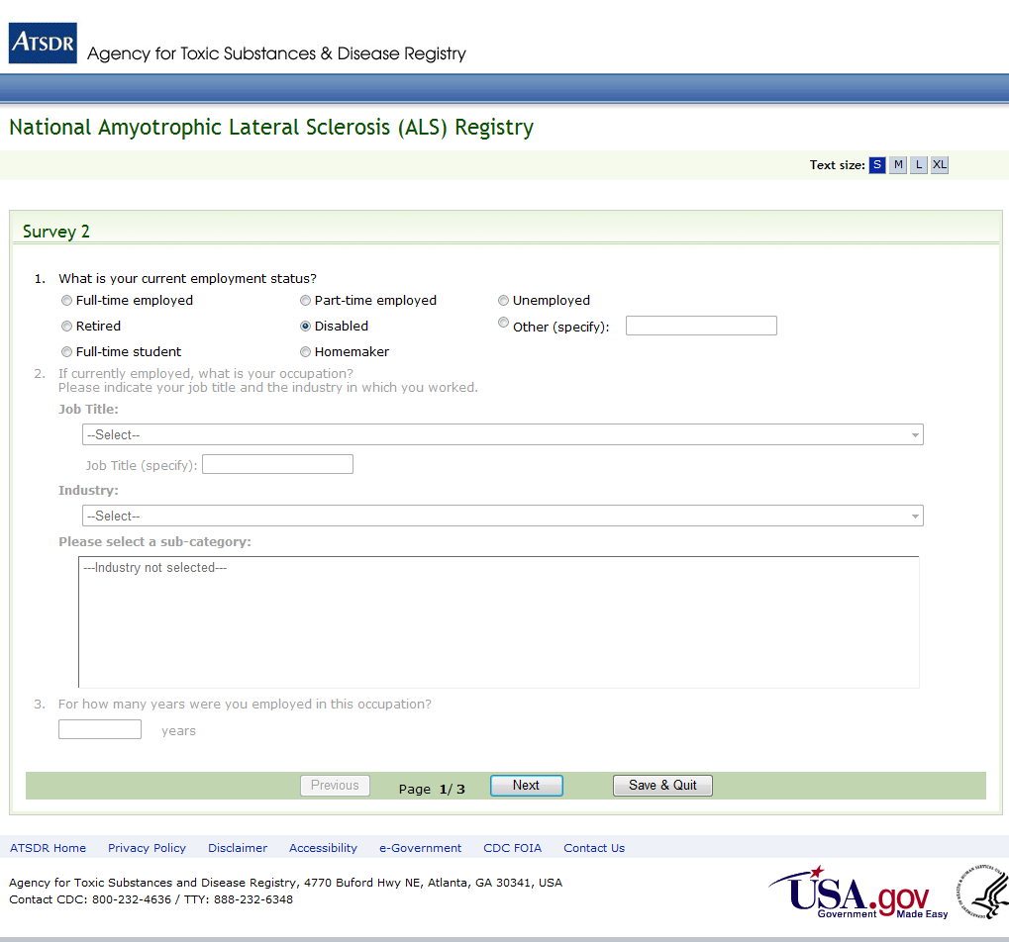
Figure 9: Survey 2, Page 1 of 3
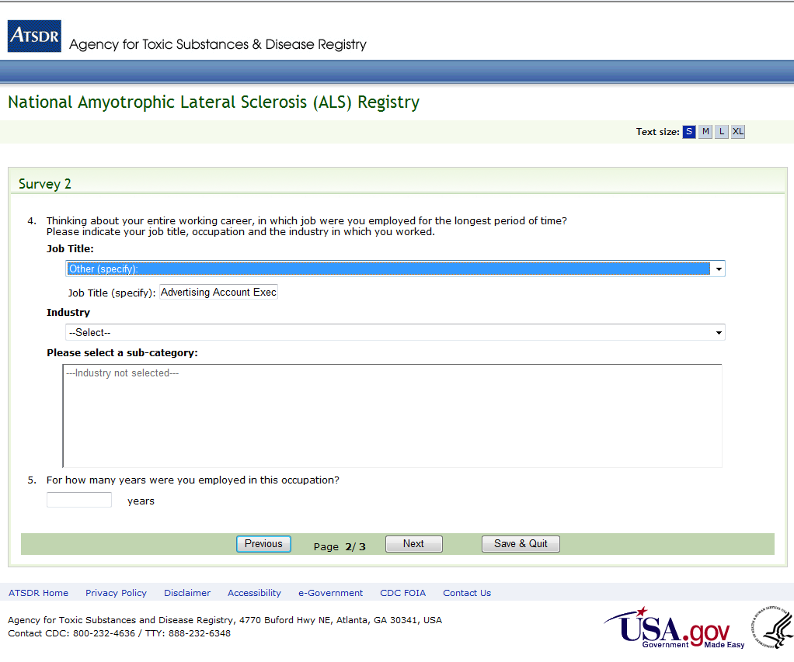
Figure 10: Survey 2, Page 2 of 3
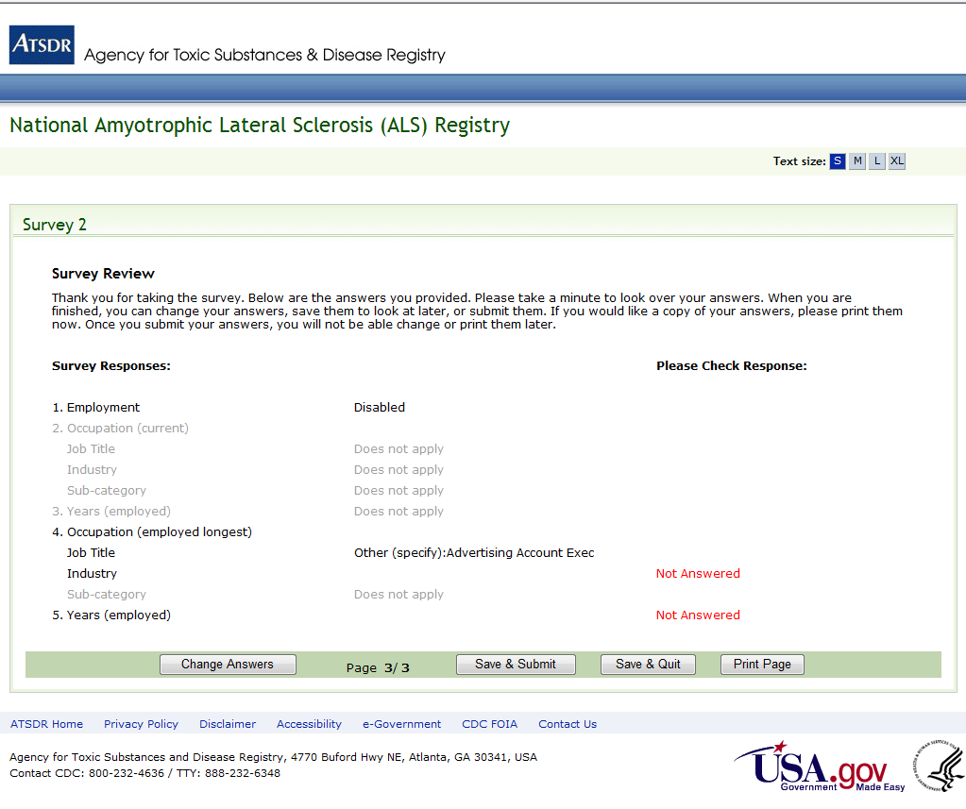
Figure 11: Survey 2, Page 3 of 3
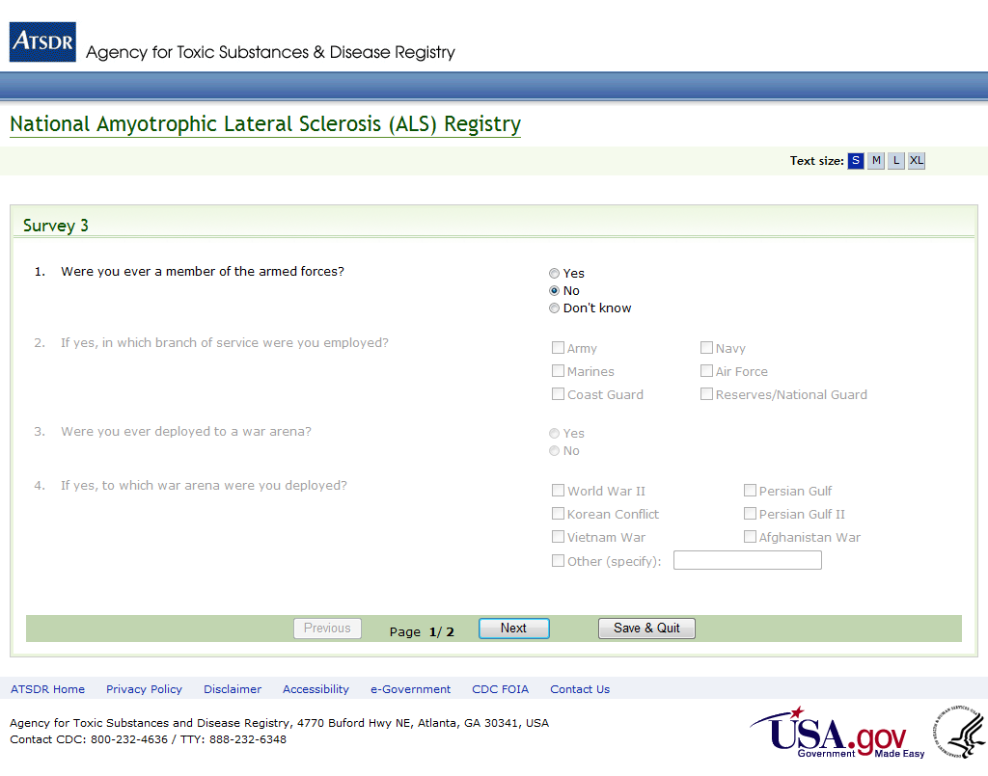
Figure 12: Survey 3, Page 1 of 2
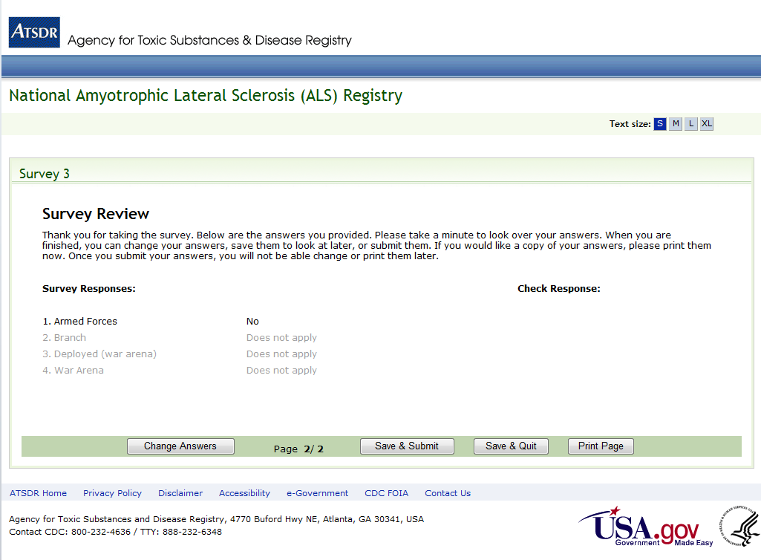
Figure 13: Survey 3, Page 2 of 2
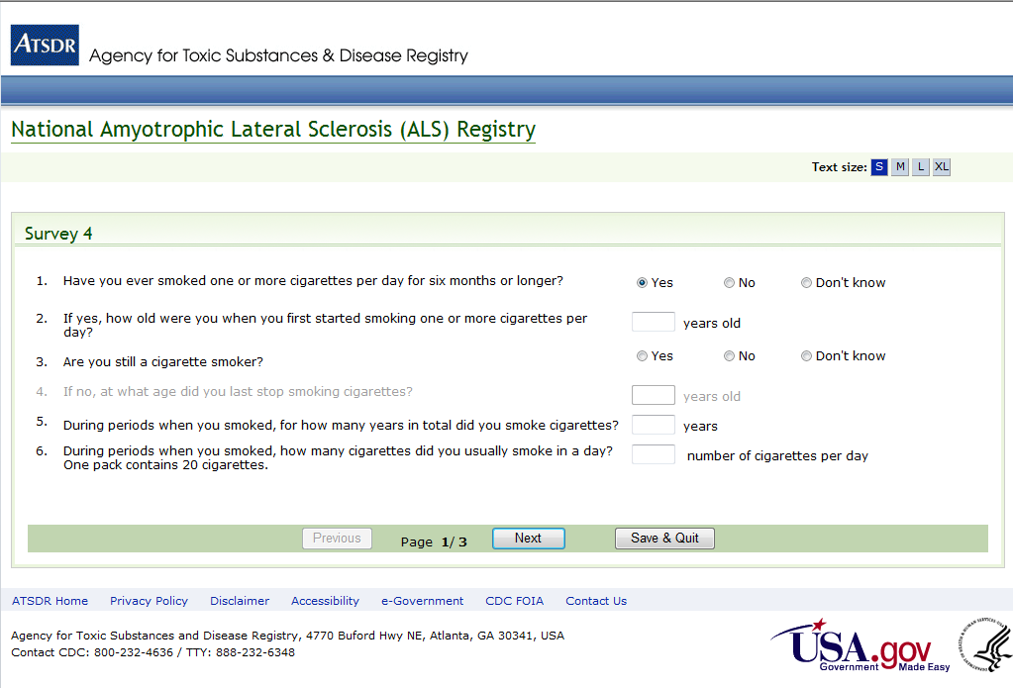

Figure 14: Survey 4, Page 1 of 3
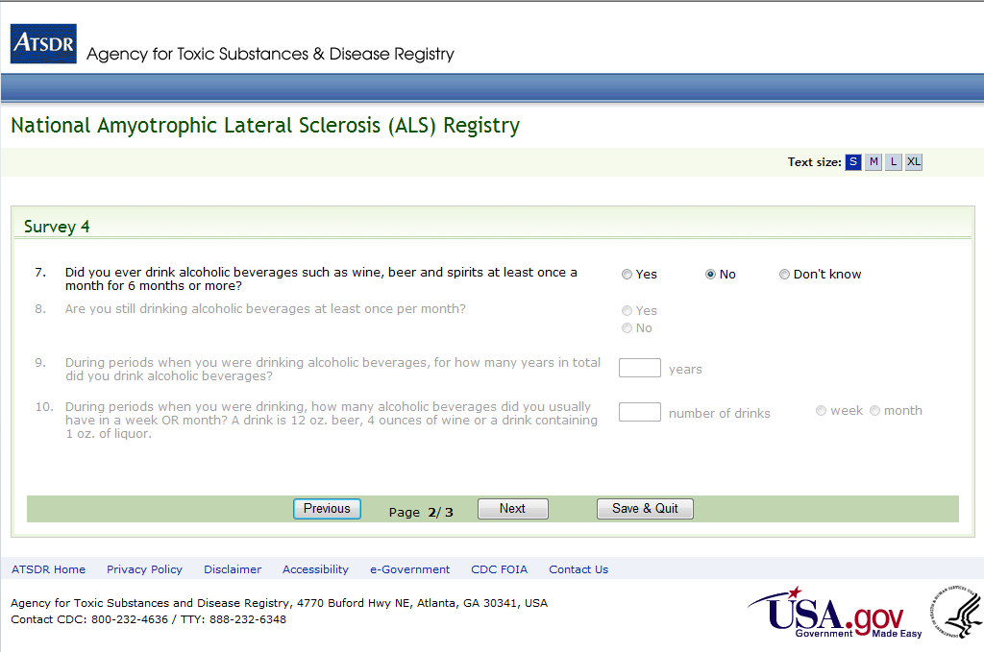

Figure 15: Survey 4, Page 2 of 3
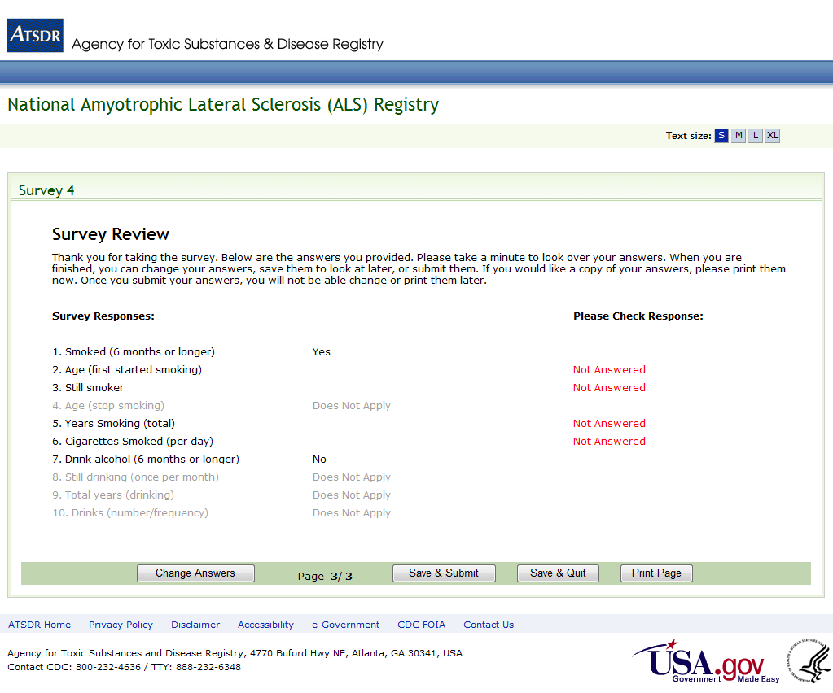
Figure 16: Survey 4, Page 3 of 3
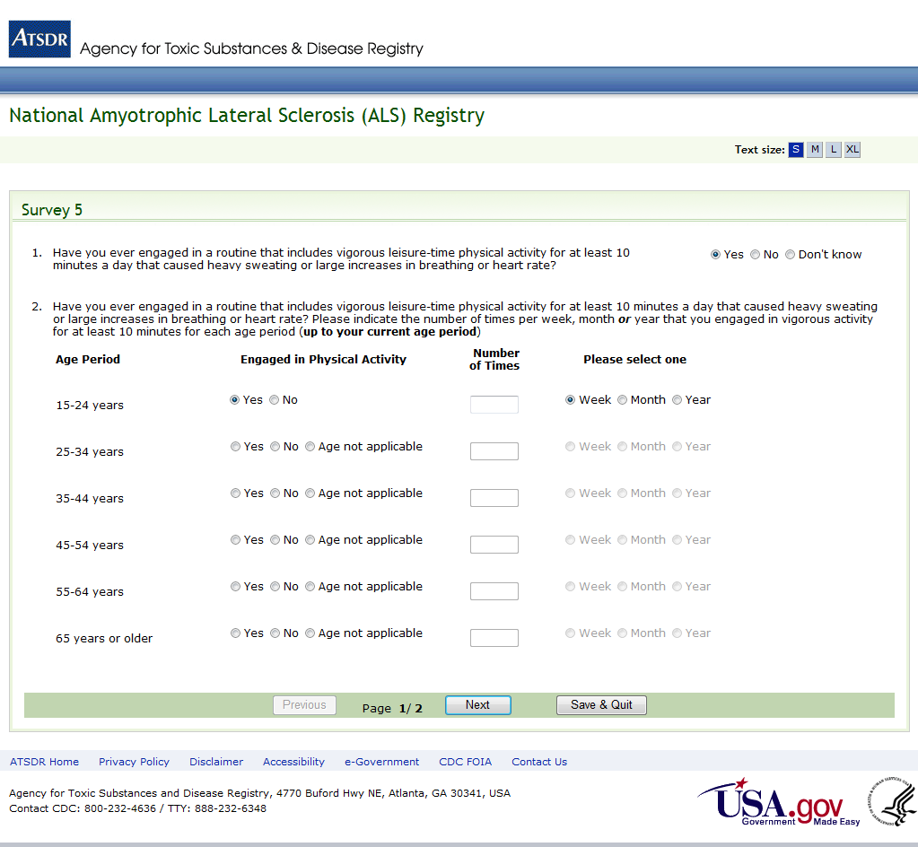

Figure 17: Survey 5, Page 1 of 2
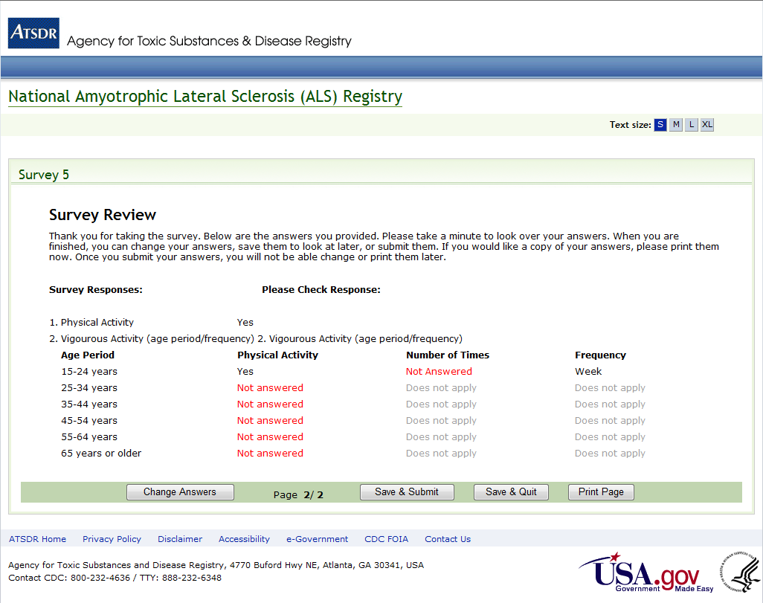

Figure 18: Survey 5, Page 2 of 2
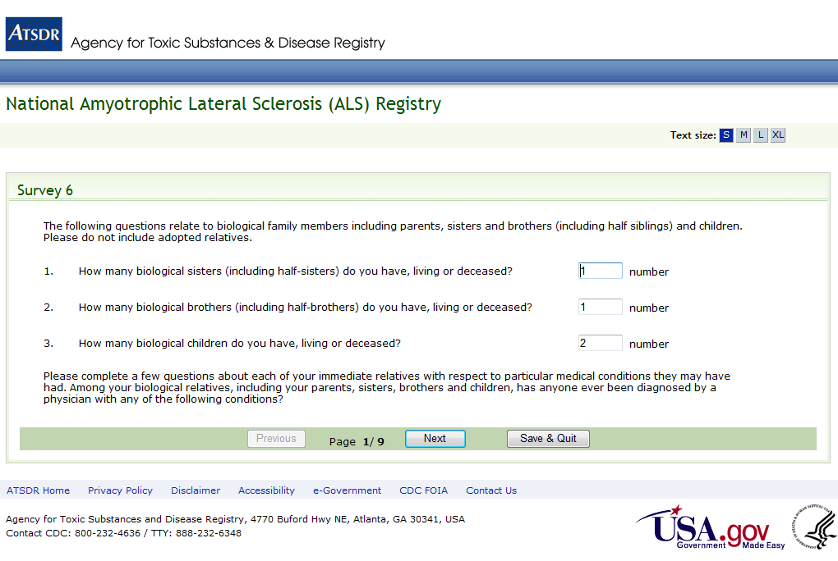
Figure 19: Survey 6, Page 1 of 9
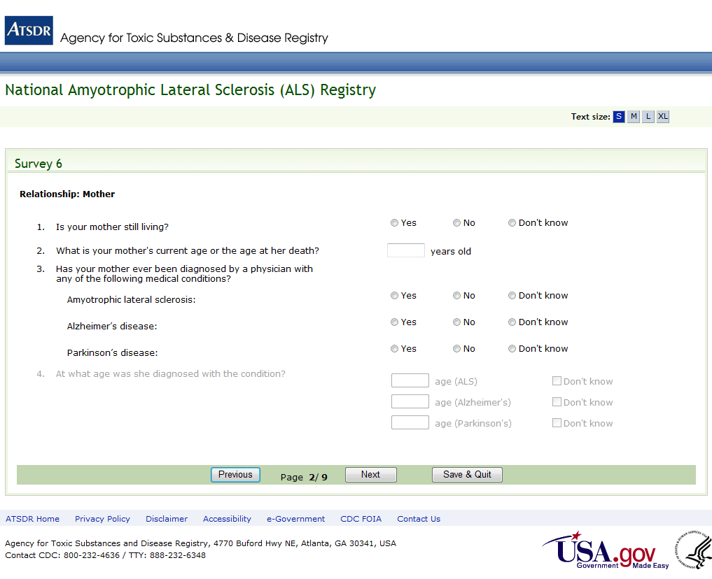
Figure 20: Survey 6, Page 2 of 9
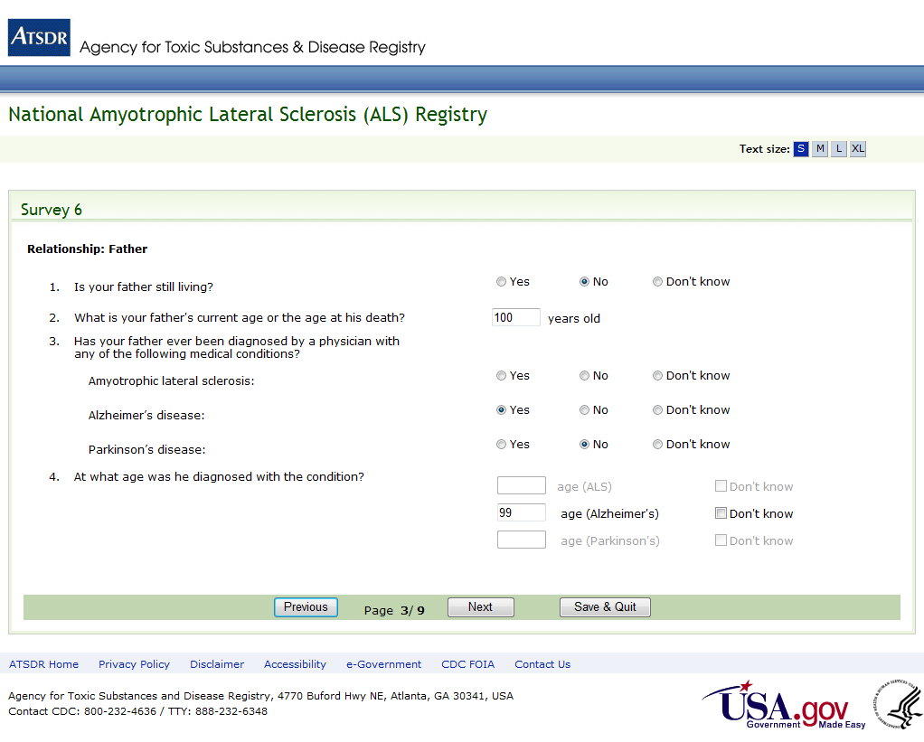
Figure 21: Survey 6, Page 3 of 9
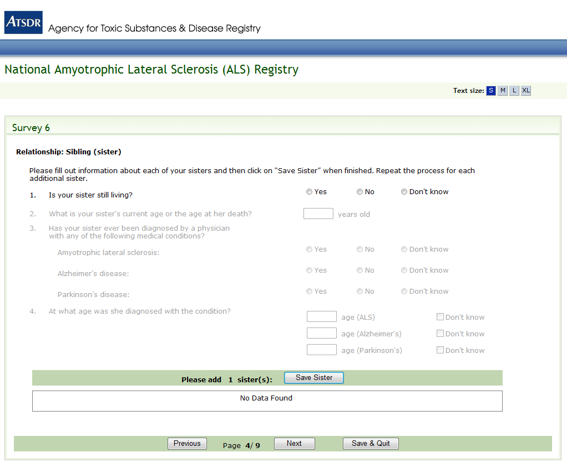
Figure 22: Survey 6, Page 4 of 9
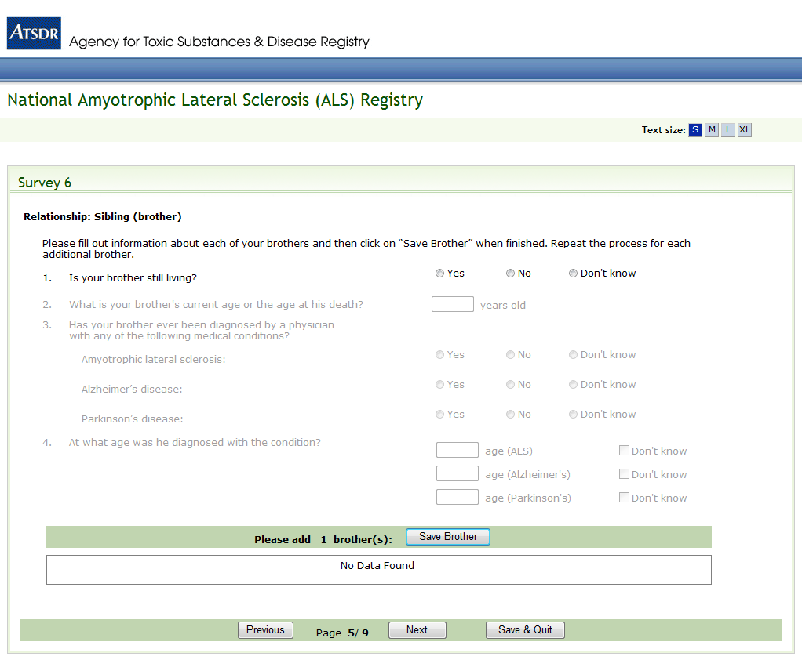
Figure 23: Survey 6, Page 5 of 9
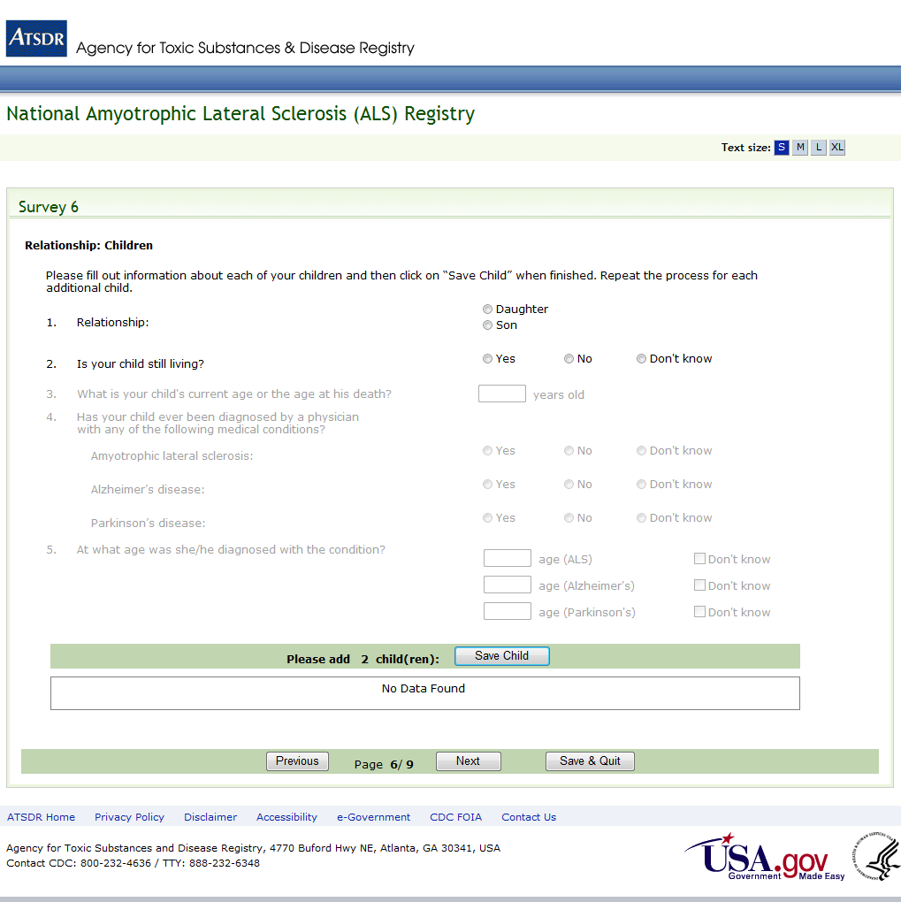
Figure 24: Survey 6, Page 6 of 9
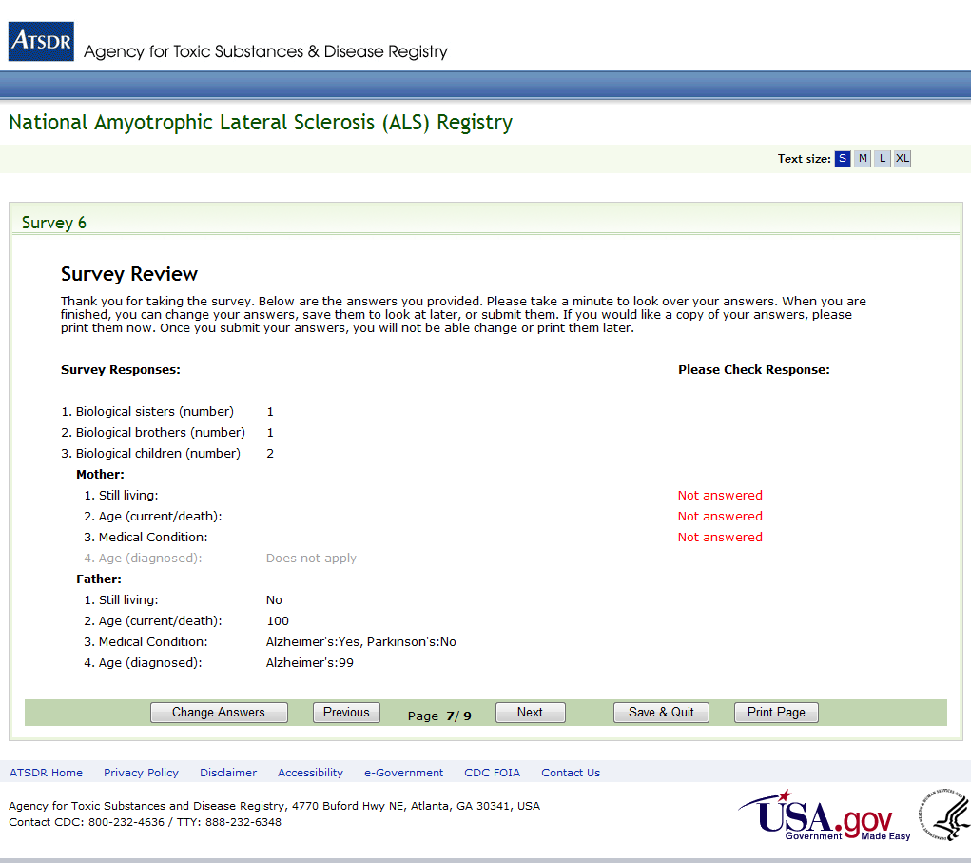
Figure 25: Survey 6, Page 7 of 9
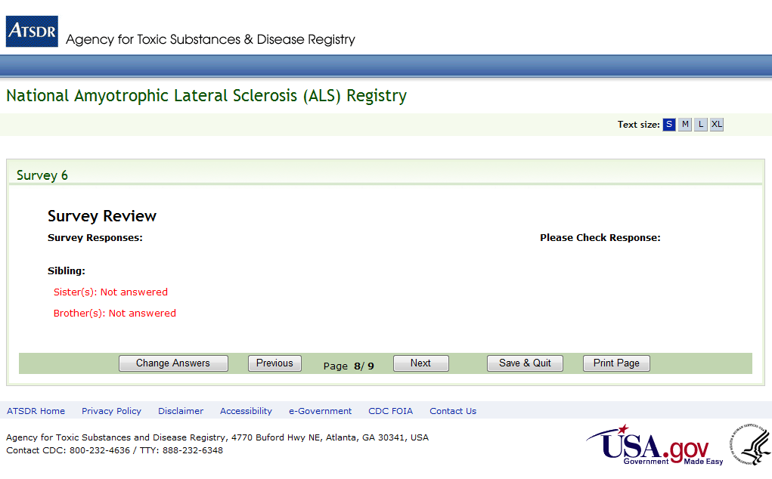
Figure 26: Survey 6, Page 8 of 9

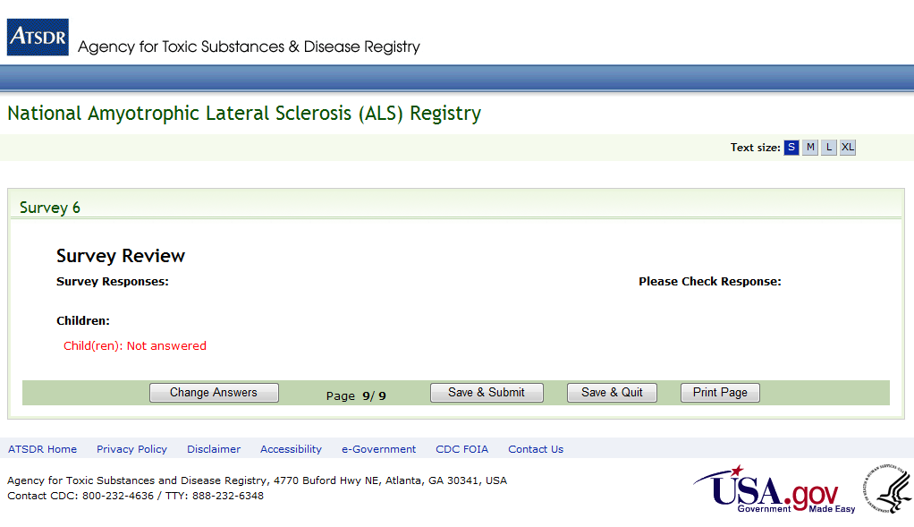
Figure 27: Survey 6, Page 9 of 9
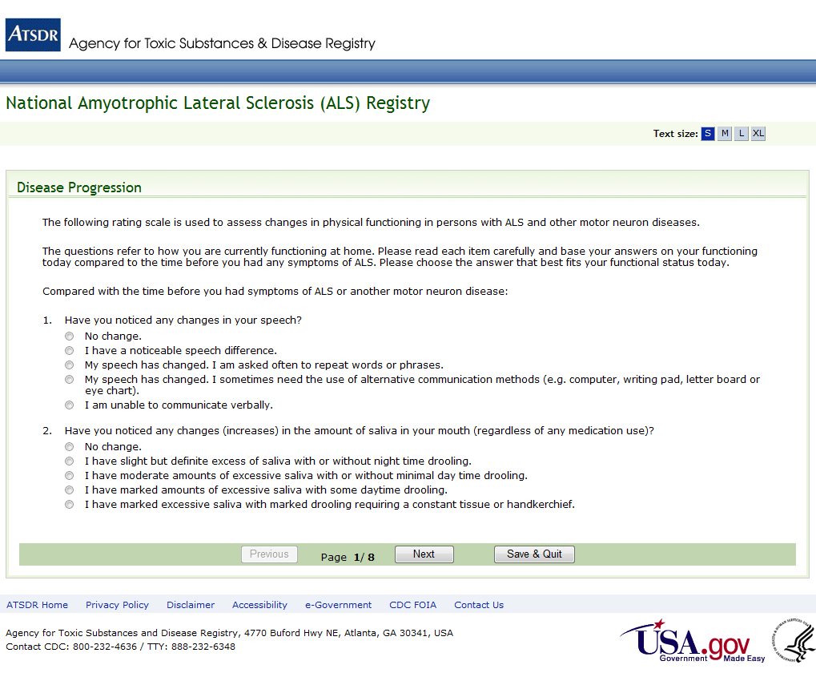
Figure 28: Disease Progression Survey, Page 1 of 8
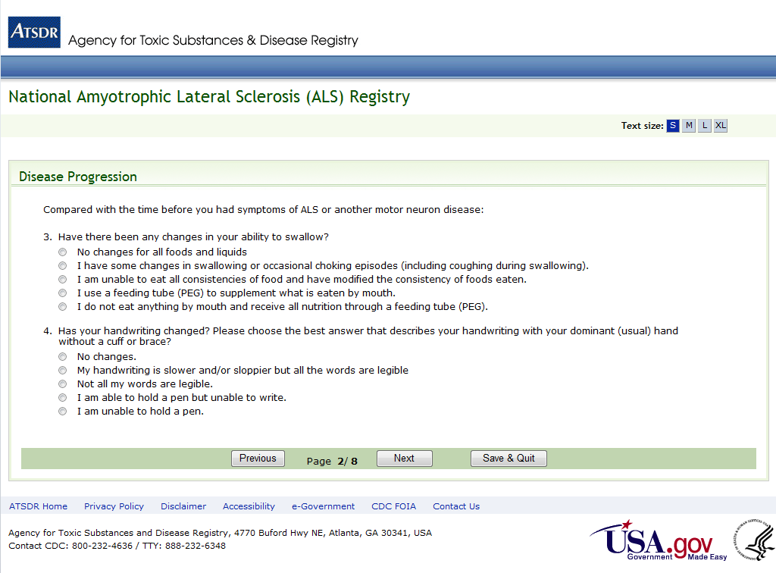

Figure 29: Disease Progression Survey, Page 2 of 8
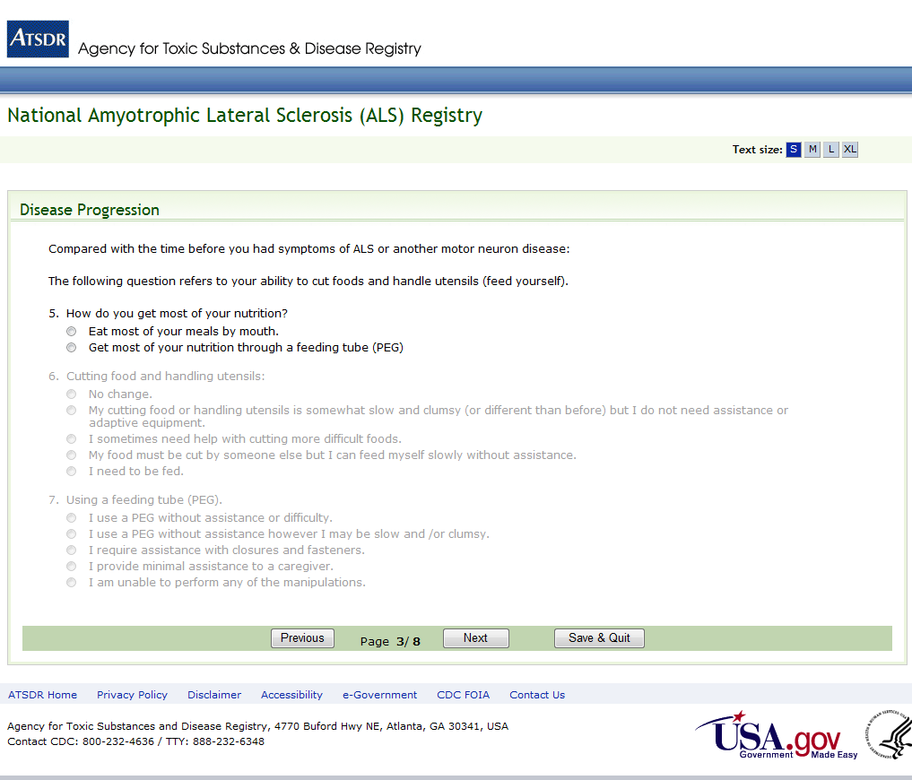

Figure 30: Disease Progression Survey, Page 3 of 8
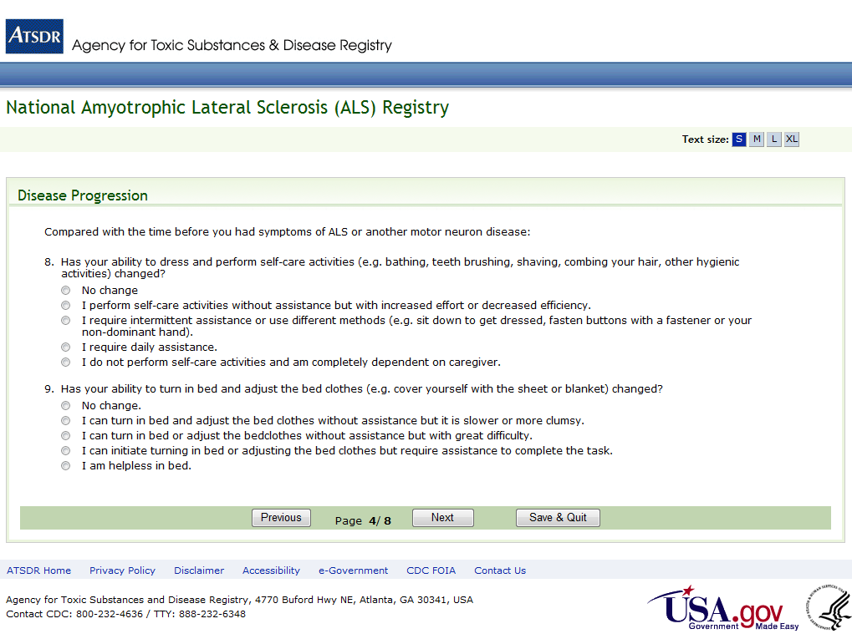
Figure 31: Disease Progression Survey, Page 4 of 8
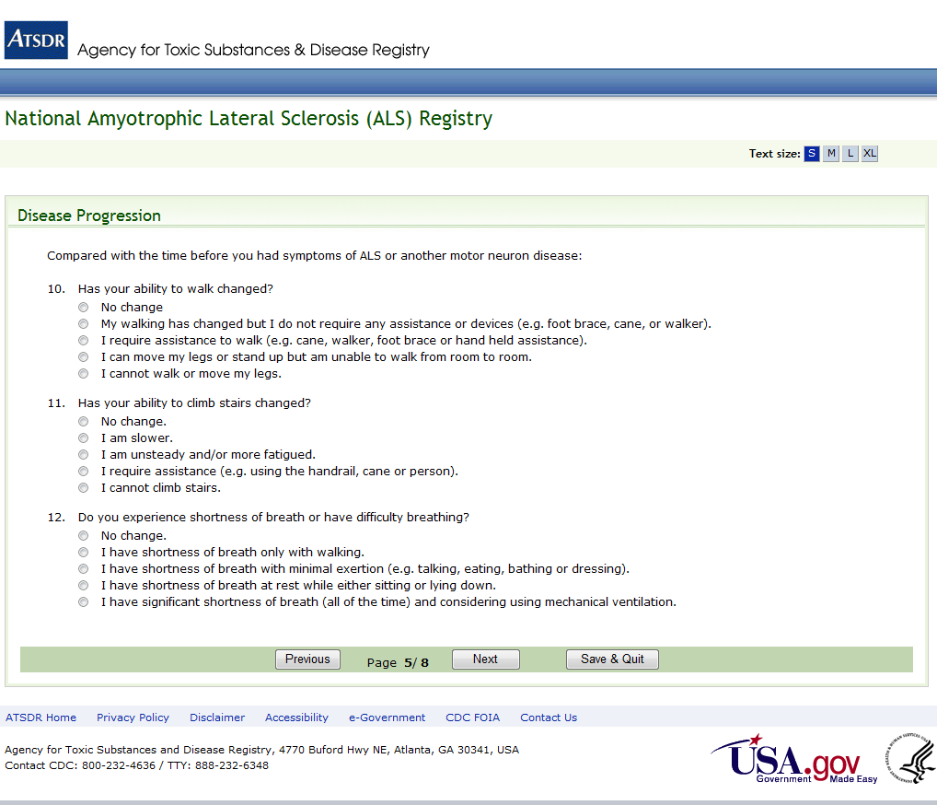

Figure 32: Disease Progression Survey, Page 5 of 8
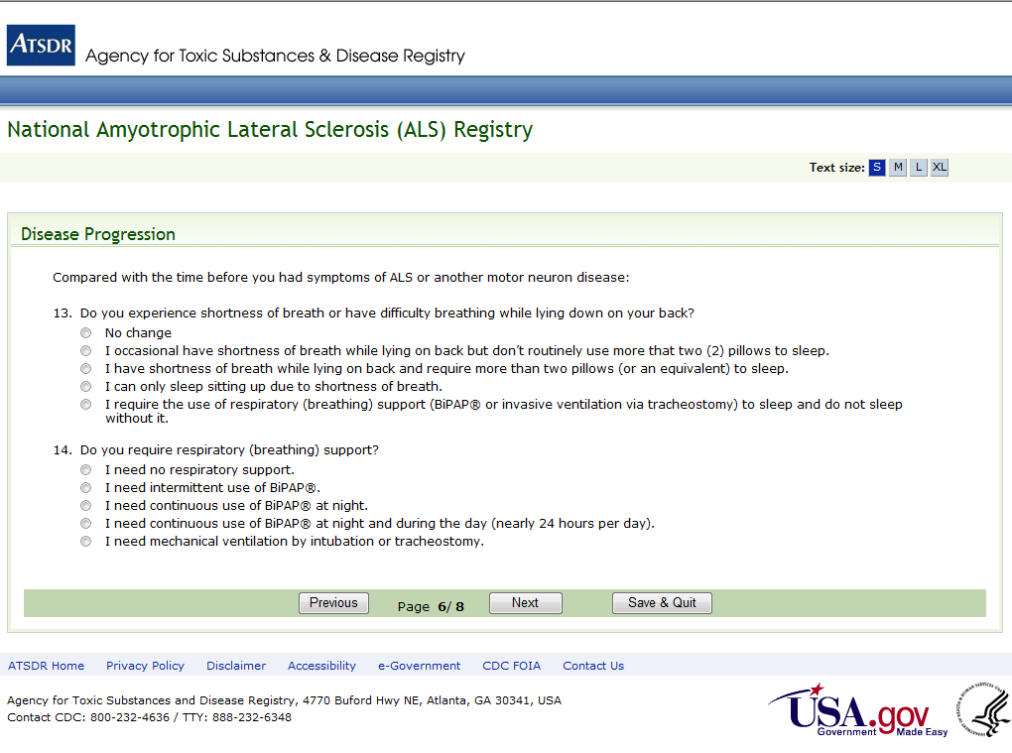
Figure 33: Disease Progression Survey, Page 6 of 8
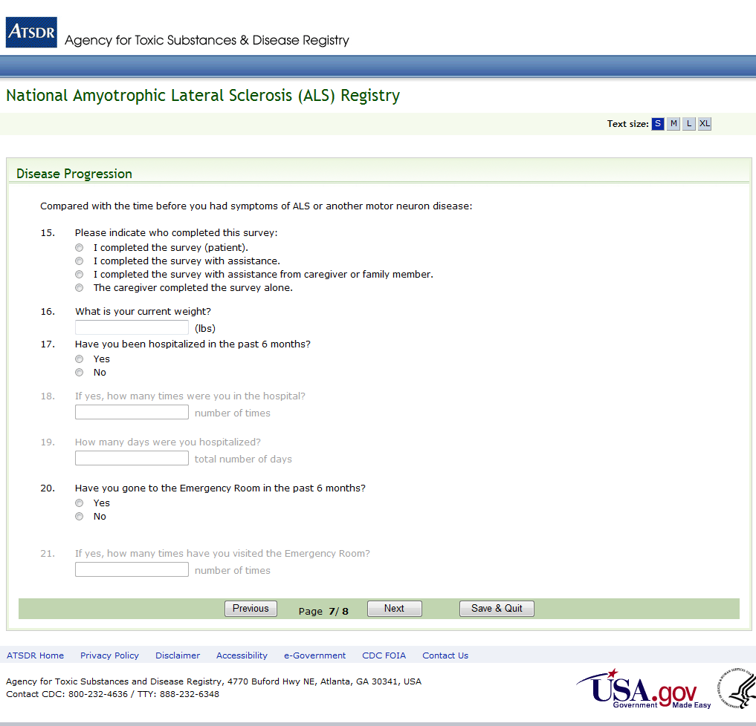

Figure 34: Disease Progression Survey, Page 7 of 8
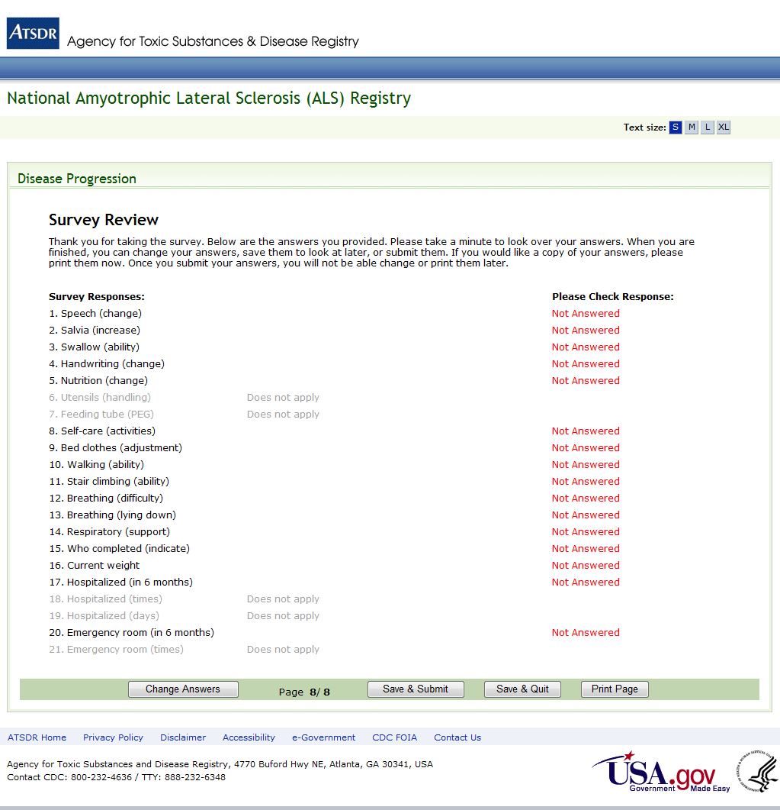

Figure 35: Disease Progression Survey, Page 8 of 8

