Attachment 6b
Screen Shots New Surveys
Table of Contents
Figure 1: Survey 8, Page 1 of 2 3
Figure 2: Survey 8, Page 2 of 2 4
Figure 3: Survey 9, Page 1 of 11 5
Figure 4: Survey 9, Page 2 of 11 6
Figure 5: Survey 9, Page 3 of 11 7
Figure 6: Survey 9, Page 4 of 11 8
Figure 7: Survey 9, Page 5 of 11 9
Figure 8: Survey 9, Page 6 of 11 10
Figure 9: Survey 9, Page 7 of 11 11
Figure 10: Survey 9, Page 8 of 11 12
Figure 11: Survey 9, Page 9 of 11 13
Figure 12: Survey 9, Page 10 of 11 14
Figure 13: Survey 9, Page 11 of 11 15
Figure 14: Survey 10, Page 1 of 3 16
Figure 15: Survey 10, Page 2 of 3 17
Figure 16: Survey 10, Page 3 of 3 18
Figure 17: Survey 11, Page 1 of 9 19
Figure 18: Survey 11, Page 2 of 9 20
Figure 19: Survey 11, Page 3 of 9 21
Figure 20: Survey 11, Page 4 of 9 22
Figure 21: Survey 11, Page 5 of 9 23
Figure 22: Survey 11, Page 6 of 9 24
Figure 23: Survey 11, Page 7 of 9 25
Figure 24: Survey 11, Page 8 of 9 26
Figure 25: Survey 11, Page 9 of 9 27
Figure 26: Survey 12, Page 1 of 3 28
Figure 27: Survey 12, Page 2 of 3 29
Figure 28: Survey 12, Page 3 of 3 30
Figure 29: Survey 13, Page 1 of 4 31
Figure 30: Survey 13, Page 2 of 4 32
Figure 31: Survey 13, Page 3 of 4 33
Figure 32: Survey 13, Page 4 of 4 34
Figure 33: Survey 14, Page 1 of 7 35
Figure 34: Survey 14, Page 2 of 7 36
Figure 35: Survey 14, Page 3 of 7 37
Figure 36: Survey 14, Page 4 of 7 38
Figure 37: Survey 14, Page 5 of 7 39
Figure 38: Survey 14, Page 6 of 7 40
Figure 39: Survey 14, Page 7 of 7 41
Figure 40: Survey 15, Page 1 of 2 42
Figure 41: Survey 15, Page 2 of 2 43
Figure 42: Survey 16, Page 1 of 2 44
Figure 43: Survey 16, Page 2 of 2 45
Figure 44: Survey 17, Page 1 of 7 46
Figure 45: Survey 17, Page 2 of 7 47
Figure 46: Survey 17, Page 3 of 7 48
Figure 47: Survey 17, Page 4 of 7 49
Figure 48: Survey 17, Page 5 of 7 50
Figure 49: Survey 17, Page 6 of 7 51
Figure 50: Survey 17, Page 7 of 7 52

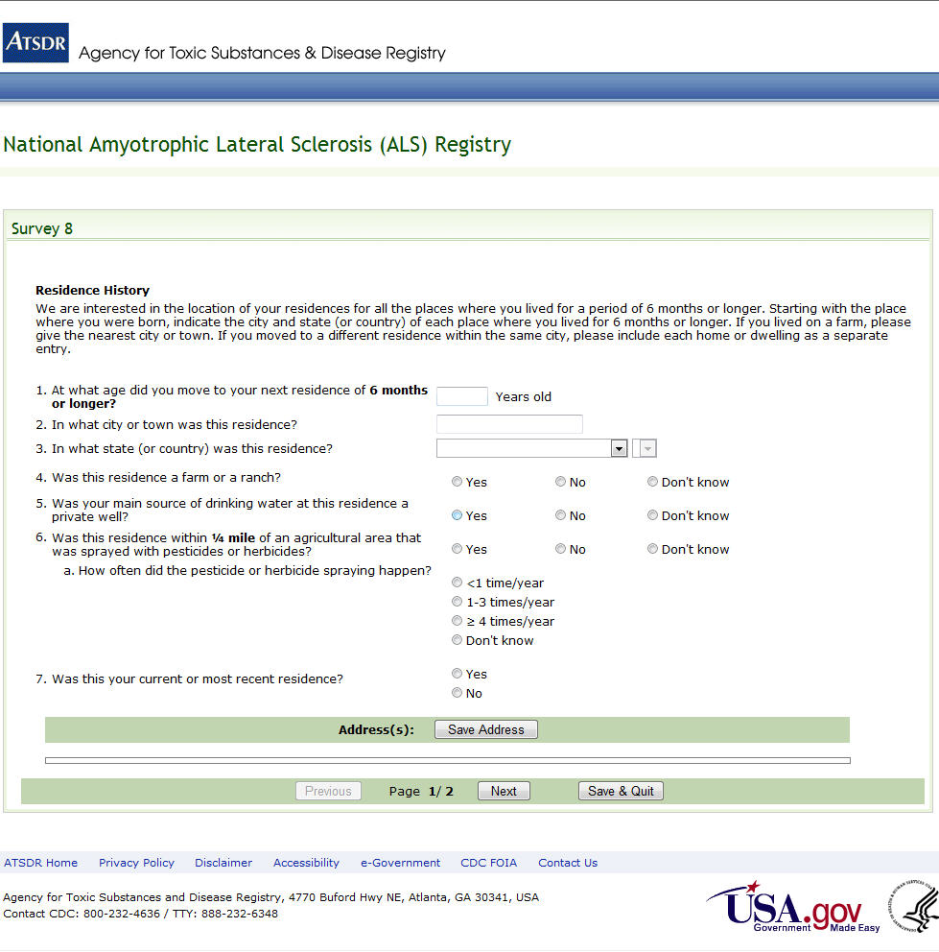Figure 1: Survey 8, Page 1 of 2

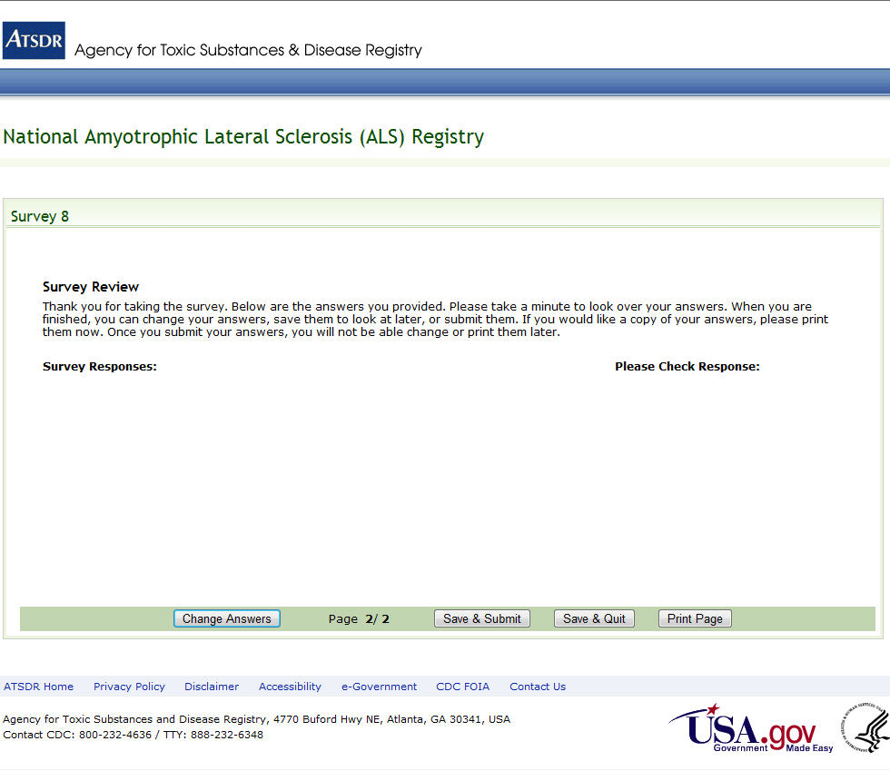
Figure 2: Survey 8, Page 2 of 2

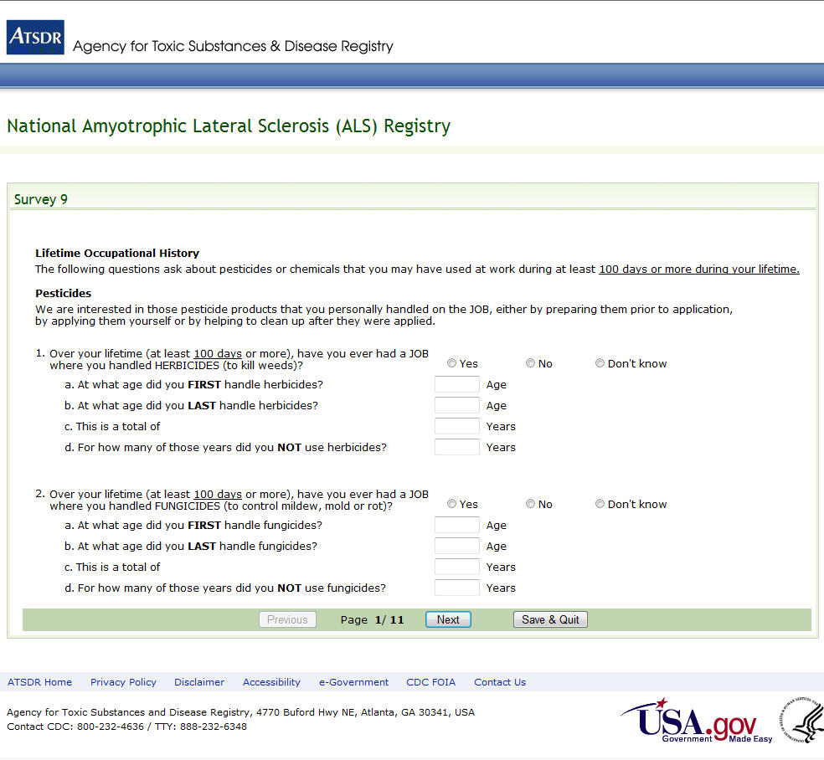
Figure 3: Survey 9, Page 1 of 11

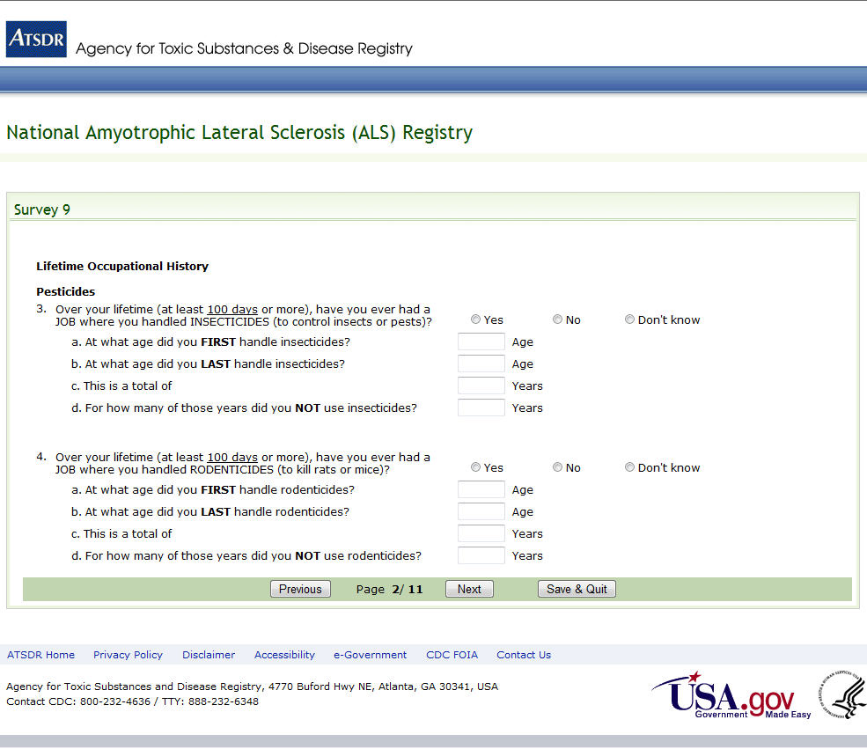
Figure 4: Survey 9, Page 2 of 11

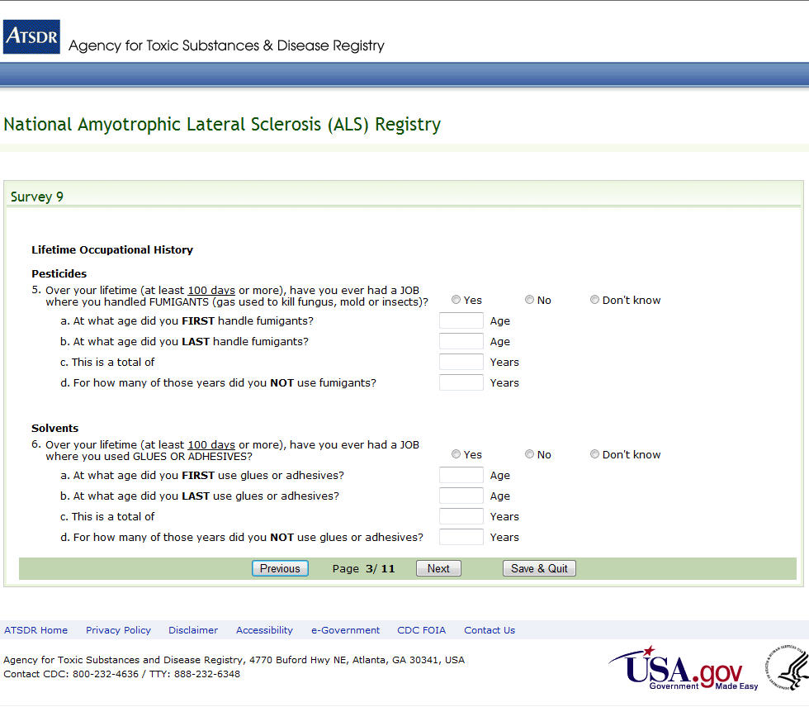
Figure 5: Survey 9, Page 3 of 11

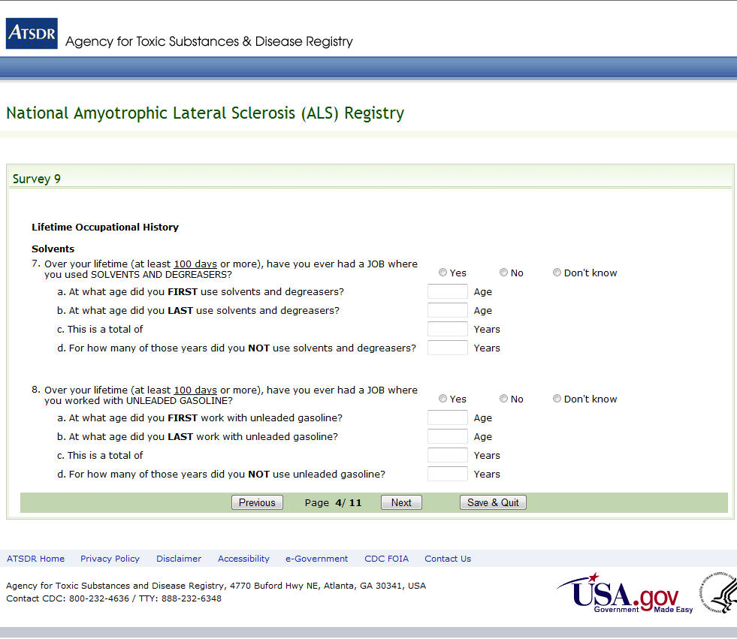
Figure 6: Survey 9, Page 4 of 11

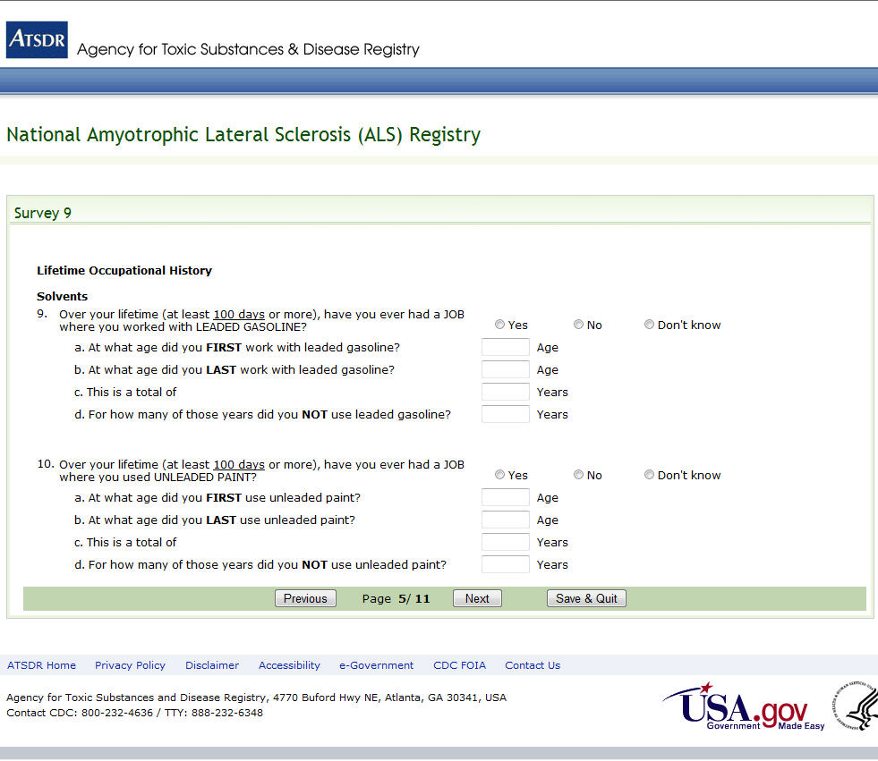
Figure 7: Survey 9, Page 5 of 11

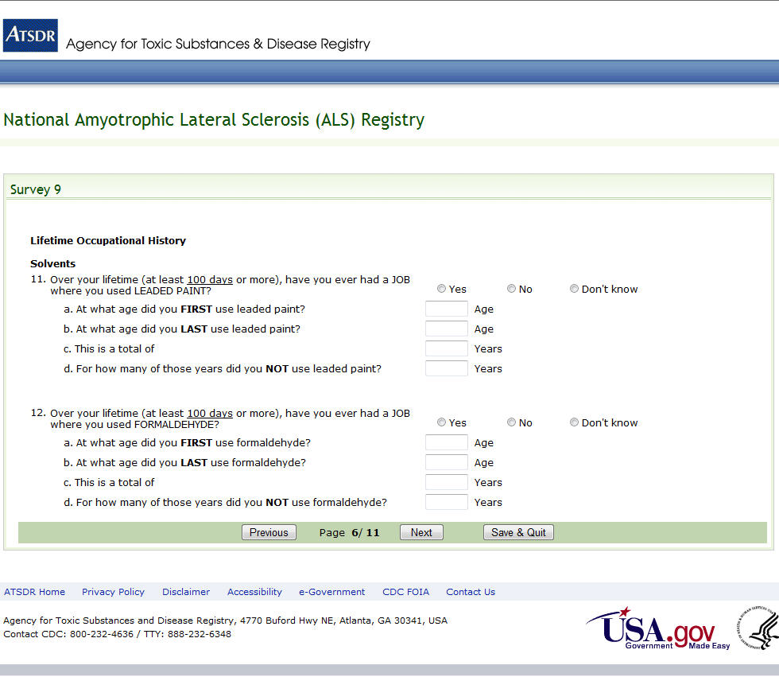
Figure 8: Survey 9, Page 6 of 11

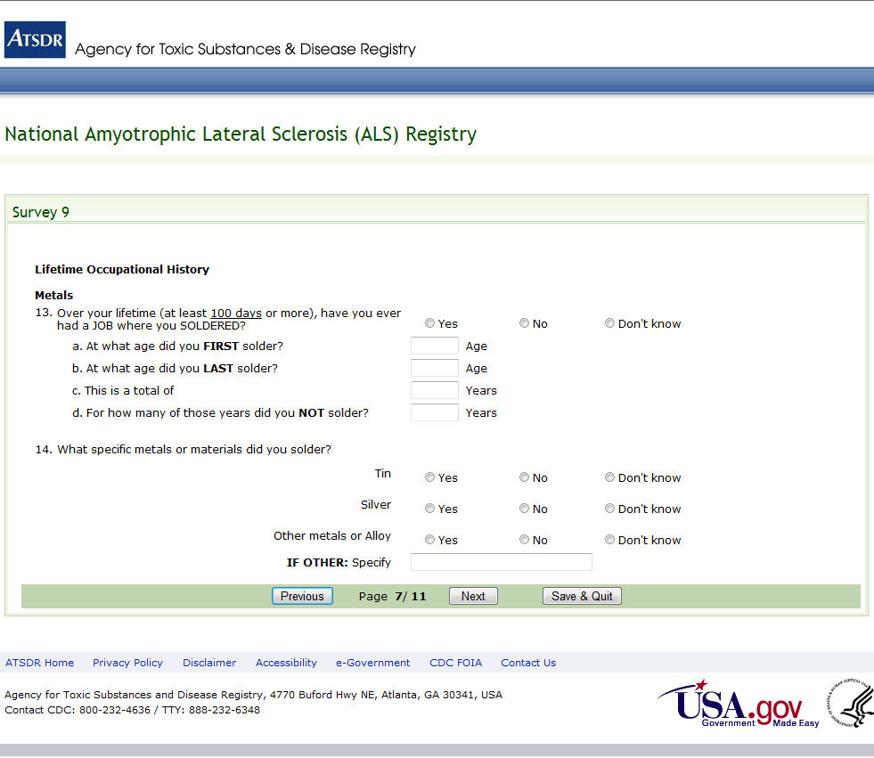
Figure 9: Survey 9, Page 7 of 11

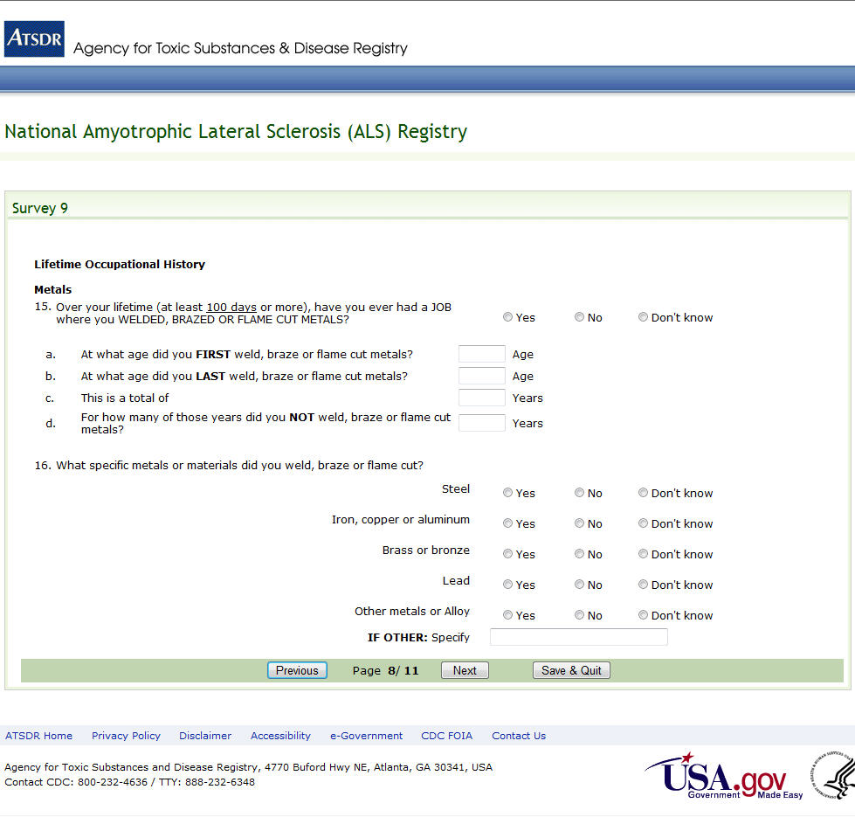
Figure 10: Survey 9, Page 8 of 11

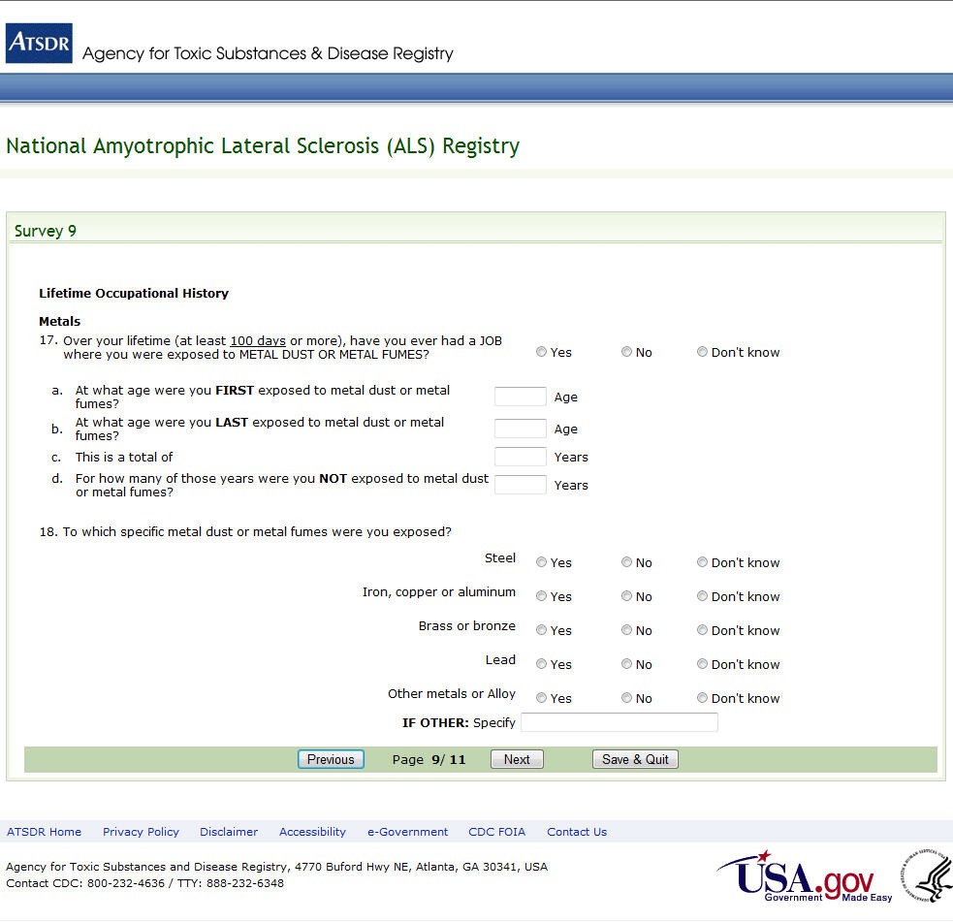
Figure 11: Survey 9, Page 9 of 11

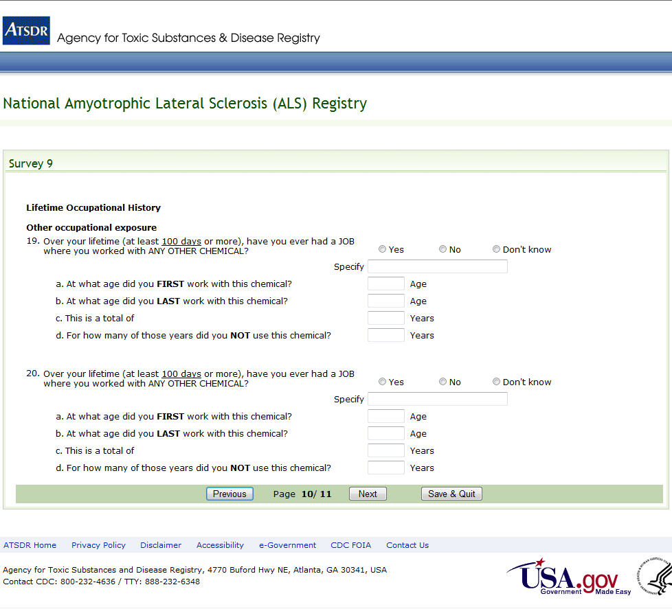
Figure 12: Survey 9, Page 10 of 11

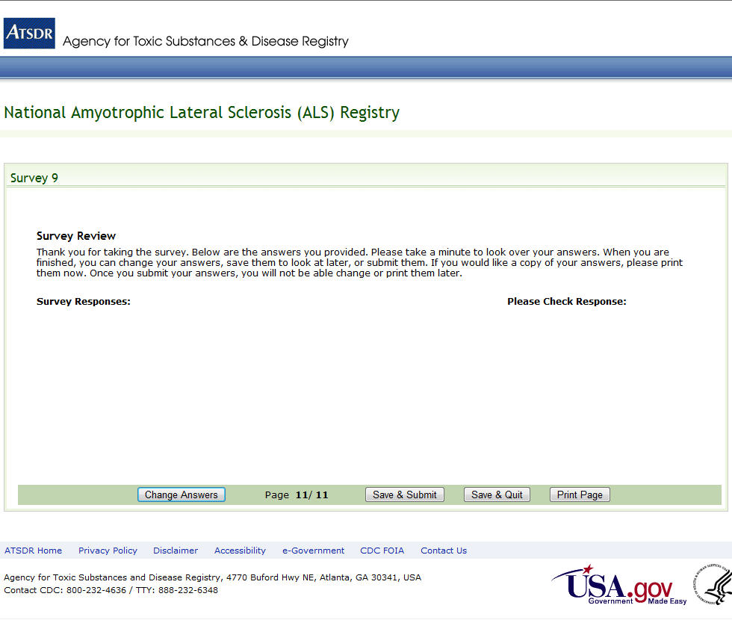
Figure 13: Survey 9, Page 11 of 11

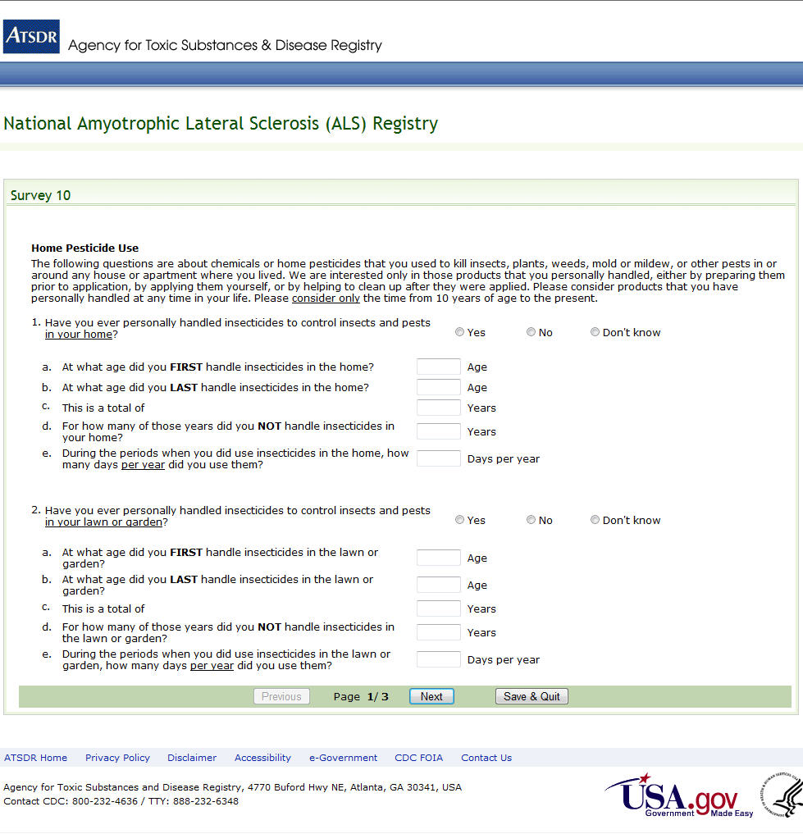
Figure 14: Survey 10, Page 1 of 3

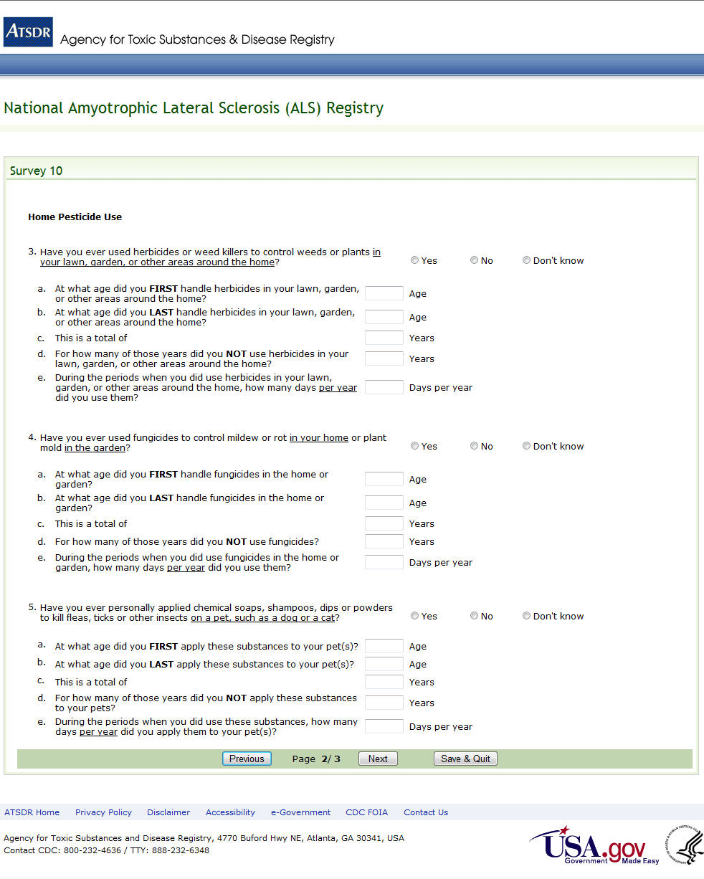
Figure 15: Survey 10, Page 2 of 3

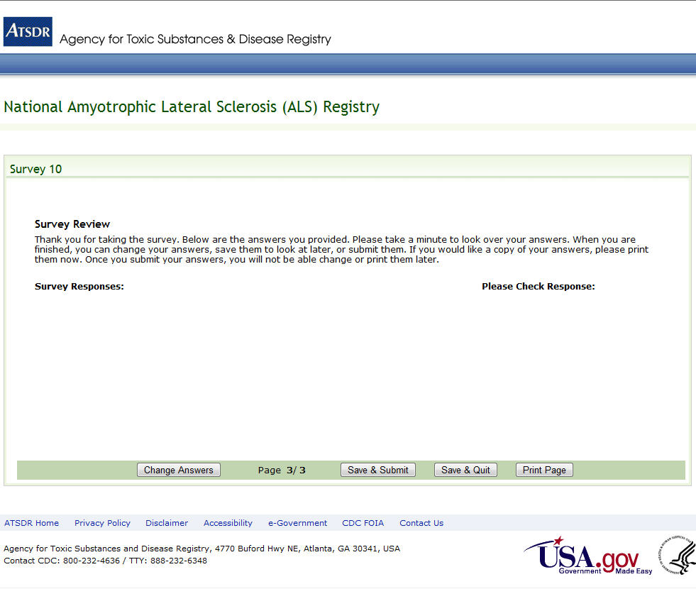
Figure 16: Survey 10, Page 3 of 3

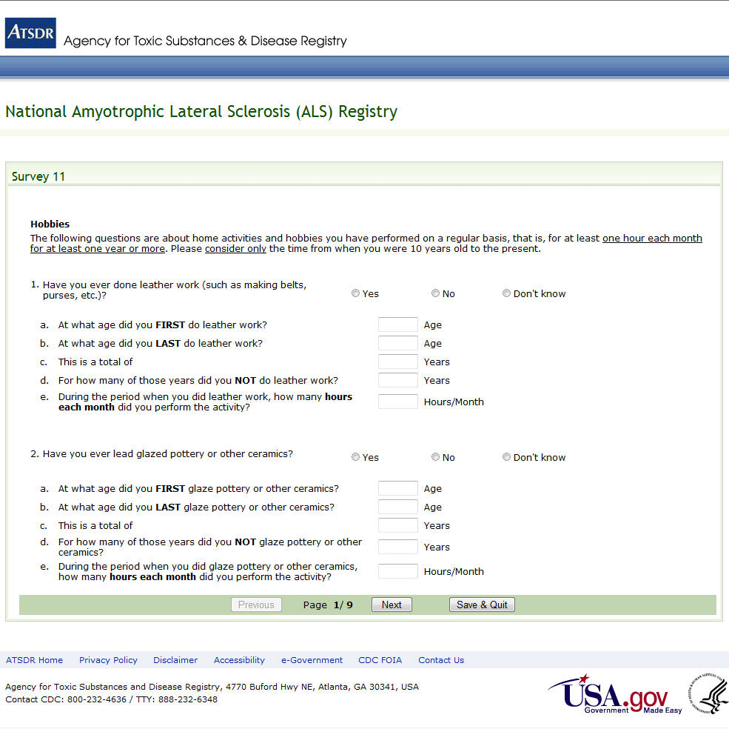
Figure 17: Survey 11, Page 1 of 9

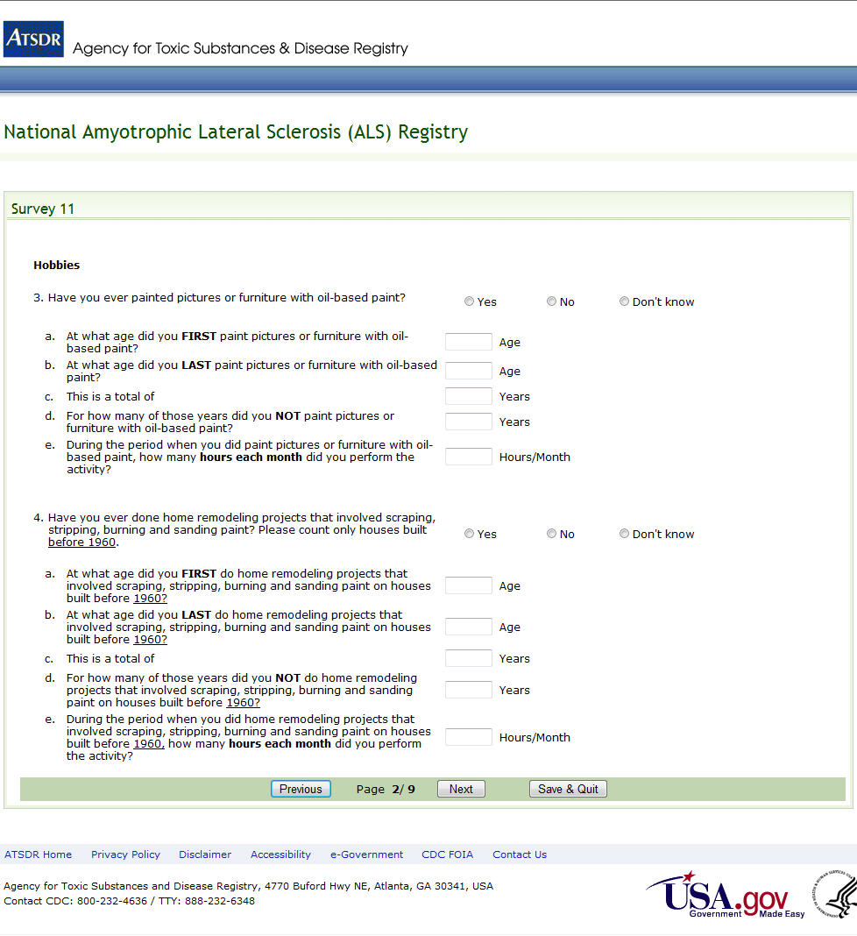
Figure 18: Survey 11, Page 2 of 9

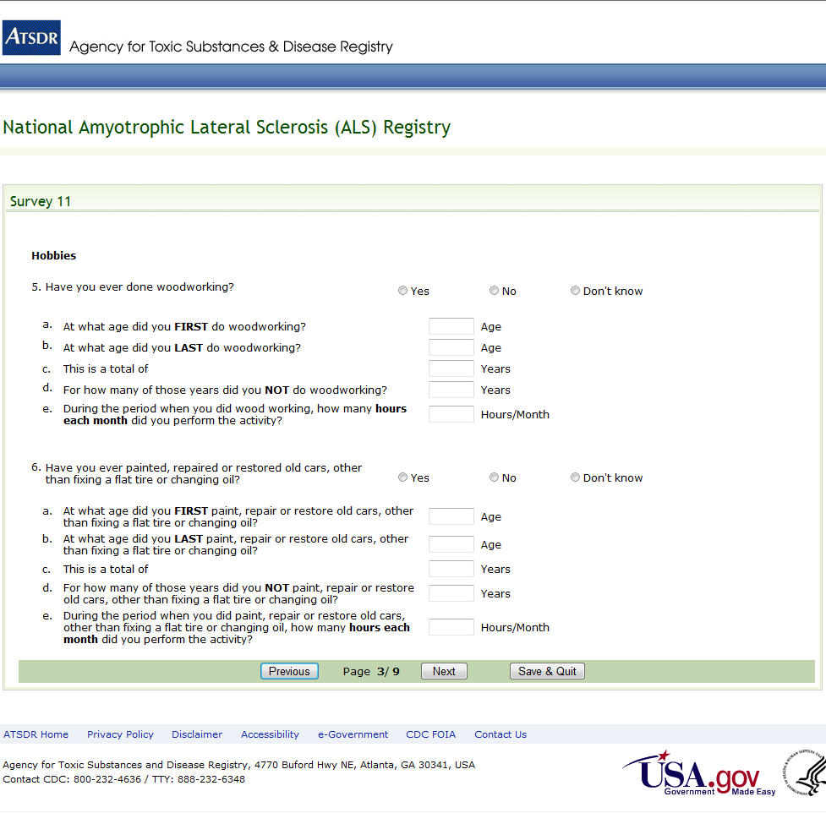
Figure 19: Survey 11, Page 3 of 9

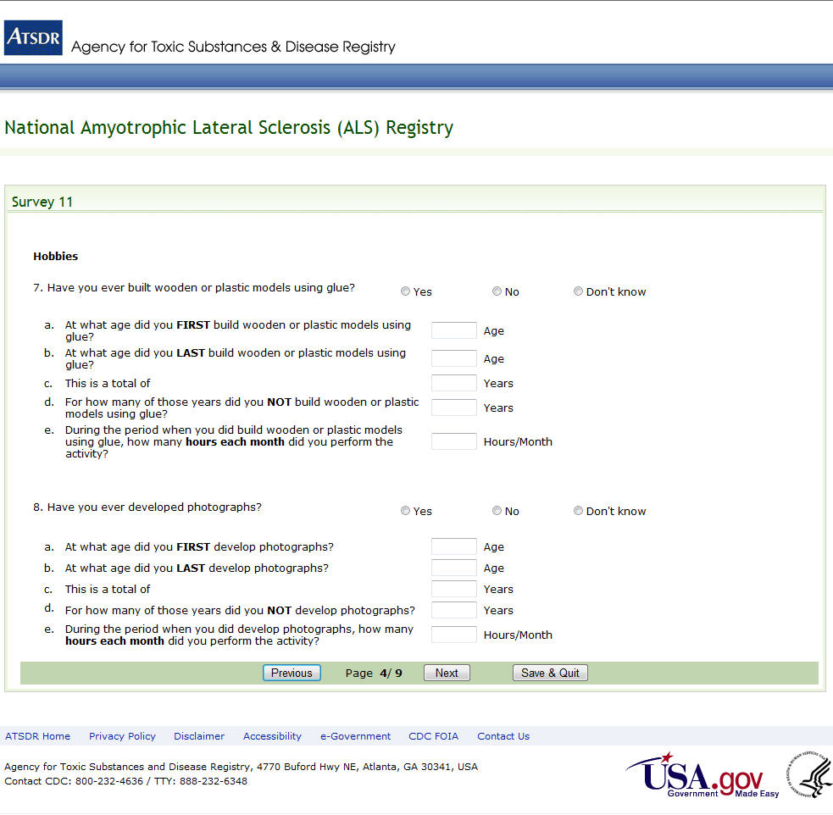
Figure 20: Survey 11, Page 4 of 9

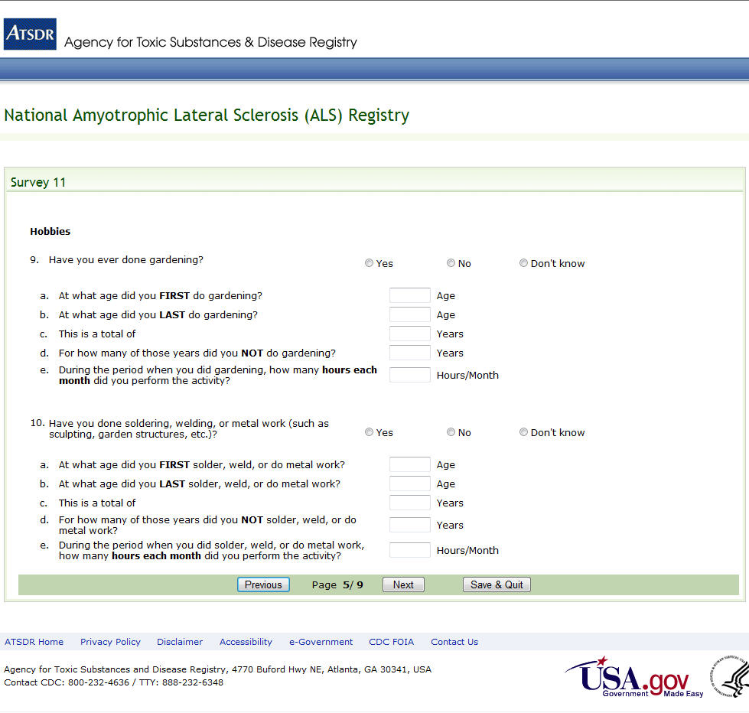
Figure 21: Survey 11, Page 5 of 9

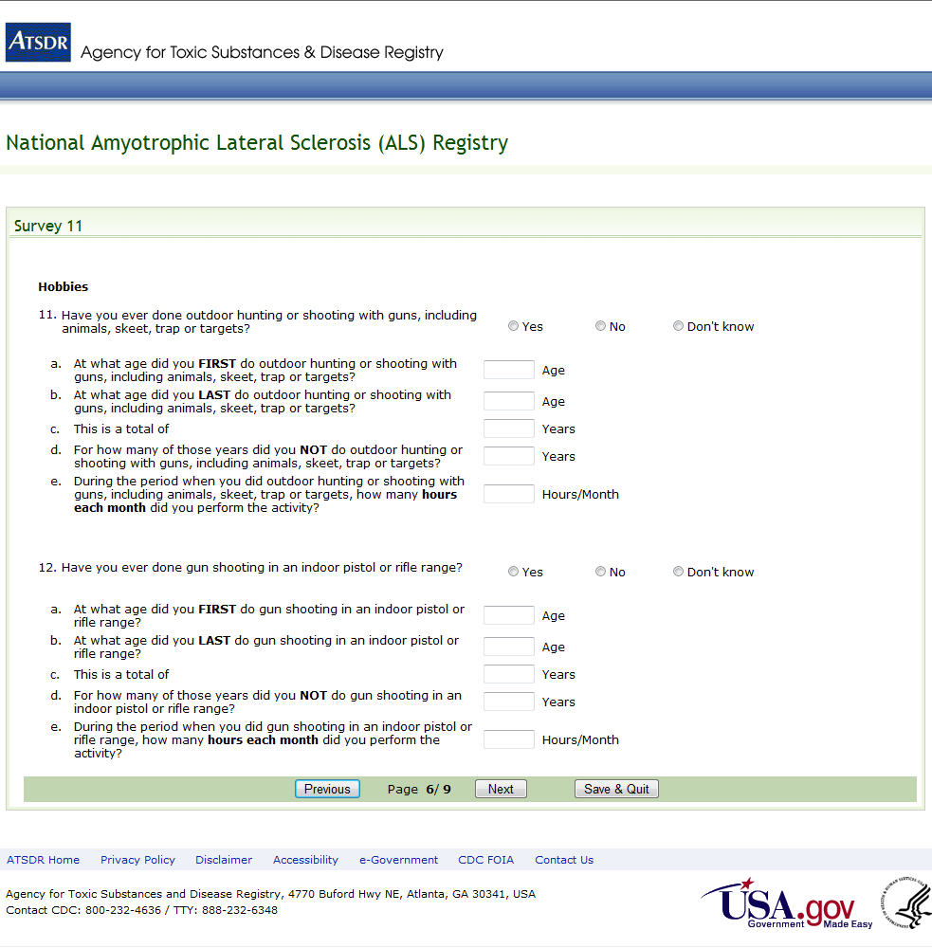
Figure 22: Survey 11, Page 6 of 9

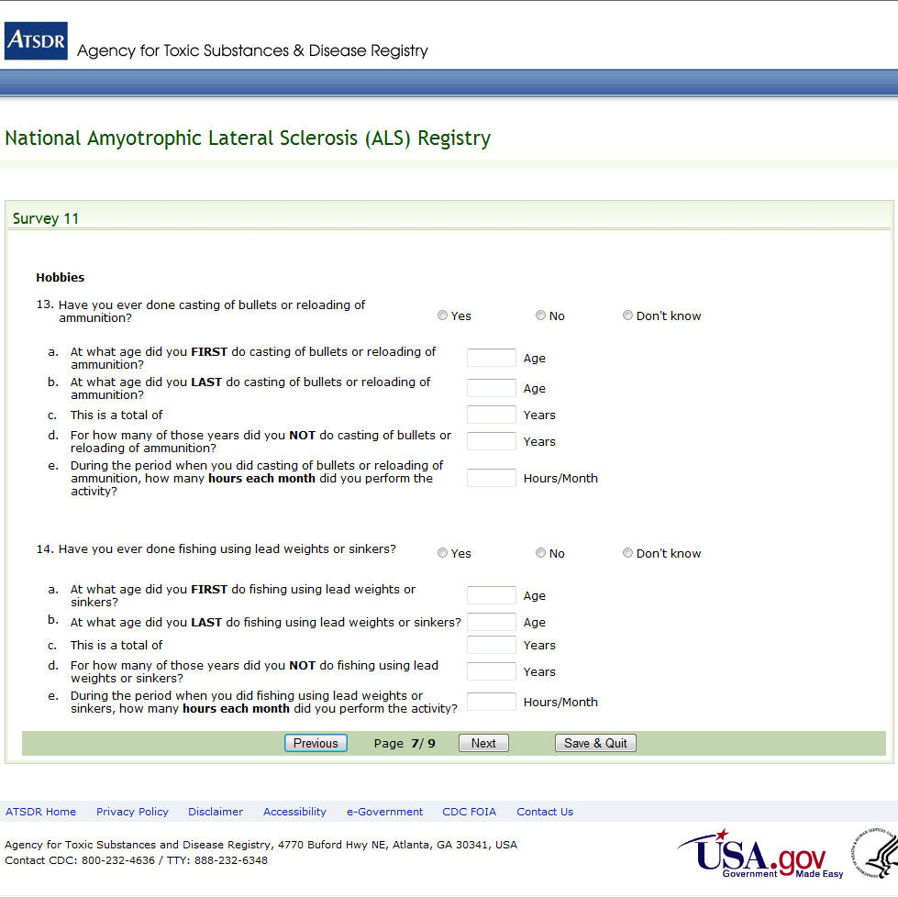
Figure 23: Survey 11, Page 7 of 9

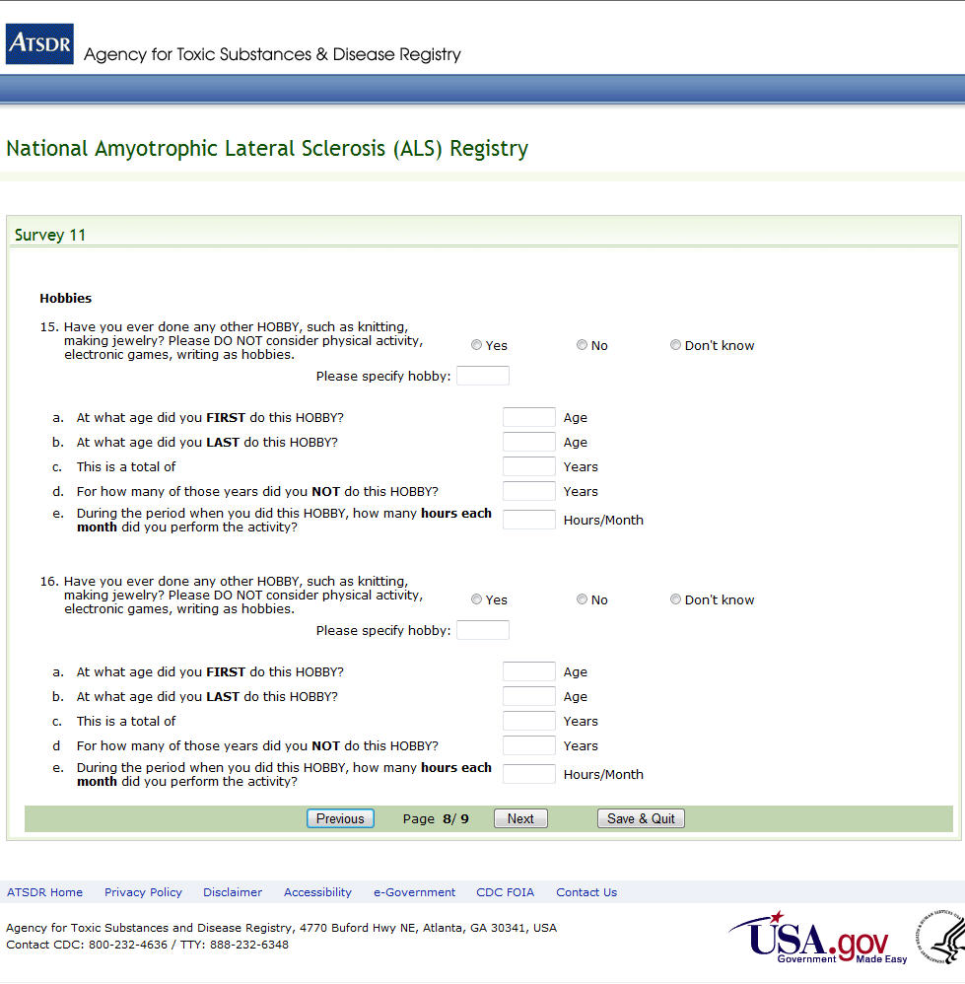
Figure 24: Survey 11, Page 8 of 9

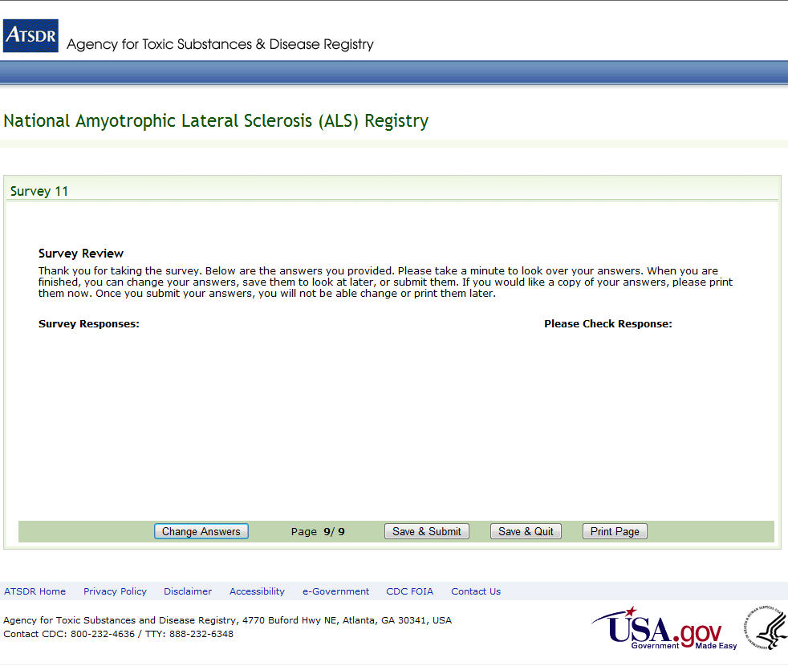
Figure 25: Survey 11, Page 9 of 9

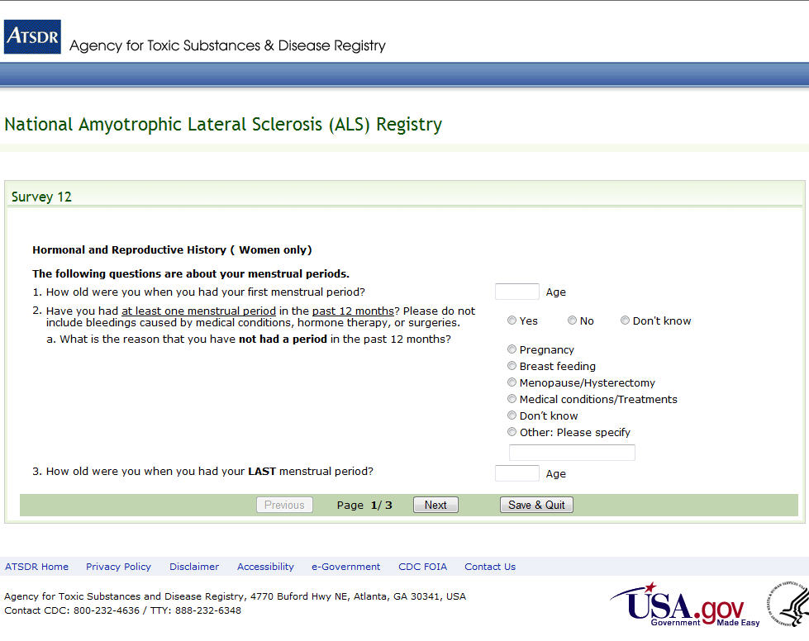

Figure 26: Survey 12, Page 1 of 3

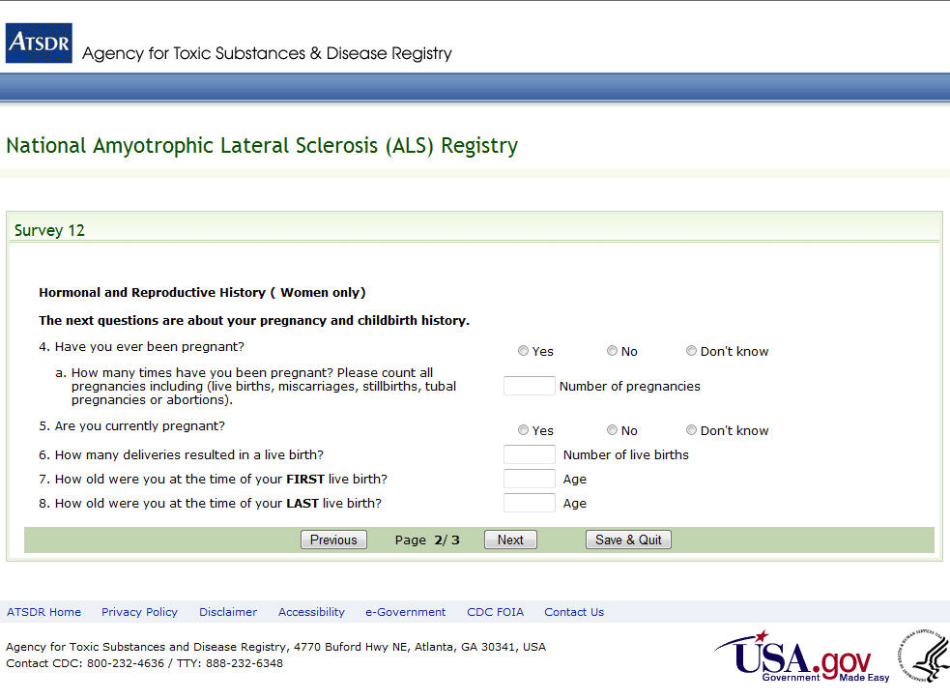
Figure 27: Survey 12, Page 2 of 3

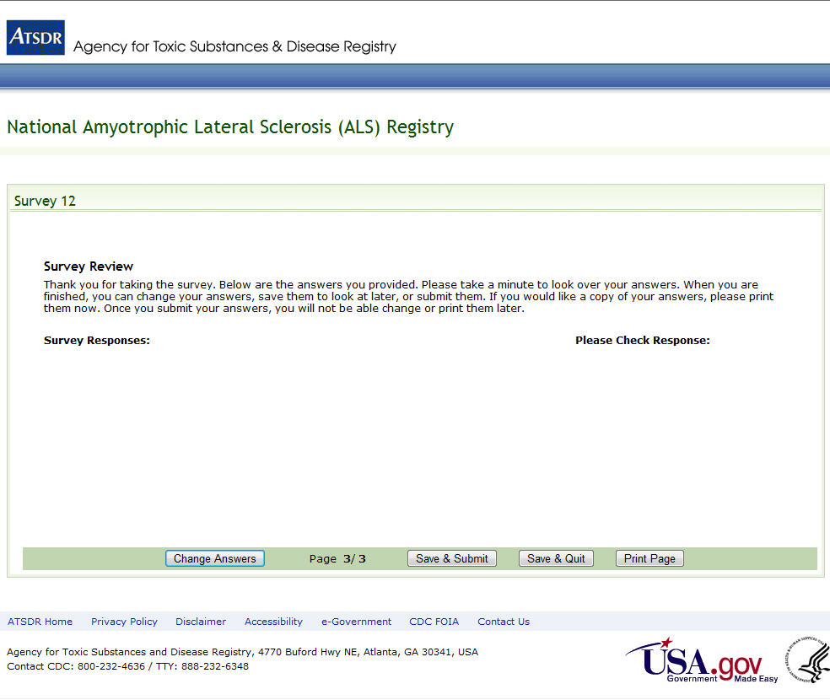
Figure 28: Survey 12, Page 3 of 3

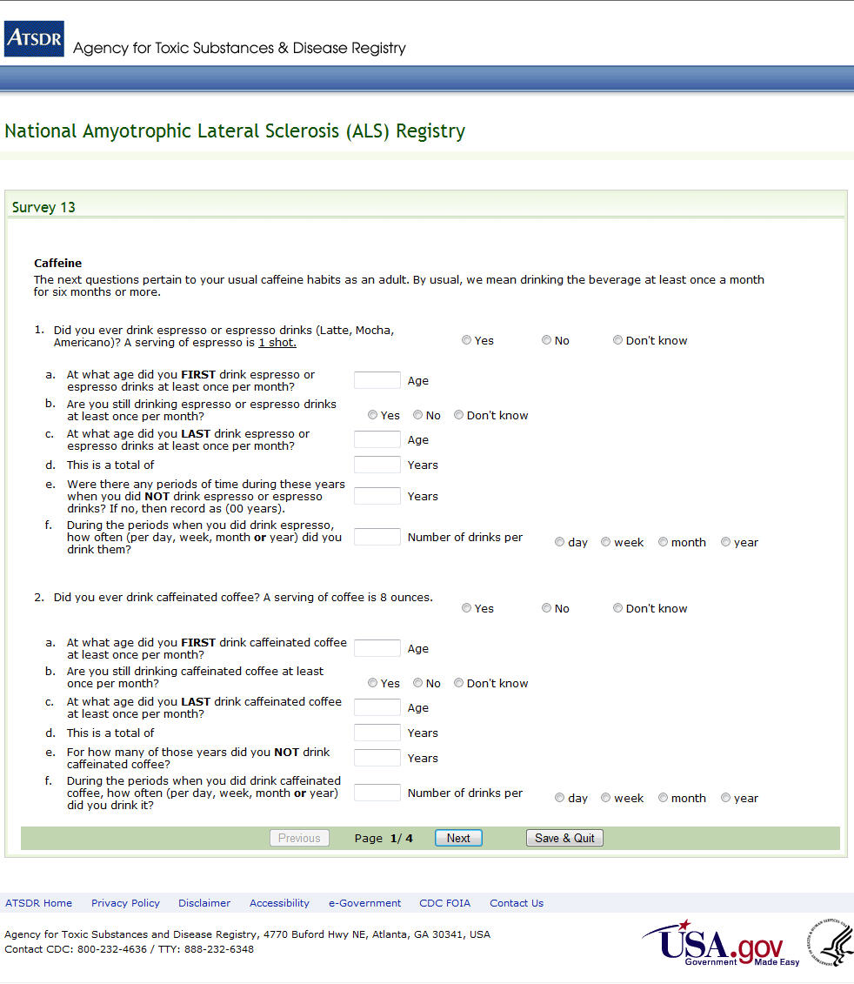
Figure 29: Survey 13, Page 1 of 4

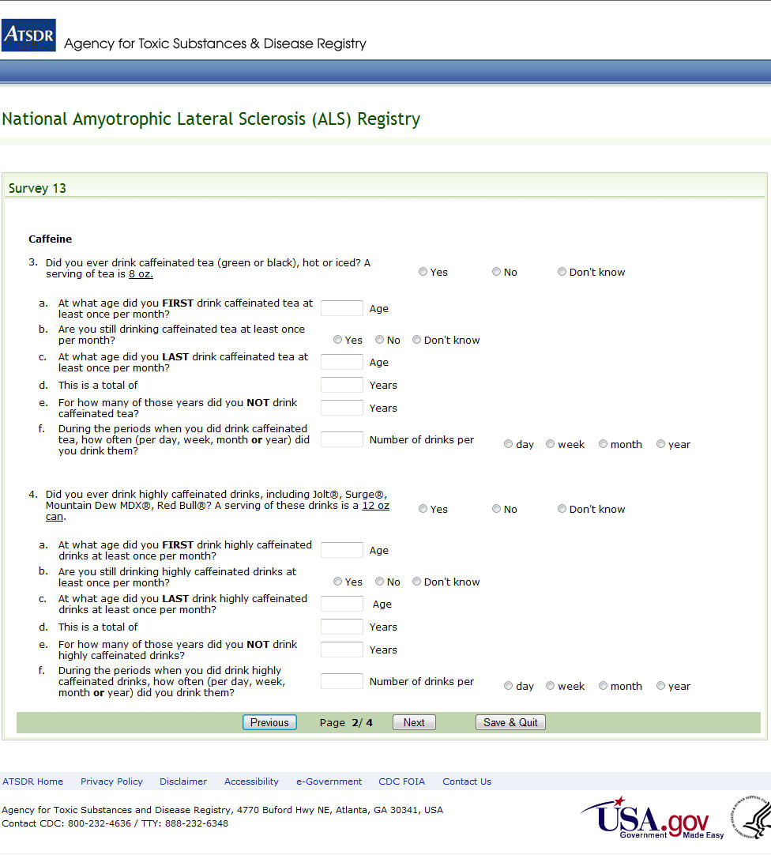
Figure 30: Survey 13, Page 2 of 4

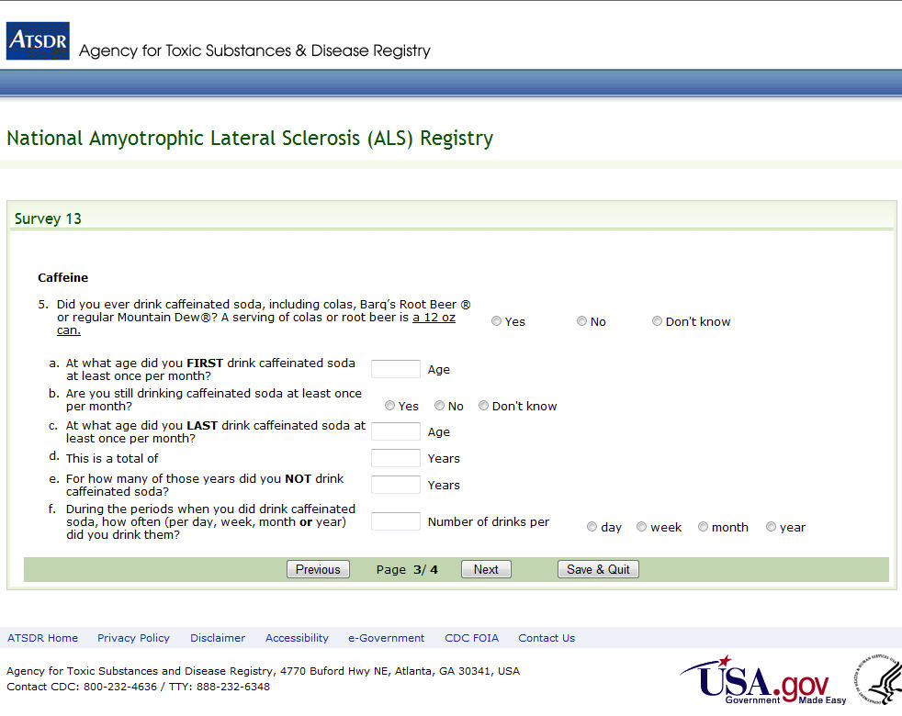
Figure 31: Survey 13, Page 3 of 4

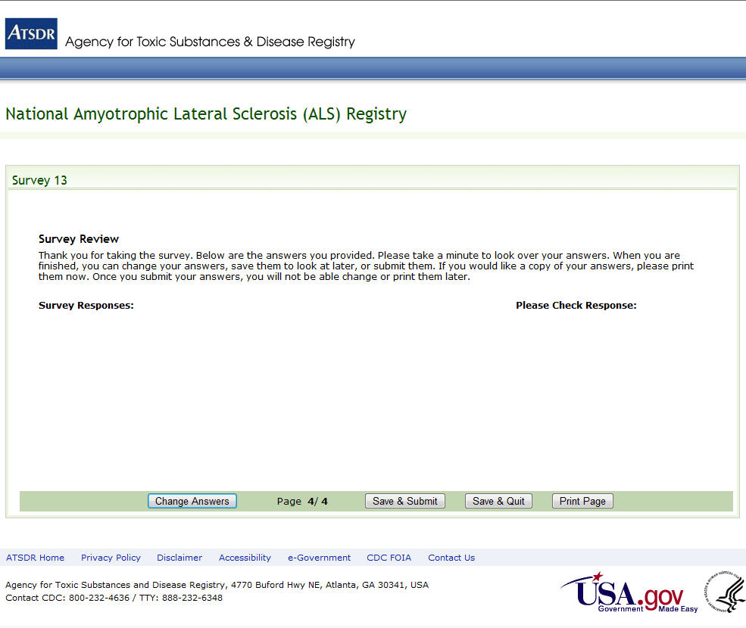
Figure 32: Survey 13, Page 4 of 4

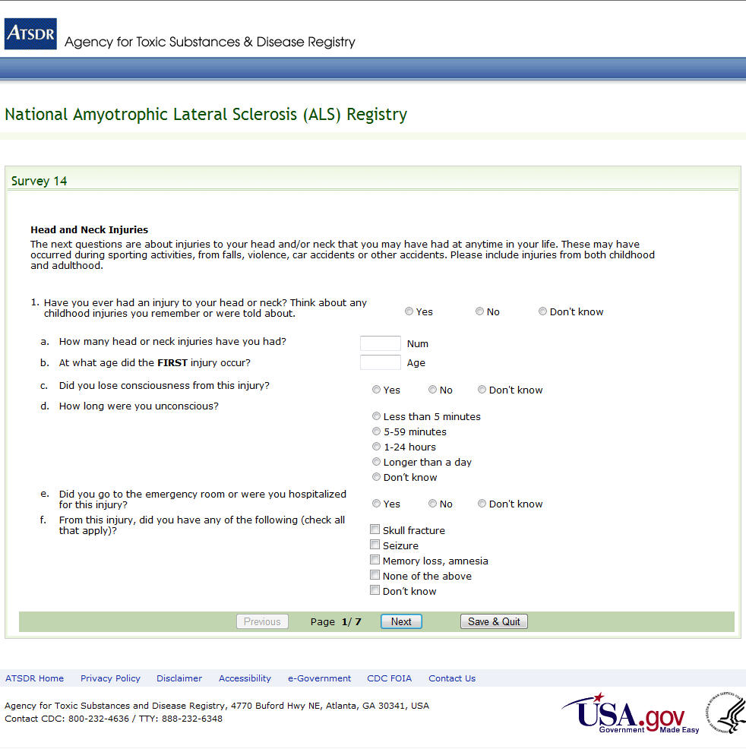
Figure 33: Survey 14, Page 1 of 7

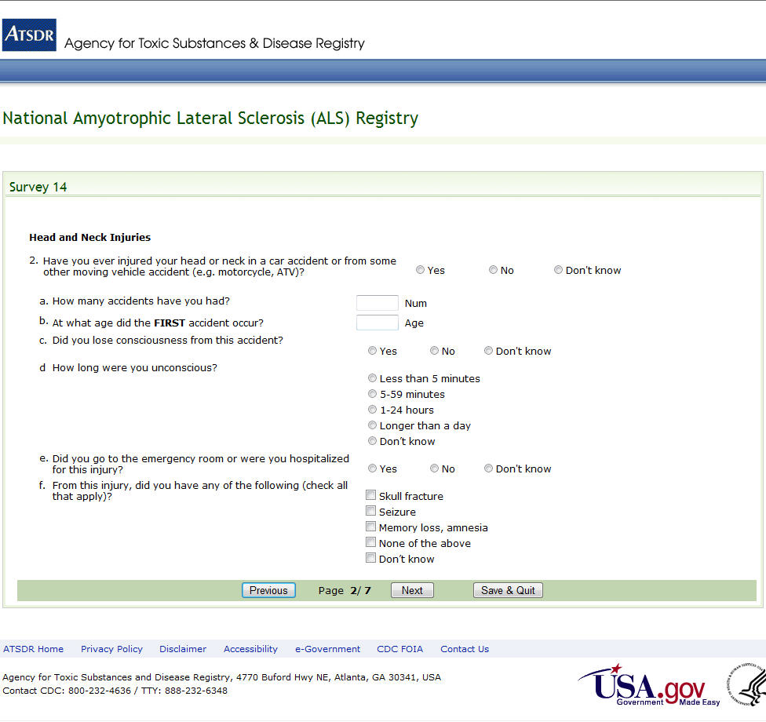
Figure 34: Survey 14, Page 2 of 7

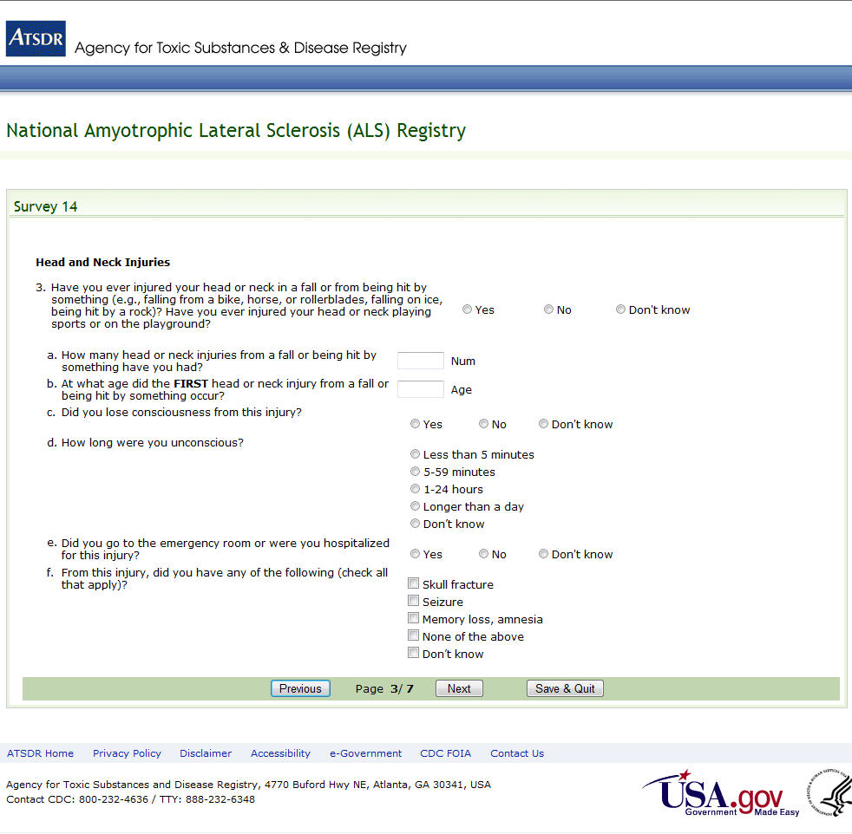
Figure 35: Survey 14, Page 3 of 7

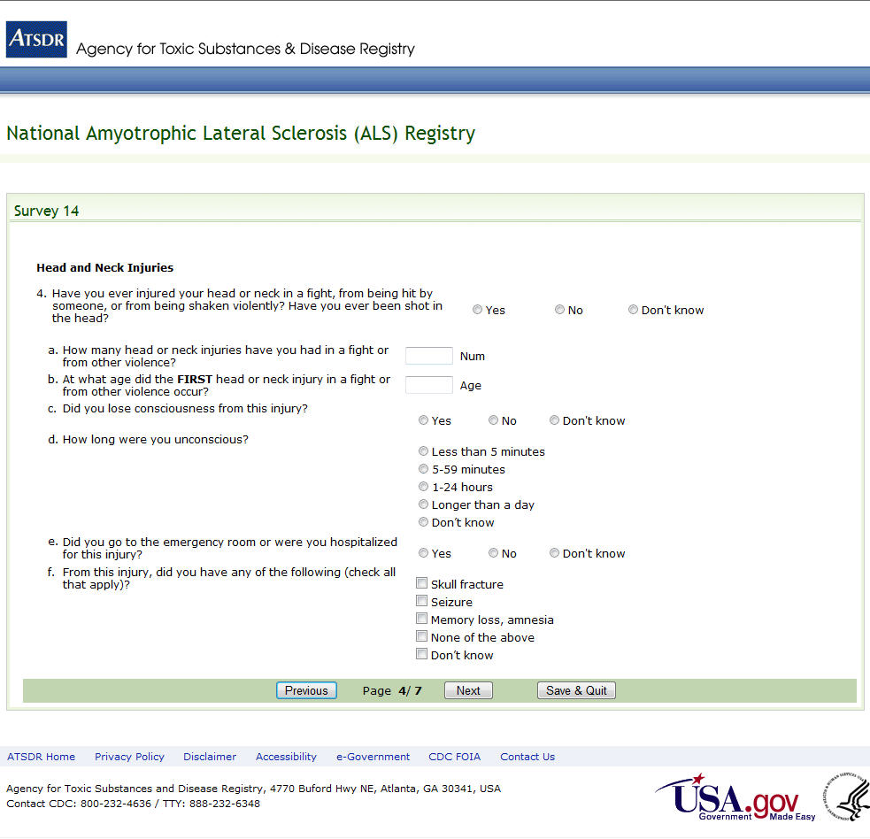
Figure 36: Survey 14, Page 4 of 7

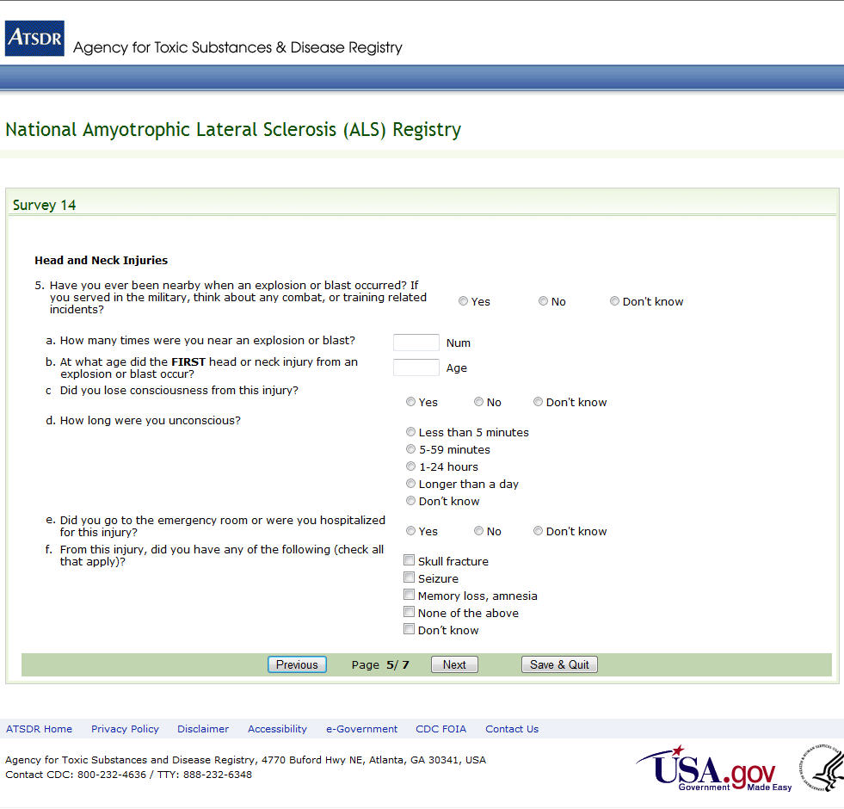
Figure 37: Survey 14, Page 5 of 7

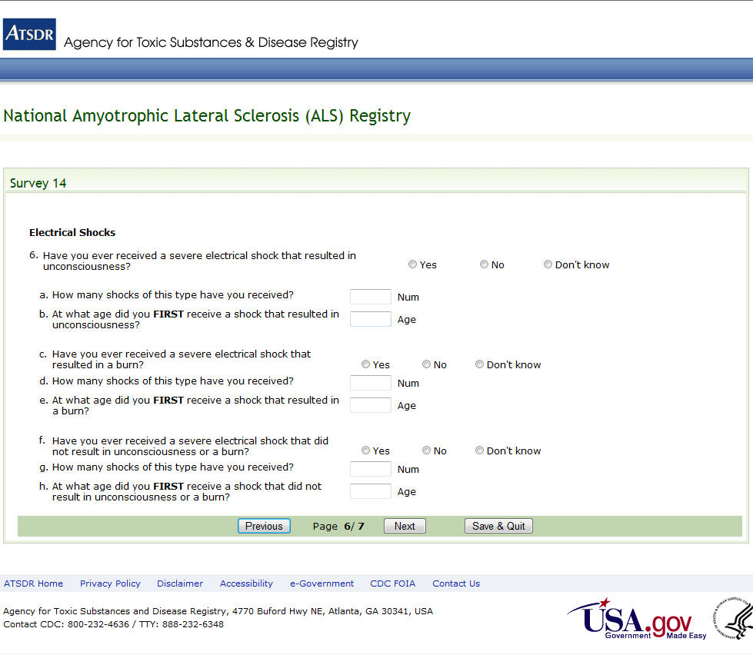
Figure 38: Survey 14, Page 6 of 7

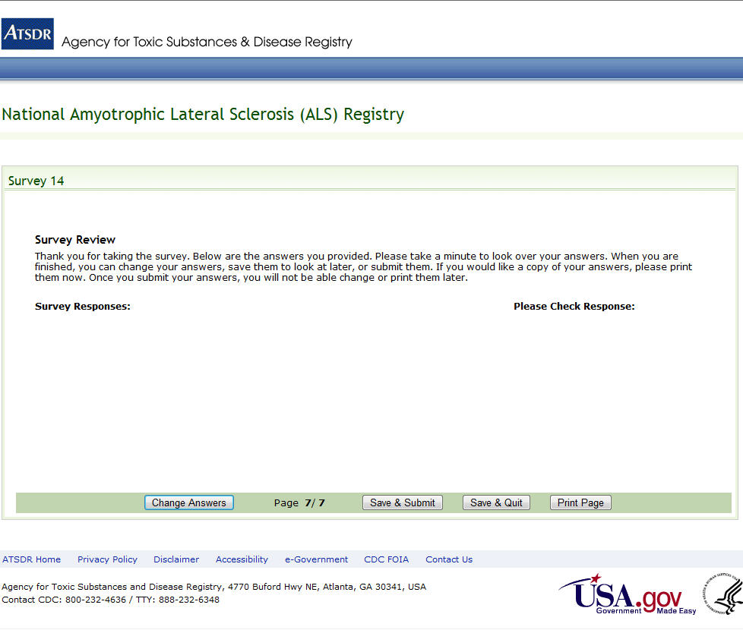
Figure 39: Survey 14, Page 7 of 7

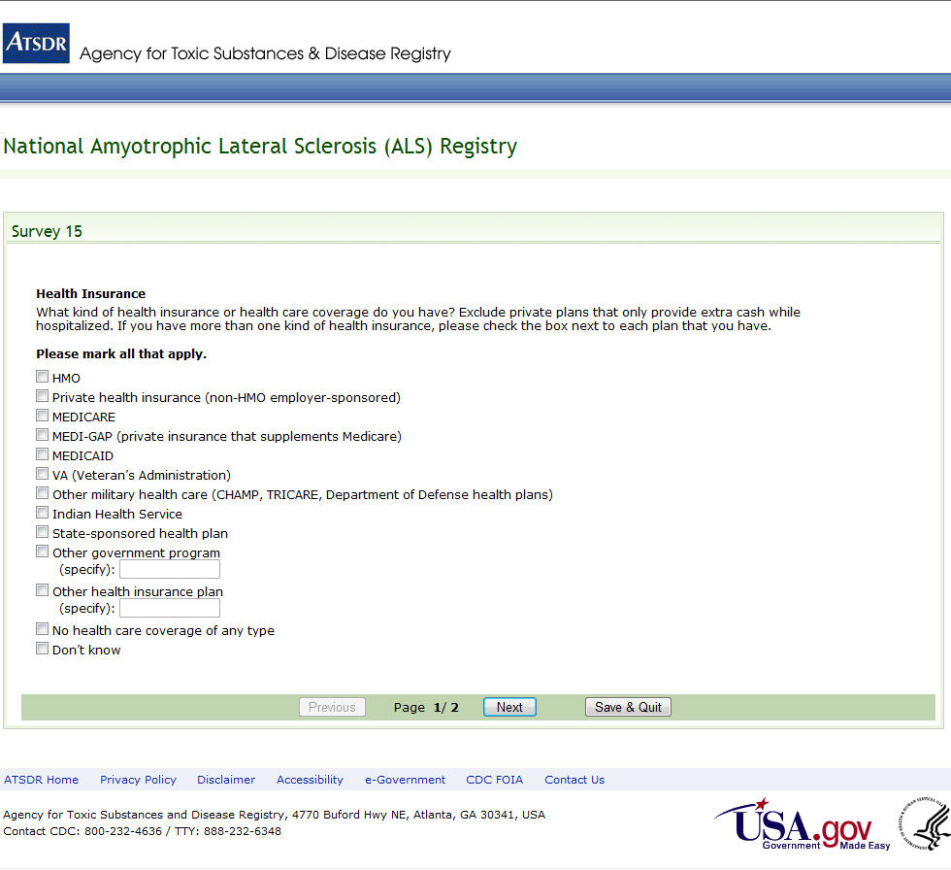
Figure 40: Survey 15, Page 1 of 2

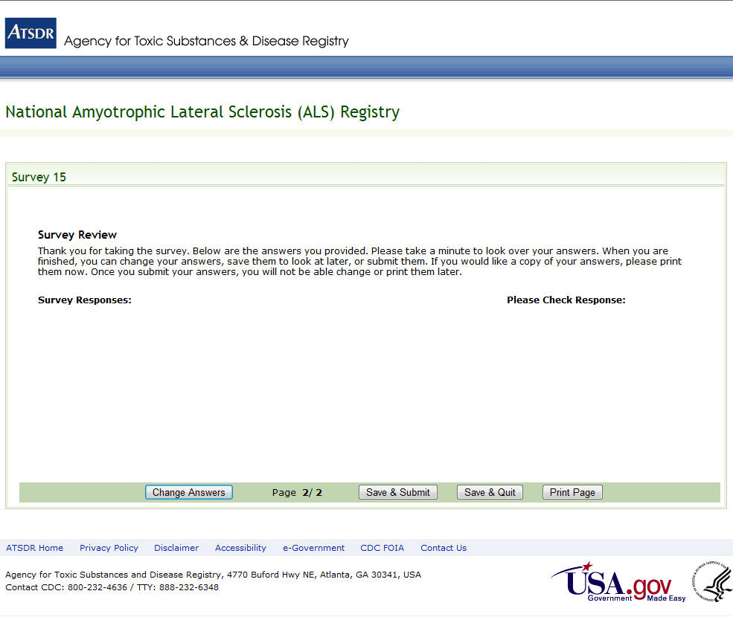
Figure 41: Survey 15, Page 2 of 2

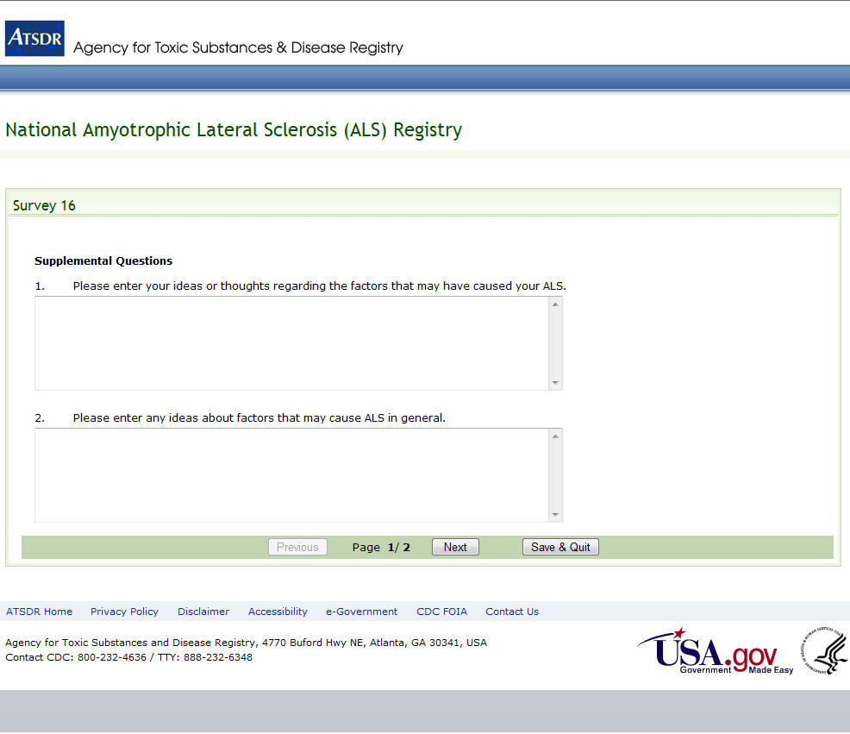
Figure 42: Survey 16, Page 1 of 2

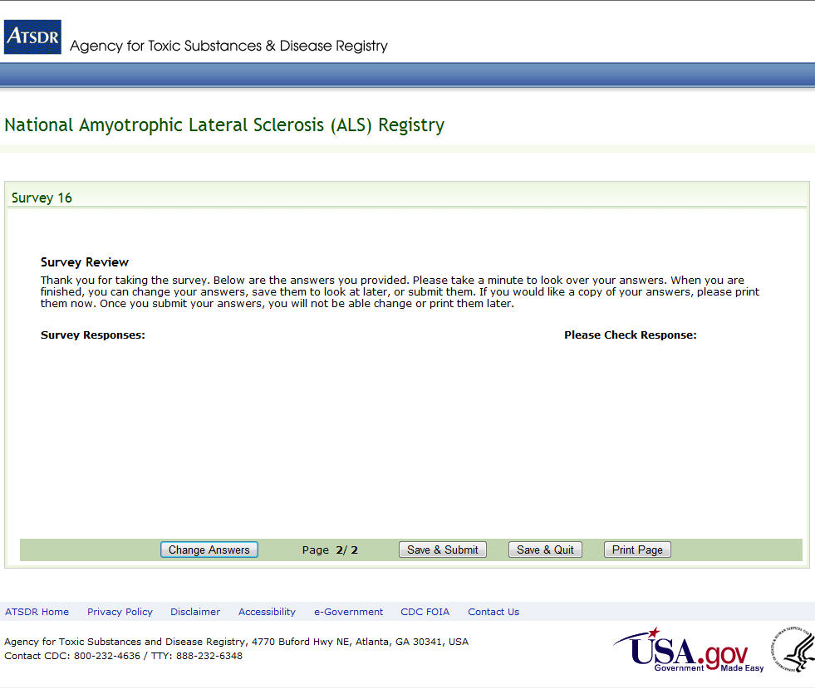
Figure 43: Survey 16, Page 2 of 2

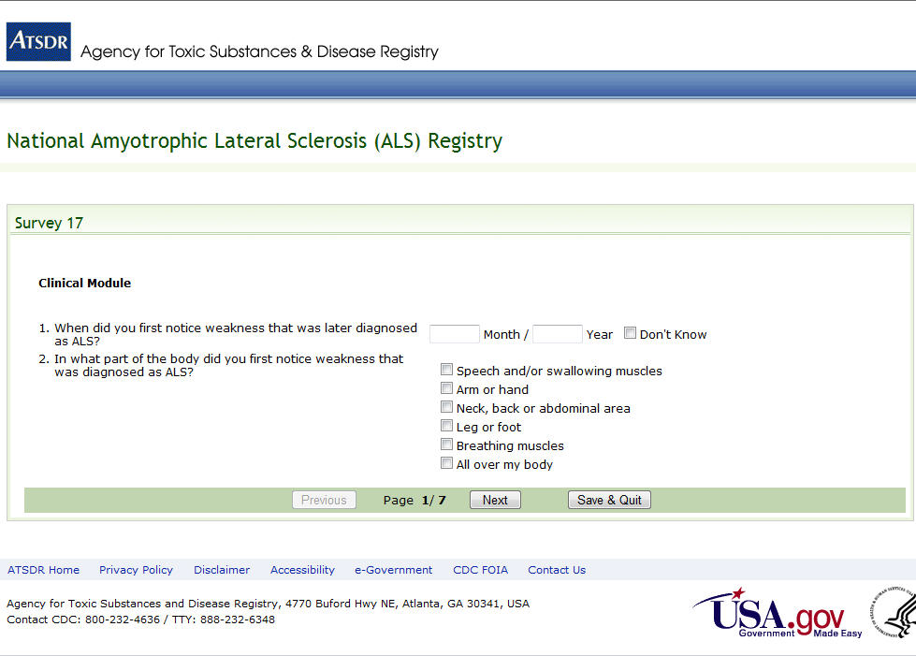
Figure 44: Survey 17, Page 1 of 7

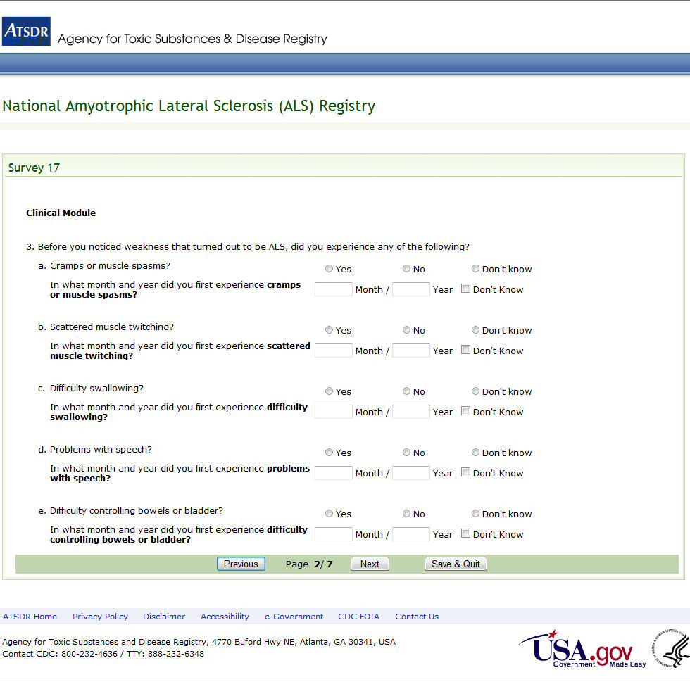
Figure 45: Survey 17, Page 2 of 7

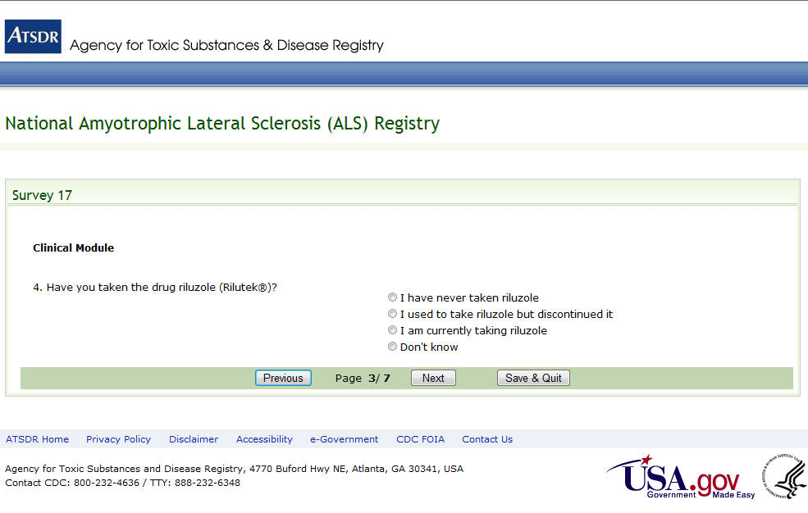
Figure 46: Survey 17, Page 3 of 7

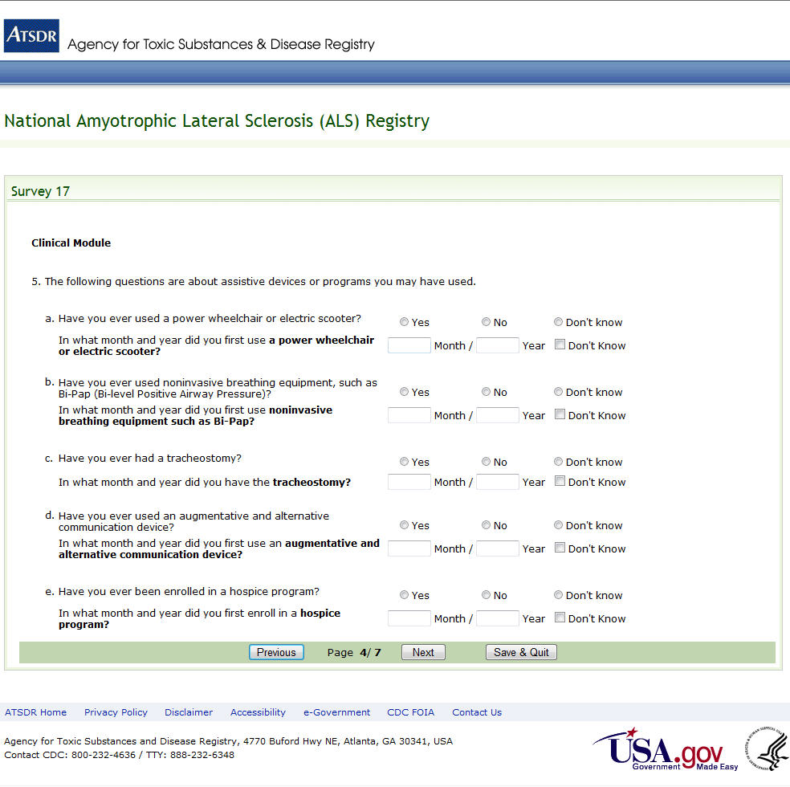
Figure 47: Survey 17, Page 4 of 7

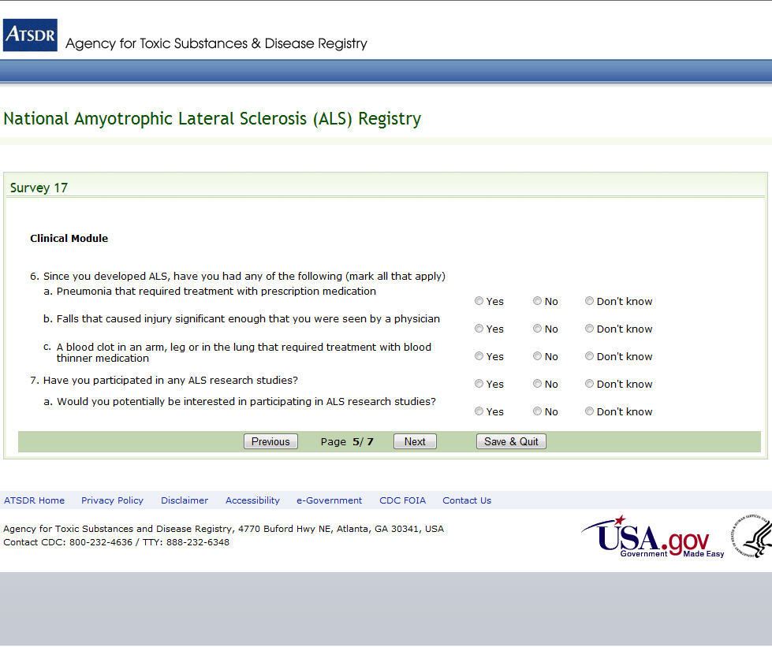
Figure 48: Survey 17, Page 5 of 7

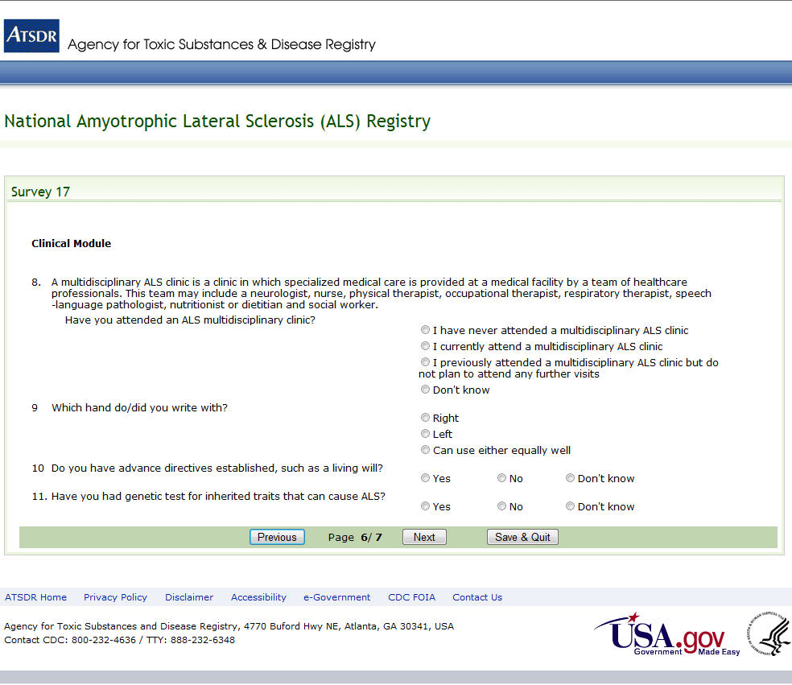
Figure 49: Survey 17, Page 6 of 7

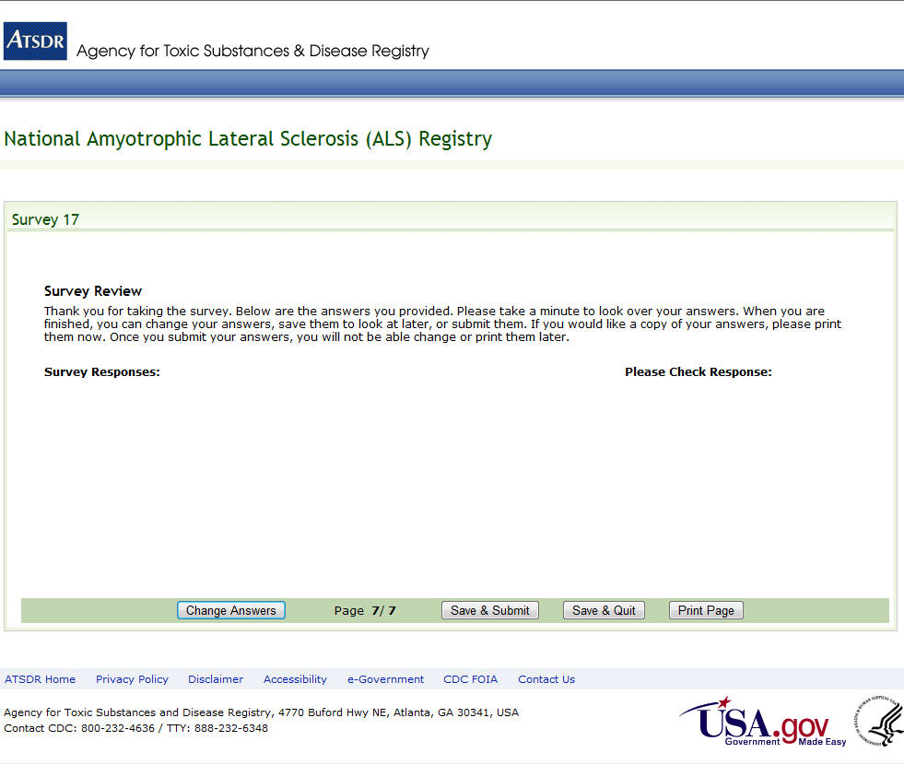
Figure 50: Survey 17, Page 7 of 7

