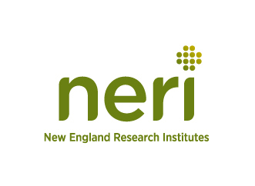
Recruitment Letter for Focus Group

Hello. My name is Michael Maurao and I work at New England Research Institutes, Inc. (NERI).
NERI is creating a video game (rated E for everyone) as part of a research study to teach children about clinical studies through game play. This project is being conducted by NERI and is supported by a grant from the Federal Government (National Institute of Heart, Lung, and Blood, National Institutes of Health). This video game is built on the successful program, ‘Children and Clinical Studies’ available at http://www.nhlbi.nih.gov/childrenandclinicalstudies/.

The objective of this game is to help children understand the myths or misunderstandings about clinical studies and to help lessen fears about participating, and to educate about the different kinds of clinical studies. This game will generally educate adolescents about what clinical research is and does not require that they have been or will be in a clinical study.
Children between the ages of 8 and 14 years will be able to be part of this study and will be asked to be part of a focus group. They will play a small part of the game and be asked to talk about what they like and don’t like. Your child must be able to understand, read and speak English because the questions they will be asked will be in English.
We need to ask you a few questions to figure out if your child is eligible to participate. Please call me at at 1-800-775-6374 X 675 to go over these few questions if your child is interested in helping with this study.
Some details:
- The study will be held at Cumberland Lincoln Boys and Girls Club during the hours your child is attending.
- Your child will get a gift card for $25 for being part of this study. NERI is not selling anything. Participation is voluntary and the information provided is private and will be kept secure to the extent permitted by law.
- This packet includes a consent form to be signed by the parent and an assent form which should be reviewed with and signed by the child. These forms should be sent back to Cumberland Lincoln Boys and Girls Club after you call our office to see if they are eligible.

Thank you for your time and interest.
Sincerely,

Michael P. Maurao, PMP
Project Manager
New England Research Institutes
P: 617-972-3675
F: 617-926-8246
mmaurao@neriscience.com

