**Sources of Funding Question in WIPA/ETO**

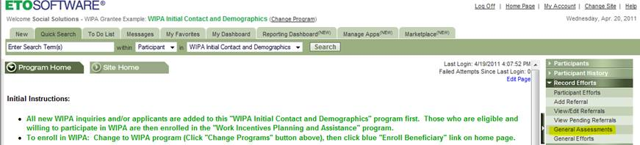

Screen 1 (Change to existing screen): Select the new option “General Assessments”

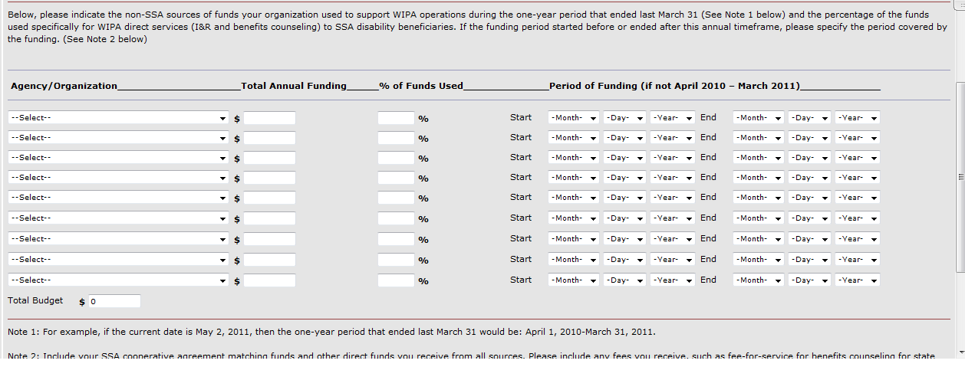

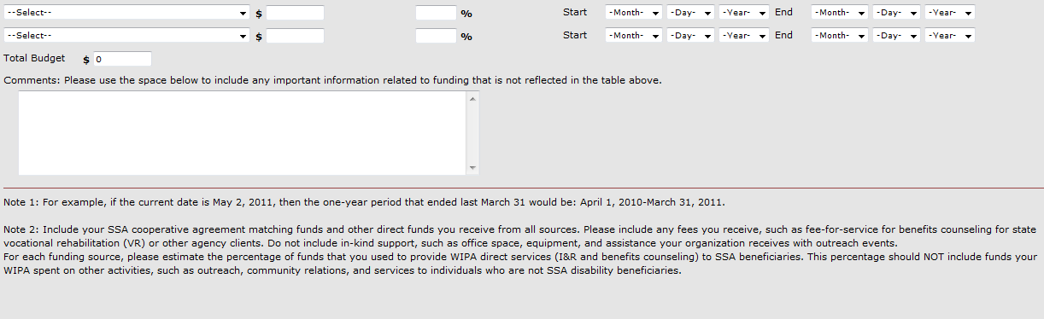

Screen 2 (New): The sources of funding question.

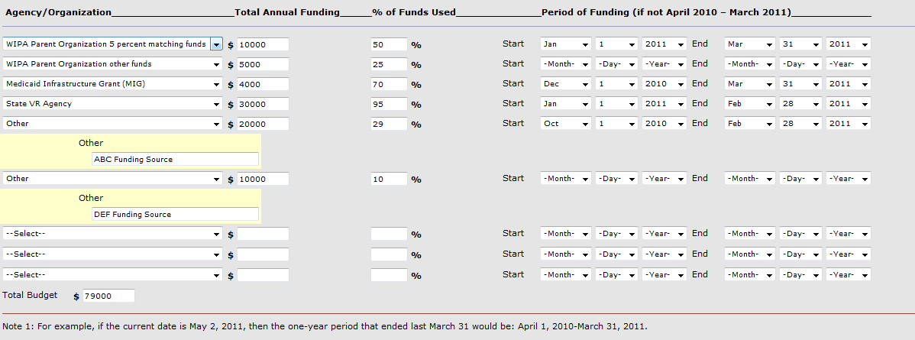

Screen 2 (Example): Example data entered and options selected from drop down boxes