C10. DCFS CASI-ACASI Measures and Instruction Screens
Note: The CASI/ACASI interview will be administered following the informed consent/assent process that uses the forms in Attachments C7 and C9.
CASI/ACASI Measures
Abbreviated Dysregulation Inventory (ADI) (Mezzich et al., 2001)

Designed to assess three areas: (a) Emotional/Affective Dysregulation, (b) Behavioral Dysregulation, (c) Cognitive Dysregulation. The parent version, which is identical to the original instrument, instructs the parent to complete the instrument using the child as a reference.

Parenting Practices Chicago Survey-Parent Version (PPCS)(Gorman-Smith et al., 1996)

Designed to assess three constructs: Positive Parenting, Discipline Effectiveness, Discipline Avoidance, and Monitoring.

Social Provisions Scale (SPS) (Russell & Cutrona, 1984)

Designed to examine how respondent’s social relationships provide social support. Includes six constructs: (a) Attachment, (b) Social Integration, (c) Reassurance of Worth, (d) Reliable Alliance, (e) Guidance, and (f) Opportunity for Nurturance.

Youth Social Support Instrument (YSS) (LONGSCAN, 1998)

Designed to assess perceived social support received from familial adults, non-parental, and a peer.

Trauma Symptom Checklist for Children (TSCC; Briere, 1996)

Designed to assess distress and related symptoms after an acute or chronic trauma including Anxiety, Depression, Anger, Posttraumatic Stress, and Dissociation.

Parent Contact with Youth Instrument (Questions are from an instrument being used with foster youth in the current Illinois Adult Connections Study

Designed to assess the youth’s contact with his or her mother and father.

Youth Emotional Permanency Instrument (Questions are from an instrument being used with foster youth in the current Illinois Adult Connections Study and the Arizona PII site Permanent Connections Inventory)

Designed to examine the quality of the youth’s relationships with adults.

Introduction for Foster Parent
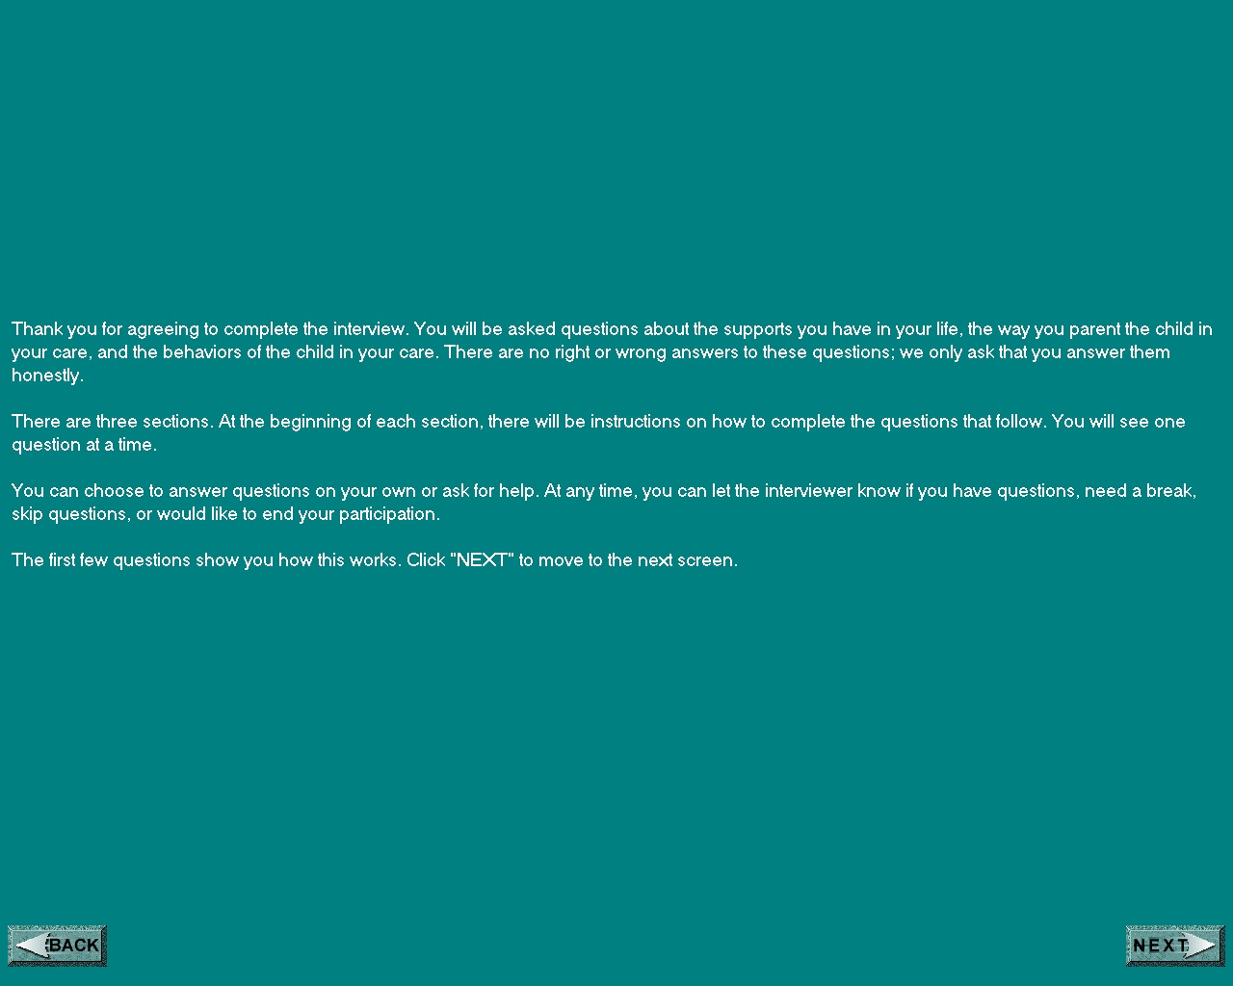

Parenting Practices Chicago Survey –Parent Version (PPCS)

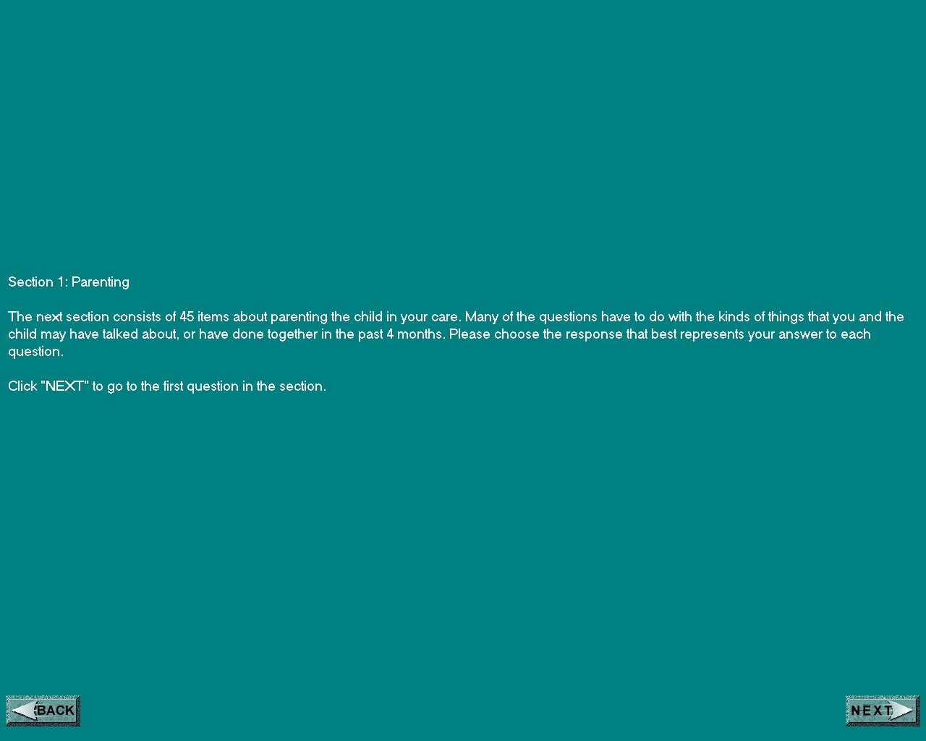
Social Provisions Scale (SPS)

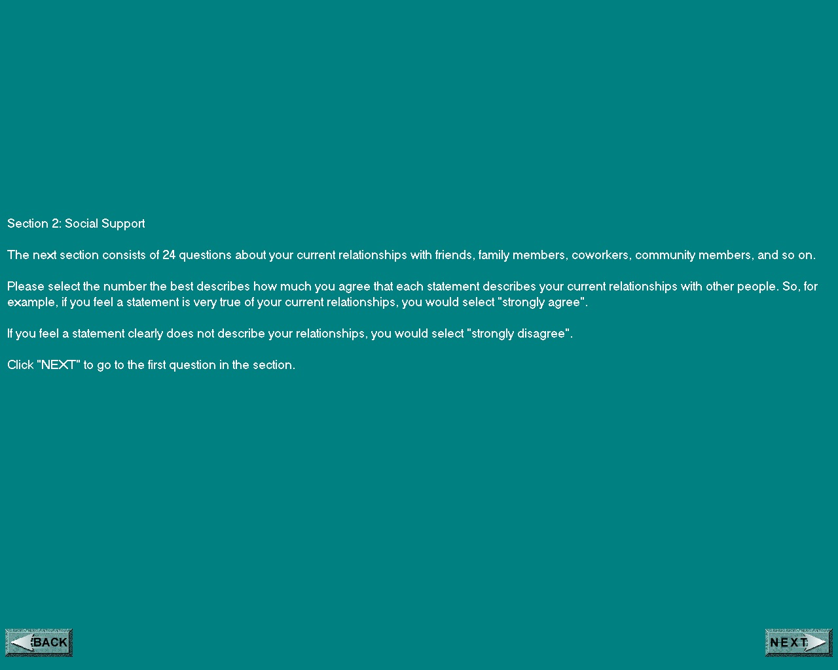

Abbreviated Dysregulation Inventory (ADI)-Parent Version

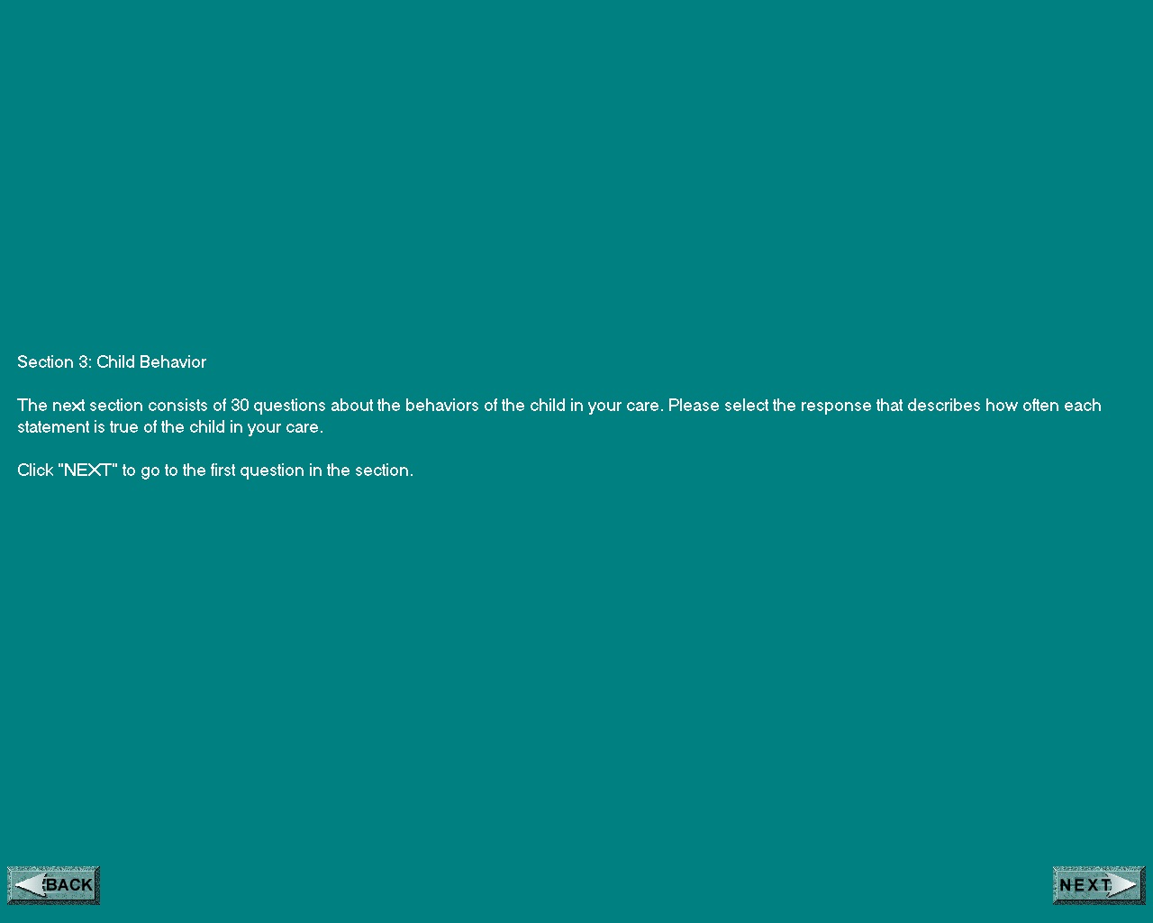

Introduction for Youth

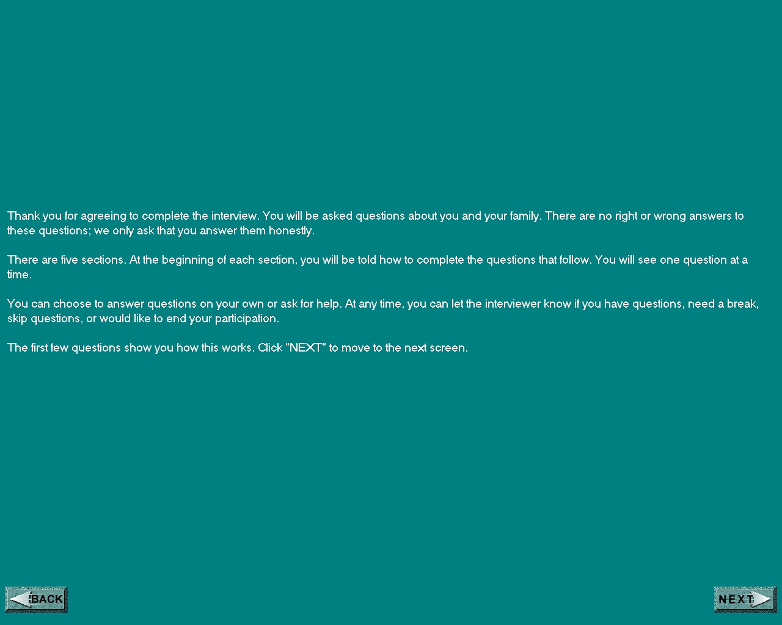

Youth Social Support Instrument (YSS)
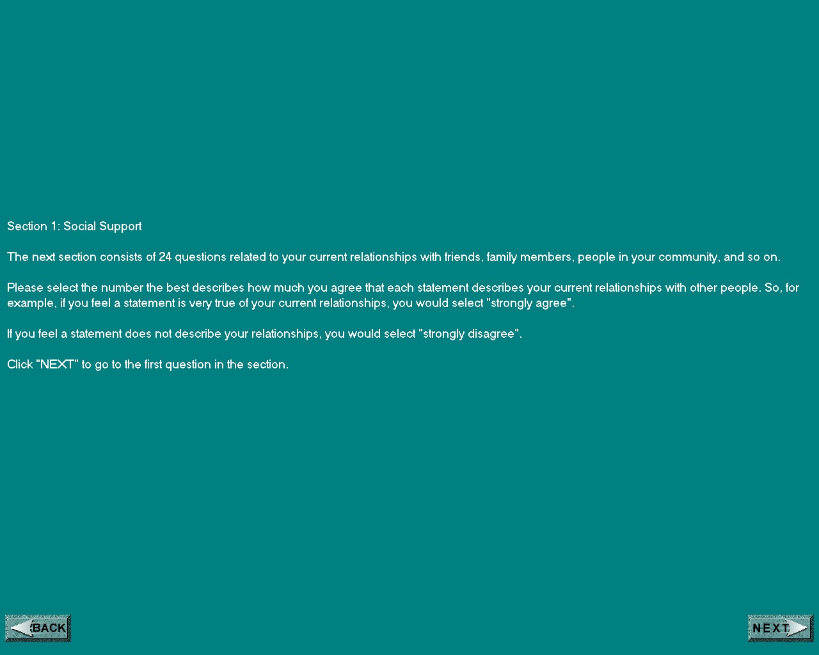

Youth Emotional Permanency Instrument (YEP)

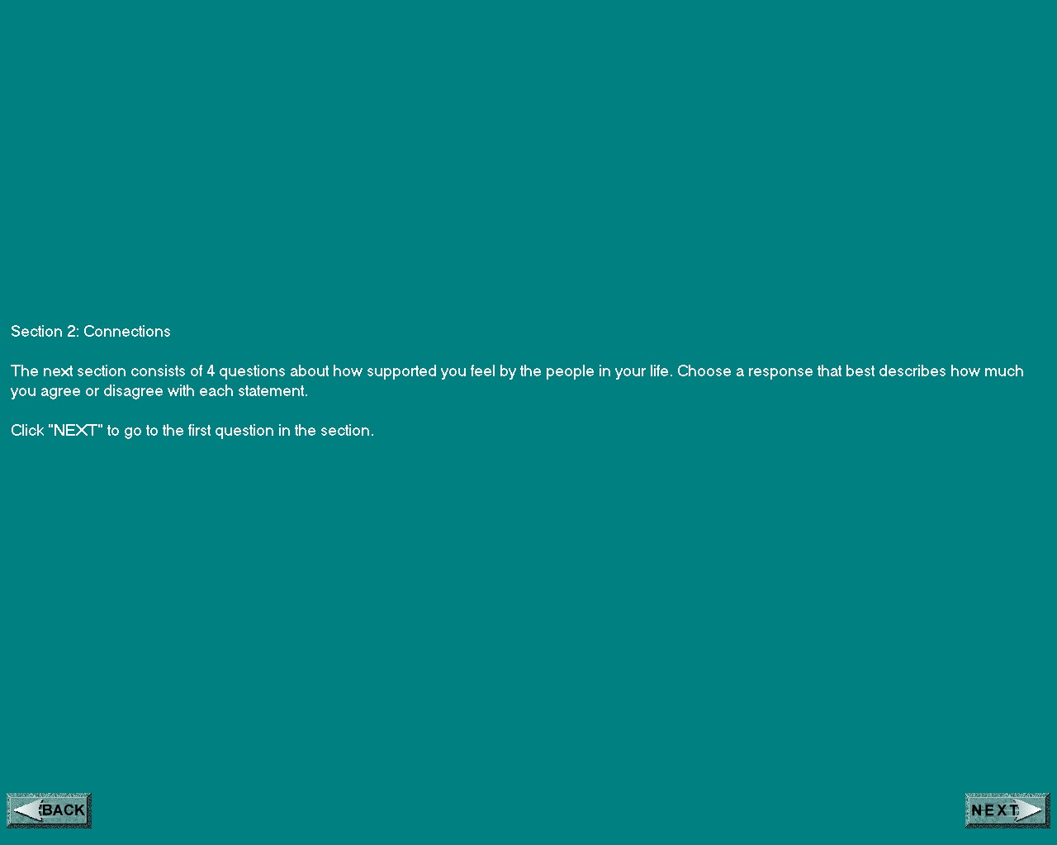

Abbreviated Dysregulation Inventory (ADI)

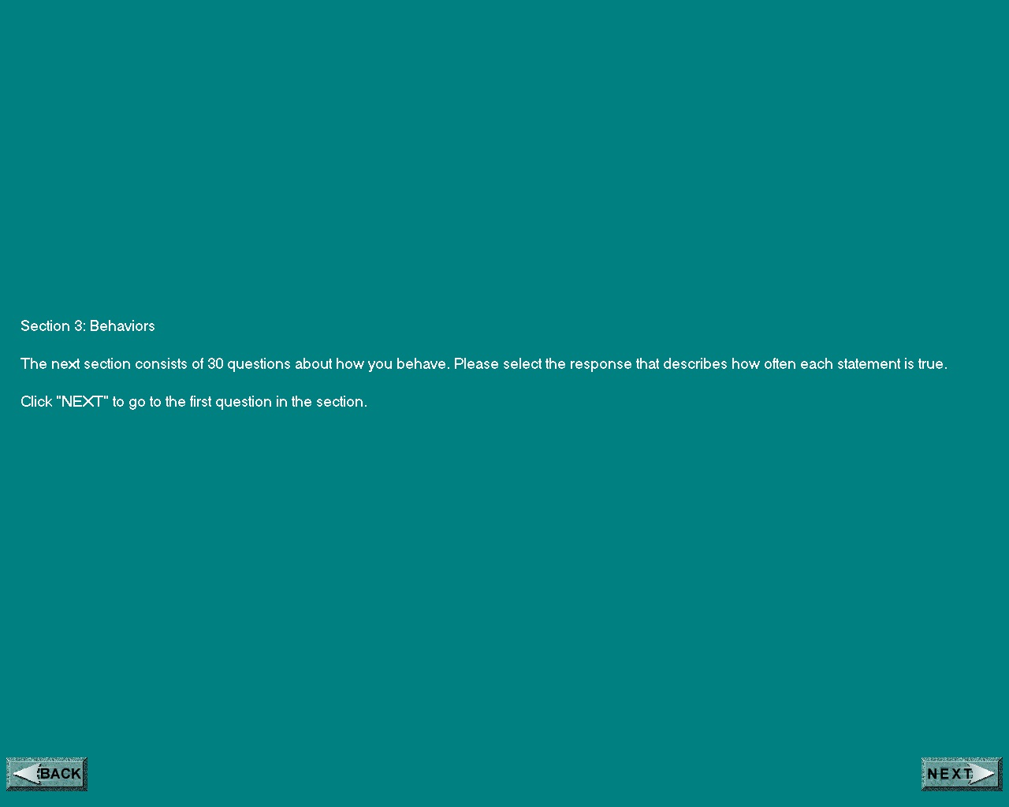

Parent Contact with Youth Instrument (PCY)

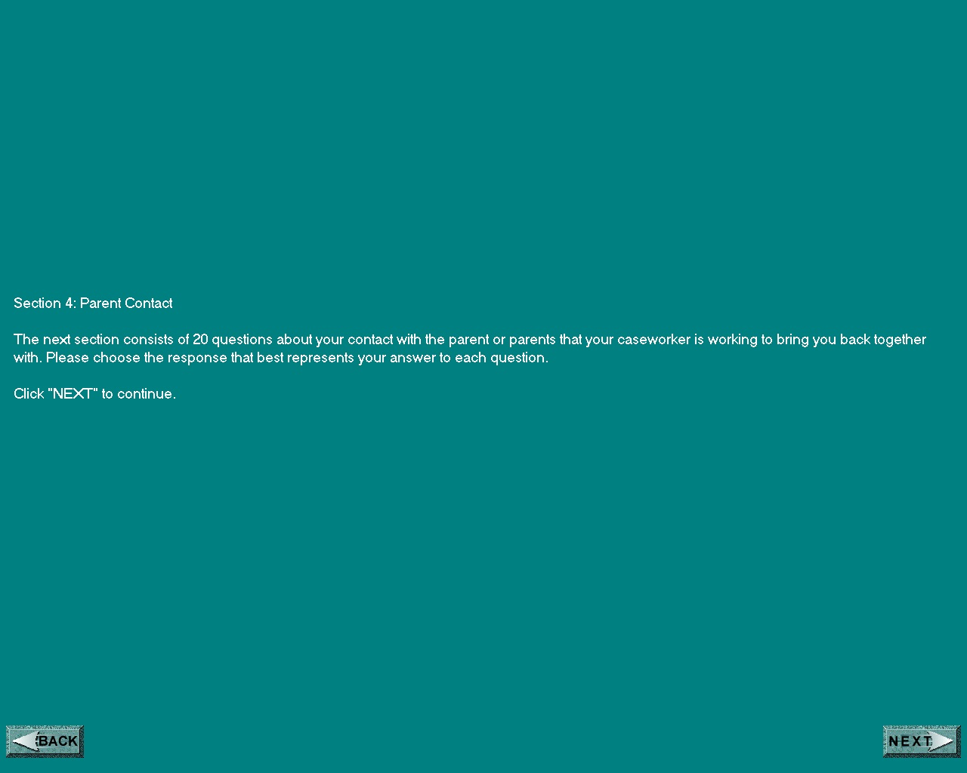

Parenting Practices Chicago Survey-Parent Version (PPCS)

