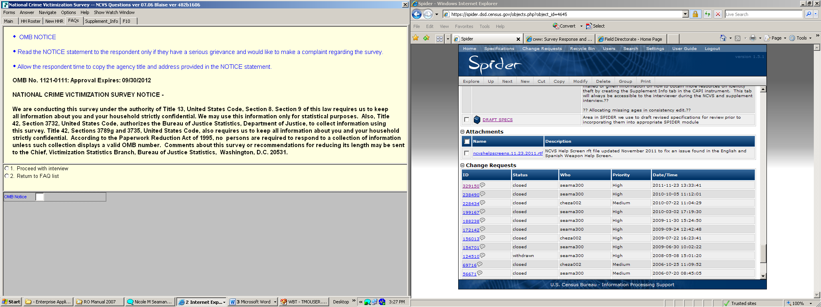

Screenshot of NCVS Instrument screen containing the OMB number/expiration date.

