Department of Memorandum
Veterans Affairs

Date: May 31, 2013

From: VHA PRA Compliance Liaison (10B4)

Subject: Revisions to VA Form 10-0103

To: VA OMB Desk Officer

VA Form 10-0103, Veterans Application for Assistance (in Acquiring Home Improvements and Structural Alterations) has been revised to simplify fillable form fields:

Section I – Veteran/Service member Application

Previous 2010 form:

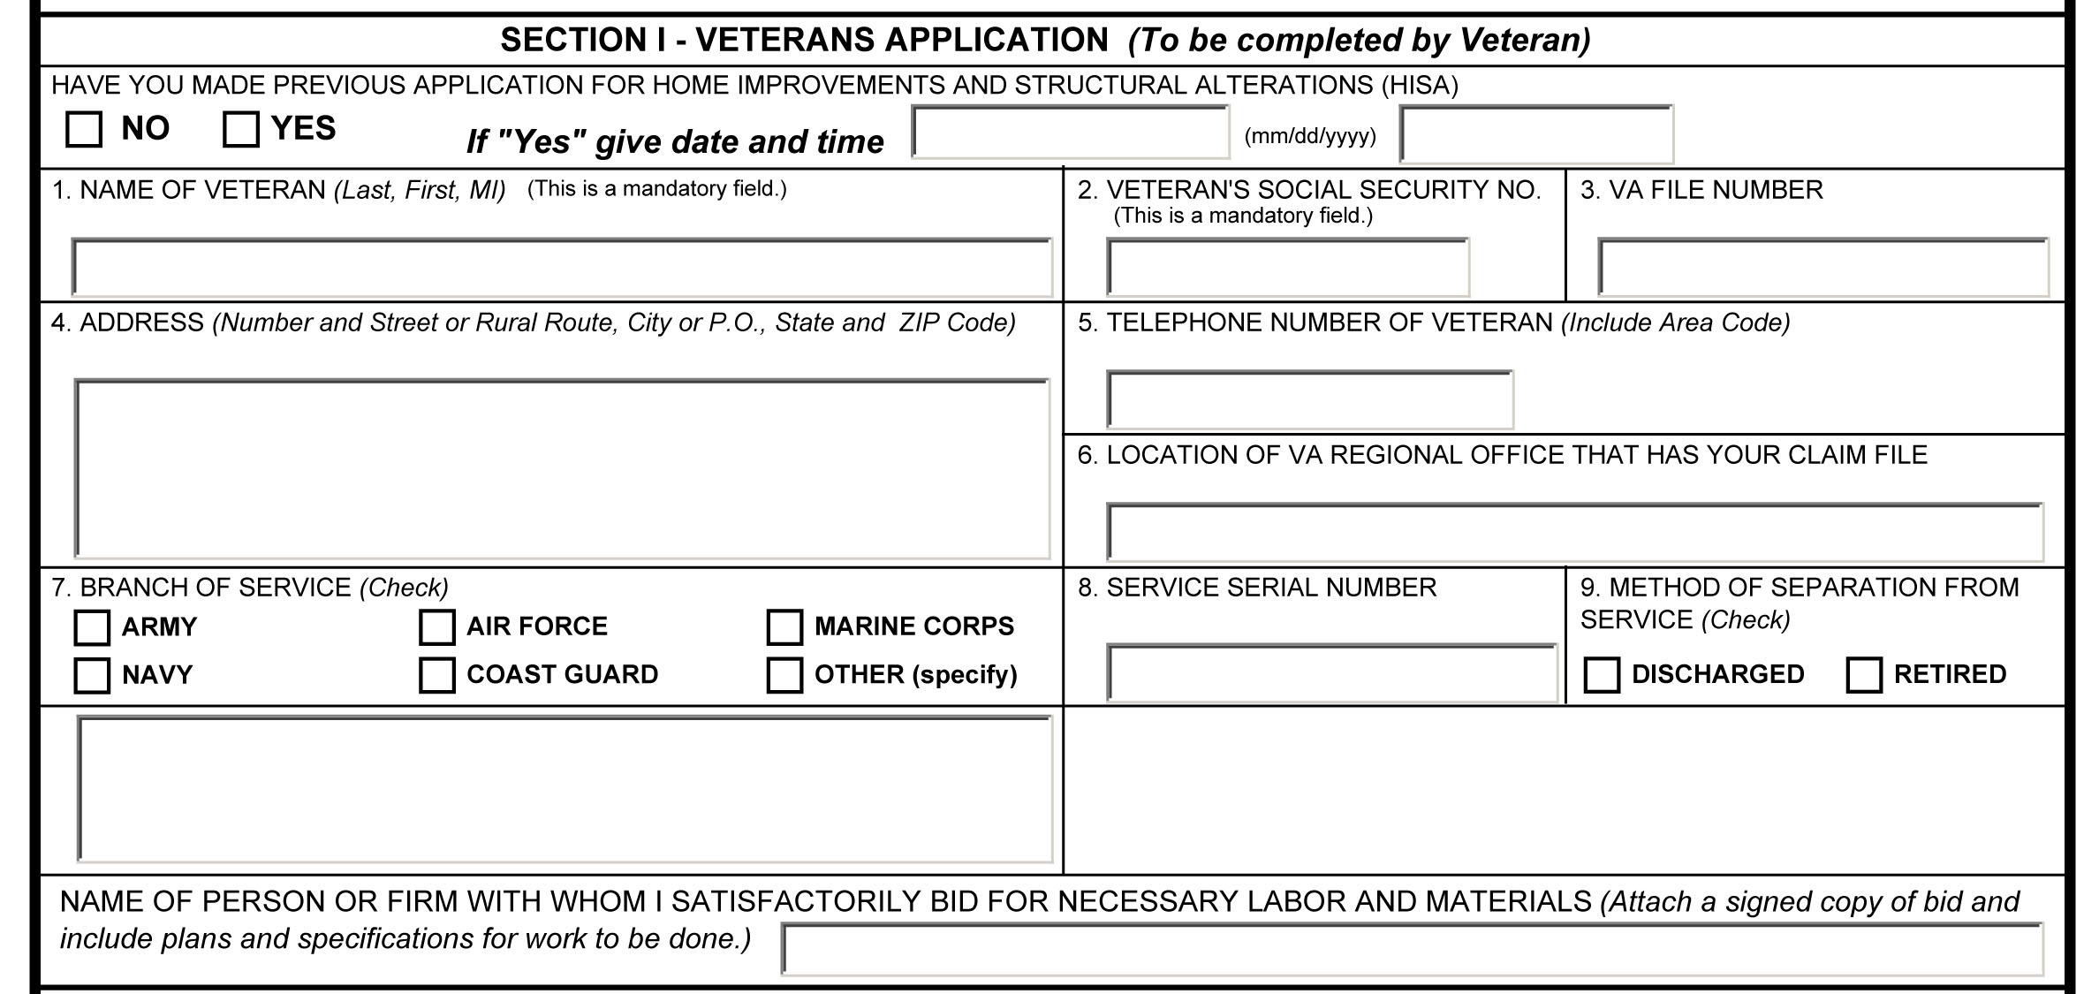

- PRA and PA statement has been removed from top of page to bottom of page 2.
- Highlighted fillable fields 3, 6, 7, 8 and 9 have been removed.

Revised 2013 form: Page 1 of 2

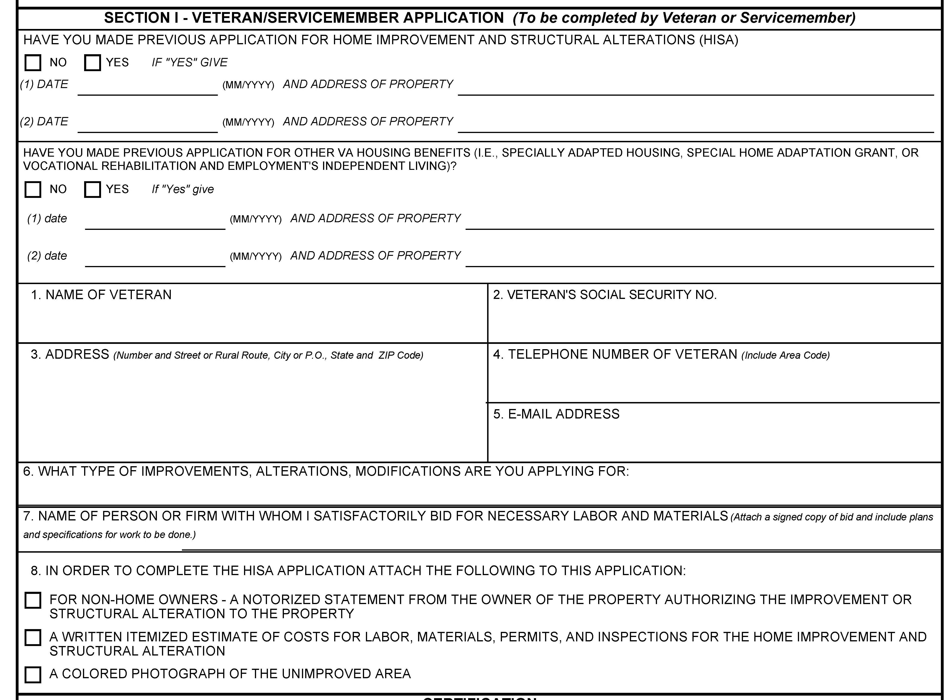

- Page 1, Section I: PRA and PA Statement information has been moved to bottom of page 2
- Top block “HISA” alterations has been revised to include Date 1 and Date 2
- Second block “Have you made previous application…” question blocks have been added.
- Number 5. “email address” is included as new fillable field
- Number 6. “what type of improvements, alterations…” new fillable field has been added
- Number 8. Is new with three check boxes
- Certification statement at bottom of page 1 has been revised to include HISA benefits
statement with yes or no check boxes.
- The expiration date will be included in the form header with the OMB control number and estimated burden

Previous 2010 form: Section 2, Page 2

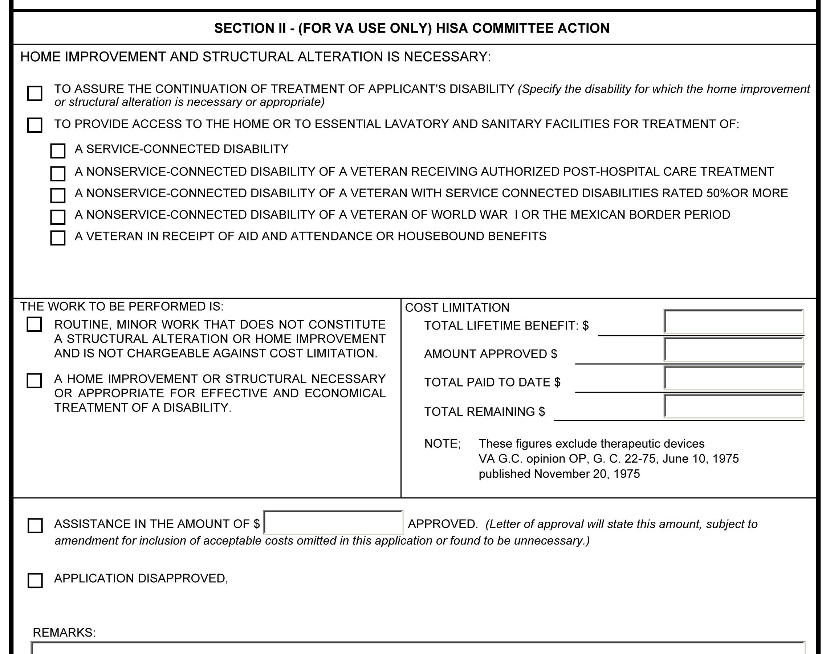

- Page 2, “Home Improvement” red text block 1: First checkbox text has been revised
- Text block 1 Yellow highlighted area boxes have been deleted
- Block 2, “The work to be performed”…: has been removed
- Block 3, Cost Limitation “Note” has been removed
- Block 4 has been revised.

Revised 2013 form: Page 2 of 2

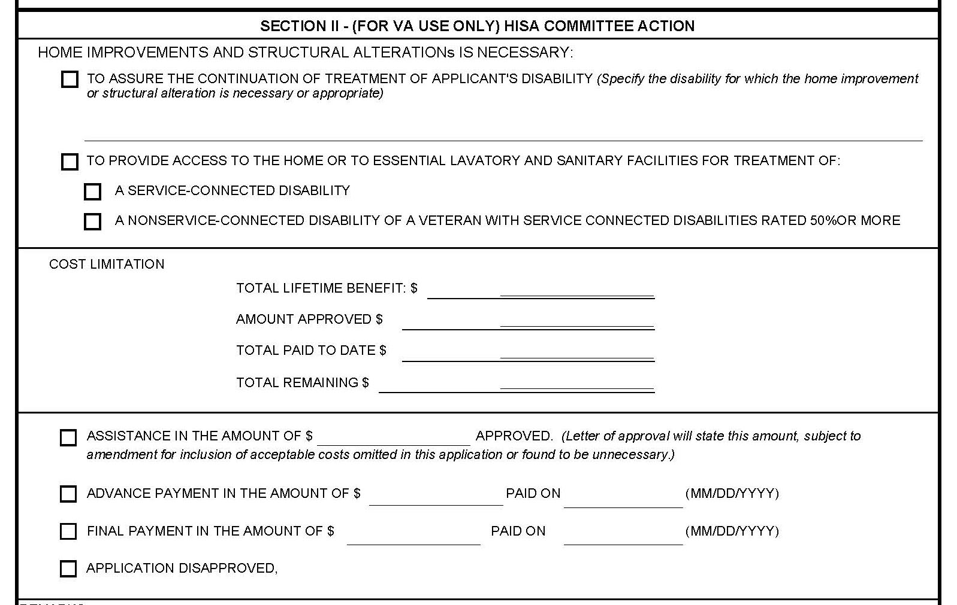

- Page 2, Section 2 first check box revised
- Check box 4 was deleted
- Check boxes 6 and 7 were deleted.
- Cost Limitation” becomes text block 2, centered, minus “Note.”
- Block 4. has been revised to include 2 new check boxes, “Advanced Payment” and
“Final Payment.”

