Fill out the Vendor Registration Form by entering the appropriate information in the fields displayed. Select the |SUBMIT| button at the bottom of the page. | 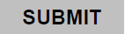
The Select Email Client window displays. Read it and make the most appropriate choice. Then select |OK|.  Note: If you are using an Internet email service such as Yahoo, Gmail, or Hotmail, you will then need to save your form and return it manually to VENDOR_REGISTRATION@NCUA.GOV using your Internet email service. | 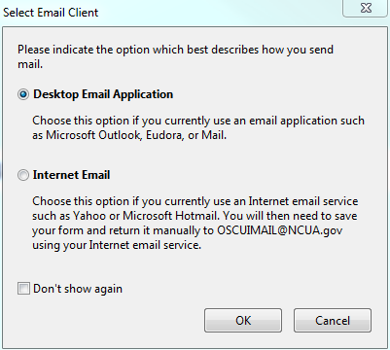
To submit a PDF form with a desktop email application:
If you use Microsoft Outlook Express or Microsoft Outlook to manage your email, these programs automatically compose an email to VENDOR_REGISTRATION@NCUA.GOV, attach your completed form and send it.

- Select the |SUBMIT| button at the bottom of the PDF form.
- In the Select Email Client dialog box, select Desktop Email Application; then select |OK|
- Your default email application displays a new email message with the To, Subject, Body, and Attachment fields automatically filled in.
- Then select |SEND| on your email application
- Click Close in the Email Confirmation dialog box in Acrobat.

To submit a PDF form with a web-based email service (Yahoo, Gmail, Hotmail, etc.):
- Select the |SUBMIT| button at the bottom of the PDF form.
- In the Select Email Client dialog box, select Internet Email if you are using a web-based email client (Yahoo, Gmail, Hotmail, etc.). Then select |OK|.
- In the Sending the Data File dialog box, select |Save Data File|. Then choose a location on your computer to save the file; (HINT: Choose DESKTOP, later it will be easy to find the file when you need it. Make a note of both where the file is going and the name of the file. The file extension is .pdf) select |Save|.
- Open a new browser window, log in to your web-based email service, and use your service to create a new blank email.
- After saving the file, minimize the window containing the form, open another tab or window and open your email program such as Yahoo, Gmail, Hotmail or smiliar.
- Compose an email to: VENDOR_REGISTRATION@NCUA.GOV. Put the completed form name (“Vendor Registration Form”) in the subject line, then click on the appropriate place in your email program to “ATTACH” a file. Browse your computer for the completed form that was saved in Step 3. Click on the located field to attach it, then select |SAVE| to send the email.

If you need a copy of the filled-in form, select Print before submitting the form.
OMB 3133- Expiration Date:

