Dear Agricultural Producer:

Few issues are as important to agricultural sustainability as on-farm water use. To ensure that all efforts to develop and promote efficient irrigation practices and ensure long-term sustainability of water resources, the U.S. Department of Agriculture is conducting the 2013 Farm and Ranch Irrigation Survey. Conducted as a follow-on survey to the Census of Agriculture, the results of this survey will provide a single source of comprehensive, up-to-date information on irrigation and water use across the agricultural industry. This is your chance to make your voice heard on this important issue.

Please respond to the Census promptly in either of the following ways:

* Online at [www.agcensus.usda.gov](http://www.agcensus.usda.gov). Responding online is fast, easy and secure. Complete instructions are on the reverse of this letter. Note that you need the identification number on the enclosed Census form to begin.
* By mail. Complete the enclosed form and mail it back in the return envelope provided.

The Census of Agriculture is both required by law and protected by law (Title 7, U.S. Code). As with all information collected by USDA’s National Agricultural Statistics Service, Federal law requires us to keep your identity and your answers completely **confidential**.

Please respond by **February 10, 2014.** If you have questions or need assistance, call (888) 424-7828.

Thank you in advance for your participation in the Farm and Ranch Irrigation Survey.

Sincerely,

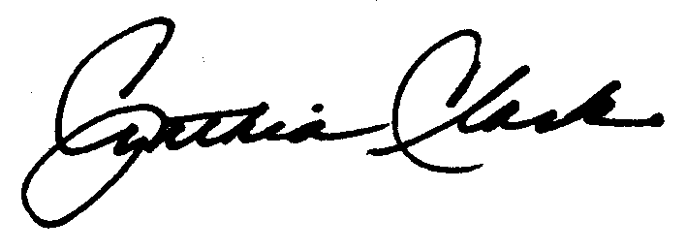

Dr. Cynthia Clark

Administrator, National Agricultural Statistics Service

U.S. Department of Agriculture

Enclosures





**United States**

**Department**

**of Agriculture**

**National**

**Agricultural**

**Statistics**

**Service**

