Screen shot of Internet-based model where FSMIP reviewers post scores

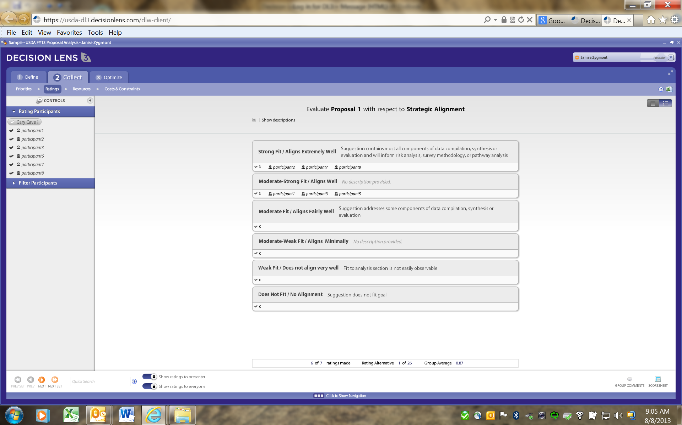

Screen shot of Internet-based model where FSMIP reviewers post comments

