Screen shot of Internet-based model where FSMIP reviewers post scores

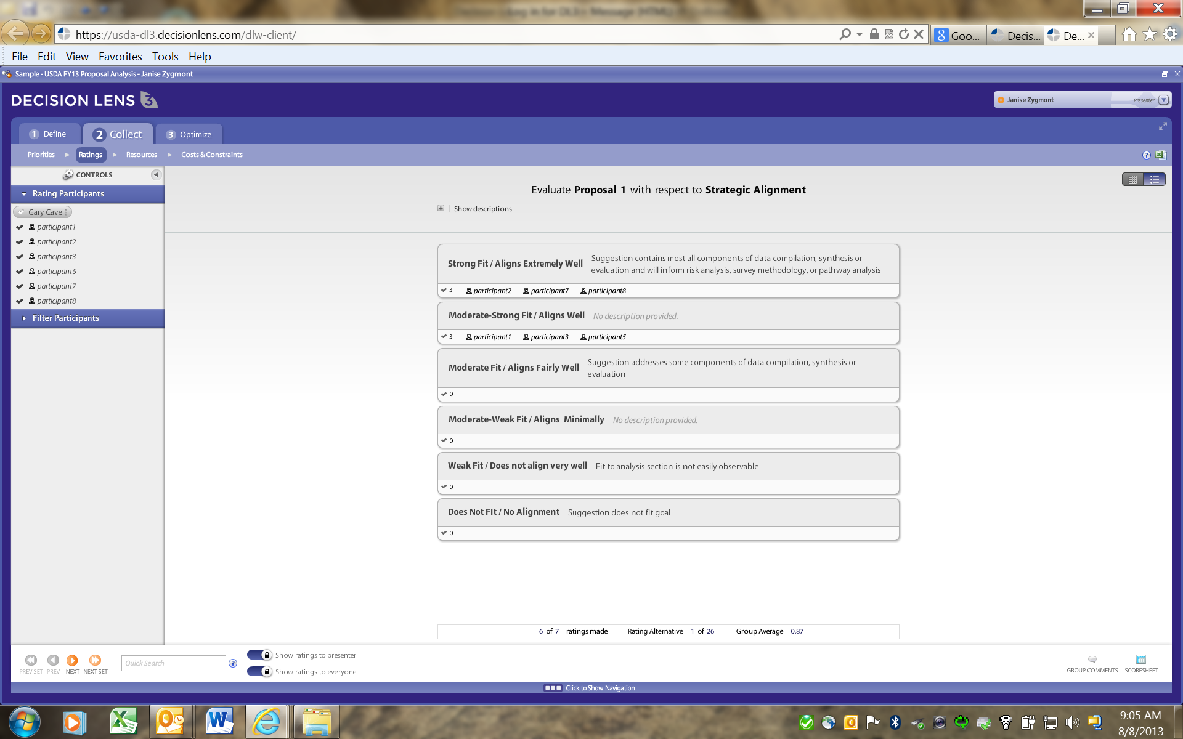
Screen shot of Internet-based model where FSMIP reviewers post comments

