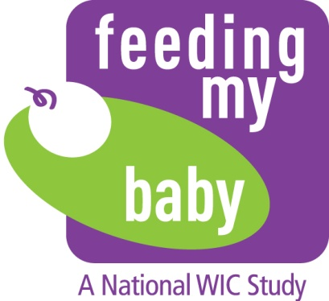

Appendix NN.1
Participant Reminder Scripts
For Email, Voicemail and Texting from Field Liaisons -ENGLISH

Missed Interview Appointment
Telephone, voicemail and email
Hello, this is [NAME] from the Feeding My Baby Study. We missed you for your interview appointment. Please call our toll-free number, XXX-XXX-XXXX to reschedule your appointment and get your $20 incentive. We look forward to speaking with you.
Text
Please call XXX-XXX-XXXX to complete your next Feeding My Baby interview and get your $20 incentive.
Confirmation of baby’s birth
Telephone, voicemail
Hello, this is [NAME] from the Feeding My Baby Study. You enrolled in the study in [MONTH] at [NAME OF WIC SITE]. I was just following up to see if you have had your baby. Please give me a call back, toll-free at XXX-XXX-XXX. I hope you are doing well. Thanks.
Email
Hello, this is [NAME] from the Feeding My Baby Study. You enrolled in the study in [MONTH] at [NAME OF WIC SITE]. I was just following up to see if you have had your baby. Please send me an email or give me a call back (toll-free) at XXX-XXX-XXX and let me know. I hope you are doing well.
Take care,
[NAME]
Script for TRC Automated Reminder Call (Voice Mail Message)
Hello, this is the Feeding My Baby Study. We are calling to remind you of your next interview appointment at [TIME] on [DAY] [DATE]. We will call you at this number. If you want to complete the interview before that date, please call XXX-XXX-XXXX. If your child is going to be at daycare the day before your interview, you may want to have the daycare person write down the foods your child ate at daycare and give it back to you when you pick up your child.
We look forward to speaking with you.

