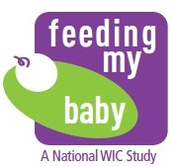

**Appendix X.1**

**Note Sheet for AMPM – ENGLISH**

To document foods child ate/drank away from home

This note sheet is for you to use to jot down the foods your child ate or drank away from home the day before your interview. We will not ask you to return it. You will use it as a reference for the interview.

If your child is going to be at daycare the day before your interview, you may want to have the daycare person write down the foods your child ate at daycare and give it back to you when you pick up your child.

|  |  |  |
| --- | --- | --- |
| *What food did child drink or eat?* | *How much did child drink or eat?* | *What time did child drink or eat?* |
| *Example:* |  |  |
| Bottle | 8oz | 7:30A |
| Baby rice cereal | 4oz | 11A |
| Baby peaches | 4oz jar | 11A |
| Bottle | 8 oz | 11:30A |
|  |  |  |
|  |  |  |
|  |  |  |
|  |  |  |
|  |  |  |
|  |  |  |
|  |  |  |
|  |  |  |
|  |  |  |
|  |  |  |
|  |  |  |
|  |  |  |