Letter #1: Pre-Notification

August 26, 2013

Dear Orange County Resident,

The National Oceanic and Atmospheric Administration (NOAA) is conducting a study in Orange County to learn about residents’ opinions of local beaches and to better understand the types of things that people want when they visit these beaches. The study will provide information that will help NOAA in developing management strategies for coastal areas. We are working with <<SURVEY ORGANIZATION>> on the study.

Your household is one of a small number of Orange County households that were randomly selected to participate in this study. In about a week, you will receive a short questionnaire in the mail from <<SURVEY ORGANIZATION>>. When you receive the questionnaire, please take a few minutes to fill it out and return it in the included pre-paid envelope. Please complete the questionnaire *even if you rarely visit local beaches*. This will allow us to obtain responses from a representative group of residents.

We thank you in advance for your willingness to assist NOAA in this research effort. If you have any questions at all, please feel free to call <<SURVEY ORGANIZATION>>’s toll-free number at <<PHONE>> and ask for <<CONTACT>>.

Sincerely,

Nancy Wallace,

Director, Marine Debris Program

National Oceanic and Atmospheric Administration

Letter #2: First Copy of Survey

September 1, 2013

Dear Orange County Resident,

As you may recall, I wrote to you last week about participating in a survey of Orange County residents. The questionnaire that I wrote to you about is enclosed. The National Oceanic and Atmospheric Administration (NOAA) needs your help in understanding residents’ opinions of local beaches and the types of things that people want when they visit these beaches. This information will help NOAA in developing effective management strategies for coastal areas.

Your household is one of a small number of Orange County households that were randomly selected to participate in this study. In order for the results to be truly representative of Orange County residents, it is important that each questionnaire be completed and returned. We have enclosed a small token of appreciation as our way of saying thank you for completing the questionnaire.

There are a few things that you should note:

* The questionnaire should be completed by the adult (18 years of age or older) who lives in your household whose birthday will be the first to occur after today. Please have this person complete the questionnaire *even if he or she rarely visits local beaches*. This will allow us to obtain responses from a representative group of residents.
* The questionnaire should be returned in the pre-paid reply envelope that we have included here.
* The questionnaire has an identification number for mailing purposes only. Your address will be removed from our database after we receive your completed questionnaire.

We are extremely grateful for your willingness to assist NOAA in this research effort. If you have any questions at all, please feel free to call <<SURVEY ORGANIZATIONS>>’s toll-free number at <<PHONE>> and ask for <<CONTACT>>.

Sincerely,

Nancy Wallace,

Director, Marine Debris Program

National Oceanic and Atmospheric Administration

Letter #3: Reminder Postcard

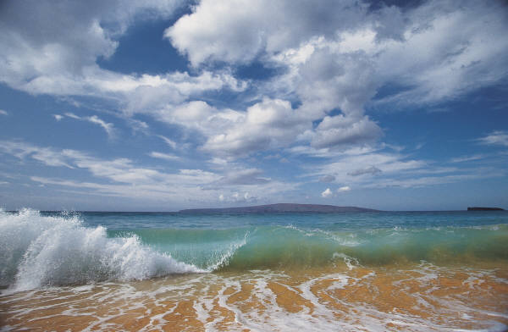

Last week I mailed you a questionnaire seeking your opinion about local beaches. If you have already completed and returned the questionnaire, please accept our sincere thanks.

We know your time is valuable, but if you have not completed and returned the questionnaire, we hope that you can do so today. You are one of a small number of households in Orange County randomly selected to provide opinions on this matter. It is extremely important that we hear from you so that our results accurately represent the opinions of Orange County residents.

If you need another copy of the questionnaire, please call <<CONTACT>> at <<SURVEY ORGANIZATION>> at <<PHONE>> and a questionnaire will be mailed to you today.

Thank you in advance for your help!

Nancy Wallace,

Director, Marine Debris Program

National Oceanic and Atmospheric Administration

Letter #4: Second Copy of Survey

September 22, 2013

Dear Orange County Resident,

About three weeks ago I wrote to you seeking your opinions on local beaches. As of today we have not received your completed questionnaire.

I am writing to you again because of the significance each questionnaire has to the usefulness of our study. Our program at the National Oceanic and Atmospheric Administration (NOAA) is undertaking this study in order to learn what people care about when they choose to visit a beach in the local area. This is extremely important, as it will help NOAA in developing effective management strategies for coastal areas.

Your household was selected through a scientific sampling process in which every household in Orange County had an equal chance of being selected. Only about one out of every 250 households is being asked to complete this questionnaire. In order for the results of our study to be truly representative of the opinions of Orange County residents, it is essential that each household in the sample return their questionnaire.

As I mentioned in my previous letter, the questionnaire should be completed by the adult (18 years of age or older) who lives in your household whose birthday is the first to occur after September 1st. Please have this person complete the questionnaire even if he or she rarely visits local beaches. This will allow us to obtain responses from a representative group of residents. The questionnaire should be returned in the pre-paid reply envelope that we have included here. Your address will be removed from our database after we receive your completed questionnaire.

We are extremely grateful for your willingness to assist NOAA in this research effort. If you have any questions at all, please feel free to call <<SURVEY ORGANIZATION>>’s toll-free number at <<NUMBER>> and ask for <<CONTACT>>.

Sincerely,

Nancy Wallace,

Director, Marine Debris Program

National Oceanic and Atmospheric Administration

Letter #5: Non-Respondent Follow-Up Survey

October 20, 2013

Dear Orange County Resident,

You recently received a survey from the National Oceanic and Atmospheric Administration asking for your opinions about local beaches. Your household was one of a small number in Orange County randomly selected to provide opinions on this subject.

* If you already completed the questionnaire that we sent earlier, thank you very much. You do not need to respond to this letter.
* If you have decided not to complete the questionnaire, please consider completing the enclosed follow-up survey. This follow-up survey is very brief, and it is extremely important in helping us to understand the overall results.

The survey should be completed by the adult (18 years of age or older) who lives in your household whose birthday is the first to occur after September 1st. Please have this person complete the survey *even if he or she rarely visits local beaches*. The survey can be returned in the pre-paid reply envelope that we have included here. Your address will be removed from our database after we receive your completed survey.

We are extremely grateful for your willingness to assist NOAA in this research effort. If you have any questions at all, please feel free to call <<SURVEY ORGANIZATION>>’s toll-free number at <<PHONE>> and ask for <<CONTACT>>.

Sincerely,

Nancy Wallace,

Director, Marine Debris Program

National Oceanic and Atmospheric Administration