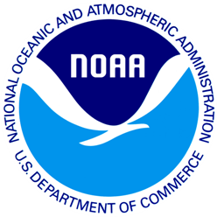
<<DATE>>
<<STATE>> Resident
<<Add 1>>
<<Add 2>>
<<City>>, <<State>> <<Zip>>

Dear <<STATE>> Resident:
I am pleased to inform you that the National Oceanic and Atmospheric Administration has selected you to participate in a survey of recreational saltwater fishing. This study is part of an effort to learn about recreational saltwater fishing activities in [State]. This survey provides vital information that is used to enhance recreational fishing opportunities for [State] residents.
You were chosen at random as part of this scientific study, and we cannot replace you with someone else. Your answers will make sure that people like you are counted. This is a voluntary survey. Responses are kept confidential as required by section 402(b) of the Magnuson- Stevens Act and NOAA Administrative Order 216-100, Confidentiality of Fisheries Statistics, and will not be released for public use except in aggregate statistical form without identification as to its source.
You should receive the survey in the mail within the next week.
- It usually takes 10 minutes or less to fill out the survey.
- We will include a small token of our appreciation for your participation in this study with the survey.

If you have any questions or comments about this study, we would be happy to talk with you. Please contact XXXXXXXXX at XXX-XXX-XXXX, or you can write to us at the address at the bottom of this letter.

Thank you again for your help with this important study.

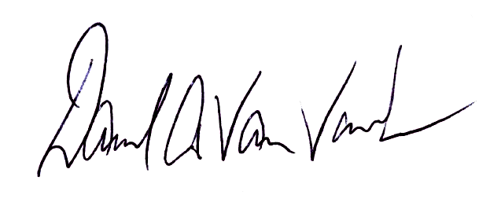
Yours sincerely,

Dave Van Voorhees
Chief, Fisheries Statistics Division
NOAA Fisheries, Office of Science and Technology

