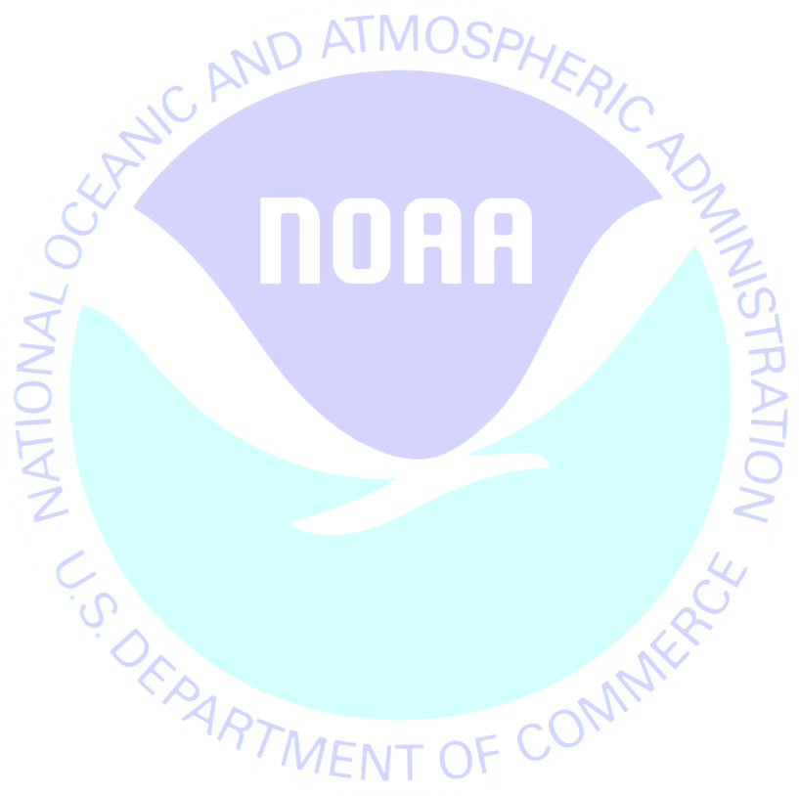
June 6, 2012

We recently sent you a Saltwater Fishing Survey on behalf of the National Oceanic and Atmospheric Administration. If you have already completed and returned the survey, please accept our sincere thanks. If not, I encourage you to do so today.
This study is being conducted to learn more about the impact of recreational fishing on natural resources in [State]. Please know that your answers are completely confidential and will be used only for this study in accordance with the Magnuson-Stevens Act and NOAA Administrative Order 216-100.
If you did not receive the survey or need another copy, please call XXXXXXXX toll-free at 1-XXX-XXX-XXXX.
Sincerely,
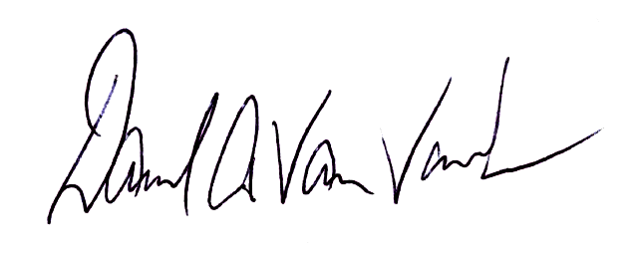

Dave Van Voorhees
Chief, Fisheries Statistics Division
NOAA Fisheries, Office of Science and Technology
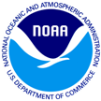
Saltwater Fishing Survey
1009 Slater Rd
Suite 110
Durham, NC 27703

Proper Name
Add1
Add2
City, St Zip

