Appendix F: Subject Matter Expert Questionnaire

Form Approved
OMB No. 0920-xxxx
Expires xx/xx/20xx

Date _____________________ Questionnaire: SME ID# _________

Subject Matter Expert Questionnaire
We would like if you could answer questions about how you prefer to have information presented to you. We are interested in your opinions about how information could be presented to you while you are working. The questionnaire has 4 sections. There is no right or wrong answer to these questions; we are only interested in your opinions. We ask that you answer the questions as honestly as possible. We will go through this questionnaire with you, if you have any questions, please let me know. You will be given specific instructions to use for each of the sections.

Section 1

Demographic Information
Please provide us with some information about yourself. Be as accurate as you can with this information.
Age _______ Years Gender (circle one): Male Female
Height ________Feet ________Inches Weight: _____________Pounds

Mining Experience
Current job title: ______________________________________________________________________________________
Number of years in current position: _______________________________________________________________________
Number of years working at current mine: ________________ __________________________________________________
Other positions you have had in mining: ____________________________________________________________________
Total number of mines you have worked in: _________________________________________________________________
Total number of years you have worked in mining: ___________________________________________________________

Public reporting burden of this collection of information is estimated to average 1 hour per response, including the time for reviewing instructions, searching existing data sources, gathering and maintaining the data needed, and completing and reviewing the collection of information. An agency may not conduct or sponsor, and a person is not required to respond to a collection of information unless it displays a currently valid OMB control number. Send comments regarding this burden estimate or any other aspect of this collection of information, including suggestions for reducing this burden to CDC/ATSDR Reports Clearance Officer, 1600 Clifton Road NE, MS D-74, Atlanta, Georgia 30333; ATTN: PRA (0920-XXXX).

Section 2

General Preference
In this section, we will ask you general questions about how you like information presented to you while you work. Many pieces of equipment that you work with now give you feedback or information about how the machine is working or what is going on in the environment, whether it is a gauge, a display, or something else. This is what we are talking about.
We will begin by talking about some options for combining the information from various pieces of equipment. For example, looking for information on one display instead of three could be an option. For each of these questions, I would like you to rate on a scale from 1 to 7 how the presentation method would help or burden you while doing your job if it was included in your work equipment today. A rating of 1 means that it would be very burdensome to you and 7 means that it would be very helpful. [Give Scale] Use this scale to answer the questions.

Scale

1 2 3 4 5 6 7
Very Burdensome Neutral Very Helpful

- You have a lot of information coming back to you from your equipment and environment. During your routine job, how helpful would it be if some of the information from the equipment you wear was displayed on a single display, similar to the military examples here?
(Show pictures 1 and 2)
Response: _____________
- During your routine job, how helpful would it be if some of the information from the equipment you wear was displayed on a “head-up display”? (For example glasses, on the windshield, on a separate glass pane)?
(Show pictures 3, 4, 5, and 6)
Response: ____________
- During your routine job, how helpful would it be if some of the information from the equipment you wear was transmitted through an earpiece?
(Show pictures 7, 8 and 9)
Response: _____________

Now, I’d like you to think specifically about the feedback you get from a machine if something goes wrong. For example, you could get feedback in the form of an alarm, vibration or a flashing light.
- If there was a problem with a piece of equipment you were working with, how helpful would an auditory tone or warning be to you? This tone could be played through an ear piece or speaker.
Response: _____________
- If there was a problem with a piece of equipment you were working with, how helpful would a vibration alert be to you? This could be presented like the vibration from your cell phone or pager.
Response: _____________
- If there was a problem with a piece of equipment you were working with, how helpful would a warning light be to you?
Response: _____________
- If there was a problem with a piece of equipment you were working with, how helpful would a display message be to you?
Response: _____________

Section 3

Information – Daily Basis
With all of the new sensor technology like the electronic trackers, personal dust monitor, and proximity sensors entering into the mining industry more information than ever is available to individual miners. To prevent overload or distraction, it is critical to understand what information is important to you and when you need it.
The next set of questions is related to the IMPORTANCE of various types of information that you may need during your ROUTINE JOB. For these questions, importance means most critical for your safety and productivity equally. Importance does not mean how often something occurs.
- First, go through the list and mark the items that are NOT critical to know on a TYPICAL DAY with an X.
_____ Environmental Conditions in the Mine (methane, oxygen, airflow, dust)
_____ Location (of yourself, others, and equipment)
_____ Proximity (to operating equipment)
_____ Time of Day
_____ Health (of yourself and others)
Now, I’d like you to rank all items from most IMPORTANT (1) to least important (5) based on what you think is the most critical for YOU to know and understand to do your routine job.
_____ Environmental Conditions in the Mine (methane, oxygen, airflow, dust)
_____ Location (of yourself, others, and equipment)
_____ Proximity (to operating equipment)
_____ Time of Day
_____ Health (of yourself and others)

- There are aspects of the environment that may affect your ability to do your job. Of the environmental conditions listed below, mark the items that are NOT critical to know on a TYPICAL DAY with an X.
_____ Poisonous Gas Levels (carbon monoxide, carbon dioxide)
_____ Explosive Gas Levels (methane)
_____ Oxygen Levels
_____ Air Speed
_____ Dust Levels
Now, I’d like you to rank the items from most IMPORTANT (1) to least important (5) based on what you think is the most critical for YOU to know and understand to do your routine job
_____ Poisonous Gas Levels (carbon monoxide, carbon dioxide)
_____ Explosive Gas Levels (methane)
_____ Oxygen Levels
_____ Air Speed
_____ Dust Levels
- Knowledge of the location of people and objects in your work environment may affect your ability to do your job. Of the location information listed below, mark the items that are NOT critical to know on a TYPICAL DAY with an X.
_____ Your Location in the Mine
_____ Others’ Location in the Mine
_____ Location of Equipment (Shuttle Car, CM, etc.)
_____ Your Proximity to Equipment
_____ Others’ Proximity to Equipment
Now, I’d like you to rank the items from most IMPORTANT (1) to least important (5) based on what you think is the most critical for YOU to know and understand to do your routine job.
_____ Your Location in the Mine
_____ Others’ Location in the Mine
_____ Location of Equipment (Shuttle Car, CM, etc.)
_____ Your Proximity to Equipment
_____ Others’ Proximity to Equipment

The next set of questions is related to HOW OFTEN you use of various types of information on a TYPICAL DAY. For these questions, we are interested in the information that you check or monitor most often.

- Rank the following information based on HOW OFTEN you use them, where (1) is the information YOU WOULD check/monitor most often and (5) is the information you would check the least during your typical routine.
_____ Environmental Conditions in the Mine (gas, airflow, dust)
_____ Location (of yourself, others, and equipment)
_____ Proximity (to operating equipment)
_____ Time of Day
_____ Health (of yourself and others)

- Of the environmental conditions, rank the following based on HOW OFTEN you use them, where (1) is the information YOU WOULD check most often and (5) is the information you would check the least during your typical routine.
_____ Poisonous Gas Levels (carbon monoxide, carbon dioxide))
_____ Explosive Gas Levels (methane)
_____ Oxygen Levels
_____ Air Speed
_____ Dust Levels

- Of the location information available, rank the following based on HOW OFTEN you use them, where (1) is the information YOU WOULD check most often and (5) is the information you would check the least during your typical routine.
_____ Your Location in the Mine
_____ Others’ Locations in the Mine
_____ Location of Equipment (Shuttle Car, CM, etc.)
_____ Your Proximity to Equipment
_____ Others’ Proximity to Equipment

The next set of questions relates to your experiences on a TYPICAL DAY.
- On a typical day, what information would you like to have that is currently not given to you?

- Why do you want to have this information?

- Is there a reason why this information is not given to you?

- If some of the information from the various pieces of equipment you work with was presented to you through one device or display, what method would you prefer during your ROUTINE JOB? (Please choose only one of the following, mark the response with an X)
_____ Single display screen
_____ Single heads-up display (i.e. glasses or visor)
_____ Earpiece auditory transmission
_____ Other (Specify: ____________________________)
_____ I would prefer the information to be shown separately

- Not including the physical aspects of your job, which of the following are the most difficult or frustrating part of your job? (Please choose only one of the following, mark the response with an X)
_____ Communication (i.e. getting you message across to other miners – the problem can be the equipment or the environment)
_____ Time Management (i.e. can’t get everything done; not enough time)
_____ Information Management (i.e. what information needs to go where, who needs to know what)
_____ Working with a Specific Device (Specify:________________________)
_____ Other (Specify:_______________________________)

Section 4

Emergency Situations
I am now going to ask you some questions related to emergency situations. I am interested first in learning about any experiences that you have had.
- Have you ever been in a mining emergency?
  - Yes
  - No
- If yes, how many have you been involved with?
Note: If yes and more than one, we are going to ask specific questions about the first and last emergency.
- Can you briefly describe the first mining emergency you were in?

- Where did the first emergency occur?

- When did the first emergency occur?

- What was your role in the first emergency?

- Can you briefly describe the last mining emergency you were in?

- Where did the last emergency occur?

- When did the last emergency occur?

- What was your role in the last emergency?

Though emergency situations are rare, it is important to have the necessary information available to you (the miner) to ensure that everyone makes it safely out of the mine at the end of the day.
The next set of questions is related to the IMPORTANCE of various types of information in an EMERGENCY. For these questions, importance means the information that is most critical both for safety and for productivity equally. Importance does not mean how often you need the information.
- First, go through the list and mark the items that are NOT critical to know in an EMERGENCY with an X.
_____ Environmental Conditions in the Mine (methane, oxygen, airflow, dust)
_____ Time of Day
_____ Location (of yourself, others, and equipment)
_____ Equipment and Infrastructure State (i.e. COMs and tracking and power)
_____ Health (of yourself and others)
I would then like you to rank the items from most IMPORTANT (1) to least important (5) based on what you think is the most critical for YOU to know and understand in an EMERGENCY.
_____ Environmental Conditions in the Mine (methane, oxygen, airflow, dust)
_____ Time of Day
_____ Location (of yourself, others, and equipment)
_____ Equipment and Infrastructure State (i.e. COMs and tracking and power)
_____ Health (of yourself and others)
- Of the environmental conditions, mark the items that are NOT critical to know in an EMERGENCY with an X.
_____ Poisonous Gas Levels (carbon monoxide, carbon dioxide))
_____ Explosive Gas Levels (methane)
_____ Oxygen Levels
_____ Air Speed
_____ Dust Levels
I would then like you to rank the items from most IMPORTANT (1) to least important (5) based on what you think is the most critical for YOU to know and understand in an EMERGENCY.
_____ Poisonous Gas Levels (carbon monoxide, carbon dioxide))
_____ Explosive Gas Levels (methane)
_____ Oxygen Levels
_____ Air Speed
_____ Dust Levels

- Of the location information available, mark the items that are NOT critical to know in an EMERGENCY with an X.
_____ Your Location in the Mine
_____ Others’ Locations in the Mine
_____ Refuge Chamber/Built-in-Place Shelter Locations
_____ SCSR Cache Location
_____ Lifeline Location
I would then like you to rank the following from most IMPORTANT (1) to least important (5) based on what you think is the most critical for YOU to know and understand in an EMERGENCY.
_____ Your Location in the Mine
_____ Others’ Locations in the Mine
_____ Refuge Chamber/Built-in-Place Shelter Locations
_____ SCSR Cache Location
_____ Lifeline Location
- In an emergency, what are the top three things you would want to know first? (Please choose three of the following)
- Gas levels (methane, CO, etc.)  - Airflow  - Dust levels  - Time of Day  - Your Location in the Mine  - Others’ Locations in the Mine  - Location of your SCSR | - Lifeline Location  - Location of the Escapeways  - SCSR Cache Location  - Refuge/Built in Place Chamber Locations  - State of the Communications  - State of the Power  - Others’ Health

- Rank the following information based on HOW OFTEN you would use them, where (1) is the information YOU WOULD check most often and (5) is the information you would check the least during an EMERGENCY.
_____ Environmental Conditions in the Mine (methane, oxygen, airflow, Dust)
_____ Time of Day
_____ Location (of yourself, others, and equipment)
_____ Equipment and Infrastructure State (i.e. COMs and tracking and power)
_____ Health (of yourself and others)

- Of the environmental conditions, rank the following based on HOW OFTEN you would use them, where (1) is the information YOU WOULD check most often and (5) is the information you would check the least during an EMERGENCY.
_____ Poisonous Gas Levels (carbon monoxide, carbon dioxide))
_____ Explosive Gas Levels (methane)
_____ Oxygen Levels
_____ Air Speed
_____ Dust Levels
- Of the location information available, rank the following based on HOW OFTEN you would use them, where (1) is the information YOU WOULD check most often and (5) is the information you would check the least during an EMERGENCY.
_____ Your Location in the Mine
_____ Others’ Locations in the Mine
_____ Location of Equipment (shuttle car, continuous miner, etc.)
_____ Your Proximity to Equipment
_____ Others’ Proximity to Equipment
- In an emergency, what information would you like to have that is currently not given to you?

- Why do you want to have this information?

- Is there a reason why you are not given this information?

- Nothing
- What information would you WANT to have during an EMERGENCY that you DO NOT WANT during your ROUTINE JOB? (Select all that apply)
- Gas Levels (methane, CO, etc.)  - Airflow  - Dust Levels  - Time of Day  - Your Location in the Mine  - Others’ Locations in the Mine  - Location of your SCSR  - Lifeline Location  - Location of the Escapeways | - SCSR Cache Location  - Refuge/Built in Place Chamber Locations  - State of the Communications  - State of the Power  - Your Proximity to Equipment  - Others’ Proximity to Equipment  - Your Health  - Others’ Health  - Other (Specify: ___________________)
- Nothing
- What information would you WANT to have during your ROUTINE JOB that you DO NOT WANT during an EMERGENCY? (Select all that apply)
- Gas Levels (methane, CO, etc.)  - Airflow  - Dust Levels  - Time of Day  - Your Location in the Mine  - Others’ Locations in the Mine  - Location of your SCSR  - Lifeline Location  - Location of the Escapeways | - SCSR Cache Location  - Refuge/Built in Place Chamber Locations  - State of the Communications  - State of the Power  - Your Proximity to Equipment  - Others’ Proximity to Equipment  - Your Health  - Others’ Health  - Other (Specify: ___________________)
- Nothing

- If some of the information from the various pieces of equipment was presented to you through one device or display, what method would you prefer during an emergency situation? (Please choose only one of the following, mark choice with an X) [Show pictures again to refresh/provide example].
_____ Single display screen
_____ Single heads-up display
_____ Earpiece/auditory transmission
_____ Other (Specify: ____________________________)
_____ I would prefer the information to be separate

Helpfulness Scale
Please use this scale to rate the various scenarios explained in the question to come. I would like you to rate them on a scale from 1 to 7 based on how the equipment described would help or burden you while doing your job if it was included in your work equipment today. A rating of 1 means that it would be very burdensome to you and 7 means that it would be very helpful.

1 2 3 4 5 6 7
Very Burdensome Neutral Very Helpful

Picture #1
Arm Band
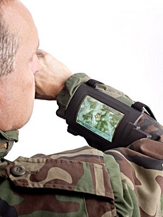

Picture #2
Chest Unit
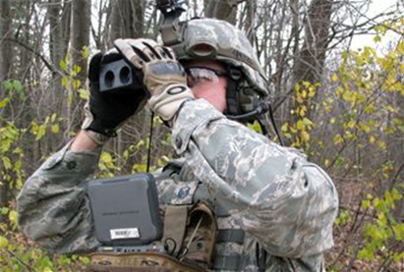
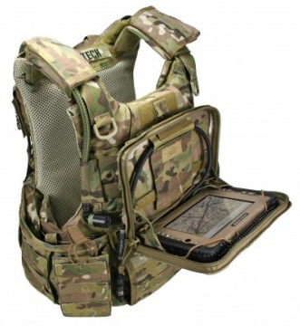
Picture #3
Google Glass “Heads-Up-Display”

Picture #4
Partial Vision “Heads-Up-Display”
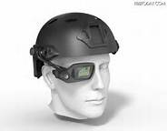
Picture #5
BMW Windshield with “Heads-Up-Display”
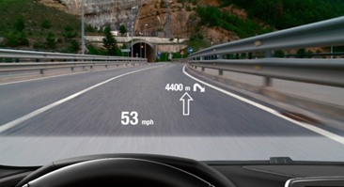

Picture #6
Fighter Pilot “Heads-Up-Display”
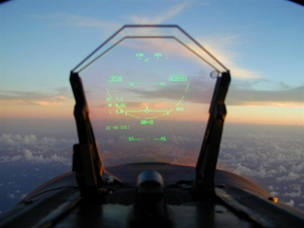

Picture #7
Earpiece Insert (without hearing protection)
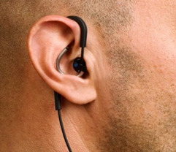

Picture #8
Earpiece Insert (with hearing protection)
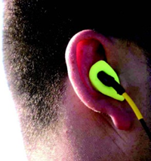

Picture #9
External Earpiece (with hearing protection)
