0925-0002 Change Request Memo Attachment A
I. Revised RPPR Instruction text for question B.4 in the Instruction Guide and on the actual screen shot (see below).
B.4 What opportunities for training and professional development has the project provided?
If the research is not intended to provide training and professional development opportunities or there is nothing significant to report during the reporting period, select Nothing to Report.
Describe opportunities for training and professional development provided to anyone who worked on the project or anyone who was involved in the activities supported by the project. Training activities are those in which individuals with advanced professional skills and experience assist others in attaining greater proficiency. Training activities may include, for example, courses or one-on-one work with a mentor. Professional development activities result in increased knowledge or skill in one’s area of expertise and may include workshops, conferences, seminars, study groups, and individual study. Include participation in conferences, workshops, and seminars not listed under major activities.

“For all projects reporting graduate student and/or postdoctoral participants in Section D. Participants, you are encouraged to describe the use of Individual Development Plans (IDPs) for those participants. Do not include the actual IDP; instead include information to document that IDPs are used to help manage the training for those individuals.

For T, F, K, R25, R13, D43 and other awards or award components designed to provide training and professional development opportunities, a response is required. Do not reiterate what is reported under Accomplishments.
Limit the response to this reporting period.

Screen Shot To Be Modified:
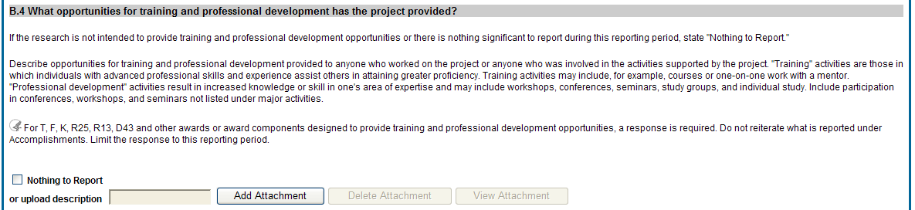
This on screen instruction will be modified to include a new first paragraph:
“For all projects reporting graduate student and/or postdoctoral participants in Section D. Participants, you are encouraged to describe the use of Individual Development Plans (IDPs) for those participants. Do not include the actual IDP; instead include information to document that IDPs are used to help manage the training for those individuals.”

II. Revised text for RPPR Section Section-D. Participants

6.4 Section D – Participants
The RPPR Section D. allows the agency to know who has worked on the project to gauge and report performance in promoting partnerships and collaborations.
D.1 What individuals have worked on the project?
Provide or update the information for: (1) program director(s)/principal investigator(s) (PDs/PIs); and (2) each person who has worked at least one person month per year on the project during the reporting period, regardless of the source of compensation (a person month equals approximately 160 hours or 8.3% of annualized effort).
Provide the name and identify the role the person played in the project. Indicate the nearest whole person month (Calendar, Academic, Summer) that the individual worked on the project. Show the most senior role in which the person has worked on the project for any significant length of time. For example, if an undergraduate student graduates, enters graduate school, and continues to work on the project, show that person as a graduate student.

NIH Instructions:
- An individual's Commons user ID may be used to partially populate his or her information
- A Commons ID is required for all individuals with postdoctoral role and/or supported by a Reentry or Diversity Supplement. When an individual is assigned a Postdoctoral, Graduate Student, or Undergraduate Role in the Commons, responses to certain data in the Personal Profile tab are required to meet NIH reporting requirements to Congress. The Commons ID is strongly encouraged, but currently optional, for all other project personnel.
- Individuals with a postdoctoral-like role should be identified as Postdoctoral (scholar, fellow, or other postdoctoral position)
- Do not include Other Significant Contributors who are not committing any specified measurable effort to this project
- Do not report personnel for whom a PHS 2271 Appointment form has been submitted through xTrain
- Required fields are marked with an *
eRA Commons User ID: Entering the User ID allows selection of “Populate from Profile” which will partially populate the individual’s information. Those with an Administrator role in the eRA Commons may search for user IDs by following the instructions at:
http://era.nih.gov/commons/commons-help/1001.htm
Senior/key personnel are defined as the PD/PI and other individuals who contribute to the scientific development or execution of a project in a substantive, measurable way, whether or not they receive salaries or compensation under the grant. Typically these individuals have doctoral or other professional degrees, although individuals at the masters or baccalaureate level may be considered senior/key personnel if their involvement meets this definition. Consultants and those with a postdoctoral role also may be considered senior/key personnel if they meet this definition.
Last 4 digits of SS# and Month/Year of birth: The provision of the partial Social Security number and month/year of birth are voluntary, and the information is used only for program management purposes.
Project Role: PD/PI names and information from their Commons Profile(s) will be prepopulated. To update the PD/PI information as displayed, go to the Commons Profile and save the changes there. For all other personnel, select from a dropdown menu of the following options:
- Co-Investigator
- Faculty
- Postdoctoral (scholar, fellow or other postdoctoral position)
- Technician
- Staff Scientist (doctoral level)
- Statistician
- Graduate Student (research assistant)
- Non-Student Research Assistant
- Undergraduate Student
- High School Student
- Consultant
- Other (specify)
Supplement Support: If personnel are supported by a Reentry or Diversity Supplement indicate type of supplement in this field.
Person Months: The metric for expressing the effort (amount of time) devoted to a specific project. The effort is based on the type of appointment of the individual with the organization; e.g., calendar year, academic year, and/or summer term; and the organization's definition of such. For instance, some institutions define the academic year as a 9-month appointment while others define it as a 10-month appointment.
Include (1) the PD/PI regardless of effort devoted to the project and (2) each person who has worked at least one person month per year on the project during the reporting period, regardless of the source of compensation.
Round to the nearest whole person month that the individual worked on the project. For example, if the individual worked 2.25 person months, indicate 2 person months. If the individual worked 4.7 person months, indicate 5 person months. If the PD/PI worked 0.5 to 1 person month, round up to 1 person month. If the PD/PI worked 0.1 to 0.4 person month, round down to 0 (zero).
To calculate person months, multiply the percentage of effort associated with the project by the number of months of the appointment. For example:
- 25% of a 9 month academic year appointment equals 2.25 (academic year) person months (.25 x 9 = 2.25). Round down to 2.
- 90% of a 12 month calendar appointment equals 10.8 (calendar year) person months (.90 x 12 = 10.8). Round up to 11.
- 35% of a 3 month summer term appointment equals 1.05 (summer) person months (.35 x 3= 1.05). Round down to 1.
- If the regular pay schedule of an institution is a 9 month academic year and the PD/PI will devote 9 academic months at 30% time/effort and 3 months summer term at 30% time/effort , then 3 academic months (.30% x 9 = 2.7, round up to 3), and 1 summer month (.30 x 3 = .9, round up to 1) should be reported
Person months reported on the RPPR are intentionally rounded to the nearest whole number to provide for generalized reporting consistent across federal agencies that support research activities. Although it is possible to report 0 (zero) person month for the PD/PI on the RPPR if the PD/PI worked .1 to .4 person month, a PD/PI must have measurable effort. Change in Level of Effort for the PD/PI(s) and other senior key/personnel designated in the NoA is reported under D.2.a below.
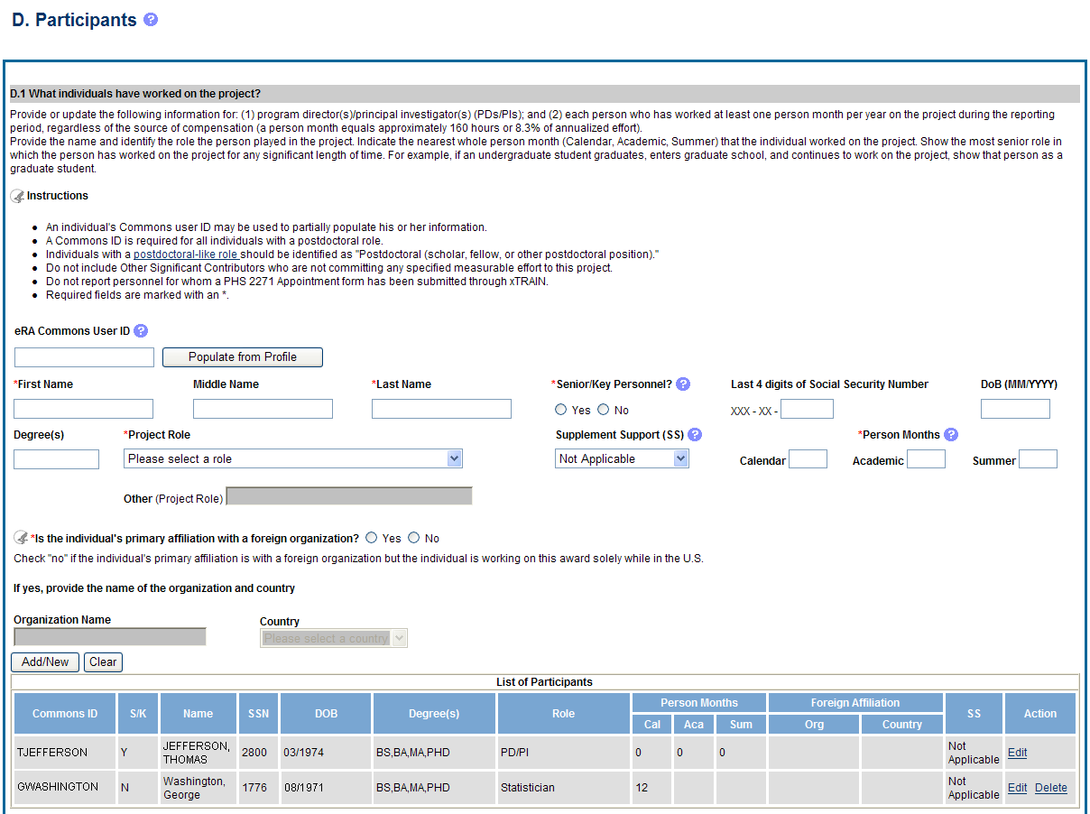
Second bullet will be revised to read:
A Commons ID is required for all individuals with an Undergraduate, Graduate Student, or Postdoctoral Role. No other changes to the screen will be made.

