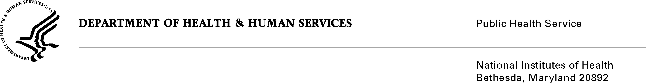

DATE: May 31, 2013

TO: Julie Wise
Office of Management and Budget (OMB)
Reports Clearance Officer, DHHS

FROM: Seleda M. Perryman
Chief, Project Clearance Branch

SUBJECT: Change Request to a Currently Approved Form
(OMB # 0925-0002, Expiration Date 08/31/2015)

In August, 2012 NIH received approval of all pre-award application forms under OMB Collection number 0925-0001, as well as post-award forms in OMB Collection 0925-0002. NIH is requesting non-substantive changes to instructions in two of the forms approved under 0925-0002 which do not change the approved data collection or anticipated burden hours. Details on these changes are provided in the attached change request document. Since the most recent approval of 0925-0002 several Federal-wide and agency-specific initiatives have begun that require modification to instructions used for progress reports cleared in this package, specifically the PHS 2590 and the NIH Research Performance Progress Report (RPPR). There is no new data collection being proposed. The changes are described in a separate justification document that explains the background and natures of the changes. Two other attachment show how the changes will appear on the document.

Attachment A: Revised RPPR Instruction text for questions B.4 & D in the Instruction Guide

Attachment B: Revised PHS 259 Form Page 7 and instructions,

Your full consideration is appreciated.

