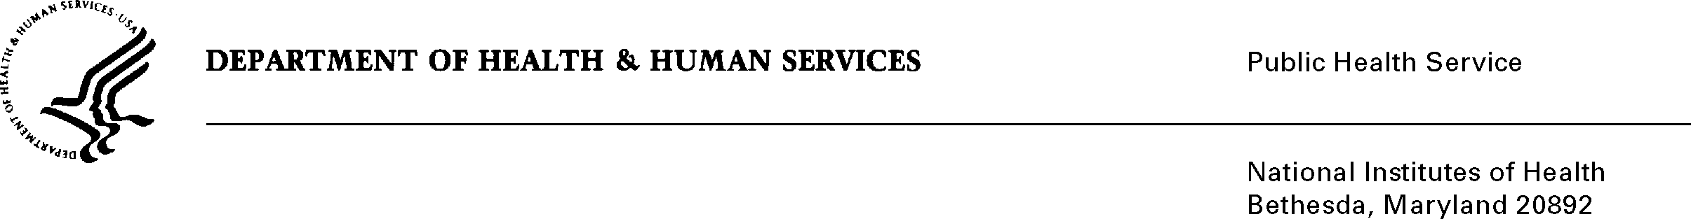
DATE: June 12, 2013

TO: Julie Wise
Office of Management and Budget (OMB)
Reports Clearance Officer, DHHS

FROM: Seleda M. Perryman
Chief, Project Clearance Branch

SUBJECT: Change Request to a Currently Approved Form
(OMB # 0925-0001, Expiration Date 08/31/2015)

In August, 2012 NIH received approval of all pre-award application forms under OMB Collection number 0925-0001, as well as post-award forms in OMB Collection 0925-0002. NIH is requesting non-substantive changes to instructions in several of the forms approved under 0925-0001 which do not change the approved data collection or anticipated burden hours. There is no new data collection being proposed on any of the existing forms. The burden increase associated with the addition of graduate and under graduate students is captured under 0925-0002 where the data collection instrument is located. 0925-0001 only captures the instruction changes. Details on these changes are provided in the attached change request justification document. Since the most recent approval of 0925-0001 several Federal-wide and agency-specific initiatives have begun that require modification to instructions used for completing applications currently cleared in this package. These are instruction changes only. The changes are described in a separate justification document that explains the background and natures of the changes. The other attachments show the text that will be used and/or how the changes will appear on the document.

Attachment A: Changes to the Supplemental Grant Application Instructions

Attachment B: Changes to PHS 398 Instructions (sections 2.2.4.2 and 1.7.1)

Attachment C: Changes to PHS 398 instructions (Biosketch, page 1-39)

Attachment D: eRA Commons Personal Profile Screenshots Changes (pp 2, 3, and 16)

Attachment E: eRA Commons Personal Profile (spreadsheet for the entire data set)

Your full consideration is appreciated.

