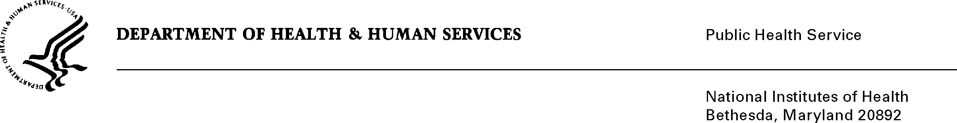

**DATE:** April 15, 2013

**TO:** David H. Sharlip, Project Clearance Liaison

Office of Administrative and Management Analysis Services

National Library of Medicine

**FROM:** NIH Privacy Act Officer

**SUBJECT:** Applicability of the Privacy Act: “Lost People Finder System”

I have reviewed the NLM submission referenced above and have determined that the Privacy Act will apply to this data collection which includes the collection of personally identifiable information intended to assist in the reunification of family members and friends who are separated during a disaster.

Information collected about missing and recovered persons would vary and include any one of the following and possibly all identifiers: name, photograph, age group and/or range, gender, status (alive, well, injured, deceased, unknown), and location. Additional free-form text and voice notes may also be collected.

Information would be made available to the public via a specialized interface to allow users to search for and locate family members and loved ones with either text or visual search.

Information would be shared with other lost person finder systems endorsed or used by other Federal agencies. The information collected would also be used to evaluate the functioning and utility of the lost person finder system and guide future enhancements to the system as various disasters occur.

The applicable NIH Privacy Act Systems of Record Notice is 09-25-0200, “Clinical, Basic and Population-based Research Studies of the National Institutes of Health (NIH), HHS/NIH/OD”.

If you have questions, contact me at (301) 402-6201.

Karen M. Plá

Enclosure