Attachment C

Survey

Survey

**Center for Substance Abuse Prevention (CSAP) Underage Drinking Prevention: “Talk. They Hear You.” Impact Evaluation Tool Development—Media Testing Survey**

**Sample Screen Shots**

Sample screen shots of the survey may be found below. A hardcopy of the full text of the survey follows.

Screen shot 1: Multiple response field

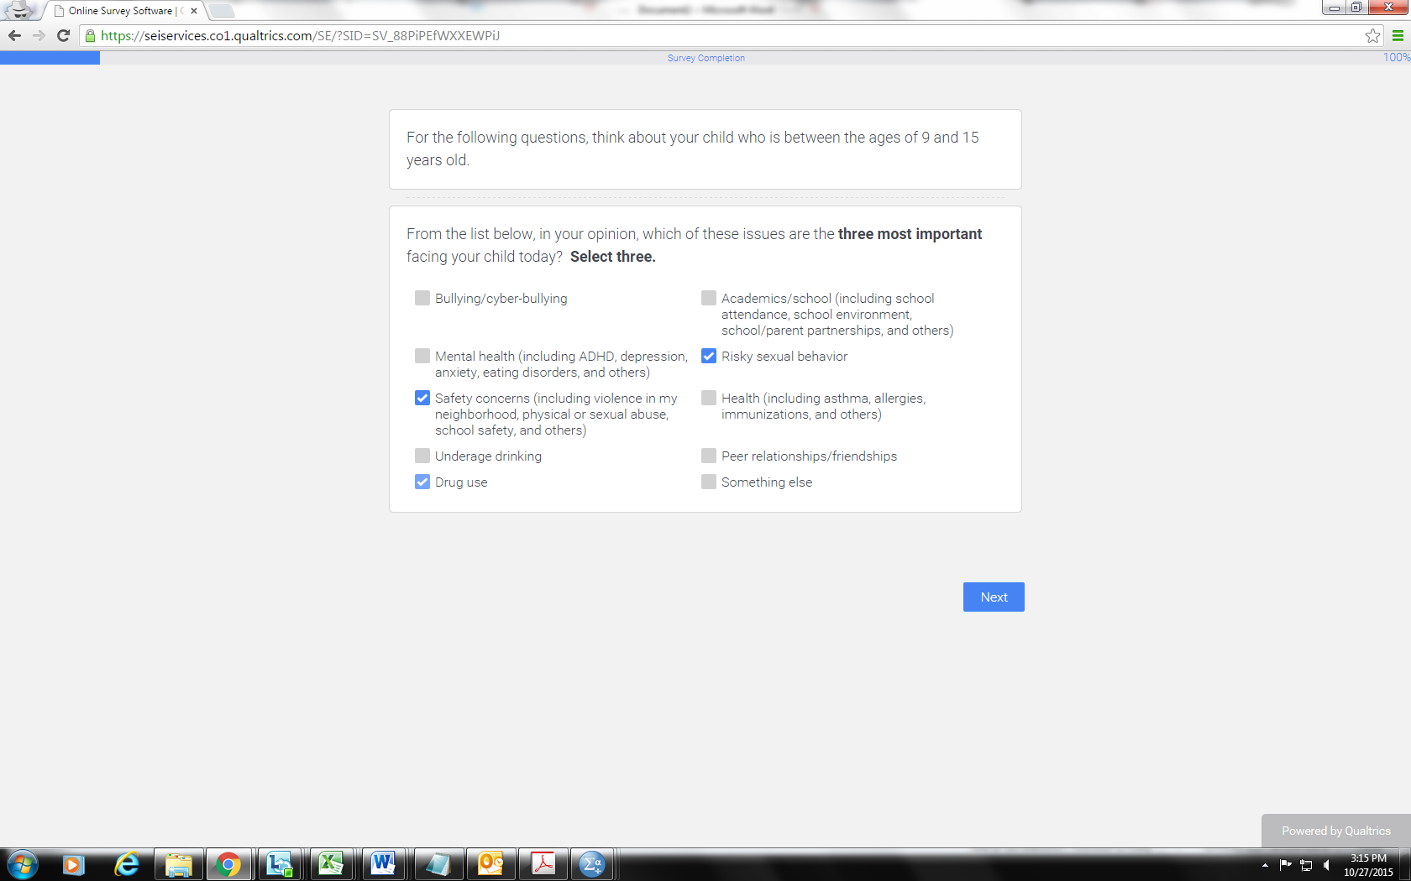

Screen shot 2: Question on familiarity with the campaign

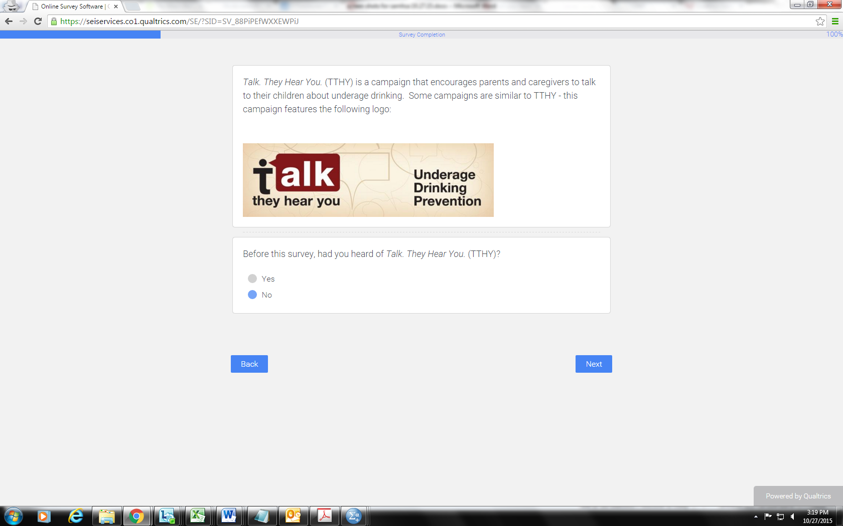

Screen shot 3: Survey completion and acknowledgment

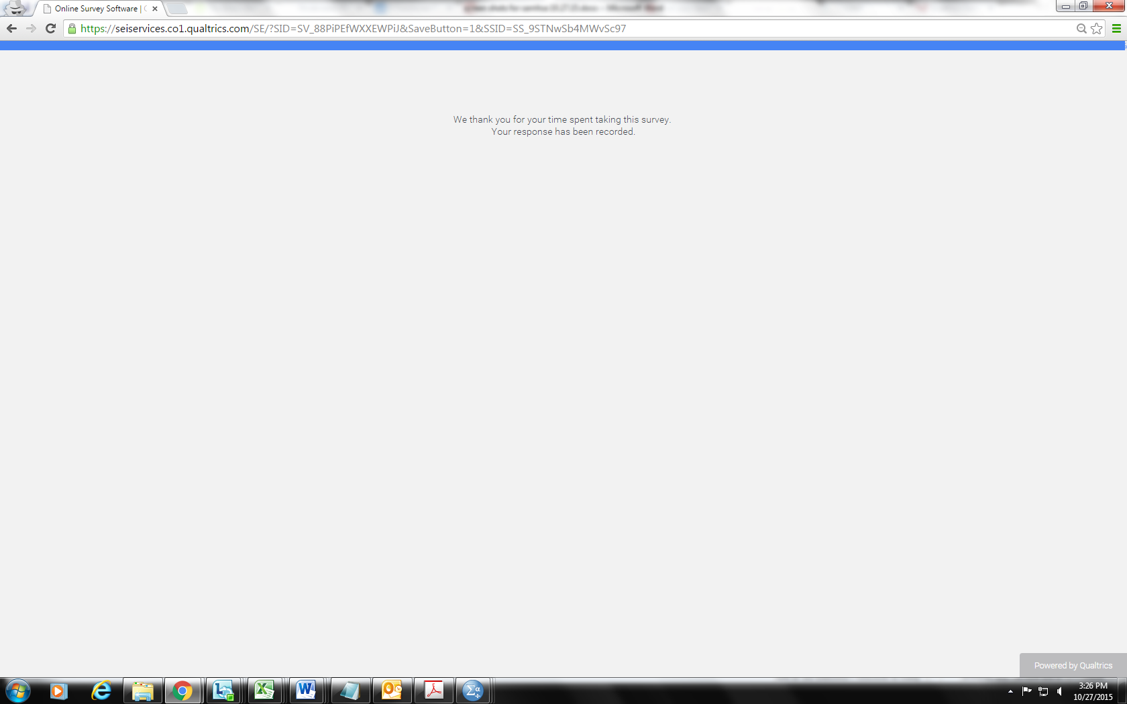

**Survey**

<Programming note: do not display section headers on screen>

**Introductory Screen**

OMB No. 0930-0196

Expiration Date: 09/30/16

Logo for SAMHSA and CSAP

Public Burden Statement: An agency may not conduct or sponsor, and a person is not required to respond to, a collection of information unless it displays a currently valid OMB control number.  The OMB control number for this project is 0930-0196.  Public reporting burden for this collection of information is estimated to average 10 minutes per respondent, including the time for reviewing instructions. Send comments regarding this burden estimate or any other aspect of this collection of information, including suggestions for reducing this burden, to SAMHSA Reports Clearance Officer, 1 Choke Cherry Road, Room 2-1057, Rockville, Maryland 20857.

Thank you for agreeing to participate in this survey about concerns parents have for their children. Your responses will help SAMHSA improve its programs to help families. All of your answers will be kept strictly confidential. No information other than your answers to the questions is being collected. No individual results will be published—only summary information from all responses.

Click here to begin the survey

**Section I: Screener**

*(All)*

1. Are you a parent or caregiver of a child between the ages of 9 and 15 years old?

*Please include children and stepchildren living in your household part time or full time.*

1. Yes

2. No

(Q1 = 1)

1a. How many children between ages 9 and 15 are in your household, part time or full time?

*Please enter the number below.*

______

<Screen break>

**Section II: Attitudes on underage drinking**

(Q1a = 1)

*For the following questions, think about your child who is between the ages of 9 and 15 years old.*

(Q1a ≥ 2)

*For the following questions, think about your children who are between the ages of 9 and 15 years old.*

<Programming note: For the remainder of the survey, respondents with one child in the target range (Q1a = 1) will see references to “child/is” and respondents with more than one child in the target range (Q1a ≥ 2) will see references to “children/are.”

*(Q1 = 1)*

<Programming note: Randomize response order>

2. From the list below, in your opinion, which of these issues are the **three most important** facing your child/children today? **Select three**.

1. Underage drinking

2. Academics/school (including school attendance, school environment, school/parent partnerships, and others)

3. Bullying/cyberbullying

4. Safety concerns (including violence in my neighborhood, physical or sexual abuse, school safety, and others)

5. Health (including asthma, allergies, immunizations, and others)

6. Mental health (including ADHD, depression, anxiety, eating disorders, and others)

7. Drug use

8. Risky sexual behavior

9. Peer relationships/friendships

10. Something else

*(Q2 = 10)*

2a. What other issue?

____________________________________

<Screen break>

*(Q1 = 1)*

3. How concerned are you about your child drinking alcohol?

1. Not at all

2. Only a little

3. Somewhat

4. Very

<Screen break>

*(Q1 = 1 AND Q3 = 2, 3, or 4)*

4. Do you think there is anything you could do to prevent your child/children from drinking alcohol?

1. Yes

2. No

<Screen break>

**Section III: The “Talk. They Hear You.” Campaign**

*(Q1 = 1)*

<Programming Note: The logo will show on the screen under the text but separate from the response options>

5. “Talk. They Hear You.” is a campaign that encourages parents and caregivers to talk to their child/children about underage drinking. Some campaigns are similar to “Talk. They Hear You.”—this campaign features the following logo:

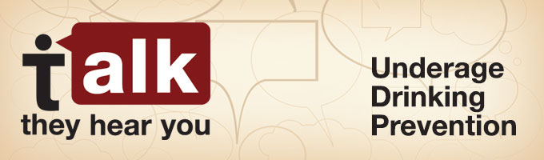

Before this survey, had you heard of “Talk. They Hear You.”?

1. Yes

2. No

<Screen break>

*(Q1 = 1 AND Q5 = 1)*

6. How familiar are you with “Talk. They Hear You.”?

1 = Not at all familiar 3 = Somewhat familiar

2 = Only a little familiar 4 = Very familiar

<Screen break>

*(Q1 = 1 AND Q5 = 1)*

<Programming note: Randomize response order>

7. Where have you seen this ad campaign? Mark all that apply.

1. A public service announcement (PSA) on TV

2. A poster or billboard

3. A pamphlet or other reading materials

4. Social media (including Facebook, Twitter, YouTube, and a mobile app)

5. E-mail or other communications from <<Organization Name>>

6. An ad on the radio

<Screen break>

*(Q1 = 1 AND Q5 = 1) AND (Q7 responses* ≥ 2)

<Programming note: Carry forward only the selections in question 8>

<Programming note: If Q7 is one response, skip Q8>

8. Where did you **FIRST** see this ad campaign? Select one.

1. A public service announcement (PSA) on TV

2. A poster or billboard

3. A pamphlet or other reading materials

4. Social media (including Facebook, Twitter, YouTube, and a mobile app)

5. E-mail or other communications from <<Organization Name>>

6. An ad on the radio

<Screen break>

*(Q1 = 1)*

9. Have you ever had a conversation with your child/children about alcohol?

1. Yes

2. No

<Screen break>

**Section IV: Those who have had the conversation**

*(Q1 = 1 AND Q9 = 1)*

<Programming note: Randomize category order>

When you talked to your child/children about underage drinking, how much did you emphasize each of the following?

1 = Not at all 3 = Somewhat

2 = Only a little 4 = Very much

10. Underage drinking is not acceptable

11. You want your child/children to be happy and safe

12. You know about alcohol and can be counted on to answer their questions

13. You will know if your child/children start(s) to drink

14. You can help your child/children figure out ways to avoid drinking

15. Underage drinking can have serious consequences

*(Q1 = 1 and Q9 = 1)*

16. Within the last 3 months, how often have you talked to your child/children about the dangers of drinking alcohol?

1. Once

2. Twice

3. Three times

4. Four times

5. Five times or more

6. Not at all in the last 3 months

<Screen break>

*(Q1 = 1 and Q9 = 1 AND Q5 = 1)*

17. Earlier, you said that you were familiar with the “Talk. They Hear You.” underage drinking prevention campaign. Did you FIRST talk to your child about underage drinking before or after you saw the campaign?

1. Before I saw the campaign.

2. After I saw the campaign.

3. Don’t know or don’t remember

*(Q1 = 1 and Q9 = 1 AND Q5 = 1)*

*<Programming note: If Q17 = 1, add “again” to the end of Q18>*

18. After you saw the campaign, did you talk to your children about underage drinking (again)?

1. Yes

2. No

*(Q1 = 1 and Q9 = 1 AND Q5 = 1)*

19. How much did the campaign help you to talk to your children about underage drinking?

1 = Not at all 3 = Somewhat

2 = Only a little 4 = Very much

*(Q1 = 1 and Q9 = 1 and Q5 = 1 and Q19 = 2, 3, or 4)*

20. What information, if anything, from the “Talk. They Hear You.” Campaign did you find to be most helpful?

____________________

<Screen break>

**Section V: Those who have not had the conversation**

*(Q1 = 1 AND Q9 = 2)*

<Programming note: Randomize response order>

21. Which of the following reasons explain why you have not had a conversation with your child/children about underage drinking? Select all that apply.

1. I am certain that my child/children is/are not drinking.

2. I am waiting until my child/children is/are older to talk to them.

3. I don’t think that underage drinking is a big problem.

4. I don’t know enough about underage drinking to talk to my child/children about it.

5. I’m not sure what to say to help my child/children avoid underage drinking

6. Talking to my child/children about underage drinking will not prevent them from drinking.

**Section VI: Demographics**

*(All)*

22. What is your sex?

1. Male

2. Female

*(All)*

23. What is your age?

1. 18 to 24

2. 25 to 34

3. 35 to 44

4. 45 to 54

5. 55 to 64

6. 65 or older

*(All)*

24. What is the highest degree or level of education you have completed?

1. Less than a high school diploma

2. Regular high school diploma or GED or alternative credential

3. Some college credit or trade school, no degree

4. Associates degree or trade school diploma/certificate

4. Bachelor’s degree

5. Master’s degree or higher

*(All)*

25. Are you of Hispanic, Latino, or Spanish origin?

1. Yes

2. No

*(All)*

26. What is your race? Select all that apply.

1. American Indian or Alaska Native

2. Asian

3. Black or African American

4. Native Hawaiian or Other Pacific Islander

5. White

*(All)*

27. Overall, how many children or stepchildren are living in your household in each age category? Enter 0 for none.

|  |  |
| --- | --- |
| Age category | Number of children |
| 8 years old or younger |  |
| 9 to 10 years old |  |
| 11 to 12 years old |  |
| 13 to 14 years old |  |
| 15 years old |  |
| 16 to 18 years old |  |
| Total number of children or stepchildren living in the household | <Programming note: autosum column here> |