OMB Control No. 1557-0236
Expiration Date: August 31, 2013

Minority-Owned Institution Survey

Institution Identification

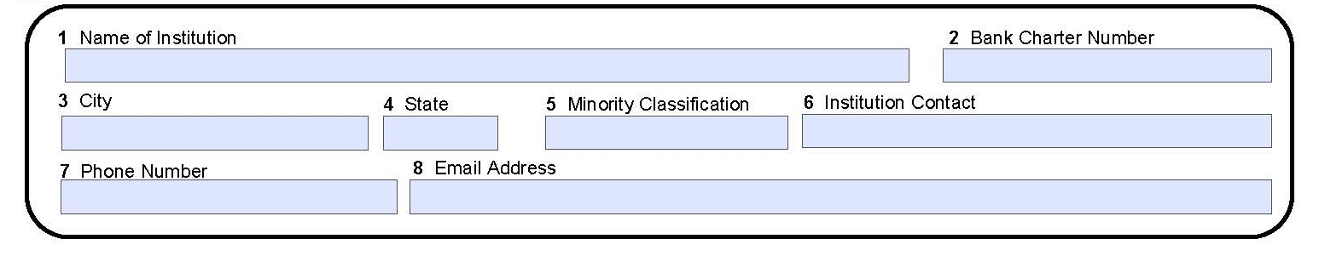

Technical Assistance
The GAO defines technical assistance as “one-on-one assistance that a regulator may provide to a bank.” For example a regulator may advise a bank on compliance with a particular statute or regulation. Regulators may also provide technical assistance that is related to deficiencies identified in safety and soundness or compliance investigations. Please respond to the following questions applying the GAO definition.

Has your institution requested technical assistance from the OCC in the past?

No ___
Yes ___
If yes, what technical assistance did you request? ____________________

Has your institution received technical assistance from the OCC in the past?
No ____
Yes ____

If yes, was the technical assistance beneficial?
No ____
Yes ____
Please explain.____________________________________________________

How can the OCC provide better technical assistance to your institution? _________________________________________________________________

Outreach
The OCC provides outreach to banks in various formats (e.g., telephone seminars; director workshops; Meet-the-Comptroller meetings; roundtable discussions on emerging issues, hot topics and best practices; and interagency events). To help the OCC determine the effectiveness of its outreach initiatives, please answer the following:

What information, training, or topics would you recommend be addressed in OCC outreach? _________________________________________________

What would be the most effective method(s) for delivering useful information, training, or topics to you and your bank?
- Webinars
- Instructor-led training
- Telephone conferences
- PowerPoint presentations
- Other: ___________________________________

Throughout the year, the OCC sponsors director workshops focusing on risk management, compliance risk, and credit risk. Did you or your directors attend any workshops in 2008?

No _____
Yes_____

If No, what were the barriers to your attending?
- Scheduling conflict
- Inconvenient location
- The budget
- Lack of need
- Other: _____________________________________

If Yes, what workshop(s) did you attend?
- A New Director’s Challenge: Mastering the Basics
- Credit Risk: A Director’s Focus
- Directors: Where Is the Risk in Your Bank?
- Compliance Risk: What Directors Need to Know

Was/Were the workshop(s) useful?
No ___
Yes ___
Please explain.___________________________________________________

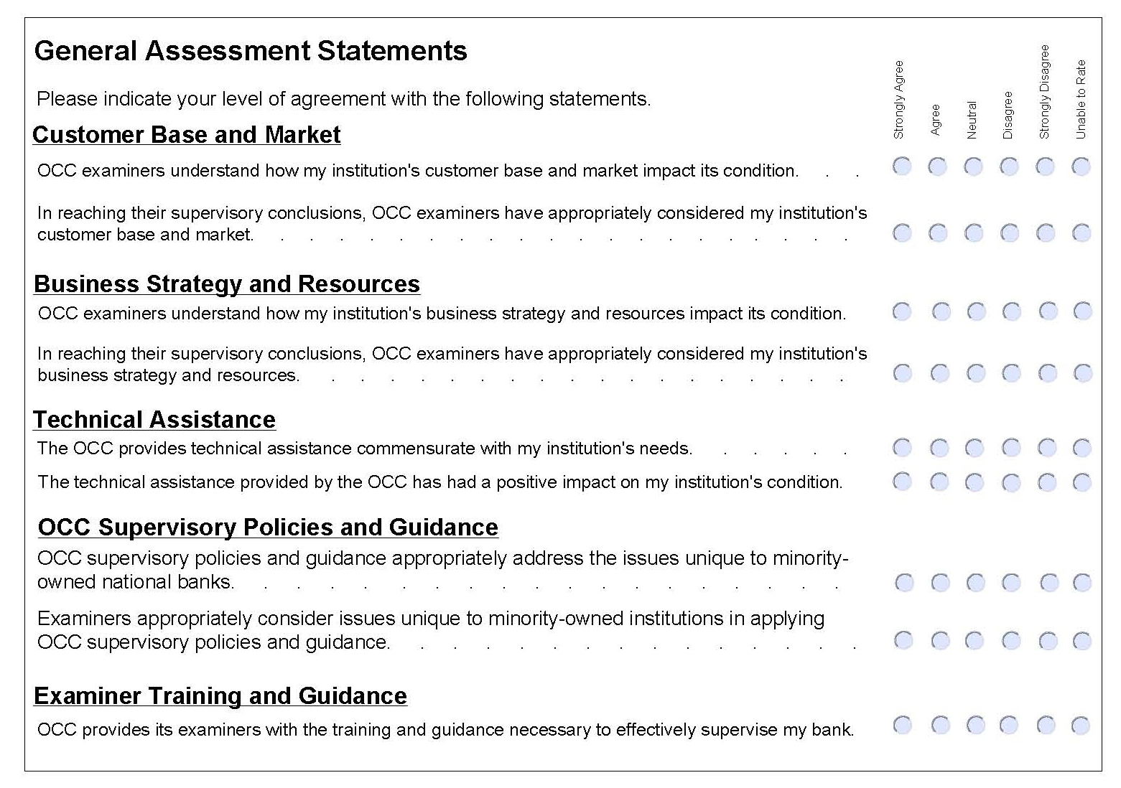

If you have any additional comments or suggestions regarding how the OCC can better serve and support minority-owned institutions, please include them below.

_____________________________________________________________________
_____________________________________________________________________
_____________________________________________________________________

Thank you for participating in this survey. Your feedback is important to our ongoing efforts to provide high quality bank supervision to minority-owned institutions banks.

