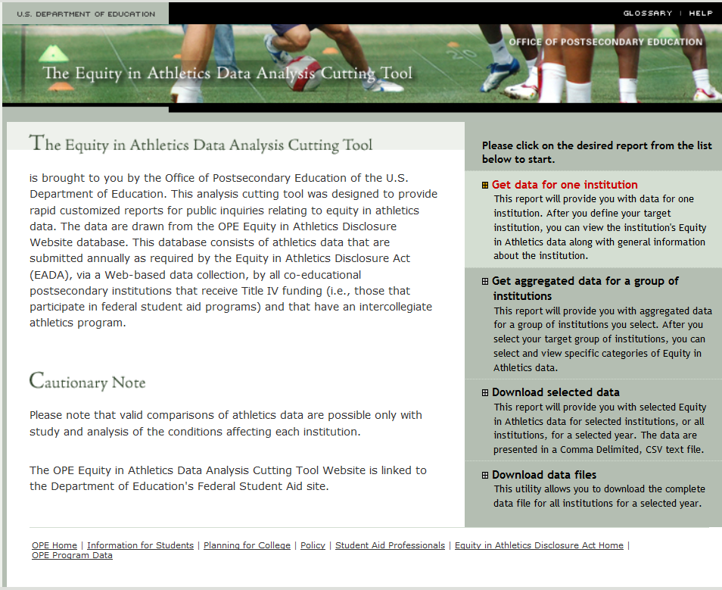

The data collected in this survey are provided by institutions in accordance with the EADA and may not be the same as data used for determining compliance with other Federal or state laws, including Title IX of the Education Amendments of 1972.