THE EQUITY IN ATHLETICS DISCLOSURE ACT
WEB-BASED DATA COLLECTION
SCREEN SHOTS

U.S. Department of Education
Office of Postsecondary Education

Log In
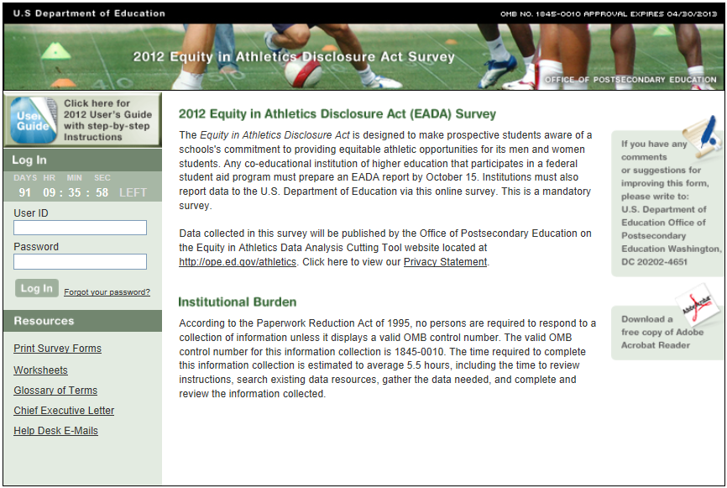

Survey Eligibility

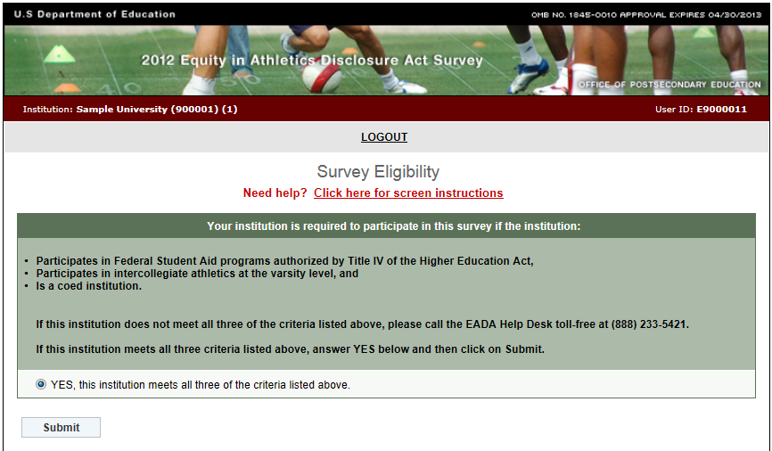

Important — Please read this before you begin…

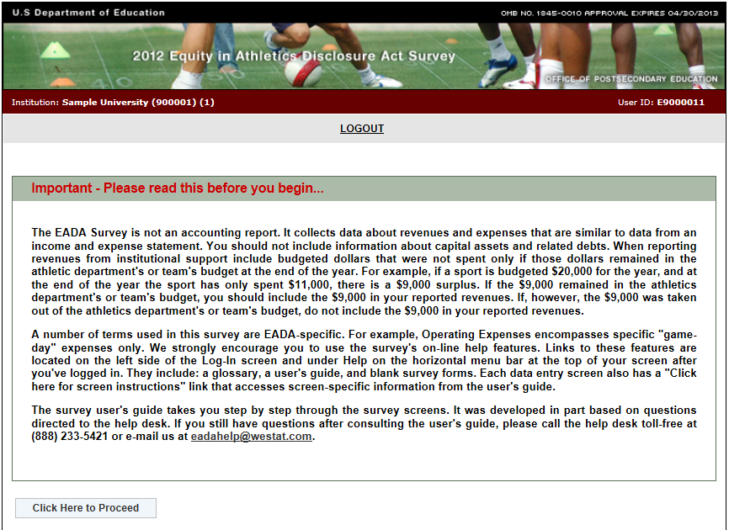

Registration
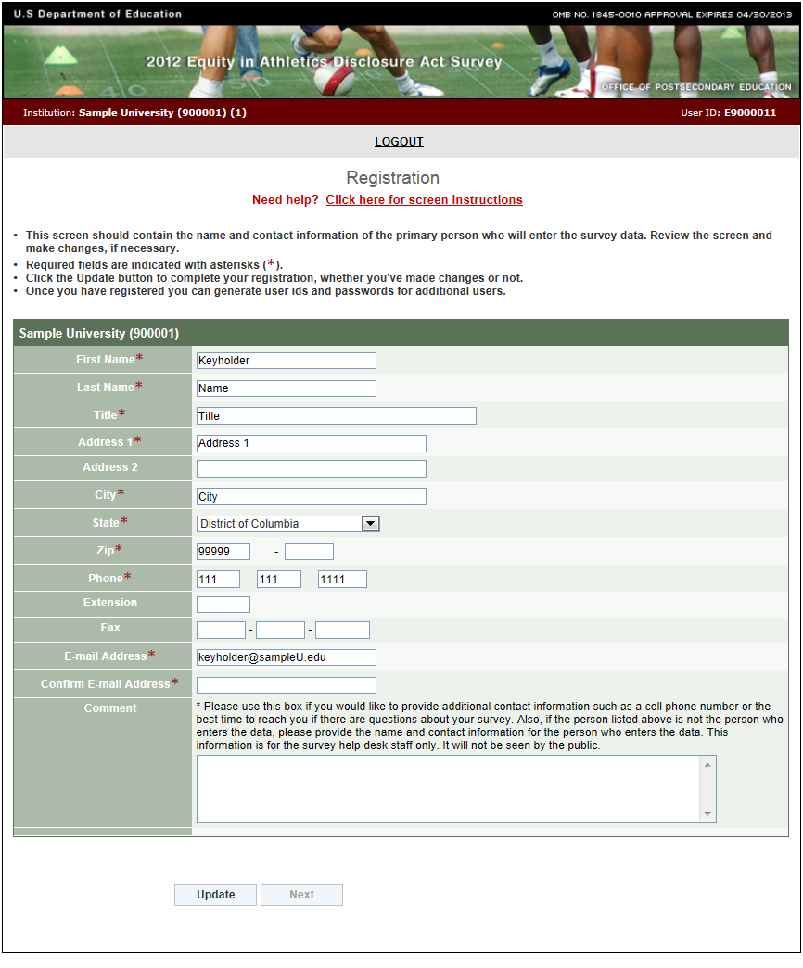

Institution Identification
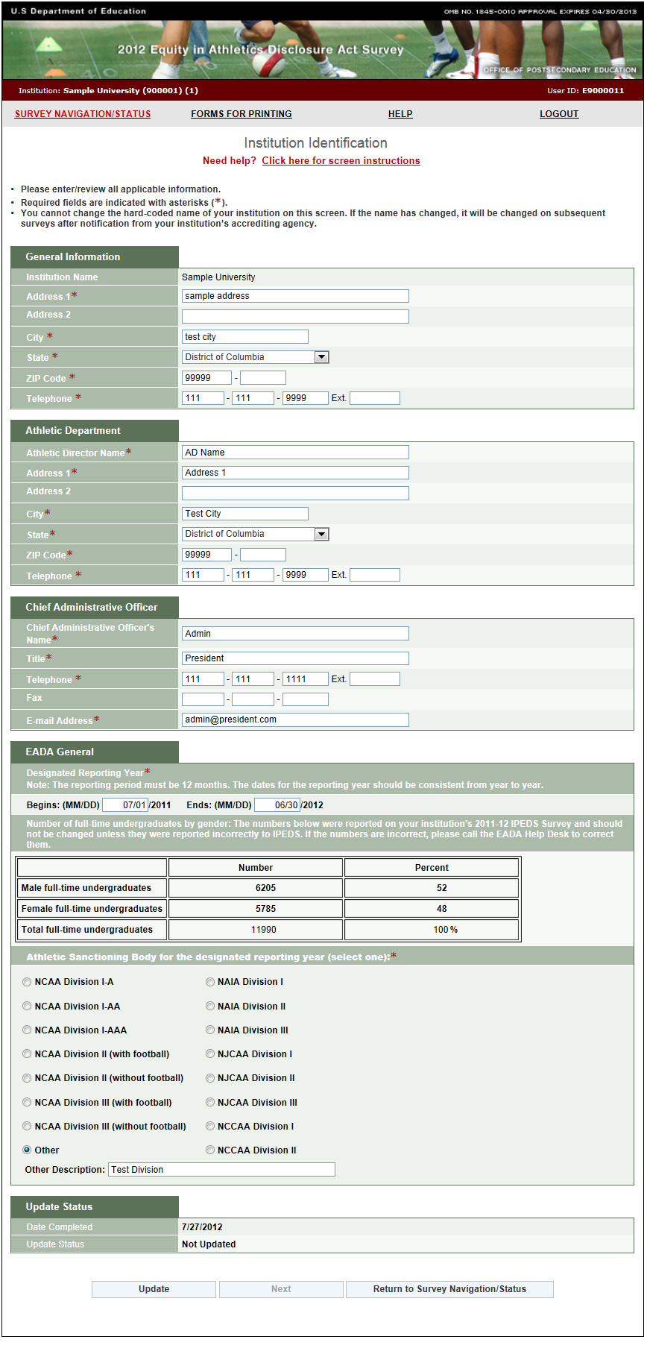

Screening Questions
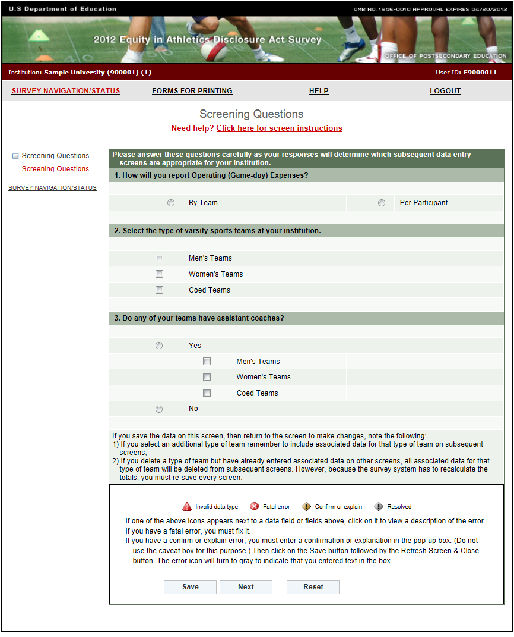

Sports Selection
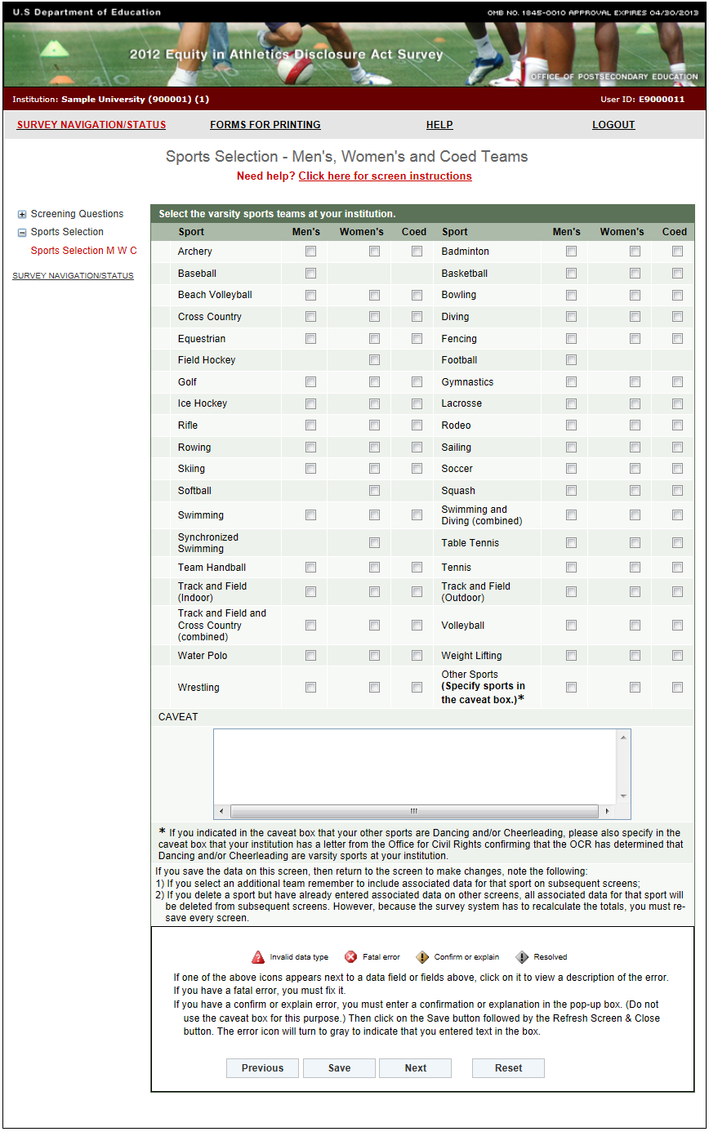

Athletics Participation
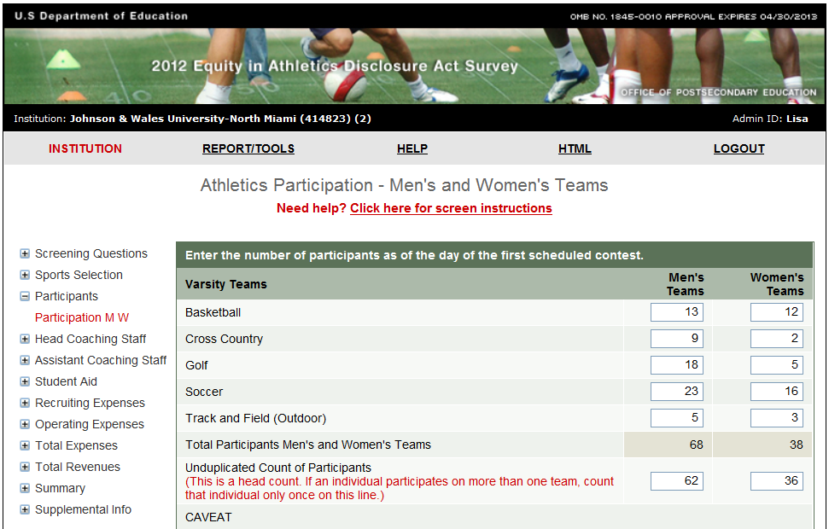
CAVEAT
(For each men’s or women’s team that includes opposite sex participants, specify the number of male and the number of female students on that team in this caveat box. This does not apply for coed teams. Additionally, provide any other clarifying information here.)
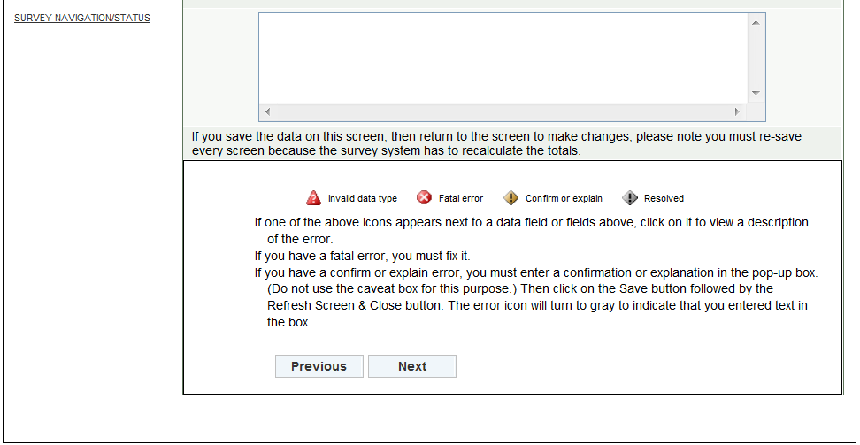

Head Coaches Men’s Teams
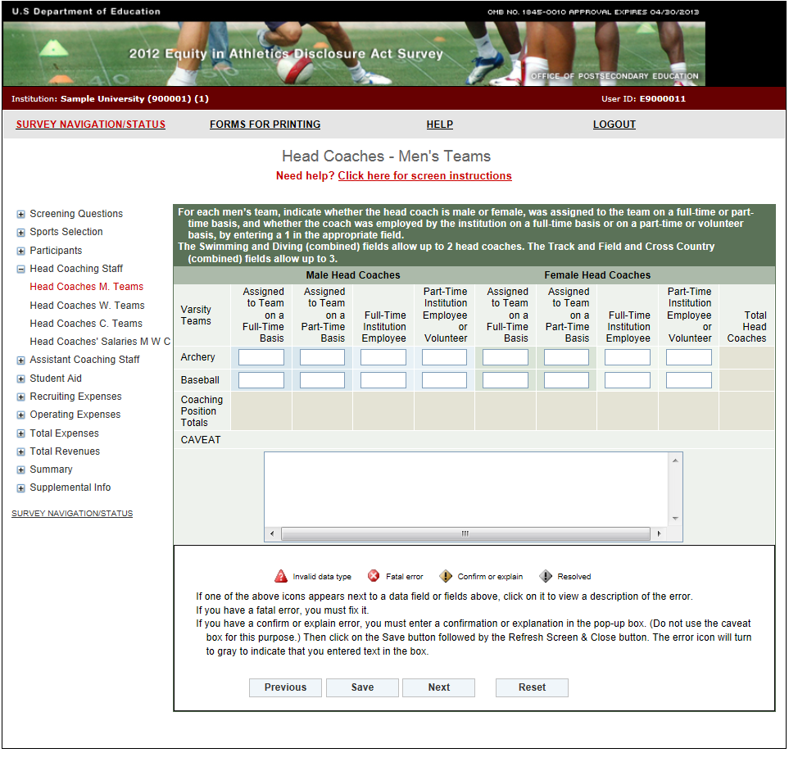

Head Coaches Women’s Teams
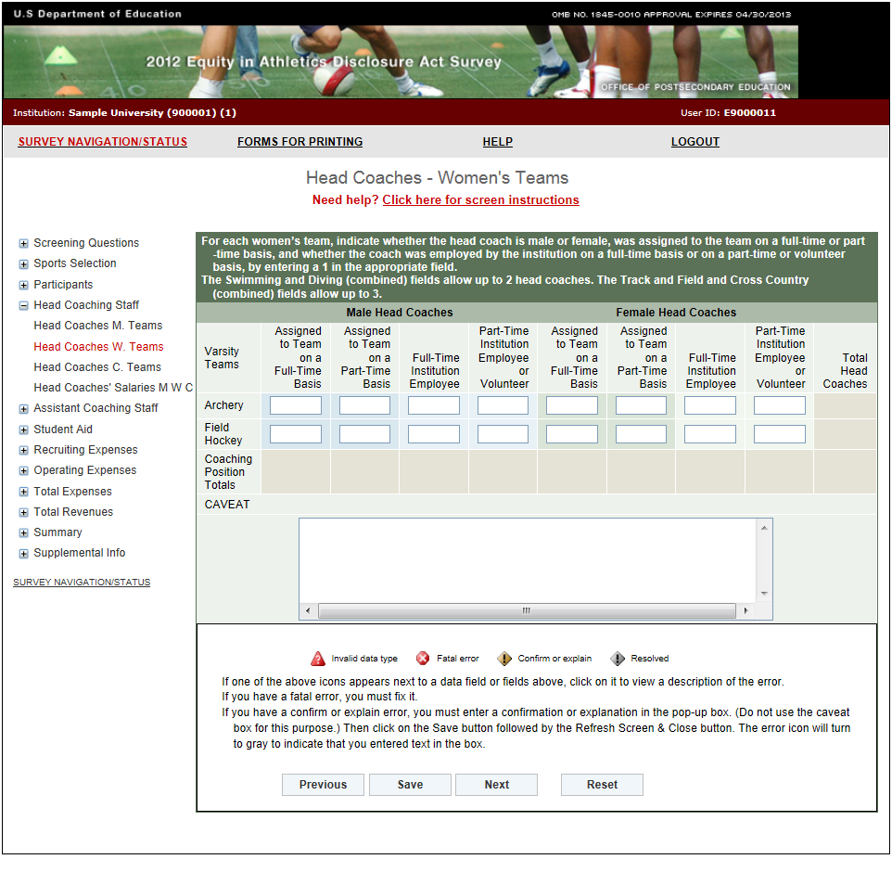

Head Coaches Coed Teams
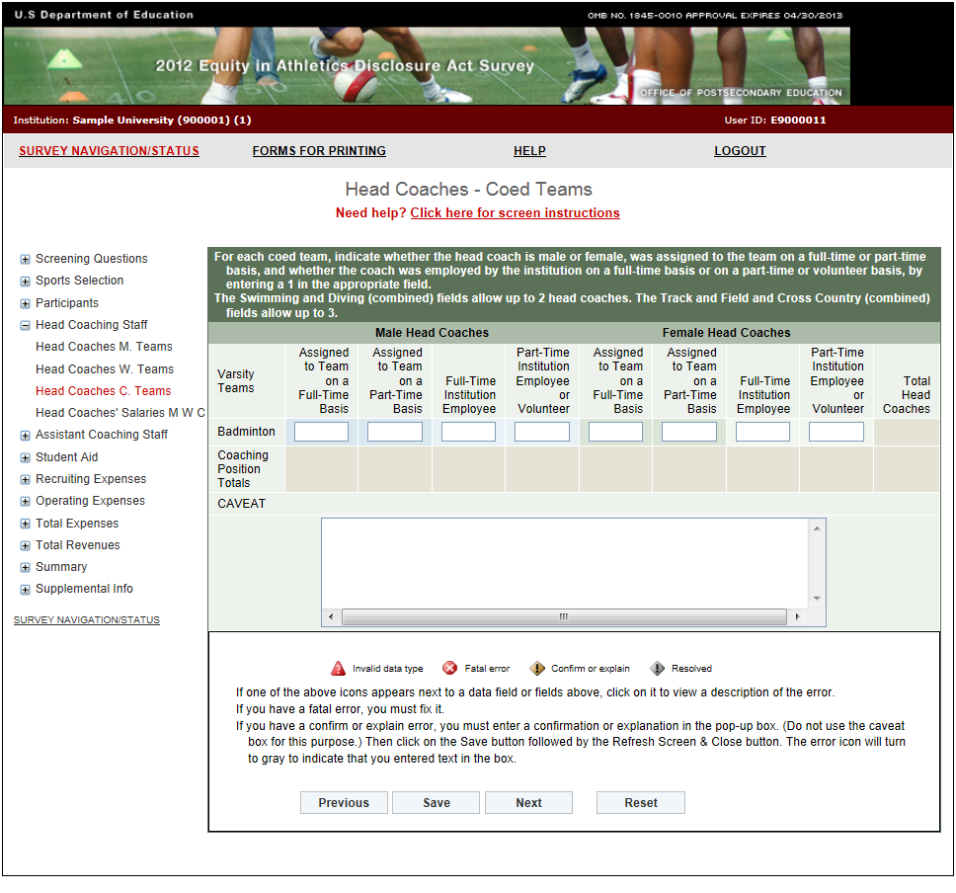

Head Coaches’ Salaries
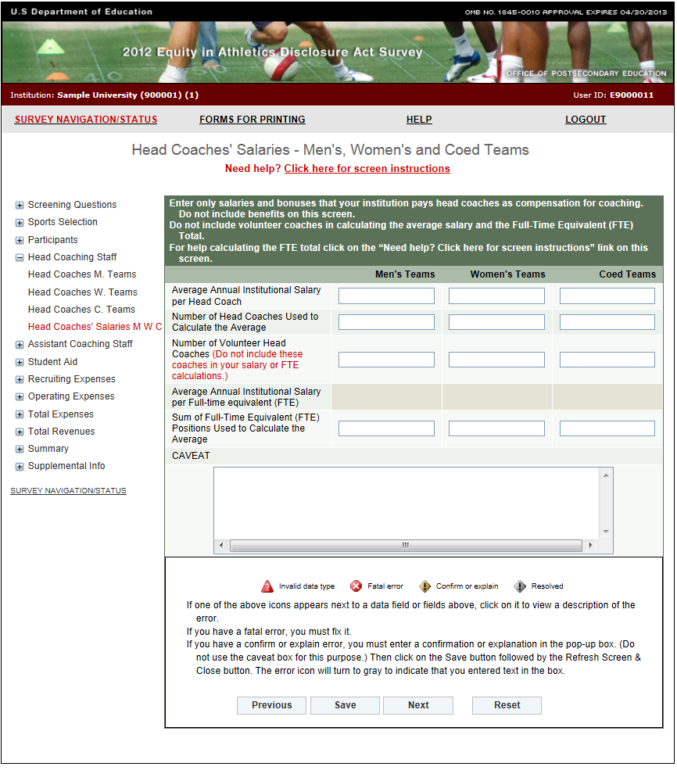

Assistant Coaches Men’s Teams
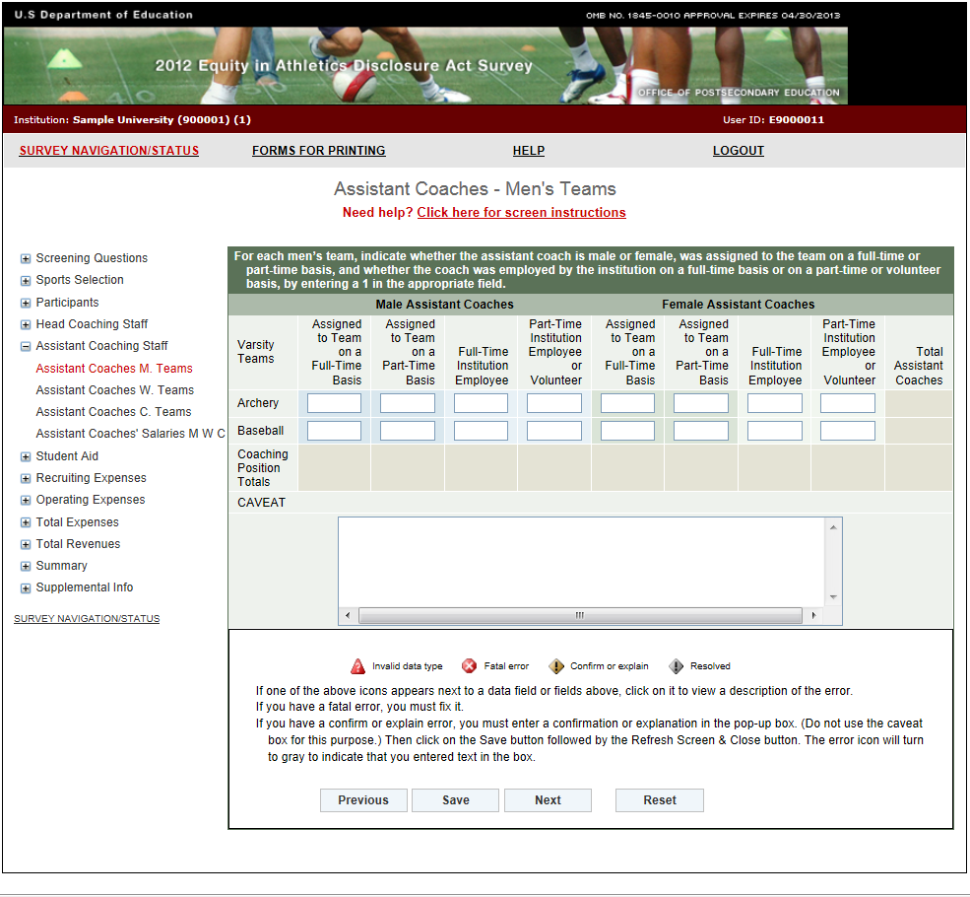

Assistant Coaches Women’s Teams
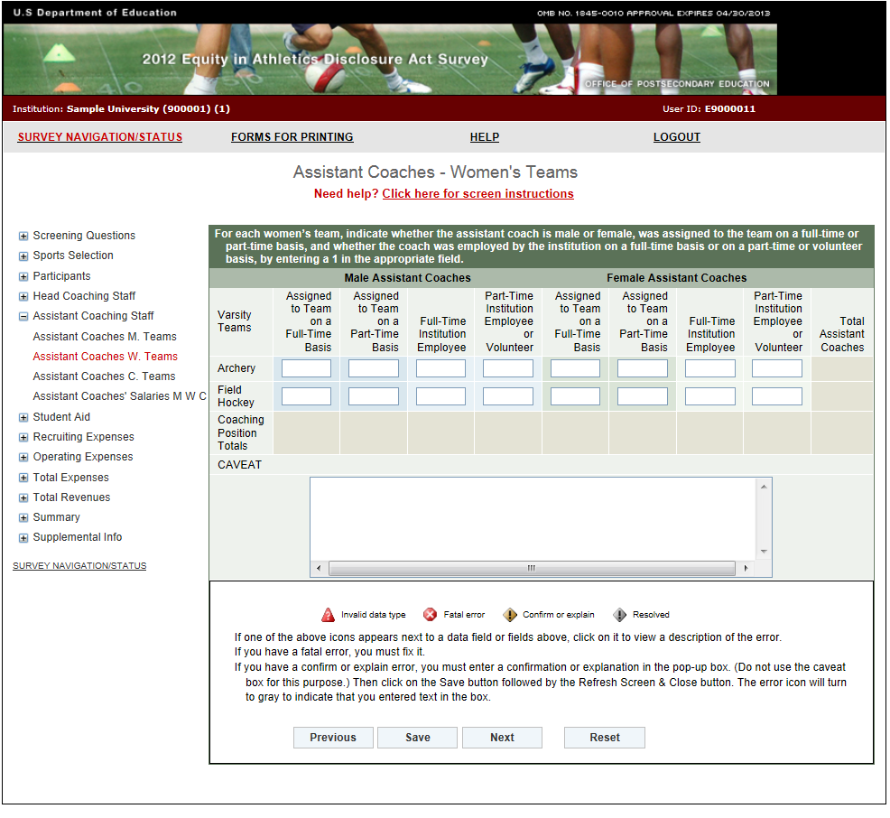

Assistant Coaches Coed Teams
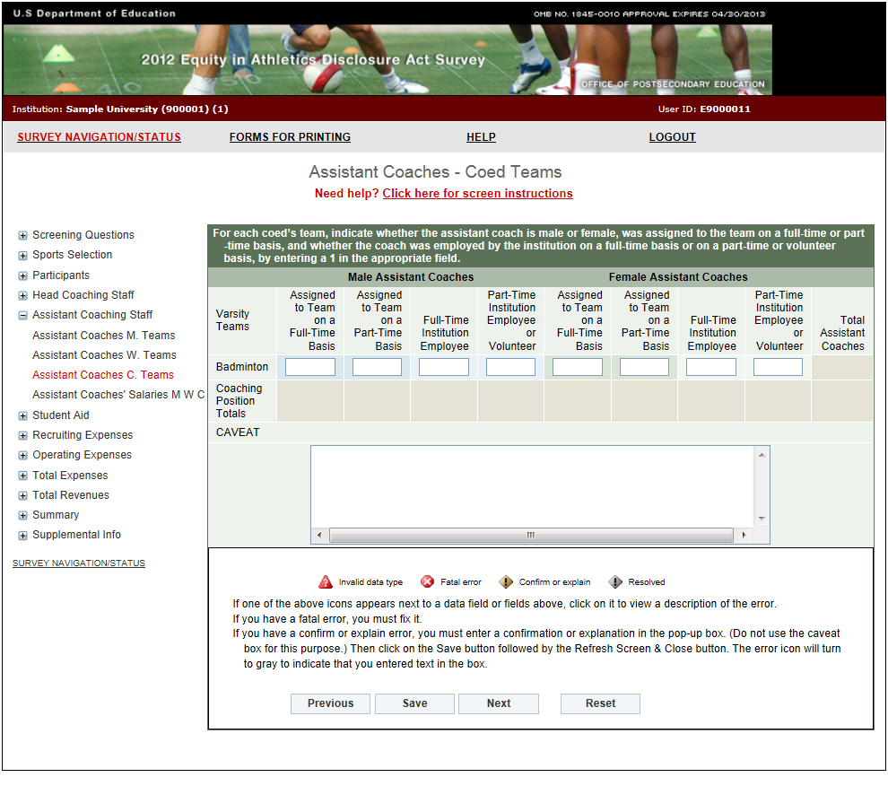

Assistant Coaches’ Salaries
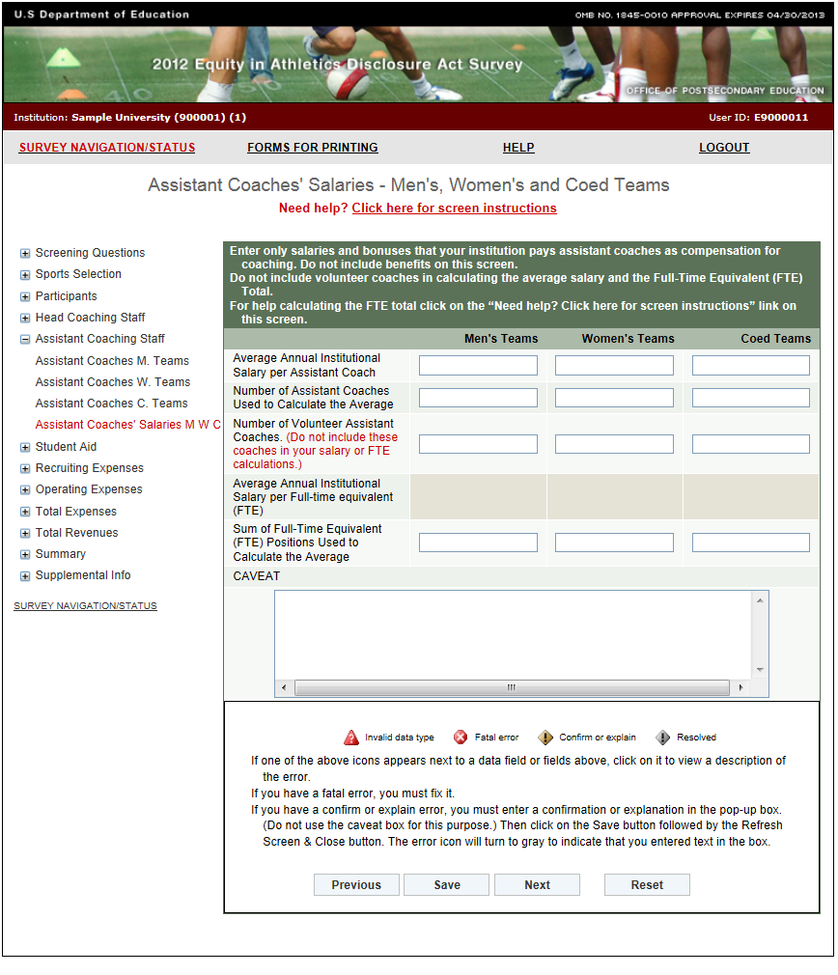

Athletically Related Student Aid
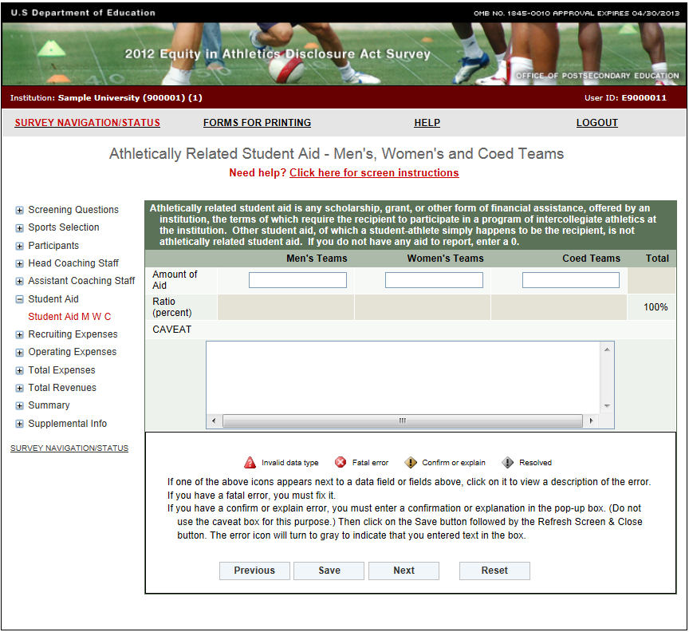

Recruiting Expenses
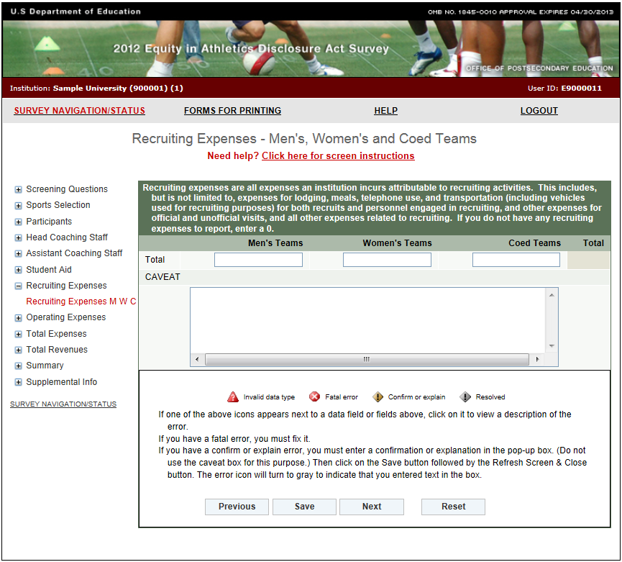

Operating (Game-Day) Expenses by Team/per Participant
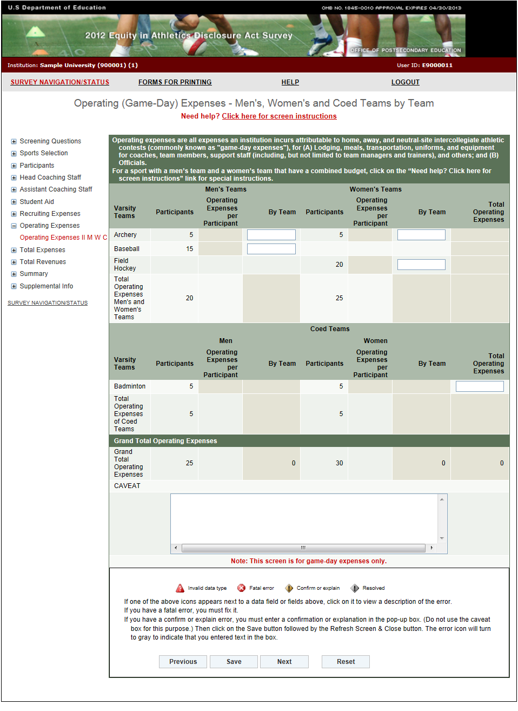

Total Expenses
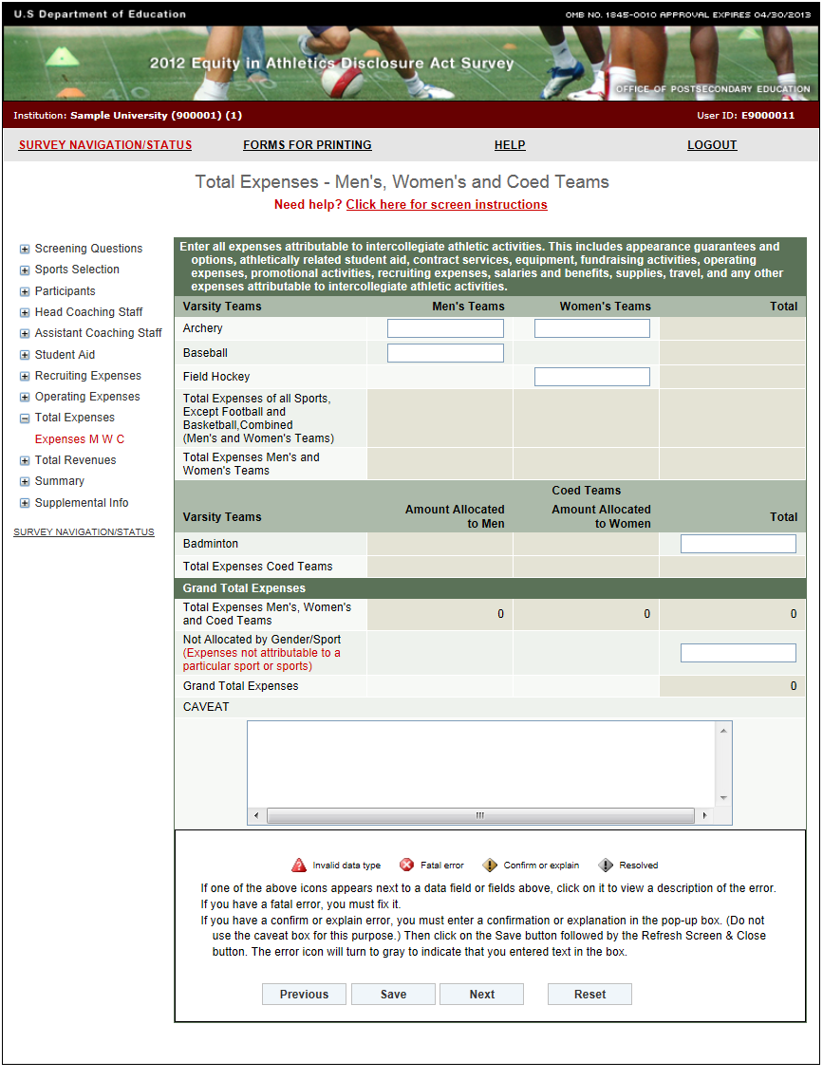

Total Revenues
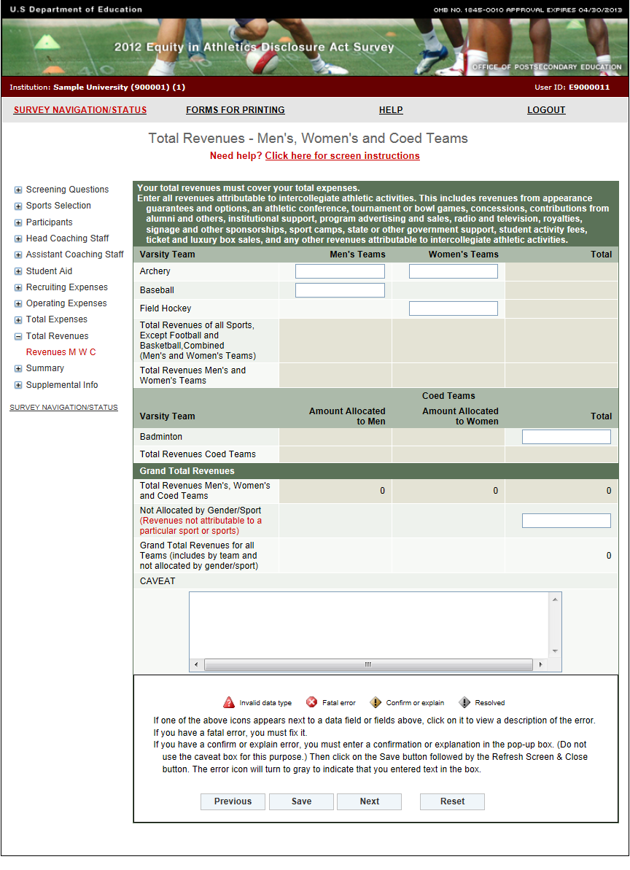
Summary
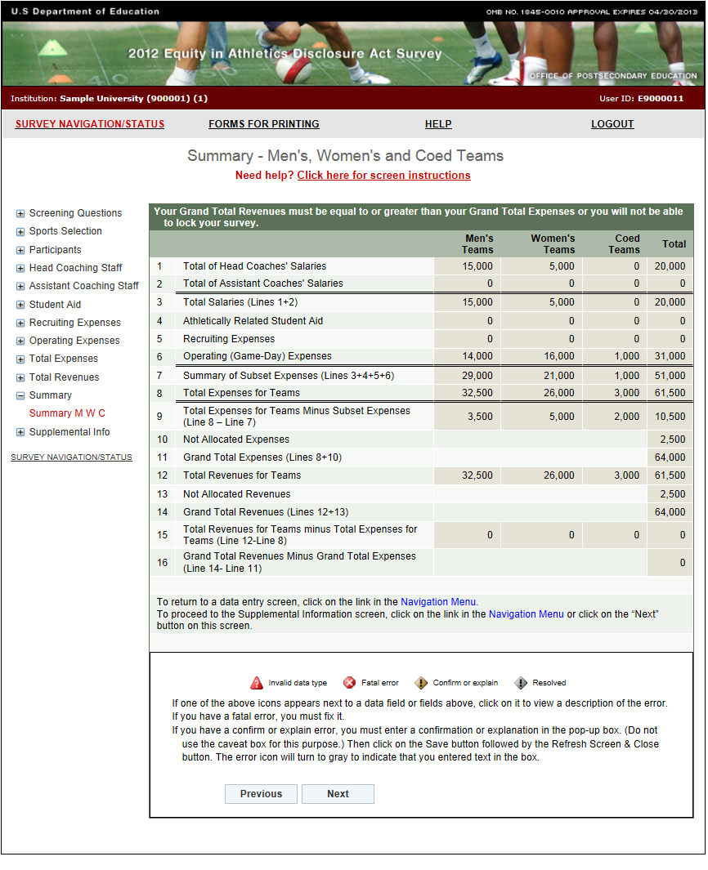

Supplemental Information
