MEMORANDUM UNITED STATES DEPARTMENT OF EDUCATION

Institute of Education Sciences
National Center for Education Statistics

To: Shelley Martinez, OMB

From: Gail Mulligan and Jill McCarroll, NCES

Date: June 25, 2013

Re: ECLS-K:2011 Spring 2nd Grade Full Study, 3rd Grade Recruitment, and 3rd and 4th Grade Tracking (OMB# 1850-0750 v.12-13) – Spring 3rd Grade School Contact for Hearing Evaluation Change Memo (OMB# 1850-0750 v.14)

We are requesting an amendment to the ECLS-K:2011 Spring 2nd Grade Full Study, 3rd Grade Recruitment, and 3rd and 4th grade Tracking data collection (OMB# 1850-0750 v.12-13), which was approved in October 2012, with a change request approved in January 2013.

As discussed in the Supporting Statement Part A of the approved package, sampled schools will be contacted in the fall prior to the third-grade data collection round. In the fall of the 2013-14 school year, school coordinators will be sent information about the study, including a letter describing the study activities planned for the spring, the role of the school coordinator, and a list of participating children who will be assessed in the spring.

During this fall contact period, an experienced team of school recruiters will work with the school coordinators to discuss the logistics of the spring assessment visit. Additionally, school recruiters will confirm whether the children on a list of study children sent to the school are still enrolled in the school, identify the teachers of the sampled children, and set an assessment date for the spring.

Since the approval of the previous clearance package (OMB# 1850-0750 v.12-13), the National Center for Deafness and Other Communication Disorders (NIDCD), a sponsoring partner for ECLS-K:2011, has decided to exercise a contract option to evaluate children’s hearing in the spring third-grade round (spring 2014). The planned hearing evaluation will be modeled after the ECLS-K:2011 hearing component that was very successfully incorporated into the fall second-grade collection. The hearing evaluation data will be collected in a subsample of schools, and recruiters will need to discuss the logistics for this hearing component with school coordinators during the advanced school contact call in the fall.

Thus, this amendment requests approval to substitute the previously approved advance school contact coordinator letter with the revised versions of the letters shown below (changes are highlighted in yellow), plus a hearing evaluation flyer that describes the hearing evaluation goals and protocols (see pages 42-44 in the attached revised Appendix A). There are two versions of the revised school coordinator letter because the hearing screenings are conducted in only a subsample of schools. The letter for schools in which hearing evaluations are not being conducted is almost identical to the previously approved letter. However, the following text has been removed due to a change in the way in which the list of students participating in the study will be given to each school: “As mentioned above, the list of participating children will be sent to you in a separate mailing. Please keep an eye out for this mailing.”

In addition to the changes made to the respondent letters as a result of adding the hearing evaluation, the time of the child assessment has been revised in each of the third-grade recruitment letters from 75 to 80 minutes. Since the development of the third-grade recruitment letters, the ECLS team conveyed two Content Review Panels (CRPs). The CRPs recommended additional domains of assessment that, while adding 5 minutes of burden, increase the breadth of topics that the ECLS-K:2011 can assess and, therefore, the study's research utility.

One other change was made in the Spring 3rd grade letter for participating districts with previously non-participating schools into which study children have transferred to make the language used there consistent with the language used in all the other letters. Specifically, “working memory” was revised to just “memory.”

All of the revised respondent materials have been incorporated into the accompanying Appendix A that was approved in the previous OMB package (OMB# 1850-0750 v.12-13). Only the revised hearing flyer was not included in the package in which clearance was obtained for recruitment for the spring third-grade data collection, because the activity was not originally planned for the third grade. The flyer that will be used for the third-grade hearing evaluation is very similar to the flyer approved for and used in the spring second-grade data collection. This flyer has been added at the end of Appendix A (pages 42-44). The revisions to the respondent materials described in this memo are also shown below in yellow highlighted text using copies of the revised materials.

Because the third-grade data collection has not yet been cleared (only recruitment in preparation for the data collection), this request has no associated change in respondent burden for the advance school contact in the fall and does not affect the total cost to the federal government for this study. Approval for the third-grade data collection and the associated with it respondent burden and costs of conducting the hearing evaluations in the spring third-grade data collection will be sought in the package requesting approval for all aspects of that data collection, which will enter the clearance process in early July 2013.

Previously Approved Letter
for School Coordinators
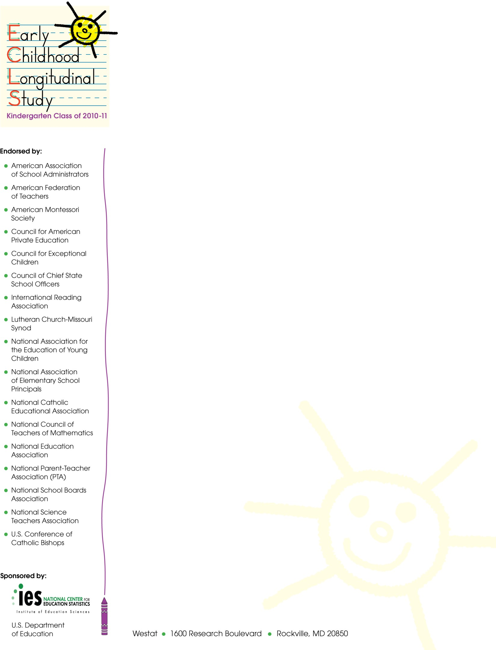
Fall 2013

[NAME]
[SCHOOL NAME]
[ADDRESS 1]
[CITY, STATE ZIP]

Dear School Coordinator:

We are very happy that your school is participating in the Early Childhood Longitudinal Study, Kindergarten Class of 2010-11 (ECLS-K:2011). As you may know, we collected information last year from the children participating in the study, their parents, their teachers, and their school’s administrator. We are looking forward to following these children this school year.

This spring, children will complete one-on-one assessments with trained ECLS-K:2011 assessors. These assessments are designed to measure children’s reading, mathematics, and science skills and knowledge, as well as obtain indicators of children’s memory and ability to follow rules in a structured task. Children also will have their height and weight measured and will complete a questionnaire about themselves and their experiences in school. These assessment activities will take approximately 75 minutes for each child to complete.

A component of the data collection involves collecting information about the sampled students from their teachers using self-administered questionnaires. We also will collect information from the school administrator.

We appreciate your help with four tasks, which are detailed in the enclosed materials. These are (1) confirm that the children participating in the ECLS-K:2011 are attending your school (the list of participating children will be sent in a separate mailing); (2) confirm the date and time for the spring activities; (3) identify an appropriate space for the assessments; and (4) identify the primary teachers of the participating children. Please read the enclosed materials for more information about the study and your important role in it.

As mentioned above, the list of participating children will be sent to you in a separate mailing. Please keep an eye out for this mailing.

The National Center for Education Statistics (NCES) of the U.S. Department of Education’s Institute of Education Sciences is the primary sponsor of the ECLS-K:2011, which is being conducted on behalf of NCES by Westat. ECLS-K:2011 has been endorsed by the national education organizations listed on this letter. NCES is authorized to conduct this study under 20 U.S. Code, Section 9541. Under that law, the data you provide may be used only for statistical purposes and may not be disclosed, or used, in identifiable form for any other purpose except as required by law (20 U.S. Code, Section 9573). The U.S. Office of Management and Budget has approved the data collection under OMB # 1850-0750 (expires 10/31/2015).

Thank you for your support of the ECLS-K:2011. We look forward to working with you and your school. An ECLS-K:2011 representative will call you in the coming weeks to further explain the study and your responsibilities. If you have any questions or concerns in advance of the phone call, please call Westat toll free at 1-888-204-4864 or send an email to ECLSKHELP@westat.com.

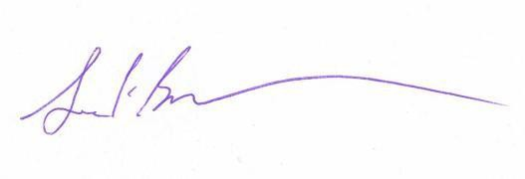
Sincerely,

Jack Buckley, Ph.D.
Commissioner
National Center for Education Statistics, Institute of Education Sciences

Revised Letters for School Coordinators

for which approval is being sought
in this submittal

- Revised letter for the school coordinator in hearing evaluation subsample schools

- Revised letter for the school coordinator in non-hearing evaluation subsample schools

Please note that the signature section of the letters is somewhat scrunched in this document, but formatting issues such as that will be fixed before the final letters are printed. Also, added text about the hearing evaluation has been highlighted so it can be seen easily. This highlighting will be removed before the final letters are printed.
Fall 2013
[NAME]
[SCHOOL NAME]
[ADDRESS 1]
[CITY, STATE ZIP]

Dear School Coordinator:

We are very happy that your school is participating in the Early Childhood Longitudinal Study, Kindergarten Class of 2010-11 (ECLS-K:2011). As you may know, we collected information last year from the children participating in the study, their parents, their teachers, and their school’s administrator. We are looking forward to following these children this school year.

This spring, children will complete one-on-one assessments with trained ECLS-K:2011 assessors. These assessments are designed to measure children’s reading, mathematics, and science skills and knowledge, as well as obtain indicators of children’s memory and ability to follow rules in a structured task. Children also will have their height and weight measured and will complete a questionnaire about themselves and their experiences in school. These assessment activities will take approximately 80 minutes for each child to complete. In addition to participating in the assessment, some children will have their hearing evaluated. These evaluations occur at multiple points throughout the study so that researchers can study how hearing may change during the elementary school years. The hearing evaluation will take approximately 15 minutes.

A component of the data collection involves collecting information about the sampled students from their teachers using self-administered questionnaires. We also will collect information from the school administrator.

We appreciate your help with four tasks, which are detailed in the enclosed materials. These are (1) confirm that the children participating in the ECLS-K:2011 are attending your school (the list of participating children will be sent separately); (2) determine the date and time for the spring activities; (3) identify an appropriate space for the assessments and hearing evaluations; and (4) identify the primary teachers of the participating children. Please read the enclosed materials for more information about the study and your important role in it.

The National Center for Education Statistics (NCES) of the U.S. Department of Education’s Institute of Education Sciences is the primary sponsor of the ECLS-K:2011, which is being conducted on behalf of NCES by Westat. ECLS-K:2011 has been endorsed by the national education organizations listed on this letter. NCES is authorized to conduct this study under 20 U.S. Code, Section 9541. Under that law, the data you provide may be used only for statistical purposes and may not be disclosed, or used, in identifiable form for any other purpose except as required by law (20 U.S. Code, Section 9573). The U.S. Office of Management and Budget has approved the data collection under OMB # 1850-0750 (expires 10/31/2015).

Thank you for your support of the ECLS-K:2011. We look forward to working with you and your school. An ECLS-K:2011 representative will call you in the coming weeks to further explain the study and your responsibilities. If you have any questions or concerns in advance of the phone call, please call Westat toll free at 1-888-204-4864 or send an email to ECLSKHELP@westat.com.

Sincerely,

Jack Buckley, Ph.D.
Commissioner
National Center for Education Statistics, Institute of Education Sciences

Fall 2013
[NAME]
[SCHOOL NAME]
[ADDRESS 1]
[CITY, STATE ZIP]

Dear School Coordinator:

We are very happy that your school is participating in the Early Childhood Longitudinal Study, Kindergarten Class of 2010-11 (ECLS-K:2011). As you may know, we collected information last year from the children participating in the study, their parents, their teachers, and their school’s administrator. We are looking forward to following these children this school year.

This spring, children will complete one-on-one assessments with trained ECLS-K:2011 assessors. These assessments are designed to measure children’s reading, mathematics, and science skills and knowledge, as well as obtain indicators of children’s memory and ability to follow rules in a structured task. Children also will have their height and weight measured and will complete a questionnaire about themselves and their experiences in school. These assessment activities will take approximately 80 minutes for each child to complete.

A component of the data collection involves collecting information about the sampled students from their teachers using self-administered questionnaires. We also will collect information from the school administrator.

We appreciate your help with four tasks, which are detailed in the enclosed materials. These are (1) confirm that the children participating in the ECLS-K:2011 are attending your school (the list of participating children will be sent separately); (2) determine the date and time for the spring activities; (3) identify an appropriate space for the assessments; and (4) identify the primary teachers of the participating children. Please read the enclosed materials for more information about the study and your important role in it.

The National Center for Education Statistics (NCES) of the U.S. Department of Education’s Institute of Education Sciences is the primary sponsor of the ECLS-K:2011, which is being conducted on behalf of NCES by Westat. ECLS-K:2011 has been endorsed by the national education organizations listed on this letter. NCES is authorized to conduct this study under 20 U.S. Code, Section 9541. Under that law, the data you provide may be used only for statistical purposes and may not be disclosed, or used, in identifiable form for any other purpose except as required by law (20 U.S. Code, Section 9573). The U.S. Office of Management and Budget has approved the data collection under OMB # 1850-0750 (expires 10/31/2015).

Thank you for your support of the ECLS-K:2011. We look forward to working with you and your school. An ECLS-K:2011 representative will call you in the coming weeks to further explain the study and your responsibilities. If you have any questions or concerns in advance of the phone call, please call Westat toll free at 1-888-204-4864 or send an email to ECLSKHELP@westat.com.
Sincerely,

Jack Buckley, Ph.D.
Commissioner
National Center for Education Statistics, Institute of Education Science

School coordinators are previously-identified school staff who serve as liaisons to the project, working with project field staff to arrange for the assessment day activities.
School recruiters are specially-trained data collection contractor staff who recruit districts and schools into the study. They are typically used in advance school contacts because they have experience talking with school staff and discussing logistical arrangements, as well as recruiting new transfer schools that are identified during the pre-assessment contacts.
A full description of the hearing evaluation procedures will be included in the next OMB package (1850-0750, v.15), scheduled to enter the clearance process in early July 2013. The hearing evaluation is expected to take about 15 minutes and will include a short set of hearing-related questions asked of the children to aid analysts in the interpretation of the collected hearing evaluation data, a brief visual inspection of the ears, the collection of measures of middle ear function in both ears, and the collection of specific audiometric thresholds. Hearing evaluations following the same protocol and with the same subsample of children were previously conducted as part of the study when the children were in the fall of their second grade year (approved under OMB package #1850-0750, v.10-11).
Previously the list of students was sent to schools using Fed Ex, with signature required. The study is switching to a secure electronic messaging system. The electronic messaging system process has been reviewed by NCES's IT team.

