Animal and Plant  Health Inspection  Service  Veterinary Services | NAHMS Dairy 2014  Heifer Calf  Fecal Collection Record | National Animal  Health Monitoring  System  2150 Centre Dr #B  Ft Collins, CO 80526  Form Approved  OM B Number 0579-0205  Approval expires:XX/XXXX

Calf Fecal (CF) Kit: #

Calf fecal samples are to be collected from operations participating in the longitudinal calf component (blood, colostrum, and ear notch testing and completion of diary cards).

- Collect individual fecal samples from up to 2 heifer calves 2-4 weeks of age that are enrolled in the calf study. A total of 12 calves will be sampled over the year-long study.
- These samples will be tested for Cryptosporidium, giardia, microsporidia and blastocystis.
- Review the materials in the Biologics Manual for detailed collection information.
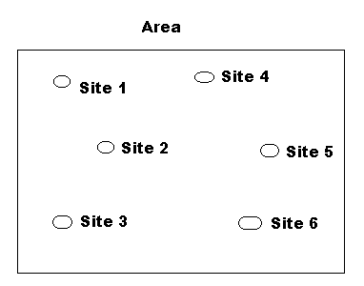
- Each sample should be about golf-ball size and placed in an individual flat bottom container provided.
- Place a Calf ID sticker on the side of the container (not the lid).

- Collect two composite fecal samples from a pen of weaned calves (2-6 months of age). For each composite fecal sample, collect manure samples from 2 different weaned calf AREAS (see figure at right). If there is only a single weaned calf area, collect a single composite sample. Collect about 2 ounces (~ 2 tablespoons) of manure/slurry from each of six SITES within an AREA and place in the sample container.
- These samples will be tested for Shiga Toxin E Coli (STEC) and Salmonella.
- Place the label on the body of the container (not the lid).
For weaned calf samples, an area consists of 6 sites and samples from 2 areas on each operation will be collected.
- Complete the Collection Form. See example in Biologics Handbook.
- Keep samples cool, pack with fresh ice packs before shipping and ship to ARS
(Fayer Lab) via Fed Ex within 24 hours of collection.
- Send the Collection Form to your NAHMS Coordinator.

According to the Paperwork Reduction Act of 1995, an agency may not conduct or sponsor, and a person is not required to respond to, a collection of information unless it displays a valid OMB control number. The valid OMB control number for this information collection is 0579-0205. The time required to complete this information collection is estimated to average .25 hours per response, including the time for reviewing instructions, searching existing data sources, gathering and maintaining the data needed, and completing and reviewing the collection of information.
NAHMS-306
Jan 2014
Dairy 2014 - Heifer Calf Fecal Collection Record CF Kit: #
Farm ID | # of people involved  ____ Fed VMO ____ Fed AHT ____Producer  ____ State VMO ____ St AHT ____ Priv Vet  ____ Others-specify: | Key Collector’s name and phone # | Time to collect & prep samples | Overall travel time
8-digits: St, Op, | Enter number for each category |  | Hours | Hours

Preweaned study calves (2-4 weeks of age):

Sample # | NAHMS Calf ID | Ear Tag/  Farm Calf ID | Collection Date  (MM/DD/YY)
1 | Place sticker here!
2 | Place sticker here!

Weaned calves (2-6 months of age):

Sample # | Sample location | Age of calves in pen | Collection Date  (MM/DD/YY)
1
2

